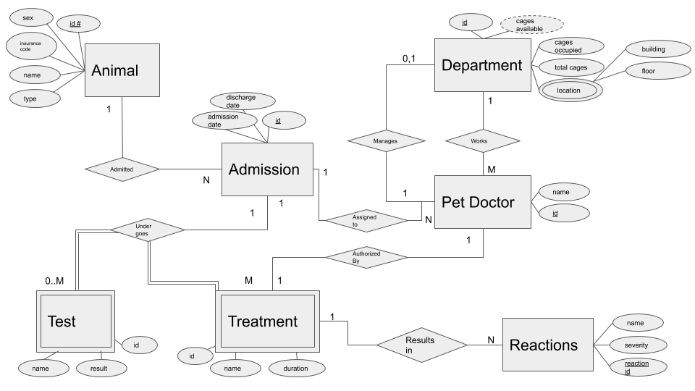

Entities

1. Animal (sex, identification number, pet insurance code, name, type)
2. Admission (admission_date, discharge_date, admission­_id)
3. Test (name, result, test_id)
4. Treatment (treatment_id, name, duration)
5. Reaction (name, severity, reaction­_id)
6. Pet Doctor (doctor_id, name)
7. Department (department_id, cages_available, cages_occupied, total_cages, location(building_no, floor))

Relationships

1. Admitted <Animal, Admission> 1:N PARTIAL/PARTIAL
2. Under Goes Test <Admission, Test> 1:M PARTIAL/TOTAL
3. Under Goes Treatment <Admission, Treatment> 1:M PARTIAL/TOTAL
4. Authorized By <Pet Doctor, Treatment> 1:1 PARTIAL/TOTAL
5. Results In <Treatment, Reactions> 1:1 TOTAL/TOTAL
6. Manages <Pet Doctor, Department> 1:0..1 PARTIAL/PARTIAL
7. Works <Pet Doctor, Department> M:1 PARTIAL/PARTIAL

ASSUMPTIONS

1. Only one pet doctor authorizes an animal treatment
2. I would ask the client more about the cages in the department. As of now, I assume that the number of cages in a department is updated through a human process, and its relationship is not important enough to be specified in the database design.
3. An animal can be admitted multiple times. This admission is treated differently and they can get a new doctor.
4. A test does not need a doctor’s authorization in the database. These lab tests are dependent on the admission. So, we might test how fast an animal can run around in a circle for example. This will be tied to a specific case, not the animal, as it will be important for the doctors to see this when deciding treatments.

Resulting schemas after mapping

**ANIMAL** (sex, identification number, pet insurance code, name, type)

**ADMISSION** (admission_date, discharge_date, admission­_id, animal_id)

FK (animal_id) -> ANIMAL(identification_number)

**TEST** (name, result, test_id, admission_id)

FK(admission_id) -> ADMISSION(admission_id)

**TREATMENT** (treatment_id, name, duration, admission_id, authorized_by, reaction_id)

FK(admission_id) -> ADMISSION(admission_id)

FK(authorized_by) -> PET_DOCTOR(doctor_id)

FK(reaction_id) -> REACTION (reaction­_id)

**REACTION** (name, severity, reaction­_id)

**PET_DOCTOR_ASSIGNMENT**(admission_id, doctor_id)

* The PK is the concatenation of these keys

FK(admission_id) -> ADMISSION(admission_id)

FK(doctor_id) -> PET_DOCTOR(doctor_id)

**PET_DOCTOR** (doctor_id, name, department)

FK(department) -> DEPARTMENT(department_id)

**DEPARTMENT_HEADS**(doctor_id, department_id)

* The PK is the concatenation of these keys

FK(doctor_id) -> PET_DOCTOR(doctor_id)

FK(department_id) -> DEPARTMENT(department_id)

**DEPARTMENT** (department_id, cages_available, cages_occupied, total_cages, building_no, floor)