**Mathew Varughese**

MAV120

CS 1699

HW 4

**Part I – Implement AlexNet**

AlexNet(

(features): Sequential(

(0): Conv2d(3, 96, kernel_size=(11, 11), stride=(4, 4))

(1): ReLU(inplace=True)

(2): MaxPool2d(kernel_size=3, stride=2, padding=0, dilation=1, ceil_mode=False)

(3): Conv2d(96, 256, kernel_size=(5, 5), stride=(1, 1), padding=(2, 2))

(4): ReLU(inplace=True)

(5): MaxPool2d(kernel_size=3, stride=2, padding=0, dilation=1, ceil_mode=False)

(6): Conv2d(256, 384, kernel_size=(3, 3), stride=(1, 1), padding=(1, 1))

(7): ReLU(inplace=True)

(8): Conv2d(384, 384, kernel_size=(3, 3), stride=(1, 1), padding=(1, 1))

(9): ReLU(inplace=True)

(10): Conv2d(384, 256, kernel_size=(3, 3), stride=(1, 1), padding=(1, 1))

(11): ReLU(inplace=True)

(12): MaxPool2d(kernel_size=3, stride=2, padding=0, dilation=1, ceil_mode=False)

)

(flatten): Flatten()

(classifier): Sequential(

(0): Dropout(p=0.5, inplace=False)

(1): Linear(in_features=9216, out_features=4096, bias=True)

(2): ReLU(inplace=True)

(3): Dropout(p=0.5, inplace=False)

(4): Linear(in_features=4096, out_features=4096, bias=True)

(5): ReLU(inplace=True)

(6): Linear(in_features=4096, out_features=4, bias=True)

)

)

**Validation Set Accuracy**: 0.9046

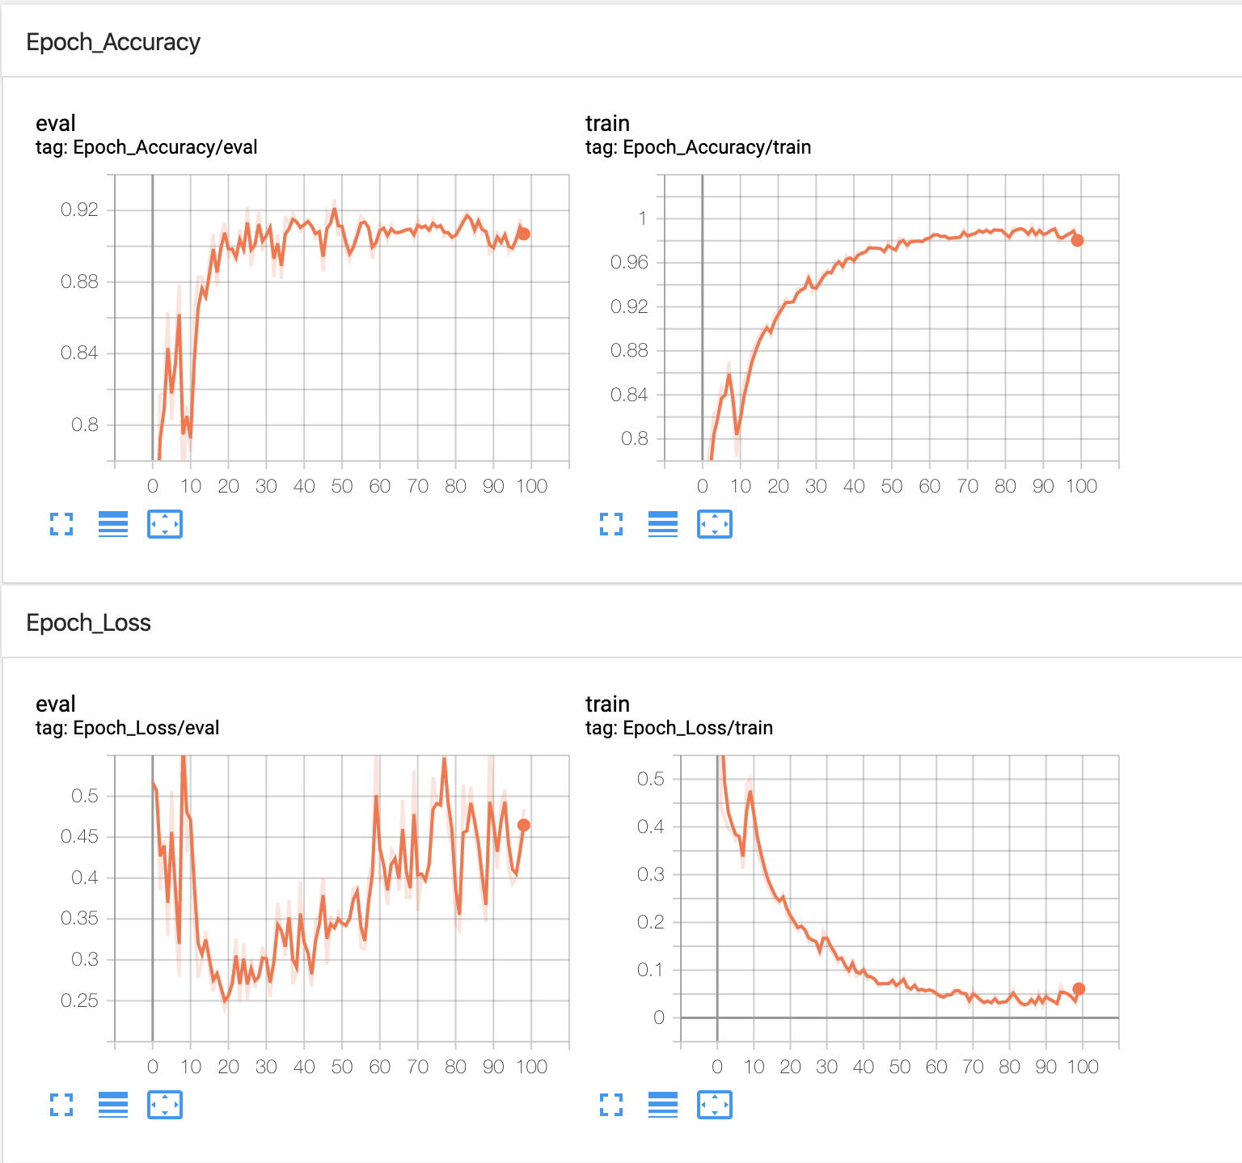

**Part I – Implement AlexNet**

AlexNetLargeKernel(

(features): Sequential(

(0): Conv2d(3, 96, kernel_size=(21, 21), stride=(8, 8), padding=(1, 1))

(1): ReLU(inplace=True)

(2): Conv2d(96, 256, kernel_size=(7, 7), stride=(2, 2), padding=(2, 2))

(3): ReLU(inplace=True)

(4): Conv2d(256, 384, kernel_size=(3, 3), stride=(1, 1), padding=(1, 1))

(5): ReLU(inplace=True)

(6): Conv2d(384, 384, kernel_size=(3, 3), stride=(1, 1), padding=(1, 1))

(7): ReLU(inplace=True)

(8): Conv2d(384, 256, kernel_size=(3, 3), stride=(2, 2))

(9): ReLU(inplace=True)

)

(flatten): Flatten()

(classifier): Sequential(

(0): Dropout(p=0.5, inplace=False)

(1): Linear(in_features=9216, out_features=4096, bias=True)

(2): ReLU(inplace=True)

(3): Dropout(p=0.5, inplace=False)

(4): Linear(in_features=4096, out_features=4096, bias=True)

(5): ReLU(inplace=True)

(6): Linear(in_features=4096, out_features=4, bias=True)

)

)

**Validation Set Accuracy**: 0.8734

