**Mathew Varughese**

CS 1699

HW 5

**Part I: Sentiment Analysis on IMDB Reviews**

1. **Running GRU Cell**

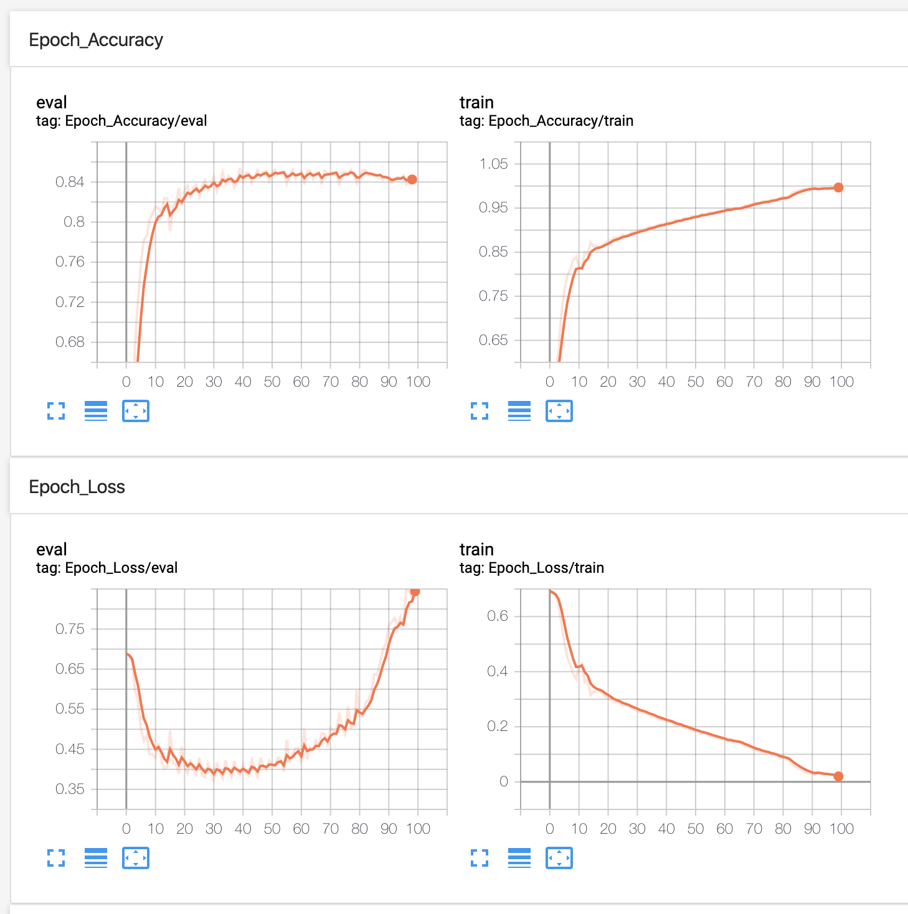

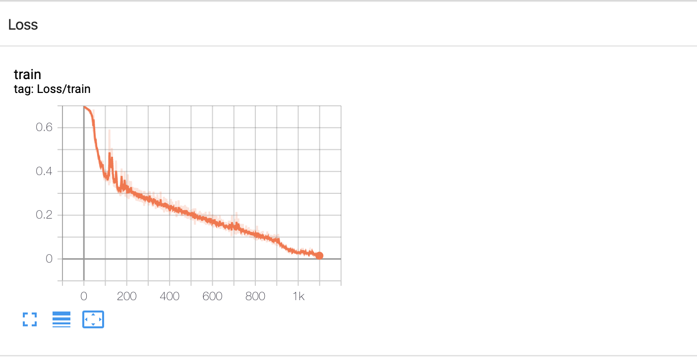

1. **Total Parameters**

|  |  |  |  |
| --- | --- | --- | --- |
| GRU | LSTM | PEEPHOLED | COUPLED |
| Total Parameters: 68700 | Total Parameters: 91600 | Total Parameters: 121600 | Total Parameters: 68700 |

1. **Results**

The next pages include the results. All LSTMs performed pretty similar. The coupled LSTM was a little better and slightly faster. The Peephole Loss graph shows it followed a slightly different trajectory than the other LSTMs. However, I think this exercise shows that different LSTM architectures do not make *that big* of a difference. As mentioned in the [Greff, et al (2015)](https://arxiv.org/pdf/1503.04069.pdf) paper, these LSTM variants are about the same. This chart shows the validation accuracy and the time taken.

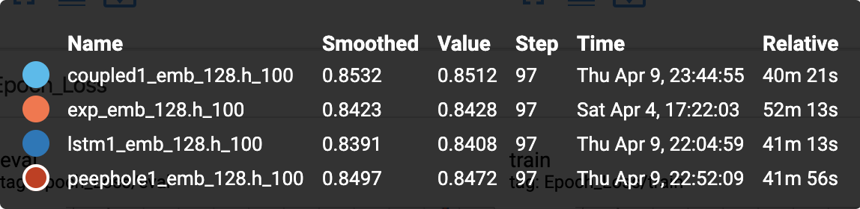

GRU

LSTM

PEEPHOLE

COUPLED

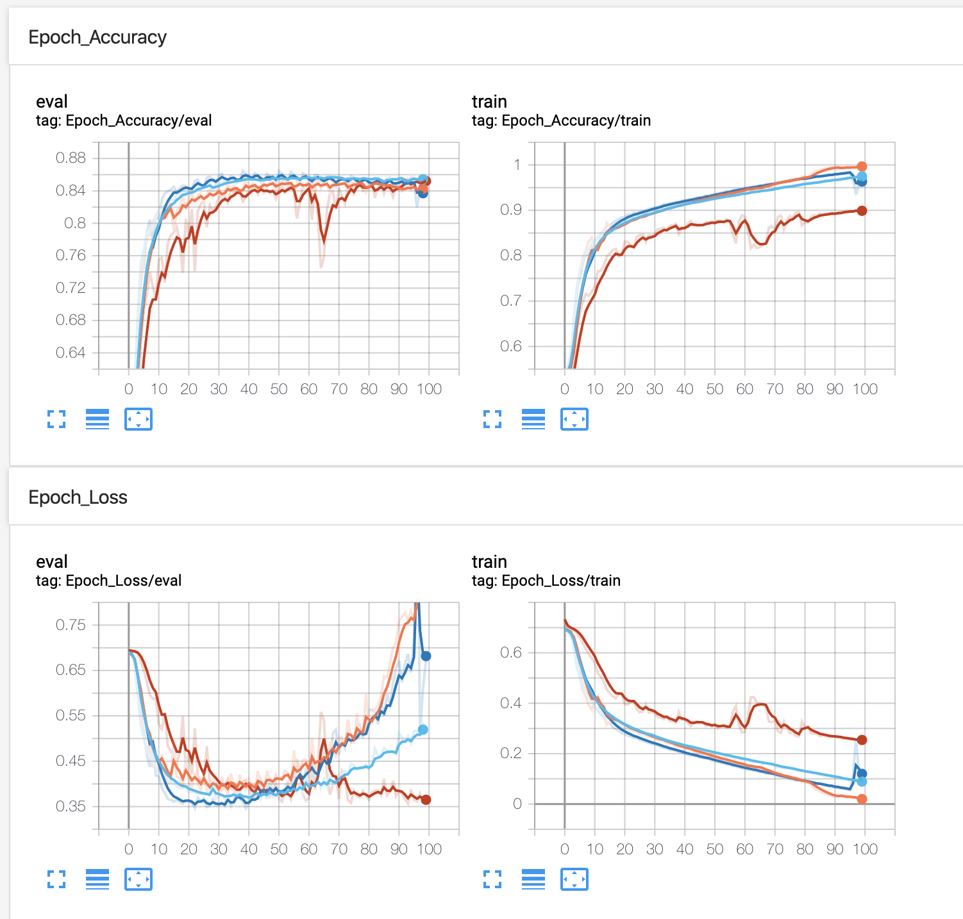

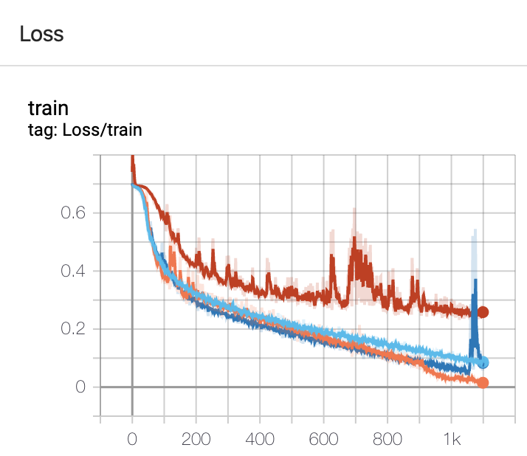

**Part II: Building a Shakespeare Writer**

Model Architecture:

SentenceGeneration(

(embedding): Embedding(65, 50, padding_idx=0)

(rnn_model): GRUCell(input_size=50, hidden_size=50, bias=True)

(classifier): Linear(in_features=50, out_features=65, bias=True)

)

Loss: 2.0736, Accuracy: 0.4115: : 545it [43:13, 4.76s/it]

Loss: 1.9892, Accuracy: 0.4310: : 545it [37:11, 4.09s/it]

Loss: 1.8494, Accuracy: 0.4666: : 545it [37:20, 4.11s/it]

Loss: 1.7587, Accuracy: 0.4979: : 545it [38:24, 4.23s/it]

Loss: 1.7559, Accuracy: 0.4809: : 545it [38:25, 4.23s/it]

Loss: 1.7565, Accuracy: 0.4843: : 545it [38:19, 4.22s/it]

Loss: 1.7184, Accuracy: 0.4903: : 545it [38:26, 4.23s/it]

Loss: 1.6420, Accuracy: 0.5258: : 545it [38:04, 4.19s/it]

Loss: 1.6337, Accuracy: 0.5182: : 545it [38:23, 4.23s/it]

Loss: 1.6120, Accuracy: 0.5038: : 545it [38:00, 4.19s/it]

|  |  |
| --- | --- |
|  |  |

This was generated, after 10 epochs:

ROMEO and JULIET

:

A amamen for of your ragain's firs,

St. up bes othnil's breaks

Mague, dene say 'telf me are tannt,

no? carried an vione you not so was mind I do

he beward: he thing sweet it incad like look'

reser, to fare for'th the

can. Sawnal I tan shall I call known loves,

Poep and perpose,

Groy Eve live Apailes decang

yo med ouse mernects, neight,

There aydial Fremuped to hastly, soltas,

Look on that houndis.

JULIET:

The bood I.

Your suchence buge what a hast lold,

Thush this migh's most park Ancer

By, anlless, eart'gl the Gaid brace

Tee aboud by you so dan let neprit,

Chough hazs of your nothraves him? O prits to for sigs,

And pleack my Emnow, the subsuen he twes right.

POLIUS:

No ances and not prinfens

To supper! Wronder to arm and mit.

Thits od'y me mutar pulled my honess, leired.

CLOMETLANUS:

I, I day, breads on membuse of beserce:

Belard, them intell you meed I to mad of whilats

I worth for that scarte.

Why Vame is shall you preaves

They in but the heir pellest; up thy great;

And for we

That is pretty crazy.

I tried it again with different parameters, mainly a bigger hidden size, and got a slightly better accuracy.

Model Architecture:

SentenceGeneration(

(embedding): Embedding(65, 60, padding_idx=0)

(rnn_model): GRUCell(input_size=60, hidden_size=130, bias=True)

(classifier): Linear(in_features=130, out_features=65, bias=True)

)

Loss: 1.8615, Accuracy: 0.4606: : 545it [02:32, 3.58it/s]

Loss: 1.6313, Accuracy: 0.5080: : 545it [02:32, 3.57it/s]

Loss: 1.6182, Accuracy: 0.5174: : 545it [02:32, 3.57it/s]

Loss: 1.4917, Accuracy: 0.5411: : 545it [02:32, 3.57it/s]

Loss: 1.5287, Accuracy: 0.5368: : 545it [02:32, 3.57it/s]

Loss: 1.5037, Accuracy: 0.5318: : 545it [02:32, 3.58it/s]

Loss: 1.4634, Accuracy: 0.5555: : 545it [02:32, 3.57it/s]

Loss: 1.4492, Accuracy: 0.5428: : 545it [02:32, 3.57it/s]

Loss: 1.4743, Accuracy: 0.5521: : 545it [02:32, 3.57it/s]

Loss: 1.3784, Accuracy: 0.5775: : 545it [02:32, 3.57it/s]

Loss: 1.4391, Accuracy: 0.5580: : 545it [02:32, 3.57it/s]

The results were a little better:

ROMEO and JULIET

ELANUS:

This pringess the two enterphecificing:

Feak.

Clonce:

Nay! dead, mother, my lord, opboligrownley!

They are dozen deposistance if thou.

ALOFFYRY:

And, give of these man else stirg his pain

A witte.

Second Senatol:

All against the Durtions of I would be saled?

Come, church: how troth I mothing midned cause;

Frail nor to stay the godses will you weak'd it

all old sprait show to my near, cames it ord,

Which you knist chered of desperate their leave:

What gentle go hath a holy propost you me Moves

But is to her forth did unto the crose.

AUDINGBELLA:

Ay, that I, then?

CLARENCE:

If it with I fort! that I am thy sort,

The tongue's far it be and love the vilbors,

As I so fulll on years are my was

Sweet kills and began do our bly hear not their

peining: that's firing and loved the gods;

For you citief's book, gendle Margaonry.

AUPIOLIUS:

Fale, no faced Butis seen men, and done

Of his breast come to my vain into was,

Bossions; say, be dear stones by your son?

Therefore she was enemy

Just for fun, I also trained it on the React JavaScript source code. The results were equally as cool. Here is a snippet:

import type {ProfilingDataFrontent} from './ReactInternalTypes';

import type {ProfilerCompo}, itemCount - treeBlumsizeURI, y: 'submcon'} 'ErrorBoundary just warn; id not invoked in ent has been variables it object', () => {

const {useRef} = this.props.discreteSuspense.relation(context);

const registerTarget = currentName(type);

workInProgress.mode & ProwigressigntStartTime;

dispatchClassComponent.previous = flarNestedContext(parentType, error);

const node = node.return;

validaterleventeractions(

buttonEventNode,

expirationTime,

) {

// An unusedes beurce

return pointerType.aria;

},

() => Scheduler.unstable_newdCancelObject(renderIntoRoot))

pushRoot.findMouseEvent(

listener, rowIndex,

children,

name,

).rsound() {

inputChild(workInProgress);

class = value._dispatchInstances;

workInProgressRenderedType = renderElements(payload, numFilter);

if () => {

return null;

}

}

function App(pressList, _asuep))) {

return (

<Bexpressing development ref={emptyFanstort?: boundDerivedSetIsFiberError()} />

() =>

Co(this.props.children).toHaveBeenCalled();

expect(Scheduler).toFlushAndYield([

'Entry with an useContext value foundDepveached app['center']',

);

},

),

},

[],

};

Interesting how it learned in JavaScript to close braces, close comments, arrow notation () => {}, import statements, and so on. It still feels like it will not be able to write functioning code like this though. It knows to declare variables, but not how to use them.

**Part III: Visualizing LSTM Gates**

1. F
2. F
3. 4
4. F