Abstract — The issue of retail pricing involves finding a balance between three related factors, namely revenues, sustainability of inventory, and customer sentiments; please note that the current state-of-the-art pricing models in the literature usually optimize just one factor at a time. This study examines the issue of reinforcement-learning-based dynamic pricing in retail, based on thirty relevant publications, divided into four architectural silos, including demand forecasting, single-objective reinforcement-learning pricing, sentiment analysis, and inventory management. Furthermore, we also look at the cross-cutting research on explainable AI in pricing decision support. Comparative examination of these silos demonstrates that the current systems still lack integration and highlights two significant shortcomings in them, namely the inability to account for the non-convex Pareto optimal trade-offs in retail pricing via scalar reward functions, as well as the failure to provide natural language explanations of pricing decisions based on modelling evidence.
Keywords — dynamic pricing, reinforcement learning, multi-objective optimization, demand forecasting, sentiment analysis, explainable AI, literature review.
I. INTRODUCTION
Price setting in retail will always be a trade-off among multiple tensions. It should ensure proper income and keep stock levels from falling dangerously low when needed. In addition, consumers who view price fluctuations as being unfair might opt for alternatives. All these factors rarely converge, but most automated systems of price setting work on one aspect.
The field of reinforcement learning has approached the issue of retail pricing with a profit-based perspective. For instance, the usage of Q-Learning agents with price actions, Deep Q-Network with neural function approximation, as well as distributed pricing in the framework of platforms all have been focused on increasing revenues compared to a static pricing baseline [1], [2], [4]. Despite the importance of these improvements, the evaluation criteria are still too limited. It cannot be said that the optimisation of revenue regardless of a 20% increase in stockout rates solves the problem of pricing at all; instead, it shifts it to another place.
Firstly, the formulation of RL by Sutton and Barto assumes a scalar reward signal in a stationary environment [6]. Both assumptions fail to apply in a retail setting. The distribution of the demands may change seasonally and in response to actions of the competition. Social media activity may make or break a product overnight. Stock capacity limits are fixed upper bounds of what price choices may be made. Customer attitude, especially in review-based industries like electronics, acts as a predictor of demand changes which transactions alone cannot provide early enough [11].
However, the mismatch between the objectives being optimised by these systems and those required by the retailers goes beyond the simple lack of tuning. Indeed, Hayes et al. state the problem accurately: if revenue, sustainability of the inventory, and customer satisfaction are combined into a scalar reward function, then the optimal policy will never be able to restore non-convex Pareto-optimal compromises between objectives which are common in pricing applications [10]. Solving this problem requires not just a different reward function but also a different paradigm of optimization.
It should be noted that there is another problem that is no less important than the first one. It is necessary to keep in mind that even if the pricing algorithm provides a good solution, the output produced will be nothing more than just a number. What is the relationship between the demand signal, sentiment trend, inventory level, and the price recommendation generated? In his research, Kostopoulos et al. consider this opacity the main obstacle to the adoption of algorithmic decision support in the retail sector [25]. If the solution is correct but a manager is unable to understand and trust it, the algorithm will never be applied.
The present review made use of a systematic approach in the process of searching relevant literature via IEEE Xplore, arXiv, Google Scholar, and leading publisher databases (Elsevier, Springer, MDPI). The search was conducted using various term combinations such as “dynamic pricing,” “reinforcement learning,” “retail,” “demand forecasting,” “sentiment analysis,” and “explainable AI,” taking into consideration publications dating back to 1997 to 2026. Articles that were not directly related to reinforcement learning approaches or transformers in retail and e-commerce pricing, demand forecasting, or pricing sentiment analysis were excluded from further analysis. Papers dedicated to algorithms and architectures were considered only if they had a direct influence on the methodologies used in the context of the reviewed retail literature.
This paper focuses on studying dynamic pricing using reinforcement learning in the context of retail, seeking to understand how existing systems tackle issues related to revenue maximization, inventory sustainability, and customer sentiment, in addition to the transparency of the price-setting decisions. Thirty academic papers and preprints written between 1997 and 2026 have been reviewed and grouped into four architectural silos: demand prediction, single-objective reinforcement learning for pricing, sentiment analysis, and inventory management. An evaluation of explainable artificial intelligence methods for decision-making supplements the review. The focus of this study includes literature that applies reinforcement learning, transformer-based prediction or natural language processing (NLP)-based sentiment prediction for dynamic retail pricing; other literature that discusses general reinforcement learning, transformers and explainable AI methods is included only if it helps to understand decisions made in the literature on retail pricing. The purpose of this work is not to propose a novel system nor evaluate it but rather to define the degree of separation in existing approaches and identify the specific limitations (reward fragmentation and lack of natural language explanation) that can guide future research.

II. LITERATURE REVIEW

A. Overview and Positioning
Retail pricing through reinforcement learning (RL) is an area that has seen growth in various directions simultaneously. The early methods, based on single objectives, involved the use of tabular Q-learning followed by the adoption of deep RL to handle continuous actions and coordinated rewards in multi-seller platforms [1], [2], [4], [6], [28], [30]. Simultaneously, the emergence of transformer models has been seen as the dominant model architecture used for forecasting demand due to their ability to capture long-term temporal relations that are beyond the reach of LSTM models [12], [23]. Consumer sentiment obtained from the online review data has been leveraged for consumer segmentation based on price and quality sensitivities for better pricing policies [11].
While Krishnia [7] earlier reviewed the more comprehensive topic of the application of reinforcement learning to retail decision making, this review is different in that instead of giving a general overview of RL applications to retail, it focuses on explaining the structural fragmentation of four silos of architecture and quantifying two consistent gaps, namely reward fragmentation and explainability gap, through citation comparison.

B. Multi-objective reinforcement learning
In MORL, the scalar-valued reward is replaced by the vector-valued reward whose elements relate to specific goals. The best practical exposition has been provided by Hayes et al., who have discussed linear scalarization, Pareto front tracing and Pareto-conditioned policy methods [10]. Most relevant to pricing is the result that fixed-weighting linear scalarization cannot retrieve a non-convex Pareto front, which is a property usually observed when there is a trade-off between revenue and customer satisfaction at decreasing rates.
Hazenberg et al. apply MORL in multi-agent supply chain settings and demonstrate that vector-reward agents produce much more stable pricing strategies under changing market circumstances compared to scalar-reward agents [20]. According to Krishnia, multi-objective reinforcement learning will be the next-generation standard for enterprise retail applications for pricing, assortment, and supply chain problems [7], though this projection has not yet been empirically validated in a retail pricing implementation.

C. Transformer-based demand forecasting
Transformers have become the dominant approach to forecasting retail demand because of their ability to identify long-term temporal dependencies which LSTM based models fail to do [12], [23]. The development of the architecture from the Temporal Fusion Transformer to Informer and then to iTransformer, along with the forecasting abilities of the model, is reviewed in detail in Silo 1 of Section III-B [13], [14], [15], [16], [17].

D. Sentiment analysis for pricing
It is now being recognized that customer sentiment is a demand signal which cannot be measured based on transactional data alone, and in fact, there is evidence that shows sentiment velocity precedes dips in demand by a few days [11]. The way this signal has been utilized within pricing models is studied in Silo 3 in Section III-B [21], [22], [24].
E. Algorithm selection: PPO, DDPG, and SAC
Liu et al. provide a comparison between PPO, DDPG, and SAC in relation to their application within the realm of dynamic pricing. According to the findings, PPO is characterised by a more stable learning process when applied under a bounded action space and relatively low levels of noise in the reward, which is one of the characteristics of retail pricing [19]. On the contrary, while DDPG performs well in cases of continuous action space and low noise levels, it is still sensitive to changes in the demand.
Following Schulman et al. (2017), the use of PPO utilises a clipping technique for the surrogate objective, which will minimize any negative effects from updating the policy at each gradient descent step [5], and helps reduce any instability caused by the sudden changes in prices seen with DDPG due to varying demands.
F. Perishable inventory management
Reinforcement learning has also been applied to joint pricing-inventory decisions in perishable-goods settings, where price and replenishment are optimized together rather than sequentially [3]. This approach and its relationship to the broader inventory-management silo are examined in Section III-B.

G. Explainable AI and decision support
Kostopoulos et al. suggest natural language generation as the most efficient form of explanation modality for non-technical users of decision-support systems, listing accuracy, completeness, flexibility, and actionability as the four criteria for adoption [25]. The study by Bajpai and Pandey looks into reinforcement-learning-based decision support in a business setting, where the importance of action-level interpretation, i.e., understanding not only the price but also the reason why that exact price has been chosen, is key [26].
Cambria et al. review the connection between explainable AI (XAI) and large language models (LLMs), stating that LLMs could act as generators of explanations provided their output is supported by evidence from the model itself rather than generated freely [29]. Bilal and Lin, reviewing LLMs for XAI, state that structured prompting and retrieval-augmented generation are two of the most reliable techniques for obtaining accurate explanations [27]. Awais notes that the explanation of the customer behavioural indicators in addition to prices is what brings management to use algorithmic pricing solutions [9]. In order to conclude the analysis above, Table I is presented as an illustration of how the studies that were analyzed have been classified in terms of their methodology and data source
TABLE I: Comparative Review of Existing Dynamic Pricing Approaches
Literature | Method Used | Results | Research Gap
Apte et al., 2024 | Q-Learning, discretised pricing | Outperforms OR methods in revenue, flexibility | Ignores sentiment and inventory health
Liu et al., 2021 | Deep RL, field experiment | Measurable revenue gain over static baseline | Unstable under abrupt competitor price changes
Nomura et al., 2025 | Deep RL, joint price-inventory | Joint optimisation beats separate treatment | Only simulated, ignores real-world latency
Hayes et al., 2022 | MORL theory (scalarization, Pareto) | Scalar reward can't recover Pareto trade-offs | Theoretical only, no retail validation
Liu et al., 2026 | Sentiment-based segmentation | Sentiment velocity predicts demand drops early | Sensitive to data quality, class imbalance
Liu et al., 2024 | PPO vs DDPG vs SAC | PPO most stable, +7.3% revenue | Risk of local optima, cold-start issue
Hazenberg et al., 2025 | MARL, vector reward | More stable pricing than scalar-reward agents | Simulation-dependent, heavy compute needed
Wei & Holloway, 2025 | RL + sentiment/behavioural features | MAE 1.29, R² 0.97, better outcomes | Depends on sentiment-extraction accuracy
Huang & Yang, 2025 | RL, joint pricing-inventory control | 12.6% higher profit than heuristics | Black-box, hard to regulate/trust

III. EXISTING SYSTEM ARCHITECTURE
Literature review carried out in connection with this research study reveals that the thirty references identified represent four different domains instead of forming a unified domain. While some degree of overlap exists due to the use of similar datasets in each case, it should be noted that these four domains have developed independently of one another.
A. Input signals and data sourcing
The approaches analysed in the current investigation use mainly three types of sources of data: transactional, customer-generated text, and market data. Transactional data cover the number of transactions, product descriptions, and historical prices. Customer-generated text consists of customer reviews, returns, and social media mentions, while market data comprises competitor prices, market trends, and platform benchmarks. The key distinction between different approaches is the type of data used for the algorithm and data not taken into account.
In particular, Q-Learning algorithms covered in [1], [6], and [30] use mainly transactional data. Their states usually depend on factors such as price, demand, and stock levels, as inferred from transactional data. Reviews are normally not considered. Competitive prices are present only in cases when market competition is taken into account, for example, in [2] and [8]. Thus, there are many reinforcement learning pricing algorithms built on the partial knowledge of the retail environment. While these algorithms optimise decision-making based on observable demand patterns, they ignore customer sentiment, which plays an important role in purchasing decisions.
B. The four architectural silos
As evident from the literature review, reinforcement learning-based approaches to price products at retail could be divided into four silos based on their architecture: demand prediction, single-objective reinforcement learning pricing, sentiment analysis, and inventory management. As seen from the illustration in Figure 1, each of the silos mentioned above has developed independently from other silos and has little interaction among them.
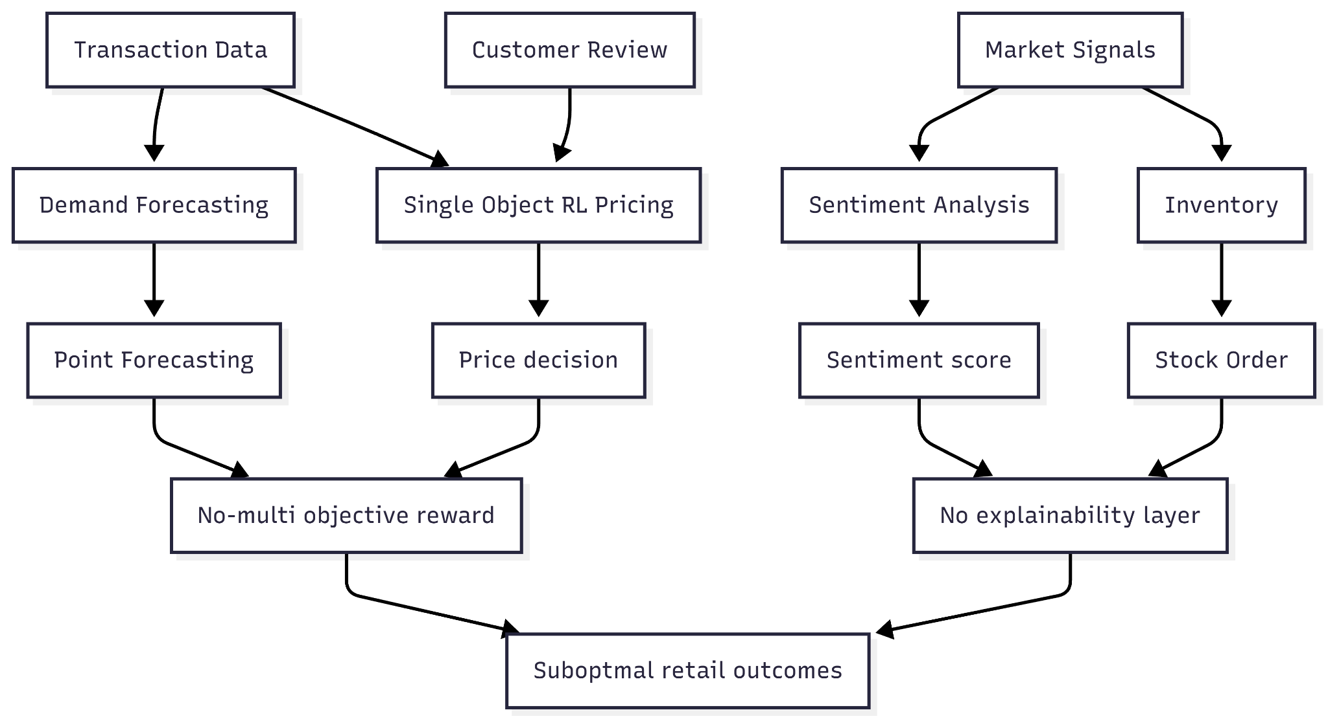
Fig. 1. Existing system architecture
Silo 1: Demand forecasting. The studies in this category [13], [14], [15], [16], [17], [23] focus on forecasting future demand using historical sales data. These models take past sales records as input and generate estimates of future demand. Earlier research mainly relied on traditional approaches such as ARIMA and LSTM [23]. More recent studies have adopted Transformer-based models, including TFT [15], Informer [16], and iTransformer [17], which have shown better performance, especially for long-term forecasting tasks. The output of these models is usually a demand prediction, while some studies also provide probabilistic forecasts through quantile estimation [14].
This superior performance has been experimentally validated in a retail-centric setting by Oliveira and Ramos [13], which compares Transformer-based architectures against classical statistical benchmarks by utilizing Walmart M5 competition dataset, containing 30,490 different time series [13]. It was found that the Transformer-based models—such as Vanilla Transformer, Informer, and Temporal Fusion Transformer (TFT)—outperform classic benchmarks like AutoARIMA and AutoETS [13] significantly. The advancements made through using Transformer-based architectures include a 26%-29% decrease in Mean Absolute Scaled Error (MASE) and even a 34% decrease in Weighted Quantile Loss (WQL) when compared to the Seasonal Naïve benchmark [13]. A comparison summary of the obtained results is presented in Fig. 2.
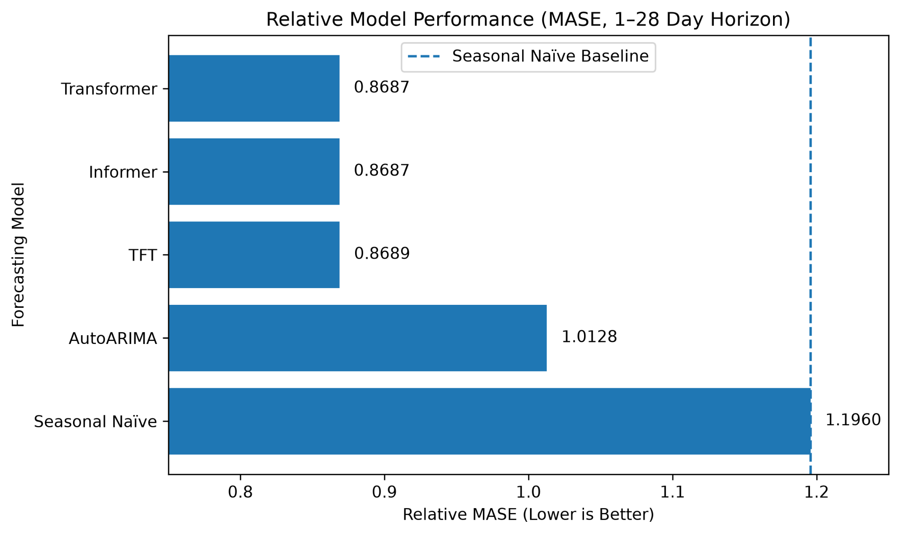
Fig. 2. MASE comparison of forecasting models. [13].
Silo 2: Single-objective RL pricing. The studies grouped in this category [1], [2], [4], [7], [19], [28], [30] use reinforcement learning techniques to determine product prices based on the current market state. In most cases, the reward function is designed around a single objective such as revenue, profit margin, or a closely related measure. Q-Learning-based approaches [1], [6] commonly use discretised price ranges and tabular state representations, while Deep Q-Networks [2] extend this idea to more complex and continuous pricing environments. Comparative studies involving PPO, DDPG, and SAC [19] indicate that the choice of reinforcement learning algorithm can affect learning performance and stability. Despite these differences, most of the reviewed approaches focus on maximising a single reward metric.
Practical application of single-objective RL is illustrated through a large-scale field experiment carried out by Liu et al. on the online platform of Alibaba’s Tmall.com since July 2018, lasting for several months over thousands of SKUs [2]. Specifically, dynamic pricing was formulated as a Markov Decision Process, and DRCR was used as the reward signal instead of revenue or RCR, as RCR had higher concavity and stability to price as opposed to revenue, highly dependent on random customer traffic [2]. For a markdown pricing experiment with 500 luxury goods SKUs, where prices were determined by a discrete DQN agent, the DQN group obtained an average RCR of 0.22 compared to 0.16 obtained by a manual pricing group and more importantly, kept a positive profit conversion rate of 0.16, whereas in the manual group profit conversion rate fell to −0.04 because of discounting below the cost of good [2]. These improvements in both RCR and profit conversion rate are illustrated in Fig. 3(a).
In a parallel daily pricing experiment with fast-moving consumer goods, both RL approaches outperformed manual pricing in terms of DRCR: the continuous-action DDPG agent obtained an average rescaled DRCR of 6.07, while the discrete DQN agent was able to get to 5.03, compared to a manual approach rescaled to 1.00 [2]. Thus, the choice of the algorithm impacts the stability, as DDPG outperforms DQN due to its continuous action space. These performance differences across the markdown and daily pricing experiments are illustrated in Fig. 3(a) and Fig. 3(b), respectively.
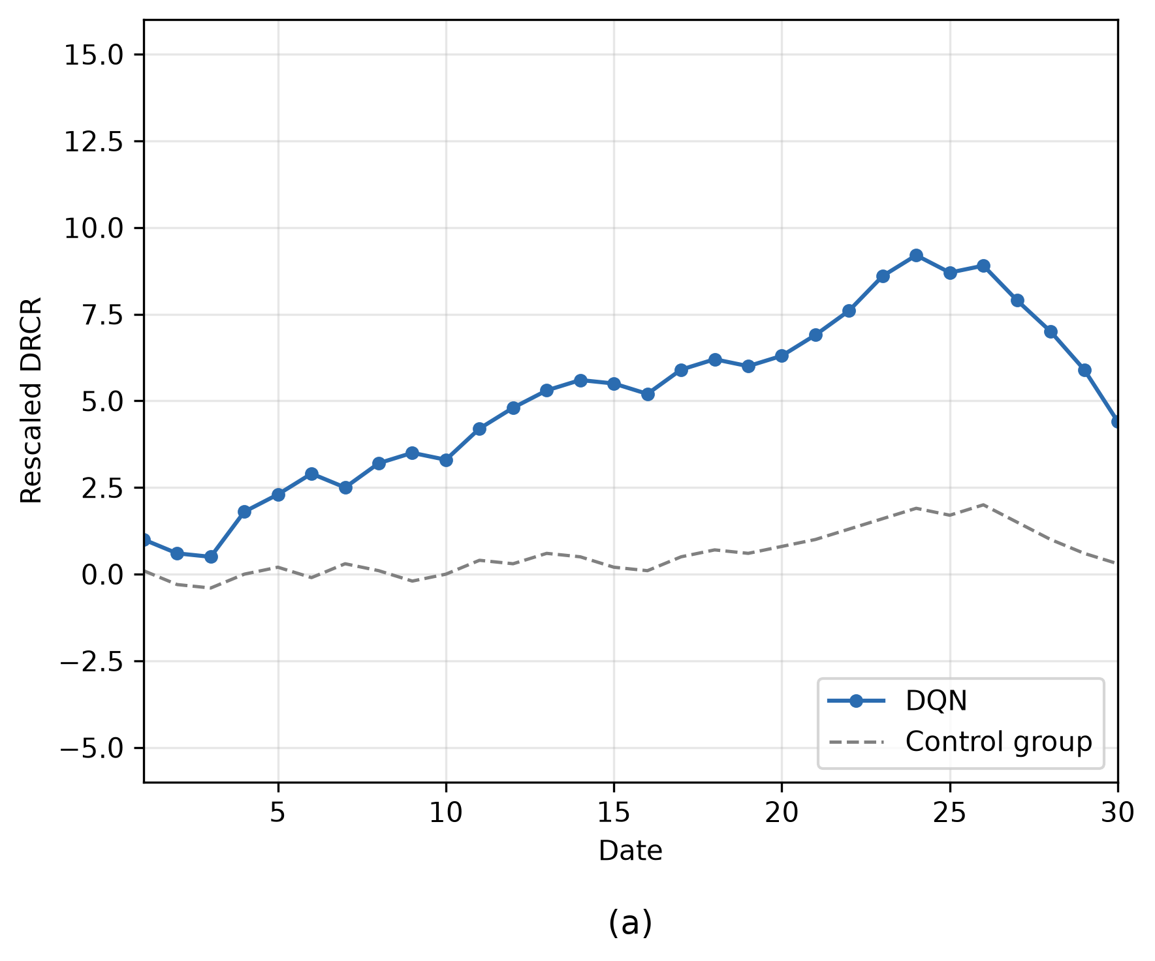
Fig. 3.a DQN vs. Control [2]
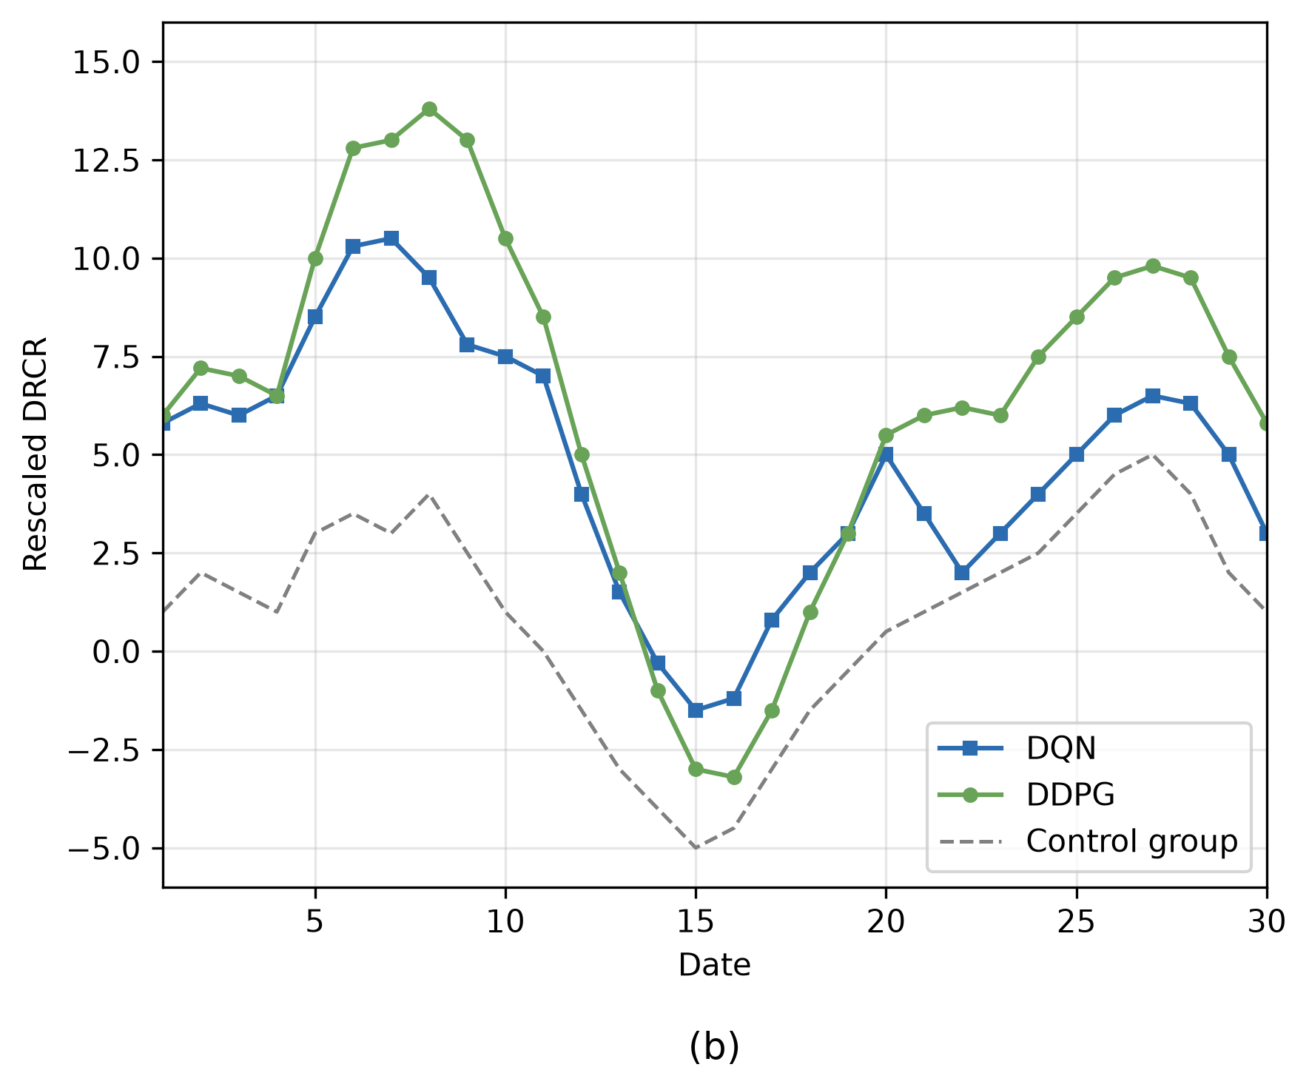
Fig. 3.b DQN vs. DDPG vs. Control [2]
Silo 3: Sentiment analysis. Papers in this category [11], [21], [22], [24] use customer reviews and social media content to extract sentiment information for pricing and segmentation tasks. Liu et al. [11] found that changes in sentiment can indicate demand declines earlier than transactional records. The sentiment extraction in these works is performed by means of language models based on transformers, for instance, BERT, which have been pre-trained to be able to understand contextually bidirectionally texts [30]. Wei and Holloway [21] incorporated sentiment into an RL-based pricing framework, making it one of the few studies that combine sentiment analysis with reinforcement learning. Wang and You [24] explored using an LLM as a pricing agent that considers product descriptions and competitor information. However, in most of these studies, sentiment is added as an extra component rather than being fully integrated into the state representation. As a result, it primarily affects demand estimates rather than playing a central role in policy decisions.
Furthermore, S. Liu et al. [11] take their sentiment-based consumer segmentation and apply it in terms of pricing decisions. This work is unique in the reviewed literature as one of the few cases where the sentiment analysis output is used directly to make the actual price decision, rather than in the demand forecasting step. Using the four price-quality segments that were identified using the results of the headphones' reviews, S. Liu et al. [11] formulate a discount pricing problem and solve it in comparison to the uniform price baseline. Those consumers who exhibit less price sensitivity get smaller discounts in order to maintain a healthy profit margin, while the price-sensitive segment gets a larger discount in order to incentivize purchases. In all simulations performed, the segmented discount approach outperformed uniform pricing in terms of revenue [11]. The revenue gains achieved by the segmented discount strategy relative to the uniform pricing baseline across the trials conducted are shown in Fig. 4.
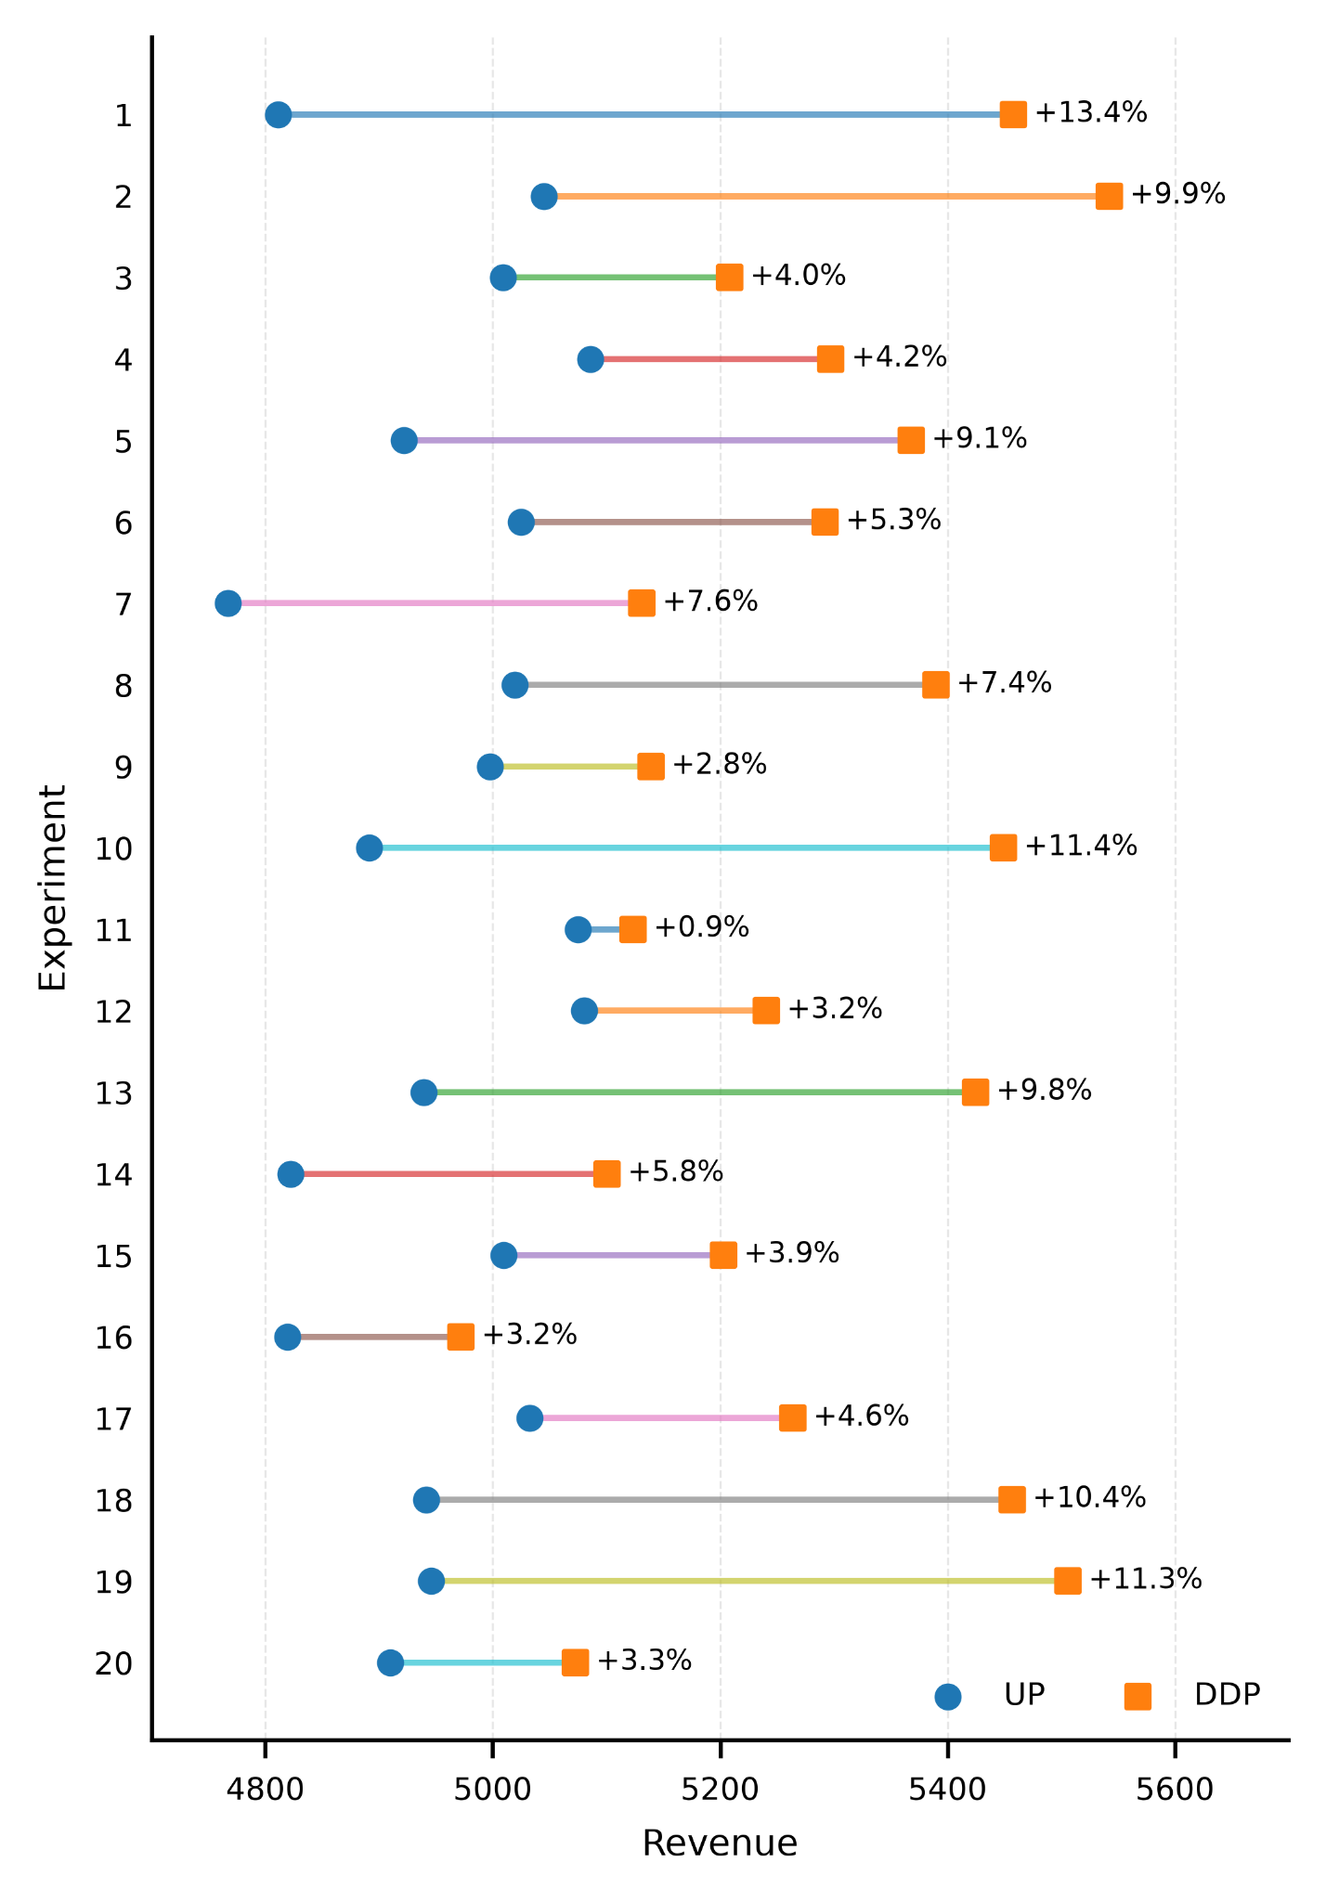
Fig. 4. Revenue comparison of DDP and UP across 20 trials [11].
This is one of the few works among the thirty reviewed that use sentiment-based information to provide pricing recommendations rather than only being part of a demand forecast. However, the presented mechanism still falls short of filling any of the two gaps mentioned in Section IV, as it is just a static discount optimization problem, and not a reinforcement-learning algorithm. The mechanism also does not consider inventory limits, and does not explain its decision using natural language [11].
Silo 4: Inventory management. The Nomura et al. [3] study introduces a rather straightforward method in this field by implementing deep reinforcement learning for simultaneous optimization of the pricing and inventory problems for perishable products. The experiments analyze DP, action-reduced DP, and PPO with different levels of price sensitivity and inventory cost. In particular, Cases 1–4 consider the impact of price sensitivity, where Case 1 is the base, while Case 2 involves low price sensitivity. Meanwhile, Cases 3 and 4 reflect high price sensitivity with different shelf life values of the product [3]. Sensitivity analysis shows that pricing policy is critical for determining the cost of holding, lost sales, and spoilage. In particular, Case 4 shows how appropriate pricing reduces the level of unsold products, resulting in 11.9% on average of total waste-related cost [3]. The resulting trade-offs between holding, lost-sales, and spoilage costs across the four price-sensitivity cases are depicted in Fig. 5.
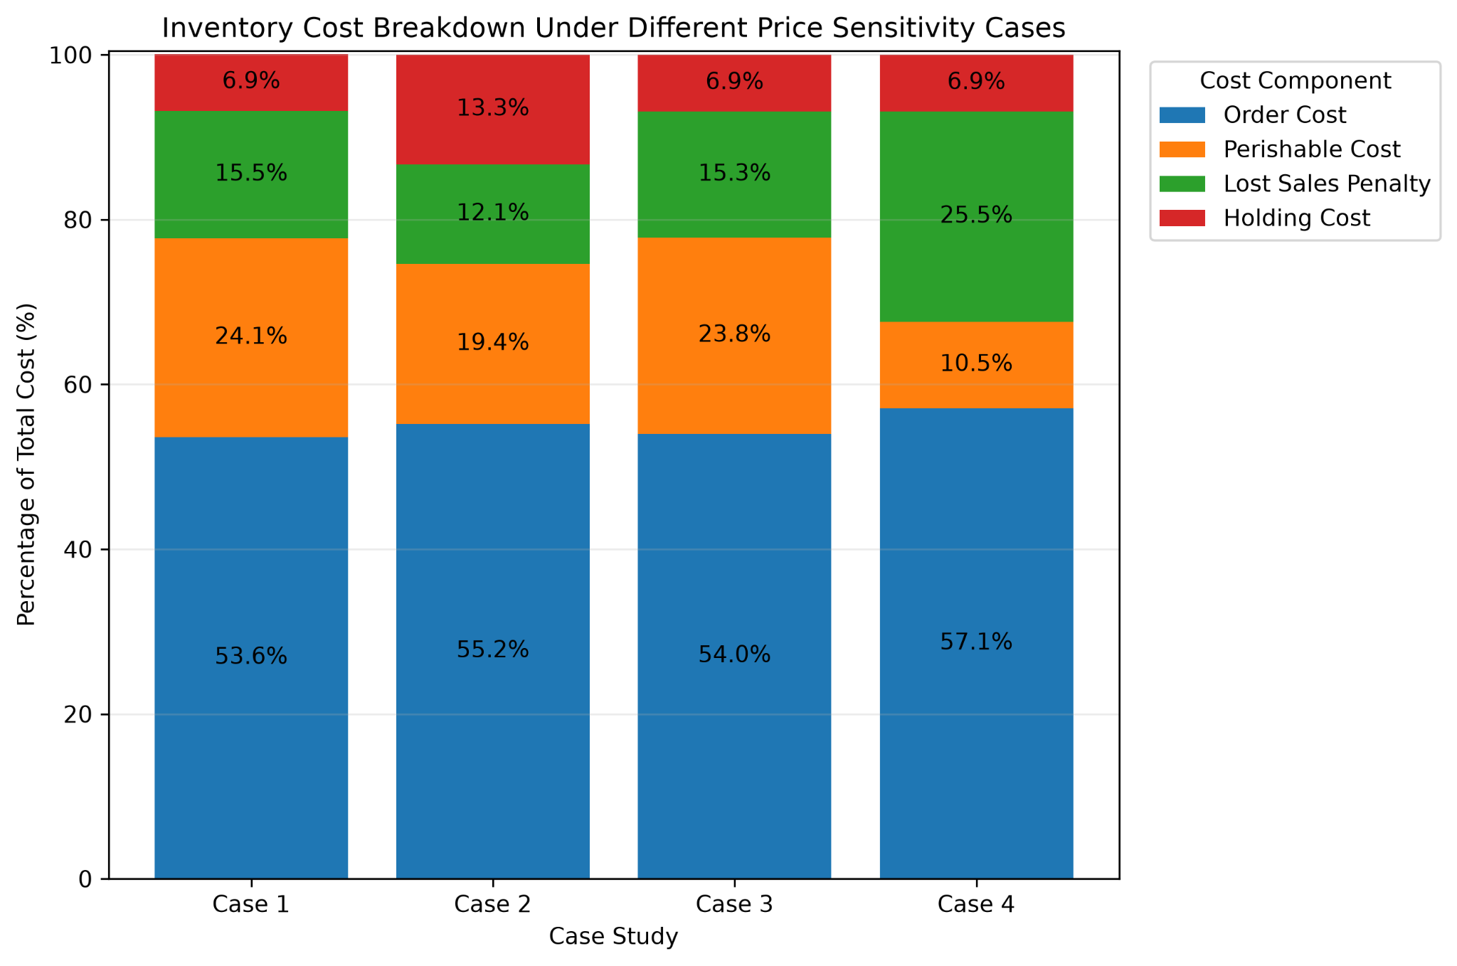
Fig. 5. Inventory Costs Across Price Sensitivity Cases [3].
In contrast, the work of Vashishtha et al. [8] accounts for competition and inventory information through a data-based pricing model. Meanwhile, Huang and Yang [28] analyze joint pricing and inventory strategies. Neither of the above approaches takes into account forecasting of future demand or sentiment analysis explicitly. In particular, Nomura et al. [3] consider demand uncertainty by employing a Markov decision process, rather than forecasting future demand. Table II consolidates the four architectural silos discussed above, outlining their representative studies, primary focus, and key limitations to support the gap analysis presented in Section IV.
TABLE II: Overview of Existing Research Silos in Dynamic Retail Pricing
Research Silo | What It Actually Optimizes and What It Ignores
Demand Forecasting | Predicts future demand from past sales but rarely feeds into the pricing decision itself.
Price-Setting (RL) | Sets the price that earns the most today, ignoring stock limits and customer reaction.
Customer Sentiment | Senses customer mood from reviews and posts but only feeds demand estimates, not price.
Inventory Management | Adjusts prices to protect stock, without knowing true demand or customer sentiment.
As the forecasting models do not provide any information on uncertainty to the pricing agents, their ability to adapt to changes in the market situation becomes limited. Also, because sentiment analysis signals are usually not incorporated into the RL state representation, pricing decisions can be made without taking into account clients' reactions. The same is true for inventory-oriented goals.
C. Explainability gap
The next issue arises after the optimisation stage. Most pricing tools present the generated pricing recommendation as a numeric value. As shown by empirical studies investigating implementation issues [7], [9], [25], [26], management tends to reject automated recommendations when the explanation of how they were formed remains unclear. This lack of clarity is noted as one of the key factors of rejection by Kostopoulos et al. [25], while Bajpai and Pandey [26] stress the gap between the precise recommendations made possible by reinforcement learning and the need for a user’s trust in these recommendations. No price optimization system among those reviewed in this work uses any dedicated method for explaining pricing decisions using natural language.

IV. RESEARCH GAPS

A. Reward fragmentation
Most RL-based single-objective pricing research works on maximizing the revenue without taking any account of sustainable inventory management or consumers' sentiments [1], [2], [4], [6], [28], [30]. Similar is the case in Krishnia's survey as well, which reveals that there is a lack of empirical evidence related to multi-objective RL for the retail industry, although the same has been recognized as the standard for the future [7]. On the other hand, Hayes et al.'s theory related to Pareto-conditioned reward schemes has not yet been validated for the retail industry [10].

B. Forecasting isolation and computational cost
Forecasts in the literature reviewed in this paper are mainly analysed as stand-alone models and not as parts of a pricing pipeline. The computational limitations are noted in some research as well: sparse attention in the Informer model is more computationally complex than traditional forecasting models [16]; iTransformer shows a decrease in performance when state/action spaces are huge [17]; and the Temporal Fusion Transformer model performs less well calibrated in high-price-sensitive markets [14], [15]. The research papers on foundational architectures like Transformer [12] and LSTM [23] don't deal with forecasting for retail purposes or reinforcement learning pricing.

C. Inventory and generalizability limitations
The collaborative pricing and inventory model proposed by Nomura et al. has only been tested using simulations and does not sufficiently consider actual supply chain complexities and delays [3]. The competitive-aware framework proposed by Vashishtha et al. has been shown to require competitor price feeds and lack generalisation to offline retail scenarios, while the multi-agent framework of Hazenberg et al. still depends on simulations and requires significant computational effort, making it less scalable in the real world [20]. While the joint pricing and inventory control framework of Huang and Yang brings about great profits in comparison with heuristics, it is a black box framework and is hard to implement from a managerial perspective.

D. Explainability and adoption barriers
Within the existing body of decision support literature, questions about transparency and interpretability are not resolved yet. Kostopoulos et al. state that there is not enough validation and integration of explainability in practice [25]. In addition, Bajpai and Pandey suggest that personalization of pricing advice may contribute to the development of ethical and price discrimination problems [26]. As for the generation of explanations, Bilal and Lin indicate that open-ended LLM generation without grounding results in explanations that do not match facts [27]. Additionally, Cambria et al. note that grounding constraints should be implemented structurally, not just through instruction following [29], which shows that the ways to implement grounding in LLM explanations already exist in the adjacent XAI literature but were not applied to retail pricing problems.

E. Algorithm-level constraints
However, even amongst the best performing group of algorithms in this review, there are some limitations in PPO which include the following facts: Firstly, according to Schulman et al., their basic framework is independent of any reward designing or multi-objective goals in the retail business domain [5]; secondly, in the comparison study by Liu et al., PPO is prone to local optimum in case of high price sensitivity [19].
V. CONCLUSION AND FUTURE WORK

A. Summary
In this review, thirty pieces of literature pertaining to reinforcement learning approaches to dynamic pricing in retail have been considered, which can be divided into four architectural silos: demand forecasting, single-objective RL pricing, sentiment analysis, and inventory management. In all four silos, there are two structural problems that arise. One is the fact that in current models, revenue, inventory, and sentiment are optimized separately and not in combination, since scalar reward functions cannot capture non-convex Pareto-optimal solutions for these objectives [10]. Another problem is that none of the mentioned systems provides an ability for natural language explanation of the reasons behind certain price setting decisions, which was highlighted before as one of the main barriers to using algorithmic pricing models by managers [25], [26].

B. Future directions
The way forward in light of the deficiencies outlined in Section IV —in terms of fragmented rewards, isolated forecasting, sentiment data dependence, generalization limitations of inventory concerns, and explainability without grounding—is to focus on those shortcomings. This can be done in an integrated fashion by rewarding designs and architectures incorporating the abovementioned disparate objectives instead of analyzing them separately [10], [20], [25], [26]. Another approach is somewhat novel and lies in the area of data scarcity between different retailers. Collaborative learning methods might allow both forecasting and sentiment models to work off pooled industry data without exposing proprietary transactional information; however, this topic is not much discussed in the reviewed retail pricing literature [7].
REFERENCES
[1] M. Apte, K. Kale, P. Datar, and P. Deshmukh, "Dynamic retail pricing via Q-learning: A reinforcement learning framework for enhanced revenue management," arXiv preprint arXiv:2411.18261, Nov. 2024.
[2] J. Liu, Y. Zhang, X. Wang, Y. Deng, and X. Wu, "Dynamic pricing on e-commerce platform with deep reinforcement learning: A field experiment," arXiv preprint arXiv:1912.02572, 2021.
[3] Nomura, Y.; Liu, Z.; Nishi, T. Deep Reinforcement Learning for Dynamic Pricing and Ordering Policies in Perishable Inventory Management. Appl. Sci. 2025, 15, 2421.
[4] Q. Liang, T. Xiao, and Z. Chen, "Distributed dynamic pricing strategy based on deep reinforcement learning in a presale mechanism," Sustainability, vol. 15, no. 13, p. 10480, Jul. 2023.
[5] J. Schulman, F. Wolski, P. Dhariwal, A. Radford, and O. Klimov, "Proximal policy optimisation algorithms," arXiv preprint arXiv:1707.06347, 2017.
[6] R. S. Sutton and A. G. Barto, Reinforcement Learning: An Introduction, 2nd ed. Cambridge, MA, USA: MIT Press, 2018.
[7] M. Krishnia, "The rise of reinforcement learning in AI for retail: Transforming decision-making processes," Eur. J. Comput. Sci. Inf. Technol., vol. 13, no. 41, pp. 25–39, 2025.
[8] S. Vashishtha, M. Garg, and M. Vimal, "A data-driven method to dynamic pricing: Unravelling inventory and competitor contests with AI in e-commerce," ShodhKosh, vol. 5, no. 6, pp. 2912–2919, Jun. 2024.
[9] M. Awais, "Optimising dynamic pricing through AI-powered real-time analytics: The influence of customer behaviour and market competition," Qlantic J. Social Sci., vol. 5, no. 3, pp. 99–108, 2024.
[10] F. Hayes et al., "A practical guide to multi-objective reinforcement learning and planning," Autonomous Agents and Multi-Agent Systems, vol. 36, no. 1, p. 26, 2022.
[11] S. Liu, Z. Liu, J. Wang, and L. Xu, "Consumer segmentation and pricing optimisation with online reviews: A sentiment analysis-based decision-making framework," J. Oper. Res. Soc., 2026, doi: 10.1080/01605682.2026.2630957.
[12] A. Vaswani et al., "Attention is all you need," in Advances in Neural Information Processing Systems (NeurIPS), 2017.
[13] J. M. Oliveira and P. Ramos, "Evaluating the effectiveness of time series transformers for demand forecasting in retail," Mathematics, vol. 12, no. 17, p. 2728, Aug. 2024.
[14] R. Caetano, J. M. Oliveira, and P. Ramos, "Transformer-based models for probabilistic time series forecasting with explanatory variables," Mathematics, vol. 13, no. 5, p. 814, Feb. 2025.
[15] B. Lim, S. Ö. Arik, N. Loeff, and T. Pfister, "Temporal fusion transformers for interpretable multi-horizon time series forecasting," Int. J. Forecasting, vol. 37, no. 4, pp. 1748–1764, 2021.
[16] H. Zhou et al., "Informer: Beyond efficient transformer for long sequence time-series forecasting," in Proc. AAAI, vol. 35, pp. 11106–11115, 2021.
[17] Y. Liu et al., "iTransformer: Inverted transformers are effective for time series forecasting," in Proc. ICLR, 2024.
[18] J. Devlin, M.-W. Chang, K. Lee, and K. Toutanova, "BERT: Pre-training of deep bidirectional transformers for language understanding," in Proc. NAACL-HLT, 2019.
[19] Y. Liu, K. L. Man, G. Li, T. R. Payne, and Y. Yue, "Evaluating and selecting deep reinforcement learning models for optimal dynamic pricing: A systematic comparison of PPO, DDPG, and SAC," in Proc. CCEAI, Shanghai, China, Jan. 2024.
[20] T. Hazenberg et al., "Multi-agent reinforcement learning for dynamic pricing in supply chains: Benchmarking strategic agent behaviours under realistically simulated market conditions," arXiv preprint arXiv:2507.02698, Jul. 2025.
[21] L. Wei and R. J. Holloway, "AI-driven dynamic pricing systems integrating customer sentiment, behaviour, and market forecasting: A real-time reinforcement learning approach," ResearchGate, Nov. 2025.
[22] A. M. Yoshi et al., "Real-time dynamic pricing using machine learning: Integrating customer sentiment and predictive models for e-commerce," Int. J. Adv. Comput. Sci. Appl., vol. 16, no. 9, 2025.
[23] S. Hochreiter and J. Schmidhuber, "Long short-term memory," Neural Comput., vol. 9, no. 8, pp. 1735–1780, Nov. 1997.
[24] H. Wang and S. You, "LLP: LLM-based product pricing in e-commerce," arXiv preprint arXiv:2510.09347, 2025.
[25] G. Kostopoulos, G. Davrazos, and S. Kotsiantis, "Explainable AI-based decision support systems: A recent review," Electronics, vol. 13, no. 14, p. 2842, Jul. 2024.
[26] A. Bajpai and S. Pandey, "Reinforcement learning in business decision support systems: Real-time optimisation of pricing and inventory," Int. Sci. J. Eng. Manage., vol. 4, no. 6, Jun. 2025.
[27] A. Bilal and B. Lin, "LLMs for explainable AI: A comprehensive survey," arXiv preprint arXiv: 2504.00125, 2025.
[28] S. Huang and Y. Yang, "Reinforcement learning optimisation strategies for dynamic pricing and inventory control in e-commerce retail," Int. J. Housing Sci., vol. 46, no. 4, pp. 29–44, Aug. 2025.
[29] E. Cambria, L. Malandri, F. Mercorio, N. Nobani, and A. Seveso, "XAI meets LLMs: A survey of the relation between explainable AI and large language models," arXiv preprint arXiv:2407.15248, 2024.
[30] D. B. Patel, "Reinforcement learning in dynamic pricing models for e-commerce," The Es Economics and Entrepreneurship, vol. 1, no. 1, pp. 41–45, Aug. 2022, doi: 10.58812/esee.v1i01.431.

