Sales Analysis & Business Dashboard
This project analyzes a retail Superstore dataset to identify sales performance, profitability, customer purchasing patterns, and the impact of discounts on business growth. The goal is to convert raw sales data into actionable business insights using Python and data visualization tools.

DEMO LINK
https://colab.research.google.com/drive/1bsONYDICP_bRjoXQDJpD46V9hOynAtsv#scrollTo=gjt8rGPBzOlQ

BUSINESS QUESTIONS
• Which region generates the most sales?
• Which category is most profitable?
• Monthly sales trends?
• Top 10 products?
• Impact of discounts on profit?

DATA UNDERSTANDING
The Superstore dataset was selected because it represents a realistic retail business environment and contains sales, profit, customer, product, and regional information. It enables comprehensive business analysis, supports various data visualization techniques, and helps answer key business questions related to sales performance, profitability, product demand, and discount effectiveness. This makes it an excellent dataset for demonstrating data analysis and business intelligence skills using Python

Profit vs sales

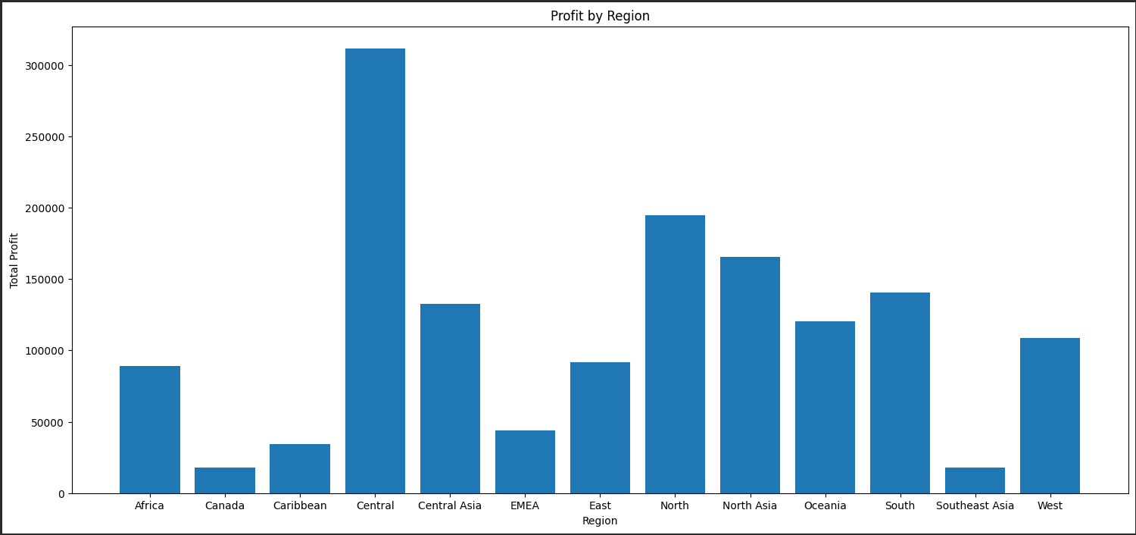

Discount vs Profits

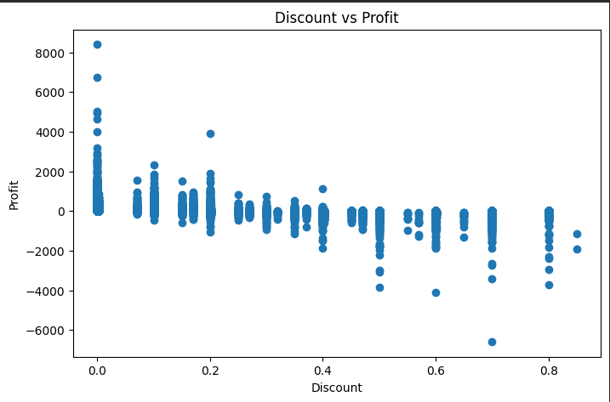

Region vs category

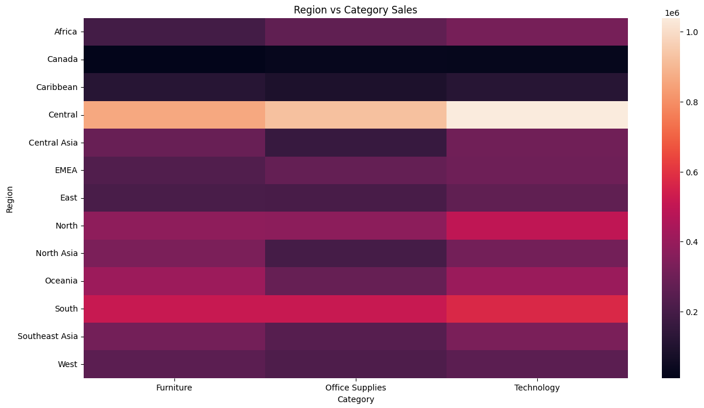

Profit distribution by Category
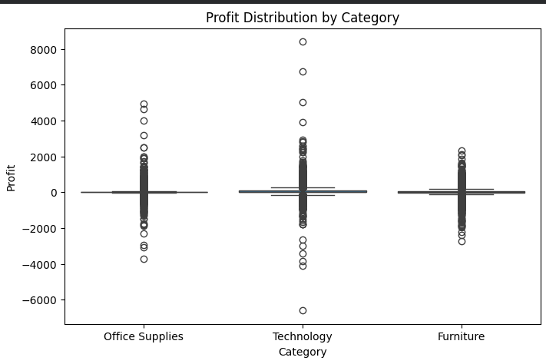

DASHBOARD

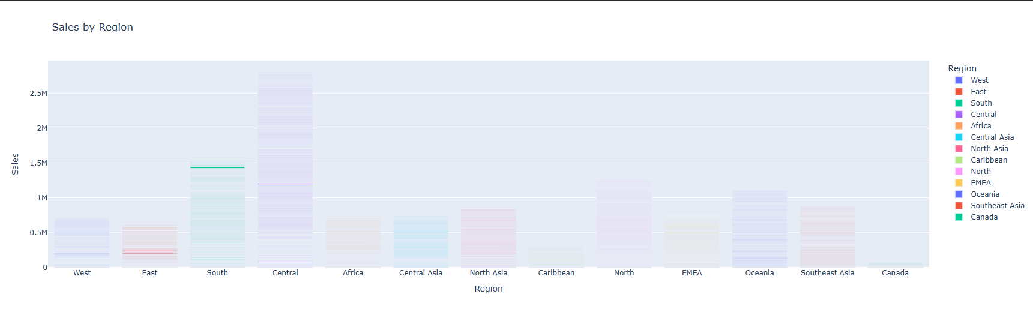

Technology
- Numpy
- Pandas
- Matplotlib
- Seaborn
- Plotly

