Database – MySQL

Database Name – social_media

Query = create database social_media

Tables: –

1. **User**

Description: User table stores details about users. User_id is the primary key. Password is stored in encrypted string. Role can be ‘ROLE_ADMIN’ OR ‘ROLE_USER’.

Query:

CREATE TABLE `user` (

`user_id` bigint NOT NULL AUTO_INCREMENT,

`user_name` varchar(255) DEFAULT NULL,

`email` varchar(255) DEFAULT NULL,

`password` varchar(255) DEFAULT NULL,

`role` varchar(255) DEFAULT NULL,

PRIMARY KEY (`user_id`)

)

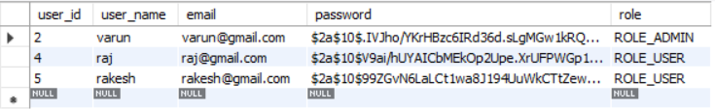

1. **Post**

Description: Post tables store post information created by the user. Post_id is the primary key. User_id is the foreign key which references the User_id column of the User table. Image_path stores the path of the uploaded image. Created_At stores the time of post created and Updated_at stores the time of post updated.

CREATE TABLE `post` (

`post_id` bigint NOT NULL AUTO_INCREMENT,

`post_title` varchar(255) DEFAULT NULL,

`post_content` varchar(255) DEFAULT NULL,

`user_id` bigint NOT NULL,

`image_path` varchar(255) DEFAULT NULL,

`created_at` timestamp NULL DEFAULT NULL,

`updated_at` timestamp NULL DEFAULT NULL,

PRIMARY KEY (`post_id`),

KEY `user_id` (`user_id`),

CONSTRAINT `post_ibfk_1` FOREIGN KEY (`user_id`) REFERENCES `user` (`user_id`)

)

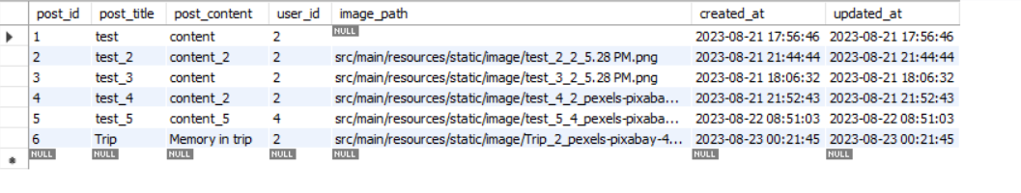

1. **post_like_dislike_map**

Description: This table stores the like dislike information for the post and user. Foreign key User_id references to User_id of the User table and Post_id references to Post_id of the Post_table. The liked_Disliked_at column stores the time when the user likes or dislikes a post.

CREATE TABLE `post_like_dislike_map` (

`like_dislike_map_id` bigint NOT NULL AUTO_INCREMENT,

`post_id` bigint NOT NULL,

`user_id` bigint NOT NULL,

`liked` char(1) DEFAULT NULL,

`disliked` char(1) DEFAULT NULL,

`liked_disliked_at` timestamp NULL DEFAULT NULL,

PRIMARY KEY (`like_dislike_map_id`),

KEY `user_id` (`user_id`),

KEY `post_id` (`post_id`),

CONSTRAINT `post_like_dislike_map_ibfk_1` FOREIGN KEY (`user_id`) REFERENCES `user` (`user_id`),

CONSTRAINT `post_like_dislike_map_ibfk_2` FOREIGN KEY (`post_id`) REFERENCES `post` (`post_id`)

)

