Data Warehouse Assignment 1

1. IPL Cricket Tournament Star schema Design:

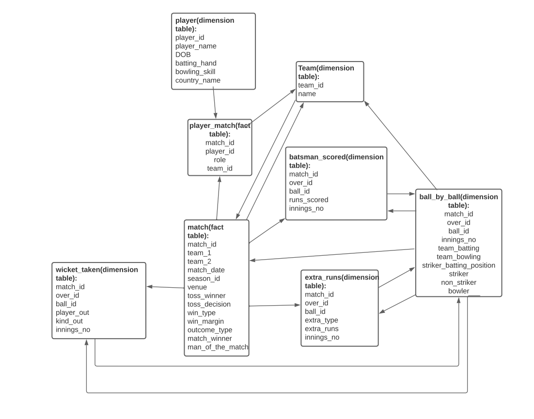

1. IPL Cricket Tournament Snowflake Schema:

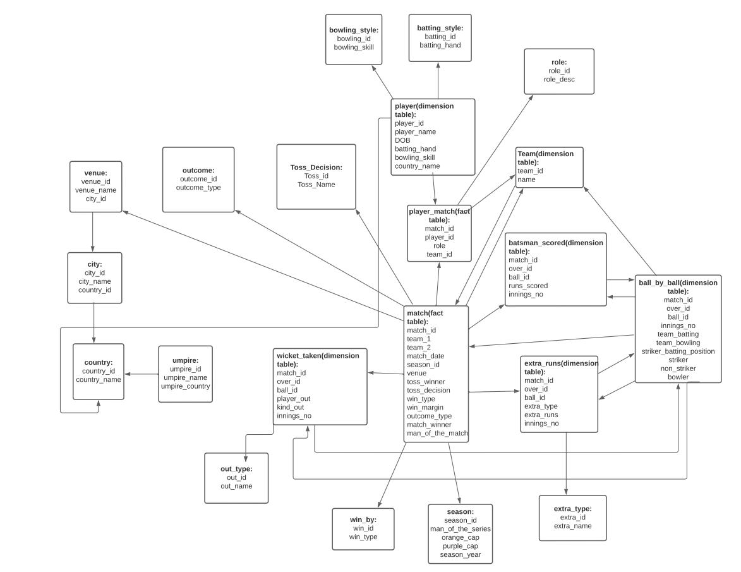

1. Food Delivery Apps like Swiggy, Zomato Star Schema Design:

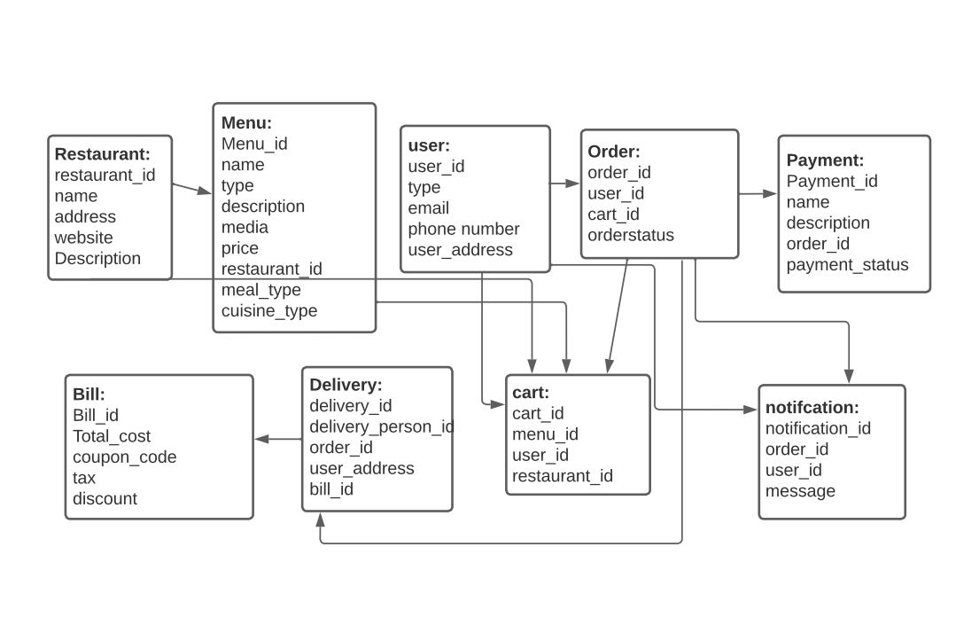

1. Food Delivery Apps like Swiggy, Zomato Snowflake Schema Design:

1. Cab ride services like uber star schema design:

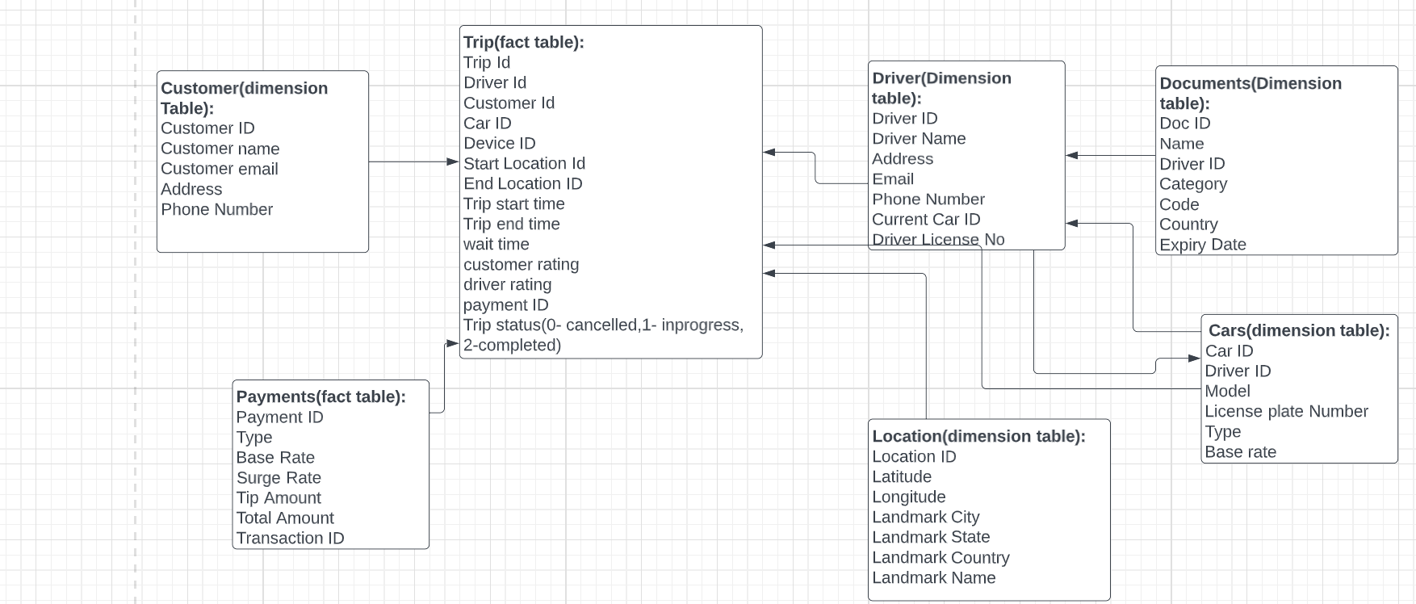

1. Cab ride services like uber snowflake schema design:

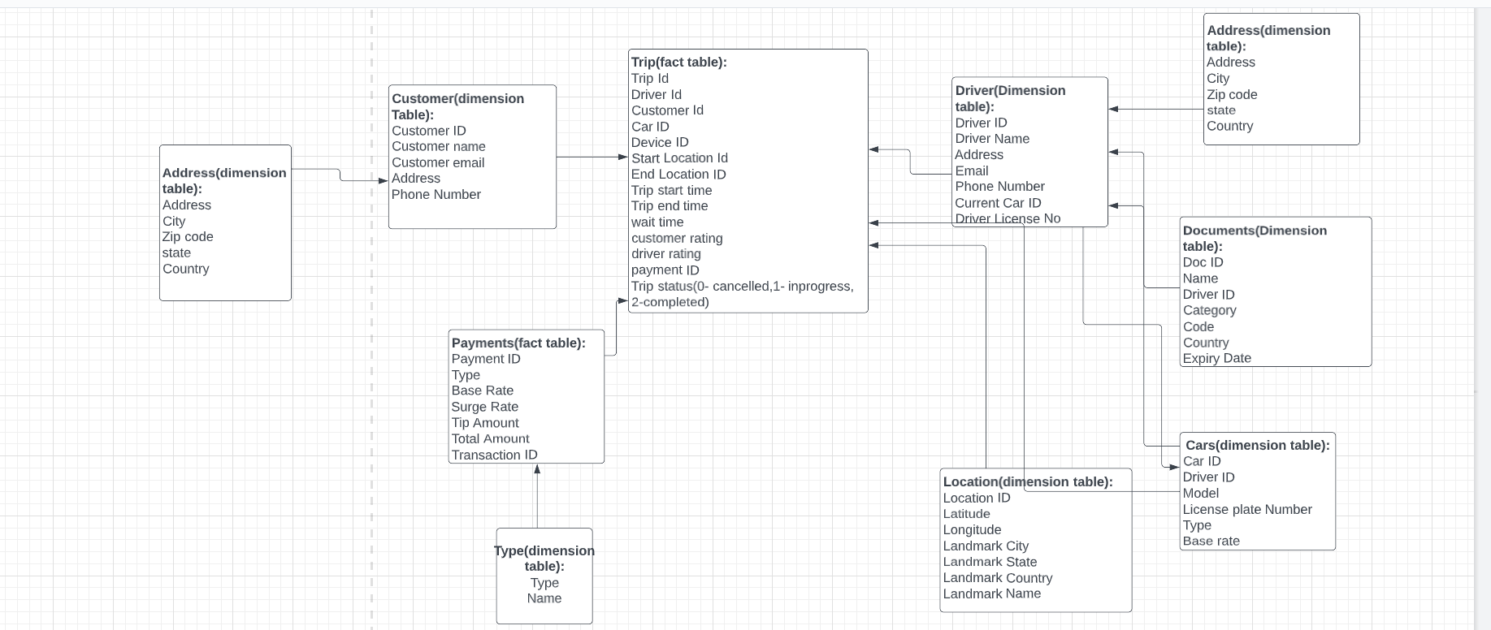

1. Restaurant table booking app like Dine out star Schema:

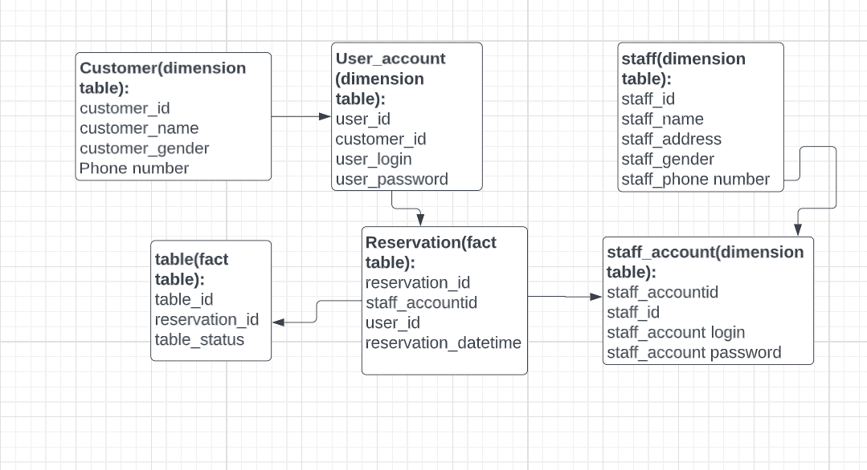

1. Restaurant table booking app like Dine out Snowflake Schema:

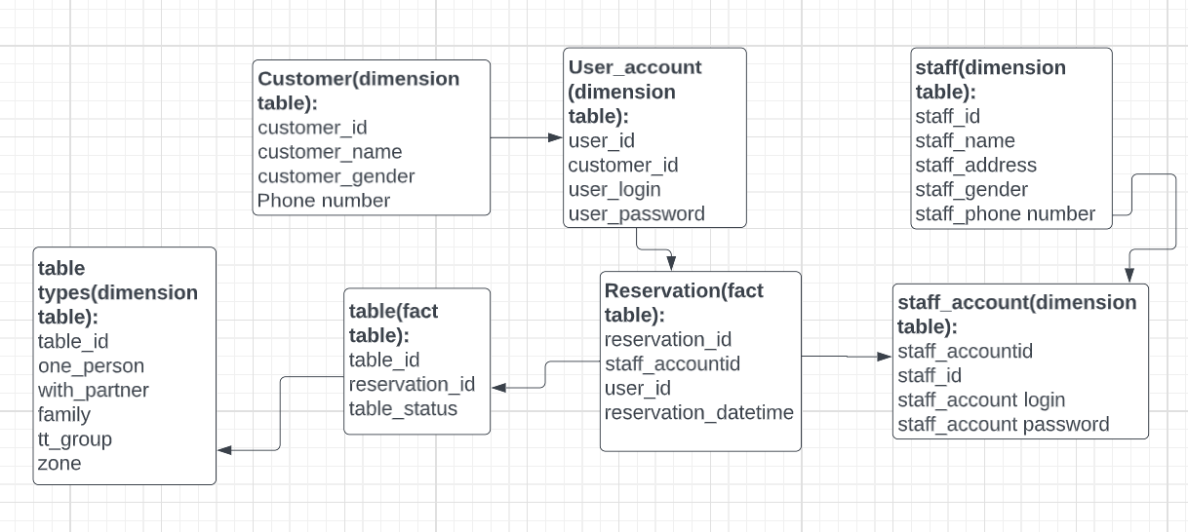

1. Covid Vaccination Application start schema:

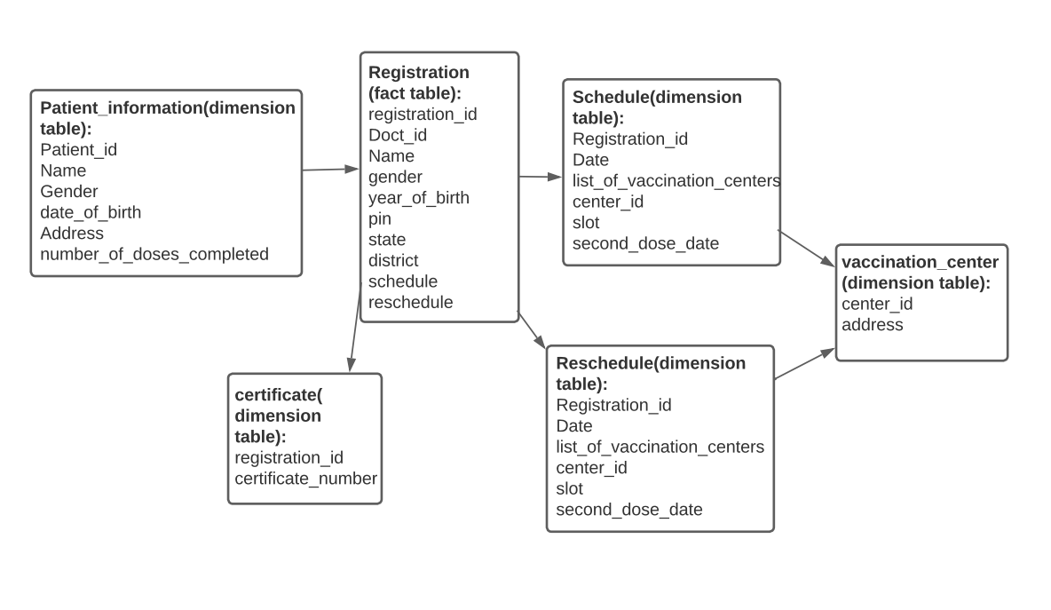

1. Covid Vaccination Application Snowflake Schema:

