**TASK EKALAVYA**

# DATABASE TASKS

1) Create an ER diagram for Hospital Management system.

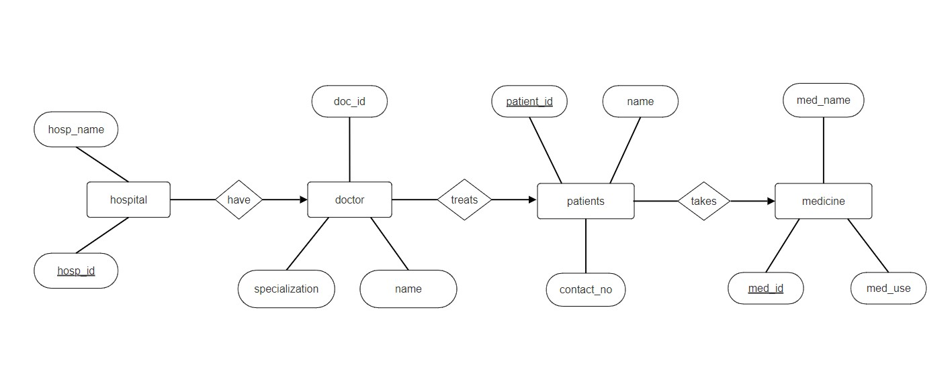

2) Setup the Postgre on your machine and create a DB.

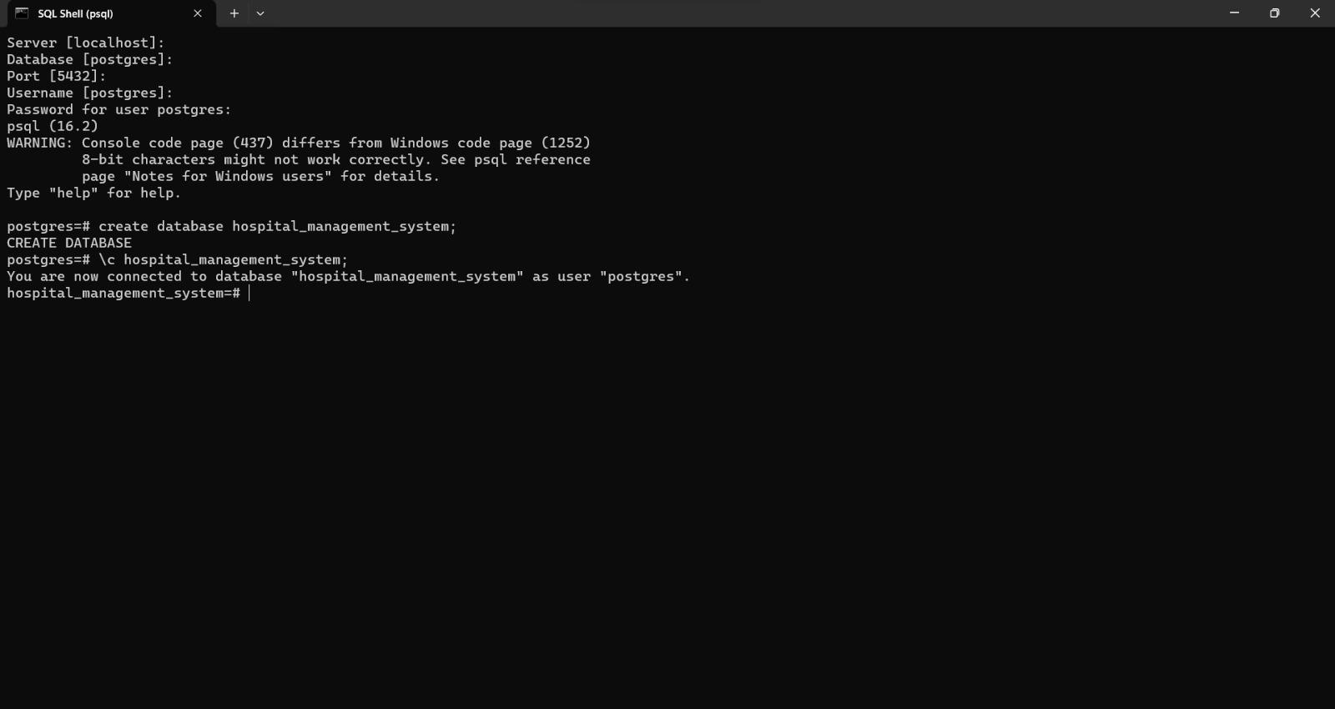

3) Add tables respective to ER diagrams .

Add data to each table with a minimum of 100 rows.

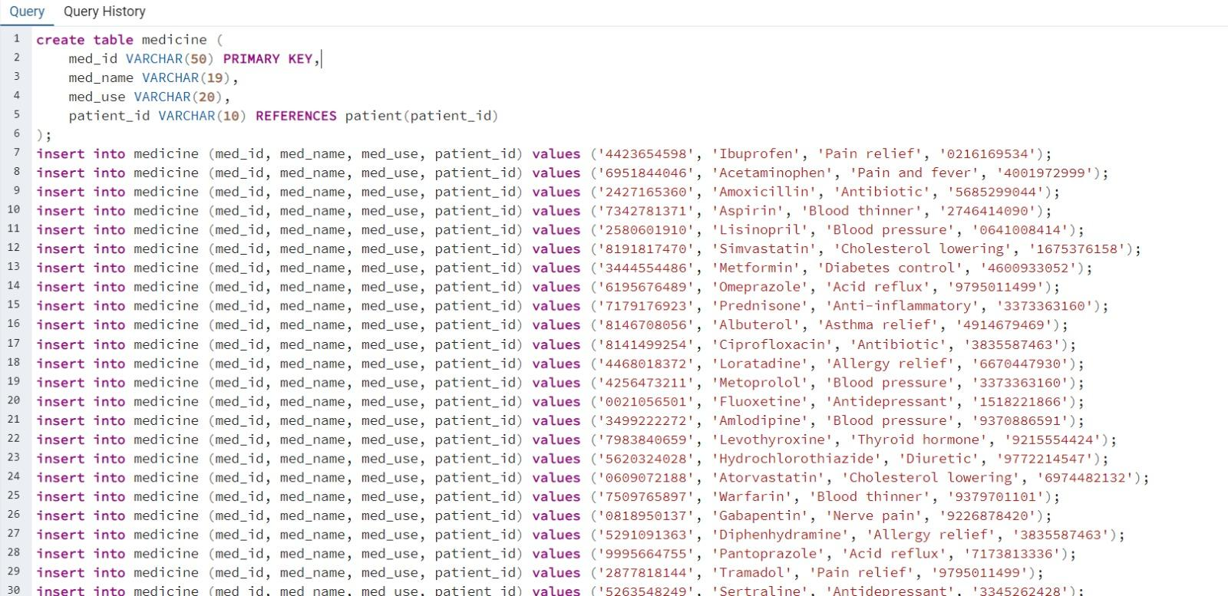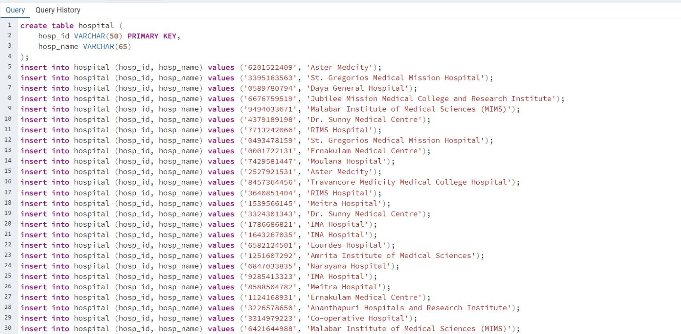

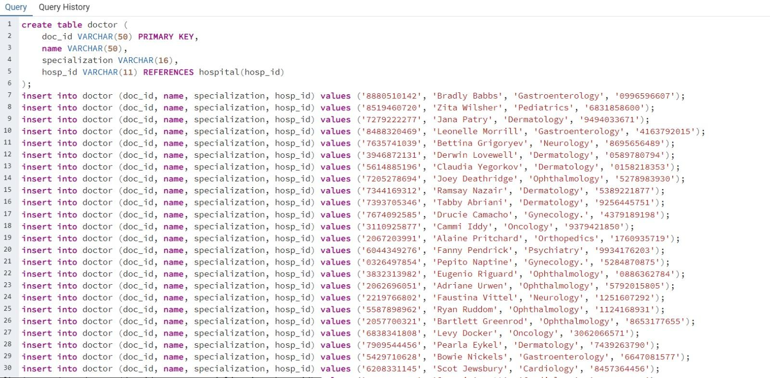

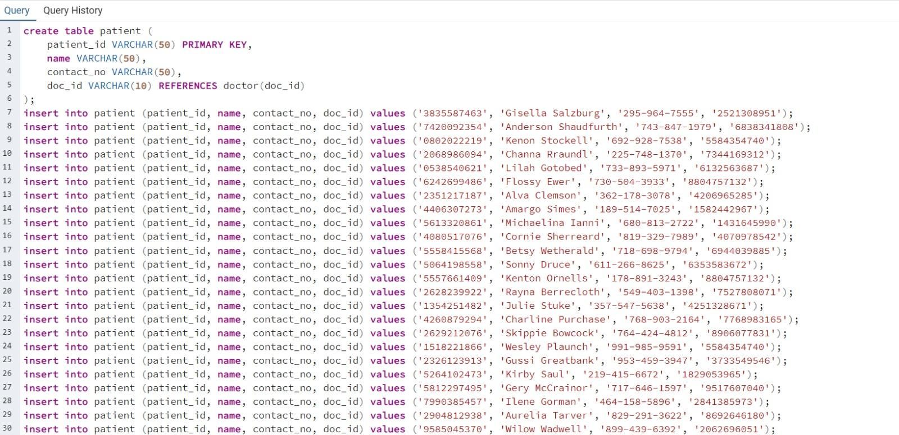

4) Write a Select query without conditions.

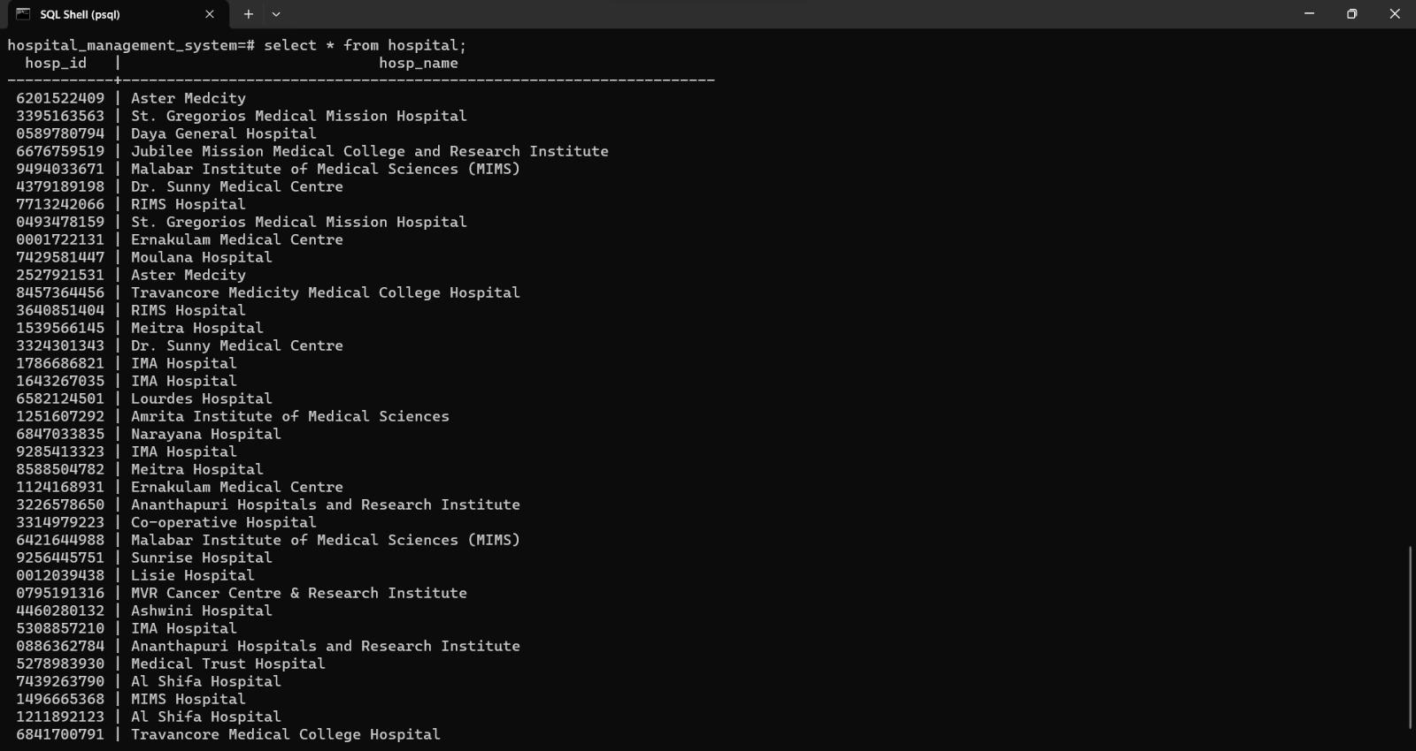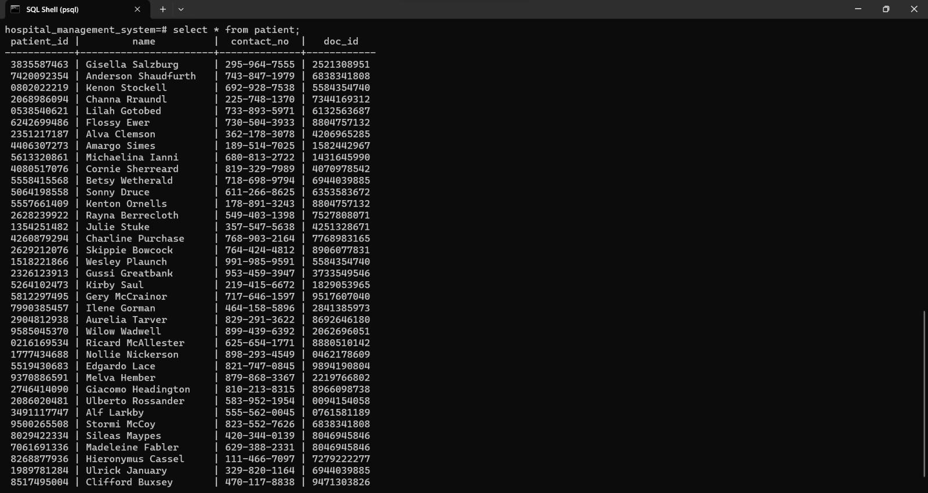

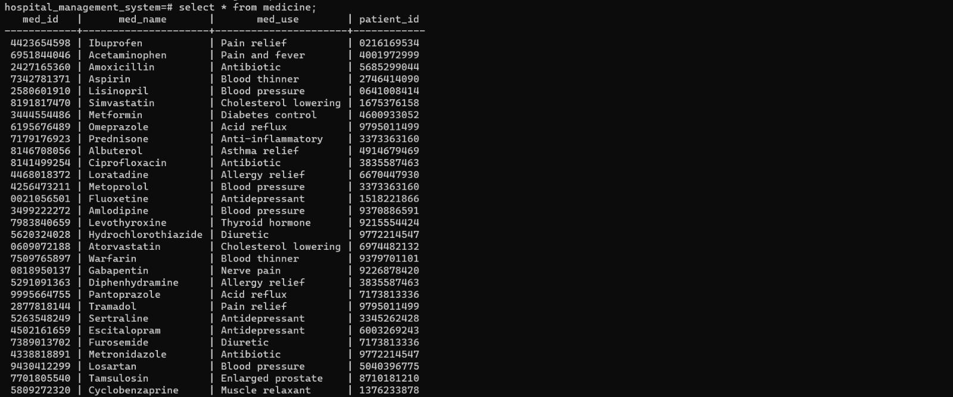

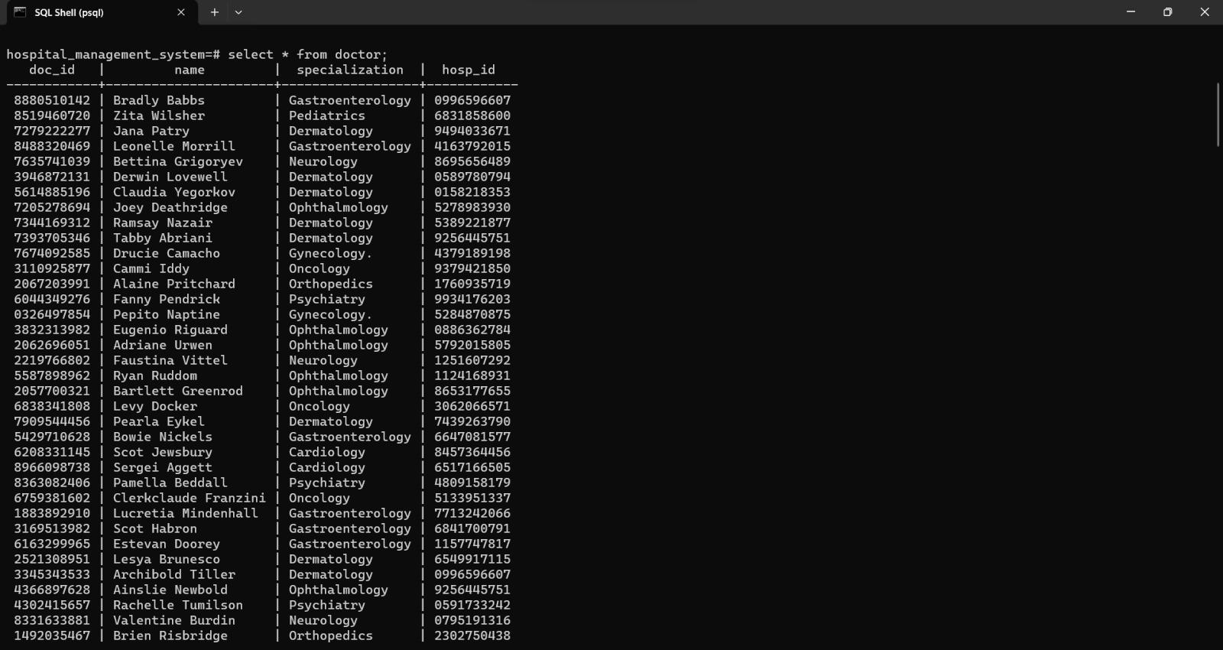

5) Write a Select query with conditions.

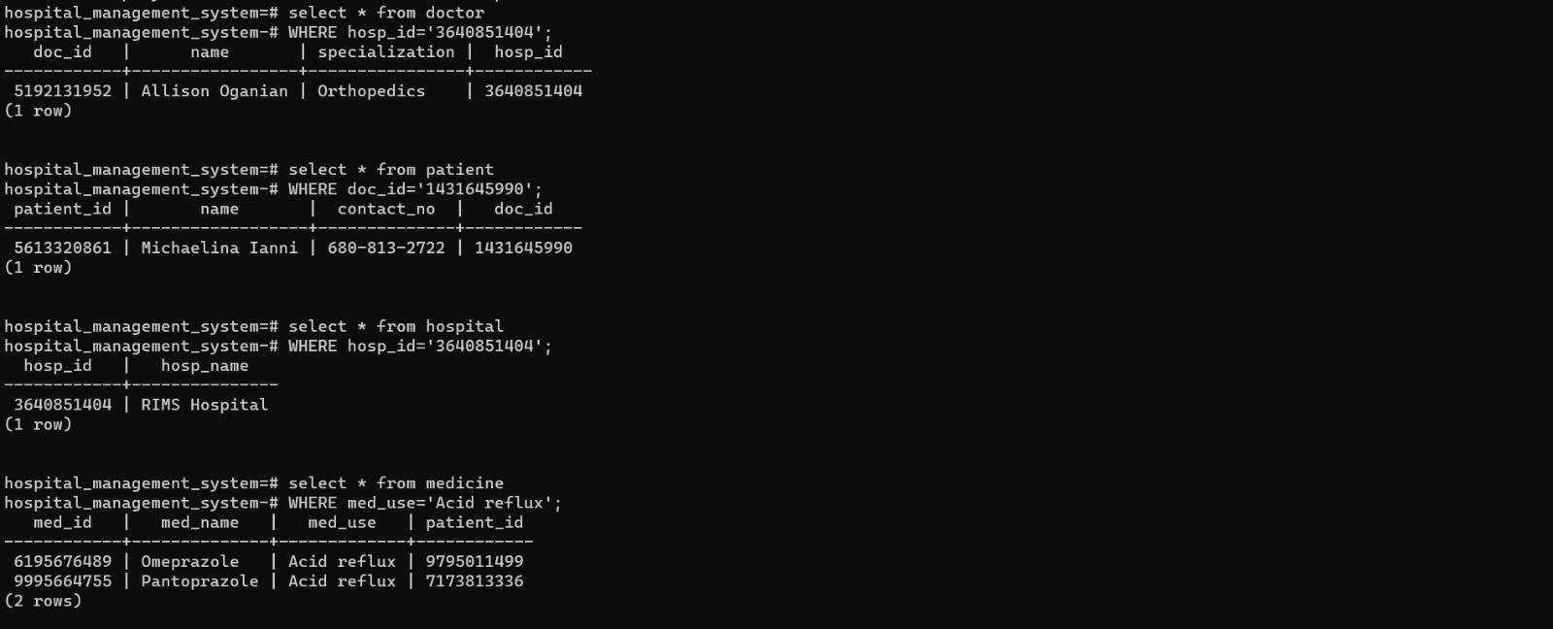

6) Write an insert query to add new data for all the tables

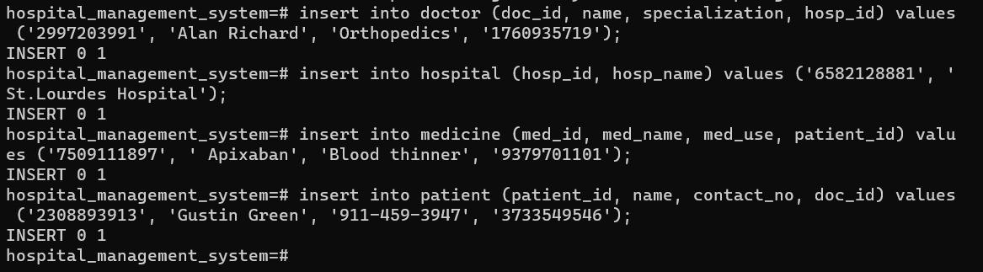

7) Write a Delete query to delete any existing data for all the tables.

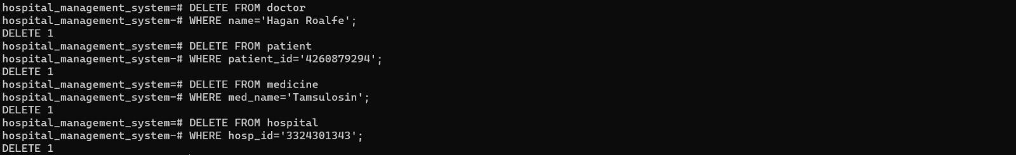

8) Write an Update query to update any existing data for all the tables.

