WEEK 1 PROJECT PLAN

Student Performance Prediction
Using Python and Machine Learning
Data Science Project Planning and Strategy Design

Submitted By | Varun Kumar
Course | Data Science
Week | Week 1
Technology | Python
Project Type | Hypothetical Data Science Project
Planned Effort | 31 Hours

Executive Summary
This Week 1 project plan proposes a hypothetical Data Science system for predicting student academic performance using Python and machine learning. The project will use student-related attributes such as attendance, study hours, previous marks, assignment performance and classroom participation to identify patterns associated with academic risk.
The purpose of this document is to design the complete strategy before technical implementation. It defines the problem, objectives, scope, data requirements, processing workflow, exploratory analysis, feature engineering, candidate machine learning models, evaluation strategy, tools, 31-hour work plan, expected outcomes and risk-mitigation measures.

1. Introduction and Project Background
Academic institutions collect a large amount of information about student attendance, assessment performance and participation. However, raw records do not automatically reveal which factors are most strongly associated with poor academic performance. Teachers may also have limited time to manually review every student's progress.
The proposed project addresses this problem by designing a predictive analytics workflow. Historical student information will be cleaned, explored and transformed into meaningful features. Machine learning algorithms will then be considered for predicting whether a student is likely to be at academic risk or likely to perform satisfactorily.
Python is suitable because it provides a complete ecosystem for data manipulation, visualization, statistical exploration and machine learning. The project is also designed so that the same plan can later be implemented using a real or appropriately simulated dataset.

1.1 Problem Statement
How can student-related academic and behavioral information be analyzed using Python to identify patterns and develop a machine learning model that can predict students who may be at risk of poor academic performance?

1.2 Project Motivation
- Provide an early-warning approach for identifying students who may need additional academic support.
- Understand which measurable factors are associated with student performance.
- Demonstrate an end-to-end Data Science workflow using Python.
- Create a structured foundation for the technical implementation in later project stages.

2. Project Objectives
- Define a clear and measurable student-performance prediction problem.
- Identify the student attributes required for analysis and future model training.
- Design a reliable process for data collection, cleaning and preprocessing.
- Perform exploratory data analysis to discover trends, relationships and potential outliers.
- Engineer useful features that can improve model learning and interpretation.
- Compare suitable classification algorithms such as Logistic Regression, Decision Tree and Random Forest.
- Evaluate candidate models using accuracy, precision, recall, F1-score and confusion matrix.
- Produce interpretable insights that could support academic intervention planning.
- Document the complete workflow so that it can be implemented and improved in subsequent weeks.

3. Project Scope

3.1 In Scope
- Student academic and attendance data preparation.
- Data quality checks and missing-value handling.
- Duplicate detection and removal.
- Exploratory data analysis and visualization.
- Feature engineering and feature selection.
- Train-test splitting and model development.
- Comparison of selected machine learning classification algorithms.
- Model evaluation and interpretation.
- Prediction of an academic-risk category.
- Documentation of findings and recommendations.

3.2 Out of Scope
- Real-time monitoring of students.
- Automatic examination grading.
- Facial recognition or biometric tracking.
- Psychological or medical diagnosis.
- Automatic disciplinary decisions.
- A complete college management system.
- Deployment as a production application during Week 1.
- Use of personally identifiable student information without appropriate authorization.

4. Methodology and Strategy
The project will follow a structured Data Science lifecycle. Each stage will produce an output that becomes an input for the next stage. The workflow is iterative: if evaluation shows weak performance, the project can return to feature engineering, data preparation or model selection.

4.1 Data Collection Strategy
The future dataset may be obtained from an appropriate public educational dataset, an authorized institutional source, a survey, or carefully simulated data for development purposes. The project will focus on variables that have a reasonable relationship with academic performance.
Feature | Type | Purpose
Student ID | Identifier | Uniquely identify records without using it as a predictive feature.
Attendance | Numeric | Measure class attendance percentage.
Study Hours | Numeric | Estimate average daily study effort.
Previous Marks | Numeric | Represent previous academic performance.
Assignment Score | Numeric | Represent continuous assessment performance.
Participation | Numeric/Categorical | Represent classroom participation.
Final Performance | Target | Target variable for prediction.

4.2 Data Cleaning and Preprocessing
- Inspect the dataset structure, columns, data types and summary statistics.
- Identify missing values and choose appropriate imputation or removal strategies.
- Detect duplicate records and remove or reconcile them.
- Validate numerical ranges, such as attendance between 0% and 100%.
- Standardize inconsistent categorical values and text formats.
- Check for unusual outliers and investigate whether they represent errors or genuine observations.
- Separate the target variable from input features.
- Encode categorical variables and scale numerical features when required by the selected model.

4.3 Exploratory Data Analysis
EDA will be used to understand distributions, relationships and possible data-quality problems before machine learning. Planned visualizations include histograms for numerical variables, bar charts for categories, scatter plots for relationships, box plots for outliers and a correlation heatmap for numerical relationships.
- Examine the distribution of final marks or academic-risk categories.
- Study the relationship between attendance and performance.
- Study the relationship between study hours and performance.
- Compare previous marks and final performance.
- Identify features that appear useful for prediction.
- Check whether the target classes are balanced.

4.4 Feature Engineering
Feature engineering will transform raw variables into representations that may be more useful for machine learning. Examples include an academic-score average and attendance categories. Features will be created carefully to avoid data leakage, meaning information from the future or target outcome must not accidentally be used as an input.

4.5 Model Selection Strategy
Model | Reason for Selection | Expected Use
Logistic Regression | Simple and interpretable baseline | Establish a baseline classification model.
Decision Tree | Easy to understand and explain | Capture non-linear decision rules.
Random Forest | Combines multiple decision trees | Compare a stronger ensemble approach.

4.6 Model Training
The dataset will be divided into training and testing subsets. A planned starting point is an 80:20 split, with the exact strategy adjusted according to dataset size and class distribution. Where appropriate, cross-validation will be used on the training data to obtain a more reliable estimate of model performance.

4.7 Model Evaluation
- Accuracy: overall proportion of correct predictions.
- Precision: proportion of predicted at-risk students who are actually at risk.
- Recall: proportion of actual at-risk students correctly identified.
- F1-score: balance between precision and recall.
- Confusion matrix: detailed view of correct and incorrect class predictions.
Because identifying at-risk students is important, recall will receive particular attention. The final model should not be selected using accuracy alone; the choice will consider multiple metrics and interpretability.

5. Project Workflow Diagram
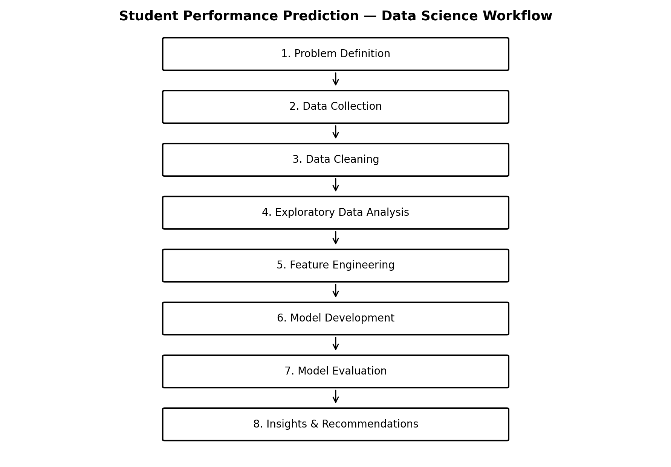
Figure 1. Planned end-to-end Data Science workflow.

6. Strategic Project Architecture
The architecture shows how student data will move through processing, analysis, feature engineering and machine learning before producing predictions and insights.
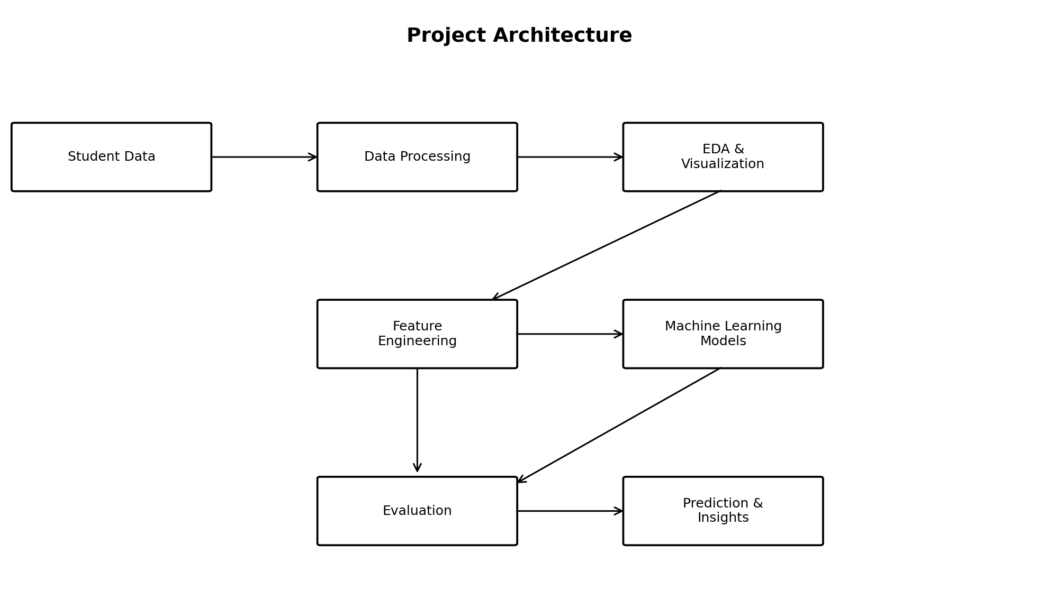
Figure 2. Proposed project architecture.

7. Tools and Technologies
Tool/Library | Role | Planned Use
Python | Programming language | Core language for the project.
Jupyter Notebook | Development environment | Interactive analysis, experiments and documentation.
Pandas | Data manipulation | Loading, cleaning and transforming tabular data.
NumPy | Numerical computing | Numerical operations and arrays.
Matplotlib | Visualization | Basic charts and plots.
Seaborn | Statistical visualization | Correlation plots and analytical visualizations.
Scikit-learn | Machine learning | Preprocessing, model training and evaluation.
CSV/Excel | Data storage | Initial tabular data format where appropriate.
Git/GitHub | Version control | Track changes and maintain project versions.

8. Project Timeline and 31-Hour Work Allocation
The planned implementation effort is approximately 31 hours, which satisfies the required 30–35 hour range. The allocation can be adjusted slightly after the dataset and technical complexity are known.
Activity | Hours | Main Deliverable
Planning & problem definition | 3 | Problem statement, objectives and scope
Data collection | 4 | Initial dataset and data dictionary
Data cleaning | 5 | Cleaned and validated dataset
EDA & visualization | 5 | Charts, trends and observations
Feature engineering | 3 | Model-ready feature set
Model development | 5 | Candidate trained models
Model evaluation | 3 | Metrics and model comparison
Documentation & presentation | 3 | Final report and visuals
Total planned effort: 31 hours
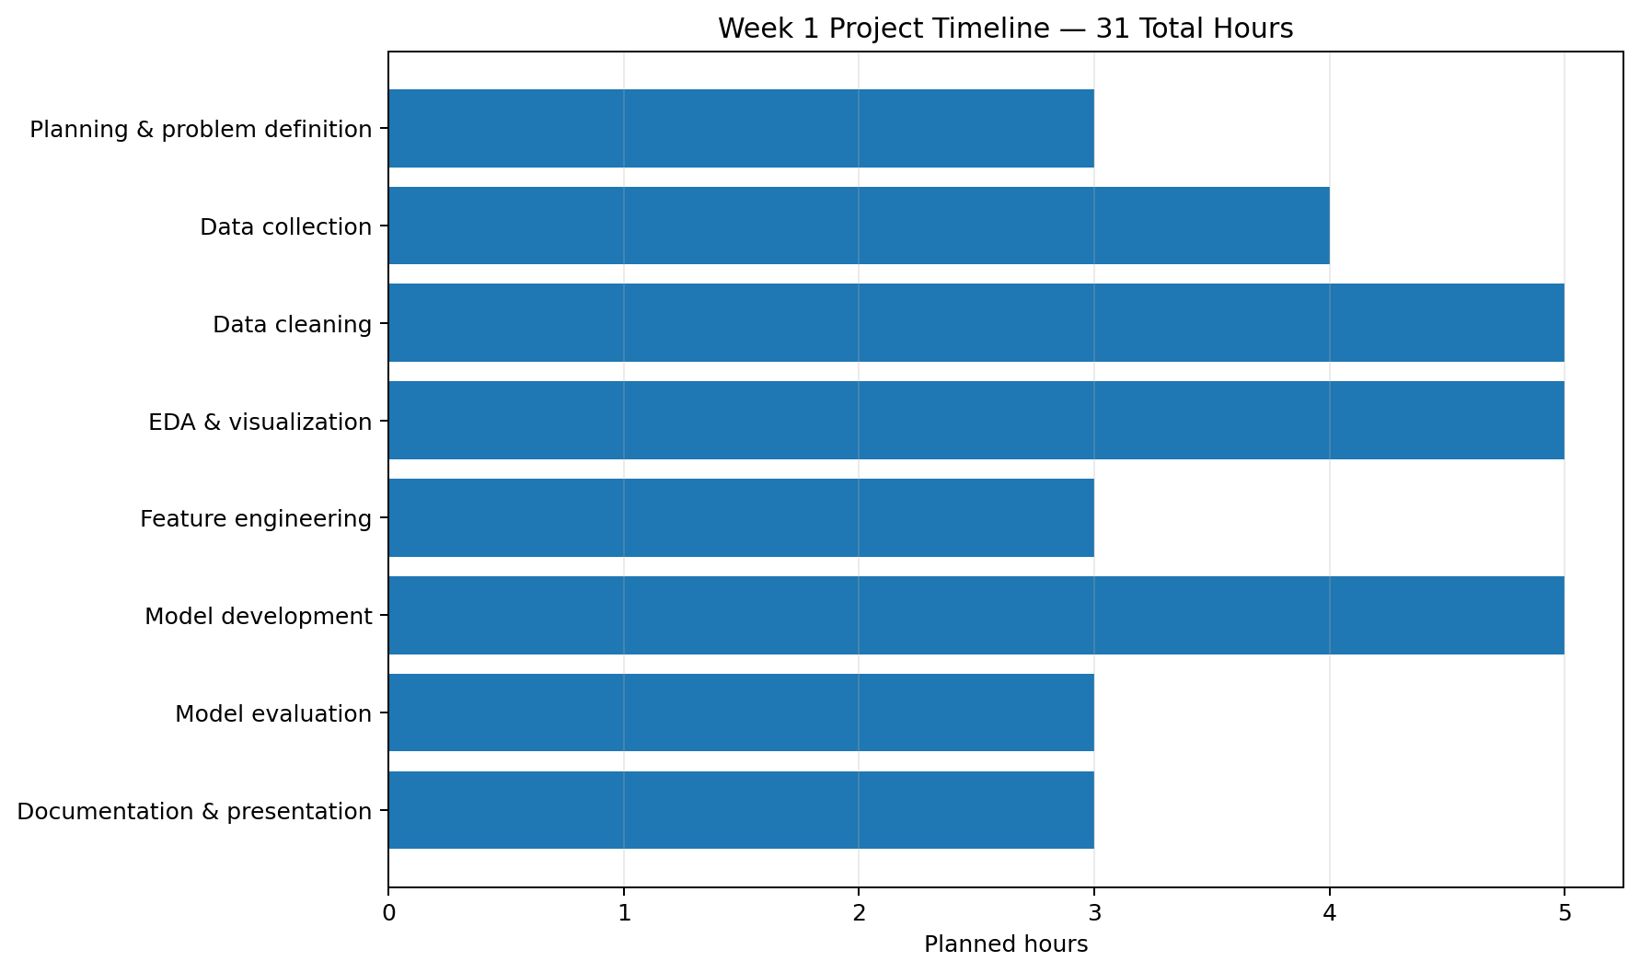
Figure 3. Planned effort distribution across project activities.

9. Expected Outcomes
- A structured and cleaned dataset suitable for analysis.
- A set of visualizations describing student-performance patterns.
- Identification of potentially important performance-related factors.
- Several candidate machine learning classification models.
- A comparison of models using multiple evaluation metrics.
- A selected model that provides useful academic-risk predictions if the data supports it.
- Actionable analytical insights that could help prioritize academic support.
- A documented workflow that can be extended into later technical implementation.

10. Anticipated Challenges and Mitigation Strategies
Challenge | Potential Impact | Mitigation Strategy
Missing values | Incomplete analysis or biased results | Use justified imputation/removal and document decisions.
Incorrect/inconsistent records | Reduced data quality | Apply validation rules and standardized formats.
Class imbalance | Poor identification of minority class | Use stratified splitting and suitable evaluation metrics.
Overfitting | Good training results but weak test performance | Use cross-validation, simpler models and regularization where appropriate.
Limited dataset size | Unstable model performance | Use appropriate validation and avoid over-complex models.
Feature leakage | Artificially high performance | Ensure target/future information is excluded from input features.
Privacy concerns | Risk of exposing student information | Use anonymized data and follow applicable data-protection requirements.
Poor interpretability | Difficult to use predictions responsibly | Prefer interpretable models and explain important features.

11. Evaluation of the Week 1 Plan
- Completeness: all required planning components are documented.
- Process understanding: the plan follows a logical Data Science lifecycle.
- Clarity: objectives, scope and methodology are explicitly defined.
- Strategy quality: each stage has a purpose, planned technique and expected output.
- Visual clarity: workflow, architecture and timeline diagrams are included.
- Feasibility: the work is allocated within the required 30–35 hour range.
- Future readiness: the plan can directly guide the technical implementation in subsequent weeks.

12. Conclusion
This Week 1 plan establishes a complete strategy for a hypothetical Student Performance Prediction project using Python. The proposed approach begins with a clearly defined problem and continues through data collection, cleaning, exploratory analysis, feature engineering, machine learning and evaluation. The 31-hour schedule provides a realistic allocation of effort, while the identified challenges and mitigation strategies address common Data Science risks.
The project is intentionally designed as a planning document rather than a completed predictive system. Its purpose is to provide a clear blueprint for the technical work that will follow.

Appendix A — Planned Project Deliverables
- Cleaned dataset.
- Jupyter Notebook containing analysis and experiments.
- EDA visualizations.
- Feature-engineering pipeline.
- Trained candidate machine learning models.
- Model comparison and evaluation results.
- Final insights and recommendations.
- Project documentation.

