1)Git Repositories:

Frontend code(Source Code Angular can be found here):

https://github.com/varun-murali-coder/meet-frontend.git

Backend code (API Documentation can also be found here):

https://github.com/varun-murali-coder/meetingScheduler-backend.git

2.)Web Hosting details(Domain name):

Frontend: http://vcoderlearn.com

Backend : api.vcoderlearn.com

3.) Project Design

a)Login Functionality:

->First the user has to register with VSCHEDULER using the sign-up button

->Once the user becomes a registered user of VSCHEDULER tool,he is redirected to the login page

->Forgot password functionality is also enabled in website ,where user can recover his password via email.

->Validations applied:

.All the fields are made mandatory

.After registeration if the user enters invalid email/password,appropriate validations are applied

Screenshots:

1.)Server side validation on login Page

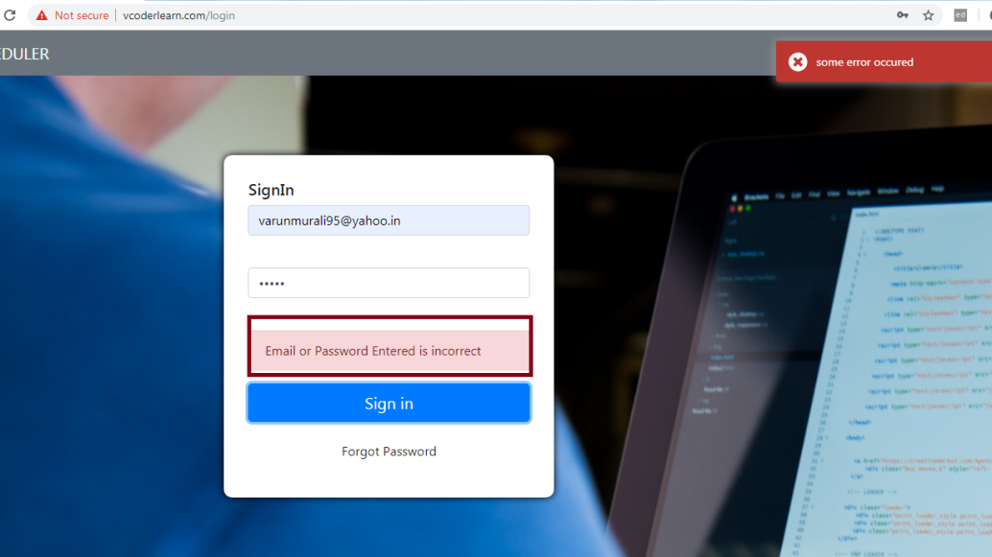

2)Client Side validation on client page(After successfull sign up customer will be redirected to login page)

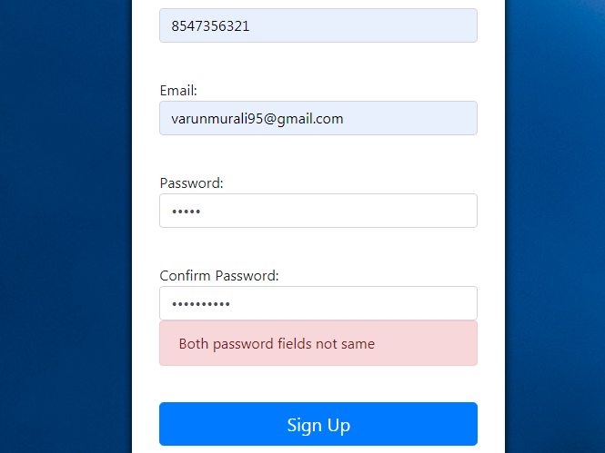

3.)Forgot Password functionality.

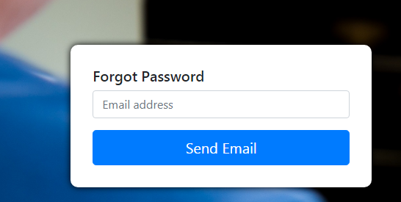

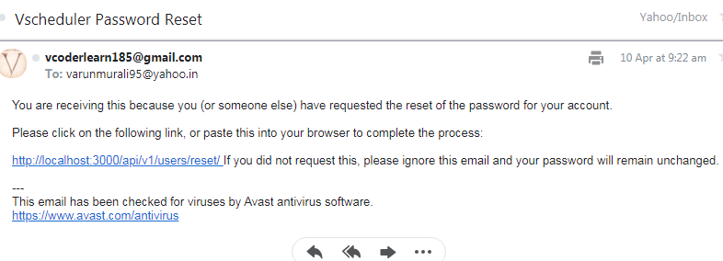

b)Dashboard Functionality(Admin & Normal User):

->After successful login ,the normal user is redirected to the user- dashboard page and admin is redirected to the admin dashboard page.

->The admin-dashboard page is populated with planner views and the list of normal users.

->The admin has only the privilege to create,update and delete meeting.

->A create button is provided at the navbar creating the meeting for admin.

->An admin can become part of a meeting if he wants by adding his email to partcipants list.

Additional feature:

->Circular logout functionality displaying the first two letters of logged in user.

->Create functionality made with the help of modal

Screenshots:

1)Normal User Page (The normal user has read only access to his planner/dashboard page):

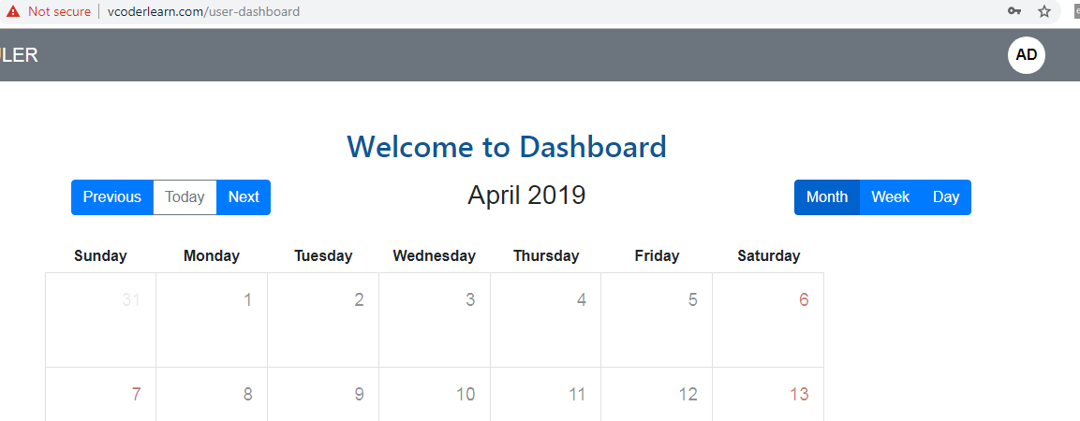

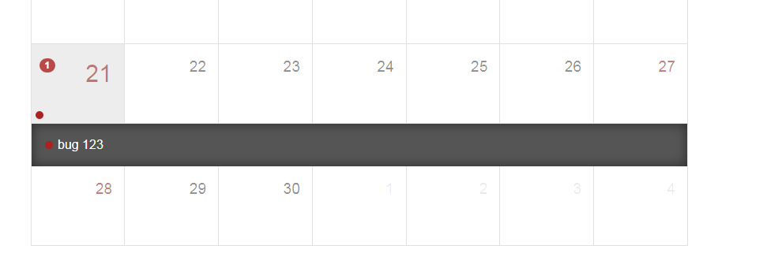

2)Admin Dashboard page

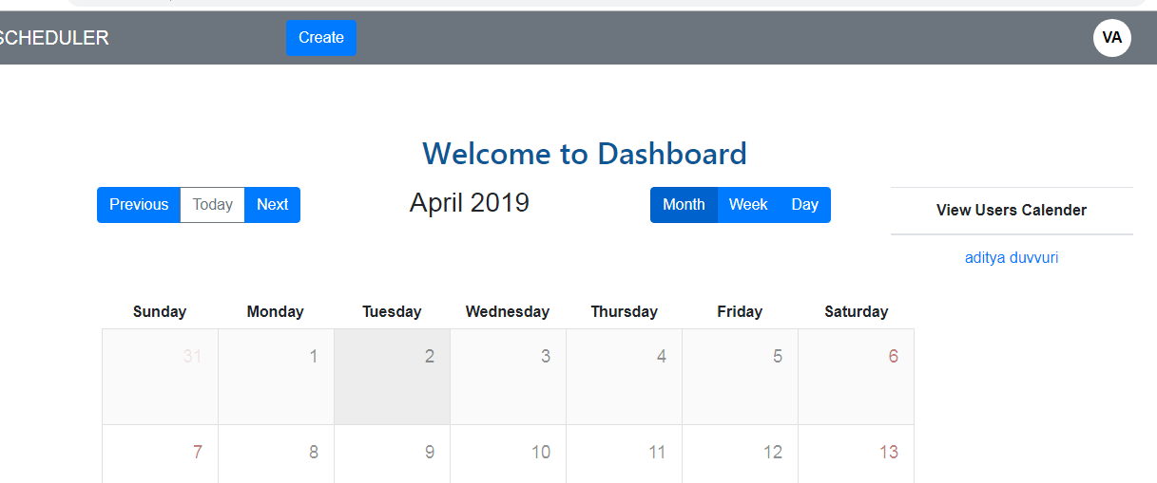

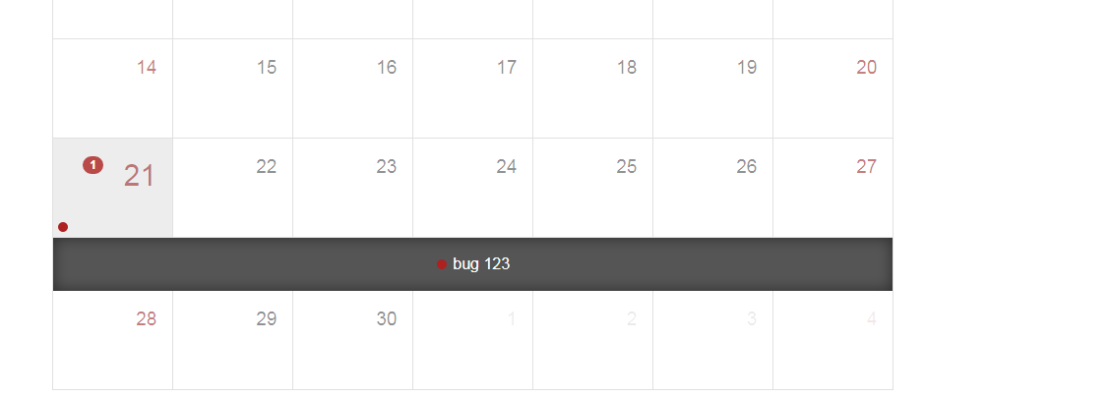

3)Meeting create Functionality:

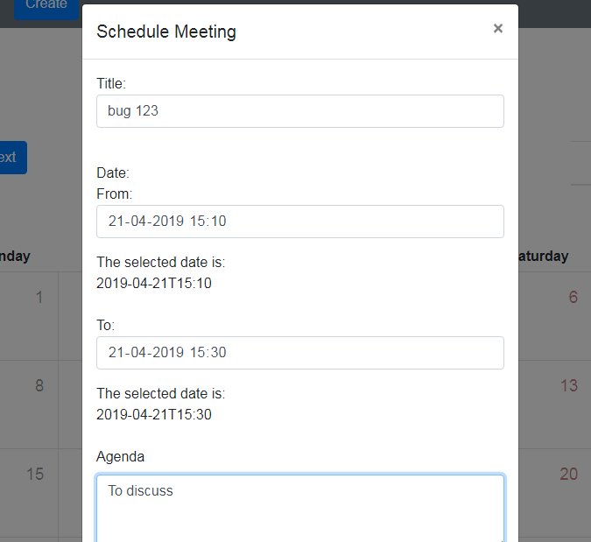

c.)Meeting Details Page

->The page is common for both normal user and admin.

->But admin has two special features added for him like edit and delete,but normal user is given view only access.

1.)Normal users details page:

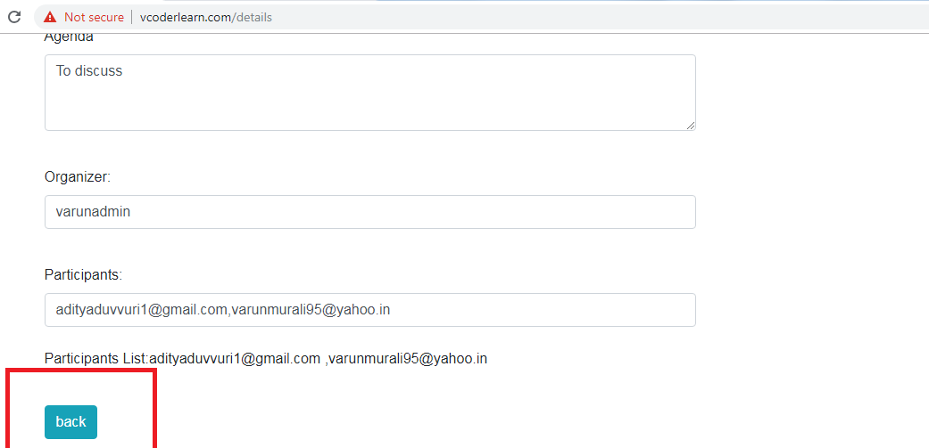

2)Admins detail page:

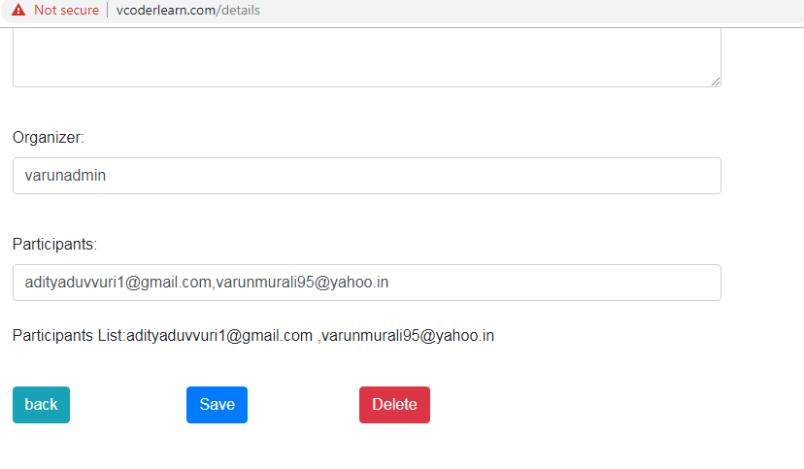

c)Planners View (Admin & Normal User):

->The planners view and dashboard functionality are kept the same.

->For admin along with the planners view for himself,he also has the option to view the calender of normal users.ie.admin-controls page.

->The edit functionality is mainly acheived in the details page by admin by using the delete button to delete the meeting as a whole or to delete a particular user from meeting he can remove the users emailId from the participants list.

->There are previous and next button provided for both the users which will be disabled for any year apart from the present year.

->There is also a 24 hour timeline view button provided for the users.

->The meetings are never removed from the planner view even if they are over,except removed by admin.These are provided for history references.

1)Admin Control Page:

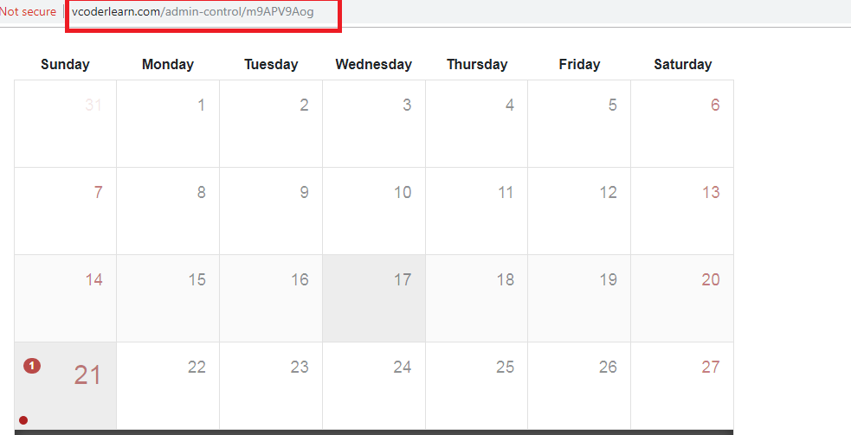

2)Button Disable functionality:

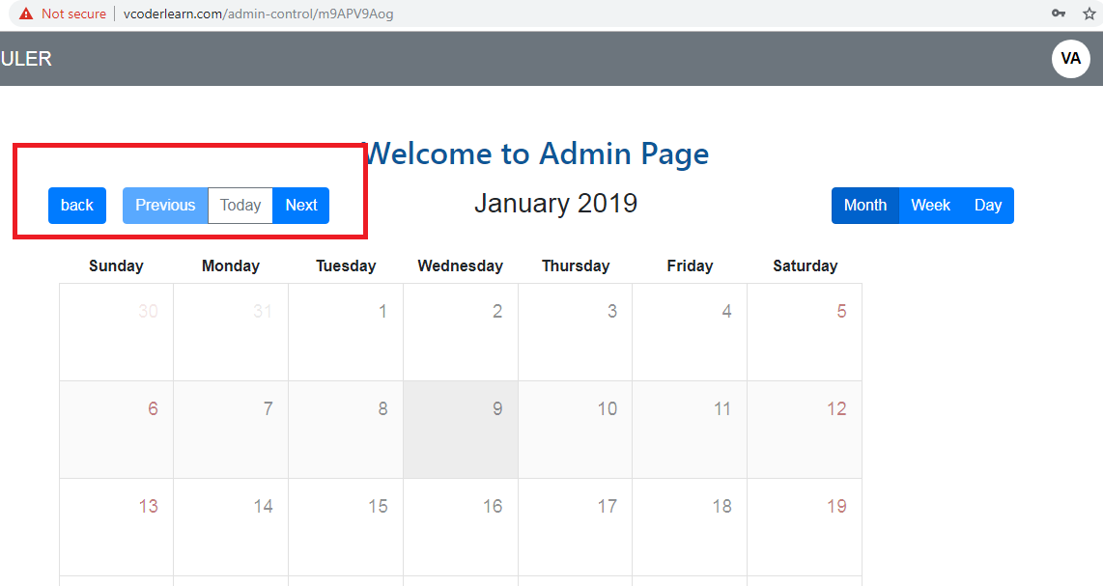

d.)User Alert Management System:

->When the user is online he is alerted about the meeting with the help of a pop up.

->He also gets notifications when a meeting is created or edited by the admin.(Implemented using SocketIO)

->When he is offline he is intimated about the same via email.

1)Pop Up Functionality:

Note:If user clicks snooze , he will get a reminder in every 5 seconds.

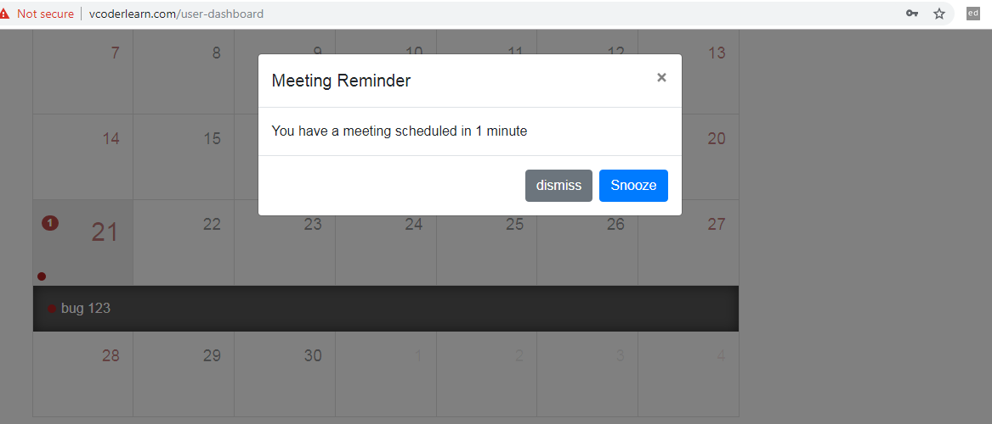

2)Emails Triggered for create and edit functionality:

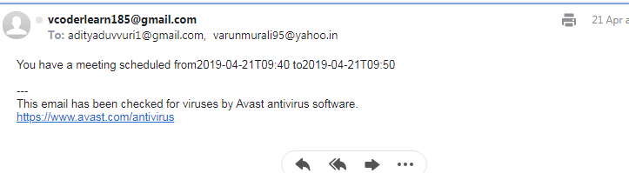

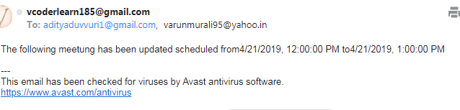

e)Error Handling

->If the server responds with a 500 status then the user is redirected to server-internal-error page.

->If the meeting is not found then the user is redirected to page-not-found page.

