Summer Internship Report 2020:
Student Name :Varun Garg
Company Name: Veoneer Inc. US
Student Id: 01743797

About Veoneer

Veoneer is a spin-off company formed out of a well know automotive passive security system company called as Autoliv. Veoneer works on active safety systems primarily on automotive radar sensors. Veoneer sells automotive radar to top automobile manufacturers like Subaru, BMW, Mitsubishi, Renault Nissan and honda.
Some of the other products by Veoneer’s are including brake control systems, radar,
night vision, driver monitoring systems, advance driving assistant system, electronic control
units, and camera vision systems and produce pedestrian protective systems.
Lowell facility of Veoneer primary works on development of Radars sensor on 77Ghz and 24
GHz. 77Ghz radars help in developing a solution to a problems like blind-spot detection, rear
cross-traffic alert, adaptive cruise control lane change assist, Safe door opening, forward and
rear collision avoidance system, free space detection, and autonomous emergency braking.
Veoneer driving monitoring system can help identify distraction while driving by taking
measurements of the eye and head movements. This feature allows the development of a level
two autonomous vehicles.
Veoneer’s is also in its early stage development of Lidar. Lidar performs a better job than
radar sensor in detection of pedestrian, detect lane markings and in the creation of 3D map of
the road. It products also includes ADAS software such as roadscape project which helps with creating maps belonging different scenarios. It future products include highway assist and valet parking support.



Below is the road map of the products.

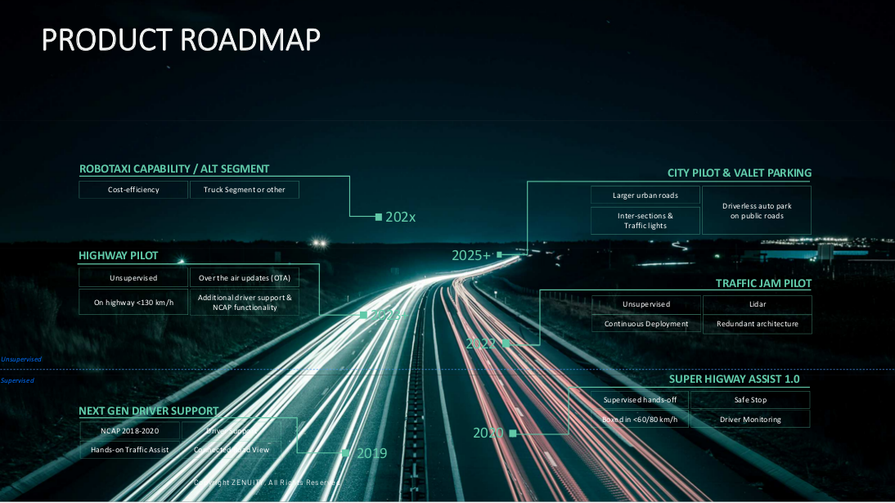

My role in the internship:
My this year task were related to analysis of data and automate, add to the data extraction process.
My tasks required me to process Geospatial information for which I had to learn geo spatial tools such as QGIS, Geopandas, OSMnx and process the spatial data. Last summer I had worked on creation of plugins for storage of data this year I work on extraction particular type of data from sensor bundle. By modification of the source code of the tool I was able to make the tool run for multiple files. I also incorporate to it dynamic input and output path handling using which I was able to locate the files located in the sub directories of the input path and save the output in an organized file structure to be to track which sub directory the input file had belong to.

Skills I learned from Internship:
1) Programming using C# , Python , SQL
2) Gain experience in handling Geospatial Data and tools
3) Opportunity to work and visualize vehicular sensor data and understanding problems in
intelligent transportation systems.

Summary of What I learned:
1.Using C# I learned to work on data extraction . Due to a large size of the project I had spend time understand the existing source code and understand the architecture and the project plan. Using the help other team member development process of creation of data parser was completed . I went through the documentation about the working of different tool in order understand the code. By understanding the C# api, I was able to perform path handling and I wrote scripts to make the tool run for multiple files and handle the sub-directory structure dynamically.

2.Developed Python script to read multiple csv files and convert the Geo spatial data into different metrics.

3.Understanding the Geographical Map development and Interfacing with map data:
I worked on understanding how the Geographical Information systems work. I developed and understanding about the basemap having the information about roads, train tracks and terrain information. I developed a script to parse out data from GIS data file obtained from Massachusetts Department website. I file an untraditional file extension.
To obtain useful data. I worked on tools which use open source map api’s map to obtain the locations streets, buildings, restaurants, highways etc near location of interest.

4.Learning to use the OSMnx: Using Osmnx methods I developed a script to obtain the road data as a graph. Using Geopandas library transformed the graphical object into Geodataframe which allowed me to identify different nodes and different edges. I created multiple plotting functions as well as function to plot the nearest node and edge near to geographical coordinate. I applied linear kinamatics equation to obtain the edges in the direction of travel. I applied graphical algorithm such as obtain shortest path.

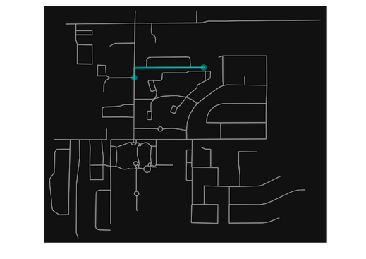

5.Learning to use Geographical information system tools:
Using QGIS Given multiple geospatial data finding the union , intersection of the data
performing operation such as union, intersection of two layers of geospatial data. A layer is GIS term which has a set of GPS coordinates and other attributes

6. Processing geospatial data using PostGIS:
Using PostGIS for processing Geographical data:
Using SQL querries avaialbe through Post GIS I process the geospatial data.Operations such as creating and loading Geospatial database. Adding vector layer from the spatial database. What is the total length of all roads, expressed in kilometers. What is the total length of all roads, expressed in kilometers? What is the largest municipality in the province, by area?
What is the length of roads fully contained within each municipality?
Example of a querries below.This query combines an attribute condition (on the municipality name) with a spatial calculation (of the area)
6.1 What is the total length of all roads, expressed in kilometers?
SELECT sum(ST_Length(the_geom))/1000 AS km_roads FROM bc_roads;

7. Understanding State Estimation using Non linear Vehicle Dynamics Model:
Understanding Non linear dynamic model for moving vehicle .I worked on understanding next step prediction of the vehicle, along with understanding the state equations and sequential estimation methods.

Supervisors:
1) Bernard : Supervised the results of my tasks and provided me the details of the
requirements
2) Bob Sletton: Supervised the data selection process.

References:
1) http://www.veoneer.com
2) https://postgis.net/docs/manual-3.0/using_postgis_dbmanagement.html
3) https://docs.qgis.org/3.4/en/docs/gentle_gis_introduction/introducing_gis.html#overview
4 Boeing, G. 2017. "OSMnx: New Methods for Acquiring, Constructing, Analyzing, and Visualizing Complex Street Networks." Computers, Environment and Urban Systems 65, 126-139. doi:10.1016/j.compenvurbsys.2017.05.004

