Stock Market Price Analysis using Linear and Polynomial Interpolation

In this analysis, we explore the use of linear and polynomial interpolation techniques to estimate stock prices for Tesla between 2010 and 2013. We will use both linear interpolation and polynomial interpolation (quadratic and cubic) to estimate stock prices at mid-year points (June).

# Hypothetical Data

We consider the following hypothetical stock prices for Tesla at the beginning of each year:  
- 2010: $20  
- 2011: $30  
- 2012: $45  
- 2013: $70  
  
We want to estimate the stock prices for mid-year points (June) using both linear and polynomial interpolation.

# Linear Interpolation

Linear interpolation is the simplest form of interpolation where the estimate for the unknown value is assumed to lie on the straight line between two known values. The formula for linear interpolation is:  
y = y1 + ((x - x1) / (x2 - x1)) * (y2 - y1)  
Where:  
- x1, y1 are the coordinates of the first point  
- x2, y2 are the coordinates of the second point  
- x is the point at which to estimate the value  
- y is the interpolated value at x.

# Polynomial Interpolation

Polynomial interpolation is a more flexible method where a polynomial is fitted to the data points. We will use quadratic (2nd degree) and cubic (3rd degree) polynomials to estimate the stock prices. These polynomials will provide a more accurate estimate by capturing the potential curvature in the data.

# Visualization

The plot below compares the original data points with the results of linear and polynomial (quadratic and cubic) interpolation. The x-axis represents the years, and the y-axis represents the stock prices in USD.

The chart is generated based on the data and interpolation techniques discussed.

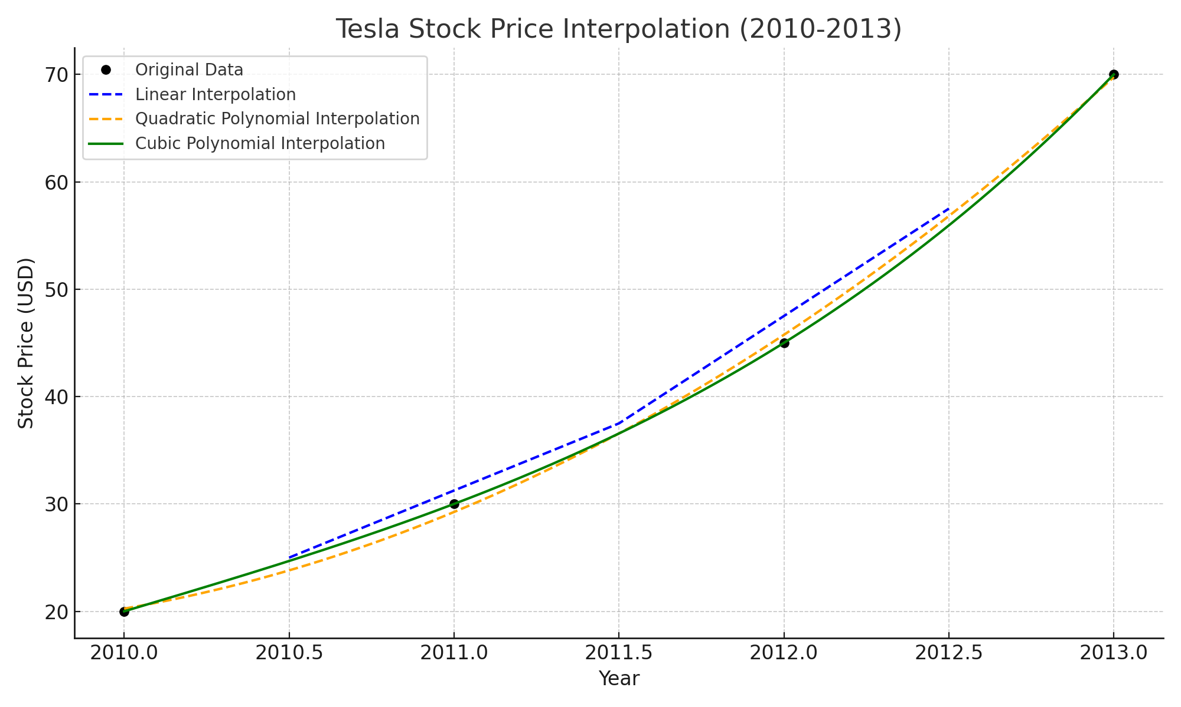

# Results

The following are the estimated stock prices using linear, quadratic, and cubic interpolation:

Year: 2010.5  
Linear Interpolation - Estimated Price: $25.00  
Quadratic Interpolation - Estimated Price: $23.81  
Cubic Interpolation - Estimated Price: $24.69  
  
Year: 2011.5  
Linear Interpolation - Estimated Price: $37.50  
Quadratic Interpolation - Estimated Price: $36.56  
Cubic Interpolation - Estimated Price: $36.56  
  
Year: 2012.5  
Linear Interpolation - Estimated Price: $57.50  
Quadratic Interpolation - Estimated Price: $56.81  
Cubic Interpolation - Estimated Price: $55.94

# Conclusion

Linear interpolation provides a simple estimate of the stock prices, while polynomial interpolation (quadratic and cubic) offers more flexibility by capturing the underlying trend in the data. The cubic polynomial interpolation in particular provides a smooth curve that fits the data points closely, making it suitable for estimating stock prices that may not follow a linear trend.

a spline interpolation, which is a form of polynomial interpolation but doesn't explicitly showcase higher-degree polynomial interpolation like quadratic or cubic interpolation using polynomial fitting.