Wright visited japan in1905 and influence a lot with tradition architecture of japan. He wrote a book on Japanese architecture art in 1912. Thought out his life he worked to design houses that consist of good and inexpensive architecture with nature as a root. Traditional Japanese architecture and art design helped him a lot to fulfill his task.

During his life, he was married three times and had eight children. Because of his personal life his working life affected a lot.

During his life time, he designed architectures for thousands of buildings from which about 400 were built. He is known for four classes or style of building that are - Prairie Style, Textile Style, Organic Style and Usonian Style. All these styles were hierarchal related.

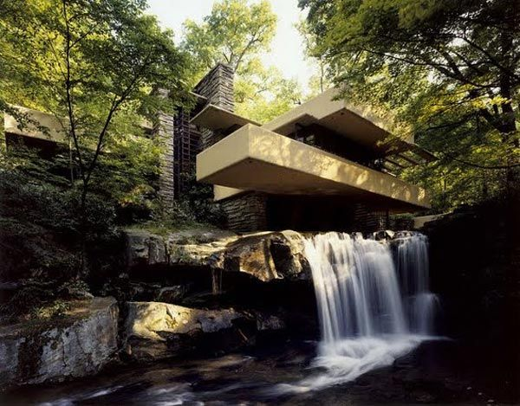

Fig: FLW’s Fallingwater Architecture

**Feature:**

* His architecture included modern designs that people generally appreciated.
* His designs were also related with nature as his Organic Architecture drew from natural resources that were combined with the influence of Japanese architecture over him.
* Three dimensional roofs.
* He also created designs for furniture, fabric, dinnerware, stained glass etc.
* Natural elements acted as the powerful art in his work. For example, stream and forest act as the art element in his fallingwater architecture.
* He designed architectures in such a way that their problems and scope was easy to analyze.
* His Prairie Style of architecture corporate low pitched roofs, a central chimney, overhanging eaves and open floor plans which was the antidote to the closed-in architecture of the Victorian era.
* Textile style had more linear approach, combined with influences from Mayan architecture.
* Concrete, steal etc. was used to provide strength to his designed buildings.
* Prevented adding of Ornamental in traditional Japanese style concepts.
* Private garden spaces.
* Mirroring the sun light for soft lighting in house.
* Adornment by natural colors and silk.
* Maximum interior space, and reduced bathroom and kitchen. (designmuseum.org)

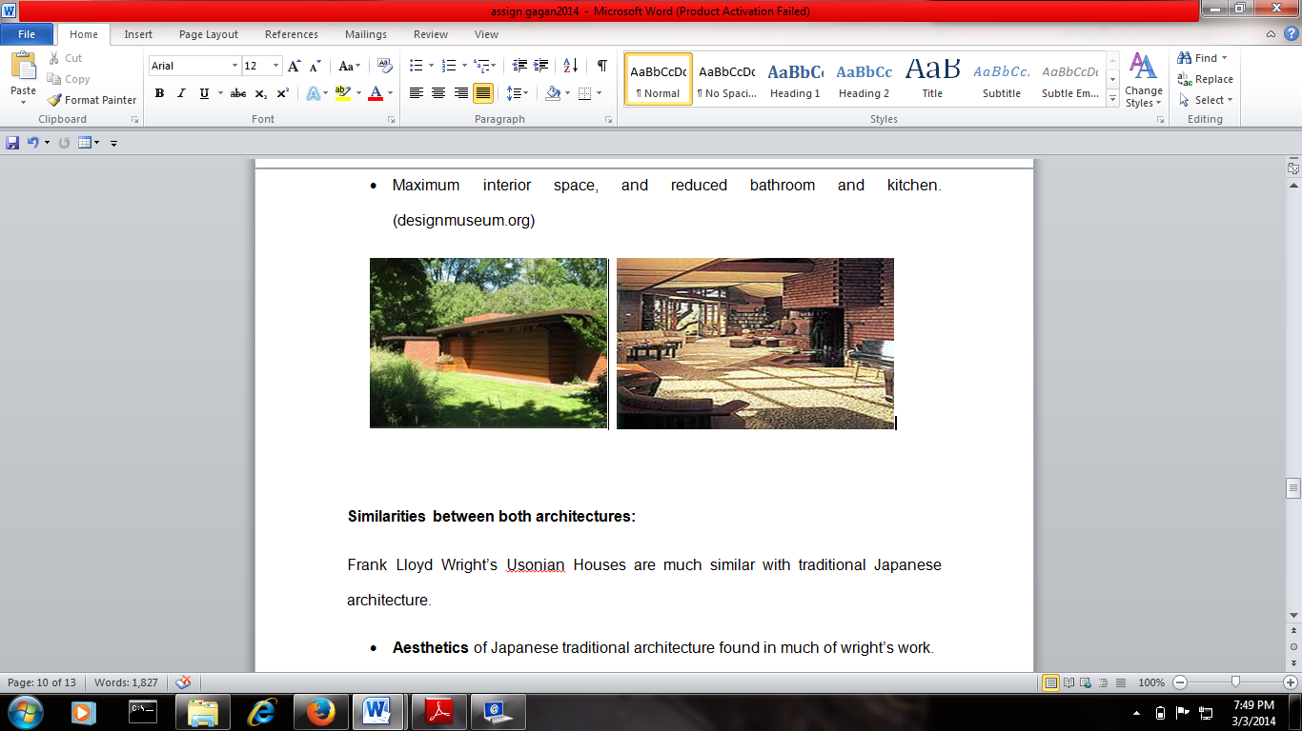

Fig: Usonian House example

**Similarities between both architectures:**

Frank Lloyd Wright’s Usonian Houses are much similar with traditional Japanese architecture.

* **Aesthetics** of Japanese traditional architecture found in much of wright’s work.
* Japanese traditional architecture concept of **horizontality** (flat roofs with eaves on a horizontal plane) and **joints** (forming joints in corners that can bear wright and be ornamental) were used by Wright. Fallingwater is the best example for joints.
* In western architecture door was opened either in or out initially. Wright added the concept of **sliding doors** in his architecture design which he got from traditional Japanese architecture.
* Concept of soft light without opening the windows and doors
* Both had same entryway concept.
* Box shape of houses.
* Gardens were present in both architectures.
* Both the architecture based on **Organic designs**. It means both architectures were related with nature and its beauty. Hence, both architectures were open to nature.(Influence Japanese Architecture, 2001, digitalarchive.wm.edu)

**Difference between both architectures:**

* FLW’s prairie style distinguishes his architectures from tradition architecture of japan.
* Furniture such as table, chair, sofa etc. was used in wright’s architecture which was not present in Japanese tradition architecture.
* Stones were used in structural foundations only but wright used stones in his architectural construction at many stages as he also used western culture techniques.
* The interior structure of traditional Japanese architecture usually consists of moya, one large hall in center that connected with all rooms. It differentiates wright’s architectures from traditional Japanese architecture.
* Construction elements of these architectures were different. Chief material of traditional Japanese architecture were wood, timber, strews, shoji etc. But wright used concrete, steal, glass, brick etc. along with traditional Japanese architecture materials.
* Private garden spaces were presented in FLW architecture but not in traditional Japanese architecture.
* Hearth designing was of western style in FLW architectures.
* Garage, basement, and attic were absent in traditional Japanese architecture.
* Interior wood was rarely painted in traditional Japanese architecture. Whereas natural colors were used for painting interior elements also.
* In traditional Japanese architecture windows or walls were flexible but in FLW’ designs walls and windows were stable i.e traditional fusuma and shoji were not used in FLW’s architectures. (Frank-Lloyd-Wright-architect, 1995, digitalarchive.wm.edu)

**Conclusion:**

As we discuss, wide variety of buildings from simple farm house to large palaces or hotels are present in japan. Japanese traditional and religion architecture are symbol of simple and peaceful life style of its people. Temples of Japan are the best example of creativity of traditional Japanese architecture designs.

FLW architecture designs were very much influenced by Japanese traditional architecture designs. FLW mix Western architecture style with the coexisting architecture design of Japan to construct new architecture design like Fallingwater.

Therefore, we can say that with the exportation of culture and people from one country to another effects the traditional architecture of countries. It means countries start adopting some of the useful concept about architecture designs of other counties. This leads to the creation of new architecture designs that are the need of today’s world to provide efficient and new product to customers. Hence in 1868, Japanese Architects started to combine traditional methods of wooden constructions with European designs for innovation. Similarly, American architects had adopted the traditional architecture designs of japan as we see in FLW’ designs.