**iPRIMED Education Solutions Private Limited**



**FINAL PROJECT**

**ON**

**“STUDENT MANAGEMENT SYSTEM”**

**Submitted by**

**(Team 06)**

**VARUN BHARADWAJ**

**SABARISH KUMAR**

**MITALI RAGHWANI**

**DEEPAK KUMAR**

**PUVVADA SANDEEP**

**FROM**

**HARMAN C++ BATCH 06**

**ABSTRACT**

Student Management System is software which is helpful for students as well as the school authorities. In the current system all the activities are done manually. It is very time consuming and costly. Our Student Management System deals with the various activities related to the students.

In the Software we can register as a user and the user has two types, student and administrator. Administrator has the power to add new users and can edit and delete a user. A student can register as a user and can add, edit and delete his profile. The administrator can add, edit and delete marks for the student. All the users can see the marks.

**TABLE OF CONTENTS**

| **SR NO** | **CHAPTER NO.** | **TITLE** | **PAGE NO** |
| --- | --- | --- | --- |
| **1.** | **Release notes** |  | **4** |
|  |  | Introduction | **4** |
|  |  | features of project |  |
|  |  | Project Details and Technology |  |
| **2.** | **Requirements specification** |  |  |
|  |  | Background of the project |  |
|  |  | System Proposal |  |
|  |  | Functionalities of application |  |
|  |  | Goals of the project |  |
|  |  | Problems statement |  |
|  |  | Requirements |  |
| **3.** | **Database design** |  |  |
| **4.** | **UML diagram** |  |  |
| **5.** | **Architecture diagram** |  |  |
| **6.** | **System Testing** |  |  |
| **7.** | **Conclusion** |  |  |

* **INTRODUCTION**

The objective of the Student information System is to allow the administrator of any organization to edit and find out the personal details of a student and allows the student to keep up to date his profile. It’ll also facilitate keeping all the records of students, such as their id, name, mailing address, phone number, DOB etc. So all the information about a student will be available in a few seconds. Overall, it’ll make Student Information Management an easier job for the administrator and the student of any organization. The main purpose of this SRS document is to illustrate the requirements of the project Student information System and is intended to help any organization to maintain and manage its student’s personal data.

* **Problems statement**

The problems occur when there is no digital records because of all paperwork some of them are mentioned which are : File lost / damaged, Human error, Space consuming and Cost consuming .File lost because of human environment. File damaged when a computerized system is not there file is always lost due to some accident like of water by some member on file accidentally. Besides some natural disaster like floods or fires may also damage the files. Some human error there may be a loss of records. Difficult to search record When there is no computerized system there is always a difficulty in searching of records if the records are large in number. Space consuming as it requires physical storage. As there is no computerized system to add each record paper will be needed which will increase the cost the management of library.

* **Proposed Solution**

In our proposed system we have the provision for adding the details of the students by themselves. So the overhead of the school authorities and the teachers has become less. Another advantage of the system is that it is very easy to edit the details of the student and delete a student when it is unnecessary.

Our proposed system has some advantages:

* User friendly interface
* Fast access to database
* Less error
* More storage capacity
* Search facility
* **Background of the project**

Creating a database for organizing and storing data received through web applications with student data and for fetching the most recent data from the database (Clients Database). The data stored in the DB must be organized and maintained in such a way it caters to the needs of the future. Derive insights from the results to devise better strategies and enhance students’ performance from the past data.

* **How does this application work?**

**ADMIN PAGE**

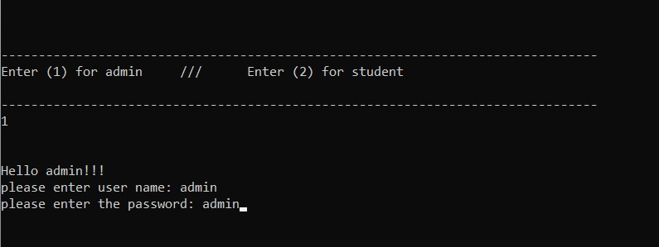

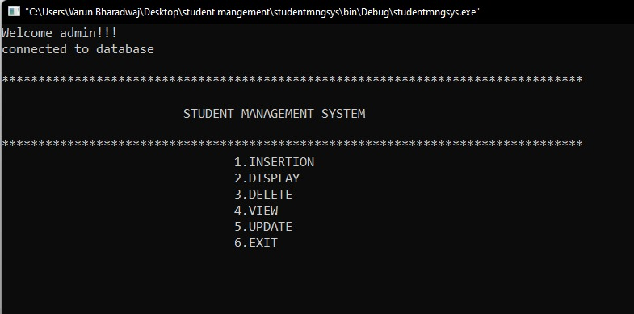

**INSERTION**

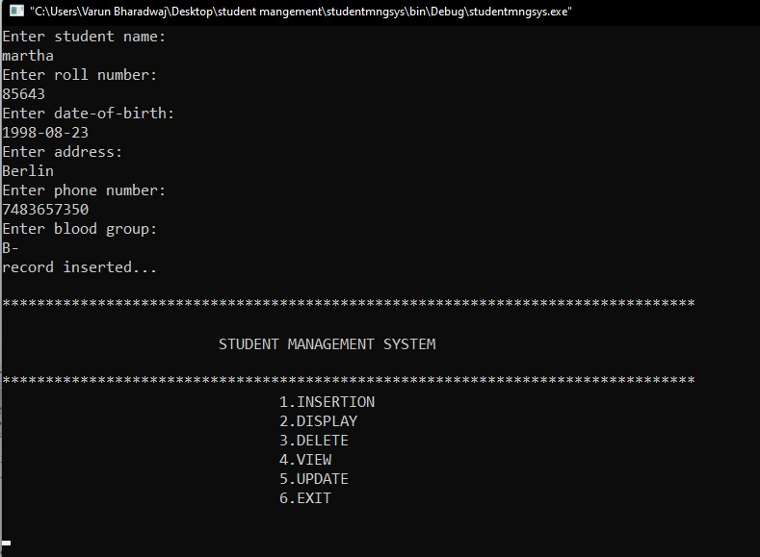

**DISPLAY**

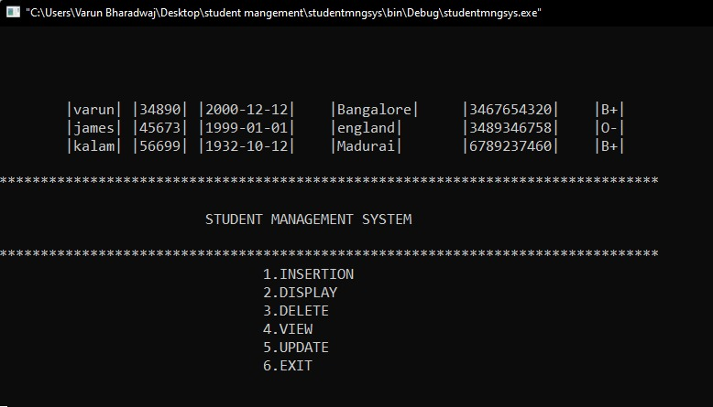

**DELETE**

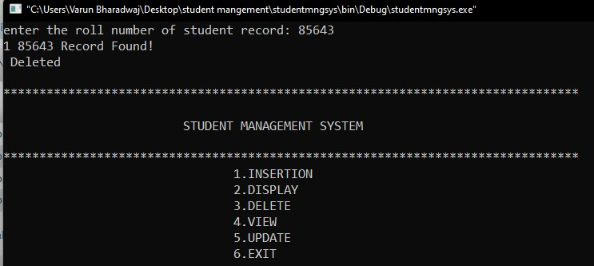

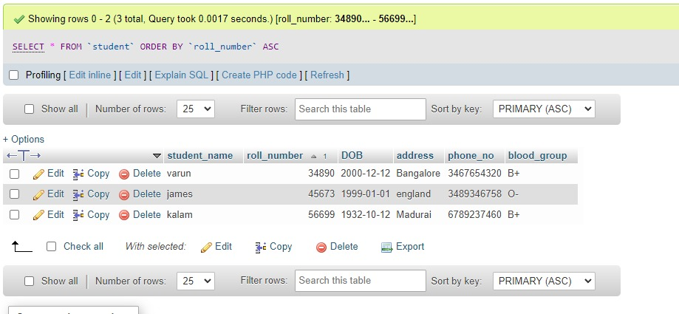

* **Goals of the project:**
* To manage details of profiles, courses, Logins, Exams.
* These systems work to coordinate scheduling and communications between faculty regarding students.
* Data integrity, privacy and security can also be protected in an open-access environment.
* To reduce unnecessary paperwork in maintaining students information.
* **Features of project**

##### **Student Management System Project Modules**

The two main users involved in this system are

1. User(i.e. Students)
2. Admin

**Admin:**

* **Dashboard**: In this section, admin can see all details in brief like Total Classes, Total Students, Total Class Notices and Total Public Notices.
* **Class**: In this section, admin can manage class (Add/Update/Delete).
* **Students**: In this section, admin can manage the students (Add/Update/Delete).
* **Notices:** In this section, the admin can manage notices (Add/Update/Delete).
* **Public Notices:** In this section, the admin can manage public notices.
* **Pages:** In this section admin, can manage about us and contact us page of administration
* **Search:** In this section admin, can search students by their student id.
* **Reports:** In this section admin, can view how many students have been registered in a particular period.
* Admin can also update his profile, change the password and recover the password.

**User (Students):**

* **Dashboard**: It is a welcome page for students.
* **View Notices**: In this section, users can view notices which are announced by the administrator.
* Students can also view his profile, change the password and recover the password.

**User (Non-Register):**

* **Home**: It is a welcome page for users.
* **About**: Users can view our page.
* **Contact:** Users can view the contact us page.
* **Project Details and Technology:**

| **ABOUT PROJECT** | **PROJECT DETAILS** |
| --- | --- |
| **Project Name:** | **Student management system project using C++ and MySQL Database** |
| **Project Platform:** | C++ console |
| **Programming Language Used:** | C++ Programming Language |
| **IDE Tool:** | codeblocks |
| **Project Type:** | Desktop Application |
| **Database:** | MySQL Database |

* **UML Diagram**
* **Class Diagram**

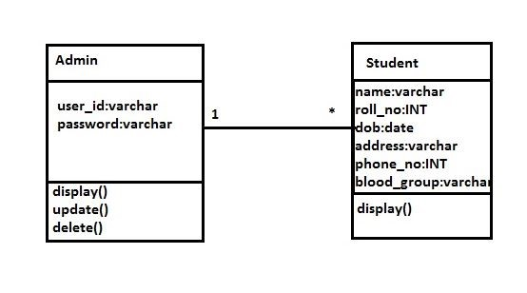  
 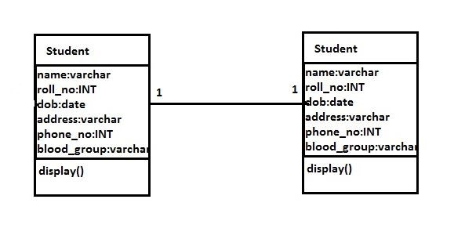

* **Database design:**

Student Table:

| Student |
| --- |
| student name  roll number  date of birth  address  phone number  blood group |

* **User-case diagram**

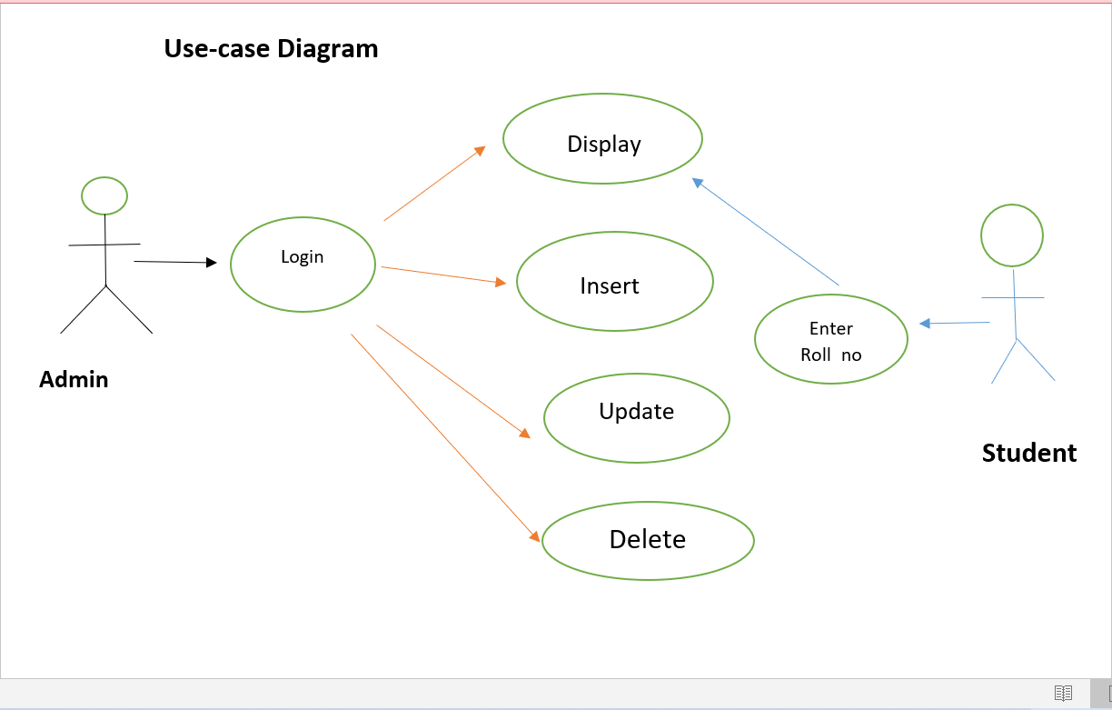

* **Architecture diagram**

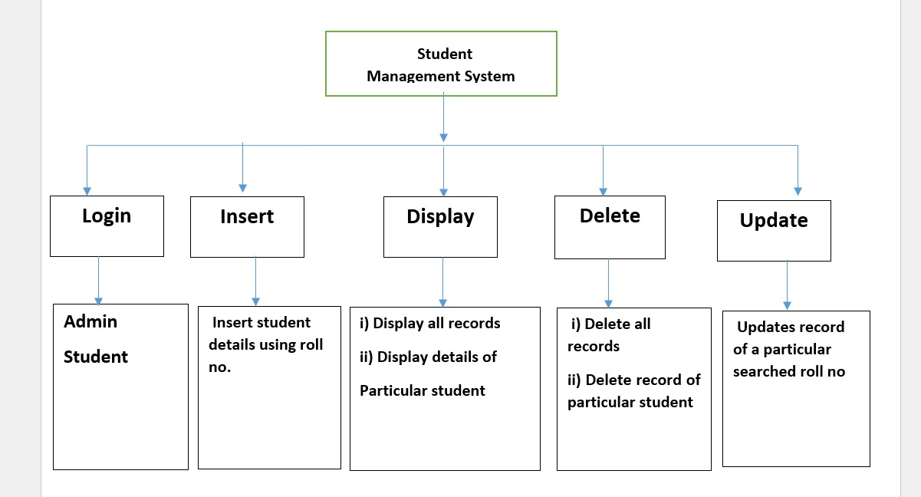

* **Requirements**

**Hardware Requirements:**

* **Processor**: Intel P-IV System
* **Processor Speed**: 250 MHz to 833 MHz
* **Ram**: 512 Mb Ram
* **Hard Disk**: 40 Gb

**Software Requirements:**

* Windows/ Linux Based OS/ Mac OS/ Any OS capable of running c++
* MySQL database
* Xampp server
* **System Testing:**
* Testing is the process of exercising software with the intent of finding and correcting errors.
* System testing is required for any applications because it gives assurance about the execution and performance.
* System Testing is carried out on the whole system in the context of either system requirement specifications or functional requirement specifications or in the context of both.
* **Conclusion**

The Student Management System can be used by educational institutions to maintain their student records easily. Achieving this objective is difficult using the manual system as the information is scattered, can be redundant, and collecting relevant information may be very time-consuming. All these problems are solved by this project.

This system helps in maintaining the information of pupils of the organization. It can be easily accessed by the manager and kept safe for a long period of time without any changes.

Thank you