Team 9(911125243100 - 104): E-Commerce Website Dataset.

EX-1: Loading and Inspecting a Real-World Dataset.

Aim
To load the May 2022 E-Commerce Product Pricing dataset (CSV) into a Pandas DataFrame and examine its structure using the .head(), .info(), .shape, and .describe() methods.

Algorithm
Step 1: Start the program.
Step 2: Import the Pandas library, which is a Python library used for data manipulation and analysis.
Step 3: Read the E-commerce CSV dataset using the pd.read_csv() function, which loads the CSV file into a DataFrame (a two-dimensional table with rows and columns).
Step 4: Display the first five records of the dataset using the .head() method to get a quick overview of the data.
Step 5: Use the .info() method to view information about the dataset, such as column names, data types, and the number of non-null values.
Step 6: Use the .shape attribute to display the dimensions of the dataset (number of rows and columns).
Step 7: Use the .describe() method to generate summary statistics such as count, mean, standard deviation, minimum, maximum, and quartile values for numerical columns.
Step 8: Analyze the displayed information to understand the structure and characteristics of the E-commerce dataset.
Step 9: Stop the program.

Procedure
- Open the Kaggle website and search for a suitable E-Commerce Product Pricing Dataset.
- Download the dataset in CSV (Comma-Separated Values) format.
- Open the downloaded dataset and verify the records and column names.
- Select the required number of records (198 rows) from the original dataset for easy analysis and save it as a new CSV file.
- Open Jupyter Notebook, Google Colab, or any Python IDE.
- Import the Pandas library using the import pandas as pd statement.
- Load the CSV dataset into a Pandas DataFrame using the pd.read_csv() function.
- Verify that the dataset has been loaded successfully.
- Perform Exploratory Data Analysis (EDA) operations such as .head(), .info(), .shape, and .describe().
- Observe and analyze the output obtained from each operation.

Python Program :

Program 1: Load the Dataset

Program
# Import Pandas library
import pandas as pd
# Load the dataset
df = pd.read_csv("EDA-Ex-1.csv")
# Display the dataset
print(df)

Program 2: Display the First Five Records (.head())

Program
# Import Pandas library
import pandas as pd
# Load the dataset
df = pd.read_csv("EDA-Ex-1.csv")
# Display the first five records
print(df.head())

Program 3: Display the Last Five Records (.tail())

Program
# Import Pandas library
import pandas as pd
# Load the dataset
df = pd.read_csv("EDA-Ex-1.csv")
# Display the last five records
print(df.tail())

Program 4: Display Dataset Information (.info())

Program
# Import Pandas library
import pandas as pd
# Load the dataset
df = pd.read_csv("EDA-Ex-1.csv")
# Display dataset information
df.info()

Program 5: Display Dataset Dimensions (.shape)

Program
# Import Pandas library
import pandas as pd
# Load the dataset
df = pd.read_csv("EDA-Ex-1.csv")
# Display the number of rows and columns
print(df.shape)

Program 6: Display Statistical Summary (.describe())

Program
# Import Pandas library
import pandas as pd
# Load the dataset
df = pd.read_csv("EDA-Ex-1.csv")
# Display statistical summary
print(df.describe())

Input Dataset
(EDA-EX-1.CSV)
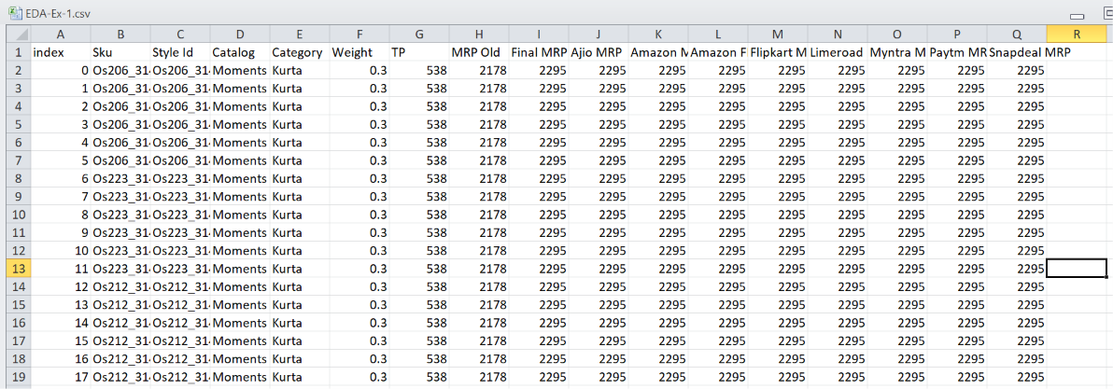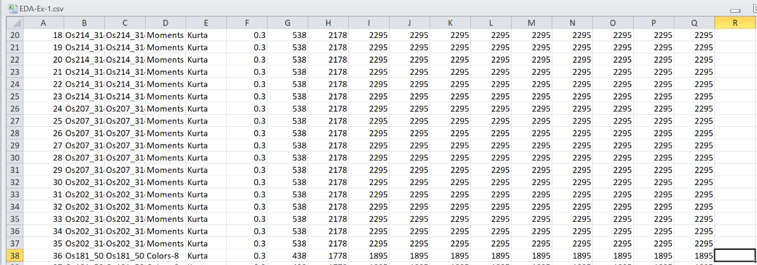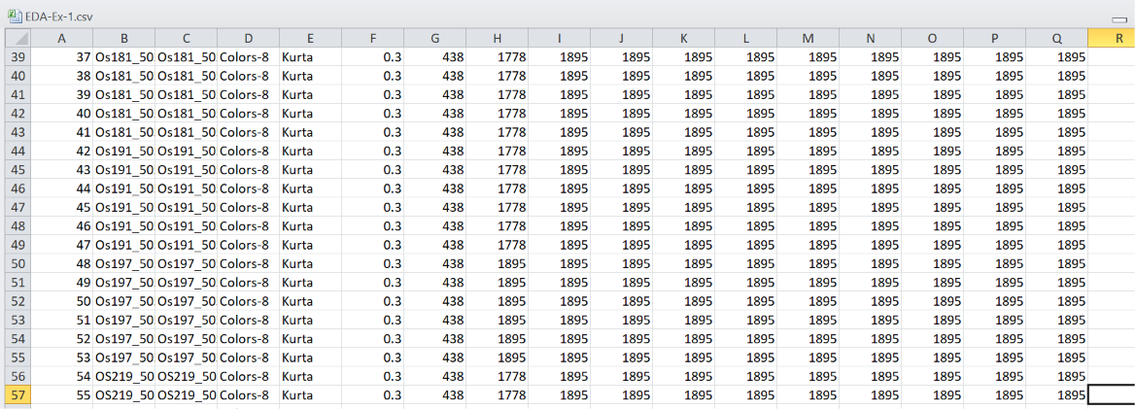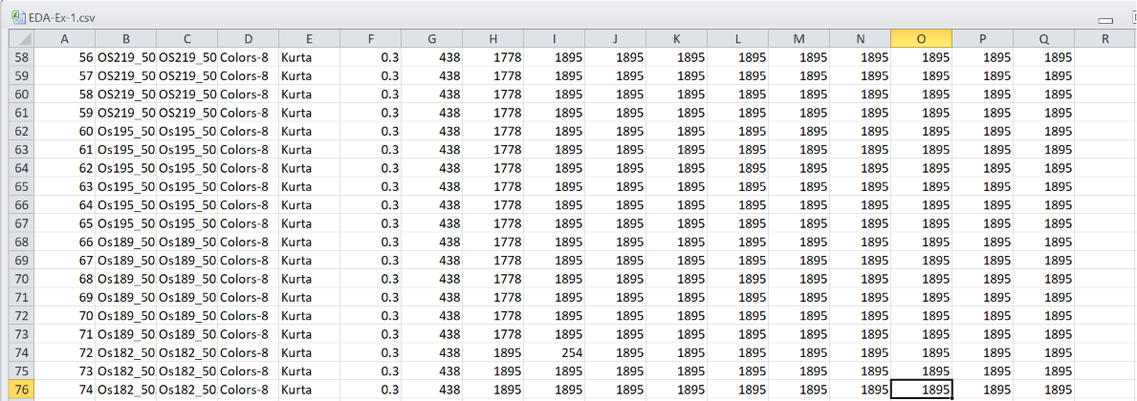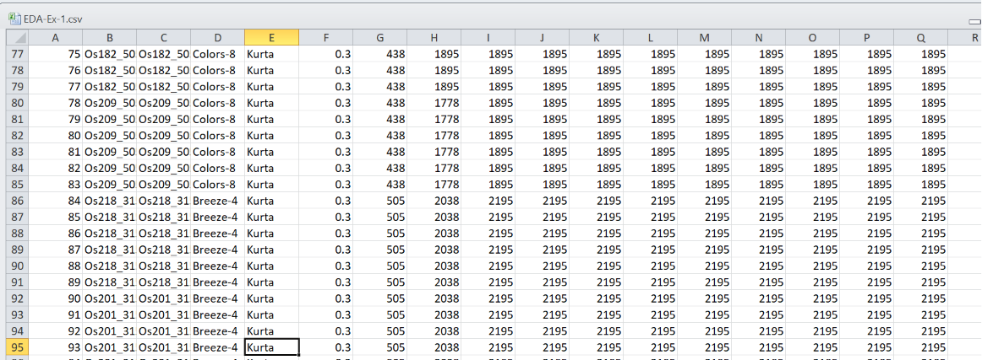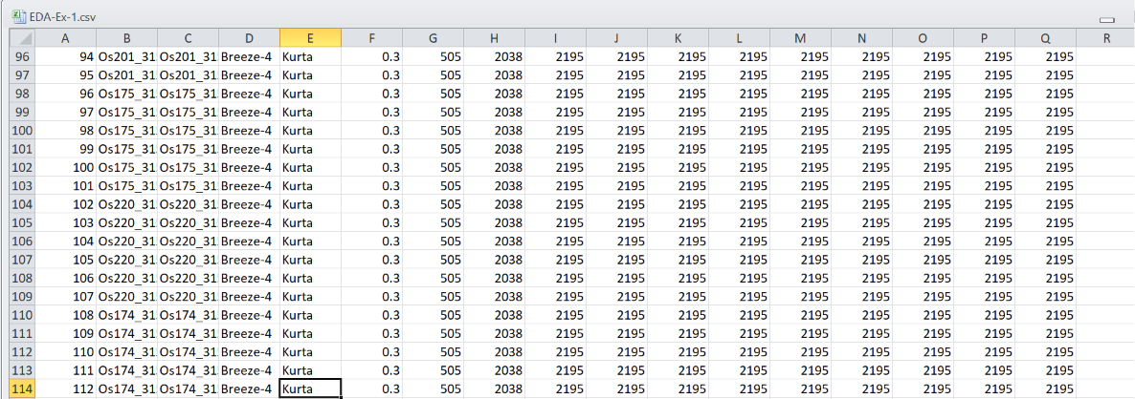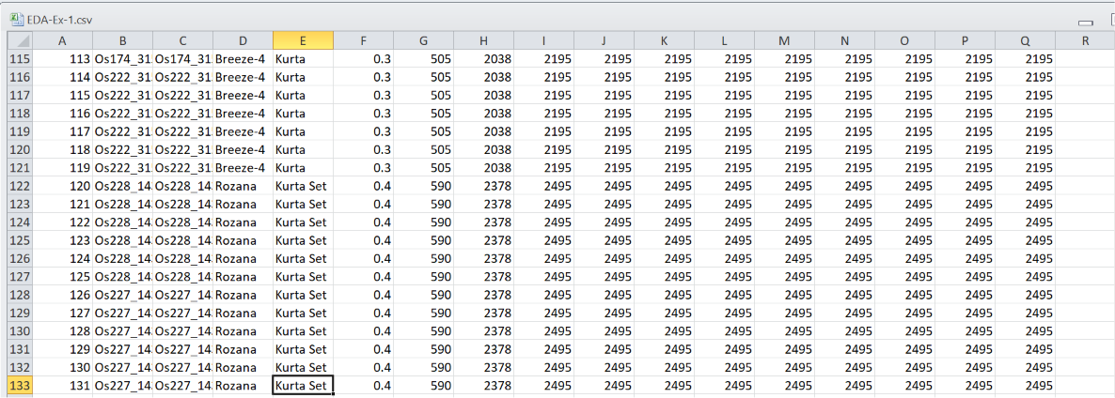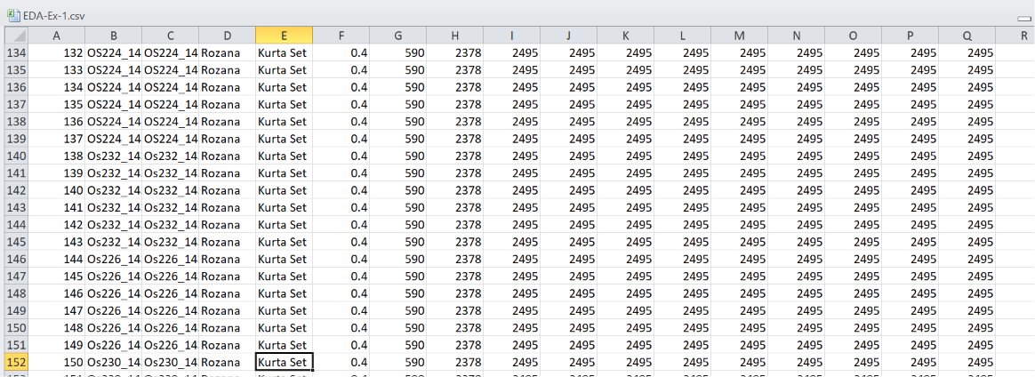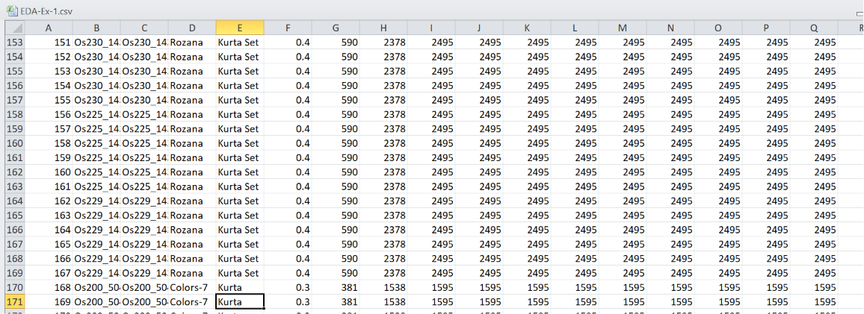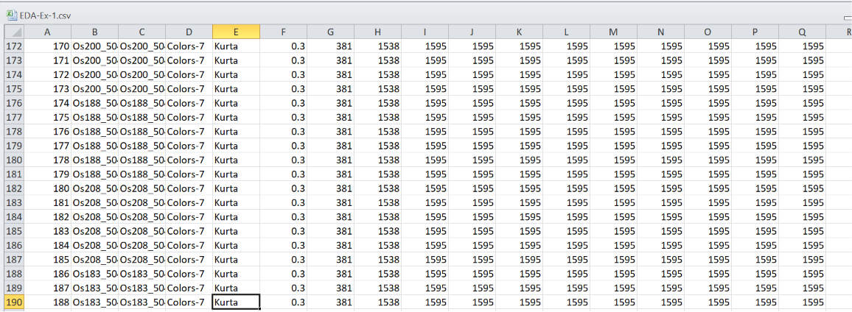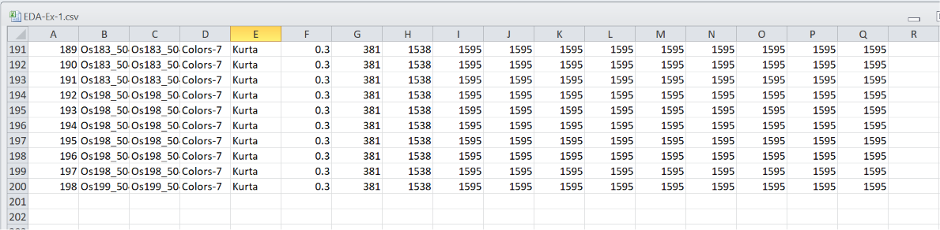

Output

Program 1:
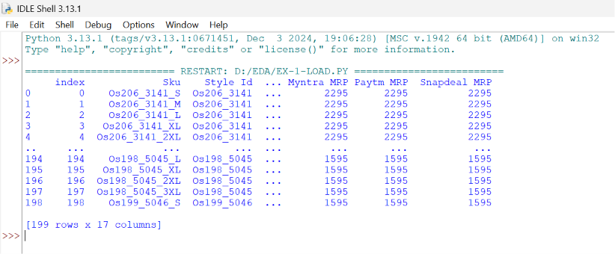

Program 2:
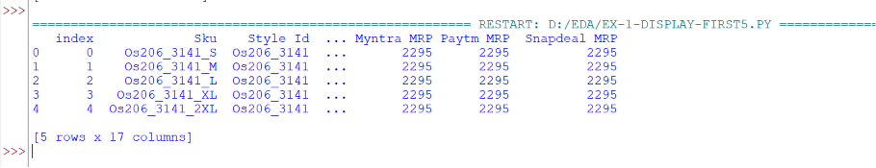

Program 3:

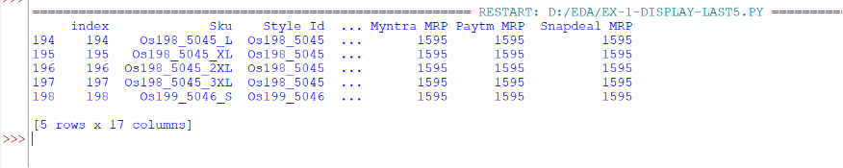

Program 4:
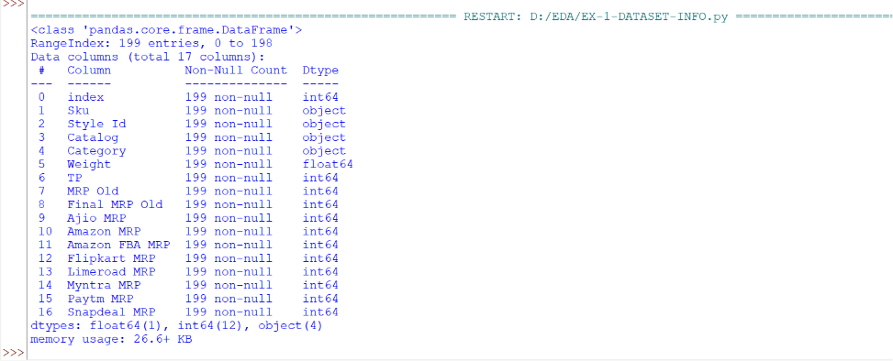

Program 5:
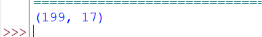

Program 6:

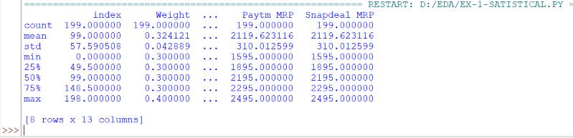

Result
Thus, the May 2022 E-Commerce Product Pricing dataset was successfully loaded into a Pandas DataFrame, and its structure, dimensions, and statistical summary were analyzed using Pandas functions.

