EXPERIMENT – 4

Data Preprocessing: Column Renaming, Data Type Conversion and Binning Techniques on E-Commerce Dataset

Aim
To rename ambiguous column names to meaningful names, convert improperly inferred data types into appropriate formats, apply equal-width and equal-frequency binning on a continuous variable (Age), and analyze the usefulness of the binned data using an E-Commerce Sales dataset.

Explanation
Data preprocessing is an essential step in data analysis and machine learning. It improves the quality, consistency, and usability of the dataset by cleaning and transforming the data before analysis. In this experiment, the following preprocessing techniques are performed:
- Renaming Columns: Changes ambiguous or unclear column names into meaningful and descriptive names, making the dataset easier to understand and analyze.
- Data Type Conversion: Converts incorrectly inferred data types (such as object) into appropriate formats (such as integer or float) to ensure accurate calculations and analysis.
- Binning (Discretization): Groups continuous numerical values into meaningful intervals or categories, making the data easier to interpret and visualize.

Types of Binning

1. Equal-Width Binning
- Divides the range of a continuous variable into intervals of equal width.
- Each bin has the same interval size, but the number of observations in each bin may vary.
- It is simple to implement and suitable for uniformly distributed data.
- In this experiment, Equal-Width Binning is applied using the pd.cut() function.

2. Equal-Frequency Binning
- Divides the data into bins such that each bin contains approximately the same number of observations.
- The width of each interval may vary depending on the distribution of the data.
- It is suitable for skewed datasets and helps reduce the impact of outliers.
- In this experiment, Equal-Frequency Binning is applied using the pd.qcut() function.

Algorithm
START
Step 1: Import the Pandas library, which is used for data manipulation, preprocessing, and analysis.
Step 2: Load the E-Commerce Sales dataset into a Pandas DataFrame using the read_csv() function.
Step 3: Display the original column names to identify ambiguous or unclear column names.
Step 4: Rename the ambiguous column names into meaningful and descriptive names using the rename() function.
Step 5: Check the data types of all columns using the dtypes attribute.
Step 6: Convert incorrectly inferred data types (such as object to float or integer) into appropriate formats using the astype() function.
Step 7: Select the continuous column (Age) for applying the binning technique.
Step 8: Apply Equal-Width Binning using the pd.cut() function to divide the Age column into equal-width intervals.
Step 9: Apply Equal-Frequency Binning using the pd.qcut() function to divide the Age column into bins containing approximately the same number of observations.
Step 10: Display the original Age column along with the newly created binned columns.
Step 11: Analyze the usefulness of the binned data by comparing the grouped categories and interpreting the results.
STOP

Python Program

Program 1: Rename Ambiguous Column Names

import pandas as pd

# Load the dataset
df = pd.read_csv("ecommerce_sales.csv")

# Display original column names
print("Original Column Names:")
print(df.columns)

# Rename columns
df.rename(columns={
'orderid': 'Order_ID',
'cust': 'Customer_Name',
'age': 'Age',
'prod': 'Product',
'qty': 'Quantity',
'price': 'Price',
'city': 'City'
}, inplace=True)

# Display updated column names
print("\nRenamed Column Names:")
print(df.columns)

Program 2: Convert Data Types
import pandas as pd

# Load the dataset
df = pd.read_csv("ecommerce_sales.csv")

# Rename columns
df.rename(columns={
'orderid': 'Order_ID',
'cust': 'Customer_Name',
'age': 'Age',
'prod': 'Product',
'qty': 'Quantity',
'price': 'Price',
'city': 'City'
}, inplace=True)

# Display data types before conversion
print("Before Conversion:")
print(df.dtypes)

# Convert Price to float
df["Price"] = df["Price"].astype(float)

# Convert Quantity to int
df["Quantity"] = df["Quantity"].astype(int)

# Display data types after conversion
print("\nAfter Conversion:")
print(df.dtypes)

Program 3: Apply Equal-Width and Equal-Frequency Binning
import pandas as pd

# Load the dataset
df = pd.read_csv("ecommerce_sales.csv")

# Rename columns
df.rename(columns={
'orderid': 'Order_ID',
'cust': 'Customer_Name',
'age': 'Age',
'prod': 'Product',
'qty': 'Quantity',
'price': 'Price',
'city': 'City'
}, inplace=True)

# Equal-Width Binning
df["Age_EqualWidth"] = pd.cut(
df["Age"],
bins=4,
labels=["Young", "Adult", "Middle Age", "Senior"]
)

# Equal-Frequency Binning
df["Age_EqualFrequency"] = pd.qcut(
df["Age"],
q=4,
labels=["Young", "Adult", "Middle Age", "Senior"]
)

# Display result
print(df[["Age", "Age_EqualWidth", "Age_EqualFrequency"]])

input Dataset

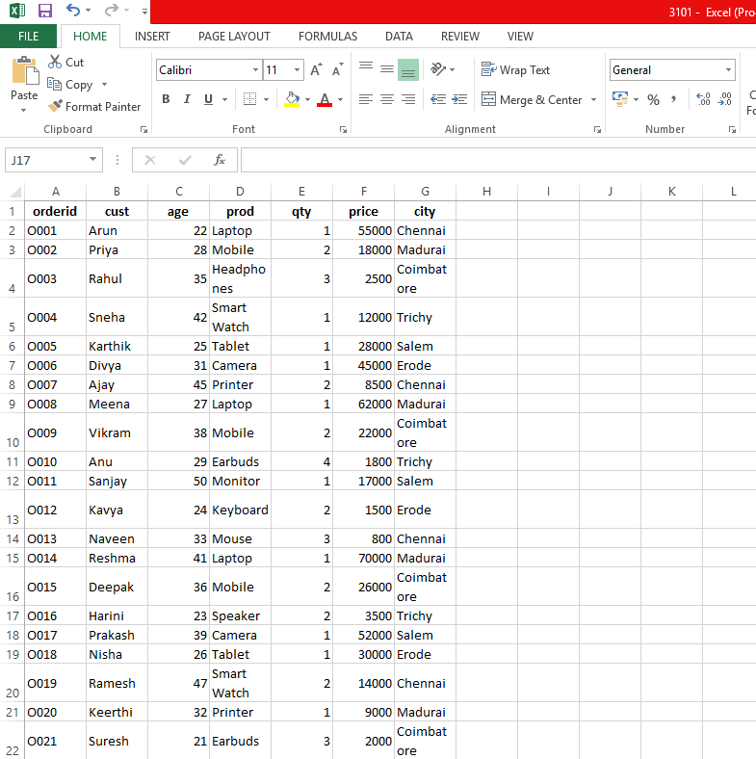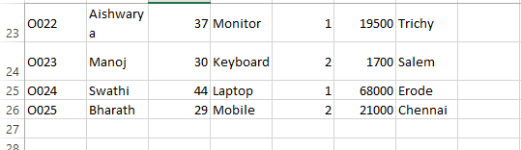

Output

Program 1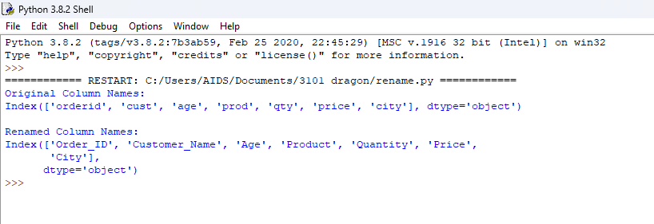

Program 2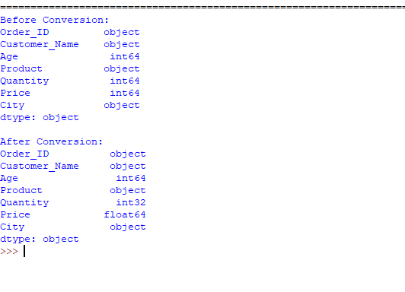

Program 3

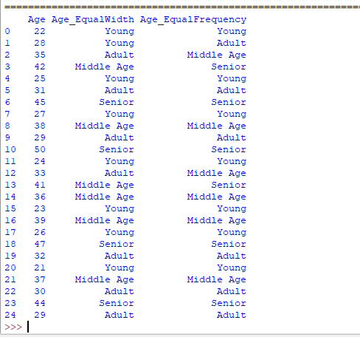

Result
The ambiguous column names were successfully renamed to meaningful names. The incorrectly inferred data types were converted into appropriate formats. Equal-Width and Equal-Frequency binning techniques were applied successfully to the Age column using pd.cut() and pd.qcut(). The newly created binned columns grouped the continuous values into meaningful categories, making the dataset easier to understand, analyze, and visualize.
Thus, the preprocessing tasks of column renaming, data type conversion, and binning were successfully performed on the E-Commerce Sales dataset.

