ETHERTRACK
TECHNOLOGIES PVT LTD
────────────────────────────
USER MANUAL
ETHERTRACK
A Complete Step-by-Step Guide for First-Time Users
────────────────────────────
Sign Up · KYC · Dashboard · Profile · Team · Emissions · Portfolio · Trading · Wallet
Version 1.0 · March 2026 · EtherTrack Technologies Pvt Ltd
India's Blockchain-Native Carbon Credit Exchange

TABLE OF CONTENTS

Section 1 — Creating Your Account
Welcome to EtherTrack — India's blockchain-native carbon credit exchange. This section walks you through creating your account for the first time.

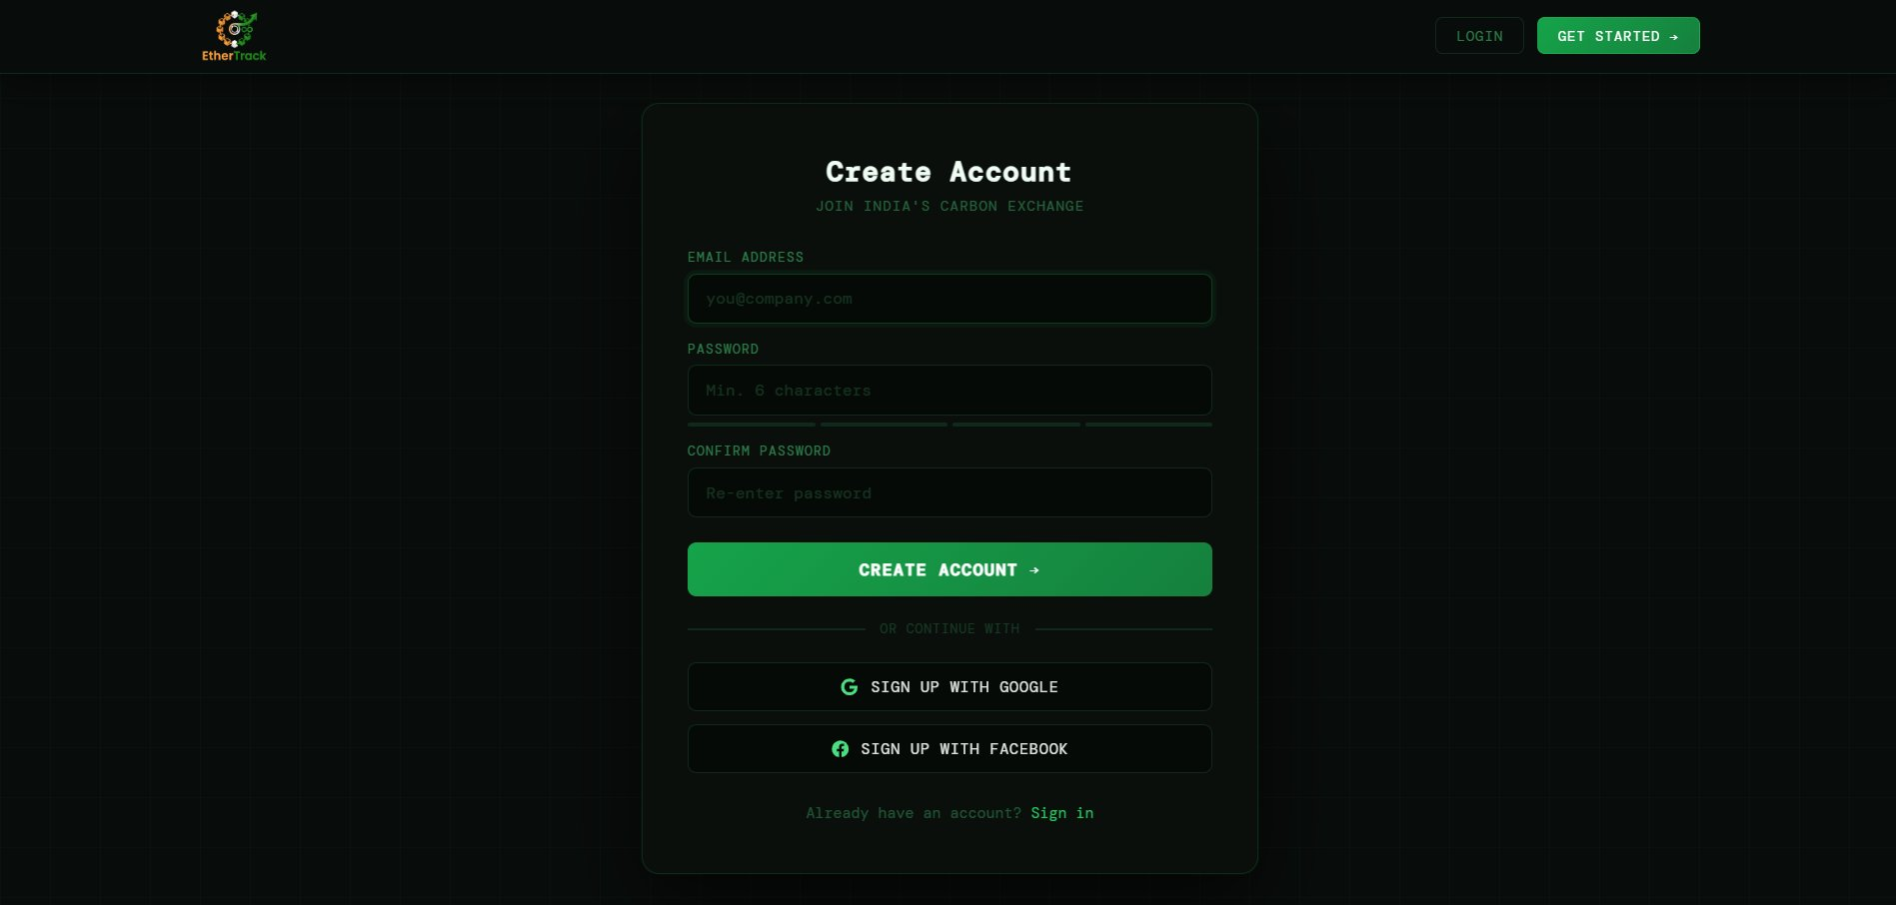
Sign Up screen — Create Account

1.1 Fields & Buttons
FIELD | DESCRIPTION | REQUIRED
EMAIL ADDRESS | Your work or personal email. Placeholder: you@company.com | Required
PASSWORD | Minimum 6 characters. Placeholder: Min. 6 characters | Required
Password Strength Bars | 4 coloured bars below the password field: Red (weak) → Orange → Yellow → Green (strong). Fill as you type. | Auto
CONFIRM PASSWORD | Re-type your password exactly. Border turns red if it does not match. | Required
CREATE ACCOUNT → | Green button. Creates your account and redirects to Login. | Button
SIGN UP WITH GOOGLE | One-click signup using Google account. No password needed. | Button
SIGN UP WITH FACEBOOK | One-click signup using Facebook account. | Button
Already have an account? Sign in | Link at the bottom. Takes you to the Login page. | Link

1.2 How to Sign Up — Step by Step
1 | Go to the Sign Up page  Click GET STARTED → in the top-right header, or navigate to /signup directly.

2 | Enter your email  Type your email in the EMAIL ADDRESS field. This email is permanently linked to your account.

3 | Create a strong password  Type a password of 6+ characters. Watch the 4 strength bars — aim for all green before continuing.

4 | Confirm your password  Re-type in CONFIRM PASSWORD. If it does not match, the border turns red.

5 | Click CREATE ACCOUNT →  Button shows CREATING ACCOUNT... while processing. On success you are redirected to Login.

ℹ NOTE
You can also use SIGN UP WITH GOOGLE or SIGN UP WITH FACEBOOK to skip the form entirely and create your account in one click.

1.3 Error Messages
FIELD | DESCRIPTION | REQUIRED
Invalid email format. | Email is not in correct format. Check for @ and domain. | Fix email
Password must be at least 6 characters. | Too short. Add more characters. | Fix password
Passwords do not match. | CONFIRM PASSWORD does not match PASSWORD. Re-type carefully. | Re-type
Account already exists. Please log in. | This email already has an account. Go to Login instead. | Go to Login
Signup failed. Please try again. | Server or network error. Wait and retry. | Retry
⚠ IMPORTANT
After successful sign-up you are taken to Login. You are NOT automatically signed in — you must log in manually.

Section 2 — Logging In
The Login screen greets you with "Welcome Back". You arrive here after signing up or any time you return to EtherTrack.

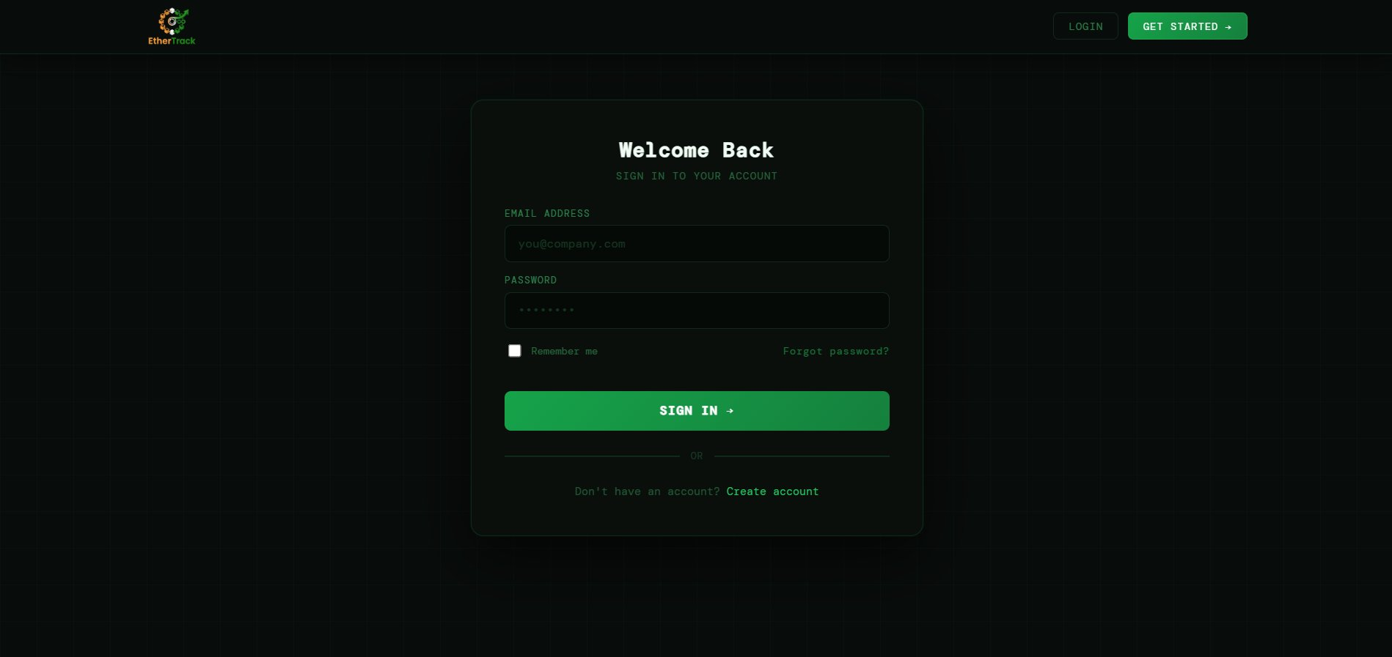
Login screen — Welcome Back

2.1 Fields & Buttons
FIELD | DESCRIPTION | REQUIRED
EMAIL ADDRESS | Your registered email address. | Required
PASSWORD | Your account password. | Required
Remember me | Checkbox — keeps you signed in on this device. | Optional
Forgot password? | Button on the right. Sends a reset link to your email. Type your email first. | Optional
SIGN IN → | Green button. Authenticates and takes you to the Dashboard. | Button
Don't have an account? Create account | Link to Sign Up page. | Link

2.2 Forgot Password — Step by Step
1 | Type your email in the EMAIL ADDRESS field  Do this before clicking Forgot password? — it uses the email you typed.

2 | Click Forgot password?  A green success box appears: "✅ Reset link sent! Check your inbox."

3 | Open the reset email  Click the link in the email from EtherTrack.

4 | Set a new password  You are taken to a Firebase page. Enter and confirm your new password.

5 | Return to EtherTrack and log in  Use your new password on the Login page.

2.3 Login Error Messages
FIELD | DESCRIPTION | REQUIRED
Incorrect email or password. | Credentials do not match. Check carefully. | Retry
No account found with this email. | No account exists. Check spelling or sign up. | Check
Too many attempts. Reset your password. | Too many failures. Use Forgot password?. | Reset
Please enter both email and password. | One or both fields empty. | Fill fields

Section 3 — Dashboard
After login you land on your Dashboard — the main home screen. It shows your live portfolio value, wallet balance, market listings, quick actions, emission progress, network status, and carbon market news.

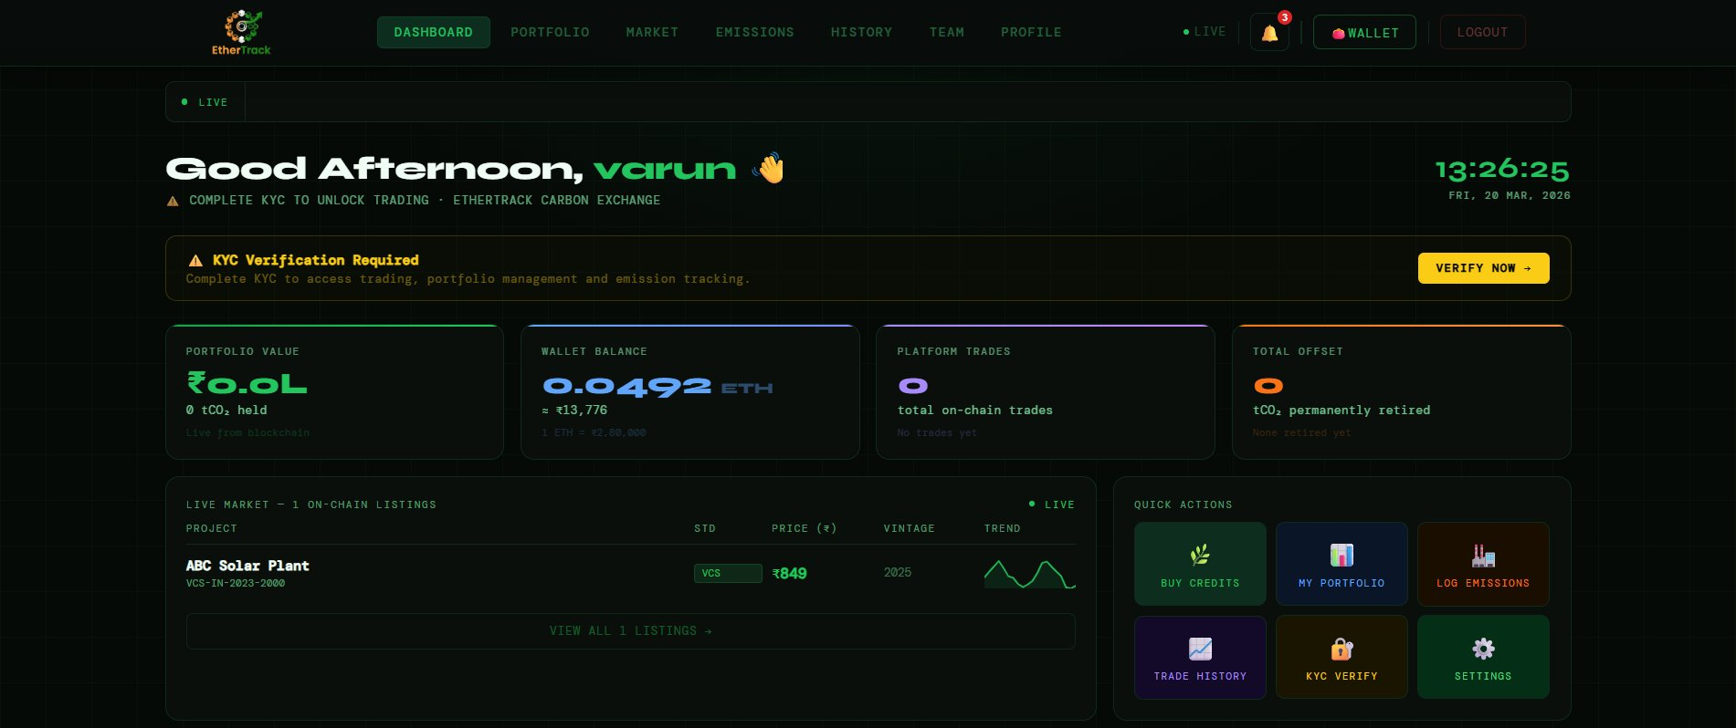
Dashboard — top section showing stats, live market, and quick actions

⚠ IMPORTANT
Until KYC is completed you will see a yellow banner: "⚠ KYC Verification Required". A VERIFY NOW → button links directly to the KYC form. Most features are locked until KYC is approved by admin.

3.1 Navigation Header
The fixed header at the top is always visible on every page. It contains the navigation bar and key controls.
FIELD | DESCRIPTION | REQUIRED
EtherTrack Logo | Top left. Click to return to Dashboard from any page. | Logo
DASHBOARD / PORTFOLIO / MARKET / EMISSIONS / HISTORY / TEAM / PROFILE | Navigation links. Active page is highlighted in green. | Nav
● LIVE | Animated green dot — confirms the platform is connected and running in real time. | Status
🔔 Bell | Notification bell. Red badge shows unread count. Click to open dropdown with last 5 notifications. | Button
👛 WALLET | Wallet button. Shows WALLET when not connected, WALLET · 0x1234...abcd when connected. | Button
LOGOUT | Logs you out and returns you to Login. | Button

3.2 Four Summary Stat Cards
FIELD | DESCRIPTION | REQUIRED
PORTFOLIO VALUE | Total value of your carbon credit portfolio in ₹, live from the blockchain. Shows tCO₂ held below. | Green
WALLET BALANCE | Your MetaMask ETH balance. Shows INR equivalent at live exchange rate below. | Blue
PLATFORM TRADES | Total number of on-chain buy and sell trades you have executed. | Purple
TOTAL OFFSET | Total tCO₂ you have permanently retired on-chain. "tCO₂ permanently retired" sub-label. | Orange

3.3 Live Market Panel
Shows all credits currently listed on the marketplace in a real-time table. Columns: PROJECT, STD (standard badge), PRICE (₹), VINTAGE, TREND (sparkline). The VIEW ALL LISTINGS → button at the bottom takes you to the full Market page.

3.4 Quick Actions Grid
FIELD | DESCRIPTION | REQUIRED
BUY CREDITS | Goes to the Market page. | Green
MY PORTFOLIO | Goes to your Portfolio. | Dark
LOG EMISSIONS | Goes to Emission Tracking. | Brown
TRADE HISTORY | Goes to Trading History. | Purple
KYC VERIFY | Goes to KYC form (visible until KYC is approved). | Yellow
SETTINGS | Goes to Settings. | Green

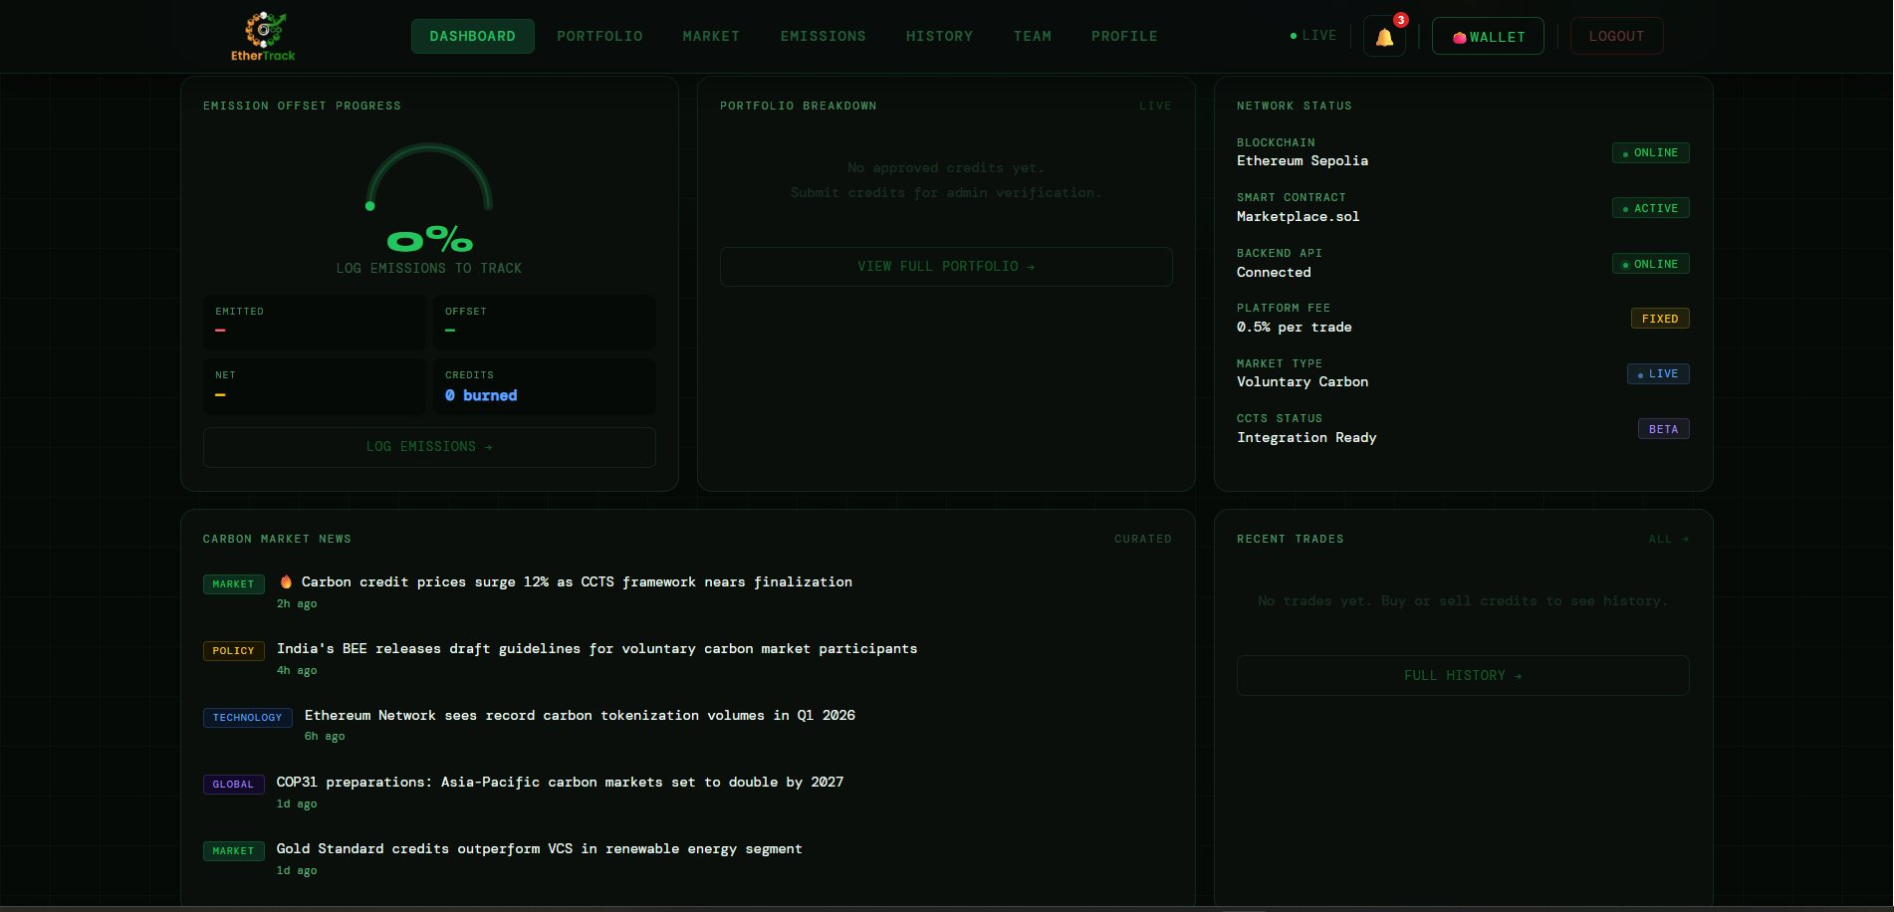
Dashboard — bottom section showing emission arc, portfolio breakdown, network status, news

3.5 Emission Offset Progress Arc
A circular arc gauge showing your net zero progress as a percentage. Below it: EMITTED (total tCO₂e logged), OFFSET (total retired), NET (emitted minus offset), CREDITS (total burned). Shows 0% until you log emissions. The LOG EMISSIONS → button links to the Emissions module.

3.6 Network Status Panel
FIELD | DESCRIPTION | REQUIRED
BLOCKCHAIN | Ethereum Sepolia — ONLINE | Status
SMART CONTRACT | Marketplace.sol — ACTIVE | Status
BACKEND API | Connected — ONLINE | Status
PLATFORM FEE | 0.5% per trade — FIXED | Status
MARKET TYPE | Voluntary Carbon — LIVE | Status
CCTS STATUS | Integration Ready — BETA | Status

3.7 Carbon Market News & Recent Trades
The news feed shows curated carbon market headlines with category tags (MARKET, POLICY, TECHNOLOGY, GLOBAL) and timestamps. The Recent Trades panel on the right shows your last few trades with a FULL HISTORY → link. Both panels are read-only.

Section 4 — KYC Verification
KYC (Know Your Customer) is mandatory before you can trade, manage a portfolio, or track emissions. It takes under 5 minutes and your data is protected under DPDP Act 2023, IT Act 2000 §43A, and UIDAI guidelines.

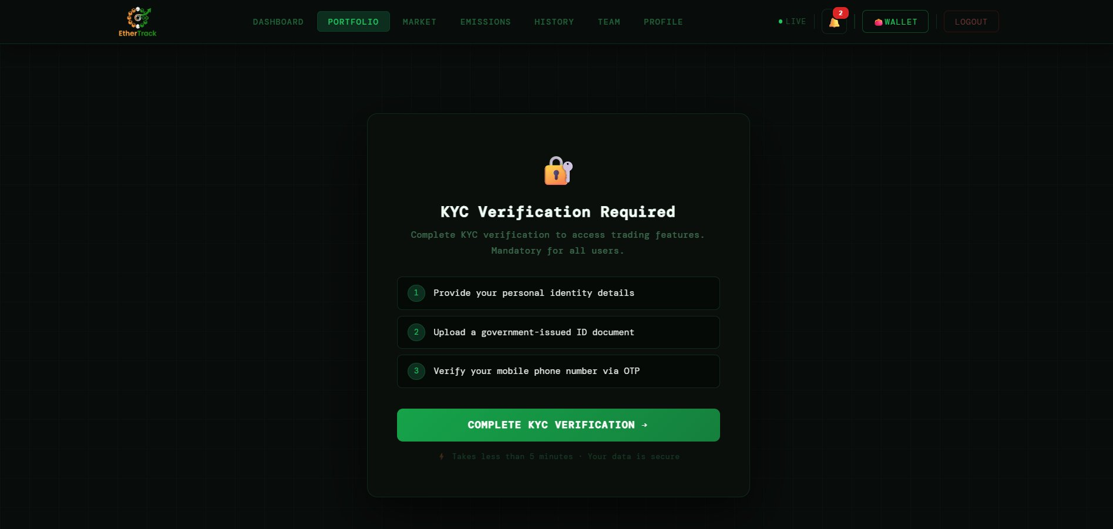
KYC gate screen — shown when accessing Portfolio, Market or Emissions before completing KYC

4.1 KYC Gate Screen
When you try to access Portfolio, Market, or Emissions without completing KYC, you see a lock screen titled "KYC Verification Required". It lists three steps: (1) Provide personal identity details, (2) Upload a government-issued ID document, (3) Verify mobile phone via OTP. Click the green COMPLETE KYC VERIFICATION → button to begin. Text below reads: "Takes less than 5 minutes · Your data is secure."

4.2 Step 1 — Identity Details
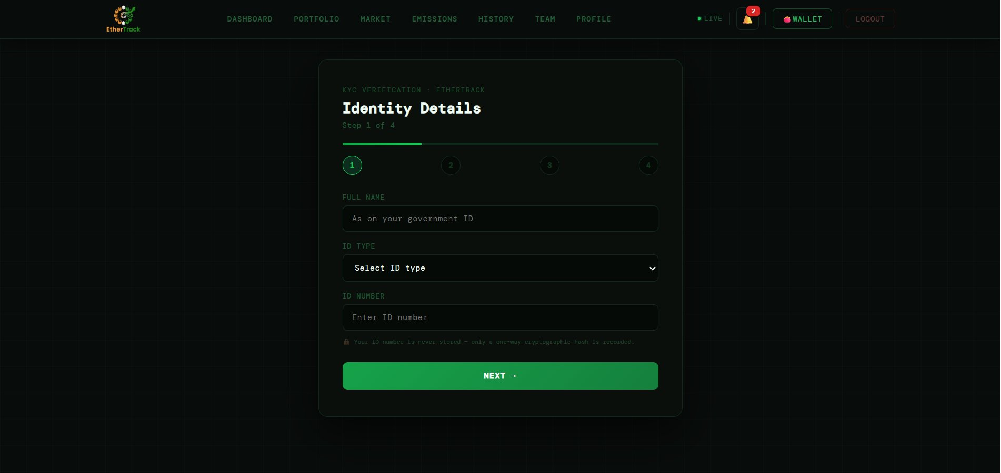
KYC Step 1 of 4 — Identity Details

FIELD | DESCRIPTION | REQUIRED
FULL NAME | Your legal name exactly as on your government ID. Placeholder: "As on your government ID" | Required
ID TYPE | Dropdown: Aadhaar Card, PAN Card, Passport, Driving License, Voter ID | Required
ID NUMBER | Changes based on ID type: Aadhaar = XXXX XXXX XXXX (12 digits), PAN = ABCDE1234F, Passport = A1234567 | Required
Privacy note | 🔒 "Your ID number is never stored — only a one-way cryptographic hash is recorded." | Info
NEXT → | Validates and advances to Step 2. Shows inline errors if any field is wrong. | Button

ℹ NOTE
Aadhaar: 12 digits, spaces stripped automatically. PAN: auto-converts to uppercase. Passport: 1 letter + 7 digits. Your actual ID number is NEVER stored anywhere — only a one-way hash for duplicate prevention.

4.3 Step 2 — Upload Document
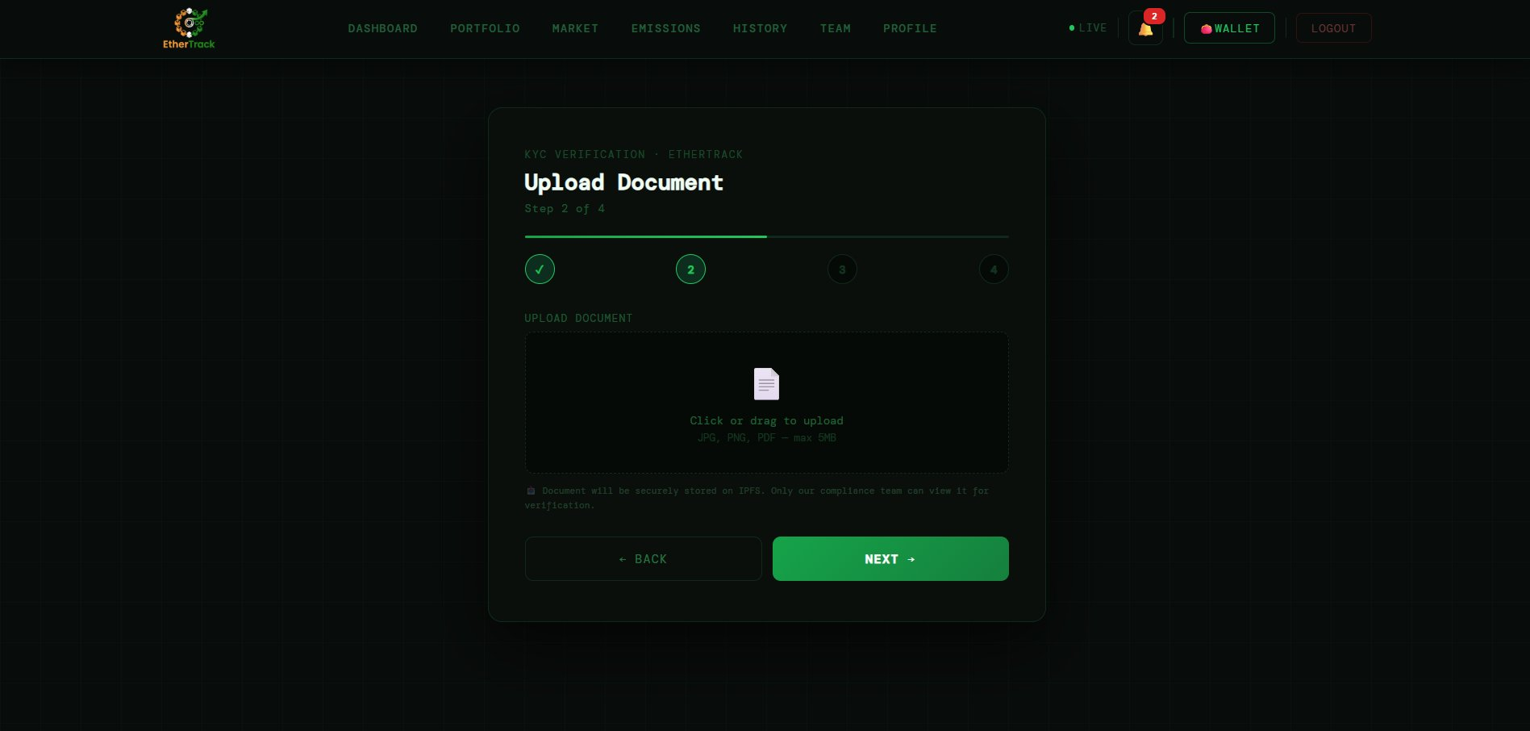
KYC Step 2 of 4 — Upload Document

FIELD | DESCRIPTION | REQUIRED
Upload area | Dashed box with 📄 icon. "Click or drag to upload". Accepted: JPG, PNG, PDF. Max 5MB. | Required
File preview | JPG/PNG files show a preview inside the box after upload. | Auto
Confirmation | Green ✓ filename line appears below the box once uploaded. | Auto
IPFS note | "📤 Document stored on IPFS. Only compliance team can view for verification." | Info
← BACK | Returns to Step 1 without losing entered data. | Button
NEXT → | Advances to Step 3 only if a file has been uploaded. | Button

4.4 Step 3 — Verify Phone
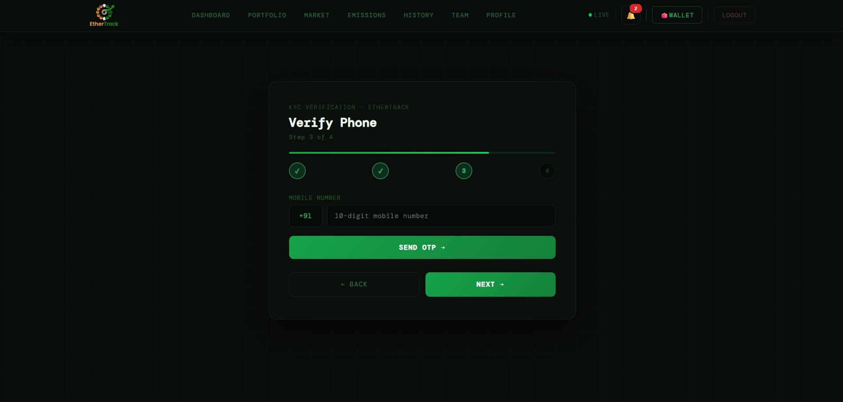
KYC Step 3 of 4 — Verify Phone via OTP

FIELD | DESCRIPTION | REQUIRED
+91 prefix | Fixed — India country code only. Cannot be changed. | Fixed
Mobile number field | 10-digit Indian number. Must start with 6, 7, 8, or 9. | Required
SEND OTP → | Sends a 6-digit OTP by SMS. Field locks after sending. | Button
ENTER OTP field | Appears after OTP is sent. Large centred 6-digit input. | Required
Timer (60s) | Yellow countdown e.g. "(58s)" — OTP expires in 60 seconds. | Auto
VERIFY OTP | Confirms the code. Shows "✅ Phone number verified!" on success. | Button
RESEND OTP | Greyed out during timer. Active at 0s to request a new code. | Button

4.5 Step 4 — Review & Submit
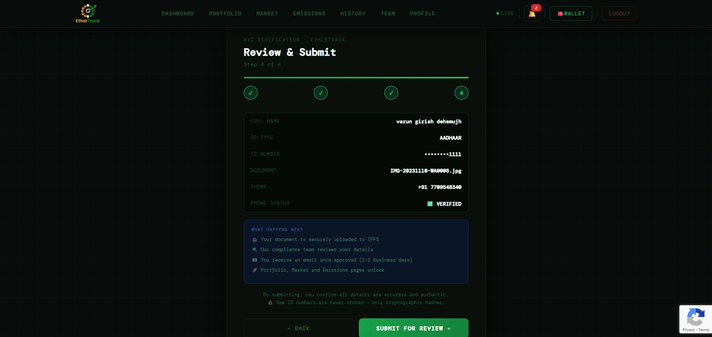
KYC Step 4 of 4 — Review & Submit showing all entered details

Review all your submitted details before final submission. The review card shows: FULL NAME, ID TYPE, ID NUMBER (Aadhaar is masked as ••••••••1234), DOCUMENT filename, PHONE number, and PHONE STATUS (✅ VERIFIED or ❌ NOT VERIFIED).

Below the review card is a blue "WHAT HAPPENS NEXT" box:
- 📤 Your document is securely uploaded to IPFS
- 🔍 Our compliance team reviews your details
- 📧 You receive an email once approved (1–2 business days)
- 🚀 Portfolio, Market and Emissions pages unlock

1 | Check all details carefully  Click ← BACK if anything needs changing. Aadhaar shows last 4 digits only.

2 | Click SUBMIT FOR REVIEW →  Processing steps show in sequence: "Uploading document to IPFS..." → "Generating cryptographic hashes..." → "Submitting KYC for admin review..." → "Finalising..."

3 | KYC submitted confirmation appears  The Under Review screen replaces the form.

4.6 Under Review Screen
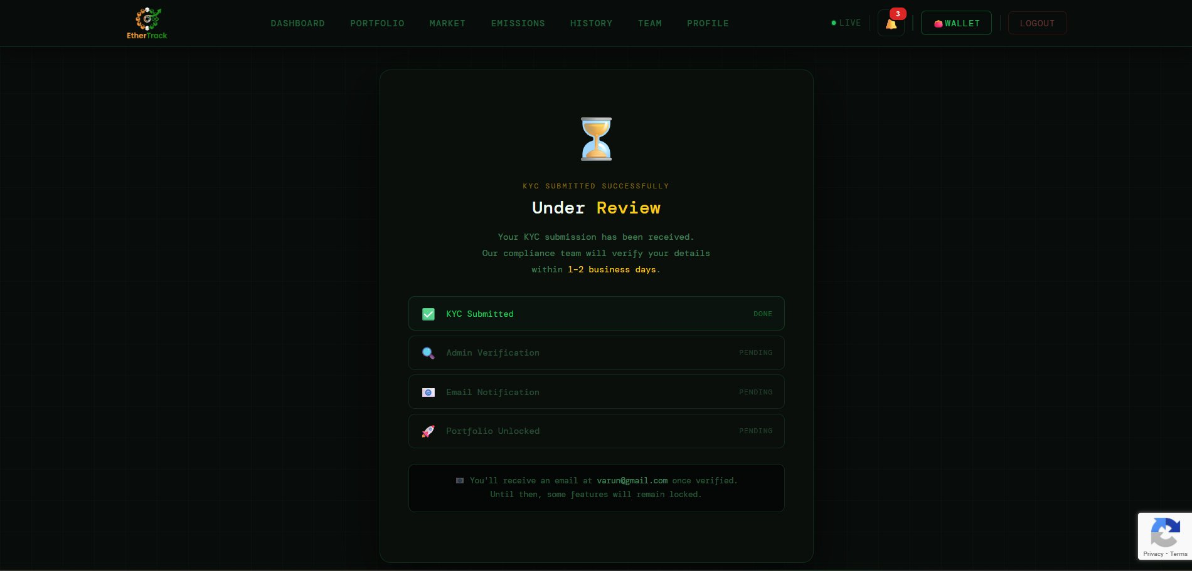
KYC Under Review screen after successful submission

FIELD | DESCRIPTION | REQUIRED
✅ KYC Submitted — DONE | Your submission was received. Shown in green. | Done
🔍 Admin Verification — PENDING | Compliance team is reviewing your documents. | Pending
📧 Email Notification — PENDING | You will receive an email when approved. | Pending
🚀 Portfolio Unlocked — PENDING | All locked features unlock after approval. | Pending

4.7 What Happens After KYC Approval
When the EtherTrack compliance team approves your KYC (within 1–2 business days), you will receive an email notification at your registered email address. Here is exactly what happens next:
1 | You receive an approval email  Subject will be from EtherTrack confirming your KYC has been verified.

2 | Return to EtherTrack and log in  If you are already logged in, refresh the page. Your Dashboard will now show "KYC VERIFIED · BLOCKCHAIN IDENTITY CONFIRMED" instead of the warning banner.

3 | All features unlock simultaneously  Portfolio page — fully accessible. Market (Trading) — fully accessible. Emission Tracking — fully accessible. Tokenize Carbon Credits — button becomes active. On-chain trading — MetaMask transactions now work.

4 | Your Profile updates  The yellow "⏳ COMPLETE KYC →" badge on your Profile is replaced by a green "✅ KYC VERIFIED" badge. The KYC STATUS stat card shows VERIFIED in green.

✅ TIP
After KYC approval, the next recommended step is to connect your MetaMask wallet (Section 12) and then set up your Company Profile in the Emissions module (Section 7) to unlock intensity benchmarks and regulatory report exports.

Section 5 — Profile & Edit Profile
Your Profile page is your personal account hub. Click PROFILE in the navigation bar.

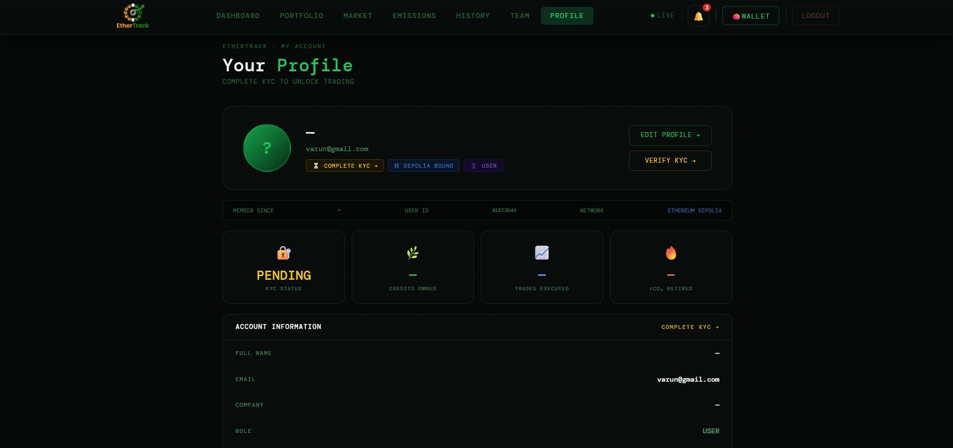
Profile page — top section showing hero card, stats, and account information

5.1 Hero Card
FIELD | DESCRIPTION | REQUIRED
Avatar circle | Your initials in a green gradient circle with a pulsing ring. Shows profile photo if uploaded. | Auto
Name & Email | Your full name and registered email. | Display
⏳ COMPLETE KYC → | Yellow badge — visible until KYC is approved. Click to go to KYC form. | Badge
✅ KYC VERIFIED | Green badge — replaces the yellow one after admin approval. | Badge
⛓ SEPOLIA BOUND | Blue badge — MetaMask wallet is linked to your account. | Badge
👤 USER | Purple badge showing your account role. | Badge
EDIT PROFILE → | Opens the Edit Profile page. | Button
VERIFY KYC → | Yellow button — visible only before KYC is approved. | Button

5.2 Member Since Strip
FIELD | DESCRIPTION | REQUIRED
MEMBER SINCE | Date your account was created (e.g. 20 Mar 2026). | Info
USER ID | First 8 characters of your unique account ID. | Info
NETWORK | Always shows ETHEREUM SEPOLIA. | Info

5.3 Stats Grid
FIELD | DESCRIPTION | REQUIRED
🔐 KYC STATUS | VERIFIED (green) or PENDING (yellow). | Stat
🌿 CREDITS OWNED | Total carbon credit tokens in your portfolio. | Stat
📈 TRADES EXECUTED | Total buy and sell trades completed. | Stat
🔥 tCO₂ RETIRED | Total tonnes permanently retired on-chain. | Stat

5.4 Account Information Table
FIELD | DESCRIPTION | REQUIRED
FULL NAME | From KYC. Shows — if not yet completed. | Display
EMAIL | Registered email address. | Display
COMPANY | Company name if set. | Display
ROLE | Account role: USER, ADMIN, etc. | Display
KYC STATUS | ✅ VERIFIED or ⏳ PENDING. | Display
KYC DATE | Date KYC was submitted. | Display
PORTFOLIO | Total portfolio value in ₹. | Display
WALLET | Truncated address 0x1234...abcd. COPY button copies full address. ⛓ ON-CHAIN badge if linked. | Display

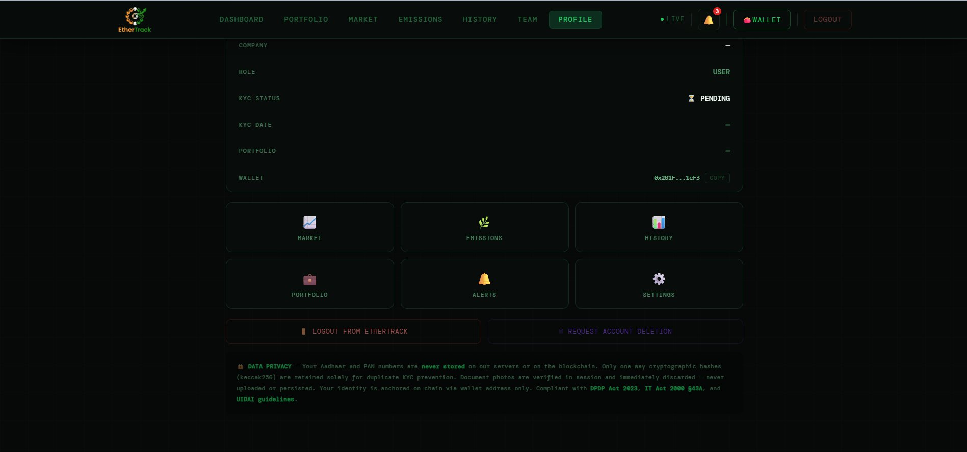
Profile page — bottom section showing quick actions, logout, and data privacy notice

5.5 Quick Actions & Account Management
FIELD | DESCRIPTION | REQUIRED
📈 MARKET / 🌿 EMISSIONS / 📊 HISTORY / 💼 PORTFOLIO / 🔔 ALERTS / ⚙️ SETTINGS | Six navigation tiles for fast access. | Tiles
🚪 LOGOUT FROM ETHERTRACK | Logs you out. Your data is not affected. | Button
🗑 REQUEST ACCOUNT DELETION | Confirms then instructs you to email support@ethertrack.in. Processed in 72 hours under DPDP Act 2023. | Button

5.6 Edit Profile
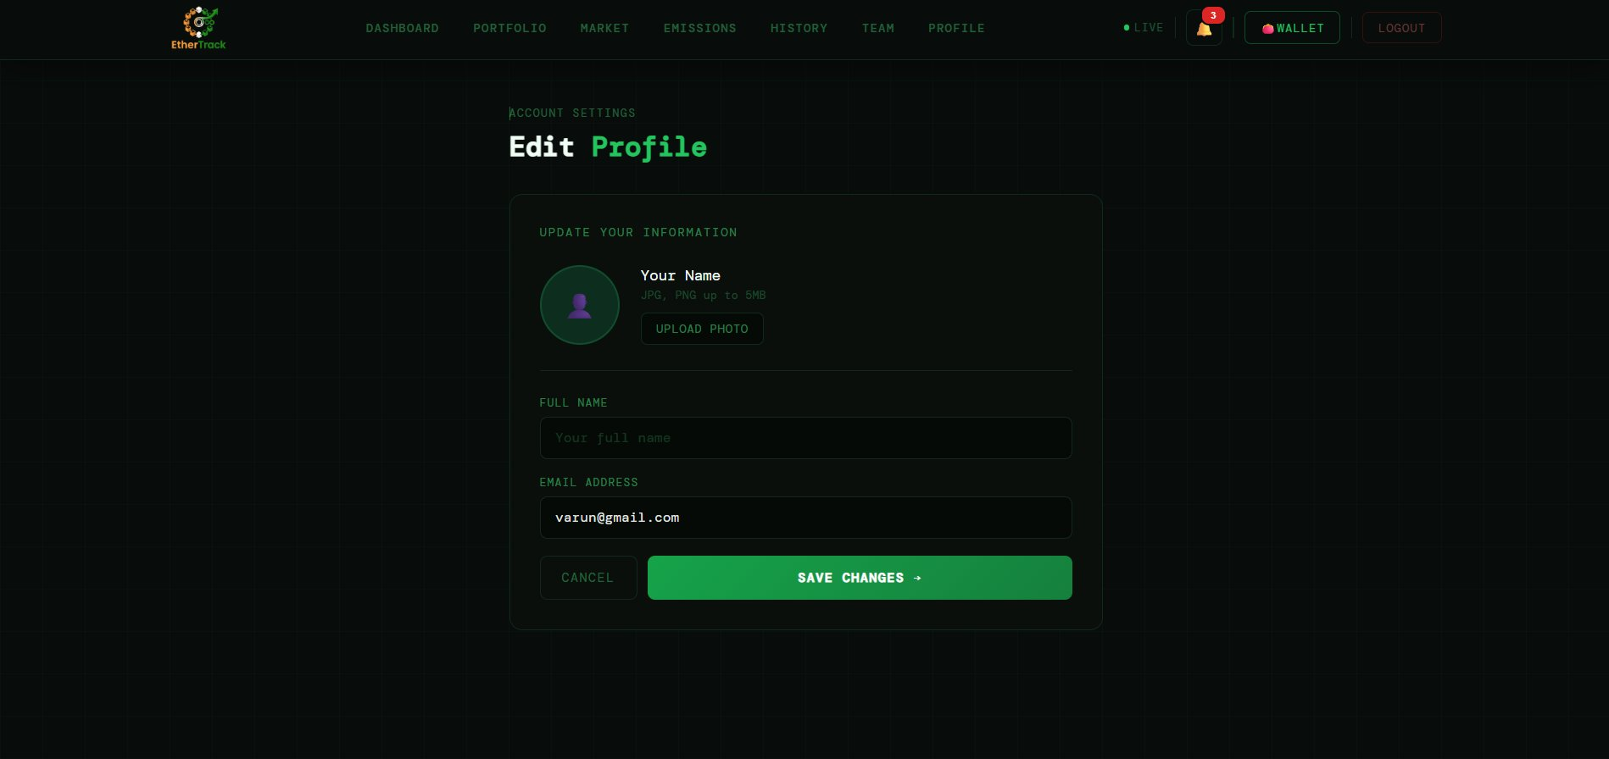
Edit Profile screen — Update Your Information

Click EDIT PROFILE → on the Profile page. The Edit Profile screen has an UPLOAD PHOTO button (JPG/PNG, max 5MB), FULL NAME field (required), EMAIL ADDRESS field (required), CANCEL (returns to Profile), and SAVE CHANGES → (green button — saves and redirects back to Profile after 1.2 seconds).

Section 6 — Team Management
Team Management lets you create an organisation workspace, invite your ESG team, assign roles, connect verifiers, and manage your subscription. Click TEAM in the navigation bar.

6.1 First Time — Create Your Organisation
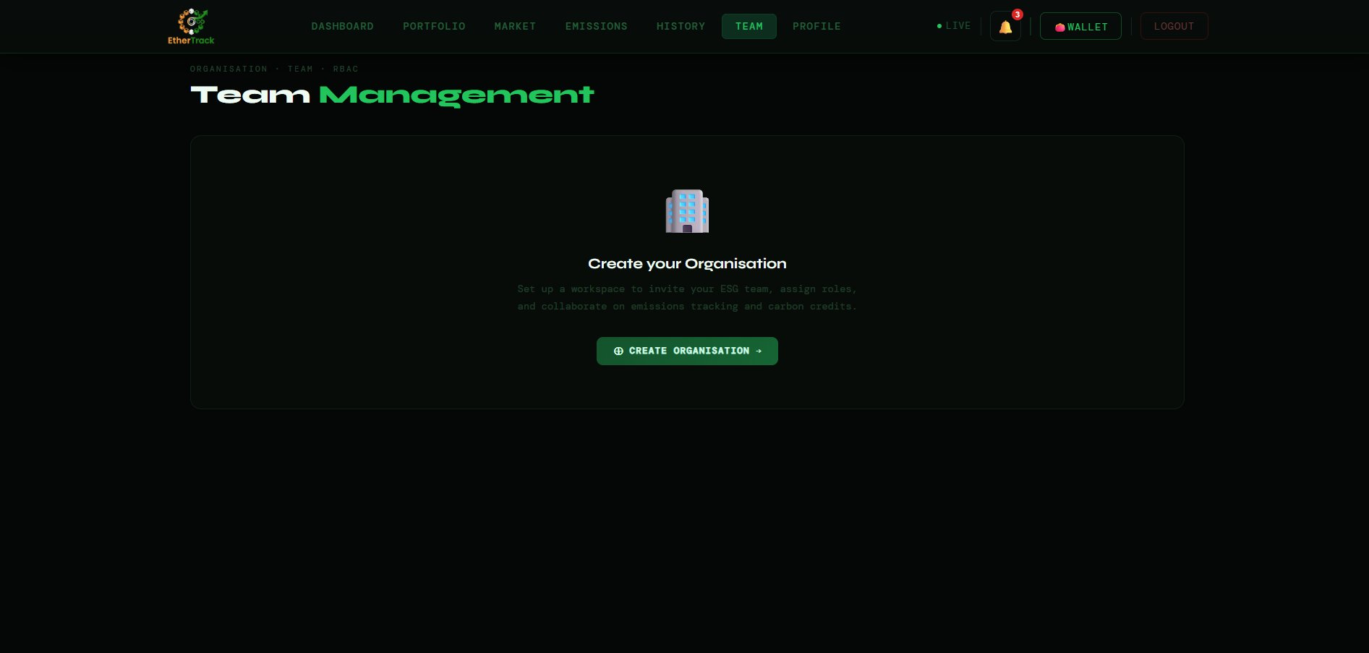
Team Management empty state — no organisation created yet

If you have not created an organisation yet, you see a building emoji with "Create your Organisation" and description text. Click ⊕ CREATE ORGANISATION → to open the creation modal.

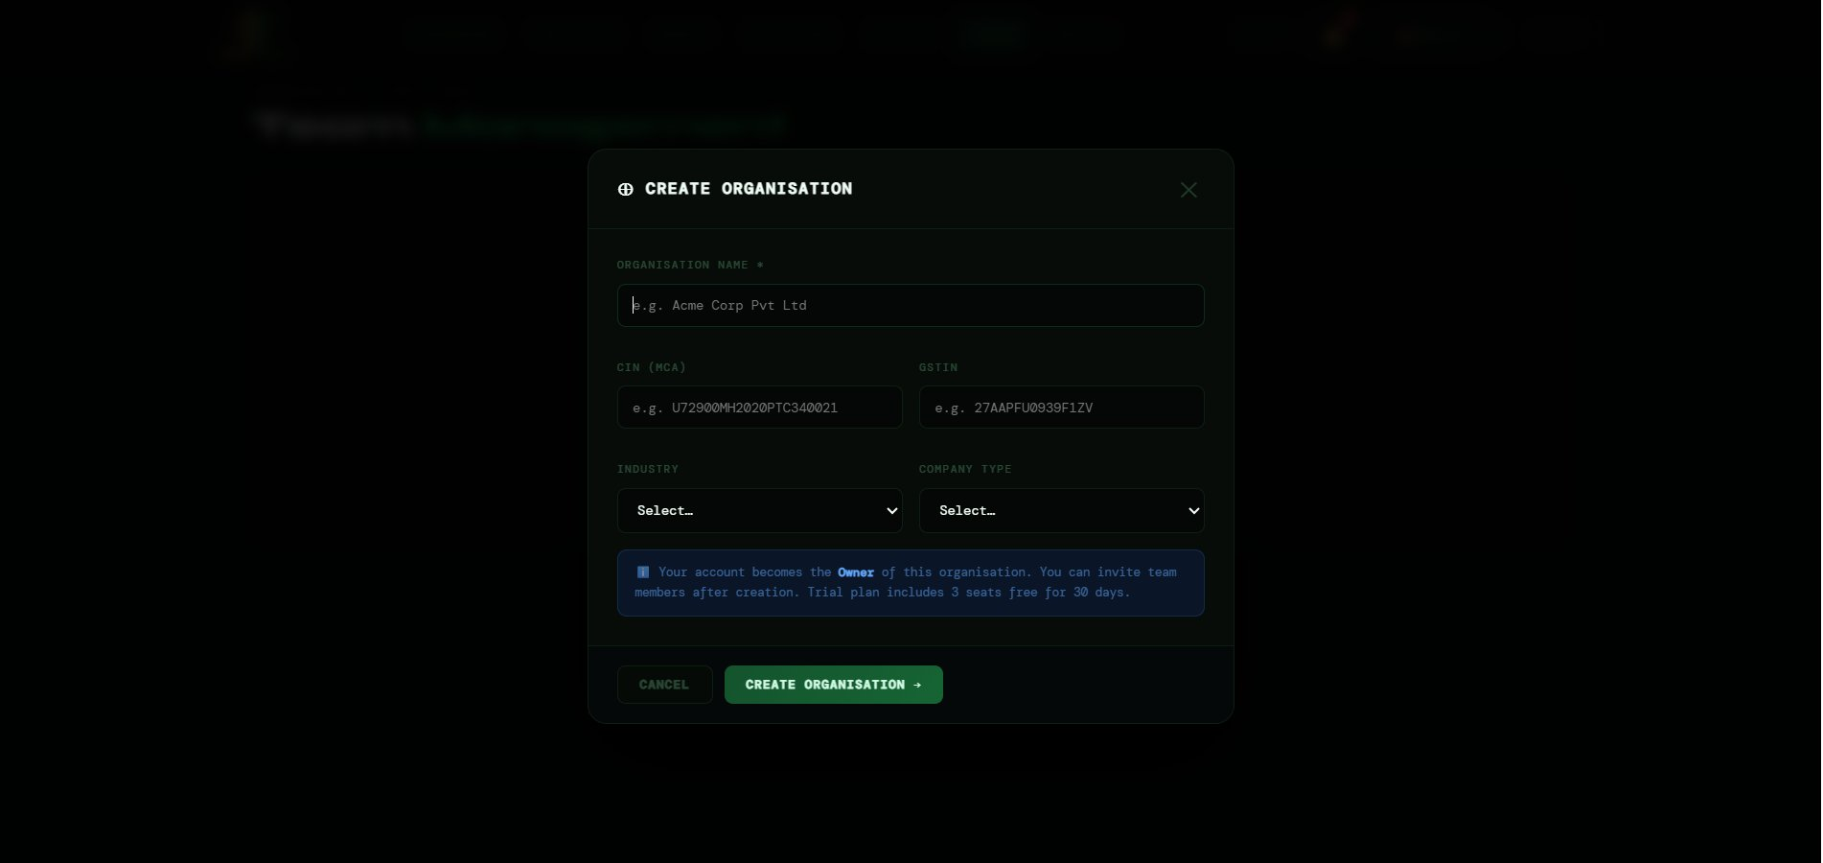
Create Organisation modal

FIELD | DESCRIPTION | REQUIRED
ORGANISATION NAME * | Full legal name (e.g. Acme Corp Pvt Ltd). Mandatory — marked with *. | Required
CIN (MCA) | Corporate Identification Number. 21 characters (e.g. U72900MH2020PTC340021). Auto-uppercase. | Optional
GSTIN | GST Identification Number. 15 characters (e.g. 27AAPFU0939F1ZV). Auto-uppercase. | Optional
INDUSTRY | Dropdown: Manufacturing, IT/Software, Finance, Healthcare, Retail, Logistics, Construction, Energy, Agriculture, Education, Other. | Optional
COMPANY TYPE | Dropdown: Private Limited, Public Limited, LLP, Partnership, Sole Proprietorship, OPC, Section 8. | Optional
Info box | Blue: "Your account becomes the Owner. Trial plan includes 3 seats free for 30 days." | Info
CREATE ORGANISATION → | Creates the org and sets you as Owner. | Button

6.2 The Organisation Workspace
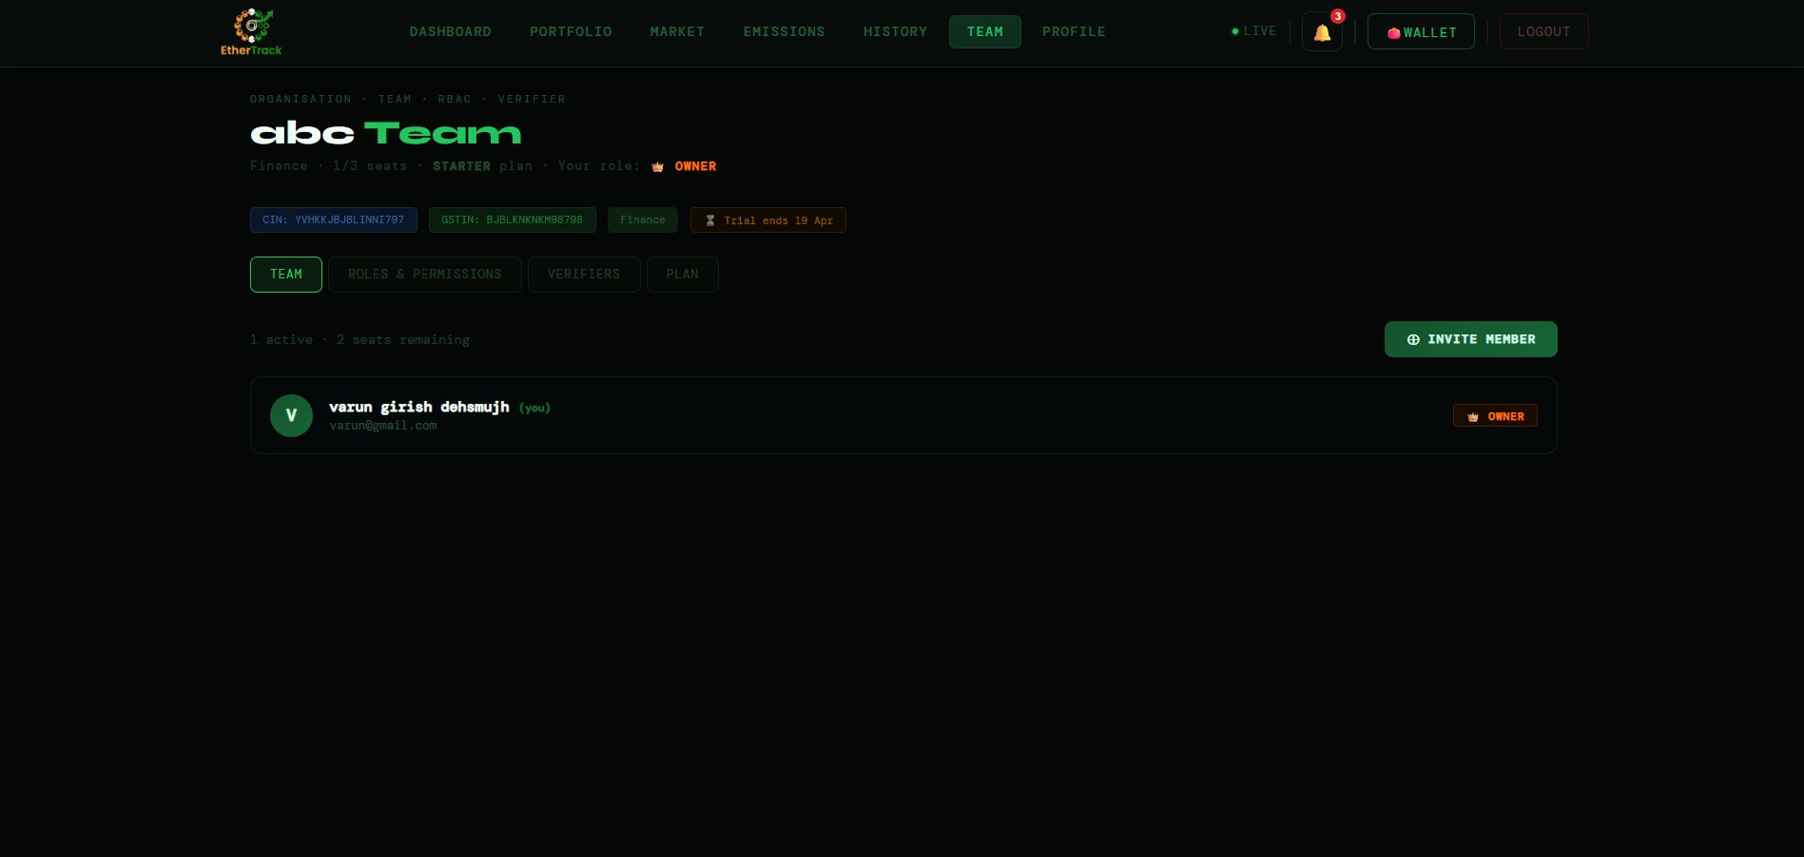
Team Management workspace showing member list and tabs

After creating your organisation, the page shows your org name (e.g. "abc Team") with a sub-line: Industry · Seat usage · Plan · Your role. Below is a strip of identity tags (CIN, GSTIN, industry, trial expiry). Four tabs: TEAM, ROLES & PERMISSIONS, VERIFIERS, PLAN.

6.3 Inviting Team Members
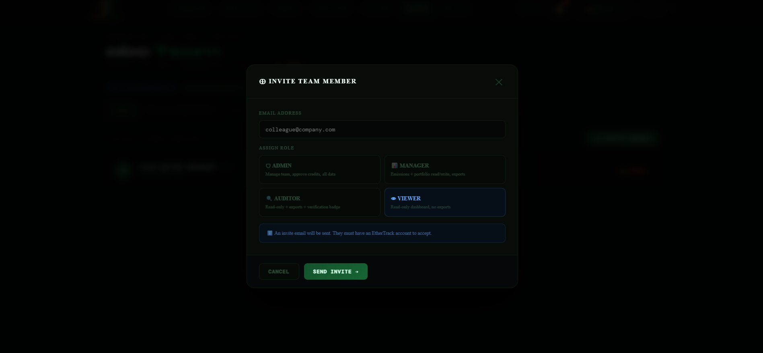
Invite Team Member modal showing role selection cards

1 | Click ⊕ INVITE MEMBER  Invite Team Member modal opens.

2 | Enter colleague's email  They must already have an EtherTrack account.

3 | Select a role  Choose from ADMIN, MANAGER, AUDITOR, VIEWER cards. Selected card highlights.

4 | Click SEND INVITE →  Button shows ⟳ SENDING... then invite appears in team list with "⏳ invite pending" badge.

6.4 User Roles — What Each Role Can Do
FIELD | DESCRIPTION | REQUIRED
👑 OWNER (orange) | Full control — billing, team, all data. Set automatically when you create the organisation. | Role
🛡 ADMIN (red) | Manage team, approve credits, access all data. Can invite and remove members. | Role
📊 MANAGER (green) | Read and write emissions and portfolio. Can export reports. | Role
🔍 AUDITOR (purple) | Read-only + exports + verification badge on reports. Cannot write data. | Role
👁 VIEWER (blue) | Read-only dashboard. No exports, no data entry. | Role

Key Permissions by Role
FIELD | DESCRIPTION | REQUIRED
Portfolio Read | Owner ✓, Admin ✓, Manager ✓, Auditor ✓, Viewer ✓ | All roles
Portfolio Write (submit, retire) | Owner ✓, Admin ✓, Manager ✓, Auditor —, Viewer — | Owner–Manager
Emissions Read | Owner ✓, Admin ✓, Manager ✓, Auditor ✓, Viewer ✓ | All roles
Emissions Write | Owner ✓, Admin ✓, Manager ✓, Auditor —, Viewer — | Owner–Manager
Reports Export PDF | Owner ✓, Admin ✓, Manager ✓, Auditor ✓, Viewer — | Owner–Auditor
Team Invite / Remove | Owner ✓, Admin ✓, Manager —, Auditor —, Viewer — | Owner–Admin
Verifier Connect | Owner ✓, Admin ✓, Manager —, Auditor —, Viewer — | Owner–Admin
Billing | Owner ✓ only | Owner only

6.5 Verifier Connection
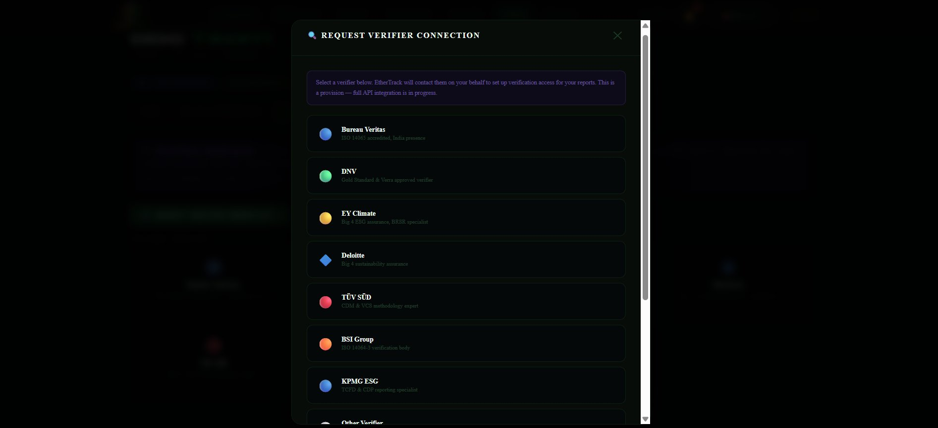
Request Verifier Connection modal showing all available verifiers

Connecting a verifier adds a verification badge to your PDF reports — required for BRSR Level 2 assurance. Click 🔍 REQUEST VERIFIER CONNECTION → to choose from: Bureau Veritas, DNV, EY Climate, Deloitte, TÜV SÜD, BSI Group, KPMG ESG, or Other Verifier. Enter your contact email and optional notes, then click SUBMIT REQUEST →. EtherTrack contacts the verifier on your behalf.

6.6 Subscription Plans
FIELD | DESCRIPTION | REQUIRED
STARTER — ₹2,500/mo | 3 seats. Emissions tracking, portfolio (5 credits max), CSV exports. | Plan
GROWTH — ₹8,000/mo | 10 seats. Unlimited emissions, 50 credits, BRSR/CDP/TCFD PDFs, priority support. | Plan
ENTERPRISE — ₹25,000/mo | 50 seats. Unlimited everything, white-label reports, verifier API, dedicated manager. | Plan

Section 7 — Emission Tracking
The Emission Tracking module is EtherTrack's full GHG inventory system covering all 3 scopes, all 15 Scope 3 categories, PAT scheme, and regulatory report exports. Click EMISSIONS in the navigation bar.

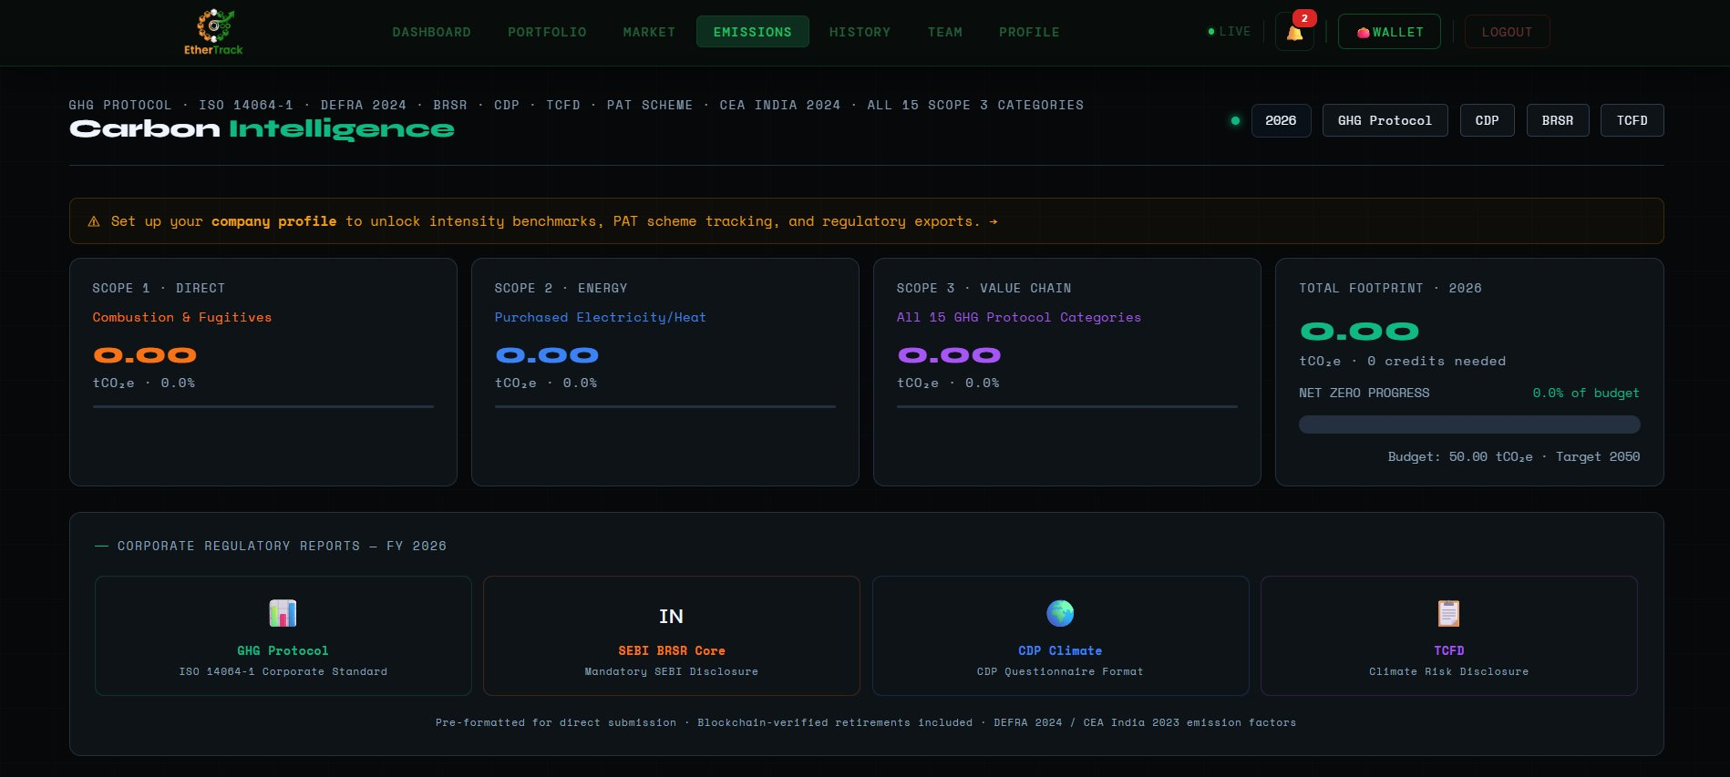
Emissions overview — scope cards, net zero progress, and report export buttons

7.1 Overview Page — Scope Cards & Reports
FIELD | DESCRIPTION | REQUIRED
SCOPE 1 · DIRECT | Combustion & Fugitives — total Scope 1 tCO₂e and % of total footprint. | Card
SCOPE 2 · ENERGY | Purchased Electricity/Heat — total Scope 2 tCO₂e. | Card
SCOPE 3 · VALUE CHAIN | All 15 GHG Protocol Categories — total Scope 3 tCO₂e. | Card
TOTAL FOOTPRINT · 2026 | Sum of all scopes. Credits needed for net zero. NET ZERO PROGRESS bar. Budget and Target year. | Card
GHG Protocol export | ISO 14064-1 Corporate Standard PDF. | Export
SEBI BRSR Core export | Mandatory SEBI Disclosure — formatted for direct portal submission. | Export
CDP Climate export | CDP Questionnaire Format PDF. | Export
TCFD export | Climate Risk Disclosure PDF. | Export

7.2 LOG EMISSION Tab
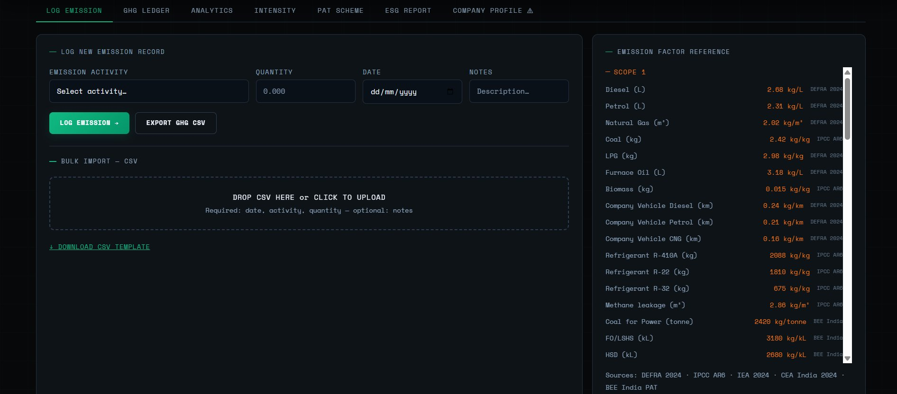
Log Emission tab showing entry form and emission factor reference panel

FIELD | DESCRIPTION | REQUIRED
EMISSION ACTIVITY | Dropdown — select the specific activity (Diesel, Petrol, Grid Electricity, Refrigerant, Business Travel Air, etc.) | Required
QUANTITY | Amount consumed in the unit for that activity (litres, kWh, km, kg, etc.) | Required
DATE | Date the activity occurred. DD/MM/YYYY picker. | Required
NOTES | Optional description (e.g. "January diesel for generators"). | Optional
LOG EMISSION → | Calculates tCO₂e using the DEFRA 2024 / CEA India 2024 factor and saves to ledger. | Button
EXPORT GHG CSV | Downloads all emission records as a CSV file. | Button
Bulk CSV drop zone | Drop zone for bulk import. Required columns: date, activity, quantity. Optional: notes. | Bulk
↓ DOWNLOAD CSV TEMPLATE | Downloads a blank template with correct column headers pre-filled. | Link
Emission Factor Reference panel | Right-side panel showing every factor: Diesel 2.68 kg/L, Petrol 2.31 kg/L, Grid India 0.79 kg/kWh, Refrigerant R-410A 2088 kg/kg, etc. Sources: DEFRA 2024, IPCC AR6, CEA India 2024, BEE India PAT. | Reference

7.3 GHG LEDGER Tab
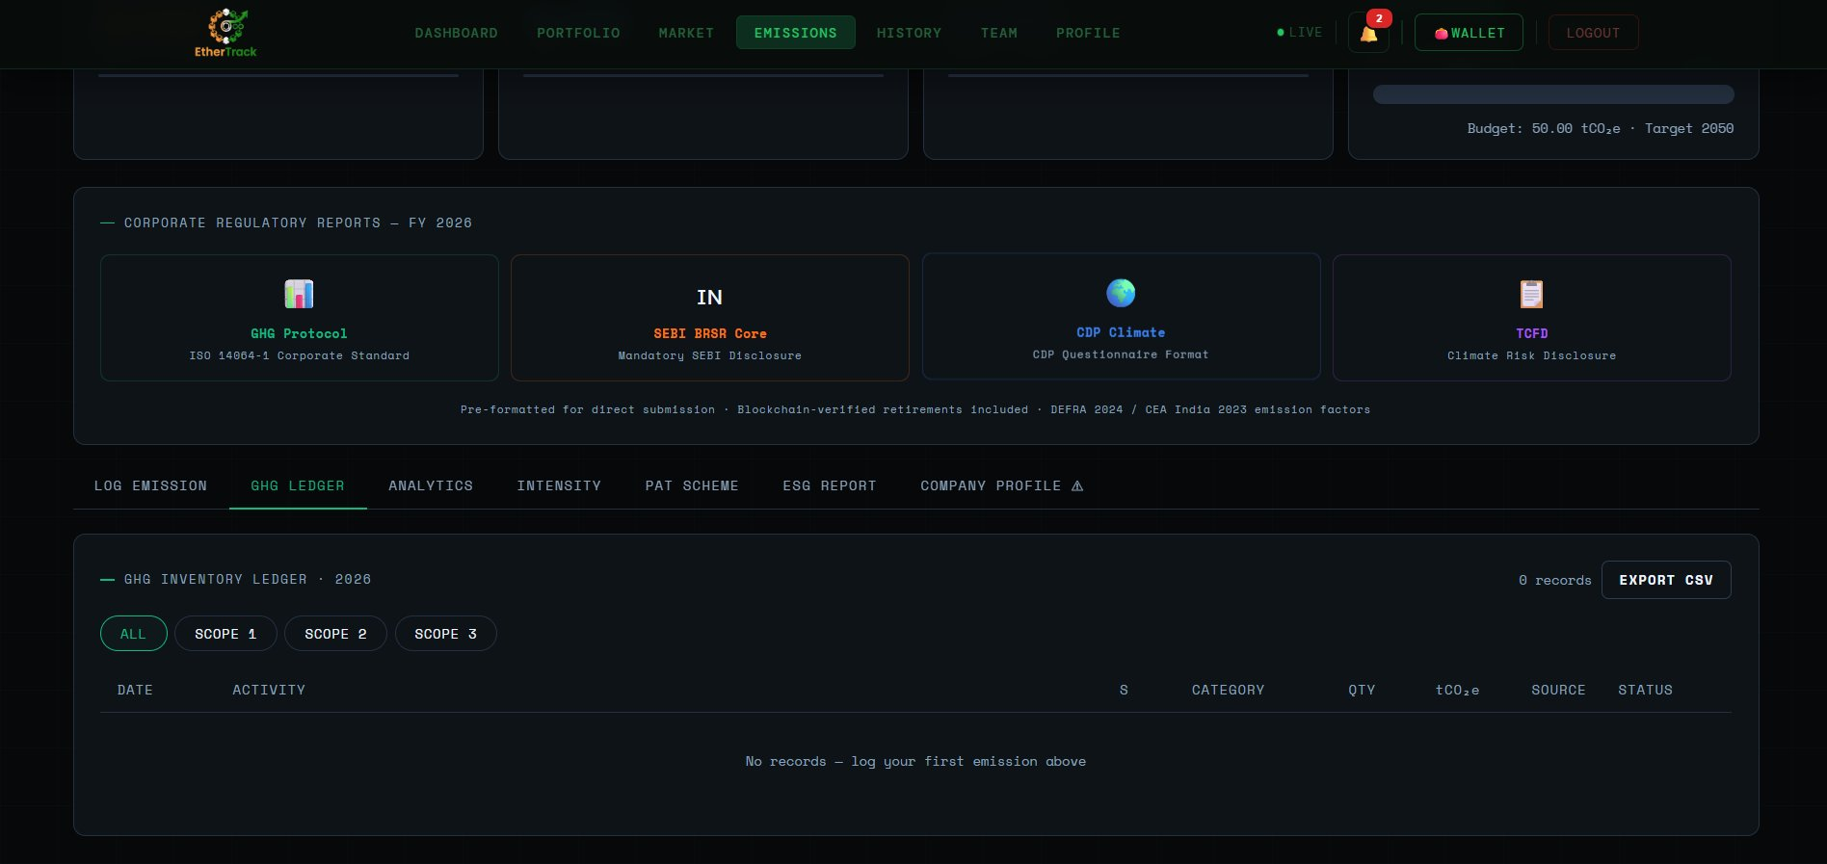
GHG Ledger tab showing the inventory table with scope filters

The GHG Ledger is your complete chronological record of every emission entry you have logged. It is your official GHG inventory register for the reporting year.
FIELD | DESCRIPTION | REQUIRED
GHG INVENTORY LEDGER · 2026 header | Title showing current reporting year. Shows total record count on the right. | Header
EXPORT CSV button | Downloads all ledger records as a CSV file. | Button
ALL / SCOPE 1 / SCOPE 2 / SCOPE 3 tabs | Filter the ledger by scope. ALL shows every entry. Click SCOPE 1, 2, or 3 to see only that scope's activities. | Filter
DATE column | The date the emission activity occurred (DD/MM/YYYY). | Column
ACTIVITY column | The specific emission activity name (e.g. Diesel Combustion, Grid Electricity, Business Travel). | Column
S column | Scope number — 1, 2, or 3. | Column
CATEGORY column | The GHG Protocol category (e.g. Stationary Combustion, Purchased Energy, Business Travel). | Column
QTY column | The quantity you entered (e.g. 500 litres, 1200 kWh). | Column
tCO₂e column | The calculated carbon equivalent — quantity multiplied by the emission factor. | Column
SOURCE column | The emission factor source used (e.g. DEFRA 2024, CEA India 2024). | Column
STATUS column | Entry status — Logged, Verified, or Pending. | Column
Empty state | When no records exist: "No records — log your first emission above". Use the LOG EMISSION tab to add your first entry. | State

✅ TIP
Use the SCOPE 1, SCOPE 2, SCOPE 3 filter tabs to review each scope separately before generating your annual report. This helps you spot missing categories or outlier entries before audit.

7.4 ANALYTICS Tab
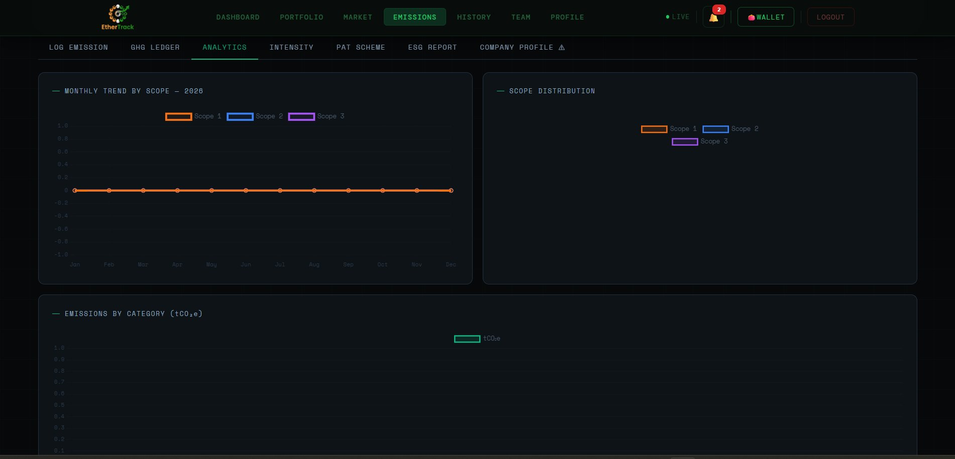
Emissions Analytics tab showing monthly trend chart and scope distribution

The Analytics tab gives you visual charts of your emission trends. It has three charts:
FIELD | DESCRIPTION | REQUIRED
MONTHLY TREND BY SCOPE — 2026 | Line chart showing monthly emissions for each scope across January to December. Orange line = Scope 1, Blue = Scope 2, Purple = Scope 3. X-axis = months, Y-axis = tCO₂e. Hover over any point to see the exact value for that month. | Chart
SCOPE DISTRIBUTION | Doughnut or bar chart showing what percentage of your total emissions comes from Scope 1, Scope 2, and Scope 3. Helps identify which scope needs the most reduction focus. | Chart
EMISSIONS BY CATEGORY (tCO₂e) | Bar chart showing emissions broken down by specific GHG Protocol category — e.g. Stationary Combustion, Purchased Electricity, Business Travel, etc. Shows which activities are your biggest emission sources. | Chart

ℹ NOTE
All charts show 0.00 until you log your first emission. Add entries in the LOG EMISSION tab and return to Analytics to see your data visualised. Charts update in real time as you log more entries.

7.5 INTENSITY Tab
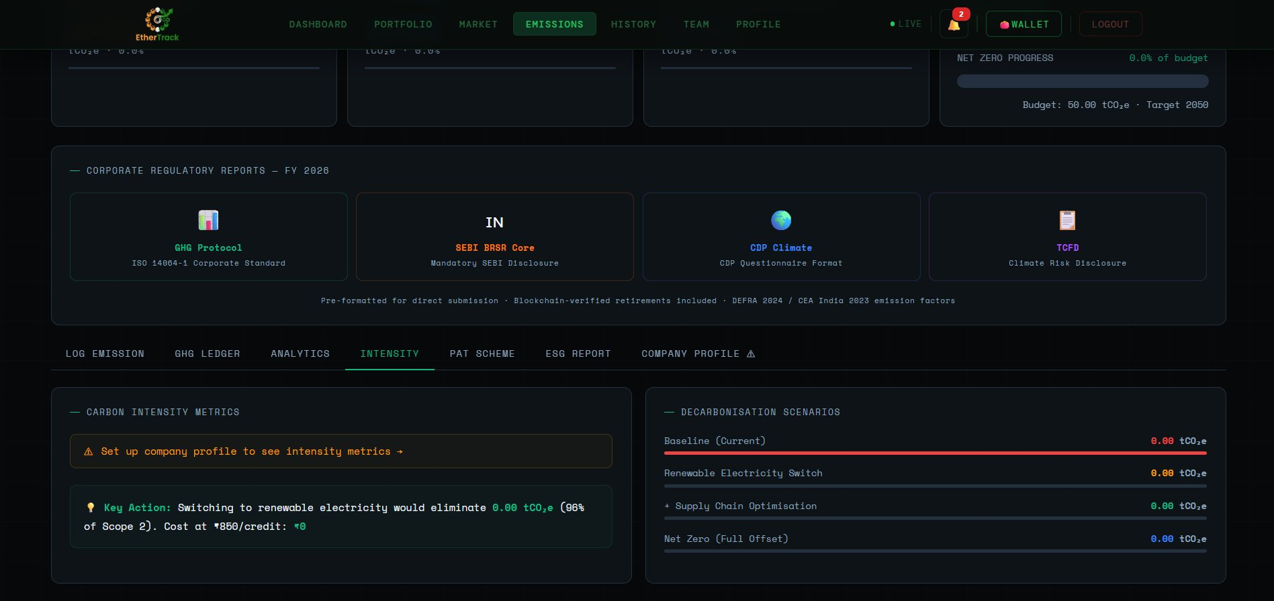
Emissions Intensity tab showing carbon intensity metrics and decarbonisation scenarios

The Intensity tab calculates your carbon intensity ratios — how much CO₂ your company produces relative to its output. These metrics are required for BRSR Core and CDP disclosures.
FIELD | DESCRIPTION | REQUIRED
CARBON INTENSITY METRICS panel | Left panel. Shows three intensity ratios once company profile is set up: Revenue Intensity (tCO₂e per crore ₹), Employee Intensity (tCO₂e per FTE), Area Intensity (kgCO₂e per sqft). Each metric is benchmarked against your industry sector — showing sector low, sector average, and sector high. | Panel
Setup prompt | If company profile is not yet filled in, shows "⚠ Set up company profile to see intensity metrics →". Click the link to go to the Company Profile tab. | Prompt
Key Action insight | A yellow tip line showing the single biggest action you can take: e.g. "💡 Switching to renewable electricity would eliminate X tCO₂e (96% of Scope 2). Cost at ₹850/credit: ₹X" | Insight
DECARBONISATION SCENARIOS panel | Right panel. Shows a waterfall of four scenario bars: Baseline (Current), Renewable Electricity Switch, + Supply Chain Optimisation, Net Zero (Full Offset). Each bar shows the tCO₂e value — letting you see visually how different actions reduce your footprint step by step toward net zero. | Panel

ℹ NOTE
You must save your Company Profile first (industry, annual revenue, employee count, floor area) before intensity metrics are calculated. Without these denominators the panel shows the setup prompt.

7.6 PAT SCHEME Tab
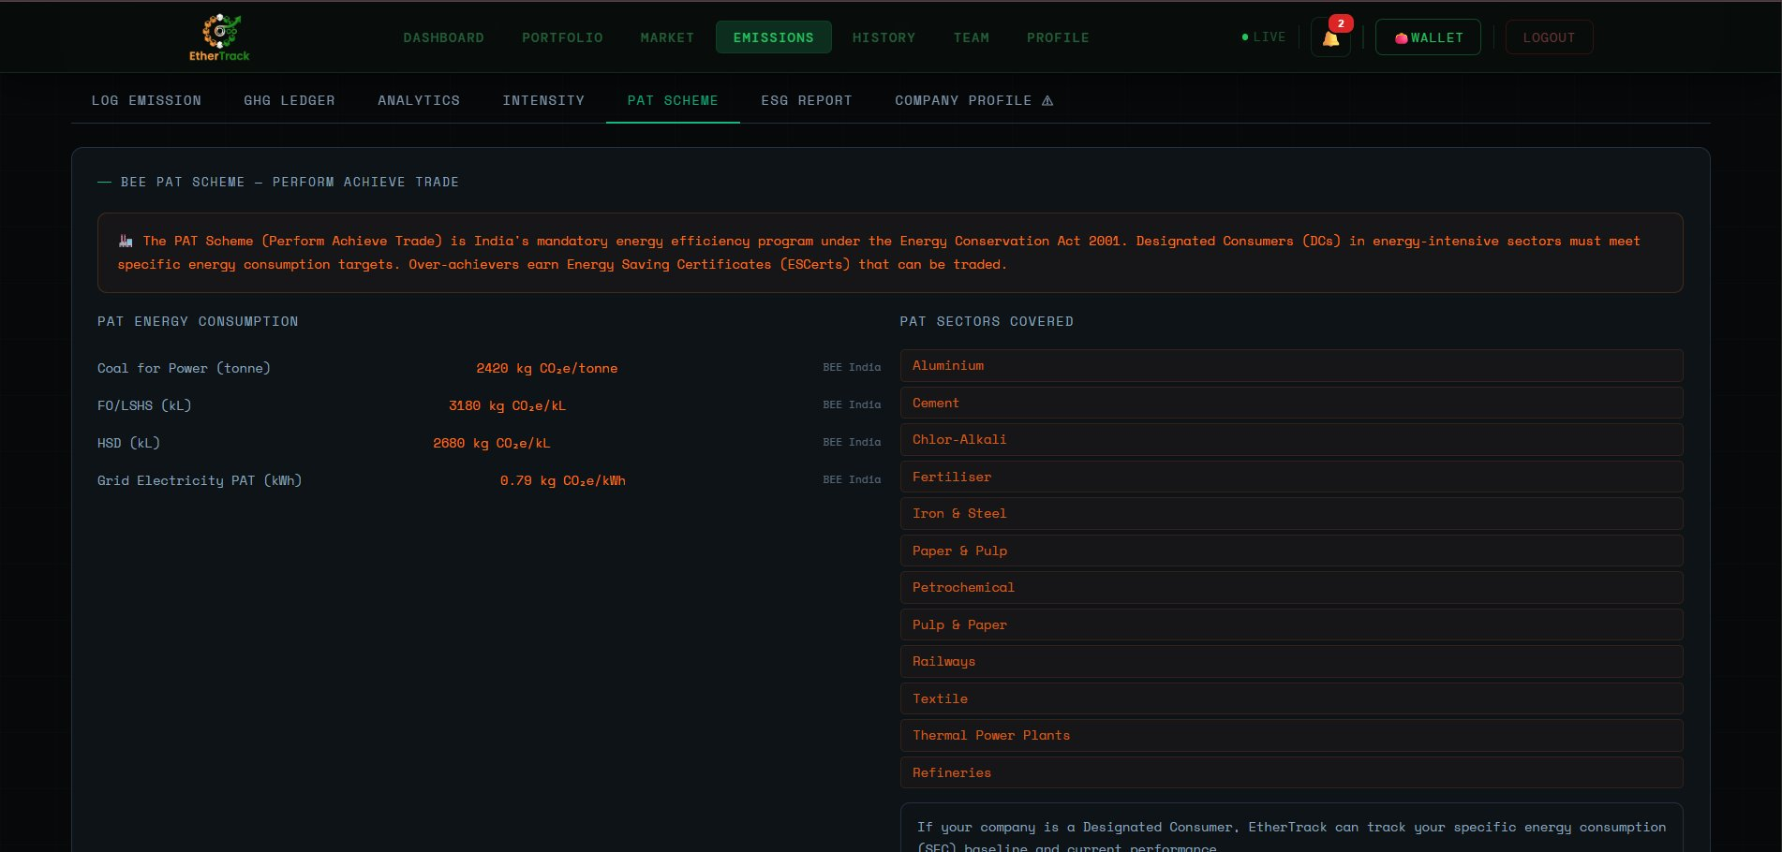
PAT Scheme tab showing BEE energy consumption categories and covered sectors

The PAT (Perform Achieve Trade) Scheme tab is for companies in energy-intensive sectors that are Designated Consumers under India's Energy Conservation Act 2001. The tab header reads "BEE PAT SCHEME — PERFORM ACHIEVE TRADE".
FIELD | DESCRIPTION | REQUIRED
Introduction box | Orange text: "The PAT Scheme is India's mandatory energy efficiency program under the Energy Conservation Act 2001. Designated Consumers (DCs) must meet specific energy consumption targets. Over-achievers earn Energy Saving Certificates (ESCerts) that can be traded." | Info
PAT ENERGY CONSUMPTION panel | Left panel. Shows four PAT-specific energy categories with BEE India emission factors: Coal for Power (tonne) = 2420 kgCO₂e/tonne, FO/LSHS (kL) = 3180 kgCO₂e/kL, HSD (kL) = 2680 kgCO₂e/kL, Grid Electricity PAT (kWh) = 0.79 kgCO₂e/kWh. These are tracked separately from the standard GHG Protocol inventory. | Panel
PAT SECTORS COVERED panel | Right panel. Lists all 11 sectors covered by PAT: Aluminium, Cement, Chlor-Alkali, Fertiliser, Iron & Steel, Paper & Pulp, Petrochemical, Pulp & Paper, Railways, Textile, Thermal Power Plants, Refineries. If your company is in one of these sectors, EtherTrack tracks your SEC (Specific Energy Consumption) against your BEE-assigned target. | Panel
Designated Consumer note | Bottom of the page: "If your company is a Designated Consumer, EtherTrack can track your specific energy consumption (SEC) baseline and current performance." | Note

ℹ NOTE
ESCerts earned by over-achieving your PAT target can be tokenized as carbon credits on EtherTrack. ESCert-to-CCC conversion tracking is on the roadmap once the CCTS PAT bridge goes live.

7.7 ESG REPORT Tab
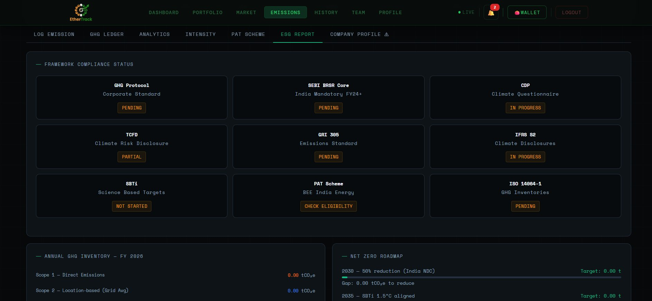
ESG Report tab showing framework compliance status and net zero roadmap

The ESG Report tab is your consolidated compliance dashboard. It shows the status of every major ESG reporting framework and your net zero roadmap.
FIELD | DESCRIPTION | REQUIRED
FRAMEWORK COMPLIANCE STATUS grid | 9 framework cards showing your current compliance status for each: | Panel
GHG Protocol — Corporate Standard | Status badge: PENDING (amber) until emissions are logged and verified. Turns green when complete. | Card
SEBI BRSR Core — India Mandatory FY24+ | Status: PENDING. Turns complete when Scope 1/2/3 data is logged and company profile is set. | Card
CDP — Climate Questionnaire | Status: IN PROGRESS. Partially met when emissions are logged. | Card
TCFD — Climate Risk Disclosure | Status: PARTIAL. Metrics & Targets section partially met when emissions data exists. | Card
GRI 305 — Emissions Standard | Status: PENDING. | Card
IFRS S2 — Climate Disclosures | Status: IN PROGRESS. | Card
SBTi — Science Based Targets | Status: NOT STARTED. Click to learn about setting science-based targets. | Card
PAT Scheme — BEE India Energy | Status: CHECK ELIGIBILITY. Click to check if your company qualifies as a Designated Consumer. | Card
ISO 14064-1 — GHG Inventories | Status: PENDING. | Card
ANNUAL GHG INVENTORY — FY 2026 panel | Left panel below the grid. Shows Scope 1 (Direct Emissions), Scope 2 (Location-based Grid Avg), and additional scope lines — all showing 0.00 tCO₂e until data is logged. This is your annual GHG inventory summary. | Panel
NET ZERO ROADMAP panel | Right panel. Shows your pathway to net zero as milestone bars: 2030 — 50% reduction (India NDC), 2035 — SBTi 1.5°C aligned, and final net zero target year. Each milestone shows the target tCO₂e reduction needed and a progress bar. | Panel

7.8 How to Generate & Download Reports
EtherTrack can generate four types of auditor-ready PDF reports. You can generate them from TWO places — the Emissions page and the Portfolio page.

From the Emissions Page
1 | Go to EMISSIONS in the navigation bar  The overview page loads showing the four scope cards.

2 | Scroll down to "CORPORATE REGULATORY REPORTS — FY 2026"  Four report cards are visible: GHG Protocol, SEBI BRSR Core, CDP Climate, TCFD.

3 | Click any report card  The PDF is generated automatically and downloads to your device. No additional steps needed.

4 | Check the FY selector  The reporting year (e.g. 2026) is shown with a green dot in the top right. Ensure it is set to your reporting year before downloading.

From the Portfolio Page
1 | Go to PORTFOLIO in the navigation bar  The portfolio overview loads.

2 | Find the "CORPORATE REPORTING EXPORTS — AUDITOR PDF" panel  Below the four stat cards. Shows GHG Protocol, BRSR Core, CDP Climate, TCFD.

3 | Select the reporting year from the FY dropdown  Top right of the panel. Choose the correct financial year (e.g. FY 2026).

4 | Click any report button to download  The PDF downloads instantly. It includes your blockchain-verified retirement records embedded automatically.

ℹ NOTE
Reports are pre-formatted using DEFRA 2024 and CEA India 2024 emission factors. Blockchain-verified retirement transaction hashes are embedded — auditors can verify them on Etherscan. Reports are formatted for direct SEBI/CDP portal submission without any manual editing.

7.9 COMPANY PROFILE Tab
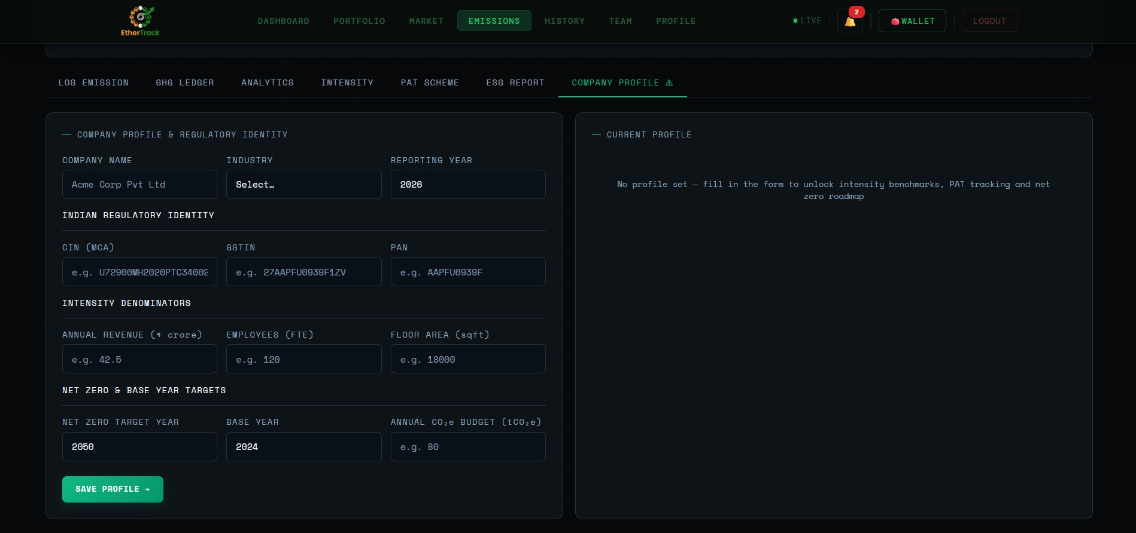
Company Profile tab showing regulatory identity and intensity denominator fields

FIELD | DESCRIPTION | REQUIRED
COMPANY NAME | Full legal name (e.g. Acme Corp Pvt Ltd). | Required
INDUSTRY | Dropdown — determines industry benchmark thresholds for intensity calculations. | Required
REPORTING YEAR | Financial year for this GHG inventory (e.g. 2026). | Required
CIN (MCA) | Corporate Identification Number. Format: U72900MH2020PTC340002. | Optional
GSTIN | GST Identification Number. Format: 27AAPFU0939F1ZV. | Optional
PAN | Permanent Account Number. Format: AAPFU0939F. | Optional
ANNUAL REVENUE (₹ crore) | Used to calculate tCO₂e per crore of revenue for BRSR intensity metric. | Optional
EMPLOYEES (FTE) | Full-time equivalents — used for tCO₂e per employee intensity. | Optional
FLOOR AREA (sqft) | Total floor space — used for kgCO₂e per sqft intensity. | Optional
NET ZERO TARGET YEAR | Year your company aims to reach net zero. Default: 2050. | Optional
BASE YEAR | Historical reference year for inventory comparisons. Default: 2024. | Optional
ANNUAL CO₂e BUDGET (tCO₂e) | Annual carbon budget shown in Dashboard total footprint card. | Optional
SAVE PROFILE → | Green button. Saves all data and unlocks intensity benchmarks, PAT tracking, and full report exports. | Button

Section 8 — Tokenizing Carbon Credits
Tokenizing converts a verified carbon credit into a blockchain token on Ethereum. Once tokenized and approved, the credit appears in your portfolio and can be held, listed for sale, or retired on-chain.

⚠ IMPORTANT
KYC must be verified before tokenizing. All submitted credits go through admin review within 1–2 business days before appearing as approved tokens.

8.1 Opening the Form
Go to PORTFOLIO. Click the green ⊕ TOKENIZE NEW CREDIT button (top right). The "Submit Carbon Credit for Verification" modal opens. A yellow notice reads: "⏳ Reviewed by compliance team within 1–2 business days." The form has three pages — scroll down to see all fields on each page.

8.2 Page 1 — Project Details
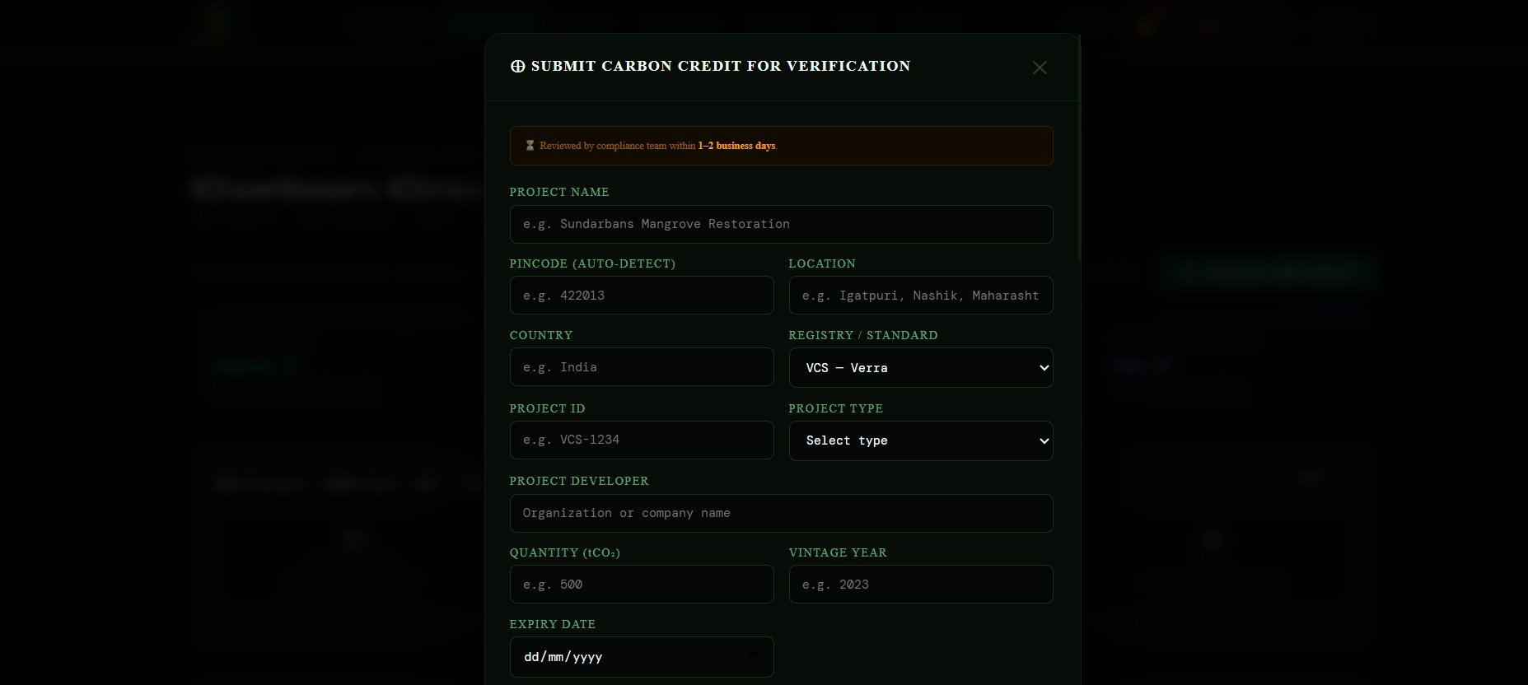
Tokenize form page 1 — project name, location, registry, developer, quantity

FIELD | DESCRIPTION | REQUIRED
PROJECT NAME | Official name of the carbon project (e.g. "Sundarbans Mangrove Restoration"). | Required
PINCODE (AUTO-DETECT) | PIN code of the project location. System auto-detects city/district. | Optional
LOCATION | City, district, state (e.g. "Igatpuri, Nashik, Maharashtra"). Auto-fills from PIN code. | Optional
COUNTRY | Country of the project (e.g. India). | Optional
REGISTRY / STANDARD | Dropdown: VCS — Verra, Gold Standard, CDM, ACR, BEE — India CCTS. | Required
PROJECT ID | Registry's project identifier (e.g. VCS-1234). | Optional
PROJECT TYPE | Dropdown: Renewable Energy, Forestry/REDD+, Agriculture, Energy Efficiency, Waste Management, Blue Carbon, Industrial, Transport, Other. | Required
PROJECT DEVELOPER | Organisation or company that developed the project. | Optional
QUANTITY (tCO₂) | Number of credits being tokenized. 1 credit = 1 tonne CO₂ equivalent. | Required
VINTAGE YEAR | Year the emission reduction actually occurred (e.g. 2023). | Required
EXPIRY DATE | Date after which the credit can no longer be used. DD/MM/YYYY format. | Optional

8.3 Page 2 — Compliance, Standards & Article 6
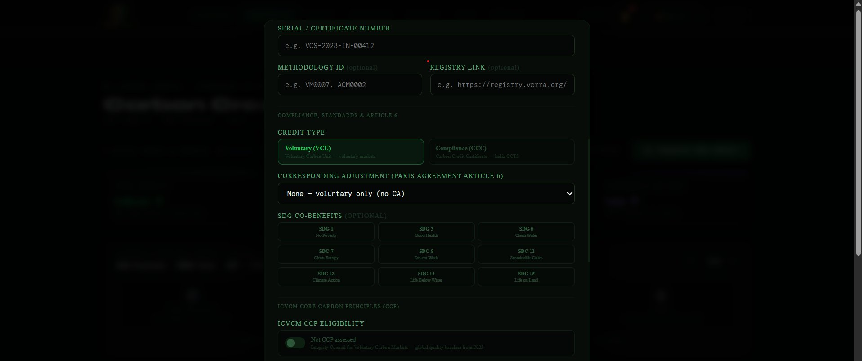
Tokenize form page 2 — serial number, credit type, Article 6, SDGs, ICVCM

FIELD | DESCRIPTION | REQUIRED
SERIAL / CERTIFICATE NUMBER | Unique serial from the registry (e.g. VCS-2023-IN-00412). Used to verify against registry. | Required
METHODOLOGY ID | Registry methodology used (e.g. VM0007, ACM0002). | Optional
REGISTRY LINK | Direct URL to credit listing on Verra/GS registry. | Optional
CREDIT TYPE | Voluntary (VCU) — voluntary markets, or Compliance (CCC) — India CCTS. | Required
CORRESPONDING ADJUSTMENT | Dropdown: None — voluntary only (no CA), Host Country CA Issued, ITMO Authorised (Article 6.4), Pending CA. Determines Paris Agreement-aligned claim eligibility. | Required
SDG CO-BENEFITS | Grid of 9 SDG tags to select: SDG 1, 3, 6, 7, 8, 11, 13, 14, 15. Required for Gold Standard credits. | Optional
ICVCM CCP ELIGIBILITY | Toggle. Default: Not CCP assessed. Enable if credit meets ICVCM Core Carbon Principles. | Optional

8.4 Page 3 — Verification, Banking & Ownership
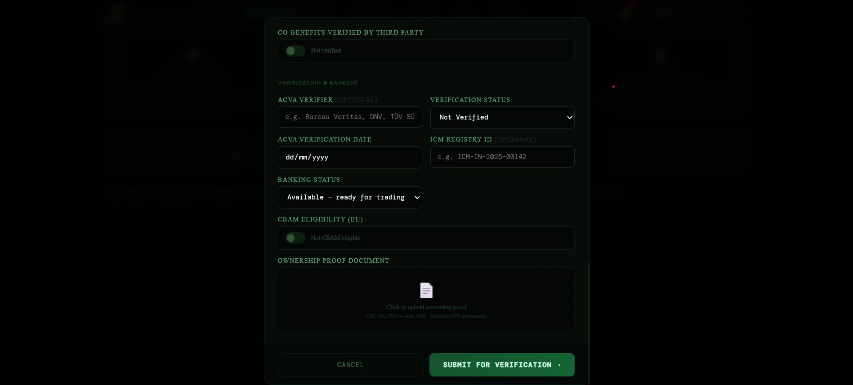
Tokenize form page 3 — verification details, CBAM eligibility, ownership proof

FIELD | DESCRIPTION | REQUIRED
CO-BENEFITS VERIFIED BY THIRD PARTY | Toggle. Enable if an accredited auditor verified the SDG co-benefits. | Optional
ACVA VERIFIER | Name of verifying auditor (e.g. Bureau Veritas, DNV, TÜV SÜD). | Optional
VERIFICATION STATUS | Dropdown: Not Verified, Verification in Progress, Verified. | Required
ACVA VERIFICATION DATE | Date verification was completed. DD/MM/YYYY. | Optional
ICM REGISTRY ID | International Carbon Market registry ID (e.g. ICM-IN-2025-00142). | Optional
BANKING STATUS | Dropdown: Available — ready for trading, Reserved, Cancelled. | Required
CBAM ELIGIBILITY (EU) | Toggle. Enable if credit meets EU Carbon Border Adjustment Mechanism requirements. Important for Indian exporters shipping to the EU. | Optional
OWNERSHIP PROOF DOCUMENT | Upload area. PDF/JPG/PNG, max 5MB. Proof of ownership — e.g. registry transfer certificate. Uploaded to IPFS. | Required
SUBMIT FOR VERIFICATION → | Submits the form. Credit enters PENDING status in portfolio awaiting admin review. | Button

Section 9 — Portfolio Management
Your Portfolio is where you manage all your carbon credit tokens. Click PORTFOLIO in the navigation bar.

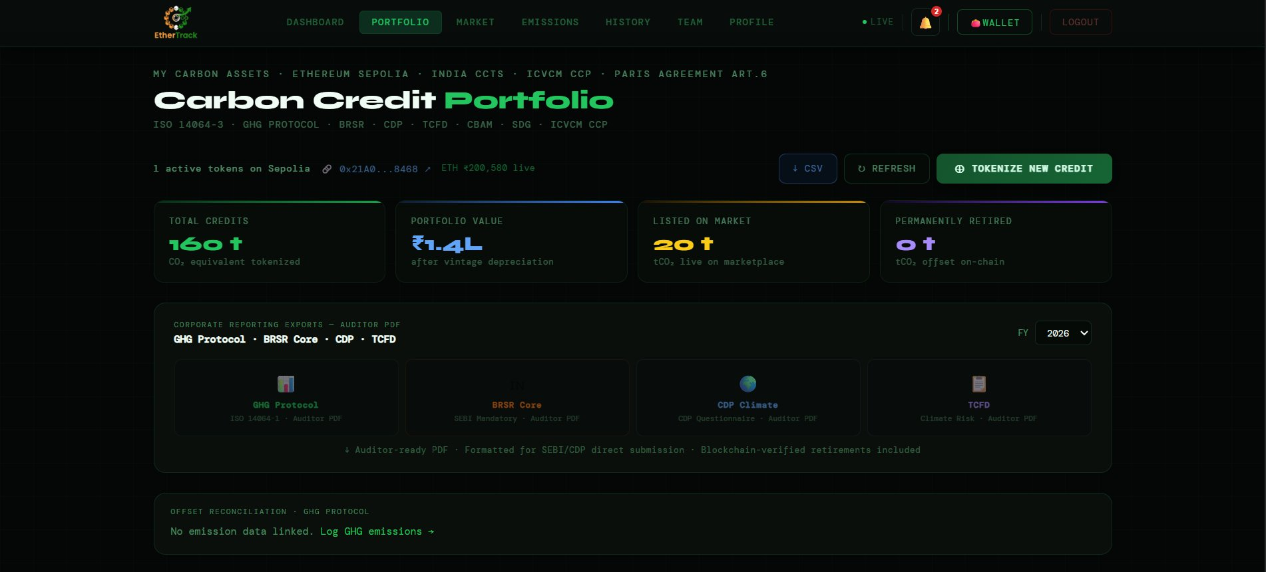
Portfolio page — header, stat cards, report exports, and offset reconciliation

9.1 Portfolio Header & Stats
FIELD | DESCRIPTION | REQUIRED
Active tokens line | Shows: "X active tokens on Sepolia · 0x21A0...8468 (wallet) · ETH ₹XXX live" | Header
↓ CSV | Downloads all portfolio data as CSV. | Button
↺ REFRESH | Refreshes data from blockchain. | Button
⊕ TOKENIZE NEW CREDIT | Opens Tokenize form (Section 8). | Button
TOTAL CREDITS | Total tCO₂ equivalent tokenized (e.g. 160 t). | Stat
PORTFOLIO VALUE | Total ₹ value after vintage depreciation (e.g. ₹1.4L). | Stat
LISTED ON MARKET | Credits currently listed for sale on the marketplace. | Stat
PERMANENTLY RETIRED | Credits burned on-chain as offsets. | Stat

9.2 Portfolio Filter Tabs
FIELD | DESCRIPTION | REQUIRED
ALL | All credits regardless of status. Badge shows total count. | Tab
HELD | Credits you hold but have not listed or retired. | Tab
LISTED | Credits actively listed for sale on the marketplace. | Tab
RETIRED | Credits permanently burned on-chain. | Tab
PENDING | Credits awaiting admin verification after tokenization. | Tab
✦ CCP | Credits with ICVCM Core Carbon Principles labelling. | Tab
CCC | Compliance Carbon Credits under India CCTS. | Tab
CBAM ✓ | Credits eligible for EU Carbon Border Adjustment Mechanism. | Tab
REJECTED | Credits rejected during admin verification. | Tab

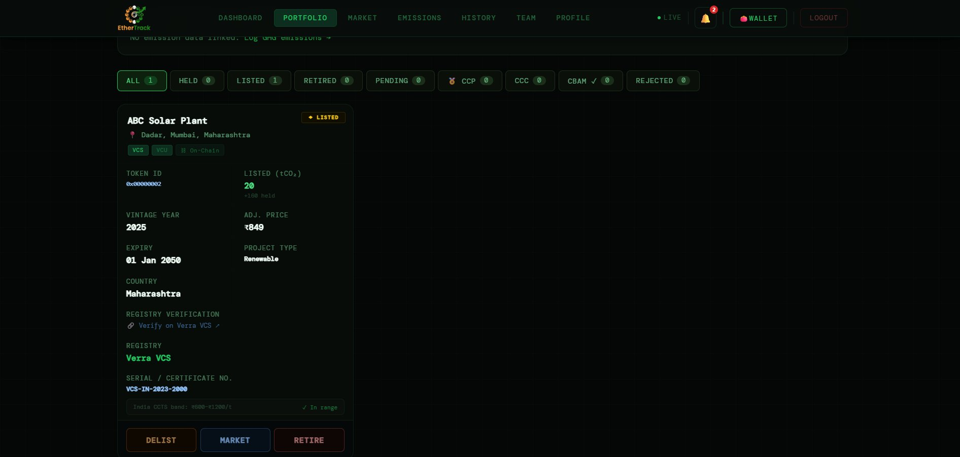
Portfolio credit card showing all metadata and action buttons

9.3 Credit Card Fields
FIELD | DESCRIPTION | REQUIRED
Status badge | Top right: ⬤ LISTED, HELD, PENDING, or PERMANENTLY RETIRED ON-CHAIN (red). | Badge
Project name & location | Bold name + pin emoji + city, state. | Display
Standard tags | VCS/GS/CDM/ACR/BEE badge + credit type (VCU/CCC) + On-Chain badge. | Tags
TOKEN ID | Ethereum token ID (e.g. 0x00000002). | Display
LISTED (tCO₂) | Credits listed for sale. | Display
VINTAGE YEAR | Year of emission reduction (e.g. 2025). | Display
ADJ. PRICE | Price after vintage depreciation (e.g. ₹849). | Display
EXPIRY | Credit expiry date (e.g. 01 Jan 2050). | Display
PROJECT TYPE | Type of project (e.g. Renewable). | Display
COUNTRY | Country of origin. | Display
REGISTRY VERIFICATION | "Verify on Verra VCS ↗" link — opens registry listing in new tab. | Link
SERIAL / CERTIFICATE NO. | Unique serial number (e.g. VCS-IN-2023-2000). | Display
India CCTS band | "✓ In range" if price is within ₹600–₹1,200/t CCTS band. | Validation
DELIST | Removes from marketplace. Credit returns to HELD status. | Button
MARKET | Takes you to Market with this credit pre-selected for trading. | Button
RETIRE | Permanently burns the credit on-chain. Irreversible. | Button

⚠ IMPORTANT
The RETIRE button is irreversible. Once a credit is retired (burned on Ethereum), it cannot be recovered, resold, or un-retired. Only retire when you are certain.

9.4 Retiring a Credit — Full Step-by-Step
1 | Click RETIRE on the credit card  A confirmation dialog appears. Read carefully.

2 | Confirm the retirement  Click Confirm in the dialog. MetaMask opens automatically.

3 | Review the MetaMask transaction  Check the contract address (Marketplace.sol), ETH amount, and gas fee. Gas fees are small on Sepolia testnet.

4 | Click Confirm in MetaMask  The burn transaction is submitted to Ethereum Sepolia.

5 | Wait for blockchain confirmation  15–30 seconds on Sepolia. The credit moves to the RETIRED tab once confirmed.

9.5 The Retirement Certificate — Full Guide
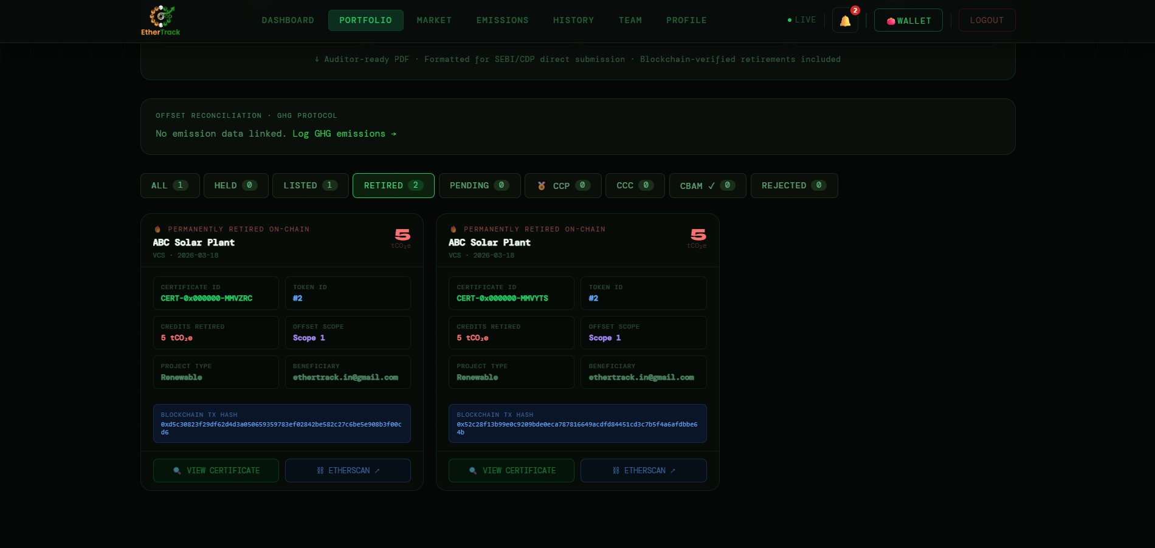
Retired tab showing two retirement certificates with blockchain TX hashes

After a credit is retired, a full ISO 14064-3 compliant retirement certificate is automatically generated. Go to the RETIRED tab in your portfolio to find all your certificates.

FIELD | DESCRIPTION | REQUIRED
PERMANENTLY RETIRED ON-CHAIN badge | Red badge at top of the card confirming on-chain burn. | Badge
tCO₂e count | Large red number showing credits retired (e.g. 5 tCO₂e). | Display
CERTIFICATE ID | Unique certificate ID (e.g. CERT-0x000000-MMVZRC) in green. This is the public verification ID. | Display
TOKEN ID | Ethereum token that was burned (e.g. #2). | Display
CREDITS RETIRED | Exact amount in tCO₂e (e.g. 5 tCO₂e). | Display
OFFSET SCOPE | GHG Protocol scope this was applied to (e.g. Scope 1). | Display
PROJECT TYPE | Type of project (e.g. Renewable). | Display
BENEFICIARY | Email of the account that made the retirement. | Display
BLOCKCHAIN TX HASH | 66-character hex string starting with 0x. This is the on-chain proof of the burn. | Display
VIEW CERTIFICATE | Opens the full ISO 14064-3 PDF certificate with QR code for public verification. | Button
ETHERSCAN ↗ | Opens the burn transaction on Etherscan — public blockchain explorer. | Link

9.6 How to Verify a Retirement Certificate
Any auditor, regulator, or third party can independently verify your retirement using just the Certificate ID or the Etherscan link — without logging into EtherTrack.

Method 1 — Verify via Etherscan (Most Direct)
1 | Find the retirement in your RETIRED tab  Open Portfolio → click RETIRED tab → find the certificate card.

2 | Copy the BLOCKCHAIN TX HASH  The full 0x... hash is shown on the card. This uniquely identifies the on-chain burn transaction.

3 | Click ETHERSCAN ↗  Opens the transaction on Etherscan Sepolia in a new tab automatically.

4 | Share the Etherscan URL with your auditor  The URL contains the transaction hash. Anyone with this link can see: the contract called (Marketplace.sol), the wallet address that retired it, the token ID burned, the timestamp, and the block number. This is permanent, public, and cannot be altered.

Method 2 — Verify via Certificate QR Code
1 | Click VIEW CERTIFICATE on the retirement card  The ISO 14064-3 PDF certificate opens.

2 | The certificate contains a QR code  The QR code links to a public verification URL on EtherTrack.

3 | Share the PDF or QR with your auditor  They can scan the QR code to open the public verification page, or search the Certificate ID on EtherTrack to confirm the retirement is real and not duplicated.

✅ TIP
For BRSR Core and CDP submissions, include the Etherscan transaction hash or the Certificate ID in the relevant field of your report. EtherTrack's report PDFs include these hashes automatically.

Section 10 — Carbon Credit Exchange (Trading)
The Carbon Credit Exchange is a live blockchain-powered trading platform. Click MARKET in the navigation bar. The page is titled "Carbon Credit Exchange" with LIVE ORDER BOOK · HYBRID AMM · AUTO-MATCHING.

⚠ IMPORTANT
KYC must be verified and MetaMask must be connected to place buy or sell orders. The KYC VERIFIED badge and SEPOLIA badge in the top right confirm your status.

10.1 Market Stats Bar
FIELD | DESCRIPTION | REQUIRED
CREDITS AVAILABLE | Total tCO₂e currently listed across all active marketplace listings. | Stat
CREDITS RETIRED | Platform-wide total tCO₂e permanently retired on-chain. | Stat
DAILY VOLUME | Total INR value of trades executed today. | Stat
AVG TRADE PRICE | Average ₹ per tonne CO₂ across all trades. | Stat
OPEN BIDS | Total ETH currently locked in open bid orders. | Stat

10.2 MARKET Tab — Browse Listings
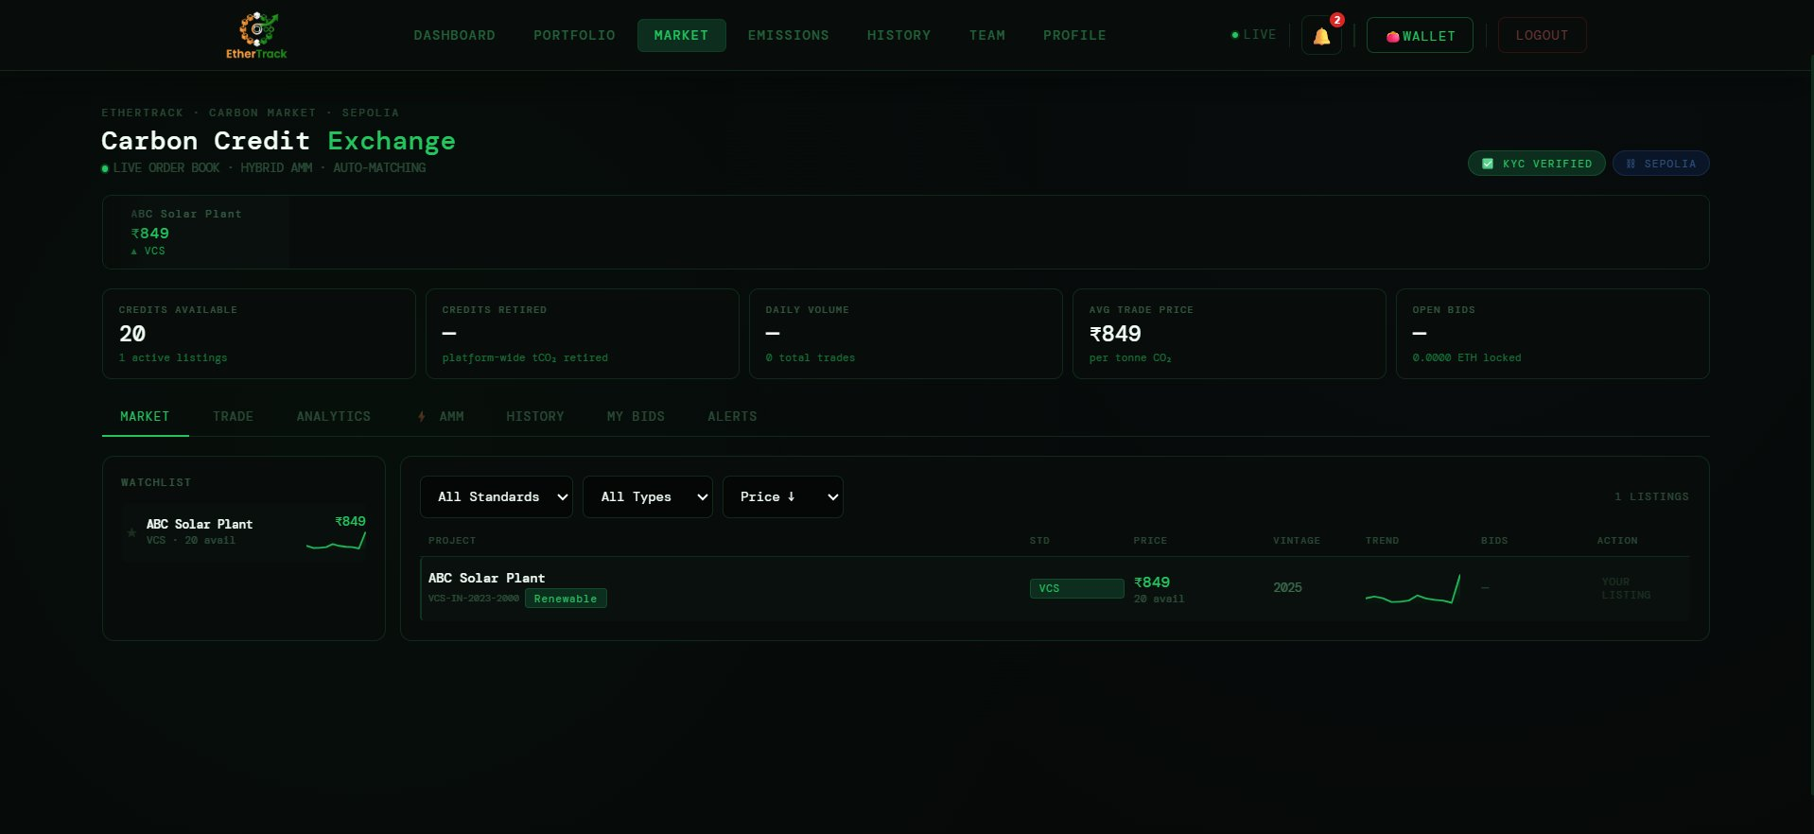
Market tab — watchlist and listings table with standard and type filters

FIELD | DESCRIPTION | REQUIRED
Watchlist (left panel) | Shows credits you are watching. Each entry shows project name, standard, price. | Panel
All Standards dropdown | Filter by: All Standards, VCS, Gold Standard, CDM, ACR, BEE. | Filter
All Types dropdown | Filter by: All Types, Renewable, Forestry, Agriculture, Waste, Industrial, Other. | Filter
Price ↓ sort | Sort by: Price high to low, Price low to high, Vintage newest first. | Sort
PROJECT column | Project name and serial number. Project type tag below (e.g. Renewable). | Column
STD column | Standard badge (VCS, GS, CDM, ACR, BEE). | Column
PRICE column | Current ask price in ₹ per tonne. | Column
VINTAGE column | Vintage year of the credit. | Column
TREND column | Sparkline chart of recent price movement. | Column
BIDS column | Number of open bids on this listing. | Column
ACTION column | YOUR LISTING if you own it. Trade button if owned by someone else. | Column

10.3 TRADE Tab — Place Orders
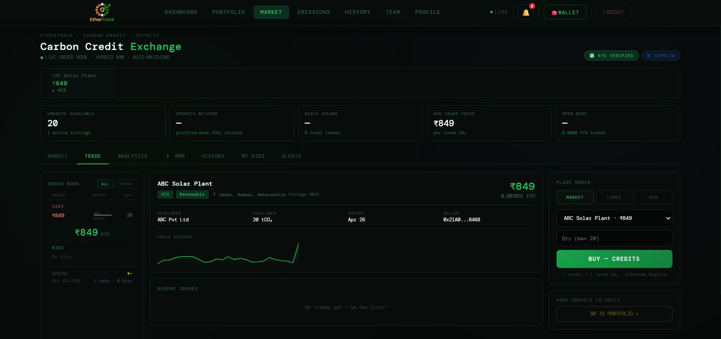
Trade tab — order book, credit detail panel, and place order panel

Order Book (Left Panel)
FIELD | DESCRIPTION | REQUIRED
ASKS (red/pink) | All current sell orders — price and quantity. Lowest ask at top. | Display
MID price | Midpoint between best ask and best bid shown in centre. | Display
BIDS (green) | All current buy orders — highest bid at top. | Display
SPREAD | Difference between best ask and best bid. | Display
ALL / TOKEN toggle | Switch between viewing all orders or orders for a specific token. | Toggle

Credit Detail Panel (Centre)
FIELD | DESCRIPTION | REQUIRED
Project name & price | Project name left, price ₹ and ETH equivalent right. | Display
DEVELOPER | Project developer company name. | Display
AVAILABLE | Quantity in tCO₂e. | Display
EXPIRY | Credit expiry date. | Display
SELLER | Truncated seller wallet address. | Display
Price History chart | Line chart of price movement over time. | Chart
RECENT TRADES | List of completed trades for this credit. Shows "No trades yet — be the first!" if empty. | Display

Place Order Panel (Right)
FIELD | DESCRIPTION | REQUIRED
MARKET order | Buys instantly at the best current ask price. No price input needed. | Order type
LIMIT order | Set maximum price you will pay. Order sits in the book until matched. | Order type
BID order | Make an offer price. Seller can accept or ignore it. | Order type
Credit dropdown | Select which credit to trade. | Select
Qty field | Number of credits to buy (max = available quantity). | Required
BUY — CREDITS button | Green. Submits order. MetaMask opens to confirm transaction. | Button
GO TO PORTFOLIO → | Link to list your own credits for sale. | Link

How to Buy Credits — Step by Step
1 | Connect MetaMask (see Section 12)  WALLET button must show ● CONNECTED with your address.

2 | Find a credit in the MARKET tab  Browse listings, check price, vintage, standard, and quantity.

3 | Click on the listing  Credit detail loads in the centre panel.

4 | Go to the TRADE tab  Click TRADE in the tab bar.

5 | Select MARKET, LIMIT, or BID  Market = instant. Limit = set a max price. Bid = make an offer.

6 | Enter quantity and click BUY — CREDITS  MetaMask opens. Review details and gas fee.

7 | Click Confirm in MetaMask  Transaction submitted. Credits appear in Portfolio after blockchain confirmation (15–30 seconds).

10.4 ANALYTICS Tab
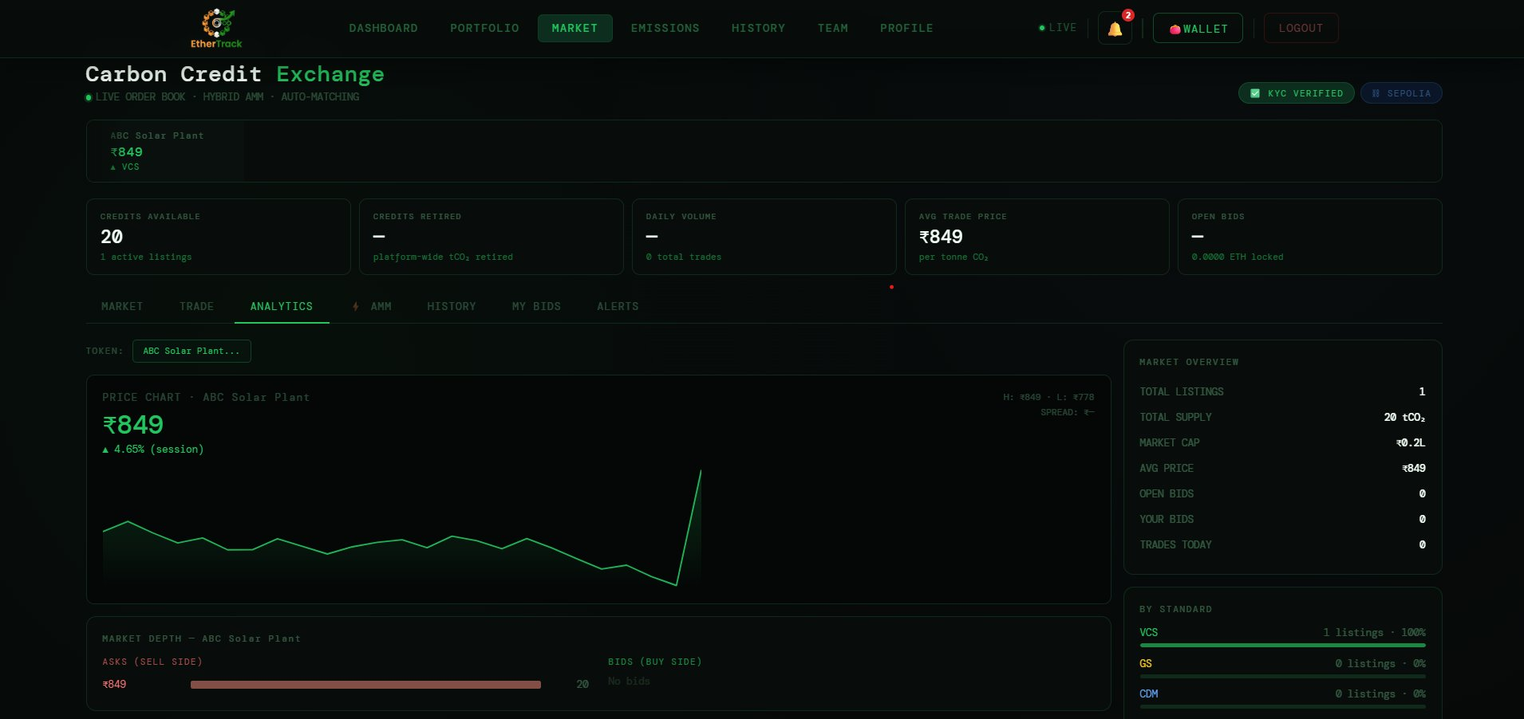
Market Analytics tab — price chart, market depth, and market overview panel

The Analytics tab gives you deep market intelligence for any listed credit. Select a credit from the TOKEN dropdown at the top.

Left Panel — Price Chart & Market Depth
FIELD | DESCRIPTION | REQUIRED
TOKEN dropdown | Select which credit to analyse (e.g. "ABC Solar Plant..."). All charts update for the selected token. | Select
PRICE CHART — [Project Name] | Large line chart showing the price history of the selected credit. Current price shown in large green text (e.g. ₹849). Session change shown below (e.g. ▲ 4.65% (session)). Top right shows H: (session high) and L: (session low) and SPREAD. | Chart
MARKET DEPTH — [Project Name] | Horizontal bar chart showing the depth of the order book. ASKS (SELL SIDE) on the left in red — bars represent the quantity available at each ask price. BIDS (BUY SIDE) on the right — bars represent buy orders. The larger the bar the more liquidity at that price level. Helps you understand if you can buy/sell without significantly moving the price. | Chart

Right Panel — Market Overview
FIELD | DESCRIPTION | REQUIRED
TOTAL LISTINGS | Total number of active credit listings on the exchange. | Metric
TOTAL SUPPLY | Total tCO₂ available across all listings (e.g. 20 tCO₂). | Metric
MARKET CAP | Total market capitalisation — supply multiplied by average price (e.g. ₹0.2L). | Metric
AVG PRICE | Weighted average price per tonne across all listings (e.g. ₹849). | Metric
OPEN BIDS | Total number of open buy bids currently in the order book. | Metric
YOUR BIDS | Number of open bids you have personally placed. | Metric
TRADES TODAY | Total trades completed today across the platform. | Metric
BY STANDARD panel | Breakdown of listings by standard: VCS — X listings — X%, GS — X listings — X%, CDM, ACR, BEE each showing their share. Helps you see which standard dominates available supply. | Panel

10.5 AMM Tab — Automated Market Maker Pools
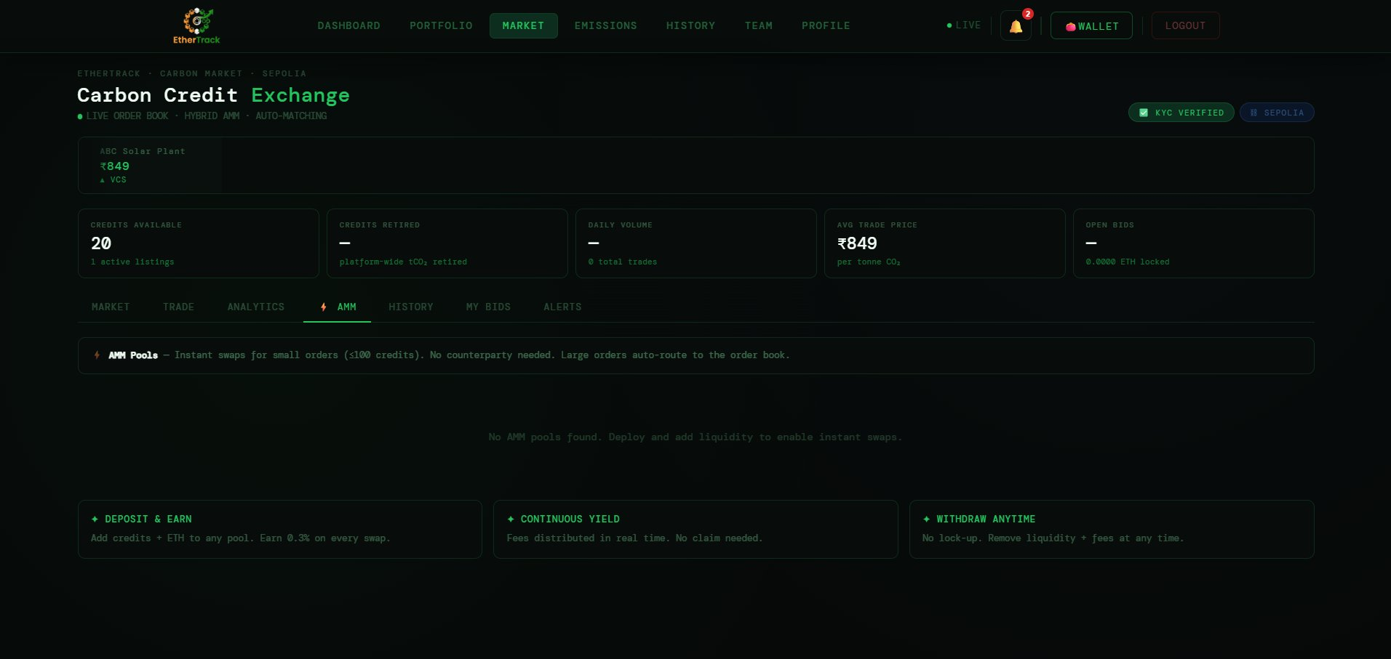
AMM tab — liquidity pool information and how to deposit and earn

The AMM (Automated Market Maker) tab is the instant swap mechanism. Unlike the order book which requires a buyer and seller to match, AMM pools let you buy or sell instantly at any time — 24/7 — without needing a counterparty.

What is an AMM Pool?
An AMM pool is a smart contract that holds a reserve of both carbon credits and ETH. When you want to buy credits instantly, you swap your ETH into the pool and receive credits in return. When you want to sell, you swap credits for ETH. The pool's algorithm (constant product formula) automatically calculates a fair price based on the ratio of credits to ETH in the pool. No human counterparty is needed.

FIELD | DESCRIPTION | REQUIRED
AMM Pools banner | Yellow ⚡ banner at the top: "AMM Pools — Instant swaps for small orders (≤100 credits). No counterparty needed. Large orders auto-route to the order book." | Info
Pool state | When no pools have been deployed yet: "No AMM pools found. Deploy and add liquidity to enable instant swaps." | State
DEPOSIT & EARN card | Explains: "Add credits + ETH to any pool. Earn 0.3% on every swap." — If you are a credit holder and want to earn passive income, deposit your credits and ETH into a pool and earn a 0.3% fee on every swap that uses your liquidity. | Feature
CONTINUOUS YIELD card | "Fees distributed in real time. No claim needed." — Your 0.3% fee earnings accumulate automatically and are distributed to your wallet in real time. You do not need to manually claim them. | Feature
WITHDRAW ANYTIME card | "No lock-up. Remove liquidity + fees at any time." — Unlike some DeFi protocols, there is no lock-up period. You can withdraw your deposited credits and ETH plus all earned fees at any time. | Feature

How AMM Works — The Simple Explanation
Pool fee: Every swap through an AMM pool charges a 0.3% fee. This fee is split between all liquidity providers in proportion to their share of the pool.
Order routing: Orders up to 100 credits use the AMM pool for instant execution. Orders larger than 100 credits are automatically routed to the order book where you wait for a counterparty match.
Price impact: Large swaps relative to the pool size will shift the price more than small ones. The market depth chart on the Analytics tab helps you understand the impact of your trade size.
No counterparty risk: When trading through AMM, the smart contract is your counterparty — not another person. There is no risk of the other side failing to deliver.

ℹ NOTE
AMM pools are more suitable for frequent small trades (under 100 credits). For large institutional trades or when you want to set a specific price, use the order book in the TRADE tab instead.

10.6 HISTORY Tab (Inside Market)
The HISTORY tab inside the Market page shows the complete trade history for the currently selected credit on the exchange — not just your own trades, but all trades by all users for that credit pair. This gives you a market-wide view of trading activity.

Currently this tab is empty as no trades have been executed on the platform yet. Once trading begins, you will see:
FIELD | DESCRIPTION | REQUIRED
TRADE ID | Unique identifier for each completed trade. | Column
PRICE | The price at which the trade was executed in ₹. | Column
QUANTITY | Number of credits traded in that transaction. | Column
TOTAL | Total INR value of the trade (price × quantity). | Column
TIME | Exact timestamp of the trade execution. | Column
TYPE | BUY or SELL — from the perspective of the aggressor (the party who initiated the trade). | Column
TX HASH | Ethereum transaction hash — click to view on Etherscan. | Column

ℹ NOTE
The Market HISTORY tab shows all trades for a selected credit. Your personal trade history across all credits is in the top-level HISTORY page (Section 11). Use the Market history to understand price trends for a specific project, and the top-level History for your own account records.

10.7 MY BIDS Tab
The MY BIDS tab shows all your currently open bid orders — bids you have placed that have not yet been matched by a seller. It is your personal bid management centre.

Currently this tab is empty as no bids have been placed yet. Once you place bids using the BID order type in the TRADE tab, you will see:
FIELD | DESCRIPTION | REQUIRED
PROJECT | The credit project you placed the bid on. | Column
BID PRICE | The price per tonne you offered in ₹. | Column
QUANTITY | Number of credits you bid for. | Column
TOTAL (ETH) | Total ETH locked in this bid (price × quantity converted to ETH). | Column
STATUS | OPEN — waiting for a seller to accept, or MATCHED — bid was accepted and trade executed. | Column
EXPIRY | When the bid expires if not matched. | Column
CANCEL BID button | Cancel an open bid and release the locked ETH back to your wallet. | Button

ℹ NOTE
When you place a BID order, ETH equal to your bid value is locked in the smart contract as escrow. If a seller accepts your bid, the ETH goes to the seller and the credits come to you. If you cancel the bid, the ETH is returned to your wallet. The OPEN BIDS stat in the market overview bar shows the total ETH currently locked in bids platform-wide.

10.8 ALERTS Tab
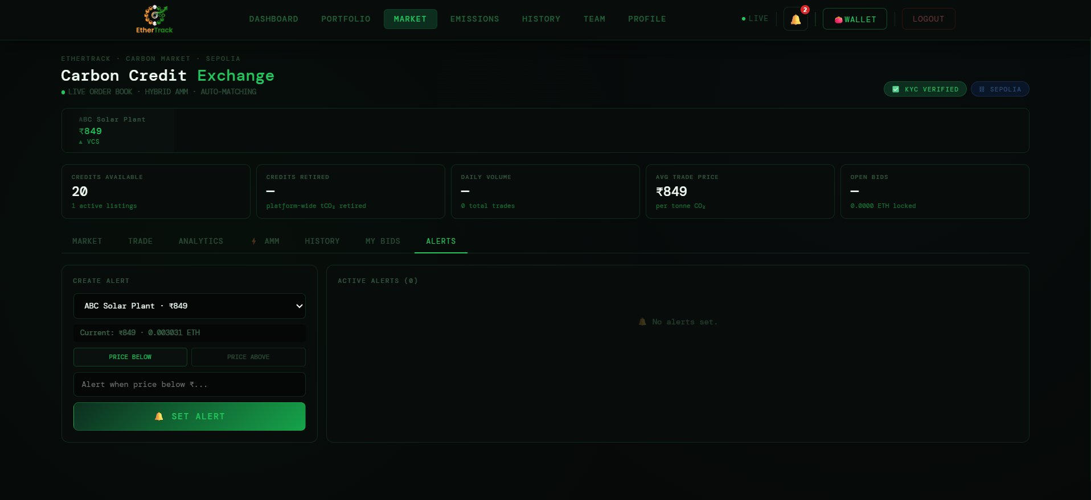
Alerts tab — create price alert form and active alerts panel

FIELD | DESCRIPTION | REQUIRED
Credit dropdown | Select which credit to set an alert for. | Select
Current price display | Shows current price and ETH equivalent (e.g. Current: ₹849 · 0.003031 ETH). | Info
PRICE BELOW / PRICE ABOVE toggle | Alert direction: notify when price drops below threshold or rises above threshold. | Toggle
Price threshold field | Enter the INR trigger price (e.g. "Alert when price below ₹...") | Required
SET ALERT button | Creates the alert. Appears in ACTIVE ALERTS panel on the right. | Button
ACTIVE ALERTS panel | Lists all currently active alerts. "No alerts set." when empty. | Display

Section 11 — Trading History
Your complete personal transaction record. Click HISTORY in the navigation bar. Titled "Trading History" with label "TRANSACTION RECORDS".

11.1 Summary Stats
FIELD | DESCRIPTION | REQUIRED
TOTAL VOLUME | Combined INR value of all your transactions. | Stat
TOTAL BOUGHT | Total INR value of all your buy transactions. | Stat
TOTAL SOLD | Total INR value of all your sell transactions. | Stat
TOTAL TRADES | Total count of all your transactions. | Stat

11.2 Filters & Export
FIELD | DESCRIPTION | REQUIRED
SEARCH | Type TXN ID (e.g. TXN-001) or market name (e.g. VCS-4821). Filters in real time. | Filter
TYPE dropdown | All Types, Buy, Sell. | Filter
STATUS dropdown | All Status, Confirmed, Pending, Failed. | Filter
EXPORT CSV button | Downloads all transactions as trading_history.csv. | Button

11.3 Transaction Table Columns
FIELD | DESCRIPTION | REQUIRED
TXN ID | Unique transaction ID (e.g. TXN-001). Muted green text. | Column
MARKET | Credit identifier (e.g. VCS-4821, REDD-1193, GS-7742, CDM-3310). | Column
TYPE | BUY (green) or SELL (red). | Column
SIZE | Number of credits traded. | Column
PRICE | Price per credit in ₹ at time of trade. | Column
TOTAL | Total ₹ value = SIZE × PRICE. Bold text. | Column
TIME | Transaction time in HH:MM:SS. | Column
STATUS | Confirmed (green badge), Pending (yellow), Failed (red). | Column

11.4 Pagination
5 records per page. Navigation: ← PREV, page number buttons (current page highlighted green), NEXT →. EXPORT CSV downloads ALL records regardless of which page you are viewing.

Section 12 — Wallet & MetaMask
MetaMask is the blockchain wallet EtherTrack uses to execute trades, retire credits, and tokenize credits. It is a free browser extension. You need it for any on-chain transaction — but you can browse and log emissions without it.

12.1 The WALLET Button States
FIELD | DESCRIPTION | REQUIRED
👛 WALLET (not connected) | Plain green-bordered button. MetaMask not connected. | State
👛 WALLET · 0x1234...abcd | Shows truncated address when connected. | State
BOUND pill (green) | Wallet is cryptographically linked to your EtherTrack account. | Badge
BINDING... pill (yellow) | Briefly shows while wallet is being silently linked. | Badge

12.2 First-Time MetaMask Setup — Step by Step
1 | Install MetaMask browser extension  Go to metamask.io. Install for Chrome, Firefox, or Brave. Create a new wallet. Save your 12-word seed phrase in a safe place — this is the only way to recover your wallet.

2 | Add Ethereum Sepolia Testnet  Open MetaMask → click the network dropdown at the top (may show "Ethereum Mainnet") → click "Add network" → search for Sepolia → select and add it. EtherTrack currently runs on Ethereum Sepolia.

3 | Get free Sepolia test ETH  Go to sepoliafaucet.com or faucet.sepolia.dev. Enter your MetaMask wallet address and request test ETH. This is test currency with no real monetary value — used only to pay gas fees on Sepolia.

4 | Click CONNECT METAMASK → in EtherTrack  In the WALLET dropdown. MetaMask popup appears. Select your account and click Connect.

5 | Wallet auto-binds to your account  EtherTrack silently signs a challenge with your wallet to prove ownership. BINDING... appears briefly, then changes to BOUND — your wallet is now permanently linked to your EtherTrack account.

12.3 Wallet Dropdown — When Connected
FIELD | DESCRIPTION | REQUIRED
● CONNECTED badge | Green badge confirming MetaMask is connected. | Status
Wallet address box | Full 0x address in a dark box. | Display
BALANCE | Your ETH balance (e.g. 0.0492 ETH). | Display
VALUE (INR) | INR equivalent at live ETH/INR rate (e.g. ₹13,776). Powered by Coingecko live price. | Display
NETWORK | Network name (e.g. Sepolia or Ethereum Mainnet). | Display
ACCOUNT LINK | ✅ BOUND (green) = linked. ⟳ LINKING... (yellow) = in progress. NOT LINKED (red) = failed. | Status
DISCONNECT WALLET button | Disconnects MetaMask. Your account data is unaffected. | Button

12.4 What Happens During a Trade or Retirement
- You click BUY — CREDITS or RETIRE.
- MetaMask opens automatically showing contract address (Marketplace.sol), ETH amount, and estimated gas fee.
- Review the gas fee. On Sepolia, gas fees use test ETH and are very small.
- Click Confirm in MetaMask to submit the transaction.
- EtherTrack shows a processing state while waiting for blockchain confirmation.
- After 15–30 seconds on Sepolia, the trade is confirmed and your portfolio updates.

⚠ IMPORTANT
Never close MetaMask or navigate away while a transaction is pending. If a transaction fails, check your Sepolia ETH balance — you may need more test ETH from the faucet.

12.5 Notification Bell — Quick Reference
FIELD | DESCRIPTION | REQUIRED
🔔 Bell badge | Red badge with unread count. | Display
Mark all read | Clears the unread badge. | Button
Notification item | Icon, title, message, and time ago. Green dot = unread. Hover shows ✕ delete button. | Display
VIEW ALL NOTIFICATIONS → | Opens full Notifications page. | Link
Auto-generated for | KYC Submitted, KYC Approved, Credit Tokenized, Trade Executed, Credit Retired, Price Alert triggered. | Events

Section 13 — INR Wallet & Payments
EtherTrack now supports full Indian Rupee (INR) payments alongside MetaMask ETH. The INR Wallet is your dedicated financial hub for depositing funds via UPI or Net Banking, withdrawing to your bank account, tracking all transactions, and trading carbon credits directly in rupees — no crypto wallet required for buying. Click WALLET in the navigation bar to open it.

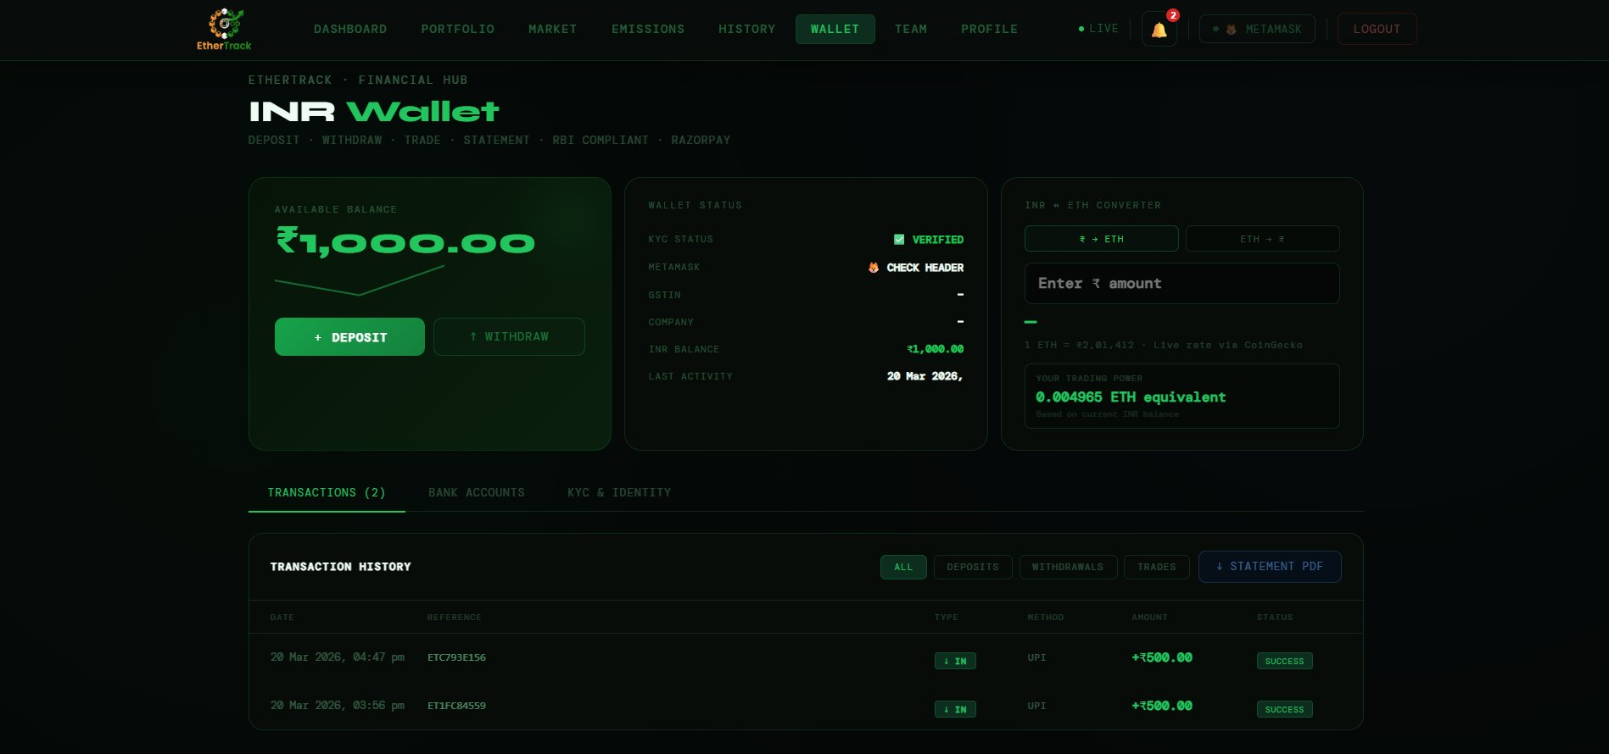
INR Wallet — main page showing balance, wallet status, INR↔ETH converter, and transaction history

13.1 The Wallet Page — Three Top Cards

Available Balance Card (Left)
FIELD | DESCRIPTION | REQUIRED
AVAILABLE BALANCE | Your current spendable INR balance in large green text (e.g. ₹1,000.00). | Display
Balance sparkline | A small line chart showing your balance trend over recent transactions. | Chart
🔒 Locked in orders | Shown below balance if any INR is currently locked in open bid orders. | Display
+ DEPOSIT button | Green button. Opens the Add Funds modal to top up your wallet via UPI/Net Banking. | Button
↑ WITHDRAW button | Opens the Withdraw Funds modal to send money to your bank account. | Button

Wallet Status Card (Centre)
FIELD | DESCRIPTION | REQUIRED
KYC STATUS | ✅ VERIFIED (green) or ⚠ PENDING (yellow). Click if pending — takes you to KYC form. | Status
METAMASK | 🦊 CHECK HEADER — MetaMask connection is managed in the header bar, not here. | Info
GSTIN | Your company GSTIN if set in your profile. | Display
COMPANY | Your company name if set. | Display
INR BALANCE | Your current wallet balance in green (same as the left card). | Display
LAST ACTIVITY | Date and time of your most recent transaction. | Display

INR ↔ ETH Converter Card (Right)
FIELD | DESCRIPTION | REQUIRED
₹ → ETH button | Convert INR amount to its ETH equivalent at live rate. | Toggle
ETH → ₹ button | Convert ETH amount to its INR equivalent at live rate. | Toggle
Amount input field | Enter the amount to convert. Result updates instantly. | Input
Conversion result | Shows converted amount in large green text (e.g. 0.004965 ETH). | Display
Live rate line | 1 ETH = ₹X,XX,XXX · Live rate via CoinGecko (updated every 5 minutes). | Info
YOUR TRADING POWER | Shows how much ETH your current INR balance is equivalent to. Helps you understand your buying power on the exchange. | Display

13.2 Depositing Funds — Step by Step
Depositing adds INR to your EtherTrack wallet. All deposits are processed through Razorpay — India's RBI-authorised Payment Aggregator. Your payment is 256-bit encrypted.

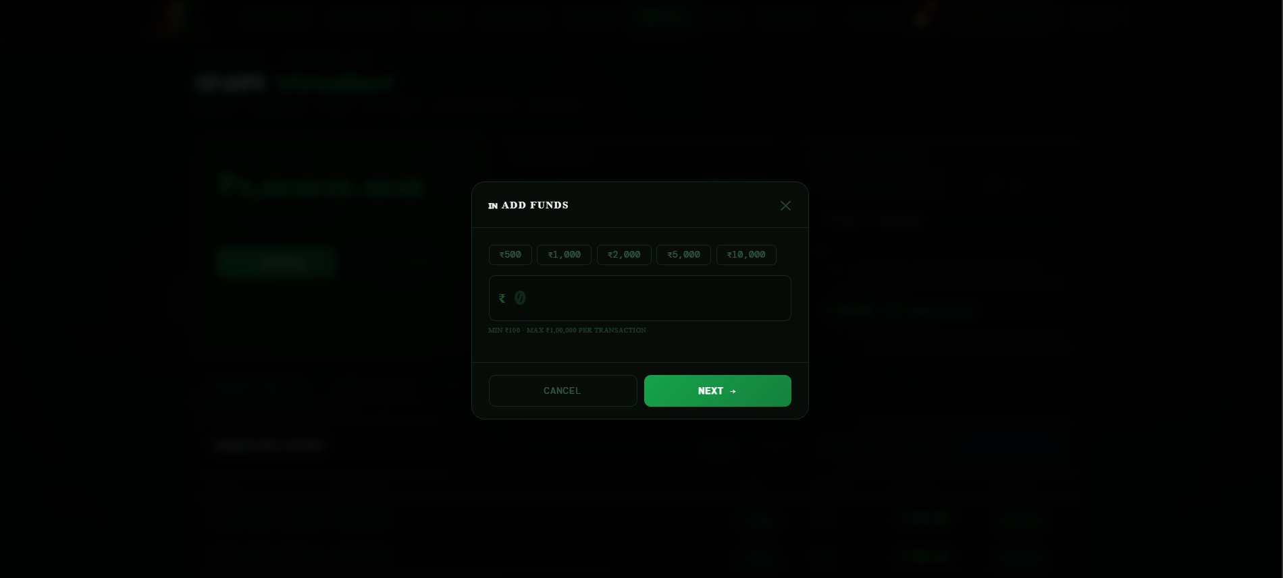
Add Funds modal — Step 1: Enter amount with quick preset buttons

Step 1 — Enter Amount
FIELD | DESCRIPTION | REQUIRED
Quick preset buttons | ₹500, ₹1,000, ₹2,000, ₹5,000, ₹10,000. Click any to auto-fill the amount field. Selected preset highlights green. | Presets
₹ Amount field | Large input with ₹ prefix. Type any amount. Minimum ₹100, Maximum ₹1,00,000 per transaction. | Required
Limit hint | "MIN ₹100 · MAX ₹1,00,000 PER TRANSACTION" shown below the field. | Info
CANCEL | Closes the modal without any action. | Button
NEXT → | Validates the amount and advances to payment method selection. Shows inline error if amount is below ₹100. | Button

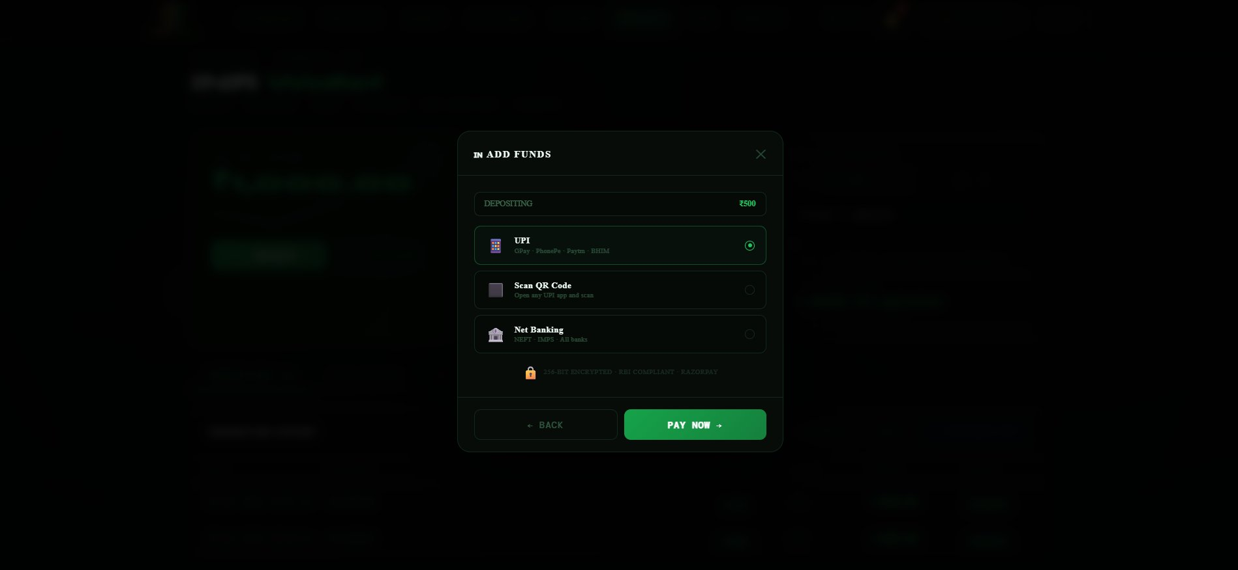
Add Funds modal — Step 2: Select payment method (UPI selected)

Step 2 — Choose Payment Method
FIELD | DESCRIPTION | REQUIRED
DEPOSITING pill | Shows your chosen amount at the top (e.g. DEPOSITING ₹500). | Display
📱 UPI | GPay · PhonePe · Paytm · BHIM. Fastest — instant settlement. Pre-selected by default. | Method
⬛ Scan QR Code | Open any UPI app and scan the QR code shown by Razorpay. Ideal if you prefer QR. | Method
🏦 Net Banking | NEFT · IMPS · All Indian banks. Slightly slower than UPI. | Method
Radio button | Green radio dot shows selected method. | Select
🔒 Security line | "256-BIT ENCRYPTED · RBI COMPLIANT · RAZORPAY" shown at the bottom. | Info
← BACK | Returns to Step 1 to change the amount. | Button
PAY NOW → | Opens the Razorpay payment popup in a new overlay. Complete the payment inside the Razorpay window. | Button

Step 3 — Complete Payment in Razorpay
1 | The Razorpay payment popup opens  A full-screen Razorpay overlay appears with EtherTrack branding (green theme). Your name and email are pre-filled from your profile.

2 | Complete UPI payment  For UPI: enter your UPI ID (e.g. name@okaxis) or scan the QR code. Approve the payment in your UPI app (GPay, PhonePe, Paytm, BHIM).

3 | Razorpay confirms payment  Once your bank confirms, Razorpay sends a success signal back to EtherTrack automatically.

4 | EtherTrack verifies and credits  EtherTrack performs cryptographic signature verification of the payment (HMAC-SHA256). Your INR wallet balance is credited instantly. The modal shows a green ✅ FUNDS ADDED! confirmation with amount, reference ID, method, and status CONFIRMED.

5 | Click DONE ✓  Closes the modal. Your new balance appears immediately on the wallet page.

ℹ NOTE
If you close the browser after paying but before seeing the confirmation, your funds are still safe. EtherTrack receives a Razorpay webhook notification automatically and credits your balance. Check your wallet after a few minutes — it will reflect the deposit.

13.3 Withdrawing Funds — Step by Step
Withdrawing sends INR from your EtherTrack wallet to your bank account via IMPS/NEFT through Razorpay Payouts. Minimum ₹100. Processed within 1–2 business days.

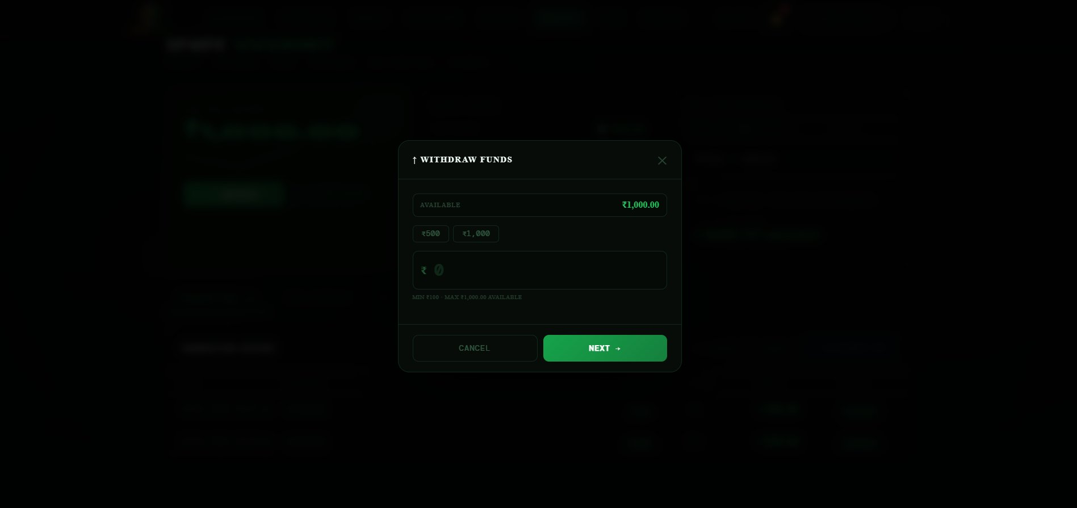
Withdraw Funds modal — Step 1: Enter withdrawal amount

Step 1 — Enter Amount
FIELD | DESCRIPTION | REQUIRED
AVAILABLE pill | Shows your current available balance at the top (e.g. ₹1,000.00). | Display
Quick presets | Shows preset amounts that fit within your available balance (e.g. ₹500, ₹1,000). | Presets
₹ Amount field | Enter the amount to withdraw. Minimum ₹100. Maximum = your available balance. | Required
Limit hint | "MIN ₹100 · MAX ₹X,XXX.XX AVAILABLE" — dynamically shows your current balance. | Info
NEXT → | Advances to bank details step. Shows error if amount exceeds balance. | Button

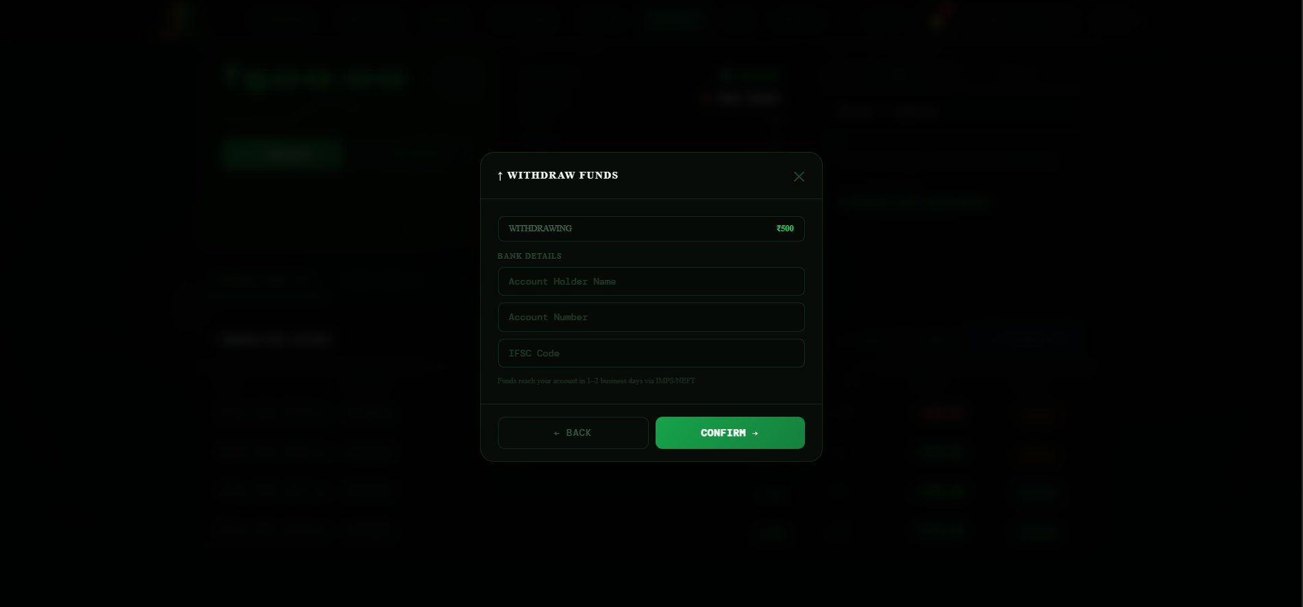
Withdraw Funds modal — Step 2: Bank details with saved accounts and manual entry

Step 2 — Enter Bank Details
FIELD | DESCRIPTION | REQUIRED
WITHDRAWING pill | Shows your withdrawal amount at the top (e.g. WITHDRAWING ₹500). | Display
SAVED ACCOUNTS section | If you have saved bank accounts, they appear here as clickable cards. Click a card to auto-fill the bank details below. The selected account highlights green. | Display
OR ENTER MANUALLY section | If no saved accounts or you want a different account, enter details manually. | Section
Account Holder Name | Full name of the bank account holder — must match your bank records exactly. | Required
Account Number | Your bank account number. | Required
IFSC Code | Your bank branch IFSC code (e.g. HDFC0001234). | Required
Funds reach note | "Funds reach your account in 1–2 business days via IMPS/NEFT" | Info
← BACK | Returns to amount step. | Button
CONFIRM → | Submits the withdrawal request. Button shows PROCESSING... while request is submitted. | Button

Withdrawal Confirmation
On success the modal shows ✅ WITHDRAWAL INITIATED! with the amount debited, reference number, method (BANK), and status PROCESSING. The funds are deducted from your wallet balance immediately. They reach your bank account within 1–2 business days via IMPS or NEFT.

⚠ IMPORTANT
Your INR balance is deducted immediately when you confirm withdrawal. The actual bank transfer takes 1–2 business days. If you see the balance deducted but funds have not arrived after 3 business days, contact support@ethertrack.in with your reference number.

13.4 Transaction History Tab
The TRANSACTIONS tab (default) shows every INR movement — deposits, withdrawals, and trade deductions/refunds.
FIELD | DESCRIPTION | REQUIRED
ALL filter | Shows every transaction regardless of type. | Filter
DEPOSITS filter | Shows only incoming deposits (↓ IN badges in green). | Filter
WITHDRAWALS filter | Shows only outgoing withdrawals (↑ OUT badges in red). | Filter
TRADES filter | Shows only trade-related deductions and refunds (method = system). | Filter
↓ STATEMENT PDF button | Generates and downloads a full A4 PDF account statement with your balance, all transactions in a table, and the footer "EtherTrack Technologies Pvt Ltd · RBI Compliant · Razorpay Powered". | Button

Transaction Table Columns
FIELD | DESCRIPTION | REQUIRED
DATE | Date and time of the transaction (e.g. 20 Mar 2026, 04:47 pm). | Column
REFERENCE | Unique reference ID for the transaction (e.g. ETC793E156). Use this when contacting support. | Column
TYPE | ↓ IN badge (green) for deposits and refunds. ↑ OUT badge (red) for withdrawals and trade deductions. | Column
METHOD | Payment method used: UPI, BANK, or SYSTEM (for trade deductions/refunds). | Column
AMOUNT | Amount in INR with + (credit) or - (debit) prefix in green/red. | Column
STATUS | SUCCESS (green), PENDING (yellow), or FAILED (red) badge. | Column

13.5 Bank Accounts Tab
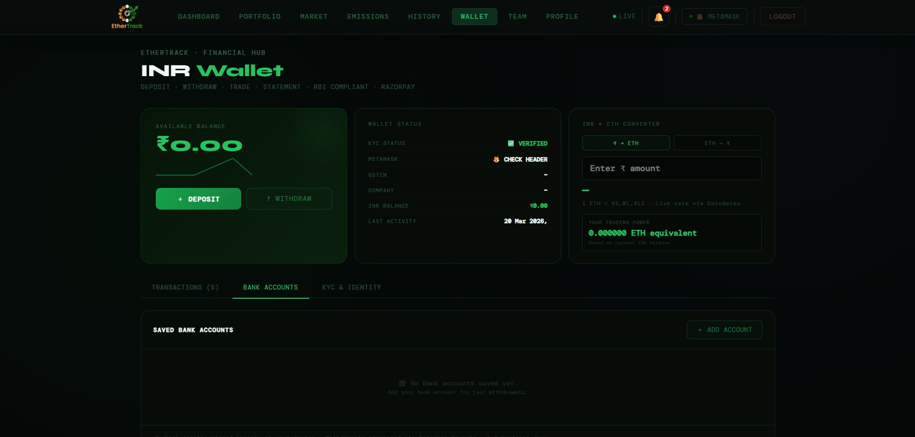
Bank Accounts tab — empty state with Add Account button

The BANK ACCOUNTS tab stores your bank account details securely in EtherTrack's database — persisted across all your devices and logins. These are used for fast withdrawal without re-entering bank details every time.

Adding a Bank Account
1 | Click + ADD ACCOUNT  The Add Bank Account form expands below the header.

2 | Fill in all four fields  ACCOUNT HOLDER NAME (e.g. Rahul Sharma), BANK NAME (e.g. HDFC Bank), ACCOUNT NUMBER (your full account number), IFSC CODE (e.g. HDFC0001234).

3 | Click SAVE ACCOUNT  Account is saved to EtherTrack's database. It appears as a card in the Bank Accounts grid. The first account you add is automatically set as DEFAULT.

Bank Account Card — Fields
FIELD | DESCRIPTION | REQUIRED
Account holder name | Shown in bold at the top. | Display
Account number | Masked as ···· ···· XXXX showing only last 4 digits for security. | Display
Bank & IFSC | Bank name · IFSC code shown below the masked number. | Display
DEFAULT badge | Green badge in top right — this account is auto-selected for withdrawals. | Badge
SET DEFAULT button | Click to make this account the default for future withdrawals. | Button
DELETE button | Red button. Removes the account from EtherTrack. If you delete the default, the next oldest account becomes default automatically. | Button

ℹ NOTE
Bank accounts are stored server-side in EtherTrack's PostgreSQL database — they persist across all your devices and browsers. You do not need to re-add accounts if you log in on a different device.

13.6 KYC & Identity Tab
The KYC & IDENTITY tab shows your account's identity and verification status, and displays your trading permissions clearly.
FIELD | DESCRIPTION | REQUIRED
🪪 KYC STATUS | VERIFIED (green) or PENDING (yellow). | Identity
🏢 COMPANY | Company name from your profile. | Identity
📋 GSTIN | Your GST Identification Number. | Identity
🪙 PAN | Your company PAN number. | Identity
🏛 CIN | Corporate Identification Number. | Identity
📧 EMAIL | Your registered email. | Identity
🏭 INDUSTRY | Your industry sector. | Identity
💼 COMPANY TYPE | Type of company (e.g. Private Limited). | Identity

Trading Permissions Grid
FIELD | DESCRIPTION | REQUIRED
✓ INR DEPOSITS | Always active. Via UPI / Net Banking. | Permission
✓ INR WITHDRAWALS | Always active. Via Bank Transfer. | Permission
CREDIT TRADING | Active only after KYC is verified. | Permission
METAMASK BIND | Active only after MetaMask wallet is connected and bound. | Permission
BRSR REPORTS | Active only after KYC is verified. | Permission
CREDIT RETIRE | Active only when both KYC is verified AND MetaMask is bound. | Permission

13.7 Trading with INR — The Payment Toggle
Once you have deposited INR into your wallet, you can use it to buy carbon credits directly in rupees — without needing ETH in MetaMask. The payment toggle is in the TRADE tab of the Market page.

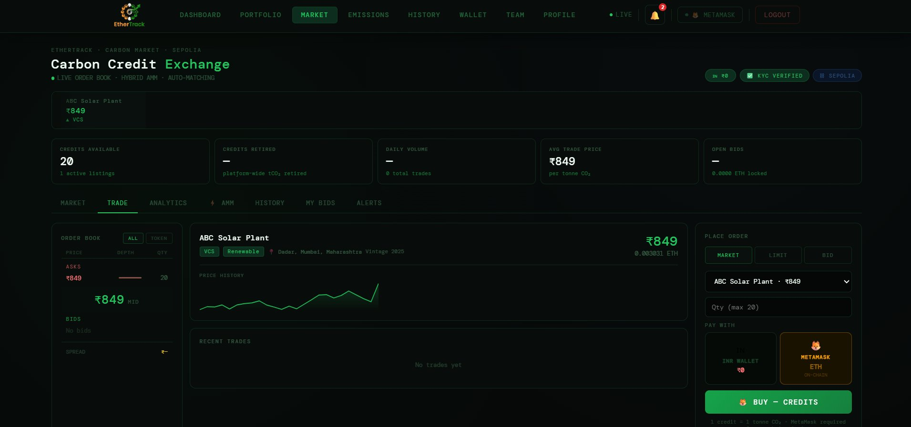
Market Trade tab — PAY WITH toggle showing INR Wallet vs MetaMask ETH options

PAY WITH Toggle — Two Options
FIELD | DESCRIPTION | REQUIRED
🇮🇳 INR WALLET button | Left card. Shows your current INR balance below the flag. Green border when selected. If you have enough balance for the trade, shows ✓ SUFFICIENT in green. If not enough, shows SHORT ₹X,XXX in red. | Payment option
🦊 METAMASK button | Right card. Shows ETH · ON-CHAIN label. Amber border when selected. Uses your MetaMask wallet ETH balance for payment. | Payment option
+ ADD FUNDS TO WALLET → | Appears below the toggle if INR WALLET is selected but balance is insufficient. Click to go directly to the Wallet page to deposit more funds. | Button

How INR Trading Works — Step by Step
1 | Select INR WALLET in the PAY WITH toggle  The toggle highlights green. Your INR balance is shown. Check that ✓ SUFFICIENT is shown for your trade size.

2 | Choose your credit, quantity, and order type  Select the credit from the dropdown, enter quantity, choose MARKET or LIMIT order. The trade summary updates showing total in ₹.

3 | Click 🇮🇳 BUY X · ₹XX,XXX button  The button shows the exact INR amount that will be deducted including the 0.5% platform fee. A confirmation modal opens.

4 | Review the confirmation modal  The modal shows a 🇮🇳 PAYING FROM INR WALLET banner with your available balance and deduction amount, full credit details, subtotal, platform fee, and total.

5 | Click 🇮🇳 CONFIRM & PAY →  EtherTrack deducts the INR from your wallet first. Then MetaMask opens to sign the on-chain credit transfer (this does not cost any additional ETH — it only signs the transaction).

6 | Approve the MetaMask signature  This is an on-chain signing step required to transfer the carbon credit token to your wallet. Click Confirm in MetaMask.

7 | Trade complete  The carbon credits appear in your Portfolio. Your INR balance reflects the deduction. A notification confirms the trade.

⚠ IMPORTANT
MetaMask is still required for INR trades — it is needed to sign the on-chain credit token transfer. INR pays the rupee cost; MetaMask signs the blockchain transfer. If you reject MetaMask after INR is deducted, the system automatically refunds your INR wallet. You will see a REFUND entry in your transaction history.

INR Trade Summary — What You See
FIELD | DESCRIPTION | REQUIRED
Subtotal | Quantity × price per credit in ₹. | Line
Vintage adjustment | Discount applied if credit is over 2 years old. | Line
Platform fee (0.5%) | EtherTrack's trading fee in ₹. | Line
TOTAL (INR WALLET) | Final amount deducted from your INR wallet. Shown in green if sufficient, red if not. | Total

13.8 Technical Notes for the Informed User
For users who want to understand how the system works under the hood:
- Payment security — Every deposit is verified server-side using HMAC-SHA256 cryptographic signature matching between EtherTrack's backend and Razorpay. The frontend cannot fake or manipulate a payment — only the verified Razorpay signature is accepted.
- Atomic balance operations — Your INR balance is updated using PostgreSQL atomic transactions. There is no possibility of double-spending or race conditions — the database enforces balance >= amount before any debit.
- Webhook safety net — Even if your browser closes mid-payment, Razorpay sends a webhook to EtherTrack's server directly. Your balance is credited automatically without any action from you.
- Audit trail — Every transaction records balance_before and balance_after. EtherTrack maintains a complete immutable ledger of every INR movement in your account.
- Auto-refund protection — If MetaMask rejects after INR is deducted, the refund is processed automatically in the same API call. It appears as a SYSTEM credit in your transaction history with a refund reference.
- Powered by Razorpay — Razorpay is an RBI-authorised Payment Aggregator under the Payments and Settlement Systems Act 2007. UPI, Net Banking, and bank payouts all operate through Razorpay's licensed infrastructure.

Section 14 — User Journey Scenarios
This section walks you through complete real-world workflows from start to finish. Each journey connects multiple modules so you see exactly how everything works together. Find the scenario that matches your goal and follow it step by step.

Journey 1 — First-Time Setup: Zero to Fully Ready
You have just created your account. You need to go from zero — no wallet, no KYC, no data — to fully set up and ready to trade. This journey takes approximately 20 minutes.

Time required: 20 minutes total. KYC approval takes 1-2 business days after submission.

1 | Create your account  Go to EtherTrack and click GET STARTED in the header. Enter your email, create a strong password (watch the 4 strength bars — aim for all green), confirm it, and click CREATE ACCOUNT. You are redirected to the Login page.

2 | Log in to your Dashboard  Enter your email and password. Click SIGN IN. You land on your Dashboard. A yellow KYC banner at the top means everything is locked until KYC is done.

3 | Complete KYC — 4 steps  Click VERIFY NOW in the yellow banner. Step 1 — enter your full name, select ID type (Aadhaar recommended), enter your ID number. Step 2 — upload a scan or photo of your ID (JPG/PNG/PDF, max 5MB). Step 3 — enter your 10-digit Indian mobile number, click SEND OTP, enter the 6-digit code within 60 seconds, click VERIFY OTP. Step 4 — review all details, click SUBMIT FOR REVIEW. The Under Review screen appears.

4 | Wait for KYC approval email  You receive an email from EtherTrack once approved (1-2 business days). Return to the app and refresh — the yellow banner disappears and all pages unlock simultaneously.

5 | Install MetaMask and get test ETH  Install MetaMask from metamask.io. Open MetaMask, click the network dropdown, search for Sepolia, add it. Go to sepoliafaucet.com, enter your wallet address, request free test ETH.

6 | Connect and bind MetaMask  Click WALLET in the EtherTrack header. Click CONNECT METAMASK. The MetaMask popup appears — select your account and click Connect. The BINDING... pill appears briefly then changes to BOUND. Done.

7 | Deposit INR  Click WALLET in the nav bar. Click + DEPOSIT. Choose an amount (e.g. Rs. 1,000). Click NEXT. Select UPI. Click PAY NOW. Complete payment in the Razorpay popup using GPay or PhonePe. Balance updates instantly.

8 | Set up your Company Profile  Click EMISSIONS. Click COMPANY PROFILE tab. Fill in Company Name, Industry, Reporting Year, GSTIN, CIN, Annual Revenue, Employee count, Floor Area, Net Zero Target Year. Click SAVE PROFILE. Intensity benchmarks and PAT tracking unlock.

9 | Create your Organisation  Click TEAM. Click CREATE ORGANISATION. Fill in org name, CIN, GSTIN, industry, company type. Click CREATE ORGANISATION. You are the Owner with full access. Invite your ESG team from the TEAM tab.

TIP
You are now fully set up. KYC verified, MetaMask bound, INR deposited, Company Profile complete, Organisation created. Choose a journey below based on what you want to do next.

Journey 2 — Company Wants to Offset Its Emissions (End to End)
Your company needs to measure its carbon footprint, buy the right credits, retire them on-chain, and download an auditor-ready compliance report for SEBI BRSR or CDP. This is the core workflow EtherTrack is built for.

Time required: 30-60 minutes for first setup. 10 minutes for each subsequent reporting cycle.
Pre-requisites: KYC verified, Company Profile completed, MetaMask connected or INR deposited.

Phase 1 — Measure Your Emissions
1 | Open Emission Tracking  Click EMISSIONS in the nav bar. You see the overview with Scope 1, Scope 2, Scope 3 cards all showing 0.00 tCO2e.

2 | Log Scope 1 — Direct Emissions  Click LOG EMISSION tab. Select your biggest sources from the EMISSION ACTIVITY dropdown. Example: select Diesel (L), enter quantity consumed this month (e.g. 500 litres), pick the date, add a note, click LOG EMISSION. Repeat for petrol, LPG, refrigerant leaks (R-410A has GWP of 2088 — even small leaks matter), and company vehicle fuel.

3 | Log Scope 2 — Electricity  Select Grid Electricity (kWh). Enter your total monthly electricity consumption from your electricity bill (e.g. 12,000 kWh). The CEA India 2024 factor of 0.79 kgCO2e/kWh is applied automatically.

4 | Log Scope 3 — Value Chain  Log business travel (flights in km), employee commuting (km by transport mode), purchased goods and services (spend in Rs.), and waste generated (tonnes by disposal method). Each category auto-applies the correct DEFRA 2024 emission factor.

5 | Verify your GHG Ledger  Click GHG LEDGER tab. Review all entries. Use SCOPE 1, SCOPE 2, SCOPE 3 filter tabs to check each scope. Export as CSV if you need to share the raw data with your auditor.

6 | Check Analytics and Total Footprint  Click ANALYTICS tab — see Monthly Trend, Scope Distribution, and Emissions by Category charts. Note which category is your biggest source — that is where to focus reduction efforts. Return to the overview — the TOTAL FOOTPRINT card shows exactly how many credits you need to reach net zero. This is your offset target.

Phase 2 — Buy the Right Credits
7 | Browse the Carbon Credit Exchange  Click MARKET. Filter listings by standard (VCS, GS), project type (Renewable, Forestry), and sort by price. Click on a listing that matches your budget — check Vintage Year (recent = better), ICVCM CCP status, and price history.

8 | Place your buy order  Click TRADE tab. In PAY WITH, select INR WALLET (if you have deposited funds) or METAMASK (for ETH). Enter quantity matching your offset target. Click BUY CREDITS. Review the confirmation modal — check quantity, total cost including 0.5% platform fee. Click CONFIRM AND PAY (INR) or CONFIRM IN METAMASK (ETH). Approve in MetaMask. Credits appear in Portfolio within 15-30 seconds.

Phase 3 — Retire Credits On-Chain
9 | Retire the credits  Click PORTFOLIO. Click HELD tab to find your purchased credits. Click RETIRE on the credit card. This action is irreversible — confirm. MetaMask opens, review the transaction, click Confirm. The credit is permanently burned on Ethereum.

10 | Download your retirement certificate  Click RETIRED tab. Find the retired credit card. Click VIEW CERTIFICATE. Your ISO 14064-3 PDF certificate downloads with Certificate ID, QR code, tCO2e retired, Offset Scope, Beneficiary name, and Blockchain TX Hash. Click ETHERSCAN to share a publicly verifiable link with your auditor.

Phase 4 — Generate Compliance Reports
11 | Download BRSR Core  Go to PORTFOLIO. Find Corporate Reporting Exports. Select FY 2026. Click SEBI BRSR Core. PDF downloads instantly — pre-formatted for direct SEBI portal submission with blockchain-verified retirement records embedded.

12 | Download CDP and TCFD if needed  Click CDP Climate for your CDP questionnaire-format disclosure. Click TCFD for climate risk disclosure. Click GHG Protocol for the ISO 14064-1 inventory. All reports reference the same emission data and include the same blockchain retirement hashes.

TIP
This is the full loop: measure, buy, retire, report — all on one platform with one audit trail. The retirement certificate links directly to your BRSR and CDP reports. Your auditor can verify everything independently on Etherscan without contacting EtherTrack.

Journey 3 — Project Developer: Tokenize and Sell Credits
You have verified carbon credits from a solar, forestry, or methane project registered under Verra VCS, Gold Standard, CDM, ACR, or BEE. You want to tokenize them and list them on the marketplace.

Pre-requisites: KYC verified, MetaMask connected, registry documentation ready — serial number, methodology ID, verification certificate, and ownership proof document.

1 | Open the Tokenize form  Click PORTFOLIO. Click TOKENIZE NEW CREDIT button (top right). The Submit Carbon Credit for Verification modal opens with a notice: Reviewed by compliance team within 1-2 business days.

2 | Page 1 — Project Details  Enter Project Name (official registry name), Pincode and Location (city auto-detects from PIN), Country, Registry/Standard (e.g. VCS — Verra), Project ID (e.g. VCS-1234), Project Type (e.g. Renewable Energy), Project Developer (your company name), Quantity in tCO2, Vintage Year (e.g. 2023), Expiry Date.

3 | Page 2 — Compliance and Standards  Scroll down. Enter Serial/Certificate Number from your Verra registry (e.g. VCS-2023-IN-00412), Methodology ID (e.g. VM0007), Registry Link (Verra URL). Select Credit Type: Voluntary (VCU) for standard projects, Compliance (CCC) for CCTS. Set Corresponding Adjustment status. Select any SDG Co-Benefits (required for Gold Standard). Toggle ICVCM CCP Eligibility if your credit has been assessed.

4 | Page 3 — Verification and Ownership  Enter your ACVA Verifier name (e.g. Bureau Veritas), set Verification Status to Verified, enter ACVA Verification Date. Set Banking Status to Available — ready for trading. Toggle CBAM Eligibility if relevant. Upload your Ownership Proof Document (registry transfer certificate or purchase confirmation — PDF/JPG, max 5MB). Click SUBMIT FOR VERIFICATION.

5 | Wait for admin approval  Credit appears in PENDING tab. Admin reviews within 1-2 business days. You receive a notification when approved.

6 | List on the marketplace  After approval, find your credit in HELD tab. Click MARKET on the credit card. Set your listing price. The system checks the India CCTS price band (Rs. 600-Rs. 1,200) for compliance credits. Your credit goes live on the exchange immediately.

7 | Monitor and get paid  Go to MARKET — TRADE tab. See your credit in the ASKS section of the order book. Set a price alert in ALERTS tab. When a buyer purchases, the smart contract auto-transfers ETH (or handles INR deduction). Platform fee (0.5%) is deducted. The sale appears in your Trading History.

Journey 4 — Compliance Officer: Generate BRSR Core Report
You are the sustainability or compliance officer at a listed Indian company. You need to generate a SEBI BRSR Core disclosure that is auditor-ready and can be submitted directly to the SEBI portal.

Pre-requisites: KYC verified, energy and emission data available, Company Profile not yet set up.

1 | Complete Company Profile first  EMISSIONS — COMPANY PROFILE tab. Enter Company Name, Industry (critical — determines benchmark thresholds), Reporting Year 2026, GSTIN, CIN, PAN, Annual Revenue in crore Rs. (for revenue intensity ratio), Employees FTE (for employee intensity ratio), Floor Area in sqft (for area intensity ratio), Net Zero Target Year (e.g. 2050), Base Year (e.g. 2024), Annual CO2e Budget. Click SAVE PROFILE.

2 | Log Scope 1 — all direct sources  EMISSIONS — LOG EMISSION. Log: diesel generators in litres, company vehicles km by fuel type, LPG kg, refrigerant leaks kg by gas type. Use DOWNLOAD CSV TEMPLATE and bulk import if you have many entries to save time.

3 | Log Scope 2 — electricity  Select Grid Electricity (kWh). Enter total annual electricity from your electricity bill. The CEA India 2024 factor (0.79 kgCO2e/kWh) applies automatically. If you have solar or RECs, a lower market-based factor applies.

4 | Log Scope 3 — at minimum these categories  Business travel (flights in km and hotel nights), employee commuting (km by transport mode), purchased goods and services (Rs. spend by category), waste generated (tonnes by disposal method). BRSR Core requires at minimum the material Scope 3 categories.

5 | Check Intensity metrics  EMISSIONS — INTENSITY tab. After Company Profile is saved, the CARBON INTENSITY METRICS panel shows Revenue Intensity (tCO2e per crore Rs.), Employee Intensity (tCO2e per FTE), Area Intensity (kgCO2e per sqft), each benchmarked against your industry sector. This benchmark comparison determines whether you are a sector leader or laggard in your BRSR disclosure.

6 | Review ESG Report status  EMISSIONS — ESG REPORT tab. The SEBI BRSR Core card should show IN PROGRESS or complete. The Annual GHG Inventory panel shows all three scopes. Fix any missing data categories until BRSR is ready.

7 | Download the BRSR Core PDF  Two ways: from EMISSIONS page — scroll to Corporate Regulatory Reports — click SEBI BRSR Core. Or from PORTFOLIO — Corporate Reporting Exports — select FY 2026 — click BRSR Core. The PDF includes Scope 1/2/3 data, dual Scope 2 methodology, intensity ratios, year-over-year comparison, emission factor sources (DEFRA 2024, CEA India 2024), and any blockchain-verified retirement records — ready for SEBI portal submission.

8 | Download CDP and TCFD  Click CDP Climate button for CDP questionnaire format. Click TCFD for climate risk disclosure. Both reference the same underlying data as your BRSR report — consistent across all three frameworks.

TIP
The BRSR Core PDF from EtherTrack includes DEFRA 2024 and CEA India 2024 emission factors embedded — the same sources SEBI assessors and Big 4 auditors expect to see. No manual factor documentation needed.

Journey 5 — Deposit INR and Buy Credits Quickly
You have just been KYC approved and want to buy carbon credits using Indian Rupees. No crypto knowledge needed for the payment — just a UPI app on your phone.

Pre-requisites: KYC verified, MetaMask installed (needed to sign the on-chain credit transfer even when paying in INR).

1 | Deposit INR to your wallet  Click WALLET in nav bar. Click + DEPOSIT. Select Rs. 1,000 from presets or enter a custom amount. Click NEXT. Select UPI. Click PAY NOW. The Razorpay popup opens — complete the Rs. 1,000 payment using GPay or PhonePe. Balance updates within seconds.

2 | Browse the market  Click MARKET. The Market tab shows all listings. Review PRICE, VINTAGE, and STD (standard badge). Click on a listing you want.

3 | Go to Trade tab and select INR payment  Click TRADE in the tab bar. In the PAY WITH section on the right panel, click the INR WALLET card. Your balance shows below the flag — check it shows SUFFICIENT for your order size.

4 | Enter quantity and buy  Enter the number of credits in the Qty field. The summary shows Subtotal + 0.5% platform fee = Total in Rs. Click BUY X CREDITS. Review the confirmation modal. Click CONFIRM AND PAY.

5 | Sign the MetaMask transfer  MetaMask opens to sign the on-chain credit token transfer. This does not cost additional ETH — it is just a signature. Click Confirm.

6 | Credits arrive in Portfolio  Within 15-30 seconds the blockchain confirms. Go to PORTFOLIO — your credits are in the HELD tab. You are now a carbon credit holder on Ethereum Sepolia.

Journey 6 — Invite Your ESG Team and Assign Roles
You are the company owner on EtherTrack. You need to give your sustainability manager access to log emissions, your finance auditor read-only access for reports, and your ESG consultant full admin access.

Pre-requisites: Organisation already created in Team Management.

1 | Invite the Sustainability Manager  TEAM — click INVITE MEMBER. Enter email. Select MANAGER role (read and write emissions and portfolio, export reports — cannot invite others or approve credits). Click SEND INVITE. They receive an email and must have an EtherTrack account to accept.

2 | Invite the Finance Auditor  Click INVITE MEMBER again. Enter email. Select AUDITOR role (read-only access plus export permissions and verification badge on reports — cannot write any data). Click SEND INVITE.

3 | Invite the ESG Consultant  Click INVITE MEMBER. Enter email. Select ADMIN role (manage team, approve credits, all data — everything except billing). Click SEND INVITE.

4 | Track invite status  Invited members show with an invite pending badge until they accept. Once accepted, their role pill shows in colour — orange OWNER, red ADMIN, green MANAGER, purple AUDITOR, blue VIEWER.

5 | Change a role if needed  In the TEAM tab, find the member row. Use the role dropdown next to their name (visible to Owner and Admin). Select the new role. Change is immediate.

6 | Connect a third-party verifier  Click VERIFIERS tab. Click REQUEST VERIFIER CONNECTION. Select Bureau Veritas (ISO 14065 accredited) or EY Climate (BRSR specialist). Enter your ESG contact email. Click SUBMIT REQUEST. EtherTrack contacts the verifier on your behalf. Once connected, a verification badge appears on your PDF reports — required for BRSR Level 2 assurance.

Journey 7 — Withdraw INR From Your Wallet to Your Bank
You have accumulated INR in your EtherTrack wallet — from selling credits or depositing funds you want to retrieve. You want to transfer it to your bank account.

Pre-requisites: KYC verified, positive INR balance, bank account details ready.

1 | Save your bank account (one time)  Click WALLET — BANK ACCOUNTS tab. Click + ADD ACCOUNT. Enter Account Holder Name (exactly as on your bank records), Bank Name (e.g. HDFC Bank), Account Number, IFSC Code. Click SAVE ACCOUNT. Saved permanently to your EtherTrack account — works across all devices.

2 | Initiate the withdrawal  Click WITHDRAW on the balance card. Withdraw Funds modal opens showing your available balance.

3 | Enter amount  Select a preset or type the amount. Minimum Rs. 100. Click NEXT.

4 | Select your saved account  Your saved bank accounts appear at the top. Click your account card — it highlights green and auto-fills the bank details. Or enter manually for a different account.

5 | Confirm and track  Click CONFIRM. Your INR balance is deducted immediately. Modal shows WITHDRAWAL INITIATED with reference number. Funds reach your bank within 1-2 business days via IMPS/NEFT. Check TRANSACTIONS tab — the withdrawal shows as OUT with PENDING status updating to SUCCESS once processed.

Journey 8 — Instant Swap Using AMM Liquidity Pools
You want to buy or sell a small number of credits (under 100) instantly without waiting for an order book match. AMM pools give you instant execution 24/7 with no counterparty needed.

Pre-requisites: KYC verified, MetaMask connected with Sepolia ETH, an active AMM pool exists for the credit type.

1 | Open the AMM tab  Click MARKET — AMM tab. Active pools are listed with their Credit Reserve, ETH Reserve, and current Price.

2 | Select a pool and open the swap  Click on the pool for the credit you want. Click SWAP NOW. The AMM Swap modal opens.

3 | Choose swap direction  ETH to CREDITS — to buy credits instantly. CREDITS to ETH — to sell credits instantly. Click the appropriate button.

4 | Enter amount and preview  Enter the ETH you want to spend (or credits to sell). The preview shows you receive approximately X credits (or ETH) after the 0.3% pool fee. Review the amount before confirming.

5 | Execute the swap  Click SWAP NOW. MetaMask opens. The transaction calls the AMM smart contract. Click Confirm. The swap executes on-chain — no waiting for a buyer or seller. Credits appear in your Portfolio within seconds.

NOTE
AMM pools are ideal for orders under 100 credits. For larger quantities, orders are auto-routed to the order book instead. The AMM charges 0.3% per swap — collected by the pool and distributed to liquidity providers in real time.

Journey 9 — PAT Designated Consumer: Track Energy for BEE Compliance
Your company is in one of the 11 BEE PAT sectors (cement, steel, aluminium, fertiliser, thermal power, etc.) and is a Designated Consumer. You need to track your PAT-specific energy consumption and use it for your annual BEE compliance submission.

Pre-requisites: Company Profile saved with your correct industry sector.

1 | Open PAT Scheme tab  EMISSIONS — PAT SCHEME tab. Shows the four PAT-specific energy categories: Coal for Power (tonne) at 2420 kgCO2e/tonne, FO/LSHS (kL) at 3180 kgCO2e/kL, HSD (kL) at 2680 kgCO2e/kL, and Grid Electricity PAT (kWh) at 0.79 kgCO2e/kWh — all using BEE India emission factors. Your sector is listed in the PAT Sectors Covered panel.

2 | Log PAT energy consumption  Go to LOG EMISSION tab. Select Coal for Power (tonne) from the activity dropdown — uses BEE India factor. Log all four PAT categories separately. These are tracked in your GHG Ledger alongside your standard GHG Protocol entries but flagged as PAT-specific.

3 | Check PAT compliance position  Return to PAT SCHEME tab. Your logged consumption is displayed against the BEE India emission factors. Use this to calculate your Specific Energy Consumption (SEC) against your BEE-assigned baseline target.

4 | Check eligibility in ESG Report  EMISSIONS — ESG REPORT tab. The PAT Scheme card shows CHECK ELIGIBILITY. Click it to verify whether your facility qualifies as a Designated Consumer based on your energy consumption levels.

5 | Export for BEE submission  PORTFOLIO — GHG Protocol export. The report includes your PAT-specific energy data with BEE India emission factors. Use this for your annual energy audit submission to BEE. ESCerts earned from over-achieving your PAT target can be tokenized on EtherTrack in a future update when the CCTS-PAT bridge goes live.

Section 15 — Troubleshooting and Common Issues
This section covers every common problem on EtherTrack, what causes it, and exactly how to fix it. Issues are grouped by category. For any issue not listed here, email support@ethertrack.in with your registered email, a description of what happened, and any reference numbers or transaction hashes visible on screen.

15.1 Payment and Deposit Issues

Razorpay payment failed or cancelled
FIELD | DESCRIPTION | REQUIRED
What happened | You clicked PAY NOW but the Razorpay popup showed a failure, or you closed it before completing payment. | Cause
Try again — no impact | The failed attempt does not affect your wallet. Click + DEPOSIT again and complete the payment without closing the popup. | Fix
Try a different method | If UPI fails, go back and choose Net Banking. UPI can time out during peak hours. | Fix
Pending UPI request | Open your UPI app (GPay/PhonePe) — a pending payment request may exist. Approve it directly. If not, start a fresh deposit. | Fix
Payment deducted but balance not updated | Wait 5 minutes — EtherTrack receives a Razorpay webhook backup automatically. If balance still unchanged after 10 minutes, email support@ethertrack.in with your Razorpay payment ID (starts with pay_). | Contact

Deposit successful but wallet balance not updated
FIELD | DESCRIPTION | REQUIRED
Wait and refresh | Wait 2-3 minutes and refresh the Wallet page. The webhook may still be processing. | Fix
Check Transactions tab | Click TRANSACTIONS tab. If a SUCCESS entry exists, your balance was credited — try hard-refreshing (Ctrl+Shift+R on Windows, Cmd+Shift+R on Mac). | Fix
Contact support | Email support@ethertrack.in with your registered email, the deposit amount, and the Razorpay payment ID from your bank SMS or email confirmation. | Contact

Withdrawal not received after 2 business days
FIELD | DESCRIPTION | REQUIRED
Check transaction status | WALLET — TRANSACTIONS tab. If status shows PENDING it is still processing. If SUCCESS, the transfer was initiated to your bank. | Check
Check your bank | Log into your bank account or check your bank statement for NEFT/IMPS credit from EtherTrack or Razorpay. | Check
Verify bank details | Go to BANK ACCOUNTS tab and confirm your account number and IFSC code are correct. | Check
Contact support after 3 days | If status is SUCCESS but no bank credit after 3 business days, email support@ethertrack.in with your withdrawal Reference ID (visible in Transactions tab). | Contact

15.2 MetaMask and Wallet Issues

MetaMask not connecting
FIELD | DESCRIPTION | REQUIRED
Not installed | Install MetaMask from metamask.io first. The browser extension must be installed and set up. | Fix
MetaMask is locked | Open MetaMask, enter your password to unlock it, then try connecting again. | Fix
Wrong browser | MetaMask works on Chrome, Firefox, and Brave. It does not work in Safari or standard mobile browsers. Switch to a supported browser. | Fix
Popup blocked | Allow pop-ups for EtherTrack in your browser settings. Look for a popup-blocked icon in the address bar. | Fix
Multiple wallet extensions | If Coinbase Wallet or other extensions are installed alongside MetaMask, they can conflict. Disable other wallet extensions temporarily. | Fix

Wallet shows CONNECTED but NOT LINKED
FIELD | DESCRIPTION | REQUIRED
What happened | MetaMask is connected but shows NOT LINKED instead of BOUND. The cryptographic account binding has not completed. | Cause
Disconnect and reconnect | Click WALLET — DISCONNECT WALLET. Then click CONNECT METAMASK again. Binding runs automatically on reconnect. | Fix
Refresh the page | Hard-refresh the EtherTrack page (Ctrl+Shift+R) while MetaMask is unlocked. Binding runs silently on page load. | Fix
Wallet conflict | If still NOT LINKED after two attempts, the wallet address may be linked to a different EtherTrack account. Email support@ethertrack.in. | Contact

Wrong network — not on Sepolia
FIELD | DESCRIPTION | REQUIRED
What happened | MetaMask shows Ethereum Mainnet or another network. Transactions fail because EtherTrack runs on Ethereum Sepolia testnet. | Cause
Switch network | Open MetaMask. Click the network dropdown at the top. Select Sepolia Test Network. If not listed, click Add Network, search for Sepolia, add it. | Fix
No Sepolia ETH for gas | Go to sepoliafaucet.com or faucet.sepolia.dev. Enter your MetaMask wallet address. Request free test ETH. Wait 1-2 minutes. | Fix

Transaction stuck or pending for more than 5 minutes
FIELD | DESCRIPTION | REQUIRED
Check on Etherscan | Go to sepolia.etherscan.io, paste your wallet address, and check your pending transactions. | Check
Speed up in MetaMask | Open MetaMask, find the pending transaction, click Speed Up, submit with a higher gas fee. This replaces the stuck transaction. | Fix
Cancel and retry | Open MetaMask — find pending transaction — click Cancel. Once cancelled, go back to EtherTrack and initiate the trade again. | Fix
INR deducted but trade stuck | If you paid with INR and MetaMask rejected, an auto-refund is triggered automatically. Check WALLET — TRANSACTIONS tab for a SYSTEM credit entry labelled Refund — MetaMask rejected. | Fix

15.3 KYC Issues

KYC pending for more than 2 business days
FIELD | DESCRIPTION | REQUIRED
Check your email | The approval email is sent to your registered email address. Also check spam/junk folder. | Check
Email support | After 3 business days with no response, email support@ethertrack.in from your registered email with subject KYC Review and your full name. The compliance team will check your submission status. | Contact
While waiting | The Dashboard remains accessible in read-only mode. Trading, Portfolio, and Emission Tracking unlock only after KYC approval. | Note

Error: These KYC credentials are already verified with another account
FIELD | DESCRIPTION | REQUIRED
What it means | The Aadhaar or PAN you submitted is already linked to a different EtherTrack account. Each person can only have one KYC-verified account. | Cause
If you have two accounts | Log in to your original account and use that one. Delete the duplicate account via Profile — Request Account Deletion. | Fix
If this is an error | Email support@ethertrack.in immediately with subject KYC Duplicate — Incorrect Claim, your name, email, and ID type used. The team investigates within 24 hours. | Contact

OTP not received or expired
FIELD | DESCRIPTION | REQUIRED
Wait the full 60 seconds | OTPs can be delayed by the SMS network. Wait for the complete 60-second countdown before clicking Resend. | Fix
Check number format | Enter only the 10-digit number without +91 (the country code is fixed). Must start with 6, 7, 8, or 9. | Fix
Click Resend OTP | Once the timer reaches 0, click RESEND OTP. A fresh OTP is sent. | Fix
DND registered number | If your number is on the Do Not Disturb registry, SMS OTPs may be blocked. Use a different mobile number. | Fix
Too many attempts | If you see Too many attempts. Please wait a few minutes — Firebase has rate-limited you. Wait 10 minutes before trying again. | Fix
OTP expired | The 6-digit code is only valid for 60 seconds. Click RESEND OTP and enter the new code immediately. | Fix

ID number format errors
FIELD | DESCRIPTION | REQUIRED
Aadhaar error | Must be exactly 12 digits. Remove all spaces or dashes. Do not include the Aadhaar prefix. | Fix
PAN error | Format: ABCDE1234F — exactly 5 uppercase letters, 4 digits, 1 uppercase letter. No spaces. The field auto-converts to uppercase. | Fix
Passport error | Format: 1 letter followed by 7 digits (e.g. A1234567). No spaces or dashes. | Fix

15.4 Trading Issues

Cannot buy your own listing
FIELD | DESCRIPTION | REQUIRED
What happened | You click BUY on a listing and see: Cannot buy your own listing. | Cause
What it means | You are the seller of this listing. The same wallet cannot be both buyer and seller. To remove the listing, go to PORTFOLIO and click DELIST on the credit card. | Explanation

Insufficient INR balance
FIELD | DESCRIPTION | REQUIRED
What happened | The INR WALLET card shows SHORT Rs. X,XXX in red. Your balance is not enough for the trade. | Cause
Deposit more funds | Click ADD FUNDS TO WALLET (appears below the toggle) or go to WALLET — DEPOSIT. Add the shortfall amount plus a buffer for the 0.5% platform fee. | Fix
Reduce quantity | Lower the number in the Qty field until SUFFICIENT appears in green. | Fix
Switch to MetaMask | If you have ETH in MetaMask, click the METAMASK card in the PAY WITH toggle instead. | Fix

INR deducted but MetaMask rejected — was I refunded?
FIELD | DESCRIPTION | REQUIRED
What happened | You confirmed INR payment, then rejected or closed MetaMask before approving. Your INR balance decreased. | Cause
Auto-refund is automatic | EtherTrack detects the MetaMask rejection and triggers a refund immediately. Check WALLET — TRANSACTIONS tab. You will see a SYSTEM credit entry labelled Refund — MetaMask rejected. The refund is instant. | Fix
Refund not showing after 5 minutes | Email support@ethertrack.in with your registered email, the trade amount, and the approximate time of the failed transaction. | Contact

Credits not appearing in Portfolio after purchase
FIELD | DESCRIPTION | REQUIRED
Wait for blockchain confirmation | Ethereum Sepolia takes 15-30 seconds to confirm. Wait then refresh the Portfolio page. | Fix
Check PENDING tab | Newly tokenized credits submitted for admin review show in the PENDING tab, not HELD. | Fix
Click REFRESH | The REFRESH button in the Portfolio header forces a fresh blockchain data pull. | Fix
Check Etherscan | Go to TRADING HISTORY, find the trade, click the Etherscan link. If the transaction shows Confirmed on Etherscan but Portfolio still blank, hard-refresh the page (Ctrl+Shift+R). | Fix
Contact support | If credits are confirmed on Etherscan but not in Portfolio after 10 minutes, email support@ethertrack.in with your transaction hash. | Contact

15.5 Account and Login Issues

Forgot password
FIELD | DESCRIPTION | REQUIRED
How to reset | On the Login page, type your registered email in the EMAIL ADDRESS field first. Then click Forgot password? — a green confirmation appears: Reset link sent. Check your inbox. Click the link in the EtherTrack email. Set a new password. Return and log in. | Steps
Reset email not arriving | Check spam/junk. The email comes from a Firebase/Google address. If still not received after 5 minutes, try again — verify you typed the correct email. | Fix
No account found | The email is not registered. Check for typos. If you signed up with Google or Facebook, use those login options — you may not have a password. | Fix

Locked out after too many attempts
FIELD | DESCRIPTION | REQUIRED
What happened | The error says: Too many attempts. Reset your password. | Cause
Fix | Use the Forgot password? flow on the Login page to reset your password. This also unlocks the account. | Fix

15.6 Reports and Documents

Report PDF not downloading
FIELD | DESCRIPTION | REQUIRED
Browser blocking download | Allow pop-ups and file downloads for EtherTrack in your browser settings. Some browsers block automatic downloads. | Fix
No emission data logged | If you have not logged any emissions, the GHG Protocol and BRSR reports will be empty. Log at least Scope 1 and Scope 2 data first. | Fix
Company Profile not complete | BRSR Core requires Company Profile data (GSTIN, revenue, headcount). Complete it in EMISSIONS — COMPANY PROFILE and then generate the report. | Fix
Loading error | Hard-refresh the page (Ctrl+Shift+R) and try generating the report again. | Fix

Retirement certificate QR code not working
FIELD | DESCRIPTION | REQUIRED
Use Etherscan instead | The ETHERSCAN button on the retirement card is always the most reliable verification method. The on-chain transaction is permanent and publicly accessible. | Fix
Share the TX hash directly | Copy the BLOCKCHAIN TX HASH from the retirement card. Anyone can go to sepolia.etherscan.io, paste the hash, and see the complete on-chain burn record independently. | Alternative

15.7 Quick Error Reference
FIELD | DESCRIPTION | REQUIRED
Razorpay SDK failed to load | Your browser or ad blocker is preventing the Razorpay script. Disable ad blockers temporarily and reload. | Error
Payment signature verification failed | Payment data was tampered with or a network error occurred. Try the deposit again — no money was taken. | Error
Insufficient balance or user not found | Your INR balance is lower than the amount requested. Deposit more funds first. | Error
Wallet already bound to another account | The MetaMask address is linked to a different EtherTrack account. Contact support. | Error
KYC verification required | Complete and pass KYC before this action is allowed. Click VERIFY KYC on your Profile or Dashboard. | Error
Amount must be between Rs. 100 and Rs. 1,00,000 | Adjust your deposit amount to be within the allowed range. | Error
Fill all bank details | Account Holder Name, Account Number, or IFSC Code is missing. Fill all three fields. | Error
Transaction not found or already processed | A duplicate payment verification was attempted. Check your wallet balance — it may have already been credited. | Error
OTP expired. Please resend. | The 6-digit OTP is valid for 60 seconds only. Click RESEND OTP and use the new code immediately. | Error
Aadhaar must be 12 digits | Remove all spaces and dashes and enter all 12 digits. | Error
PAN format: ABCDE1234F | Check your PAN card — 5 letters, 4 numbers, 1 letter. No spaces. | Error
reCAPTCHA expired. Please try again. | The invisible reCAPTCHA session timed out. Click SEND OTP again. | Error
Cannot buy your own listing | You are the seller. You cannot also be the buyer. Delist from Portfolio if needed. | Error
Enter valid quantity | The Qty field is empty, zero, or exceeds available supply. Enter a valid number. | Error
Complete KYC first | KYC not yet verified. Trading and Portfolio features require verified KYC. | Error
Minimum withdrawal is Rs. 100 | Increase your withdrawal amount to at least Rs. 100. | Error
Bank account details required | Account Holder Name, Account Number, and IFSC Code are all required for withdrawal. | Error

NOTE
For any issue not covered here, email support@ethertrack.in with: (1) your registered email address, (2) a description of what happened and what you were trying to do, (3) any reference numbers, transaction hashes, or error messages visible on screen. The support team responds within 1 business day.
— END OF MANUAL —
EtherTrack Technologies Pvt Ltd · Version 1.0 · March 2026
India's Blockchain-Native Carbon Credit Exchange
For questions: support@ethertrack.in

