ZUVIO GLOBAL SCHOOL
CONTACT US — CHANGES, AUDIT & REFERENCE
Dedicated Contact page • Enquiry-focused UX • CMS-ready content

Primary source: Home Page design changes(1).docx, Pages 64–65. Page 64 marks the Contact Us section and Page 65 shows the supplied Enquire Now layout reference.
Current live page audited: https://www.zuvioglobalschool.com/contact
Current live contact details: B-09, Lower Ground Floor, ITL Twin Tower, Netaji Subhash Place, Netaji Subhash Place, Pitampura, Delhi – 110034; Phone/WhatsApp +91 7827262956; info@zuvioglobalschool.com.

1. Source Document Reference — Pages 64–65
- Page 64: Contact Us is the final major page/section in the source document.
- Page 65: Enquire Now layout with contact information, social icons and an enquiry form.
- Reference layout is two-column: contact details/content on the left, form on the right.
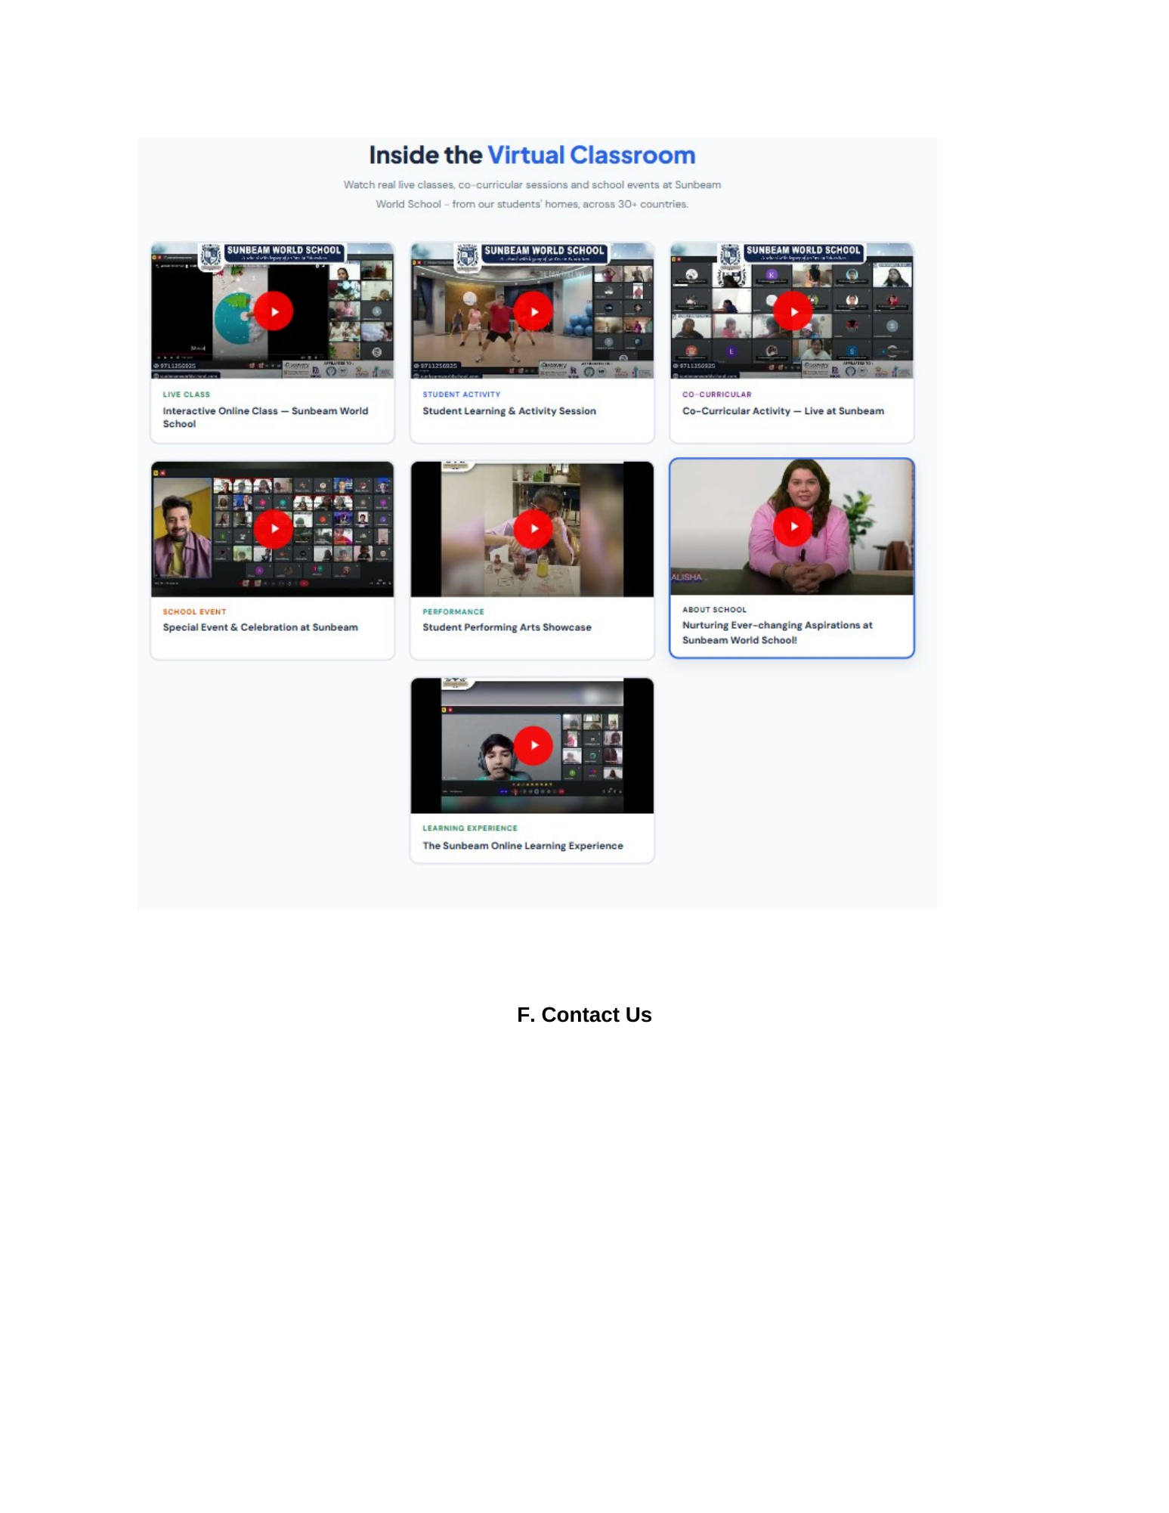
Reference image — Source Document Page 64
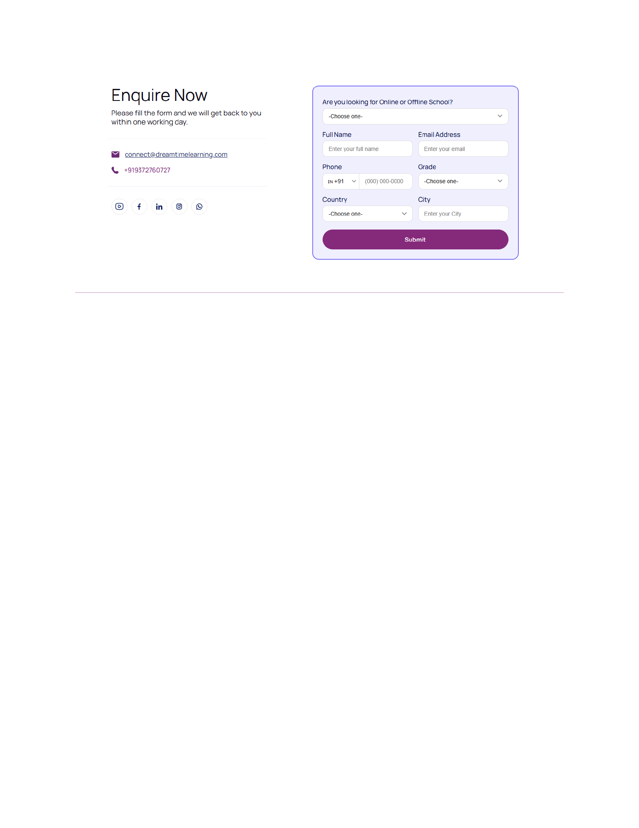
Reference image — Source Document Page 65

2. Current Live Website Audit
Area | Status | Current observation | Action
Contact information | Present | Phone, WhatsApp, email and office address are visible. | Keep verified details; centralise in CMS.
Enquiry form | Present | Form includes Parent Name, Student Name (optional), Email, Grade Level, Phone and Message/Details. | Keep; improve layout/validation and make fields CMS-configurable where practical.
Working hours | Needs correction | Current page displays 'Monday to Saturday, 10-7 AM - PM'. | Change to a clear approved time format such as 'Monday–Saturday, 10:00 AM–7:00 PM' only after confirming the intended hours.
Location map | Needs implementation | Current page shows 'ITL Twin Tower NSP Pitampura Delhi - Location Map Placeholder'. | Replace placeholder with the actual map/embed once the correct business location pin/embed is approved.
Social links | Needs visibility check | Social links exist in sitewide/footer areas, but the source Contact design calls for visible social icons within the enquiry/contact area. | Add clearly in the Contact page contact panel.
Contact page hierarchy | Needs refinement | Current page is functional but not fully aligned to the supplied two-column Enquire Now reference. | Recompose into the source-style two-column layout.
Lead capture | Present | A Request Callback/enquiry form is also used across the site. | Retain existing CRM/lead workflow and verify submission routing.

3. Recommended Contact Page Structure

3.1 Hero / Intro
- Heading: Contact Us / Enquire Now.
- Short supporting copy focused on helping families start or discuss their child's learning journey.
- Primary CTA should be the enquiry action.

3.2 Contact + Enquiry Two-Column Block
- Left column: contact message, office address, Phone/WhatsApp, email and social icons.
- Right column: enquiry form in a clearly separated card.
- Use the supplied Page 65 reference as the visual baseline.

3.3 Enquiry Form
- Parent Name — required.
- Student Name — optional.
- Email Address — required.
- Phone Number — required.
- Grade / Grade Level — required.
- Message / Details — optional.
- Clear Submit Enquiry CTA.
- Visible consent/privacy notice where required by the existing implementation.

3.4 Office / Location
- Show the verified physical address.
- Replace the map placeholder with a real map/embed after address/pin verification.
- Provide a practical route/location action where appropriate.

3.5 Final Conversion Area
- Short invitation to book a demo or continue the admissions journey.
- Use existing site conversion CTAs such as Book a Demo / Enrol Now where appropriate.
- Do not create conflicting or duplicate lead flows.

4. Content That Must Be Preserved
- Office address: B-09, Lower Ground Floor, ITL Twin Tower, Netaji Subhash Place, Pitampura, Delhi – 110034.
- Phone / WhatsApp: +91 7827262956.
- Email: info@zuvioglobalschool.com.
- Existing enquiry form fields unless an approved change is made.
- Existing working CRM/lead-routing behaviour.
- Global site contact information used in the footer.

5. Required Corrections
- Replace the visible 'Location Map Placeholder' with the actual approved map.
- Fix the malformed office-hours string '10-7 AM - PM' everywhere it appears in shared Contact/Footer content.
- Make Contact page visually match the supplied two-column Enquire Now reference.
- Keep the contact details on one side and the form on the other; do not overlay the form on top of the contact content.
- Add visible social icons/links in the contact panel and keep them consistent with the sitewide social configuration.
- Use complete 4-side borders for cards, consistent with the site-wide UI rule.
- Keep mobile layout as a clean single-column stack with contact information followed by the form.
- Use clear form labels, validation, loading state and success/error feedback.

6. Admin Panel / CMS
CMS Module | Editable Content | Actions
Contact Information | Address, phone, WhatsApp, email, office hours | ADD / EDIT / PUBLISH
Social Links | Platform, URL, icon, order, status | ADD / EDIT / DELETE / REORDER / PUBLISH
Enquiry Form | Field labels, required/optional status, helper text, success message | EDIT / ENABLE-DISABLE / REORDER
Map | Embed URL or map configuration, label, visibility | EDIT / ENABLE-DISABLE
CTA | CTA label, URL, visibility, order | ADD / EDIT / DELETE / REORDER

7. Technical / UX Acceptance Checklist
- Dedicated /contact page loads correctly.
- Header/sub-navigation Contact Us links to the dedicated page.
- Phone number is clickable on mobile.
- WhatsApp link opens the correct WhatsApp target.
- Email link opens the correct mail action.
- Social icons open correct approved profiles.
- Form validation works for required fields.
- Successful submission reaches the existing lead/CRM workflow.
- Success/error states are clear.
- Map loads correctly and no placeholder remains.
- Office hours are readable and correctly formatted.
- Desktop/tablet/mobile layouts are tested.
- No horizontal overflow or broken card layout.
- Breadcrumb and page title are correct.
- No unnecessary duplicate enquiry forms are introduced.

8. Final Decision
KEEP: Existing verified contact information and working enquiry/lead flow.
EDIT: Contact page layout, office-hours formatting, social presentation and map implementation.
ADD: Real map/embed and source-aligned two-column contact + form presentation where missing.
DO NOT: Invent contact details, office hours, social URLs or map coordinates. Verify before publishing.

9. Source Note
This reference is based on the supplied Home Page design changes(1).docx Pages 64–65 and a live crawl of the public Zuvio Global School Contact page. The source document provides the layout reference but does not provide additional verified contact data beyond the existing website, so missing details are flagged for verification rather than invented.

