ZUVIO GLOBAL SCHOOL
HOMEPAGE CHANGES — IMPLEMENTATION REFERENCE
Prepared from the supplied “Home Page design changes” document — Pages 1–9
Purpose
This document consolidates all homepage changes specified in the supplied source document into one implementation-ready checklist.
Reference visuals embedded below are taken directly from the supplied source document, preserving the original visual direction.
Scope is limited to Homepage requirements (source document pages 1–9).

Homepage Change Summary
# | Homepage area | Required change
01 | Header / navigation | Admission strip, affiliation number, contact/social links, moving USP strip, grade range, CTA-led header; remove “View Certificate” from header.
02 | Hero section | Carousel banner with enquiry form positioned beside the banner, plus Enrol Now / Take a Demo / Download Brochure CTAs.
03 | About Zuvio | Short-form About Zuvio introduction and “Who Should Choose Zuvio” summary.
04 | Learning Path | Four-stage learning journey + Learning Framework + Learning Beyond the Textbook + differentiation + graduate outcomes.
05 | Inclusivity & Beyond | Reuse Beyond co-curricular cards and add inclusive-learning value propositions.
06 | Statistics & Accreditation | Stats/numbers block and accreditation/affiliation showcase with certificate link embedded on homepage.
07 | Testimonials | Parent testimonials / reviews section with a structured review presentation.
08 | News / Updates | News, updates, blogs, awards/recognitions and Featured In structures.
09 | CEO message | CEO message as text and/or video.
10 | FAQ | Homepage FAQ section using the supplied FAQ reference/PDF structure.

1. Header, Announcement Strip & Navigation
Source reference: Pages 1–2 of the supplied document. The top-level menu is specified on page 1 and the homepage header treatment on page 2.

1.1 Top announcement / information strip
- Add a strip line with “Admissions Open 2026-2027”.
- Show affiliation number.
- Show phone/call information, email and social-media options as clickable elements.
- Add a moving strip line for Zuvio benefits / USPs and grade range in the header.
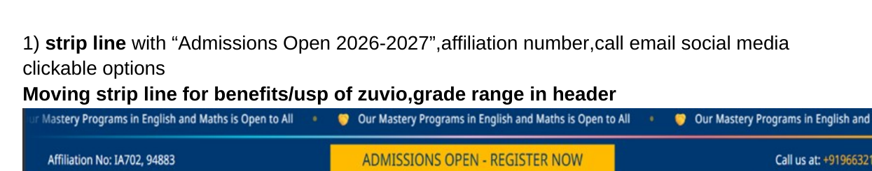
Reference image from supplied document — Page 2: announcement strip, moving USP strip and header pattern.
Header implementation note
The source reference is demonstrating the information hierarchy and placement pattern; it is not specifying that the Zuvio logo, labels or third-party brand names in the example should be copied.
The final production header should use Zuvio’s own approved brand assets, labels and contact details.

1.2 Navigation menu architecture
- Home
- About Us — About Zuvio (Story, Vision, Mission, Values, Our Approach, What Sets Us Apart, Who Should Use Zuvio); Our Team (Core Team, Leadership Team); Founder's Message (Her Message, Her Story, Her Expertise); Affiliations & Accreditations.
- Academics — Technology (LMS, Tools for Students, Teachers and Parents); Curriculum (Indian, British) with routine/schedules; Special Education; Electives (Regional Language, Foreign Language); NEP 2020; Resources (Learning, Community, Info & Support).
- Admissions — Enrol Now (Form + Process Steps + Requirements); Eligibility Criteria (including age-wise); Calendar; Fees Structure; FAQ.
- Beyond — Co-curricular; Student Achievers; Gallery.
- Contact Us.

2. Hero / Banner + Enquiry Form
Required change: Use a carousel hero banner and place the enquiry form beside the banner, not on top of it.
- Carousel banner should communicate the primary admission / school proposition.
- Position enquiry form in a dedicated right-side panel alongside the banner.
- Add primary CTAs: “Enrol Now”, “Take a Demo” and “Download Brochure”.
- Keep the form visually distinct from the banner to improve readability and conversion clarity.
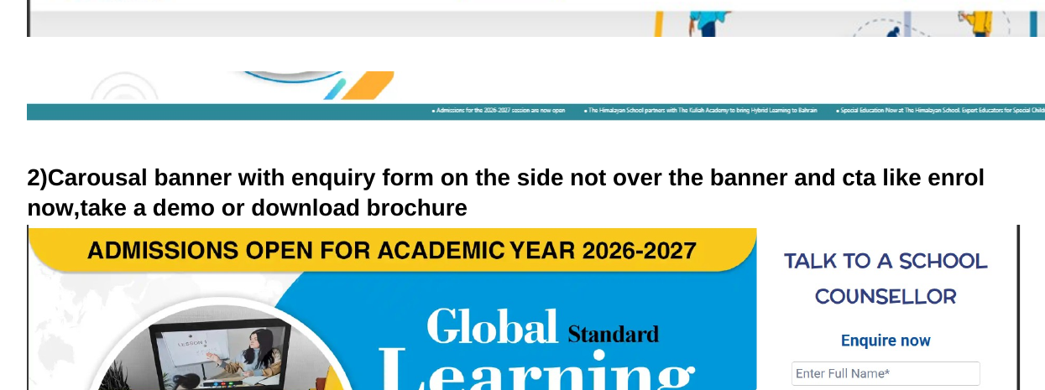
Reference image from supplied document — Page 2: carousel banner + side enquiry form composition.

3. Accreditation Certificate Placement
- Remove “View Certificate” from the header.
- Place the certificate within the homepage “Affiliation and Accreditation” section.
- The certificate should contain an embedded link / clickable action to open or verify the certificate.

Reference image from supplied document — Page 2: certificate treatment with “View Certificate” action.

4. About Zuvio — Homepage Short Form
Homepage heading: About Zuvio (who are we / why Zuvio / who should choose Zuvio)

4.1 About Zuvio (short form)
Zuvio Global School is an online school built on one belief: education should adapt to the child, not the child to the system.
We bring together a structured, curriculum-aligned programme, caring teachers and thoughtful technology to create a flexible, personalised learning experience your child can access from anywhere. Different ways of learning. One community. Equal opportunities.
That's what learning beyond boundaries means.

4.2 Who Should Choose Zuvio (short form)
Zuvio is for families who want learning to fit their life — not their life to revolve around a timetable.
- Globally mobile families who move between cities or countries
- Homeschooling & alternative-learning families who want structure with freedom
- Young athletes, artists & performers balancing demanding schedules
- Children who thrive online and learn best in a digital environment
- Learners who need a more personalised approach, pace or attention
- Children who need a different schooling environment when traditional school isn't the right fit
If you believe education should adapt to the child, Zuvio may be the right choice.

5. Learning Path

5.1 Curriculum — Section Intro
A Future-Ready Learning Journey — K to Grade 8
Aligned with CBSE, NEP 2020 and NCF — strong academic foundations blended with creativity, communication, digital fluency and real-world learning.
Every stage builds on the last: from stories, sounds and play in the Early Years to research, innovation and independent thinking in Middle School.

5.2 The Zuvio Learning Journey — 4 Stage Cards
Early Years · K–KG — Explore • Play • Discover
- Learning through stories, play, music and hands-on activities
- Early literacy, phonics and numeracy
- Communication, creativity and social-emotional growth
Outcome: Confidence, curiosity and strong foundations
Foundation Stage · Grades 1–2 — Build • Question • Create
- Strengthening reading, writing and maths
- Connecting classroom concepts to everyday life
- Art, life skills and digital literacy
Outcome: Numeracy, communication and independent thinking
Preparatory Stage · Grades 3–5 — Understand • Apply • Collaborate
- Interdisciplinary, application-led learning
- Science, coding and computational thinking
- Communication, financial awareness and creativity
Outcome: Conceptual understanding, research and digital fluency
Middle School · Grades 6–8 — Think • Apply • Innovate
- Deeper analysis, research and discussion
- Coding & AI awareness, entrepreneurship, design thinking
- Leadership, global citizenship and career exploration
Outcome: Critical thinking, independence and real-world readiness
Strong Foundations. Future Skills. Learning Without Boundaries.
CTA: Explore the Full Curriculum →
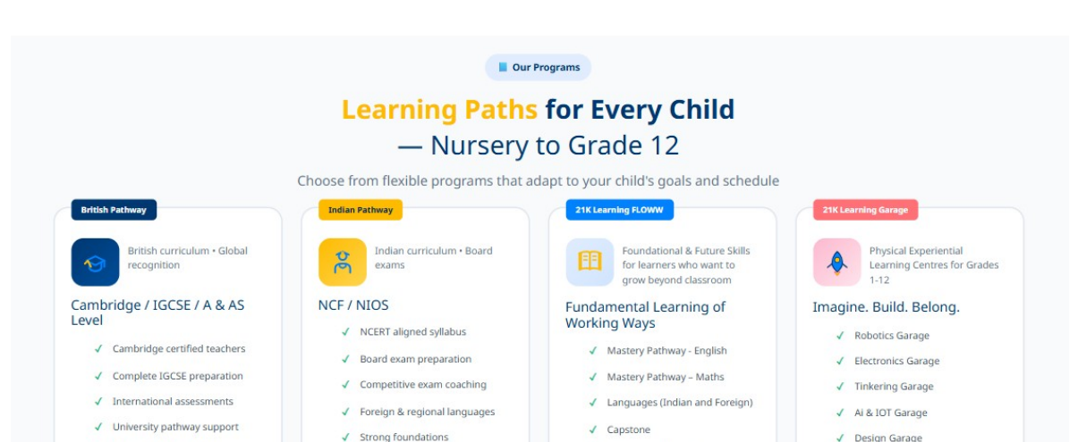
Reference image from supplied document — Page 6: stage/program card composition that can inform homepage learning-path card treatment.

5.3 The Zuvio Learning Framework — From Knowing to Doing
- Know — Build the foundation of essential concepts and ideas
- Think — Question, analyse, reason and solve
- Create — Imagine, experiment, design and innovate
- Connect — Communicate, collaborate and understand other perspectives
- Apply — Use knowledge confidently in projects and real life
Knowledge → Understanding → Application → Innovation

5.4 Learning Beyond the Textbook
Because the world is the real classroom.
- Projects & Experiments — learning by doing, testing and discovering
- Technology & Digital Learning — used creatively and responsibly
- Communication & Collaboration — presentations, teamwork, global interaction
- Life Skills — decision-making, independence and financial awareness
- Creativity & Innovation — art, coding and design thinking
- Global Exposure — cultures and ideas beyond boundaries

5.5 What Makes Zuvio Different
- Assessment for Growth — We measure progress and skills, not just marks — with meaningful insights for parents.
- Personalised Learning — Teacher guidance, digital tools and targeted support that adapt to each child’s pace and needs.
- Zuvio Beyond — Co-curricular activities, enrichment and extra academic support, matched to your child’s interests.

5.6 The Zuvio Graduate — by the end of Grade 8
Academically Strong · Curious · Confident & Articulate · Creative · Digitally Fluent · Collaborative · Independent · Globally Aware · Future-Ready
Not just ready for the next grade — ready to learn, adapt and grow in a changing world.

6. Inclusivity & Beyond Section
- Use co-curricular cards from the Beyond page in this homepage area.
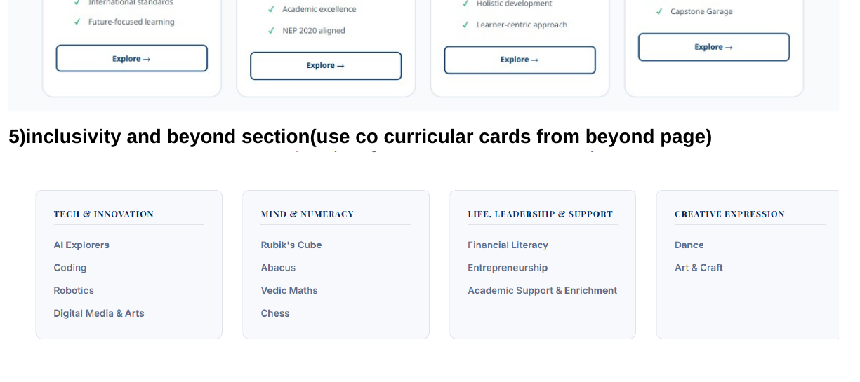
Reference image from supplied document — Page 6: Learning Paths + co-curricular cards + inclusive-learning copy.

6.1 Core inclusive-learning statements
- Inclusive by Design — Learning built around how your child learns — not the other way round.
- Learn From Anywhere — A complete school experience that moves with your family, across cities or countries.
- Personalised Attention — Teacher-led, small-group classes where every child is known, seen and supported.
- Flexible Pacing — Space to move ahead, slow down or revisit — without the pressure to keep up.
- Beyond Academics — Confidence, communication, creativity and life skills — not just marks.
- Special Education Support — A qualified Special Educator and personalised plans for diverse learning needs.

7. Statistics & Affiliations / Accreditations

7.1 Statistics / numbers
Add a dedicated statistics / numbers strip or section. The source document marks this as a required homepage section but does not supply the final numeric values in the homepage text.

7.2 Accreditations and affiliations
- Create a dedicated homepage accreditation / affiliation showcase.
- Place the certificate / verification link in this section rather than the header.
- The supplied visual reference shows a three-card accreditation layout with logos and labels.
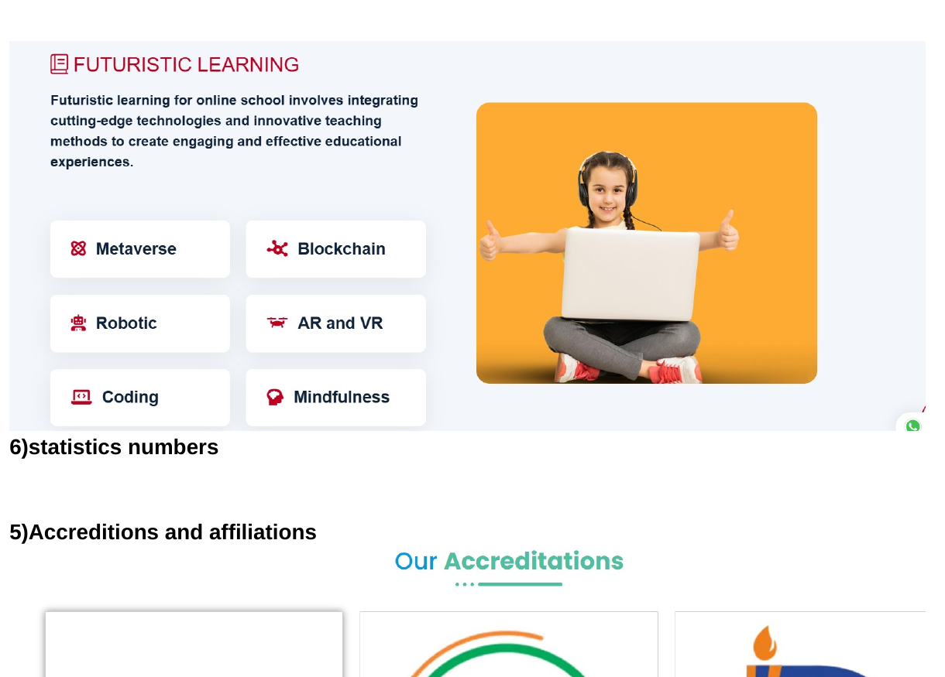
Reference image from supplied document — Page 7: futuristic-learning / stats lead-in and accreditation-card layout.

8. Parent Testimonials / Reviews
Required: create a structured parent testimonial/review section. The source specifically labels this as a structure to be made.
- Use testimonial cards with parent name, child/class context where approved, and review copy.
- Use a “View More Testimonials” style CTA when applicable.
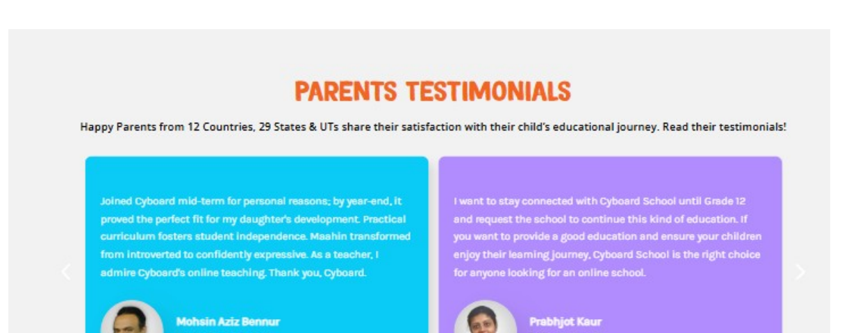
Reference image from supplied document — Page 8: parent testimonials carousel/card structure.

9. News / Updates / Blogs / Awards & Recognition
- Create a homepage module for latest news and updates.
- Show selected blog/news cards with image, title, short summary and “Learn more” CTA.
- Use the same area or a related module to surface awards and recognition.
- The source document labels the final structure as “News/updates/blogs/awards and recognitions”.
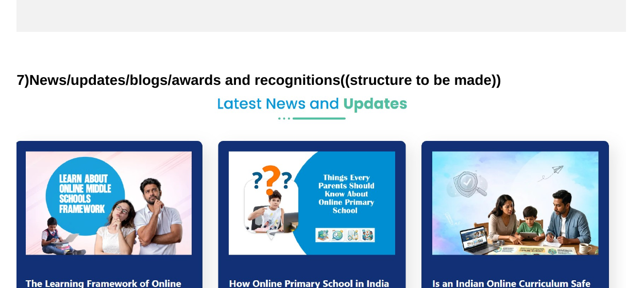
Reference image from supplied document — Page 8: “Latest News and Updates” three-card layout.

10. Featured In
Create a “Featured In” media-logo strip / carousel. The supplied reference shows publication logos displayed in rounded containers.
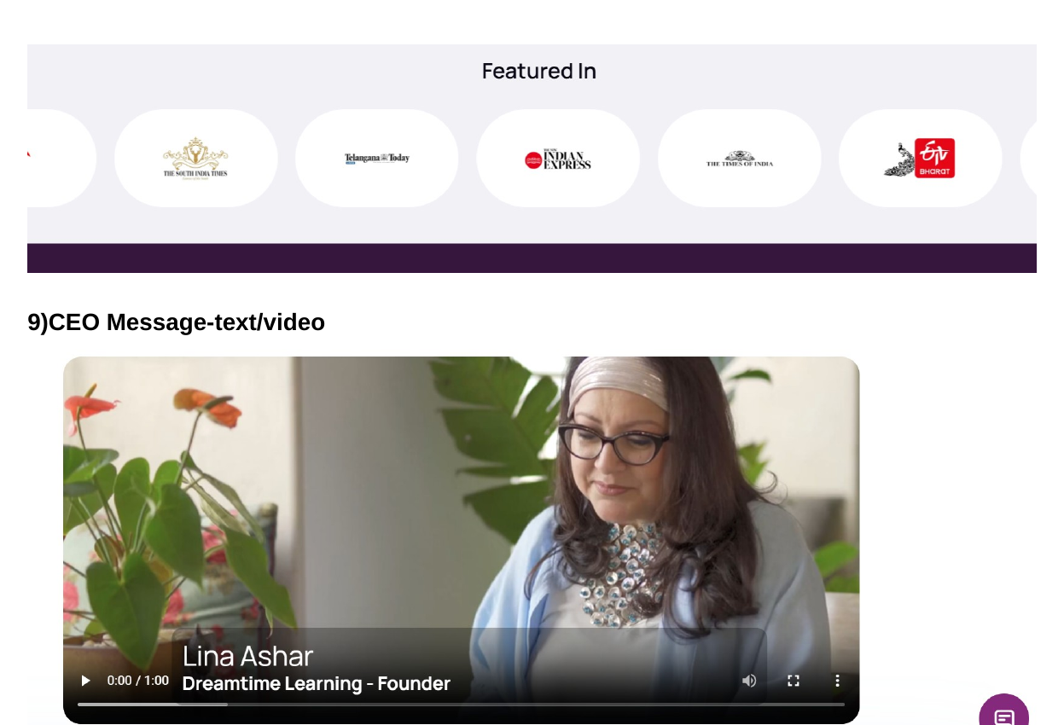
Reference image from supplied document — Page 9: Featured In logo row and CEO/video presentation.
Featured In implementation
Use only verified publications / media brands approved by Zuvio.
Logos should be clickable when the corresponding media article or feature is available and approved for linking.

11. Founder's Message — Text / Video
Approved Founder’s Message
Learning Without Boundaries. Growing With Purpose.
Dear Parents, Students and Members of the Zuvio Community,
Education today must prepare children not only for examinations, but for a world that is constantly evolving.
At Zuvio Global School, we believe that meaningful learning is not defined by the walls of a classroom. It is defined by curiosity, connection, opportunity and the confidence to explore beyond what is already known.
Our vision is to create a 100% online, future-ready learning environment where every child has the opportunity to learn beyond geographical boundaries while receiving the guidance, structure and personal attention needed to thrive.
At Zuvio, strong academics form the foundation, but learning goes much further. We encourage our students to question, think critically, communicate confidently, collaborate, create and apply their knowledge to real-world situations. Technology enables our classrooms, but teachers, relationships and meaningful human interaction remain at the heart of the learning experience.
We recognise that every child is different. Their interests, abilities, pace and aspirations are unique. Our approach therefore aims to create a learning journey that gives students the flexibility to discover their strengths while developing the knowledge, skills and values required for the future.
We also believe education is a partnership. Parents, educators and students must work together to create an environment in which children feel supported, inspired and empowered to take ownership of their learning.
Zuvio Global School is not simply about bringing a traditional classroom online. We are reimagining how learning can happen when boundaries are removed and possibilities are expanded.
Our aspiration is simple yet powerful: to nurture confident learners, independent thinkers, compassionate individuals and responsible global citizens who are prepared not just for the next grade, but for the world ahead.
Welcome to Zuvio Global School — a global learning community where every child is encouraged to learn, explore, create and grow without boundaries.
Warm regards,
Founder
Zuvio Global School
Reference image from supplied document — Page 9: original video/message presentation reference; use for layout inspiration only.

12. FAQ
FAQ Source: “Zuvio Parent FAQ - Online Schooling” (3-page PDF supplied by the user).
Homepage implementation: use an accordion UI with “View all” and “Contact us” actions, while keeping the complete answers available on the dedicated FAQ page.
1. What are the timings of online classes?
Zuvio follows age-appropriate class durations. Classes are scheduled within the 9:00 AM-1:00 PM window, depending on the grade. Pre-Primary: approximately 2 hours. Primary: approximately 2.5 hours. Middle School: approximately 3 hours. The timetable includes suitable breaks, interactive activities and a balanced mix of teacher-led and student-led learning.
2. How does online schooling work at Zuvio?
Zuvio Global School is a 100% online school where students attend structured live classes with teachers from home. Students follow a planned timetable and academic calendar and receive learning resources, assignments, projects, assessments and teacher support through the school's digital learning ecosystem.
3. Is the Zuvio curriculum CBSE-mapped?
Yes. Zuvio's academic curriculum is mapped to CBSE learning outcomes and designed with reference to NEP 2020 and NCF guidelines. This supports grade-appropriate concepts, competencies and structured academic progression.
4. What is the Oxford theme-based curriculum approach?
Zuvio incorporates an Oxford-based thematic learning approach, where concepts are connected through meaningful themes instead of always being taught as isolated topics. A theme can bring together language, environmental studies, creativity, research, communication and real-world applications, helping children understand connections across subjects.
5. What is Project-Based Learning?
Project-Based Learning allows students to learn by doing. Students explore a question, challenge or real-life topic and create a project, presentation, model, report or solution. This helps develop critical thinking, creativity, communication, research, collaboration and problem-solving skills.
6. How is Artificial Intelligence integrated into the curriculum?
AI learning is introduced in an age-appropriate manner as part of Zuvio's future-ready learning approach. Students gradually learn AI concepts, responsible use of technology, problem-solving and practical applications. Zuvio's AI learning approach uses IBM-supported/certified learning resources and frameworks, subject to the applicable programme and certification requirements.
7. How are examinations and assessments conducted?
Assessment includes formative assessments, projects, assignments, class participation, portfolios and summative assessments. Formal assessments are conducted online according to school examination guidelines. For Nursery-UKG, assessment is primarily activity- and observation-based rather than dependent on formal written examinations. Parents receive regular feedback and progress reports.
8. Can parents speak directly with teachers?
Yes. Parents can communicate with teachers and the academic team through WhatsApp groups, email, scheduled virtual meetings and Parent-Teacher Meetings (PTMs), depending on the requirement.
9. What is NIOS, and how does it relate to online schooling?
The National Institute of Open Schooling (NIOS) provides recognised open-schooling pathways in India. Where applicable, families seeking a formal open-schooling certification pathway can explore NIOS according to its prevailing eligibility, registration and examination requirements. Important: NIOS and a CBSE-mapped curriculum are not the same. Curriculum mapping describes what and how a student learns, while NIOS is an examination/certification pathway.
10. Can my child move back to an offline school later?
Yes, students can transition from online learning to an offline school. Admission is governed by the receiving school's admission policy, documentation, grade-level requirements and applicable board/regulatory rules. Zuvio can support parents with relevant academic records and progress documentation.
11. Are co-curricular activities included in online schooling?
Yes. Co-curricular learning is planned in sync with the academic curriculum. Activities may include art, communication, storytelling, STEM, innovation, digital skills, presentations, competitions, projects and other age-appropriate enrichment experiences. The aim is to support academic, creative, social and emotional development.
12. Will children get enough interaction in an online school?
Yes. Live classes can include discussions, quizzes, presentations, show-and-tell, collaborative activities, projects, peer interaction and teacher questioning. Students are encouraged to actively participate rather than simply watch a screen.
13. How is student progress monitored?
Teachers monitor progress through classroom participation, assignments, projects, quizzes, assessments and portfolios. Regular reviews help identify learning gaps and determine where additional academic support may be required.
14. What happens if my child is struggling with a concept?
Teachers can identify learning gaps through continuous assessment and classroom interaction. Students may receive additional clarification, practice material and academic support according to their learning needs.
15. How much screen time will my child have?
Zuvio follows grade-appropriate live-class durations. Online lessons are complemented by offline activities such as reading, writing, worksheets, projects, art, research, experiments and hands-on learning. The objective is not to keep children continuously in front of a screen.
16. Is online schooling suitable for children living outside India?
Online schooling can be particularly useful for NRI and internationally mobile families seeking continuity in learning while living abroad or moving between countries. Families should separately check compulsory-schooling and recognition requirements applicable in their country of residence.
17. What support is provided to students joining in Term 2?
Students joining mid-session can undergo a baseline/diagnostic assessment to understand their current learning level. Teachers can then identify gaps and provide a bridge learning plan to support a smooth transition into the ongoing curriculum.
18. What makes Zuvio's online learning approach different?
Zuvio combines structured academics, CBSE-mapped learning, thematic learning, project-based education, AI and digital skills, experiential learning, co-curricular activities and regular parent-teacher interaction in a flexible online environment. The focus is on developing confident, independent and future-ready learners.
Source note: Programme, curriculum, certification, examination and progression details are subject to applicable school policies and external provider/regulatory requirements. Partnership and certification references should be read according to the specific programme applicable to the learner.
Reference images from supplied FAQ PDF — Pages 1-3.
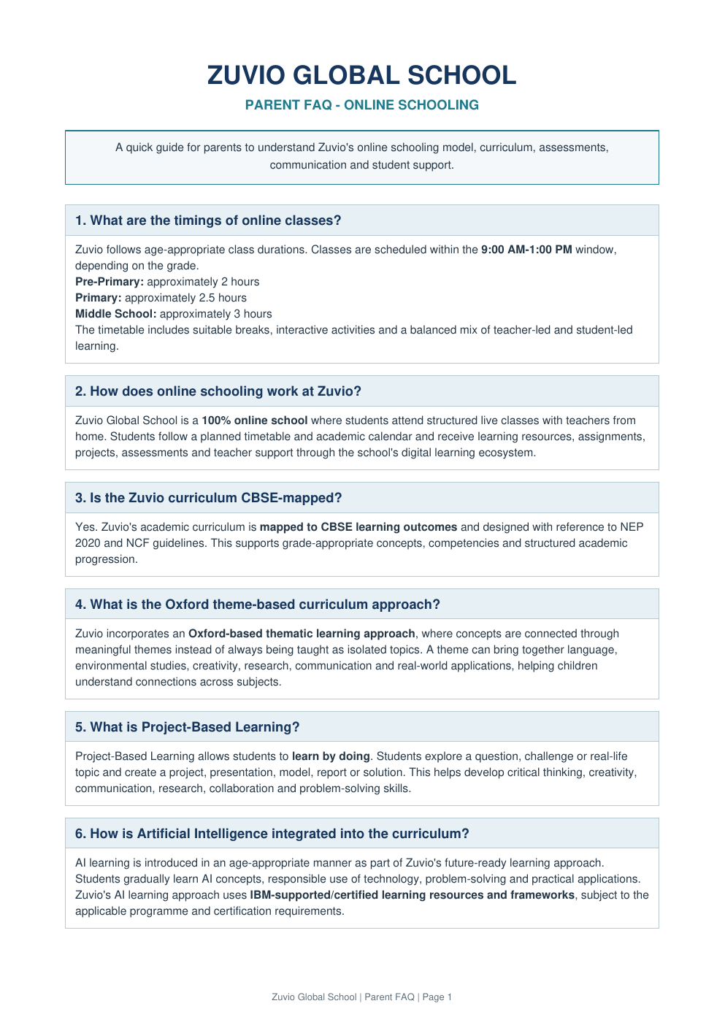
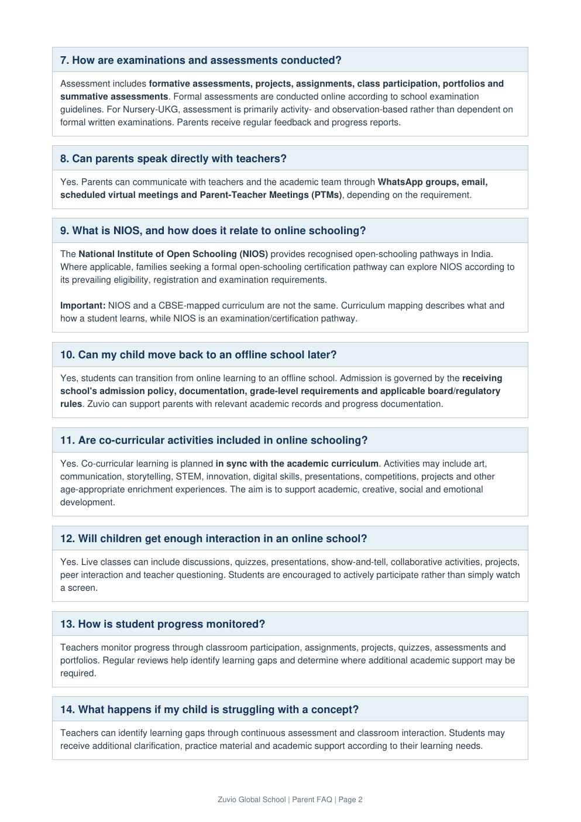
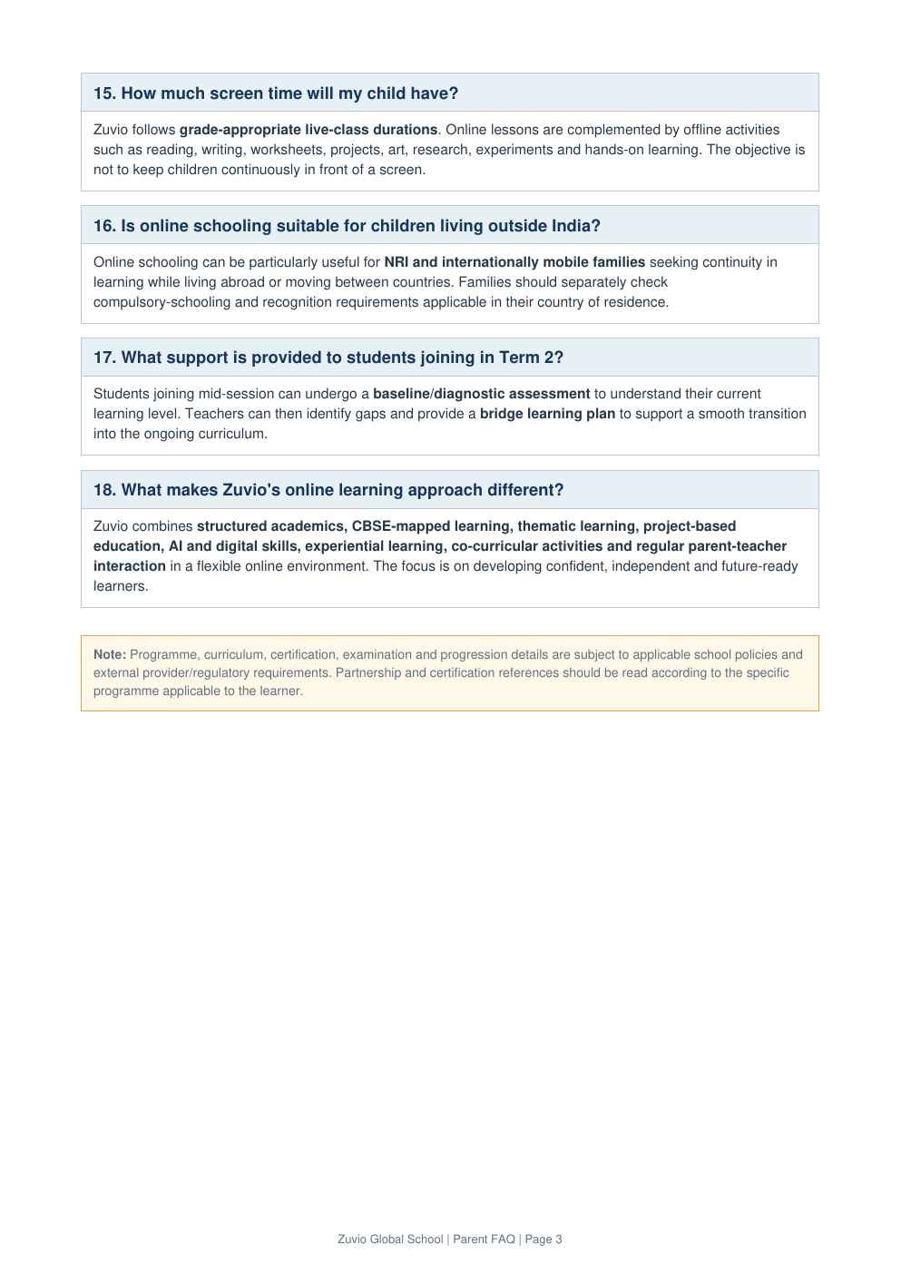
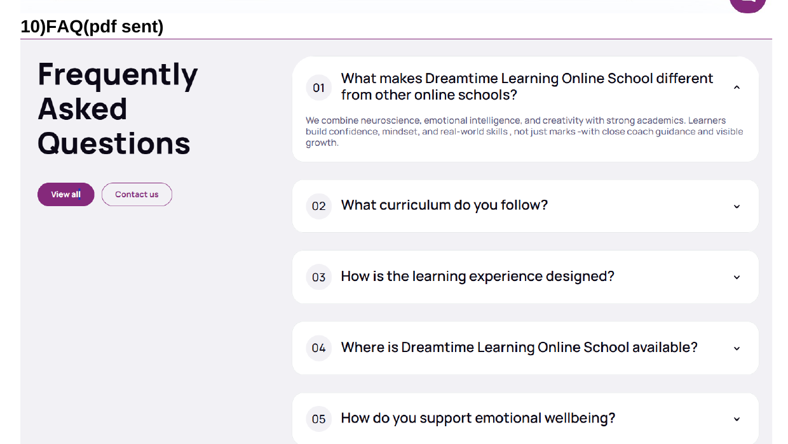

13. Recommended Final Homepage Sequence (from the supplied changes)
- Announcement strip — Admissions Open 2026–2027 + affiliation/contact/social links
- Moving USP / benefits strip + grade range
- Primary header/navigation
- Hero carousel + side enquiry form + primary CTAs
- About Zuvio short form
- Who Should Choose Zuvio short form
- Learning Path / Curriculum journey
- Zuvio Learning Framework
- Learning Beyond the Textbook
- What Makes Zuvio Different
- Inclusivity & Beyond
- Statistics / numbers
- Affiliations & Accreditations + certificate link
- Parent Testimonials / Reviews
- News / Updates / Blogs / Awards & Recognition
- Featured In
- Founder's Message
- FAQ
- Final CTA / enquiry conversion area (where required by design system)
Source-control note
All copy and requirements in this document are transcribed or condensed from the supplied “Home Page design changes” document, with no outside content added to the required homepage specifications.
The embedded images are reference visuals taken from the supplied document pages 2, 6, 7, 8 and 9.

