ZUVIO GLOBAL SCHOOL

About Us — Website Changes, Audit & Reference
Based on the supplied 65-page source document + live website audit

1. Current Website Audit — About Us
Live page audited: https://www.zuvioglobalschool.com/about
Area | Current Live Site | Required Action
Current structure | Story → Vision → Mission → 8C Philosophy → Leadership Team. | Needs restructuring to the approved About Us architecture.
Our Story | Present and functional. | Keep, but align messaging with supplied source copy.
Vision & Mission | Present. | Keep and align to approved copy/reference.
Values | Current site uses an 8C Philosophy. | Add/replace with the approved “What Matters at Zuvio” values section.
What Sets Us Apart | Not present as a dedicated section on the live About page. | Add the six approved differentiators.
ZUVIO Approach | Not present as the approved Z-U-V-I-O framework on the current About page. | Add full Z-U-V-I-O section.
Who Should Choose Zuvio | Not present as the full About-page section. | Add the complete audience section.
Our Team | Present. | Retain relevant team members but remove Rashmi Bhasin per approved instruction.
Founder’s Message | Founder profiles exist; current About page also exposes individual founder pages. | Use “Founder’s Message” terminology and approved Founder content.
Founder story / expertise | Individual founder profile content exists. | Reorganize into the approved Founder story/profile layout.
Affiliations & Accreditations | Not integrated into the About page structure as specified. | Add dedicated section/page with approved credentials and certificate links.
Live audit evidence: The current About page currently shows Story, Vision, Mission, the 8C Philosophy and Leadership Team, including Rashmi Bhasin as Academic Head. Rashmi Bhasin is also reachable through a dedicated profile URL.

2. Approved About Us Information Architecture
- About Us
- → About Zuvio (Story, Vision, Mission, Values, Our Approach, What Sets Us Apart, Who Should Choose Zuvio)
- → Our Team (Core Team / Leadership Team)
- → Founder’s Message (Message, Story, Expertise)
- → Affiliations & Accreditations

3. Page-by-Page Implementation Requirements

Page 10 — About Zuvio — Story + Vision/Mission
- Hero/intro: About Zuvio
- Use the supplied Zuvio Story copy as the primary story narrative.
- Add Vision and Mission blocks.
- Use a strong “online school / learning beyond boundaries” visual beside the story content.
Implementation note: The source starts the About Us journey with Zuvio Story and then Vision/Mission. The supplied page 10 visual shows a large image-led story treatment.
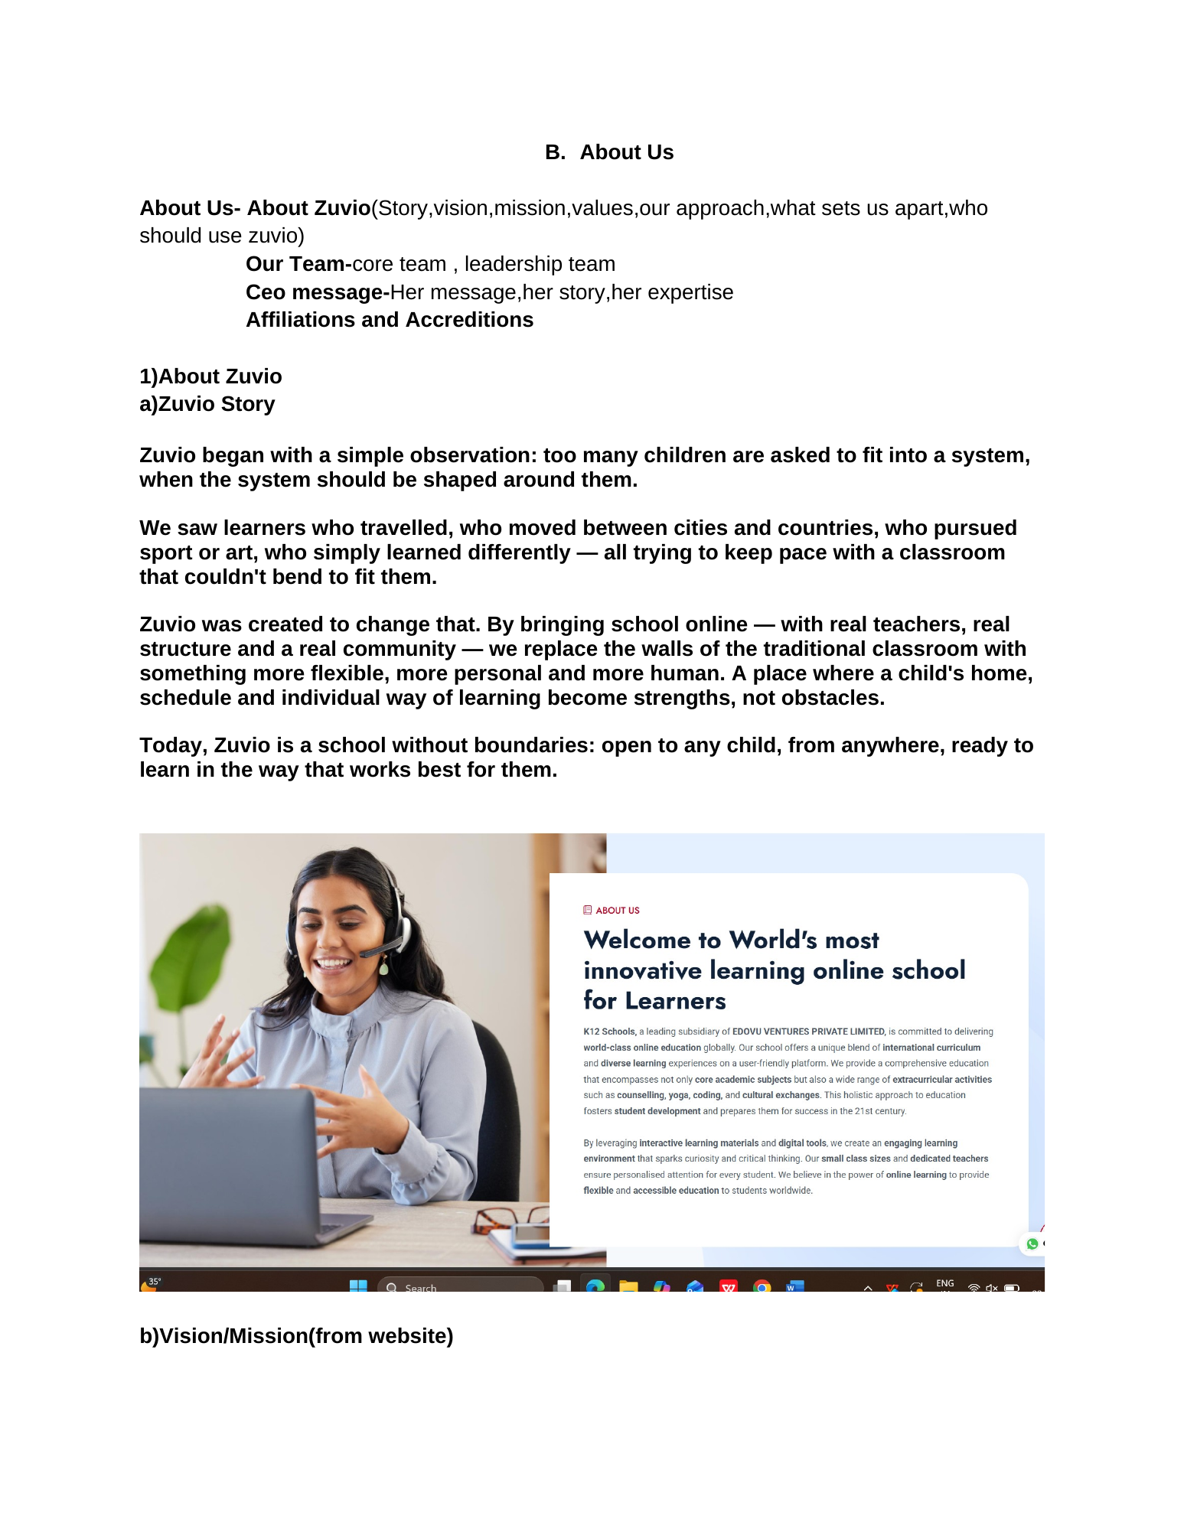
Reference image from source document — Page 10

Page 11 — Values — What Matters at Zuvio
- Headline: What Matters at Zuvio
- Subheading: The Values Behind Everything We Do
- Six value blocks: Child at the Centre; Inclusion by Design; Personalised Learning; Growth, Not Just Marks; Beyond Academics; Learning Without Boundaries.
- Closing line: “Inclusive by design. Personalised by need. Future-ready by purpose.”
Implementation note: Do not simply retain the current 8C Philosophy as the values section; the approved source specifies the six values above.
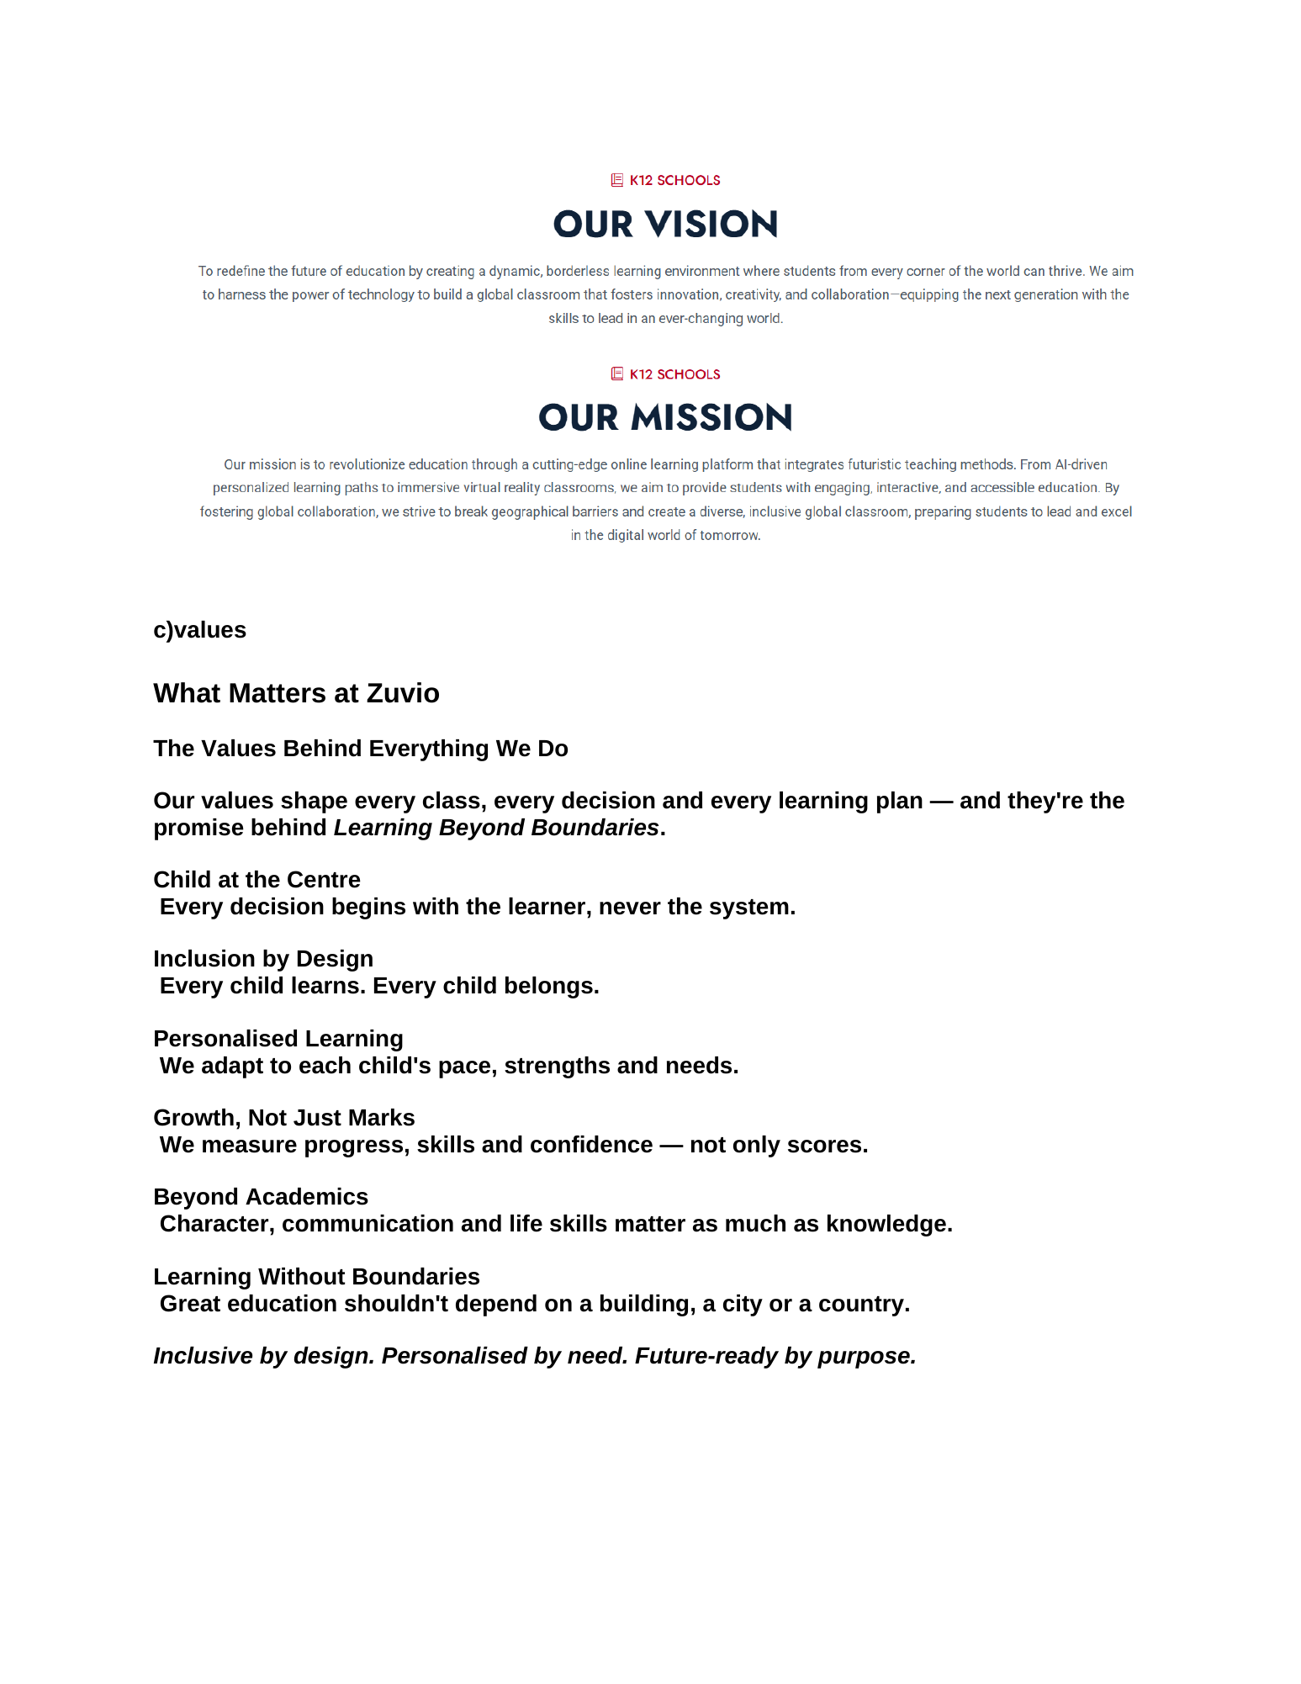
Reference image from source document — Page 11

Page 12 — What Sets Us Apart
- Add six differentiators: Online, but deeply human; Personalised by default; Inclusive by design; Flexible for real life; Beyond academics; Parents as partners.
- Use card-based layout with clear visual hierarchy.
Implementation note: The source explicitly defines six differentiators and the current live About page does not present them as this dedicated approved section.
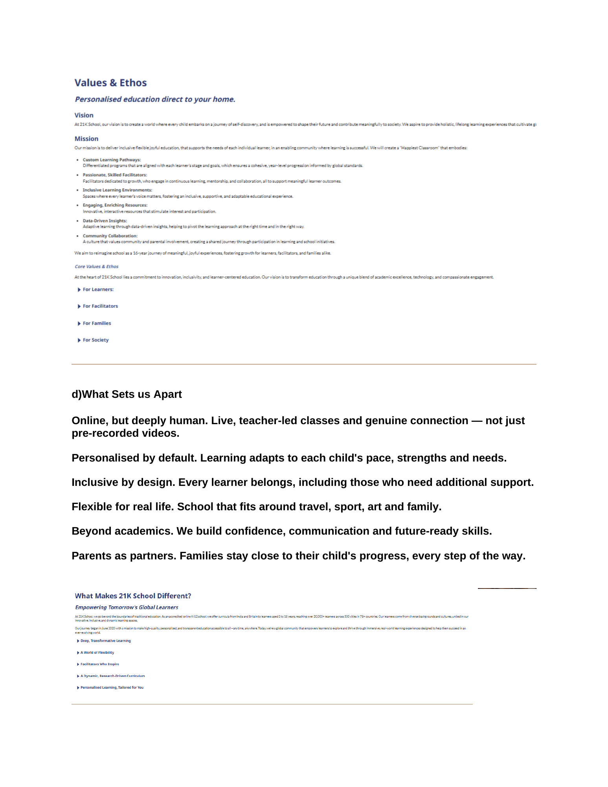
Reference image from source document — Page 12

Page 13 — Our Approach — ZUVIO, Zoomed In
- Use the exact Z-U-V-I-O framework.
- Z — Zoomed-In Attention
- U — Understand Every Learner
- V — Versatile Pathways
- I — Inclusive by Design
- O — Opportunities Without Boundaries
- Use a visual framework/card layout to make the acronym scannable.
Implementation note: Reference visual shows the ZUVIO framework as a dedicated visual concept. Keep the wording faithful to the source.
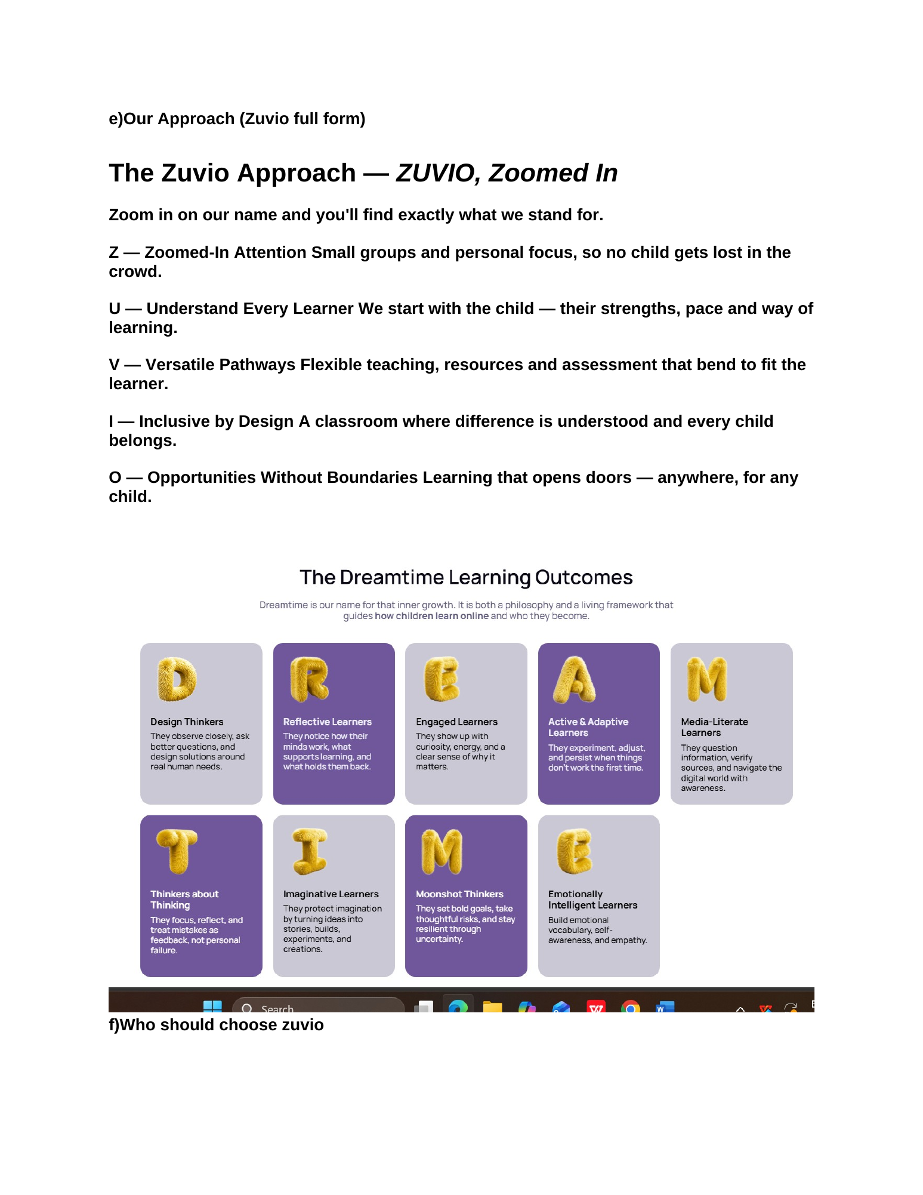
Reference image from source document — Page 13

Page 14 — Who Should Choose Zuvio
- Intro: “Every child deserves a learning journey that fits their life.”
- Include: Flexible learning families; Homeschooling & alternative-learning families; Globally mobile families; Young athletes, artists & performers; Children who thrive online; Learners needing a personalised approach; Parents seeking future-ready education; Children needing a different environment.
- Closing CTA: “Learn. Explore. Grow. From anywhere.”
Implementation note: Use the full source audience list. Do not reduce it to a 4-card summary.
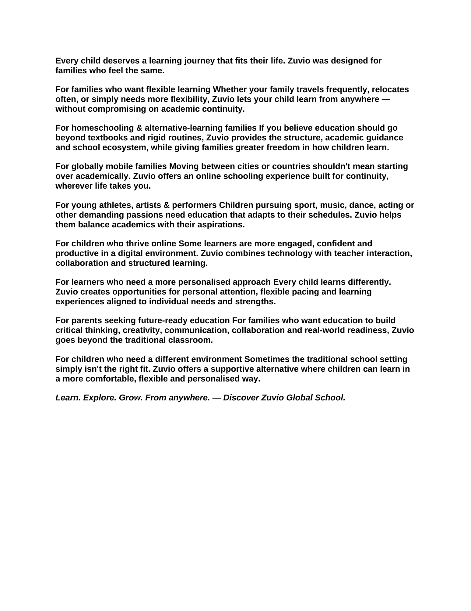
Reference image from source document — Page 14

Page 15 — Our Team
- Pull the current live team data into the new layout.
- Remove Rashmi Bhasin from the public team listing and related profile link.
- Preserve remaining valid leadership profiles.
- Use Core Team / Leadership Team naming consistently.
Implementation note: The source document explicitly instructs: take team content from website and remove Rashmi Bhasin from the team.
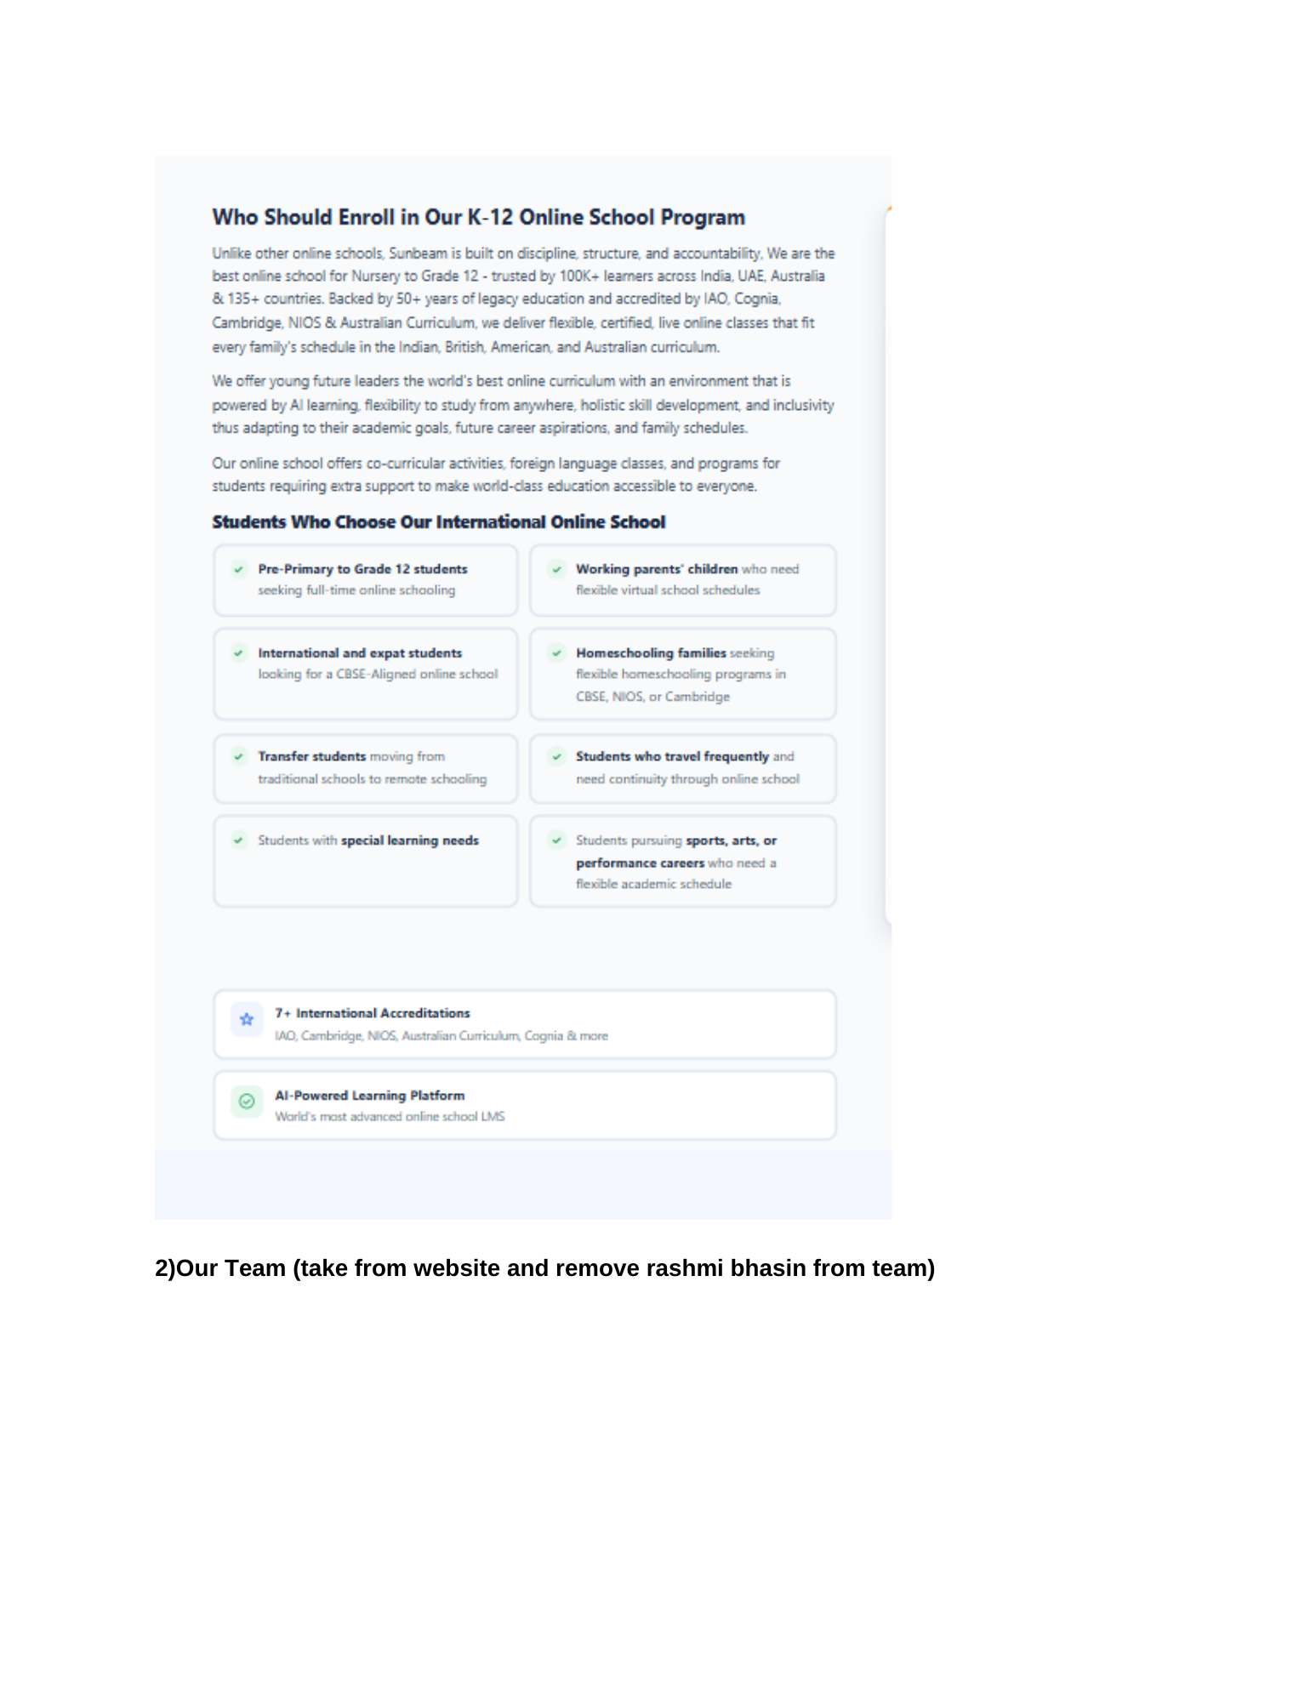
Reference image from source document — Page 15

Page 16 — Founder’s Message — intro + leadership visual
- Use “Founder’s Message” (not CEO Message).
- Title: “Learning Without Boundaries. Growing With Purpose.”
- Show founder portrait/profile area plus message excerpt.
- Use the latest approved Founder copy supplied for the project.
Implementation note: The source page 16 introduces Founder’s Message; the later user-approved content should take precedence over the older CEO sign-off shown in the legacy DOCX.
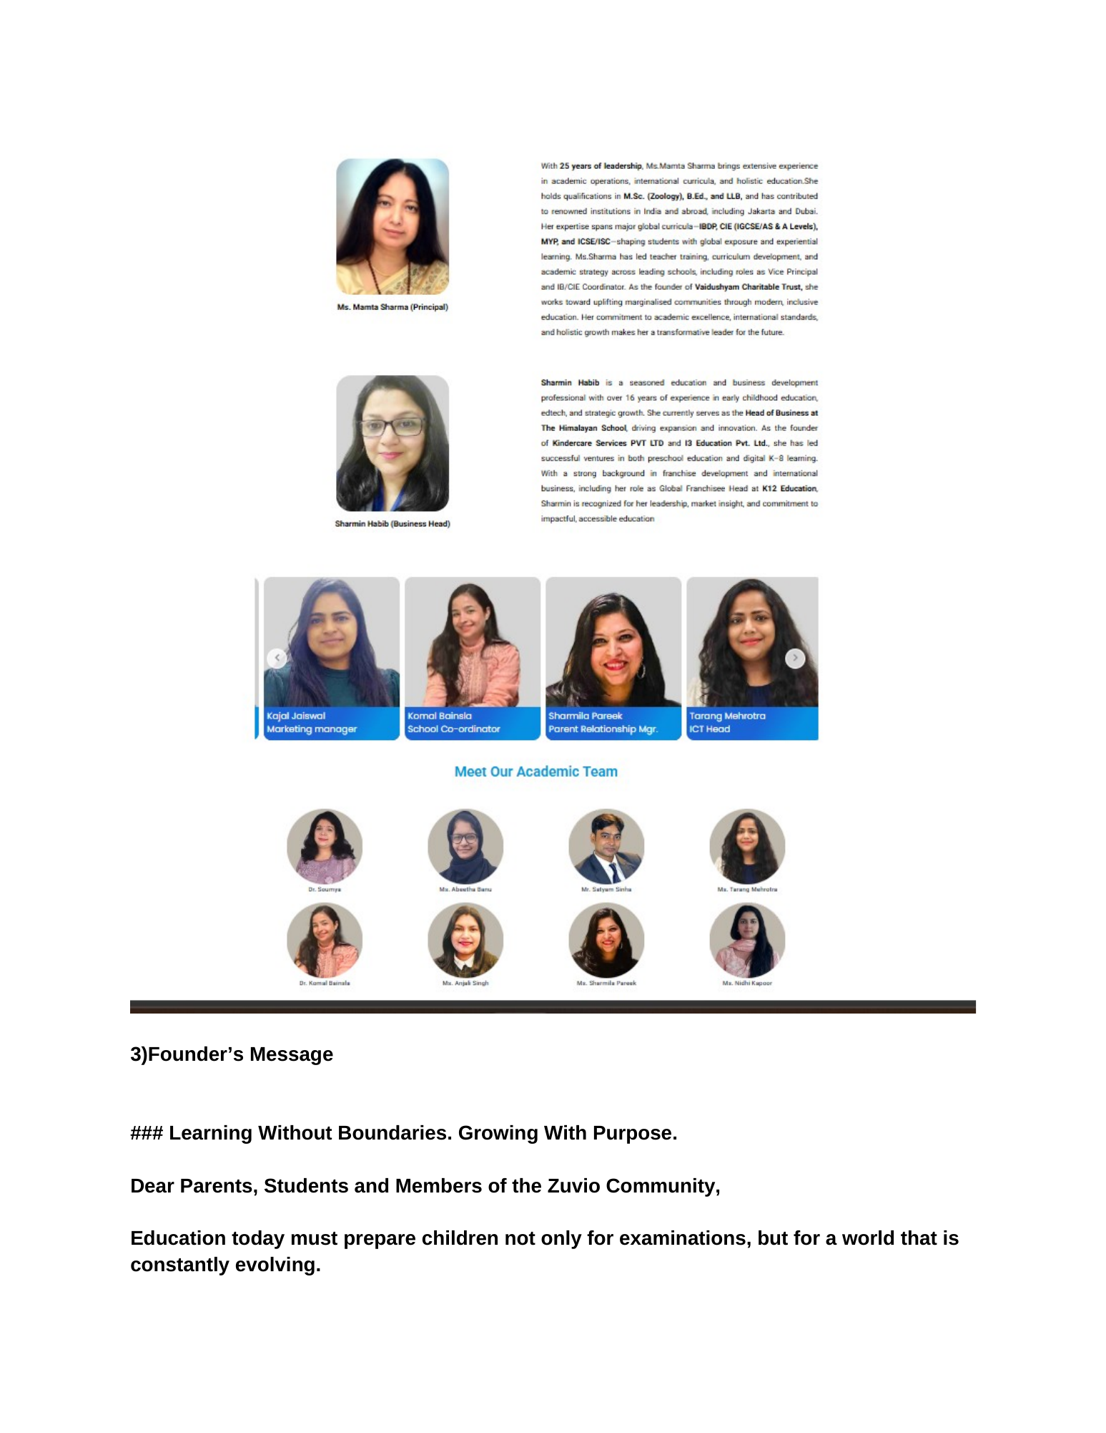
Reference image from source document — Page 16

Page 17 — Founder’s Message — full content
- Place the full approved Founder’s Message copy on the page.
- End with: Warm regards, Founder, Zuvio Global School.
- Use readable long-form typography and a supporting founder visual.
Implementation note: Keep the message as the approved project content; do not revert to “CEO Message”.
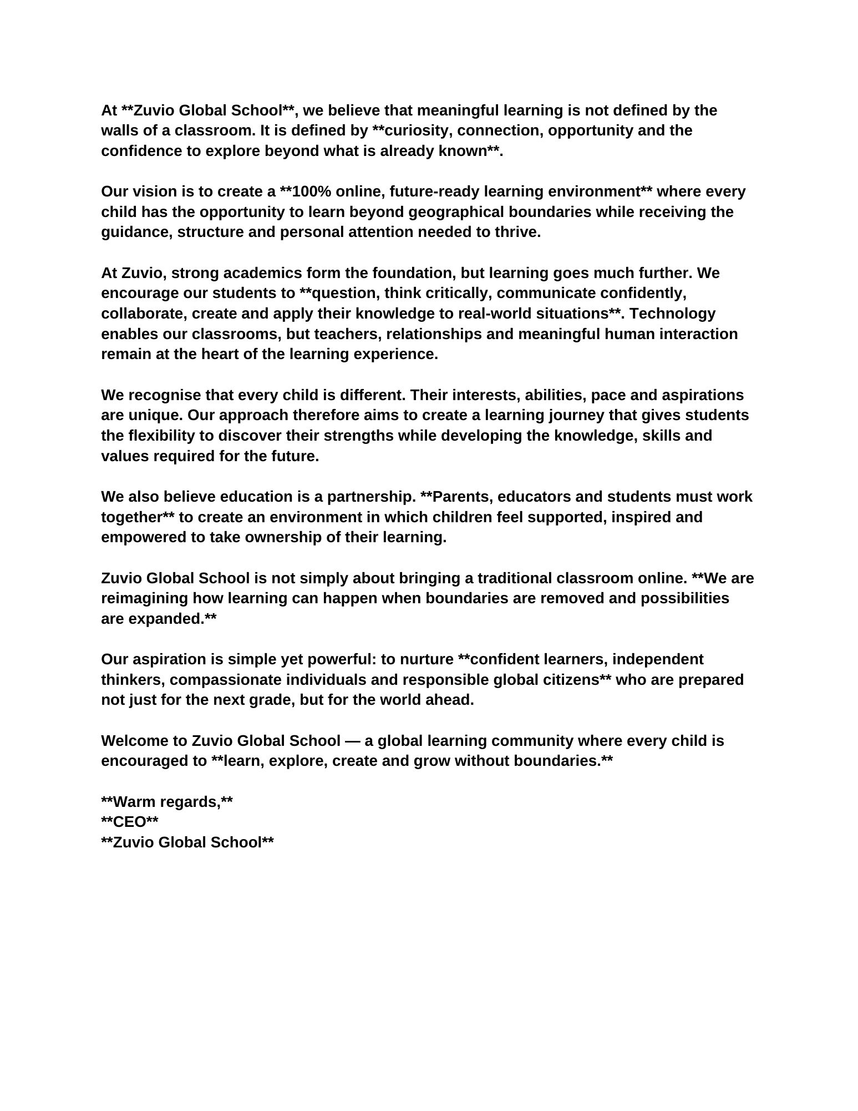
Reference image from source document — Page 17

Page 18 — Founder Profile / Visionary Educator
- Founder profile hero: name, role, expertise, experience and key credentials.
- Add short “Visionary Educator” content block.
- Use credential/experience cards only where source material supports them.
Implementation note: Reference page shows a profile-first leadership layout with credentials and a quote.
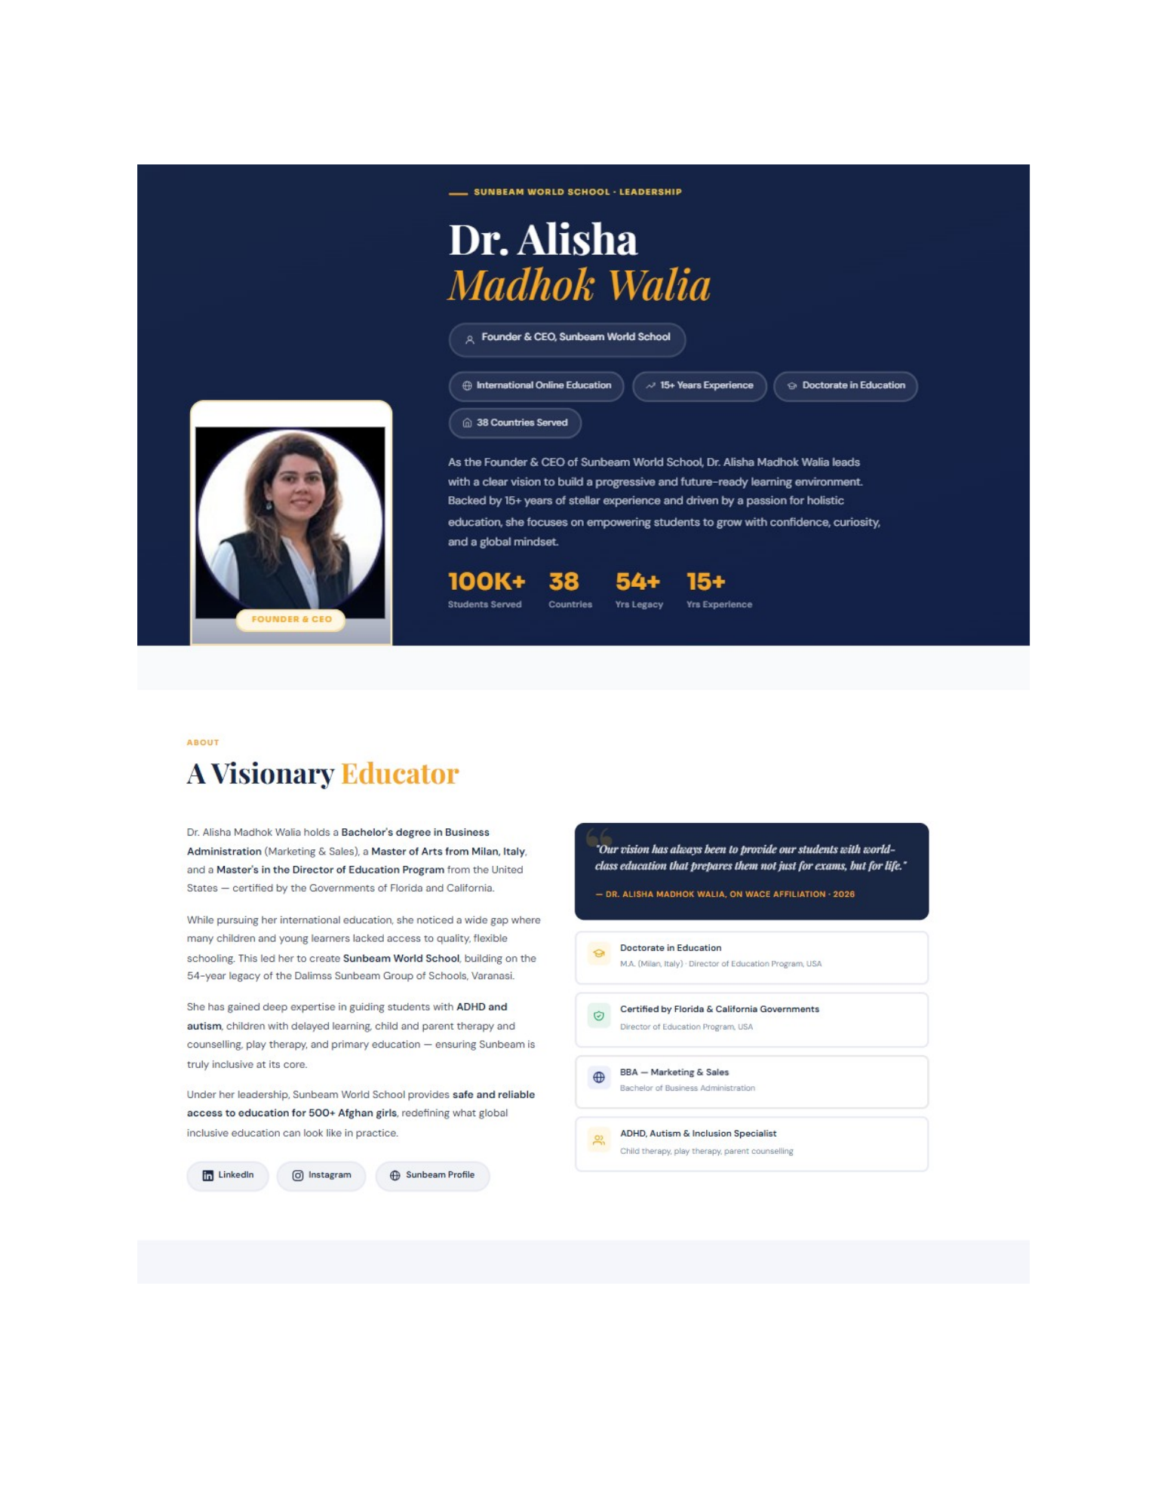
Reference image from source document — Page 18

Page 19 — Areas of Specialisation
- Create a 6-card specialisation grid: Global Online Education; Inclusive Education; EdTech Leadership; Child & Parent Therapy; Academic Excellence; Strategic Growth.
- Use icons and concise descriptions from the reference visual/source.
Implementation note: Do not invent additional specialisations.
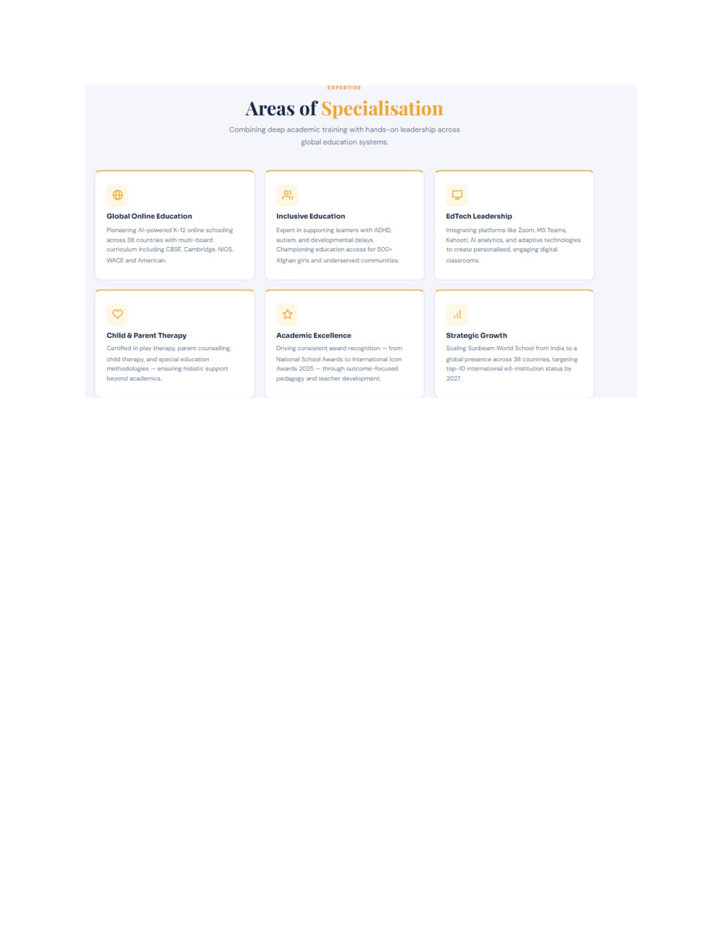
Reference image from source document — Page 19

Page 20 — Founder Story / Career Journey + Affiliations
- Add “Her Story” timeline/career journey.
- Add awards/media only when actual approved evidence exists.
- Follow with Affiliations & Accreditations.
- Use approved accreditation sources and certificate links; do not invent credentials.
Implementation note: This page is the transition from founder story/career journey to affiliations and accreditation.
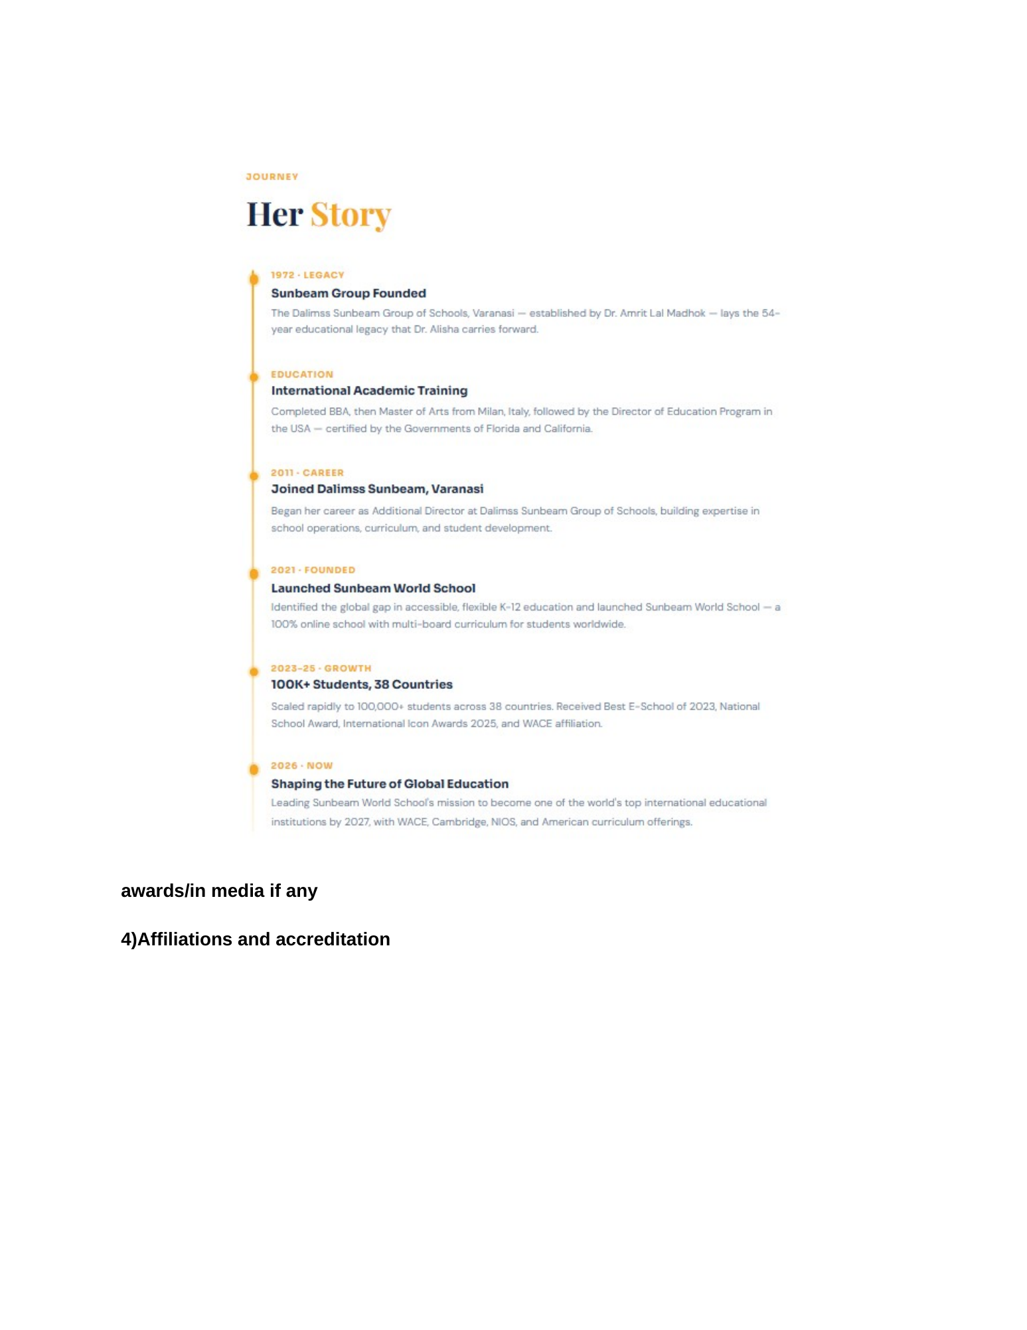
Reference image from source document — Page 20

4. Current Live-Site Issues to Fix
Issue | Finding | Required Change
Rashmi Bhasin still listed | Current About page lists Rashmi Bhasin as Academic Head and links to a profile page. | Remove from team listing and public profile navigation as previously approved.
8C Philosophy vs approved Values | Live page currently uses the 8C Philosophy. | Implement the six approved Zuvio values section in the new About structure.
Missing dedicated “What Sets Us Apart” | The approved six differentiators are not part of the current About page structure. | Add them as a dedicated section.
Missing approved ZUVIO Approach | Current page does not present the exact Z-U-V-I-O framework from the source. | Add the acronym framework with source copy.
Missing full “Who Should Choose Zuvio” section | Current page does not show the full source audience list. | Add all approved audiences.
Founder terminology | Project has moved from CEO Message to Founder’s Message. | Use Founder terminology consistently across navigation, page title, metadata and CMS.
Affiliations placement | Needs to be part of the About architecture. | Create dedicated Affiliations & Accreditations section/page with certificate links.
CMS synchronization | About content needs independent section/item management. | Admin must mirror the About Us hierarchy and support CRUD/reorder/publish.

5. Admin Panel / CMS Requirements — About Us
- ABOUT US CMS must contain: About Zuvio, Our Team, Founder’s Message, Affiliations & Accreditations.
- Each page/section must support ADD, EDIT, DELETE, MOVE, REORDER, PUBLISH/UNPUBLISH.
- Our Team: member name, role, photo, bio, profile URL, active status, display order.
- Founder: portrait, title, message, story, expertise/specialisations, social/profile links where approved.
- Values / Differentiators / ZUVIO Approach: each item must be individually editable and reorderable.
- Accreditations: logo, name, description, certificate/verification URL, CTA label, active status, order.
- Media manager must allow image upload/replace/delete and retain stable links where practical.
- Any change made in Admin must immediately reflect on the frontend after publish without hardcoded duplication.

6. Recommended Final About Us Page Flow
1. About Us Hero
2. About Zuvio / Story
3. Vision & Mission
4. Values — What Matters at Zuvio
5. What Sets Us Apart
6. Our Approach — ZUVIO, Zoomed In
7. Who Should Choose Zuvio
8. Our Team
9. Founder’s Message
10. Founder Story / Expertise
11. Areas of Specialisation
12. Awards / Media (when verified)
13. Affiliations & Accreditations
14. Final CTA / Contact

7. Source & Live Audit Notes
Source document: Home Page design changes(1).docx — About Us material is on Pages 10–20.
Live site audited: https://www.zuvioglobalschool.com/about
Important: The source document is the content/design authority for this implementation. The live website audit is used to identify current gaps and existing content that can be reused. Where the latest project instruction differs from the legacy DOCX wording (for example, Founder’s Message instead of CEO Message), the latest approved project instruction should be followed.

