EXPERIMENT – 1
TITLE: Introduction to Java Environment
1. Explore and understand the role of JDK, JRE, and JVM.
- JDK (Java Development Kit): The JDK is a software development kit that provides tools for compiling, debugging, and running Java programs. It includes the JRE.
- JRE (Java Runtime Environment): The JRE is the environment required to run Java applications. It includes the JVM.
- JVM (Java Virtual Machine): The JVM is the runtime engine that executes Java bytecode. This is what makes Java platform-independent ("write once, run anywhere"). The JVM translates the bytecode into instructions that the underlying operating system can understand.

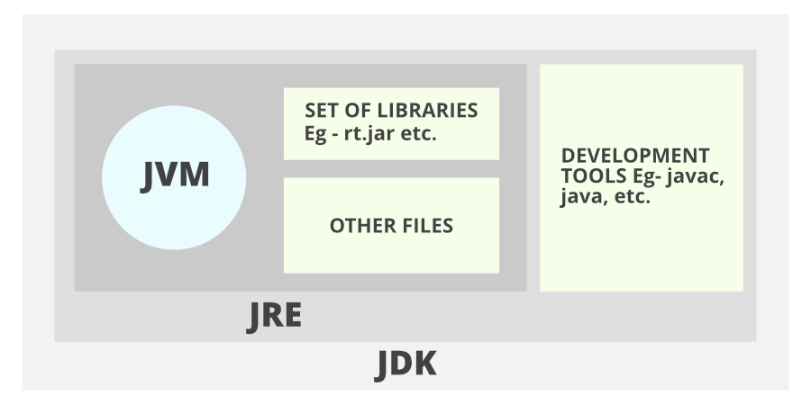

2. Install latest available JDK and verify the Java Environment.
- Download: Download the latest JDK from Oracle's website (or a suitable alternative like Adoptium/Temurin).
- Installation: Follow the installation instructions for your operating system (Windows, macOS, Linux).
- Verification: Open a command prompt or terminal.
  - Type javac -version and press Enter. This should display the installed JDK version.
  - Type java -version and press Enter. This should display the installed JRE version.

3. Create a Sample Hello World Program using simple text editor (e.g., Notepad) and show the steps to compile and execute the program using command prompt.
- Create the file: Open a text editor (Notepad, VS Code, etc.) and type the following code:
- Save the file: Save the file as HelloWorld.java.
- Compile: Open a command prompt or terminal, navigate to the directory where you saved the file, and type javac HelloWorld.java and press Enter. This creates a HelloWorld.class file.
- Run: In the same command prompt, type java HelloWorld and press Enter. This executes the program, and "Hello, World!" should be printed to the console.
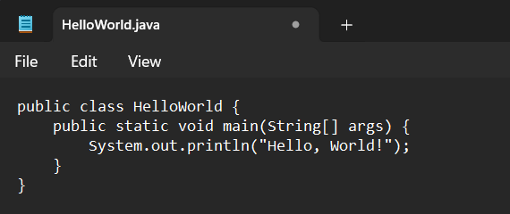

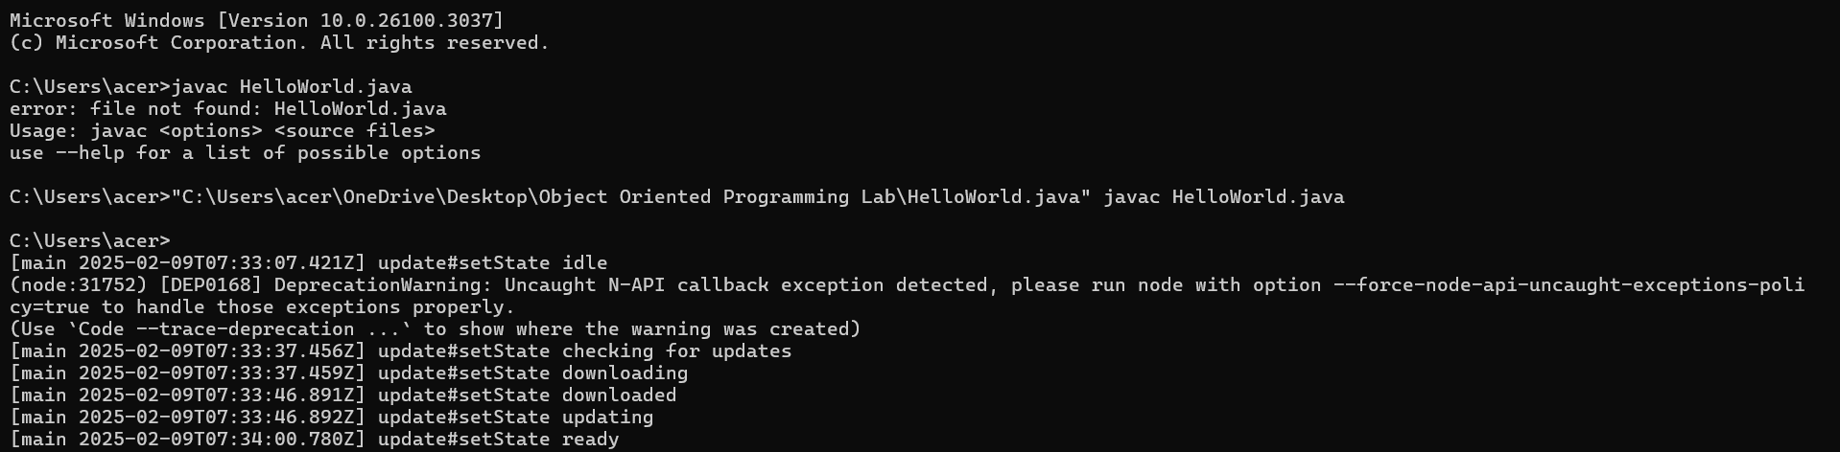
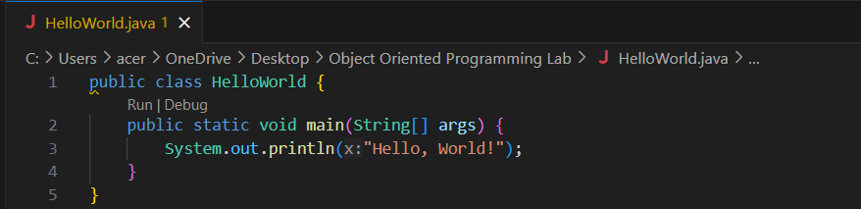

4. Display your name and complete address in different lines.
Create a new Java file (e.g., MyInfo.java) with the following code (replace the bracketed information with your details):
Compile and run this program using the same steps as in step 3.
