CISCO PACKET TRACER

Having successfully set up a network using a Router, Switch, and end devices, this document enlists the steps to connect two or more Routers followed by setting up a DHCP server and an HTTP server

Connecting 2 or more routers together

1. Click on one of the routers and go to physical tab

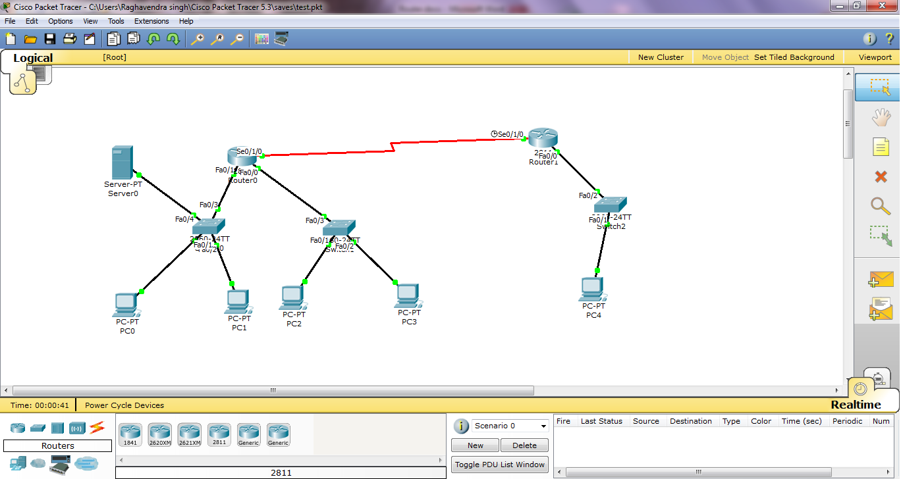

1. Turn the power switch off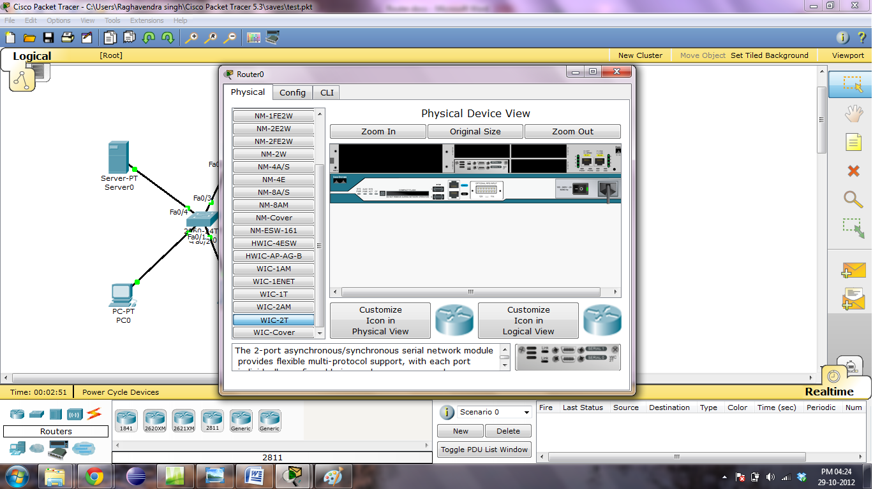
2. Install the component WIC-2T by dragging it to one of the slots
3. Power on the Router and wait till it boots
4. Go to config section and under the interface header to new ports would be added
5. After the power on, all ports need to be reset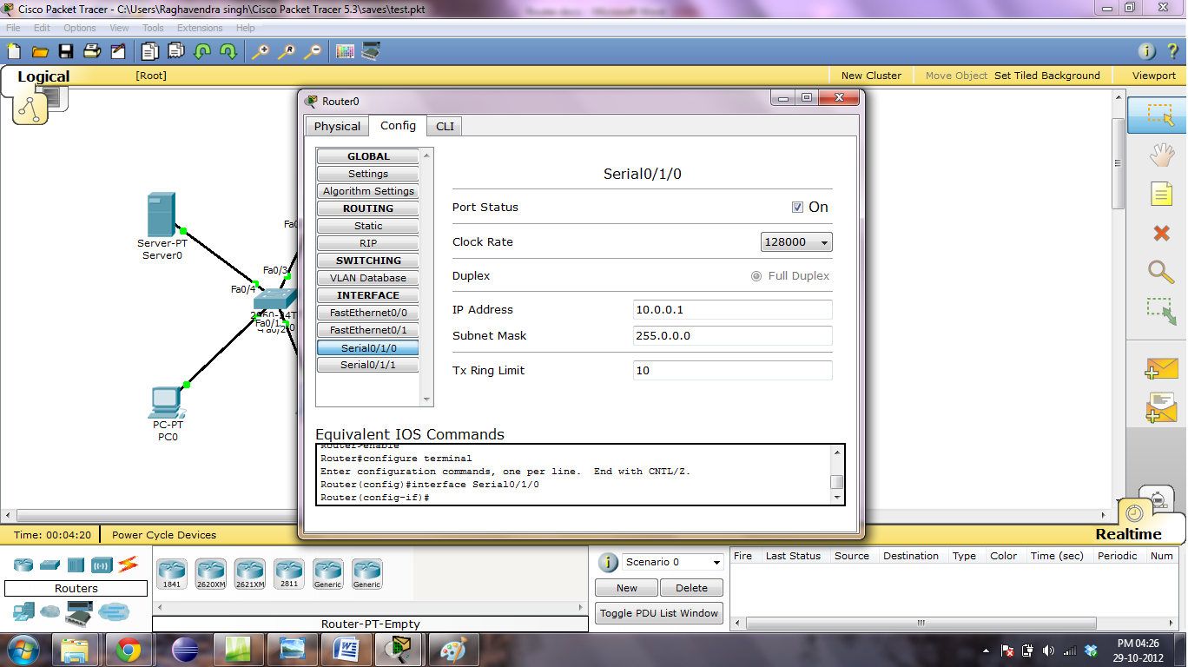
6. To program the serial port, turn it on and set the clock rate (say 128000)
7. Set the ip address to some value (say 10.0.0.1) and set the subnet as well
8. Come out to the design window and similarly program all other routers
9. To connect two routers pick up the serial DTE wire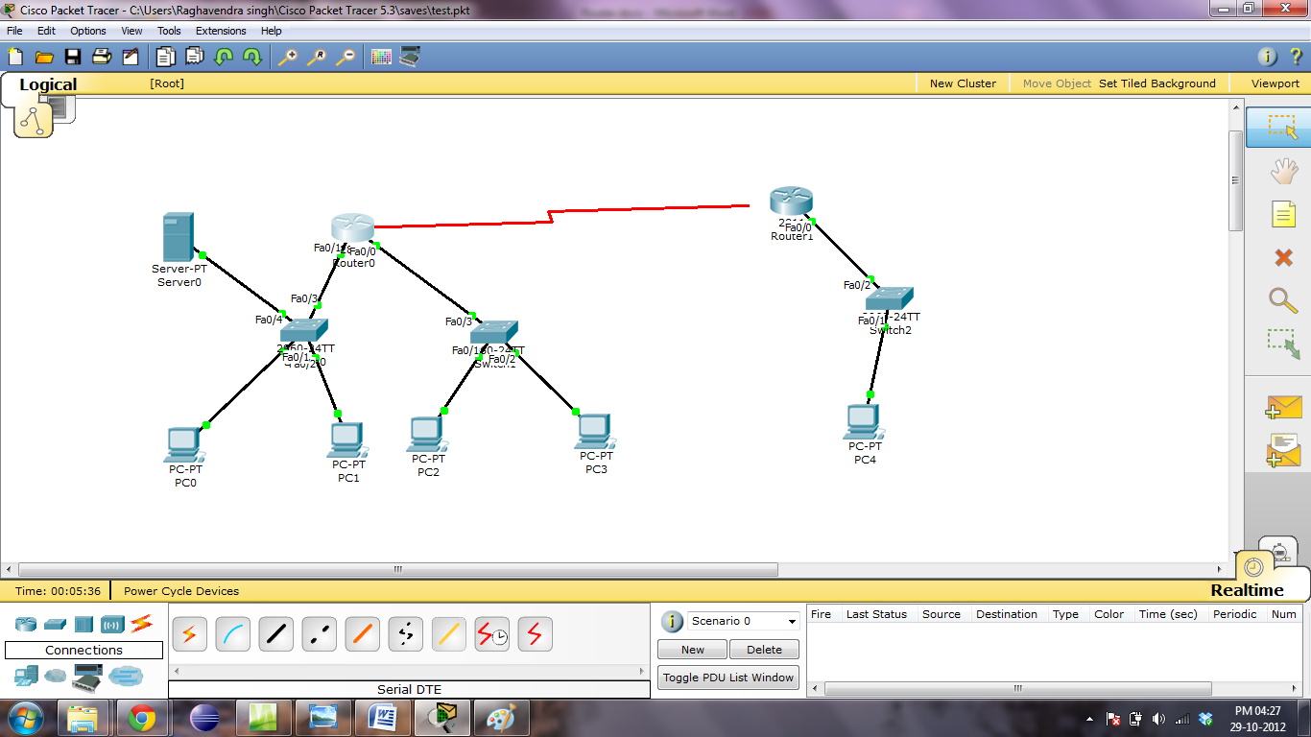
10. After making the connections the routers RIP table has to be filled
11. Click on a router and go to config tab
12. Click on RIP button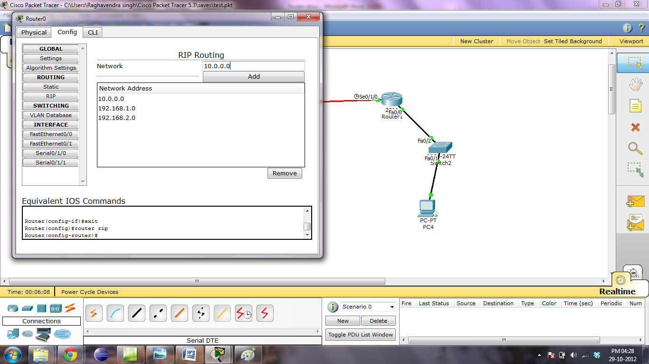
13. In the adjacent panel type in all the networks that are connected to that router
14. Repeat the same process for all the routers. The network is now ready to use.

Setting up a DHCP Server

1. Pick up a generic server from end devices and connect it to a switch along with other end devices. Set a static ip address in desktop->ip configuration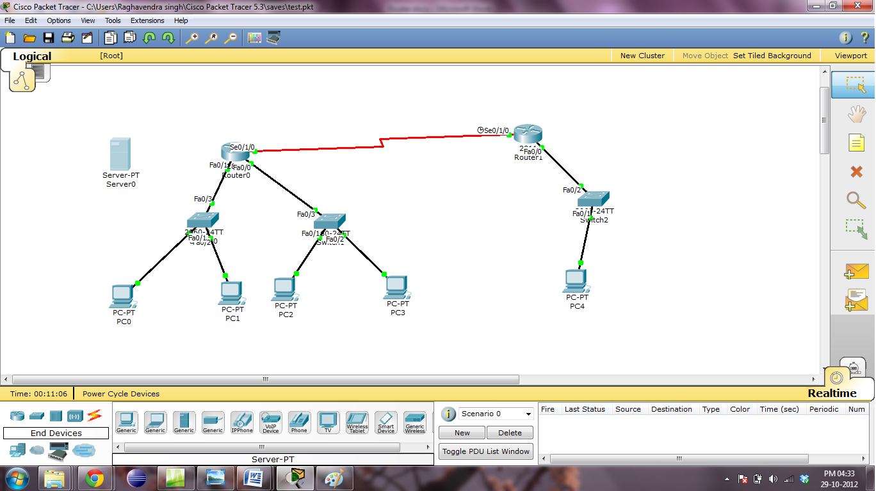
2. Click on the server and go to config tab
3. Fill in server name(optional), followed by a gateway ip address 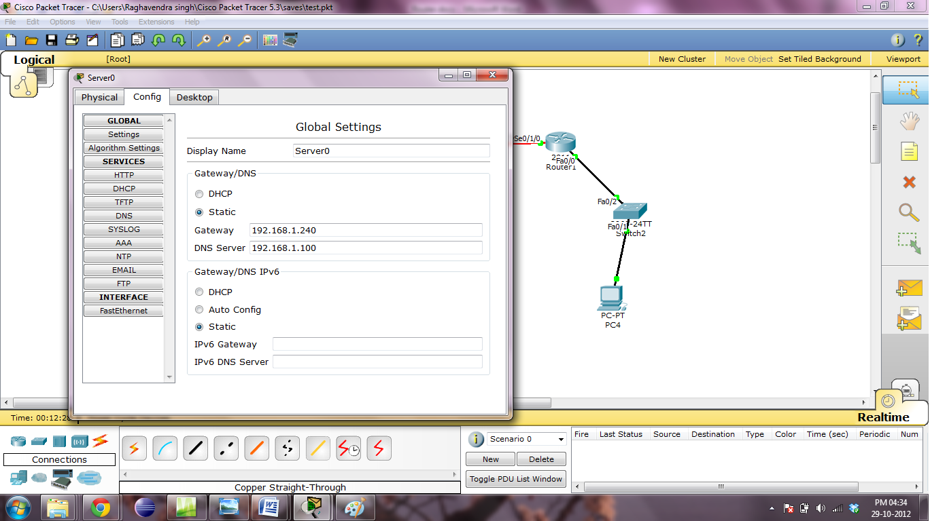
4. Now click on the DHCP tab on the left panel and set up a new server pool
5. Switch the service on and set a pool name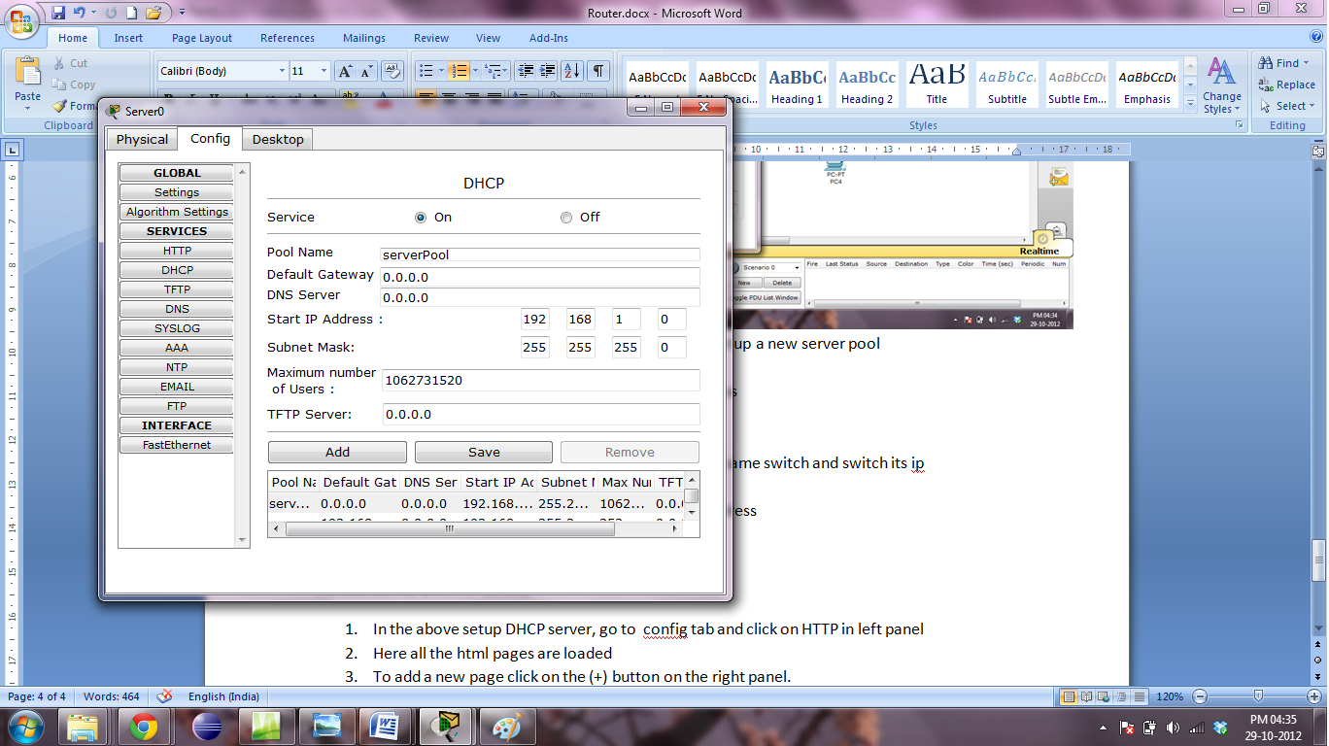
6. Type the default gateway and the starting ip address
7. Fill the max. no. of users(say 256).
8. After filling in the details press add
9. Now open any other end device connected on the same switch and switch its ip configuration from static to DHCP. 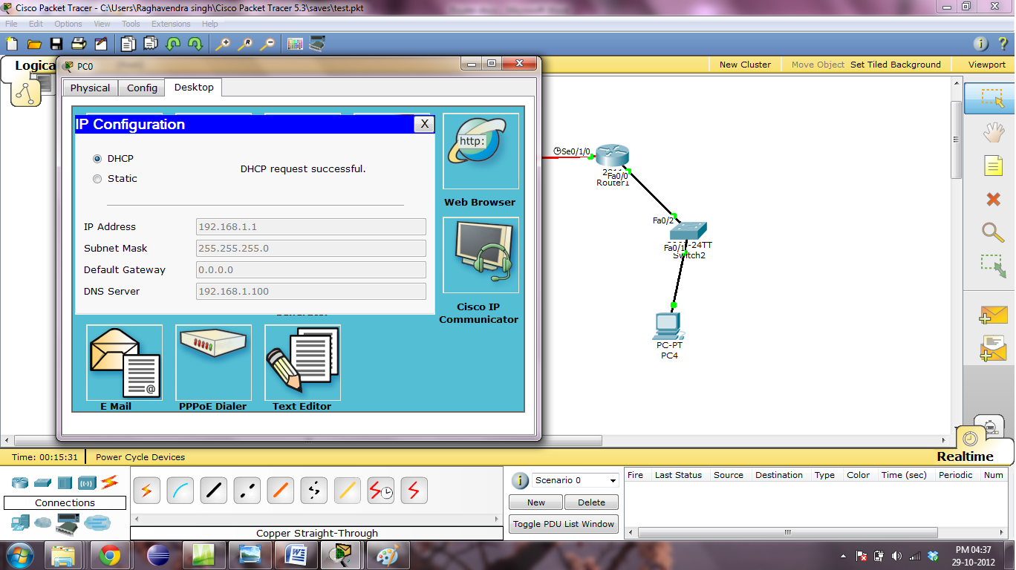
10. The DHCP server will successfully allocate an ip address

Connection to an HTTP service

1. In the above setup DHCP server, go to config tab and click on HTTP in left panel
2. Here all the html pages are loaded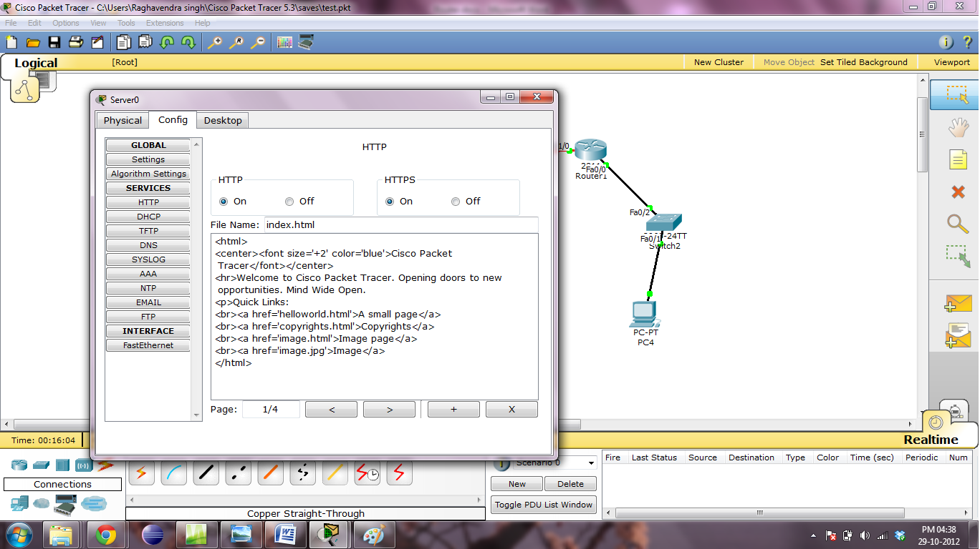
3. To add a new page click on the (+) button on the right panel.
4. A new file pops up (say file1.html)
5. Type in the content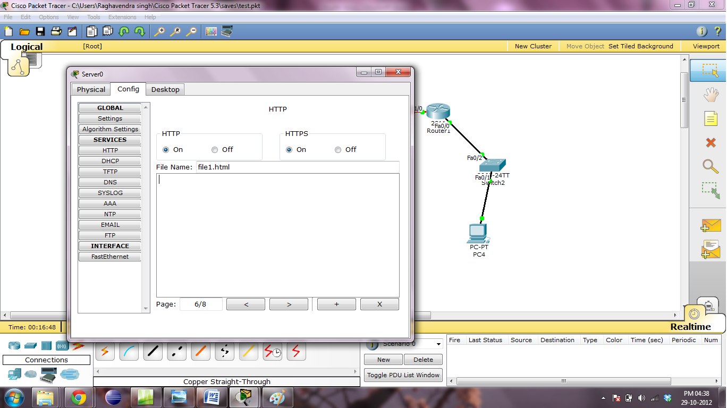
6. Go to any end system on the same switch and open the web browser.
7. Type in the ip address of the server and press enter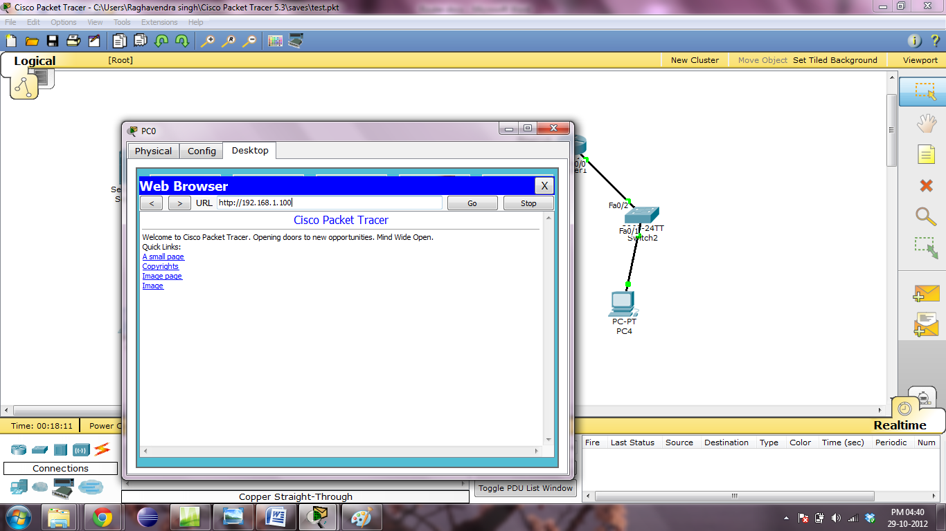
8. The file that was loaded on the server will appear on the screen