Sample code

<?php

$x = 5;

$y = 4;

echo $x + $y;

?>

]

PHP supports the following data types:

* String
* Integer
* Float (floating point numbers - also called double)
* Boolean
* Array
* Object
* NULL
* Resource

var_dump($x);: The PHP var_dump() function returns the data type and value

<?php

$cars = array(23,23.444,"Toyota",null,true,false);

var_dump($cars);

?>

**String functions**

**Function Description**

bin2hex() Converts a string of ASCII characters to hexadecimal values

chop() Removes whitespace or other characters from the right end of a string

chr() Returns a character from a specified ASCII value

echo() Outputs one or more strings

explode() Breaks a string into an array

fprintf() Writes a formatted string to a specified output stream

ltrim() Removes whitespace or other characters from the left side of a string

ord() Returns the ASCII value of the first character of a string

print() Outputs one or more strings

printf() Outputs a formatted string

rtrim() Removes whitespace or other characters from the right side of a string

str_repeat() Repeats a string a specified number of times

str_replace() Replaces some characters in a string (case-sensitive)

str_split() Splits a string into an array

str_word_count() Count the number of words in a string

strcasecmp() Compares two strings (case-insensitive)

strchr() Finds the first occurrence of a string inside another string (alias of strstr())

strcmp() Compares two strings (case-sensitive)

stripos() Returns the position of the first occurrence of a string inside another string (case-insensitive)

stristr() Finds the first occurrence of a string inside another string (case-insensitive)

strlen() Returns the length of a string

strncasecmp() String comparison of the first n characters (case-insensitive)

strncmp() String comparison of the first n characters (case-sensitive)

strpos() Returns the position of the first occurrence of a string inside another string (case-sensitive)

strrchr() Finds the last occurrence of a string inside another string

strrev() Reverses a string

strripos() Finds the position of the last occurrence of a string inside another string (case-insensitive)

strrpos() Finds the position of the last occurrence of a string inside another string (case-sensitive)

strspn() Returns the number of characters found in a string that contains only characters from a specified charlist

strstr() Finds the first occurrence of a string inside another string (case-sensitive)

strtolower() Converts a string to lowercase letters

strtoupper() Converts a string to uppercase letters

strtr() Translates certain characters in a string

substr() Returns a part of a string

substr_compare() Compares two strings from a specified start position (binary safe and optionally case-sensitive)

substr_count() Counts the number of times a substring occurs in a string

substr_replace() Replaces a part of a string with another string

trim() Removes whitespace or other characters from both sides of a string

constants

<?php

define("GREETING", "Welcome to W3Schools.com!");

function myTest() {

  echo GREETING;

}

myTest();

?>

Math functions

| **Function** | **Description** |
| --- | --- |
| abs() | Returns the absolute (positive) value of a number |
| acos() | Returns the arc cosine of a number |
| acosh() | Returns the inverse hyperbolic cosine of a number |
| asin() | Returns the arc sine of a number |
| asinh() | Returns the inverse hyperbolic sine of a number |
| atan() | Returns the arc tangent of a number in radians |
| atan2() | Returns the arc tangent of two variables x and y |
| atanh() | Returns the inverse hyperbolic tangent of a number |
| base_convert() | Converts a number from one number base to another |
| bindec() | Converts a binary number to a decimal number |
| ceil() | Rounds a number up to the nearest integer |
| cos() | Returns the cosine of a number |
| cosh() | Returns the hyperbolic cosine of a number |
| decbin() | Converts a decimal number to a binary number |
| dechex() | Converts a decimal number to a hexadecimal number |
| decoct() | Converts a decimal number to an octal number |
| deg2rad() | Converts a degree value to a radian value |
| exp() | Calculates the exponent of e |
| expm1() | Returns exp |
| floor() | Rounds a number down to the nearest integer |
| fmod() | Returns the remainder of x/y |
| getrandmax() | Returns the largest possible value returned by rand() |
| hexdec() | Converts a hexadecimal number to a decimal number |
| hypot() | Calculates the hypotenuse of a right-angle triangle |
| intdiv() | Performs integer division |
| is_finite() | Checks whether a value is finite or not |
| is_infinite() | Checks whether a value is infinite or not |
| is_nan() | Checks whether a value is 'not-a-number' |
| lcg_value() | Returns a pseudo random number in a range between 0 and 1 |
| log() | Returns the natural logarithm of a number |
| log10() | Returns the base-10 logarithm of a number |
| log1p() | Returns log(1+number) |
| max() | Returns the highest value in an array, or the highest value of several specified values |
| min() | Returns the lowest value in an array, or the lowest value of several specified values |
| mt_getrandmax() | Returns the largest possible value returned by mt_rand() |
| mt_rand() | Generates a random integer using Mersenne Twister algorithm |
| mt_srand() | Seeds the Mersenne Twister random number generator |
| octdec() | Converts an octal number to a decimal number |
| pi() | Returns the value of PI |
| pow() | Returns x raised to the power of y |
| rad2deg() | Converts a radian value to a degree value |
| rand() | Generates a random integer |
| round() | Rounds a floating-point number |
| sin() | Returns the sine of a number |
| sinh() | Returns the hyperbolic sine of a number |
| sqrt() | Returns the square root of a number |
| srand() | Seeds the random number generator |
| tan() | Returns the tangent of a number |
| tanh() | Returns the hyperbolic tangent of a number |

Operators

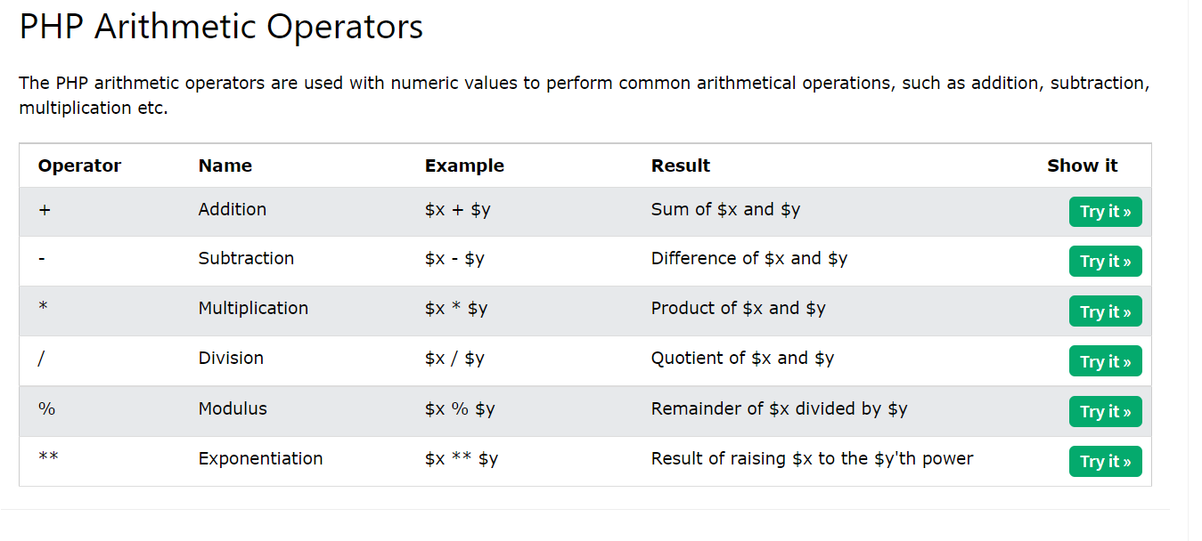 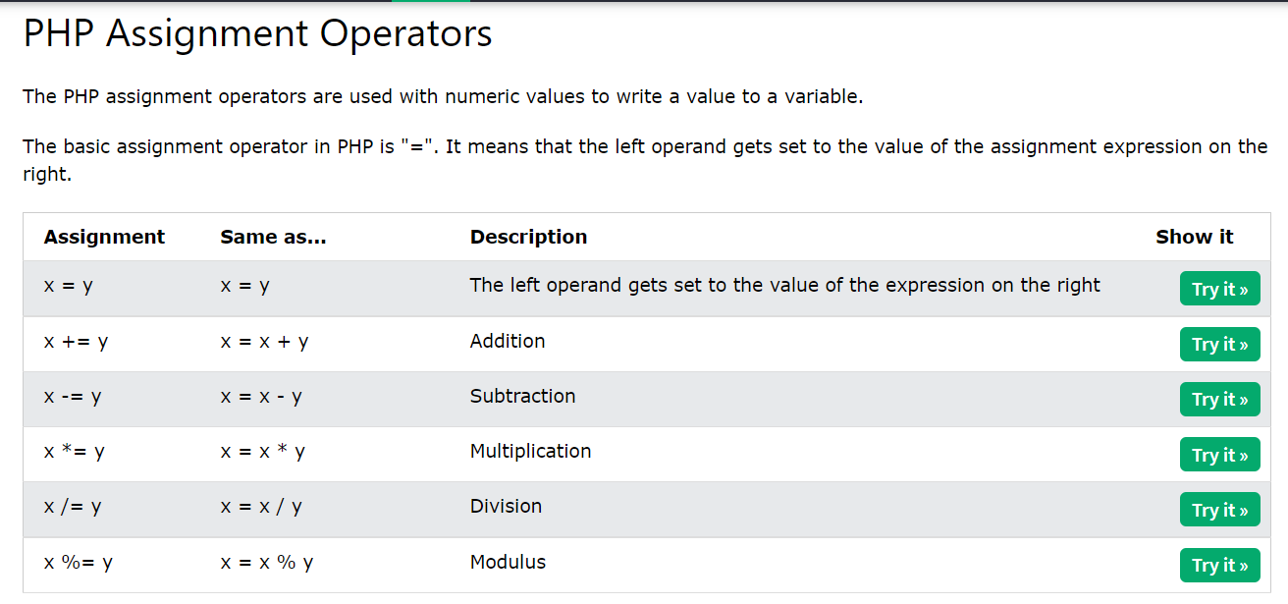 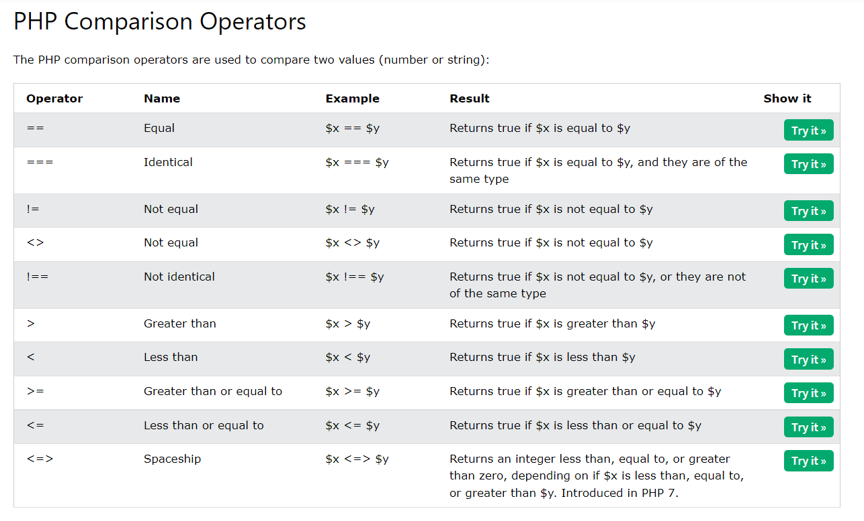 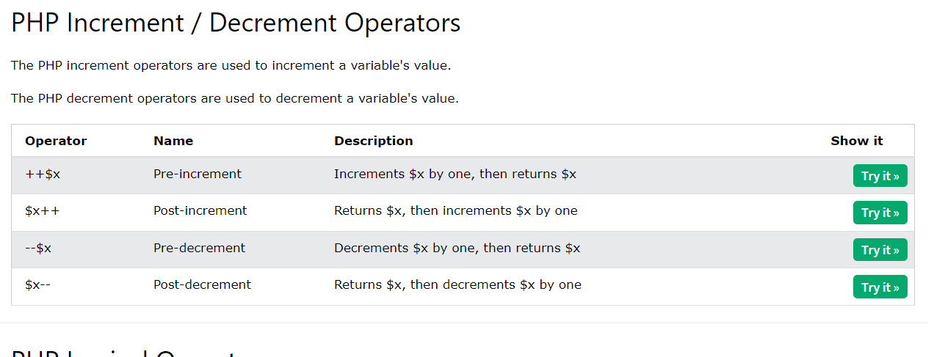 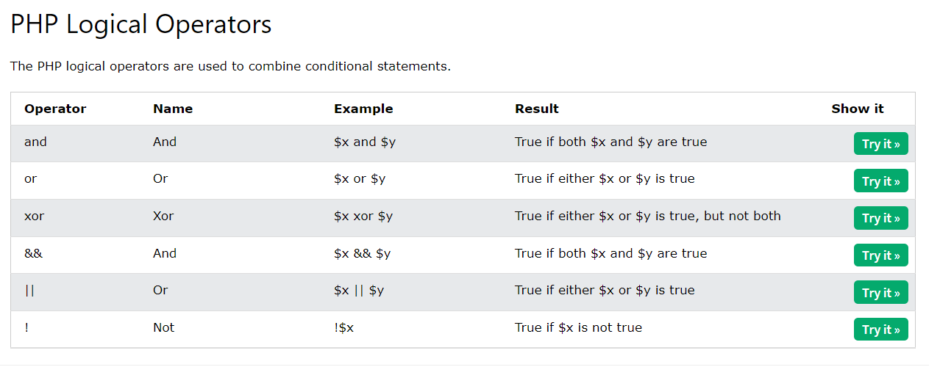 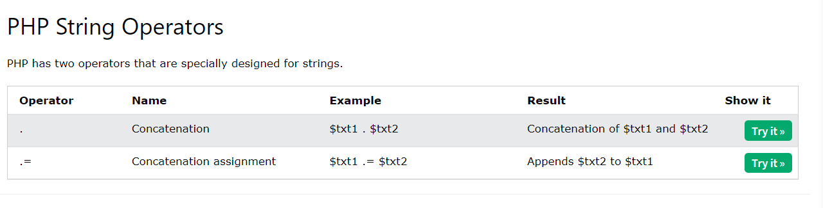 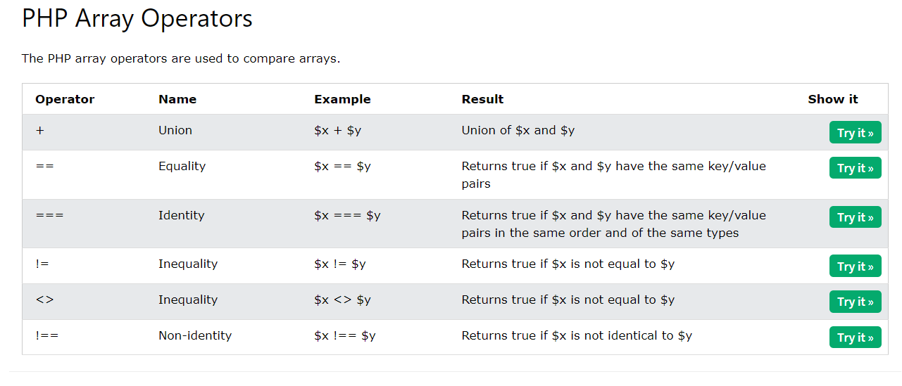 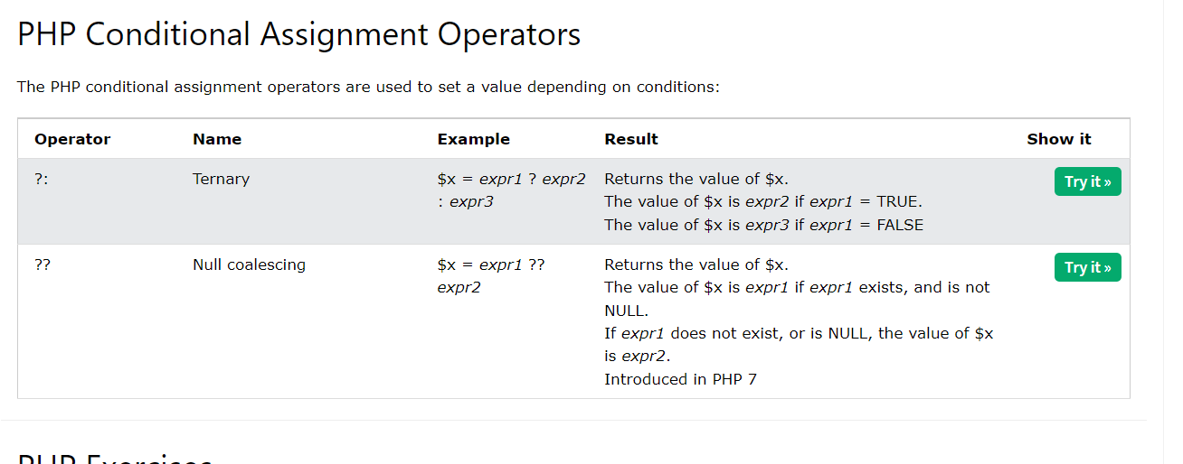

If else

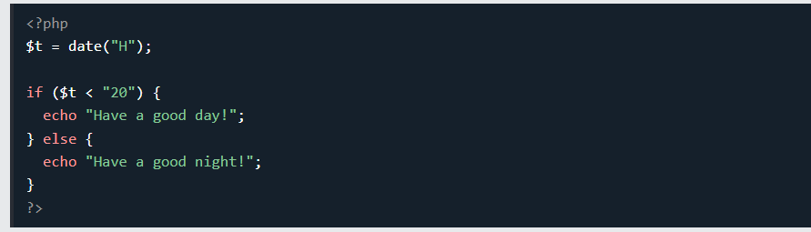

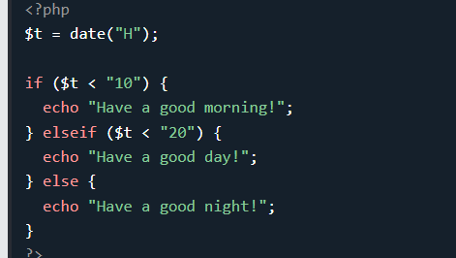

Switch

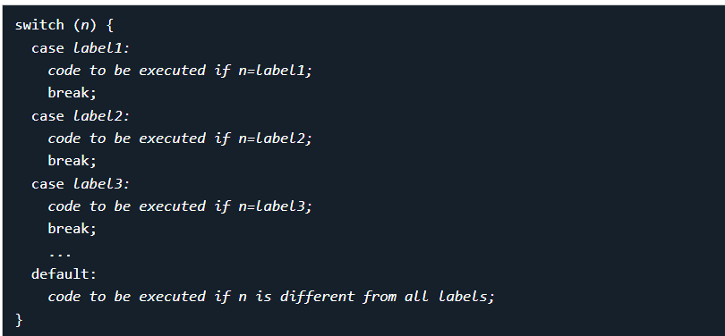

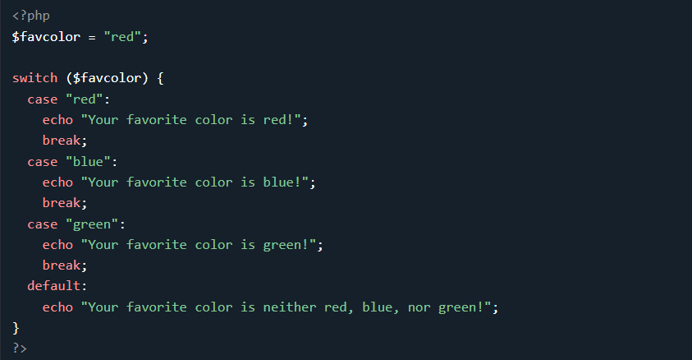

Loops

while

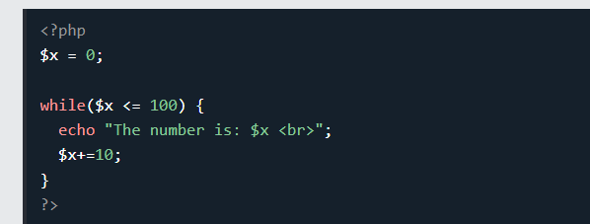

Do while

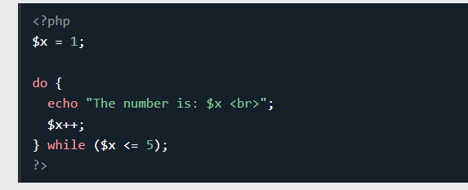

For loop

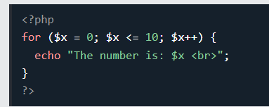

Foreach

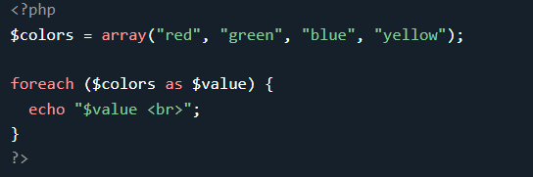

Php functions

