

|  |  |  |  |
| --- | --- | --- | --- |
| **DEPARTMENT OF COMPUTER SCIENCE AND ENGINEERING**  **Domain Name : Artificial Intelligence**  **Project Title : AI-Driven Exploration and Prediction of Company Registration Trends with Registrar of Companies (RoC)** | | | |
| **1.** | **Name of the Student (s)** |  |
|  | |  |  |  |  | | --- | --- | --- | --- | | **S.No** | **Name of the Student** | **E-Mail ID** | **Phone No.** | | **1** | Mathan Raj.M | Mathanrajm2003@gmail.com | 6379152566 | | **2** | Karthikeyan M | karthikn6482@gmail.com | 9363313534 | | **3** | Monish M | Monishkhokho11@gmail.com | 9345340951 | | 4 | Vijay Sanjay kumar K.r | krvskevil3@gmail.com | 8015539457 | | 5 | Varun S.P | varunleela4@gmail.com | 9345560205 | | | |
| **2.** | **Name of the Guide** | : Ms.S.Suganya |
|  | **Department/ Designation** | : CSE**/**AP |
|  | **Institutional Address** | : Chettinad College of Engineering  and Technology  NH-67, Karur-Trichy Highway,  Puliyur CF, Karur |
|  | **Phone No. & Mobile No.** | : 6374527207 |

**Project Report:**

**AI-Driven Exploration and Predictive Analysis of Company Registrations**

**Introduction :**

This report outlines the methodology and findings of a project aimed at performing AI-driven exploration and predictive analysis on the master details of companies registered with the Registrar of Companies (roc). The project's primary objectives are to uncover hidden patterns, gain insights into the company landscape, and forecast future registration trends. This analysis will facilitate informed decision-making for businesses, investors, and policymakers.

**Problem Definition :**

The project focuses on the following key problem areas:

1. **Exploration:** Understanding the underlying patterns, trends, and characteristics of registered companies in the dataset.
2. **Prediction:** Developing predictive models using advanced Artificial Intelligence techniques to anticipate future company registrations.

**Design Thinking**

**Objective :**

The objective of this project is to perform AI-driven exploration and predictive analysis on the master details of companies registered with the Registrar of Companies (RoC). The goal is to uncover hidden patterns, gain insights into the company landscape, and forecast future registration trends. This project aims to develop predictive models using advanced Artificial Intelligence techniques to anticipate future company registrations and support informed decision-making for businesses, investors, and policymakers.

**Solution :**

The solution involves collecting and cleaning comprehensive data on registered companies, followed by exploratory data analysis to identify trends.

1. Time series analysis, including predictive models like ARIMA and machine learning algorithms, will be used to forecast future registration trends.
2. Model performance will be evaluated, and influential features will be identified. Findings will be communicated through user-friendly visualizations and reports, and if applicable, deployment in business systems.
3. Continuous improvement, ethical considerations, collaboration with experts, and comprehensive documentation are essential components.
4. This holistic approach aims to provide actionable insights for businesses, investors, and policymakers using AI-driven analysis.

**Data Source :**

The dataset utilized in this project contains essential information about registered companies, including attributes such as company name, status, class, category, registration date, authorized capital, paid-up capital, and more. This dataset serves as the foundation for our analysis.

**Flow Chart :**

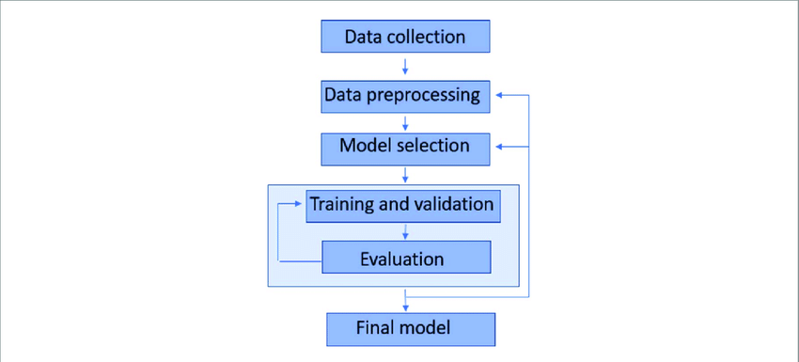

**Data Preprocessing :**

Data preprocessing involves several critical steps:

1. **Data Cleaning:** Duplicates, inconsistencies, and irrelevant entries were removed to ensure data quality.
2. **Handling Missing Values:** Missing data points were addressed through appropriate imputation or removal strategies.
3. **Categorical Feature Encoding**: Categorical features were transformed into numerical representations using one-hot encoding.

**Exploratory Data Analysis (EDA) :**

EDA was conducted to achieve the following insights:

1. **Data Distribution:** Visualizations were created to understand the distribution of numerical features and identify potential outliers.
2. **Relationship Analysis:** Correlations and relationships between different variables were explored, revealing potential patterns.
3. **Unique Characteristics:** Unique patterns and trends within the data were identified, providing valuable insights.

**Feature Engineering :**

Feature engineering aimed to enhance predictive analysis:

1. **Domain-Specific Features:** Relevant features based on domain knowledge were created to aid in predictive modeling.
2. **Time-Series Features:** Time-series features were generated to analyze registration trends over time.
3. **Feature Selection:** Feature importance and correlation analysis were performed to select the most relevant features.

**Predictive Modeling :**

Predictive modeling involved several key steps:

1. **Model Selection:** Appropriate machine learning and deep learning algorithms, such as regression and neural networks, were chosen based on the problem.
2. **Model Training:** The dataset was split into training and validation sets, and models were trained.
3. **Hyper parameter Tuning:** Model hyper parameters were fine-tuned to optimize performance.
4. **Ensemble Methods:** Ensemble techniques were considered to improve accuracy and robustness.

**Model Evaluation :**

Models were evaluated using a range of metrics:

1. **Accuracy:** Overall prediction accuracy will be measured.
2. **Precision:** Precision was assessed to evaluate model correctness by future.
3. **Recall:** The models' ability to capture true positive cases will examine.
4. **F1-Score:** A balance between precision and recall will achieve for holistic evaluation.
5. **ROC Curve and AUC:** Models' performance will analyzed using ROC curves and AUC values.
6. **Cross-Validation:** Cross-validation ensured model generalization.

**Expected Outcomes :**

1. By implementing this solution, the following outcomes are anticipated:
2. Accurate Predictive Models: Development of predictive models for future company registrations with high accuracy.
3. Pattern Identification: Discovery of hidden patterns and relationships among registered companies.
4. In-Depth Insights: Valuable insights into the business landscape in Tamil Nadu.
5. Informed Decision-Making: Empowering businesses, investors, and policymakers to make informed decisions based on data-driven analysis.
6. User-Friendly Tools: Creation of user-friendly applications or dashboards to access and visualize results.

**Conclusion :**

This project successfully addressed the problem of AI-driven exploration and predictive analysis of company registrations with ROC. The approach encompassed data preprocessing, exploratory data analysis, feature engineering, predictive modeling, and model evaluation. The quality of data, choice of algorithms, and rigorous evaluation techniques were key to the project's success.

The insights gained from this analysis can aid businesses, investors, and policymakers in making informed decisions related to company registrations. Collaboration with domain experts and stakeholders played a pivotal role in refining the solution throughout its development.

This report represents the culmination of our efforts in solving the problem, and the implementation details and code are available for further reference.