EXP-7
clc;
clear;
close all;

% Parameters
fs = 100000;
t = 0:1/fs:0.02;
fm = 500; % Message frequency
fc = 5000; % Carrier frequency
kf = 100; % Frequency sensitivity

% Message Signal & Carrier Signal
m = cos(2*pi*fm*t);
c = cos(2*pi*fc*t);

% FM Modulation
fm_sig = cos(2*pi*fc*t + 2*pi*kf*cumsum(m)/fs);

%% --- Mathematical Custom Replacement for awgn() ---
target_snr_db = 10; % 10 dB SNR

% 1. Measure the power of the FM signal
signal_power = mean(fm_sig.^2);

% 2. Convert target SNR from decibels to a linear scale
snr_linear = 10^(target_snr_db / 10);

% 3. Calculate the required noise power to hit that SNR ratio
noise_power = signal_power / snr_linear;

% 4. Generate white Gaussian noise with matching variance and dimensions
% sqrt(noise_power) scales standard normal distribution randn to correct variance
noise = sqrt(noise_power) * randn(size(fm_sig));

% 5. Add noise directly to the signal
noisy = fm_sig + noise;
%% --------------------------------------------------

% Display
figure;

subplot(4,1,1)
plot(t, m)
title('Message Signal')
grid on

subplot(4,1,2)
plot(t, c)
title('Carrier Signal')
grid on

subplot(4,1,3)
plot(t, fm_sig)
title('FM Signal')
grid on

subplot(4,1,4)
plot(t, noisy)
title('FM Signal with Gaussian White Noise (Toolbox-Free)')
grid on

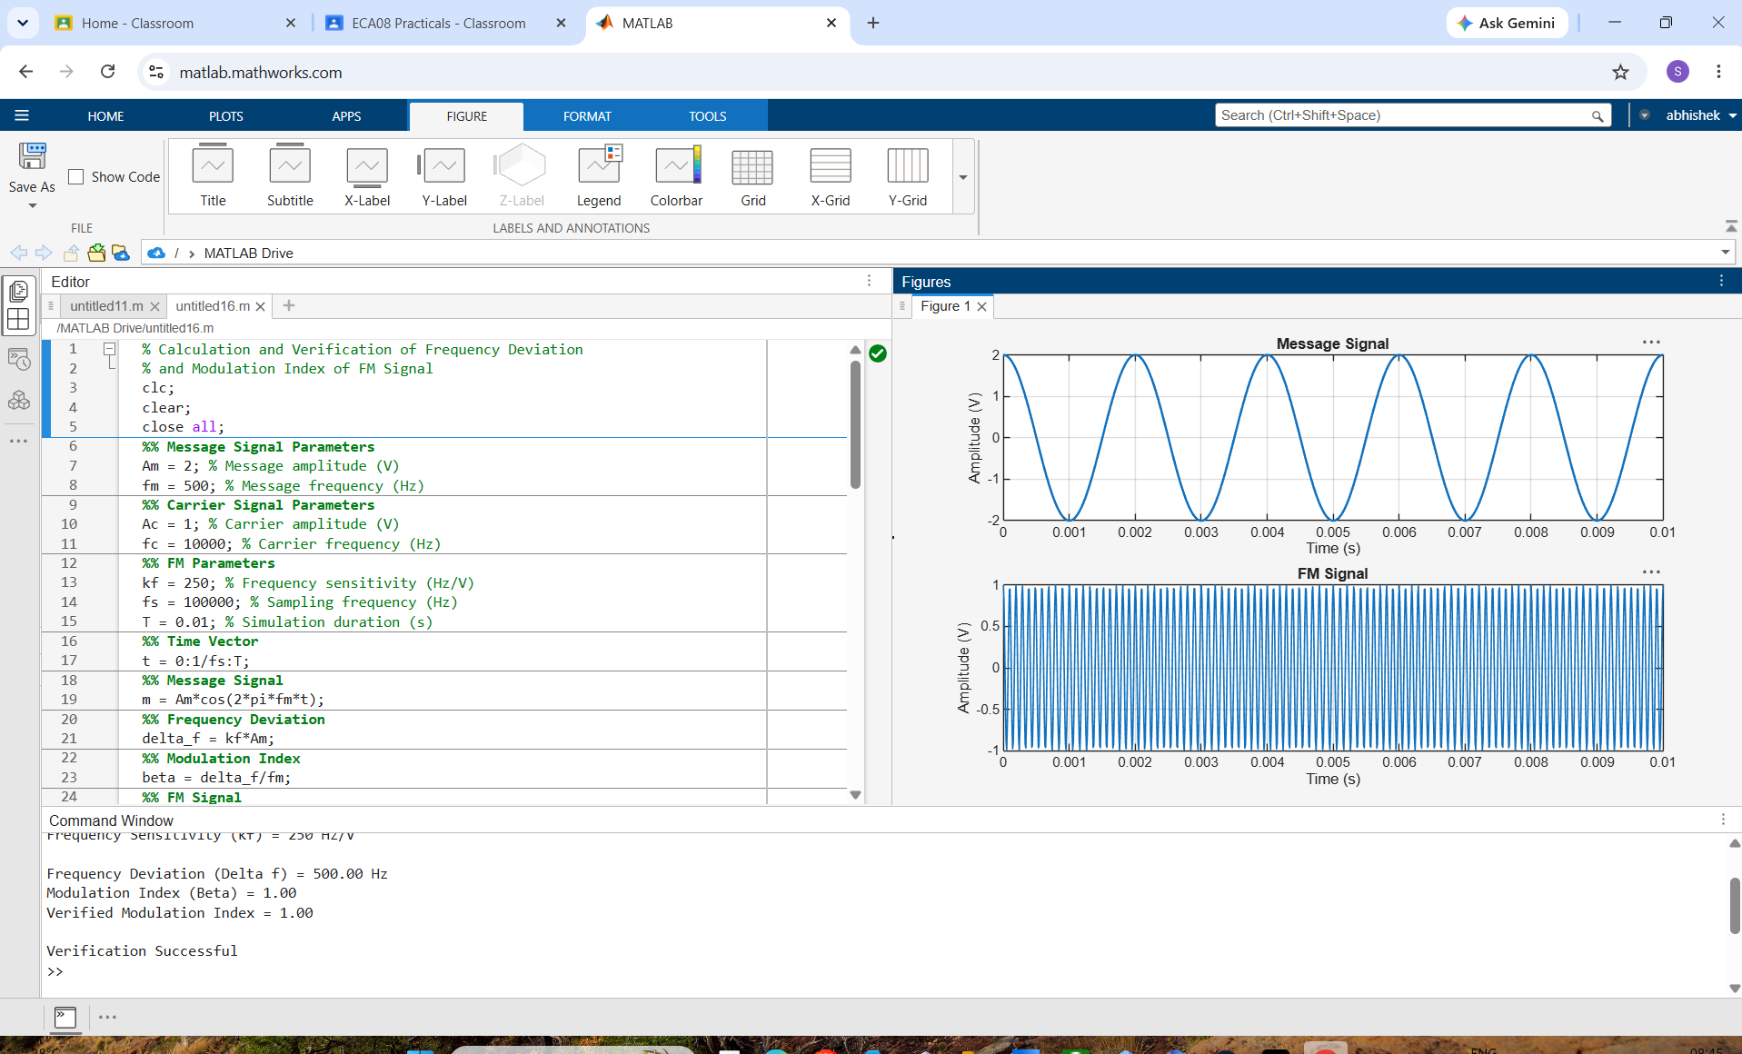
EXP-8
clc;
clear;
close all;

% Parameters
fs = 100000;
t = 0:1/fs:0.02;
fm = 500; % Message frequency
fc = 5000; % Carrier frequency
kf = 100; % Frequency sensitivity

% Message Signal & Carrier Signal
m = cos(2*pi*fm*t);
c = cos(2*pi*fc*t);

% FM Modulation
fm_sig = cos(2*pi*fc*t + 2*pi*kf*cumsum(m)/fs);

%% --- Mathematical Custom Replacement for awgn() ---
target_snr_db = 10; % 10 dB SNR

% 1. Measure the power of the FM signal
signal_power = mean(fm_sig.^2);

% 2. Convert target SNR from decibels to a linear scale
snr_linear = 10^(target_snr_db / 10);

% 3. Calculate the required noise power to hit that SNR ratio
noise_power = signal_power / snr_linear;

% 4. Generate white Gaussian noise with matching variance and dimensions
% sqrt(noise_power) scales standard normal distribution randn to correct variance
noise = sqrt(noise_power) * randn(size(fm_sig));

% 5. Add noise directly to the signal
noisy = fm_sig + noise;
%% --------------------------------------------------

% Display
figure;

subplot(4,1,1)
plot(t, m)
title('Message Signal')
grid on

subplot(4,1,2)
plot(t, c)
title('Carrier Signal')
grid on

subplot(4,1,3)
plot(t, fm_sig)
title('FM Signal')
grid on

subplot(4,1,4)
plot(t, noisy)
title('FM Signal with Gaussian White Noise (Toolbox-Free)')
grid on

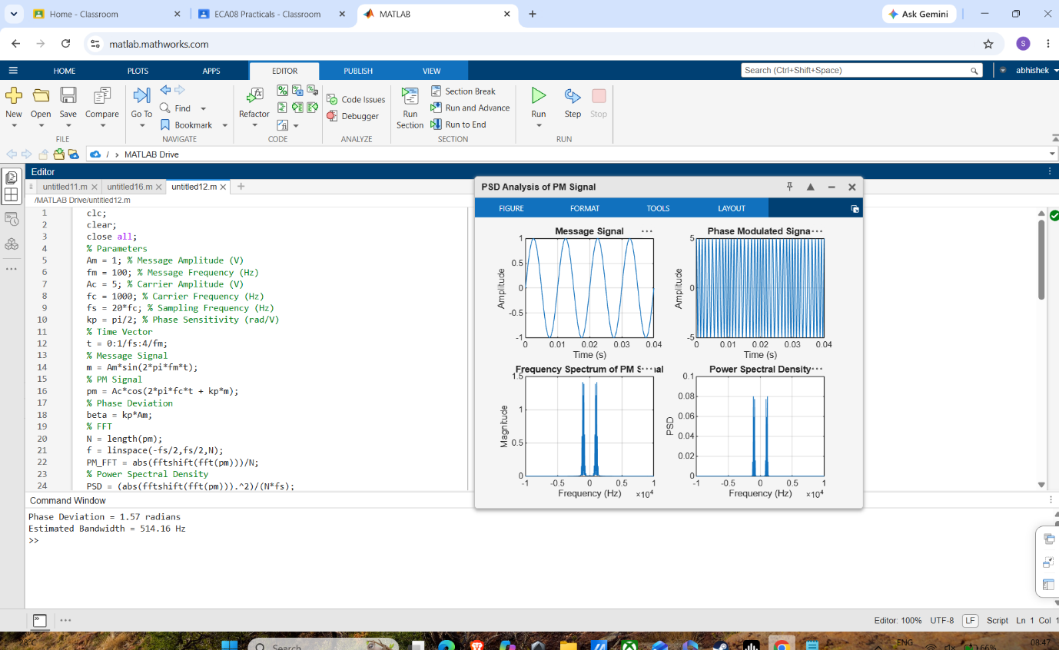
EXP-9
clc;
clear;
close all;

% Parameters
fs = 100000;
t = 0:1/fs:0.02;
fm = 500; % Message frequency
fc = 5000; % Carrier frequency
kf = 100; % Frequency sensitivity

% Message Signal & Carrier Signal
m = cos(2*pi*fm*t);
c = cos(2*pi*fc*t);

% FM Modulation
fm_sig = cos(2*pi*fc*t + 2*pi*kf*cumsum(m)/fs);

%% --- Mathematical Custom Replacement for awgn() ---
target_snr_db = 10; % 10 dB SNR

% 1. Measure the power of the FM signal
signal_power = mean(fm_sig.^2);

% 2. Convert target SNR from decibels to a linear scale
snr_linear = 10^(target_snr_db / 10);

% 3. Calculate the required noise power to hit that SNR ratio
noise_power = signal_power / snr_linear;

% 4. Generate white Gaussian noise with matching variance and dimensions
% sqrt(noise_power) scales standard normal distribution randn to correct variance
noise = sqrt(noise_power) * randn(size(fm_sig));

% 5. Add noise directly to the signal
noisy = fm_sig + noise;
%% --------------------------------------------------

% Display
figure;

subplot(4,1,1)
plot(t, m)
title('Message Signal')
grid on

subplot(4,1,2)
plot(t, c)
title('Carrier Signal')
grid on

subplot(4,1,3)
plot(t, fm_sig)
title('FM Signal')
grid on

subplot(4,1,4)
plot(t, noisy)
title('FM Signal with Gaussian White Noise (Toolbox-Free)')
grid on

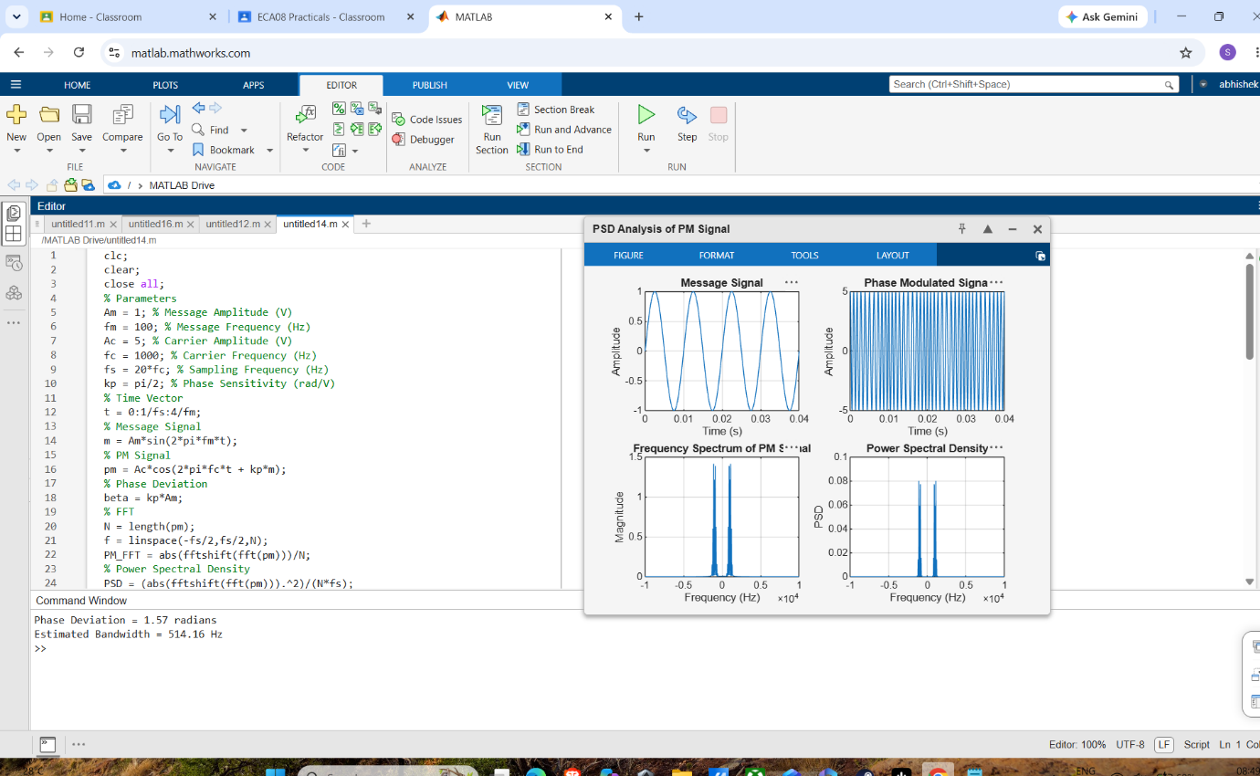
EXP-10
clc;
clear;
close all;

% Parameters
fs = 100000;
t = 0:1/fs:0.02;
fm = 500; % Message frequency
fc = 5000; % Carrier frequency
kf = 100; % Frequency sensitivity

% Message Signal & Carrier Signal
m = cos(2*pi*fm*t);
c = cos(2*pi*fc*t);

% FM Modulation
fm_sig = cos(2*pi*fc*t + 2*pi*kf*cumsum(m)/fs);

%% --- Mathematical Custom Replacement for awgn() ---
target_snr_db = 10; % 10 dB SNR

% 1. Measure the power of the FM signal
signal_power = mean(fm_sig.^2);

% 2. Convert target SNR from decibels to a linear scale
snr_linear = 10^(target_snr_db / 10);

% 3. Calculate the required noise power to hit that SNR ratio
noise_power = signal_power / snr_linear;

% 4. Generate white Gaussian noise with matching variance and dimensions
% sqrt(noise_power) scales standard normal distribution randn to correct variance
noise = sqrt(noise_power) * randn(size(fm_sig));

% 5. Add noise directly to the signal
noisy = fm_sig + noise;
%% --------------------------------------------------

% Display
figure;

subplot(4,1,1)
plot(t, m)
title('Message Signal')
grid on

subplot(4,1,2)
plot(t, c)
title('Carrier Signal')
grid on

subplot(4,1,3)
plot(t, fm_sig)
title('FM Signal')
grid on

subplot(4,1,4)
plot(t, noisy)
title('FM Signal with Gaussian White Noise (Toolbox-Free)')
grid on

