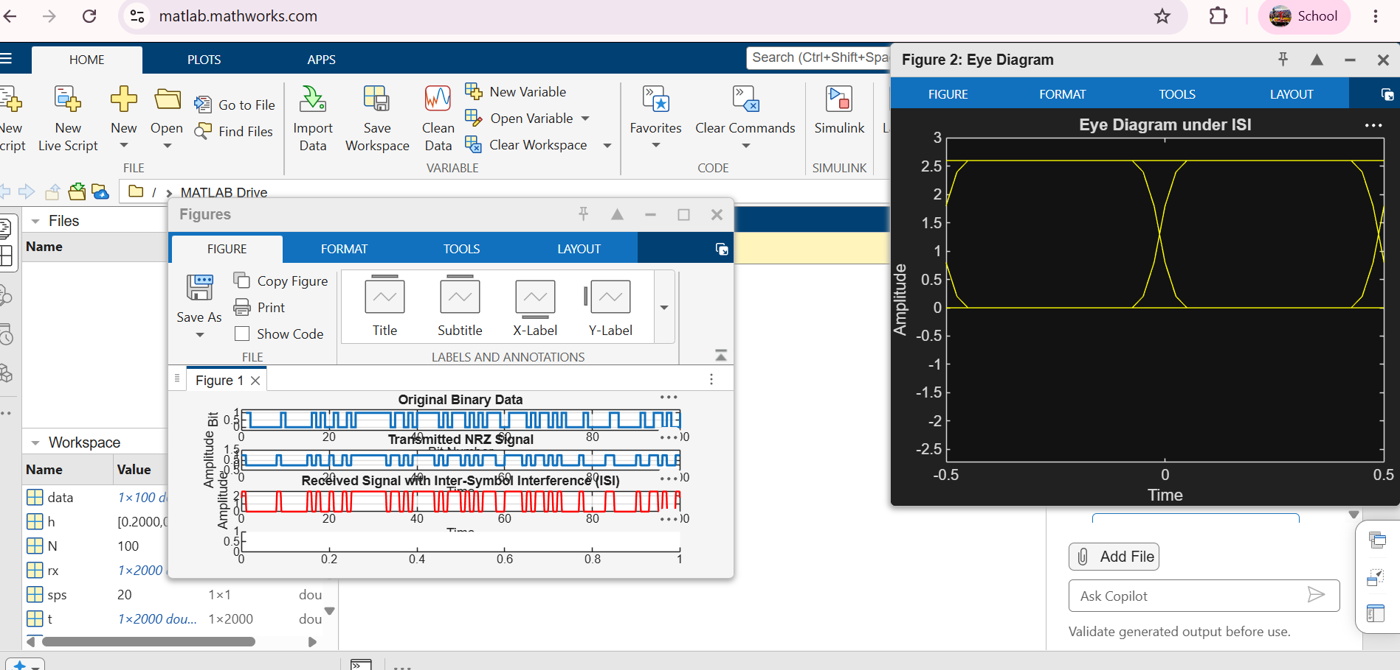

clc;
clear;
close all;
%% Parameters
N = 100; % Number of bits

sps = 20; % Samples per symbol
%% Generate Random Binary Data
data = randi([0 1],1,N);
%% NRZ Encoding
tx = repelem(data,sps);
%% Time Axis
t = (0:length(tx)-1)/sps;
%% Introduce Inter-Symbol Interference (ISI)%
% Simple Low-Pass FIR Filter (Channel)%
h = [0.2 0.6 1 0.6 0.2];
% Received Signal with ISI
rx = conv(tx,h,'same');
%% Plot Results%%
figure;
subplot(4,1,1)
stairs(data,'LineWidth',1.5)
grid on
title('Original Binary Data')
xlabel('Bit Number')
ylabel('Bit')
ylim([-0.2 1.2])
subplot(4,1,2)
plot(t,tx,'LineWidth',1.5)
grid on
title('Transmitted NRZ Signal')
xlabel('Time')
ylabel('Amplitude')
ylim([-0.5 1.5])
subplot(4,1,3)
plot(t,rx,'r','LineWidth',1.2)
grid on
title('Received Signal with Inter-Symbol Interference (ISI)')
xlabel('Time')
ylabel('Amplitude')
subplot(4,1,4)
eyediagram(rx,2*sps)
title('Eye Diagram under ISI')

