./

– Report –

VillainGod secret keeper

**NAME: - Varun Verma**

Course Code: <CODE>



Version Number:1.0

Team Members : varun verma

Team No: NA

Module: **Stepin mini project**

**TABLE OF CONTENTS**

|  |  |  |
| --- | --- | --- |
| **SERIAL No.** | **CONTENT** | **PAGE No.** |
| 1 | Problem Statement | 3 |
| 2 | intro | 3 |
| 3 | Requirements | 4 |
| 4 | Architecture | 5-7 |
| 5 | Test Plan/Test cases | 8 |
| 6 | Expected results/Outcomes | 8 |
| 7 | Conclusion | 9 |

**Introduction**

**Problem Statement:**

Everone have their own DEEPDOWN DARK DESIRES/SECRETS which we are not comfortable in sharing with anyone. But not able to share somethimg and kkep it with you lead to stress and horrible thoughts.

**Intro:**

We created VillainGod To provide user a secure and reliable environment where deep down dark secrects can be shared.

To keep notes password protected so none other then user can read edit and delete.

In this project, you need to enter a password to view, edit or delete record. Password is not required to view the main menu or to add record. you can edit the password within the application i.e, after executing or upon running the project

# Requirements:

4 W's and 1 H

Who

Anyone who want to share secrets but have trust issues can use this project.

What

This project is concerned about keeping secrets protected.

When

Anytime Anywhere when there us a need of someone to share secrets.

Why

Privacy is one of the biggest concern of todays world. keep it in mind this project is designed to be reliable source for sgaring secrets.

How

Implemented using various functionalities of C programming.

Basic requirements that are very essential are:

gcc compiler with a good system.

Any of the two linux/windows.

HIGH LEVEL REQUIREMENTS:

ID DESCRIPTION CATEGORY STATUS

HR01 User shall be able to work on windows or linux. Technical Implemented

HR02 User shall be able to choose strong password. Technical Implemented

HR03 User shall be able to remember its password. Scenario Implemented

HR04 User must have a decent system specification. Technical Implemented

LOW LEVEL REQUIREMENTS:

ID DESCRIPTION CATEGORY STATUS

HR01-LR01 User shall be able use Visual Studio/Code::Blocks software/Dev-C++. Technical Implemented

HR02-LR02 Password – contains/manages/handles password protection Technical Implemented

HR04-LR03 Minimum 10MB hard disk space required. Technical Implemented

HR04-LR04 Intel/Pentium powered system.Processor speed 1.7 GHZ required. Technical Implemented

**Hardware Requirements**

* Ram 512MB or higher.
* Minimum 10MB hard disk space.
* Intel/Pentium powered system.
* Processor speed 1.7 GHZ

**Software Requirements: -**

* Windows 8 or higher versions.
* Visual Studio/Code::Blocks software/Dev-C++.

**Functional Requirements: -**

In this project we used the concept of file handling, data structures, pointer and functions.

The basic user-defined functions used in this project are listed below:

* Password – contains/manages/handles password protection
* Add record – to add new diary record
* View record – to view added record in list
* Edit record – to modify and update an added record
* Edit password – to modify/change a password
* Delete record – to delete or remove a record permanently from system file.

**Architecture:**

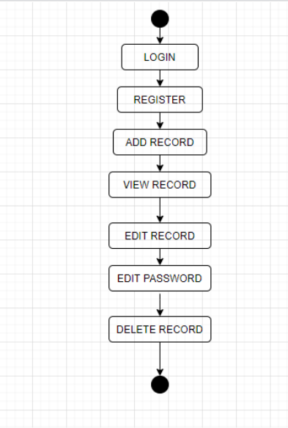

**Activity Diagram:**

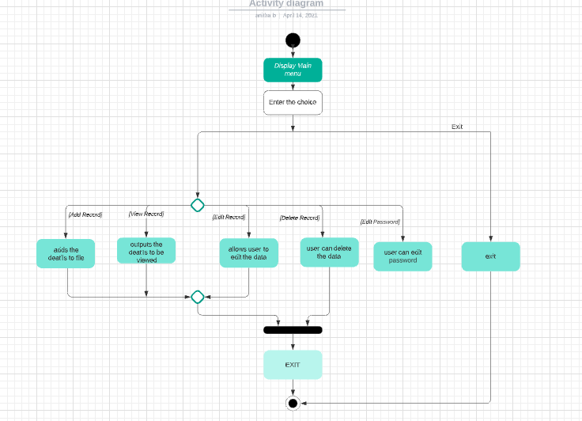

**Use Case Diagram:**

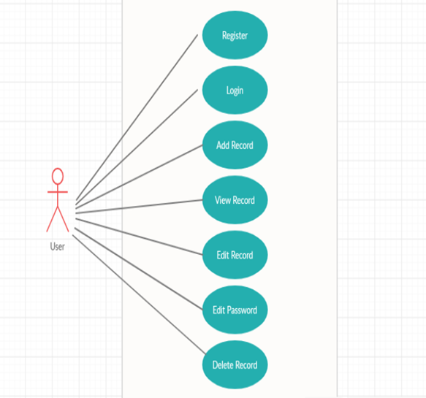

**Test Plan/Test cases**

|  |  |  |
| --- | --- | --- |
| **Test case Id** | **Test scenario** | **Test data** |
| 1 | Register the user | username- varun Pass – verunverma |
| 2 | Login the user | username – varun Pass – varunverma |
| 4 | Add secret | I am loving VillainGod. |
| 5 | View secret | varun can view the content of this diary. |
| 6 | Edit secret | varun can edit the records if and when required. |
| 7 | Edit password | Current password – varun New password – varunverma |
| 8 | Delete secret | After entering password varun can delete the records. |

**EXPECTED OUTCOMES: -**

|  |  |
| --- | --- |
| **TEST CASE ID** | **EXPECTED RESULT** |
| 1 | Varun was registered successfully |
| 2 | Varun logged – in successfully |
| 3 | Entered data recorded successfully. |
| 4 | Varun can view – I am loving VillainGod. |
| 5 | Varun can edit record |
| 6 | Varun successfully changes the password |
| 7 | Varun successfully deleted the record after entering correct password |

**Conclusion**

Based on the result of this research, it can be concluded that this system helps to maintain personal notebook easily. This project is only a humble to maintain the personal notebook. This project receives the input details and store them for future use. With this secret keeper the details can be accessed smoothly. The scope of this project is justifiable as it reduces manual work and is user friendly. This report gives an overview of all that one needs to get acquainted with in order to work with software project documentation specifically in the field of c language.

It was a diverse and enriching experience to learn about c language. This project will teach us the proper use of file handling, data structure, pointers and functions. I have achieved the user friendly, maintaining of personal notebook through this code can be managed efficiently. This will lead to an error free system of maintaining personal notebook. This helps in efficient management of time and user can concentrate on other activities. On the whole, this project helped to enhance technical skills, team work, documenting skills.

|  |  |  |  |  |  |
| --- | --- | --- | --- | --- | --- |
| **Ver. Rel. No.** | **Release Date** | **Prepared. By** | **Reviewed By** | **Approved By** | **Remarks/Revision Details** |
|  |  |  |  |  |  |
|  |  |  |  |  |  |
|  |  |  |  |  |  |
|  |  |  |  |  |  |
|  |  |  |  |  |  |

**Document History**