`V—184:(The Why’s and What’s of Kubernetes):

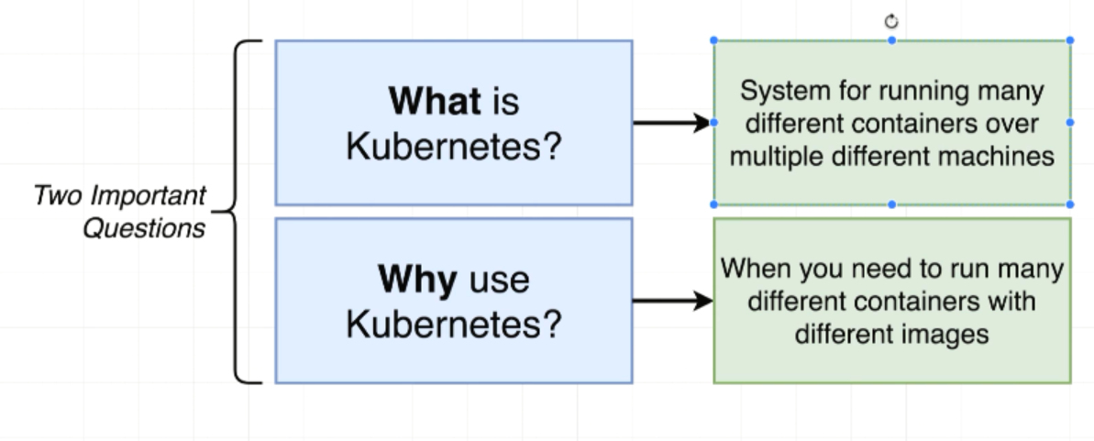

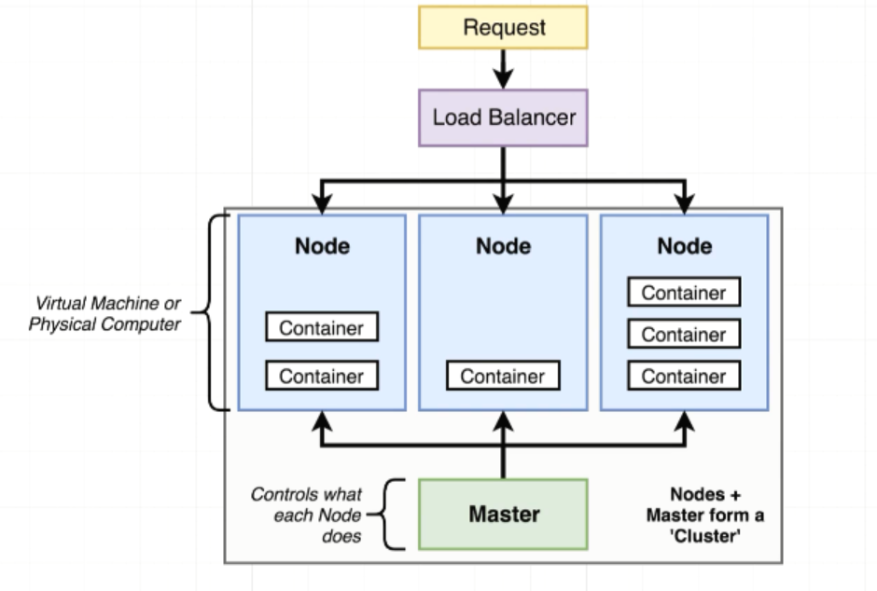

V—185:(Kubernetes in Development and Production):

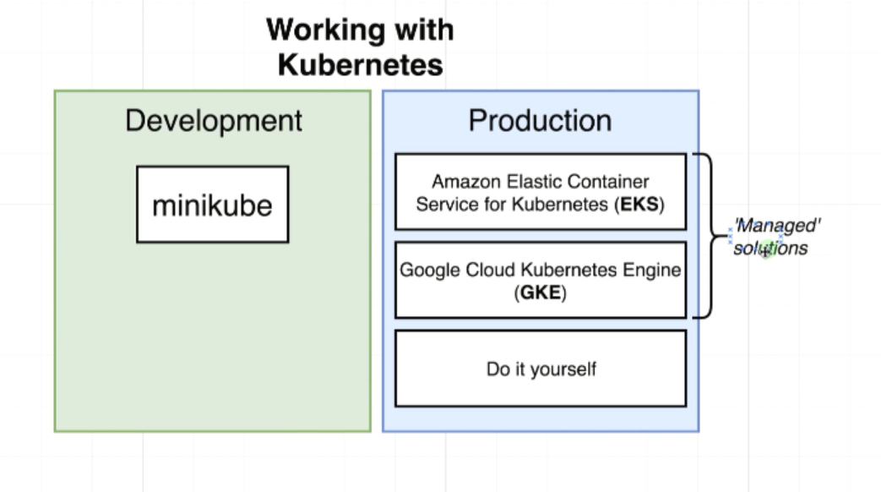

Minikube is a program that is used to setup Kubernetes on your local machine. When we start using Kubernetes in a production capacity we frequently make use of managed solutions.

Managed solutions are referenced to outside cloud provider such as cloud or Amazon AWS that will setup entire Kubernetes cluster

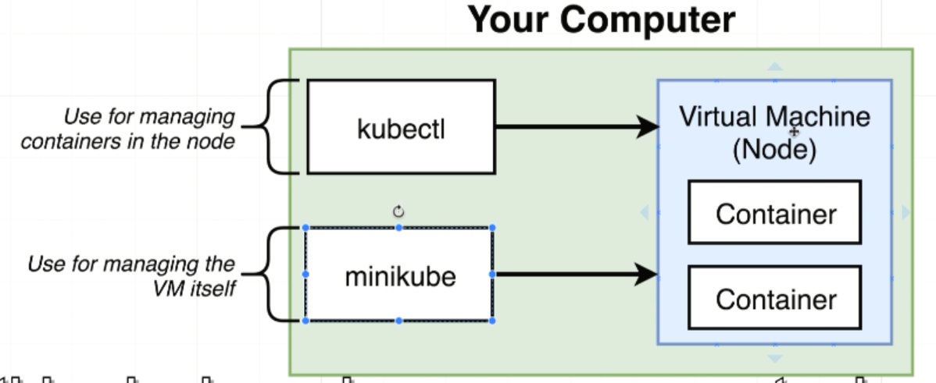

Minikube is gonna create a Kubernetes cluster on your local machine. Behind the scenes it’s gonna create a virtual machine whose purpose is gonna run some number of containers.

MiniKube is a program that is used to create vm or single node on your computer in order to interact with these things. Inorder to interact with VM, we are using a program called Kubectl. Kubectl is the program that is used to interact with a Kubernetes cluster and manage what all the different nodes are doing and what different containers they are running.

We use kubectl when anytime we want to tell a VM or node what set of containers it supposed to be running are essentially manage what the node is doing and we use program minikube just to create and run a kubernates cluster on your local machine.

We only make use of minikube in a local environment. However Kubectl is going to be a program that you use both locally and production.

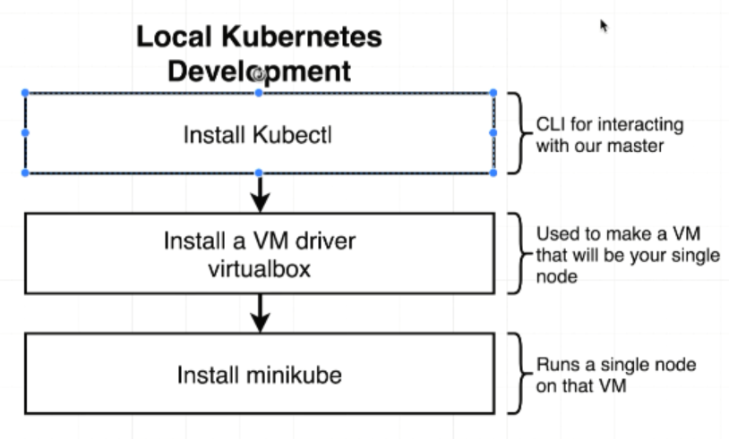

V—192:(Mapping Existing Knowledge):

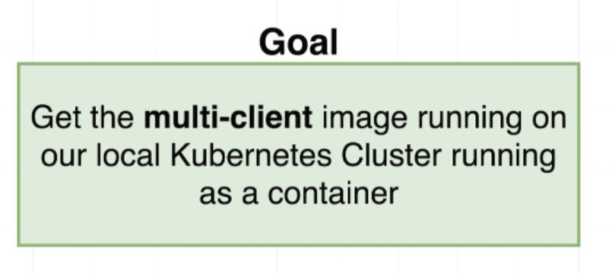

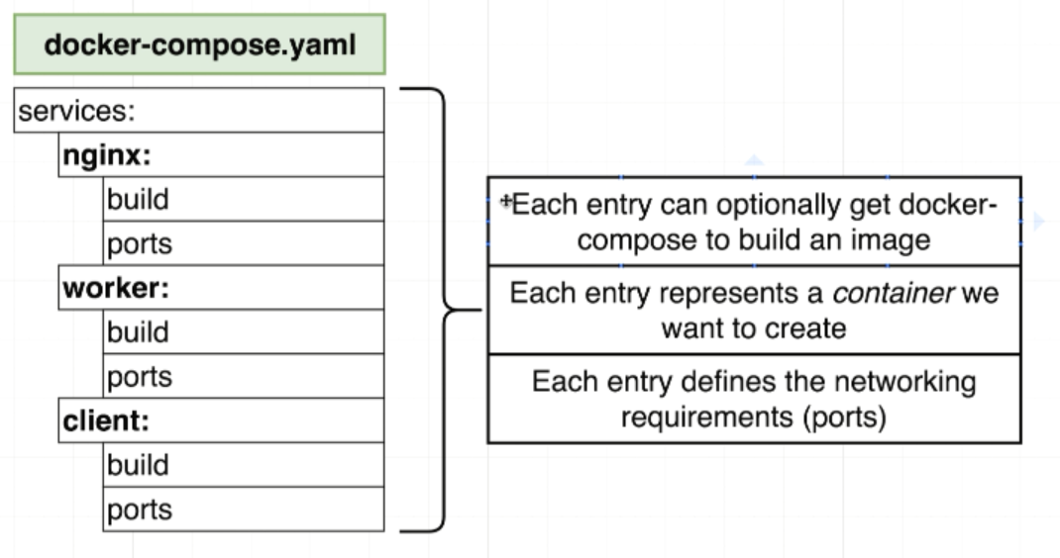

entry is nothing but a container.

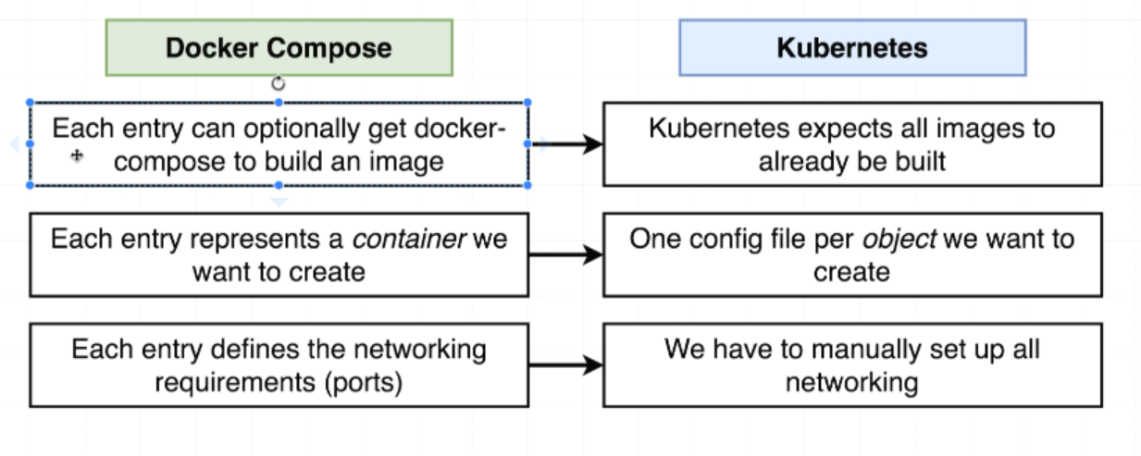

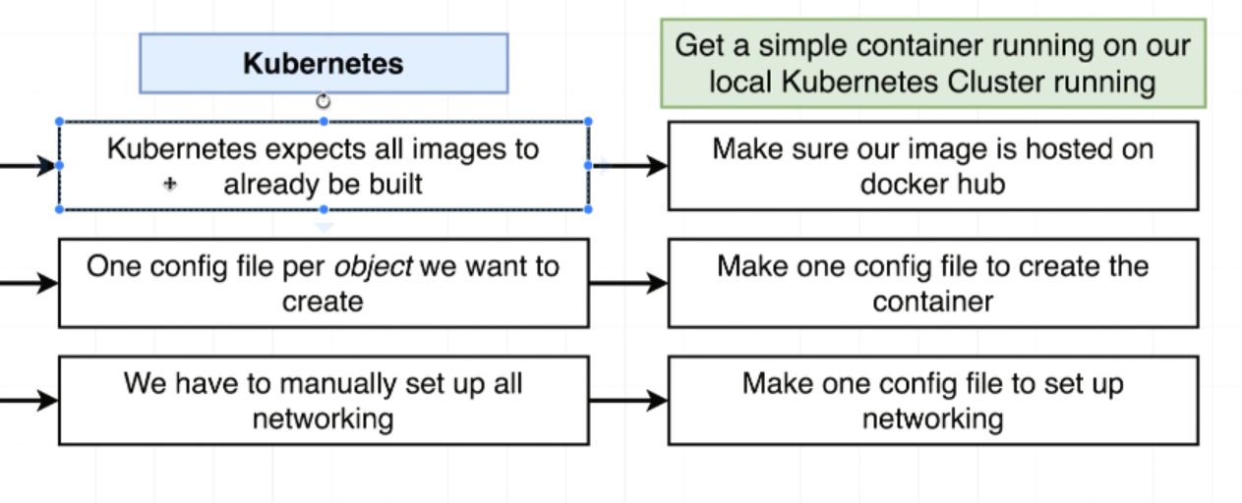

V—193:(Quick Note to Prevent an Error):

**updated 4-16-2020**

In the upcoming lecture, Stephen will be creating the **client-pod.yaml** configuration file. You may get a blank page with an error in your console when you attempt to run the pod or deployment in a future lecture:

react-dom.production.min.js:209 TypeError: this.state.seenIndexes.map is not a function

This is because we added the following line to our **client/nginx/default.conf** file in the earlier Docker lectures:

**try_files $uri $uri/ /index.html;**

This line was added to resolve some React Router issues our client app was having. However, it will break this demo because we have no Nginx container or Ingress service in place.

The best way to resolve this is to use Stephen's Client image in the pod and deployment for these demos, instead of your own:

image: stephengrider/multi-client

To be clear, this issue will not affect the multi-container Kubernetes project we will be building in Section 14. This is just a quick demo and we will not be reusing these files.

V—194:(Adding Configuration Files):