**V—2:Why use Docker?**

Docker makes it really easy to install and run new software on our computer without worrying about setup and dependencies

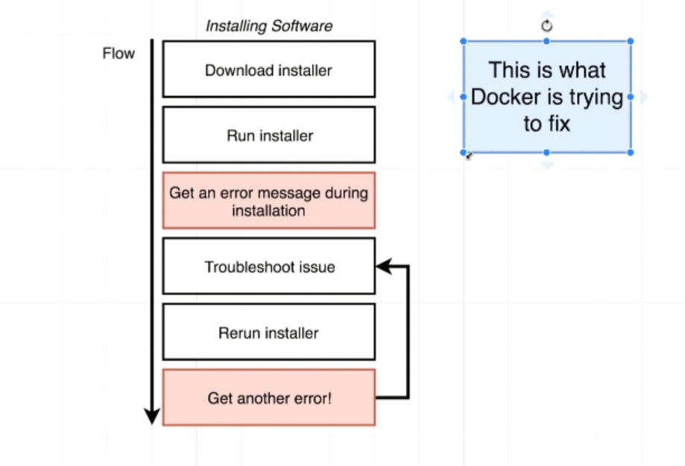

**V—3:What is Docker?**

It’s an entire ecosystem of different projects, tools and pieces of software that comes together to form a platform.

Docker is a platform or ecosystem around creating and running containers.

**What is a Container?**

A container is an instance of an image.

A container is a program with it’s own isolated set of hardware resources.

When I run a command ***docker run -it reddis*** on docker terminal. It went through a series of actions behind the scenes.

When I run that command something called docker CLI reached out to docker Hub and it downloads a single file called an image.

**Image** is an single file containing all the dependencies and all the configurations required to run a very specific program.

We can use this image to create something called container. **Container** is instance of an image.

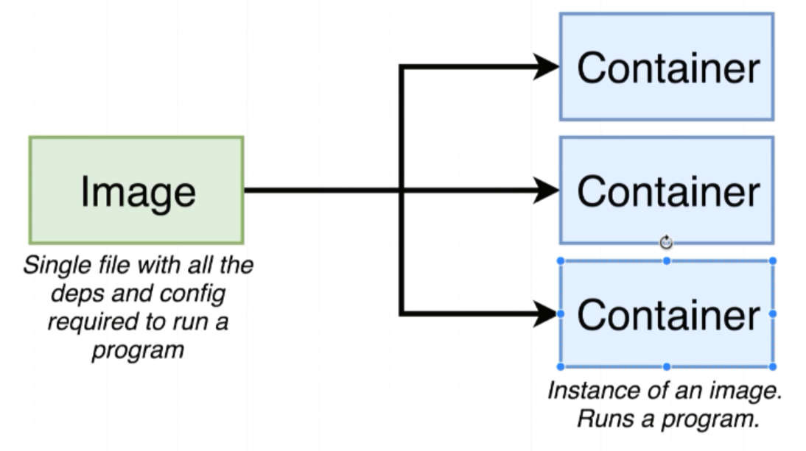

**V—4:**

**Docker Client(Docker CLI):**

Tool that we are going to issue commands to.

It doesn’t do anything with containers and images instead it is just a tool to help us interact with other piece of software called docker server

**Docker Server(Docker Daemon):**

Tools that is responsible for creating images, running containers, uploading images, maintaining containers etc.

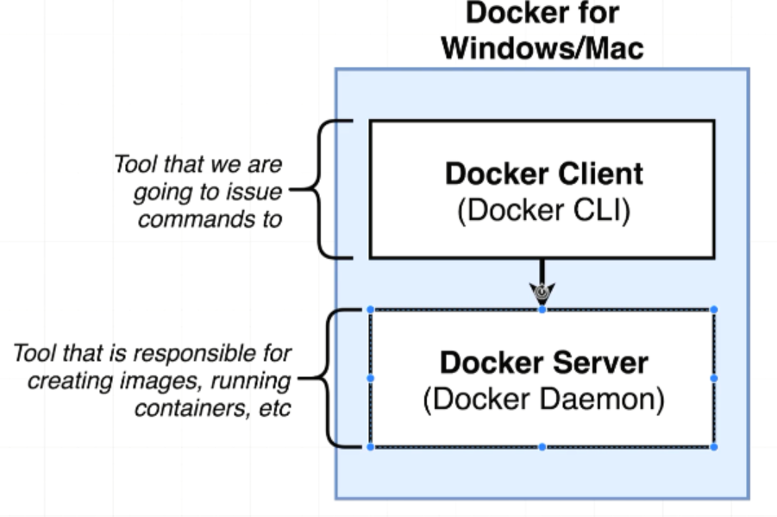

**V—11:Using Docker Client:**

*docker run hello-world* starts up the Docker CLI and Docker CLI communicating over the Docker Server

when we run *docker run hello-world* means that we wanted to start up a new container using the image with the name of the hello-world

**Docker Hub** is a public repository of free public images that we can freely download and run on our personal computer

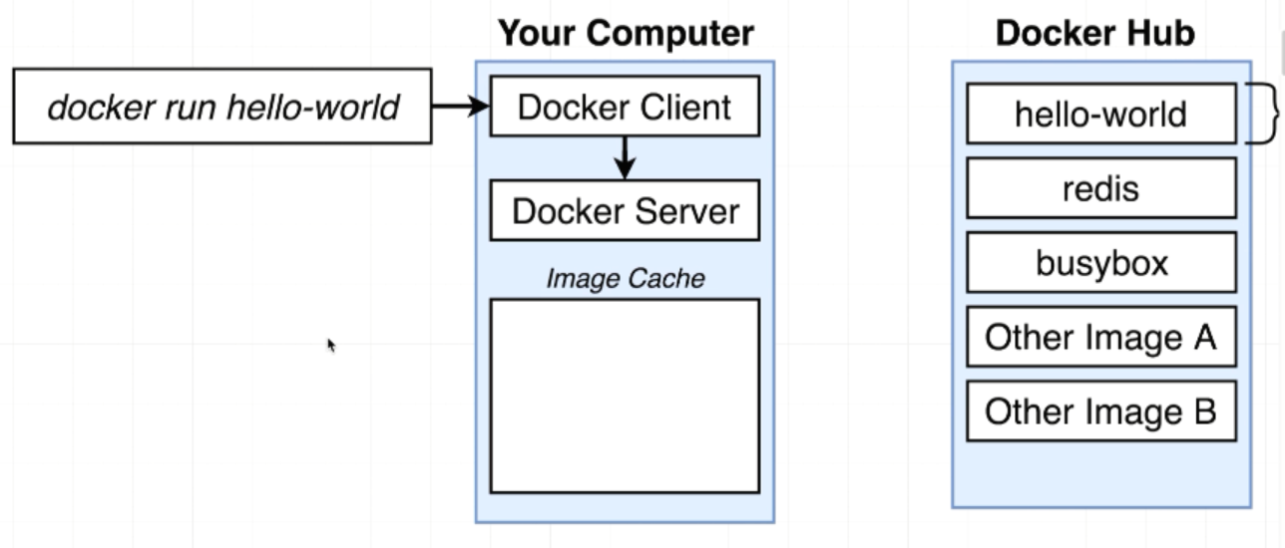

**Checking locally for hello-world image:**

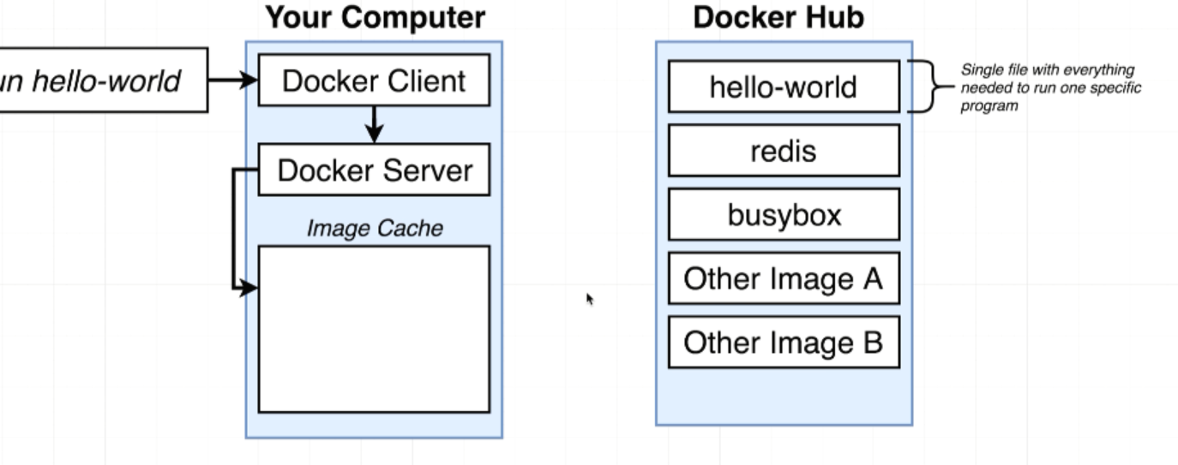

**Docker Server reaches out to Docker Hub for hello-world image:**

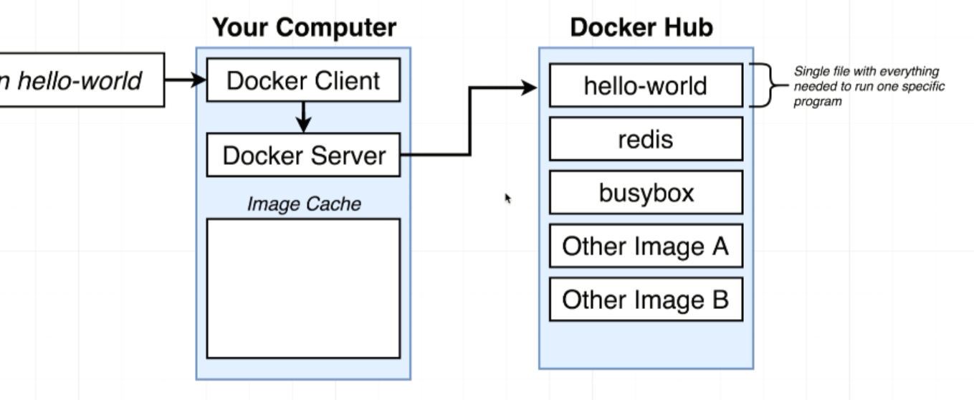

**Docker Server downloaded hello-world image from Docker Hub to Local System (Image Cache) :**

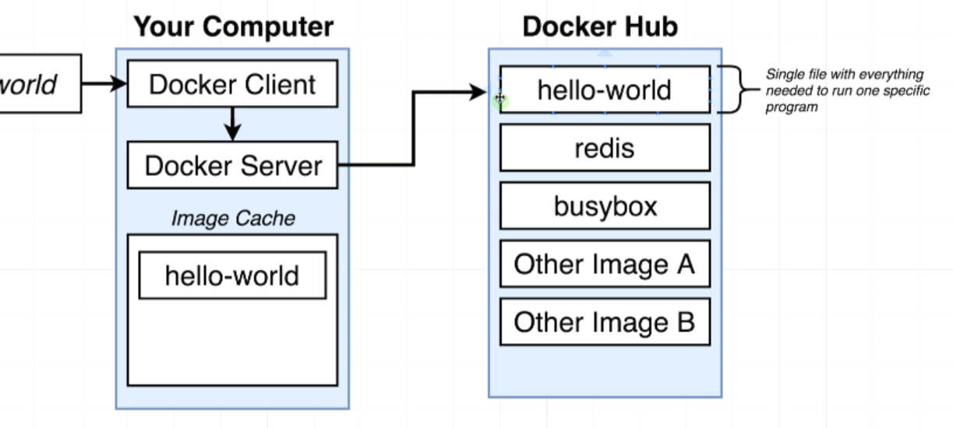

Docker server took that single file it up into the memory. It creates a container out of it and then it runs a single program inside it and that single program purpose is to print out the message that you see below

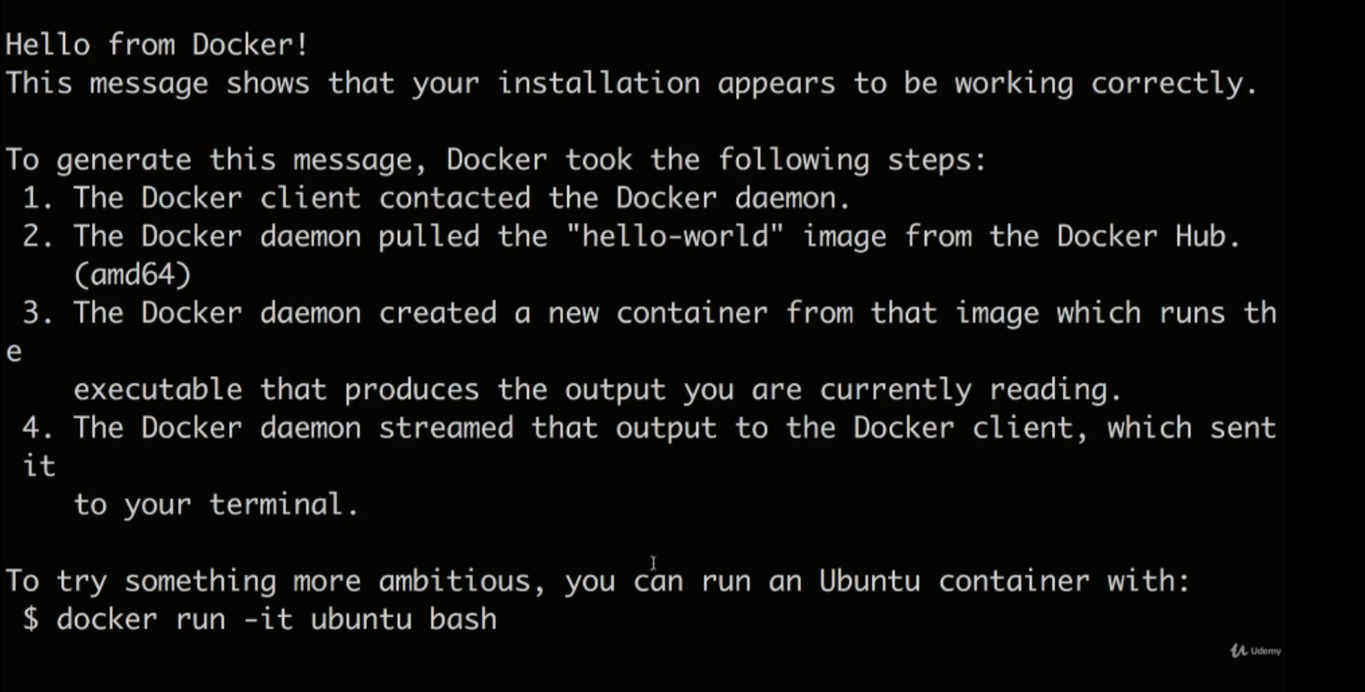

**V—12:Container:**

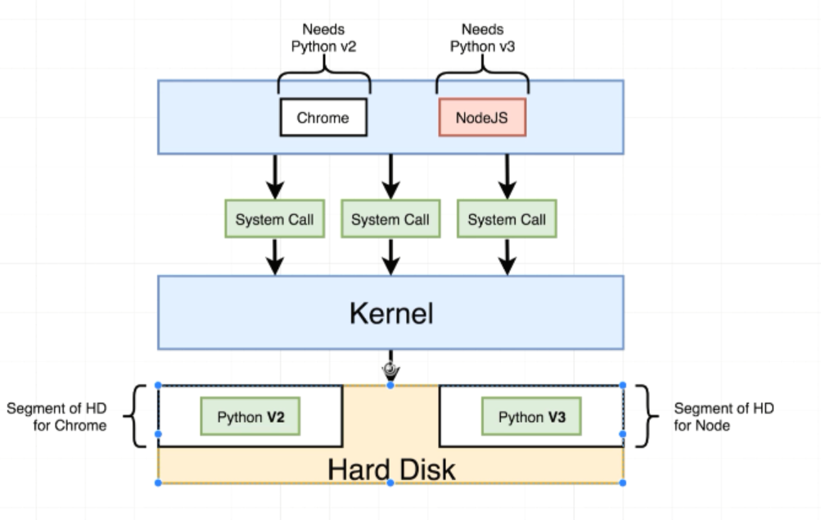

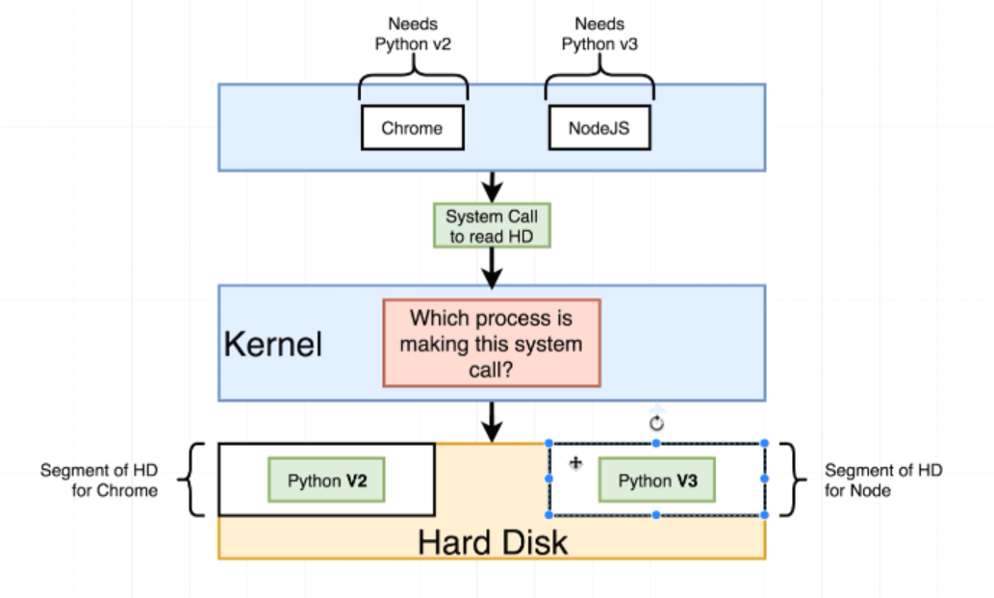

***Name spacing*** is for saying this area of the hard drive is for this process.

***Control Groups*** can be used to limit the amount of memory that a process can use

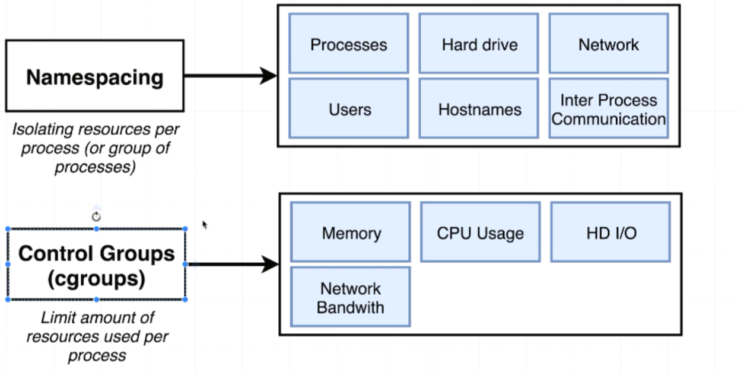

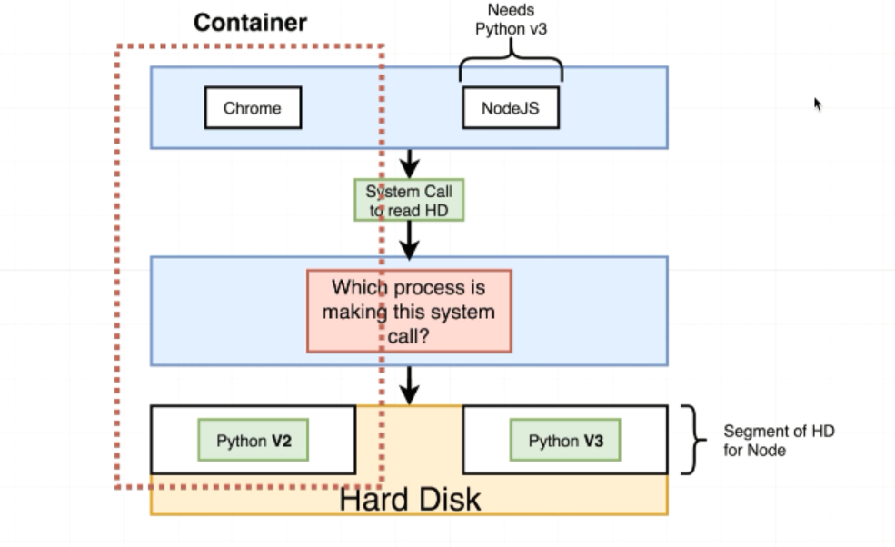

A container is a process or set of processes that have a grouping of resources specifically assigned to it.

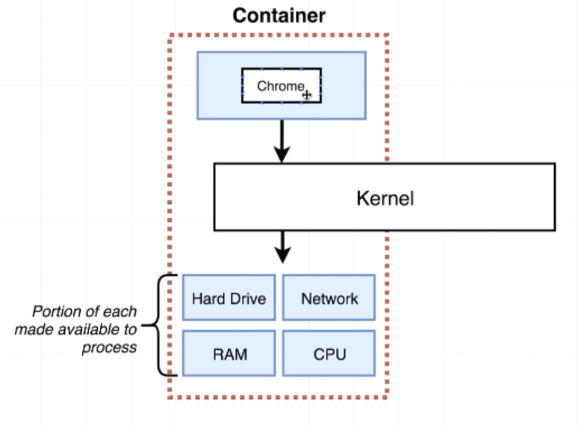

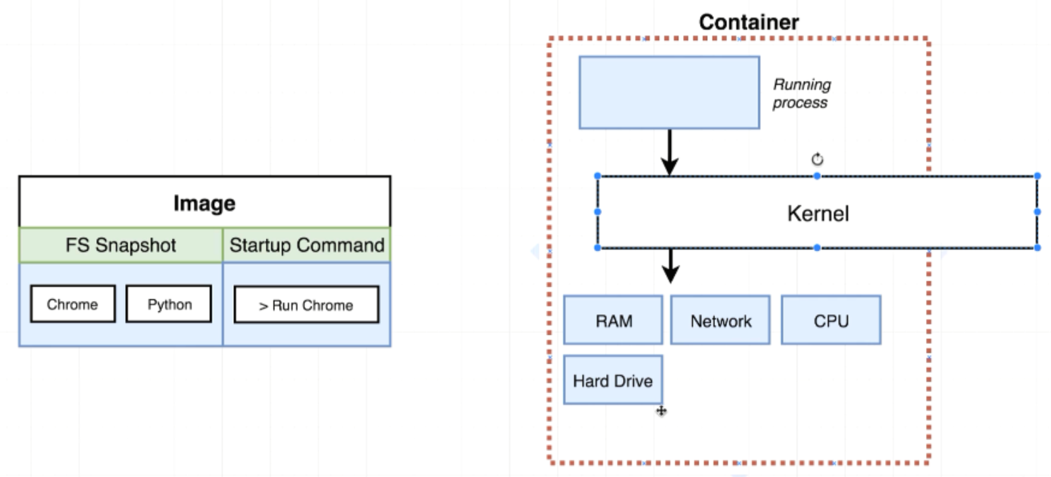

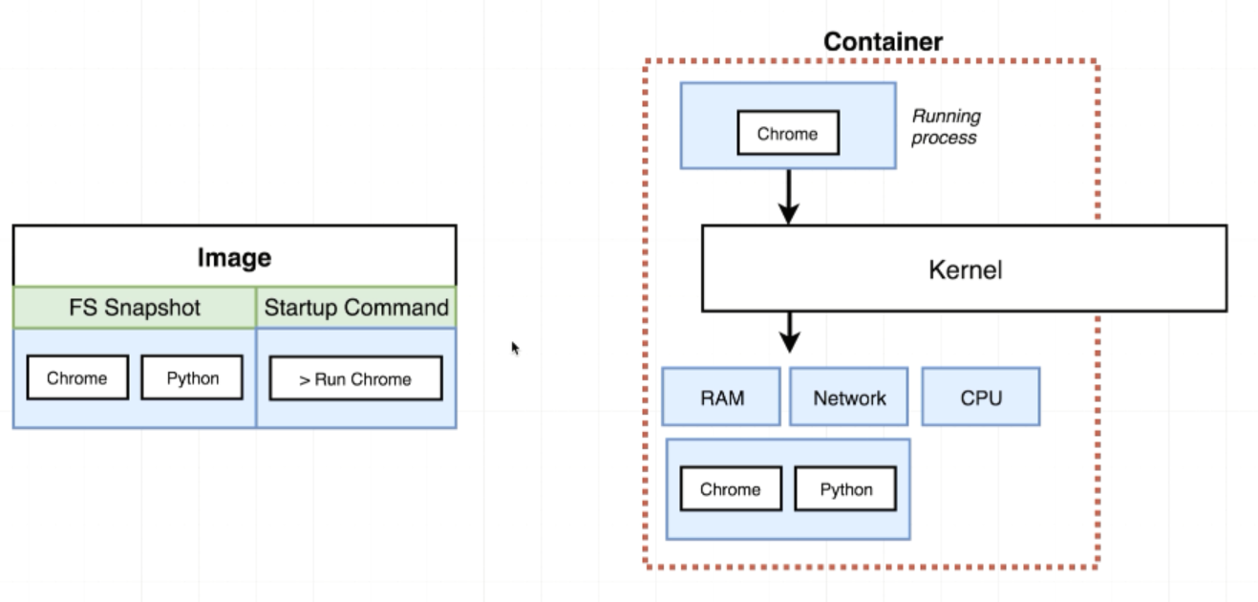

When we install a docker for windows. You installed a Linux Virtual Machine. So long docker up there is running. You technically have a Linux virtual machine running on your computer

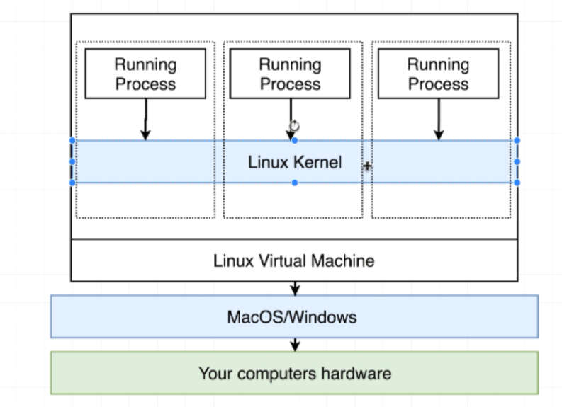

Linux Kernal is incharge of limiting the access or isolating access to different hardware resources on your computer