AI Assisted Coding
Lab Assignment-10.4

NAME : Bommeraboina Varuntej
HT.NO : 2303A51278
BATCH : 05


Task

1:

AI
-
Assisted

Syntax

and

Code

Quality

Review

Please paste the Python script you want to review in the cell below. Once you provide your script, I will simulate an AI review to identify and correct errors, and explain the changes made.



AI
-
Assisted

Code

Review

)
Demonstration
(

#

Paste

your

faulty

Python

script

here,

e.g.:

#

# def calculate_discount(total_price, discound_percentage):

#

if total_price > 100:

#

return total_price *

(1

-

discound_percentage / 100)

#

else:

#

return

total_price

#

#

product_cost

=

150

#

discount_rate

=

10

# final_cost = calculate_discount(product_cost, discount_rate)

# print('Final price:', final_cost)

Below is a sample faulty Python script and its AI-corrected version. This demonstrates how an AI tool would address syntax errors, indentation issues, incorrect variable names, and faulty function calls, along with explanations for each fix.


Task

5:

AI
-
Based

Automated

Code

Review

Report

print('
---

Original

Faulty

Script

---
')

def calculate_discount(total_price, discound_percentage):

if total_price > 100:

return total_price *

(1

-

discound_percentage / 100)

else:

return

total_price

product_cost

=

150

discount_rate

=

10

final_cost = calculate_discount(
product_cost, discount_rate)

print('Final price:', final_cost)

---

Original

Faulty

Script
---

Final price: 135.0

This section demonstrates how AI tools can perform automated preliminary code reviews to improve code quality and consistency.
We will analyze a poorly wriflen Python script and generate a structured review report.


print('
---

Poorly

Written

Script

for

Review

---
')

def

calc_avg(data_list,

divisor):

if divisor

==

0:

return 'Error: Cannot divide by zero!'

total = 0

for

item

in

data_list:

total += item

res

=

total

/

divisor

return res

my_numbers

=

[10
,

20
,

30
,

40
,

50]

count_val

=

5

avg_result =

calc_avg(my_numbers, count_val)

print(f"Average: {avg_result}")

#

Test

with

zero

divisor

zero_divisor_result = calc_avg(my_numbers, 0)

print(f"Average with zero divisor: {zero_divisor_result}")

---

Poorly

Written Script for Review

---

Average: 30.0

Average

with

zero

divisor:

Error:

Cannot

divide

by

zero!

AI-Generated Code Review Report for calc_avg :

Overall Assessment: The calc_avg function provides basic functionality but exhibits several code quality issues related to readability, maintainability, and error handling. It requires significant refactoring to meet best practices.

- Code Readability & Naming Conventions:
Issue: Cryptic function name ( calc_avg ), unclear parameter names ( data_list , divisor ), and internal variable names ( total , res ).
Risk: Reduces immediate understanding of the function's purpose and variables' roles, making maintenance and debugging harder.
Suggestion: Rename calc_avg to calculate_average , data_list to count , res to average_value for clarity. to numbers , divisor total to sum_of_numbers , and
- Formatting and Style Consistency (PEP 8):
Issue: Inconsistent spacing (e.g., around operators, after commas). Lack of blank lines between logical blocks.
Risk: Violates PEP 8 guidelines, making the code appear unpolished and harder to scan quickly.
Suggestion: Apply consistent spacing (e.g., total += item should be total += item ), add blank lines for befler logical separation.
- Error Handling:
Issue: Divides by zero check returns a string 'Error: Cannot divide by zero!' instead of raising an appropriate exception or returning a numerical indicator like None .

Risk: Returning a string for an error condition mixes data types and can lead to unexpected behavior or TypeError s downstream if the caller expects a number.
Suggestion: Raise a ValueError for division by zero ( raise ValueError("Cannot divide by zero") ) to allow callers to handle the error gracefully.
- Documentation Quality:
Issue: No docstring for the function. No comments explaining complex logic (though in this simple case, logic isn't complex, but the principle applies).
Risk: Future developers (including the author) will struggle to understand the function's purpose, parameters, and return values without reading the entire implementation.
Suggestion: Add a comprehensive docstring (using NumPy or Google style) explaining the function's purpose, arguments, return value, and potential exceptions.
- Maintainability:
Issue: The sum calculation can be simplified using Python's built-in sum() function.
Risk: Overly verbose or custom implementations for standard operations can introduce subtle bugs and are harder to maintain than idiomatic Python.
Suggestion: Replace the manual loop for summing with total = sum(data_list) .

Overall Improvement Suggestions:
  - Refactor: Improve function, parameter, and variable names.
  - Standardize: Adhere to PEP 8 for formafling.
  - Robustify: Implement proper exception handling for edge cases (e.g., division by zero).
  - Document: Add clear docstrings to explain functionality.
  - Simplify: Utilize built-in functions where appropriate to make code more concise and readable.

AI as a Code Reviewer: An Explanation

This Task 5 demonstration highlights AI's capability as more than just a code generator; it acts as an intelligent code reviewer. Here's how it works:
  - Static Analysis: The AI analyzes the code's structure, syntax, and paflerns without executing it. It compares the code against established best practices, style guides (like PEP 8), and known anti-paflerns.
  - Pattern Recognition: It recognizes 'code smells'—indicators of deeper problems in the code, such as cryptic variable names, lack of documentation, or inefficient algorithms (as seen in Task 2).
  - Contextual Understanding: While not a human, advanced AIs can infer the likely intent of the code (e.g., calculating an average) and identify where the implementation deviates from standard, robust, or secure practices for that intent.
  - Rule-Based & Learned Knowledge: AI models are trained on vast datasets of code, documentation, and best practice
guidelines. This allows them to apply both explicit rules (like PEP 8 indentation) and learned paflerns (like preferred error handling mechanisms or more efficient algorithms for common tasks).
  - Structured Feedback Generation: Based on its analysis, the AI can formulate structured feedback, categorizing issues (readability, performance, security), explaining the risks, and suggesting concrete improvements. This mimics a human code reviewer's thought process but with much greater speed and consistency.
Benefits of AI in Code Review:
Speed & Scale: Automates preliminary reviews, allowing human reviewers to focus on more complex logical issues.
Consistency: Enforces coding standards uniformly across a codebase.
Early Detection: Catches common errors and vulnerabilities early in the development cycle.
Educational: Helps developers, especially junior ones, learn best practices by providing immediate, actionable feedback.
While AI cannot fully replace human code reviewers, it serves as a powerful assistant, elevating the overall quality and efficiency of the development process.
 Task 4: Secure Coding and Reliability Review
This section demonstrates how to identify and rectify security vulnerabilities and poor error handling in a Python script, making it robust and safe for production.

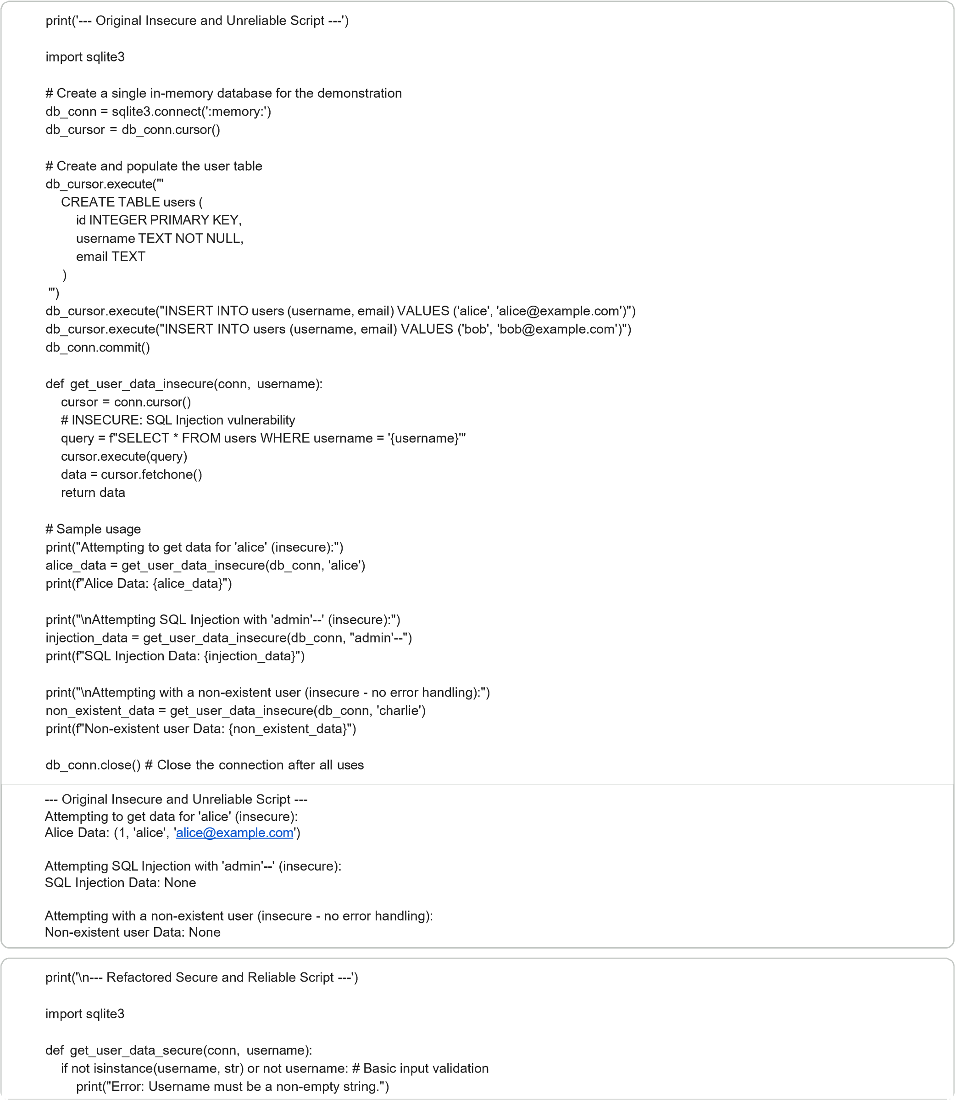
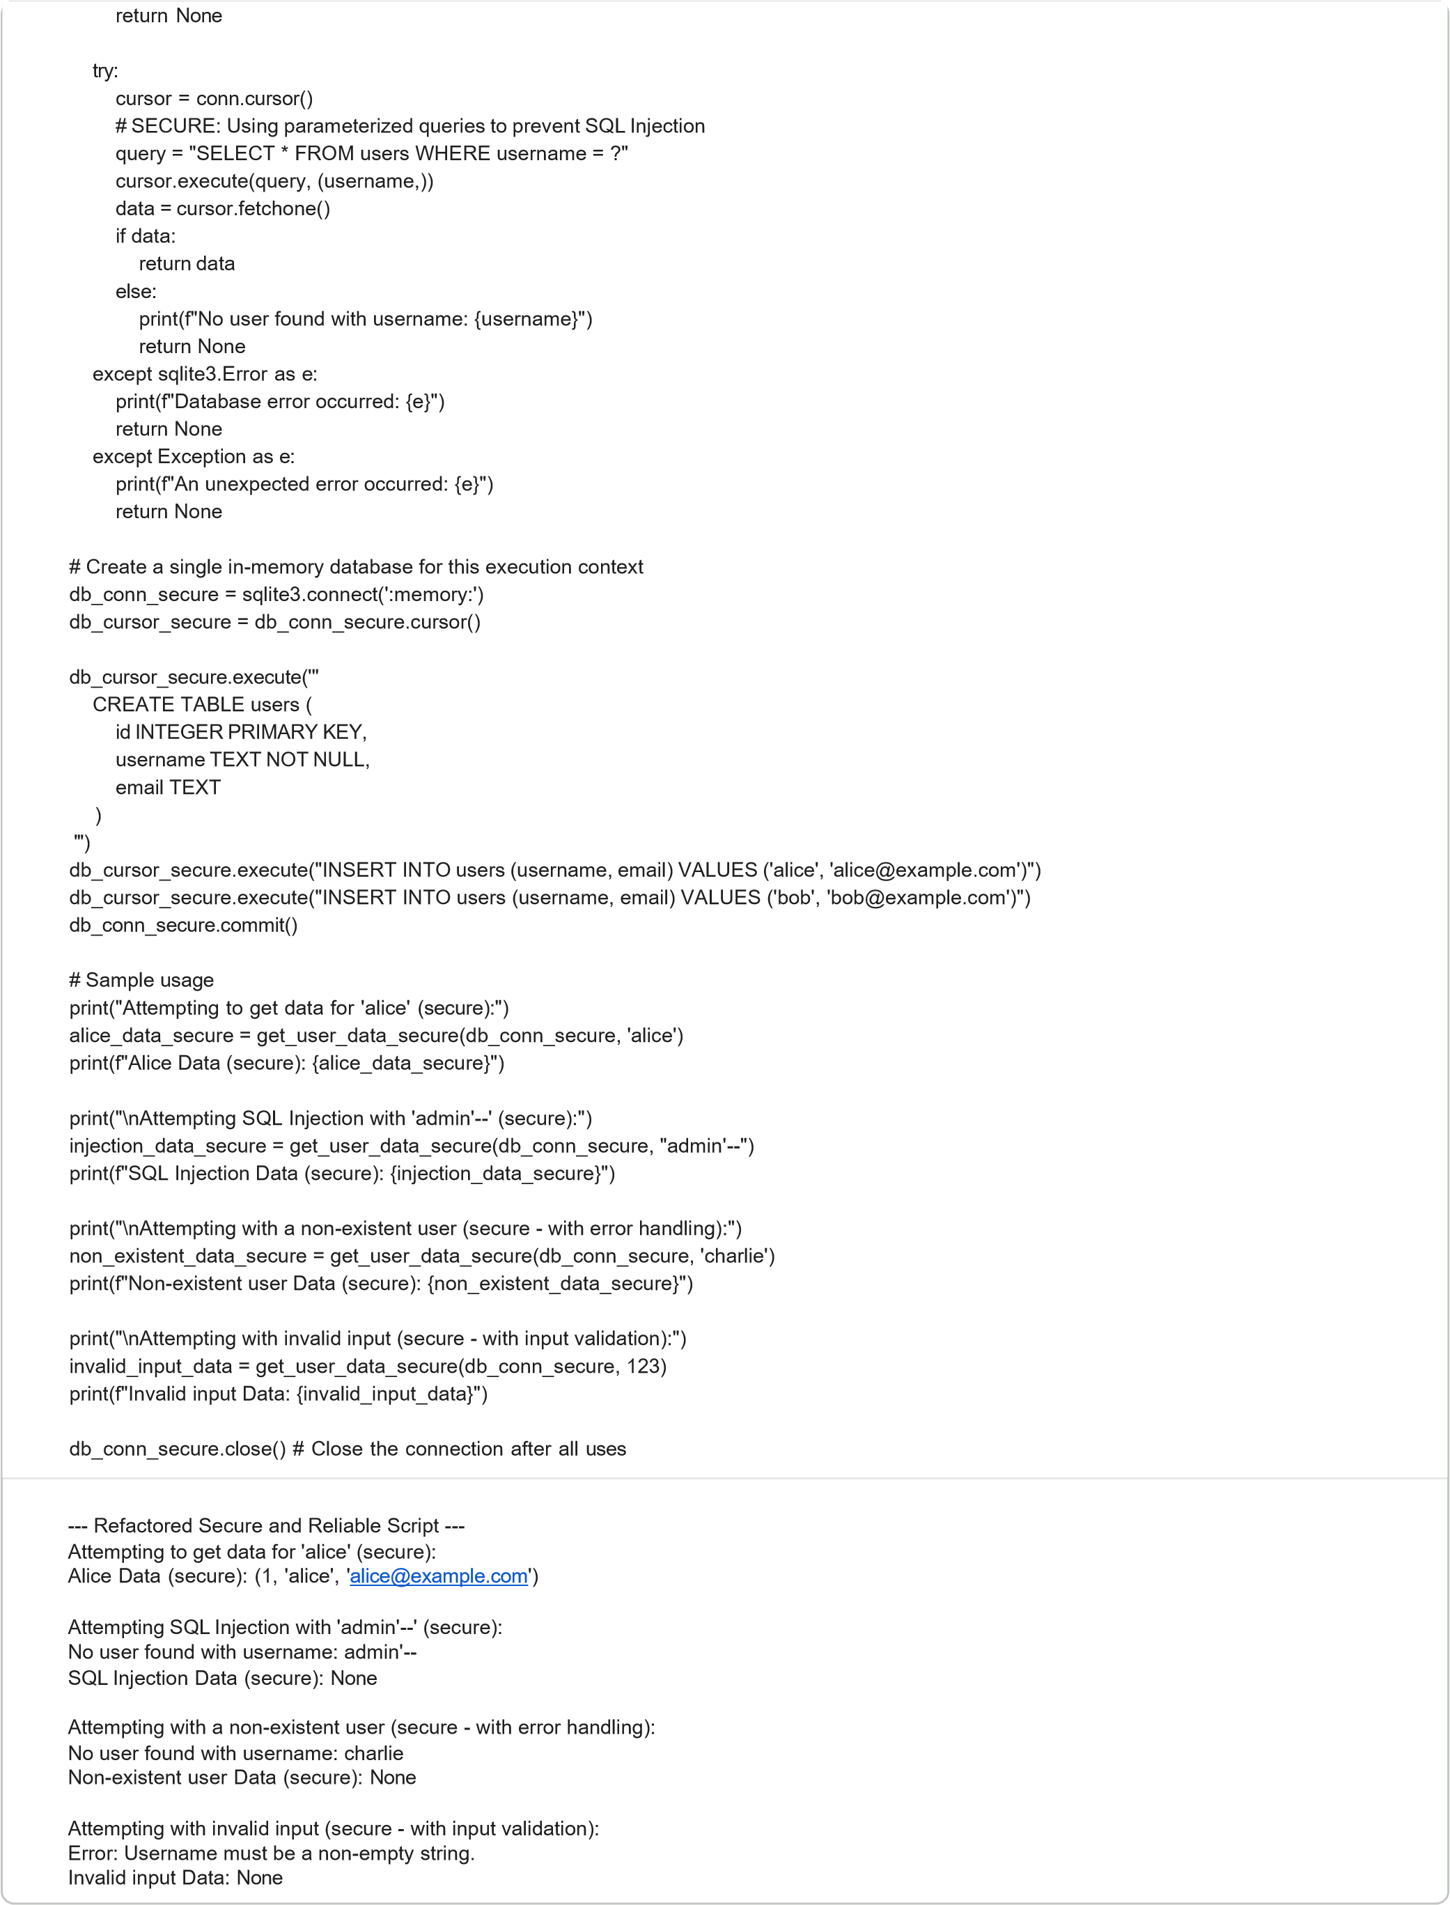

Explanation of Security and Reliability Improvements (Task 4):

1. SQL Injection Prevention (Parameterized Queries):
Original Vulnerability: The get_user_data_insecure function constructed SQL queries by directly concatenating user input into the query string ( f"SELECT * FROM users WHERE username = '{username}'" ). This is a classic SQL Injection vulnerability. An aflacker could inject malicious SQL code (e.g., 'admin'-- to bypass authentication or drop tables) as part of the username . Correction: The get_user_data_secure function uses parameterized queries ( "SELECT * FROM users WHERE username = ?" and cursor.execute(query, (username,)) ). This separates the SQL code from the user-provided data. The database driver then handles the escaping of special characters, ensuring that user input is treated as data, not executable code, thus preventing SQL Injection. 2. Input Validation:
Original Flaw: The original function did not validate the username input, potentially leading to unexpected behavior or errors if non-string or empty values were passed.
Correction: The get_user_data_secure function adds a basic input validation check ( if not isinstance(username, str) or not username: ). This ensures that the username is a non-empty string before proceeding with database operations, improving the robustness of the function.
- Robust Error Handling (Try-Except-Finally Blocks):
Original Flaw: The get_user_data_insecure function lacked any explicit error handling. If a database error occurred (e.g., connection issues, malformed queries due to injection), the program would crash or behave unpredictably without informing the user or logging the issue.
Correction: The get_user_data_secure function wraps the database operations in a try-except-finally block:
try : Contains the code that might raise exceptions (database connection, execution).
except sqlite3.Error as e : Catches specific database-related errors, prints a user-friendly message, and returns None (or raises a custom exception for higher-level handling).
except Exception as e : Catches any other unexpected errors, providing a fallback for unhandled exceptions.
finally : Ensures that the database connection ( conn.close() ) is always closed, regardless of whether an error occurred or not. This is crucial for resource management.
- Clearer Return Values:
The secure version explicitly checks if data is found and returns None with a message if no user is found, making the
function's behavior more predictable and easier to integrate into larger applications.
These improvements make the get_user_data_secure function significantly more reliable and secure against common vulnerabilities.

 Task 3: Readability and Maintainability Refactoring
This task focuses on improving the readability and maintainability of poorly structured Python code. We'll use AI to refactor a function with cryptic names, poor formafling, and lack of documentation into a clean, well-structured, and documented piece of code.

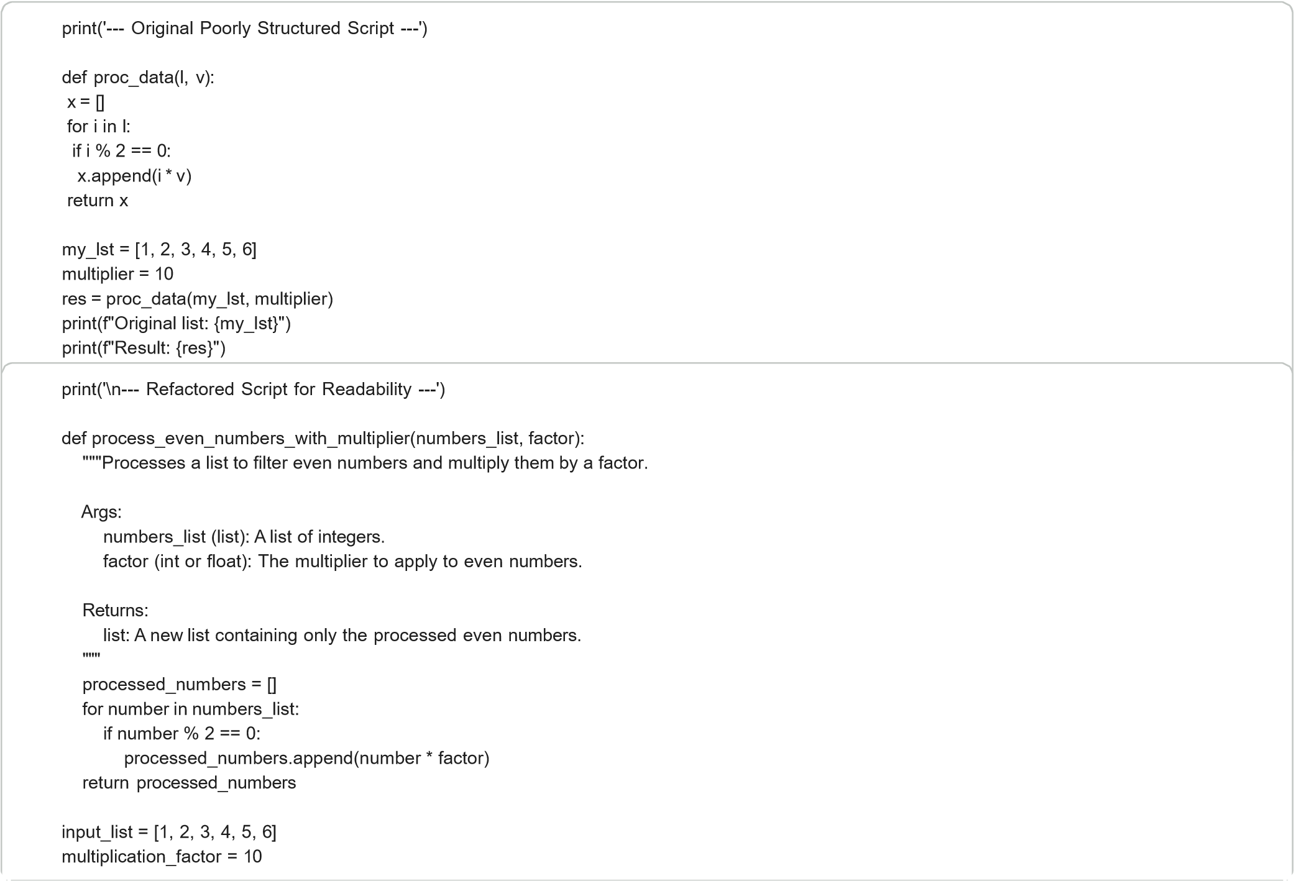



resultant_list = process_even_numbers_with_multiplier(input_list, multiplication_factor)

print(f"Original list: {input_list}")

print(f"Result:

{
resultant_list}"
)

---

Refactored Script for Readability
---

Original list: [1, 2, 3, 4, 5, 6]

Result:

[20
,

40
,

60]

Explanation of Readability Improvements (Task 3):

- Clearer Function Name:

Original: proc_data (cryptic, doesn't convey purpose).

Refactored: process_even_numbers_with_multiplier (describes exactly what the function does).

- Meaningful Variable Names:

Original: l , v , x , i (single-lefler variables, difficult to understand context).
Refactored: numbers_list , factor , processed_numbers , number , input_list , multiplication_factor , resultant_list (self- documenting names that explain their role).
- Proper Indentation and Formatting (PEP 8 Compliance):
Original: Inconsistent or non-standard indentation, which makes the code hard to read and understand the flow.
Refactored: Consistent 4-space indentation, proper spacing around operators, and adherence to PEP 8 guidelines for improved visual structure and readability.
- Added Meaningful Documentation (Docstrings):
Original: No documentation, leaving the function's purpose, arguments, and return value ambiguous.
Refactored: A comprehensive docstring explaining:
The overall purpose of the function.
Descriptions for each argument ( Args ).
A description of what the function returns ( Returns ). This significantly improves the understandability and maintainability for anyone reading or using the function.

 Task 2: Performance-Oriented Code Review
This section demonstrates how to identify and resolve performance bofllenecks in Python code, particularly focusing on inefficient algorithms for common data operations.


print('
---

Original

Inefficient

Script

for

Duplicate

Detection

---
')

def

find_duplicates_inefficient(input_list):

duplicates

=

[]

for

i in

range(len(input_list)):

for

j

in

range(i

+

1
,

len(
input_list)):

if input_list[i] ==

input_list[j] and input_list[i] not in duplicates:

duplicates.append(input_list[i])

return

duplicates

#

Sample

usage

my_list

=

[1
,

2
,

3
,

4
,

2
,

5
,

6
,

1
,

,
7

8
,

8]

inefficient_duplicates =
find_duplicates_inefficient(my_list)

print(f"Original list: {my_list}")

print(f"Inefficiently

found

duplicates:

)
{
inefficient_duplicates}"

---

Original Inefficient Script for Duplicate Detection
---

Original list: [1, 2, 3, 4, 2, 5, 6, 1, 7, 8, 8]

Inefficiently

found

duplicates:

[1
,

2
,

8]

print('
\
n
---

Optimized

Script

for

Duplicate

Detection

---
')

def

find_duplicates_optimized(input_list):

seen = set()

duplicates = set()

for

item

in

input_list:

if item in seen:

duplicates.add(item)

else:

seen.add(item)

return

list(duplicates)

#

Sample

usage



Explanation

of

Performance

Improvements

Task
(

2):

my_list

=

[1
,

,
2

3
,

4
,

2
,

5
,

6
,

1
,

7
,

8
,

8]

optimized_duplicates

=

find_duplicates_optimized(my_list)

print(f"Original list: {my_list}")

print(f"Optimizedly

found

duplicates:

{
optimized_duplicates}"
)

---

Optimized

Script

for Duplicate

Detection

---

Original list: [1, 2, 3, 4, 2, 5, 6, 1, 7, 8, 8]

Optimizedly

found

duplicates:

[8
,

,
1

2]

- Why the original approach was inefficient:

Nested Loops (O(n^2) time complexity): The find_duplicates_inefficient function uses nested for loops. For each element in
the list, it iterates through the rest of the list to find duplicates. If the list has n elements, this results in approximately n * n comparisons, making its time complexity O(n^2). This becomes very slow for large datasets.
not in duplicates check (O(k) time complexity): Inside the inner loop, it checks input_list[i] not in duplicates . Since duplicates
is a list, checking for an element's presence in a list takes O(k) time, where k is the current number of elements in the duplicates list. This adds another layer of inefficiency.
- How the optimized version improves performance:
find_duplicates_optimized
Single Pass with Sets (O(n) time complexity): The function uses a single loop to iterate through
for
the list once. It leverages Python's set data structure.

Constant Time Lookups (O(1) average time complexity): Sets provide average O(1) (constant time) for add and in operations. This means checking if an item is in seen or adding it to seen or duplicates is extremely fast, regardless of the set's size.
1.

Syntax

Fixes

and

Indentation

Issues:

Original

Error:

The

statement

inside

the

block

was

incorrectly

indented.

Correction:

The
making

it

part

of

if

total_price

>

100:

return

total_price

*

(1

-

discound_percentage

/

100)

return

if

return

n^2
Reduced Comparisons: Instead of comparisons, the optimized approach performs approximately operations (one
n lookup and one add for each element). This drastically reduces the number of operations, especially for large lists.
Overall Improvement: The optimized version transforms the time complexity from O(n^2) (quadratic) to O(n) (linear). This means that as the input list size n grows, the execution time of the optimized function increases proportionally to n , whereas the inefficient function's execution time increases proportionally to n squared, leading to significant performance gains for larger datasets.



print('
\
n
---

AI
-
Corrected

Script

---
')

def calculate_discount(total_price, discount_percentage):

if total_price > 100:

return total_price * (1
-

discount_percentage / 100)

else:

return

total_price

product_cost

=

150

discount_rate

=

10

final_price = calculate_discount(product_cost, discount_rate)

print('Final price:', final_price)

---

AI
-
Corrected

Script

---

Final price: 135.0

Explanation of AI-Generated Fixes:

statement was indented by an additional four spaces to align with standard Python syntax, block's execution scope.
correctly

2.

Naming

Corrections:

Original

Error:

The

variable

was

misspelled

missing
(

an

'i').

if

total_price

>

100:

return

total_price

*

(1

-

discount_percentage

/

100)

discound_percentage

