3. Write C program that demonstrates the usage of these notations by analyzing the time complexity of some example algorithms.

PROGRAM:

import time def sum_using_loop(n): sum = 0 for i in range(1, n+1):

sum += i return sum

def sum_using_formula(n):

return (n * (n + 1)) // 2

def main():

n = 1000000 start_loop = time.time() sum1 = sum_using_loop(n) end_loop = time.time() time_taken_loop = end_loop - start_loop print("Sum using loop:", sum1) print("Time taken using loop:", time_taken_loop, "seconds") start_formula = time.time() sum2 = sum_using_formula(n) end_formula = time.time() time_taken_formula = end_formula - start_formula print("Sum using formula:", sum2) print("Time taken using formula:", time_taken_formula, "seconds")

if __name__ == "__main__":

main()

OUTPUT: 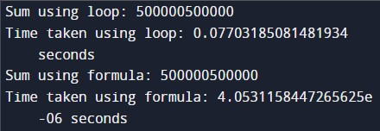

TIME COMPLEXITY: O(n)