4.Write Programs that demonstrate the mathematical analysis of non-recursive and recursive algorithms.

PROGRAM:

import time def sum_non_recursive(n): start_time = time.time() total = 0 for i in range(1, n+1): total += i

end_time = time.time() execution_time = end_time - start_time return total, execution_time

n = 1000000 sum_non_rec, time_non_rec = sum_non_recursive(n) print("Sum of the first", n, "natural numbers (non-recursive):", sum_non_rec) print("Execution time:", time_non_rec, "seconds")

OUTPUT: 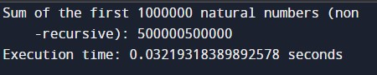

TIME COMPLEXITY: O(n)