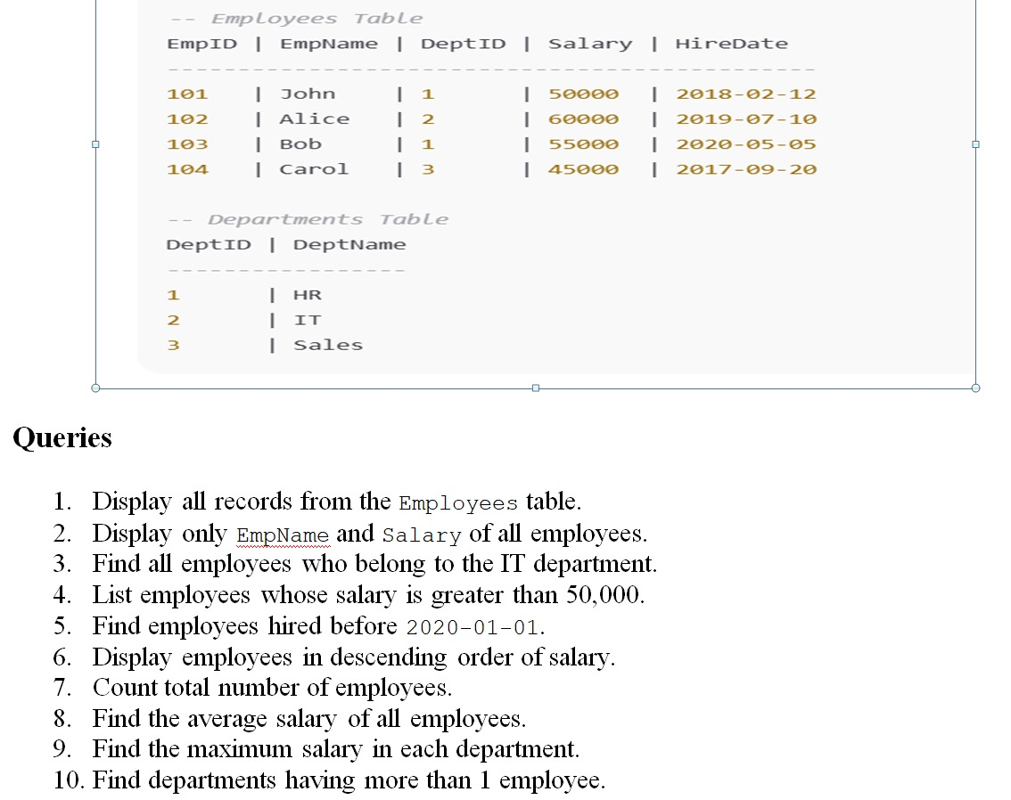

1. Display all records from the Employees table

SELECT \* FROM Employees;

EmpID EmpName DeptID Salary HireDate

101 John 1 50000 2018-02-12

102 Alice 2 60000 2019-07-10

103 Bob 1 55000 2020-05-05

104 Carol 3 45000 2017-09-20

2. Display only EmpName and Salary of all employees

SELECT EmpName, Salary FROM Employees

EmpName Salary

John 50000

Alice 60000

Bob 55000

Carol 45000

3. Find all employees who belong to the IT department

SELECT e.EmpName, e.Salary

FROM Employees e

JOIN Departments d ON e.DeptID = d.DeptID

WHERE d.DeptName = 'IT';

EmpName Salary

Alice 60000

4. List employees whose salary is greater than 50,000

SELECT EmpName, Salary FROM Employees

WHERE Salary > 50000;

EmpName Salary

Alice 60000

Bob 55000

5. Find employees hired before 2020-01-01

SELECT EmpName, HireDate FROM Employees

WHERE HireDate < '2020-01-01';

EmpName HireDate

John 2018-02-12

Alice 2019-07-10

Carol 2017-09-20

6. Display employees in descending order of salary

SELECT EmpName, Salary FROM Employees

ORDER BY Salary DESC;

EmpName Salary

Alice 60000

Bob 55000

John 50000

Carol 45000

7. Count total number of employees

SELECT COUNT(\*) AS TotalEmployees FROM Employees;

TotalEmployees

4

8. Find the average salary of all employees

SELECT AVG(Salary) AS AverageSalary FROM Employees;

AverageSalary

52500.00

9. Find the maximum salary in each department

SELECT d.DeptName, MAX(e.Salary) AS MaxSalary

FROM Employees e

JOIN Departments d ON e.DeptID = d.DeptID

GROUP BY d.DeptName;

DeptName MaxSalary

HR 55000

IT 60000

Sales 45000

10. Find departments having more than 1 employee

SELECT d.DeptName, COUNT(e.EmpID) AS EmployeeCount

FROM Employees e

JOIN Departments d ON e.DeptID = d.DeptID

GROUP BY d.DeptName

HAVING COUNT(e.EmpID) > 1;

DeptName EmployeeCount

HR 2