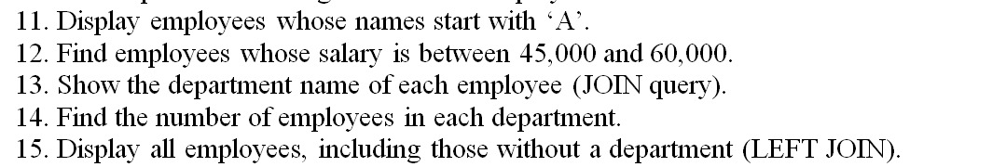

1. Display employees whose names start with ‘A’ .

Select *from employees

where empname like ‘A%’;

| **EmpID** | **EmpName** | **DeptID** | **Salary** | **HireDate** |
| --- | --- | --- | --- | --- |
| 102 | Alice | 2 | 60000 | 2019-07-10 |

1. Find employees whose salary is between 45000 and 60000

Select *from employees

where salary between 45000 and 60000

| **EmpID** | **EmpName** | **DeptID** | **Salary** | **HireDate** |
| --- | --- | --- | --- | --- |
| 101 | John | 1 | 50000 | 2018-02-12 |
| 102 | Alice | 2 | 60000 | 2019-07-10 |
| 103 | Bob | 1 | 55000 | 2020-05-05 |

1. Show the department name of each employee (join query)

SELECT e.name AS EmployeeName, d.department_name

FROM Employees e

JOIN Departments d ON e.department_id = d.department_id;

| **EmpName** | **DeptName** |
| --- | --- |
| John | HR |
| Alice | IT |
| Bob | HR |
| Carol | Sales |

1. Find the number of employees in each department

SELECT d.department_name, COUNT(e.employee_id) AS EmployeeCount

FROM Departments d

LEFT JOIN Employees e ON d.department_id = e.department_id

GROUP BY d.department_name;

| **DeptName** | **EmployeeCount** |
| --- | --- |
| HR | 2 |
| IT | 1 |
| Sales | 1 |

1. Display all employees, including those without a department (LEFT JOIN)

SELECT e.name AS EmployeeName, d.department_name

FROM Employees e

LEFT JOIN Departments d ON e.department_id = d.department_id;

| **EmpName** | **DeptName** |
| --- | --- |
| John | HR |
| Alice | IT |
| Bob | HR |
| Carol | Sales |