Part 2 — Product Understanding
AbleSpace — Caseload → Take Data Workflow
Full Stack Developer (Fresher) Assessment
I signed up for AbleSpace's free trial (app.ablespace.io) as a Teacher/Therapist and did a full hands-on walkthrough of Caseload → Take Data using the two pre-loaded demo students, including every tab, view mode, and data type I could find. Screenshots below are from that session, taken on 16 Aug 2026.

1. Entry point: Caseload → Take Data
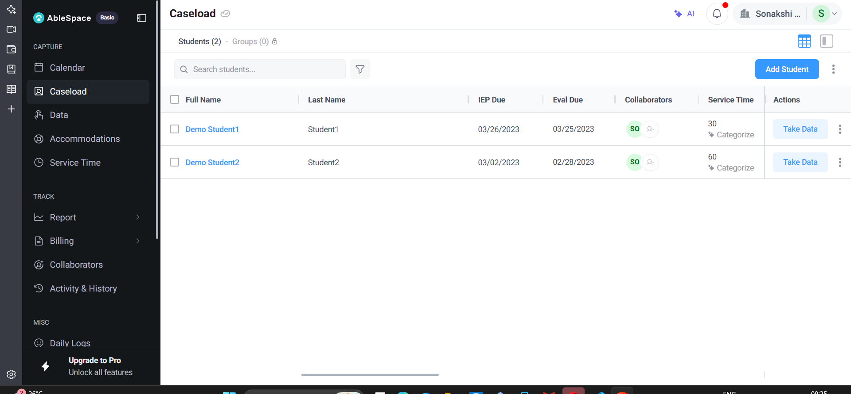
Caseload — each student row ends in a “Take Data” button.
Clicking “Take Data” opens a new Session (URL /session/<id>) with an auto-generated 30-minute time window starting now, and loads every active IEP goal for that student.

2. The Session screen and its two main panes
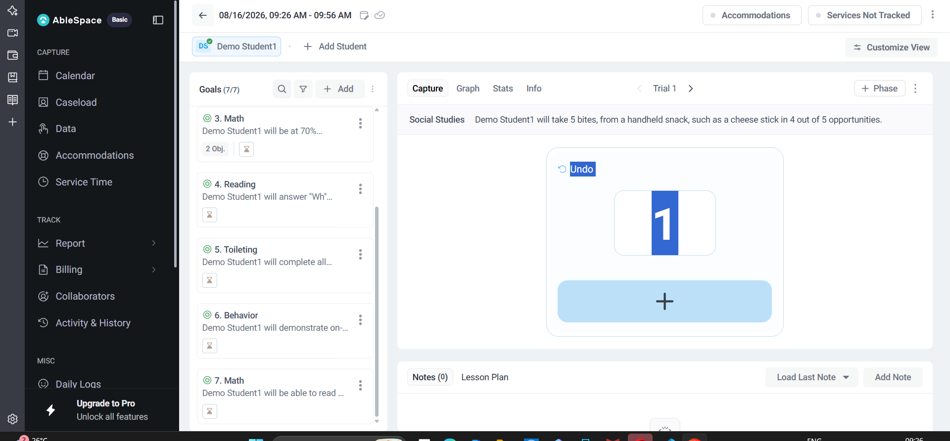
Left: Goals (7/7) list. Right: Capture pane for whichever goal is selected, with Trial navigation and a tap-to-count pad.
- Top toolbar: clickable “Accommodations” and “Services Not Tracked” chips (each opens a modal), plus “Customize View” and a student switcher (“+ Add Student” for group sessions).
- Right pane tabs: Capture / Graph / Stats / Info — covered in section 4.
- Bottom: Notes and a Lesson Plan editor — covered in section 5.

3. Logging Accommodations and Service Time
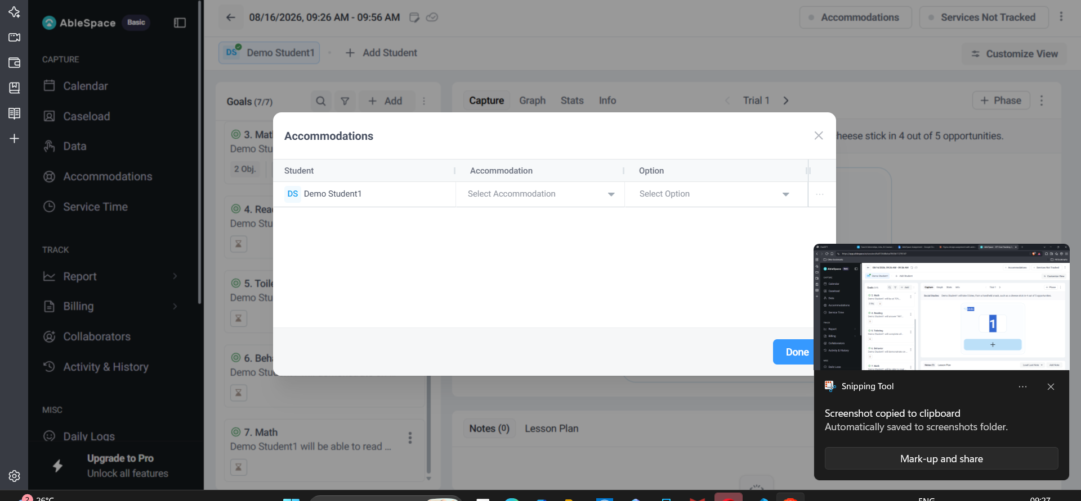
Accommodations modal — per-student Accommodation + Option dropdowns.
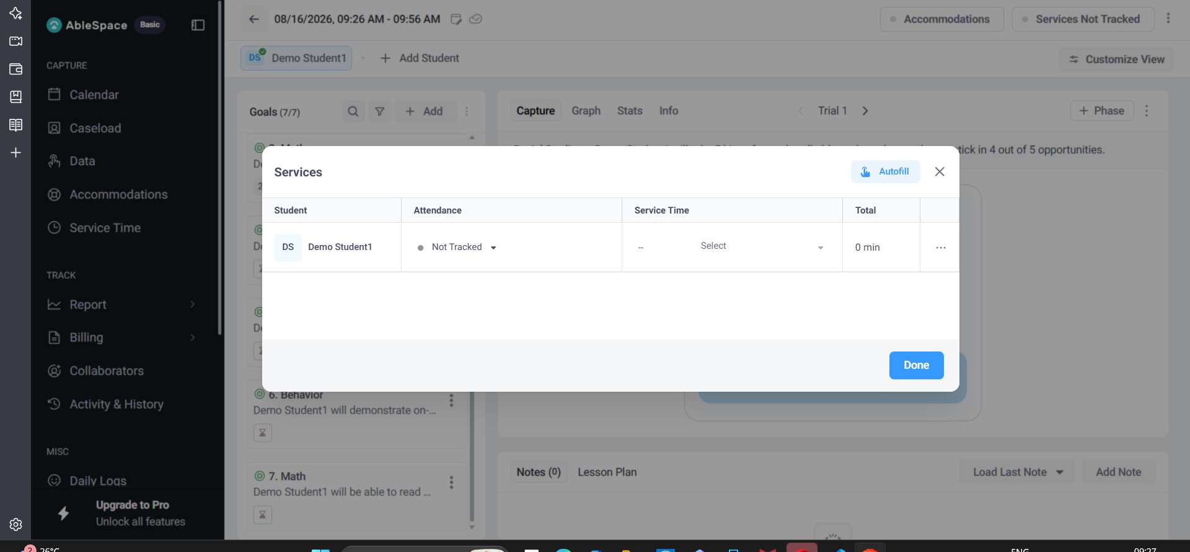
Services modal — attendance, service minutes, running Total, and an Autofill shortcut.
Both are logged independently of goal data, from small modals reachable via the top-bar chips.

4. Graph, Stats and Info — reviewing a goal's history mid-session
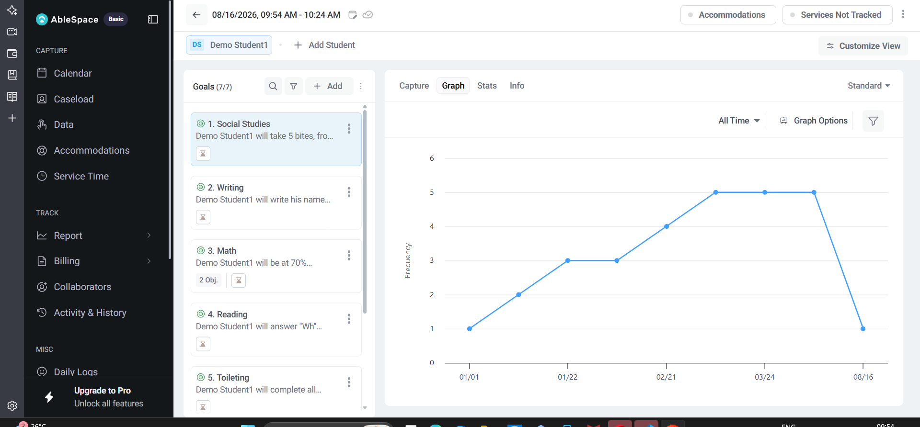
Graph tab — frequency plotted over time, with an “All Time” range picker, Graph Options, and a filter icon.
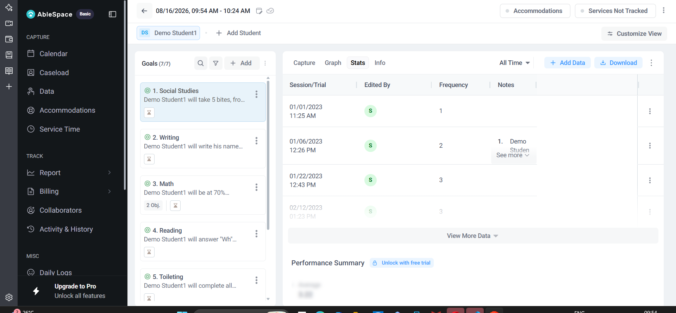
Stats tab — a Session/Trial table (date, who edited it, frequency, notes) with Add Data / Download, plus a “Performance Summary” that is paywalled (“Unlock with free trial”) even on a trial account.
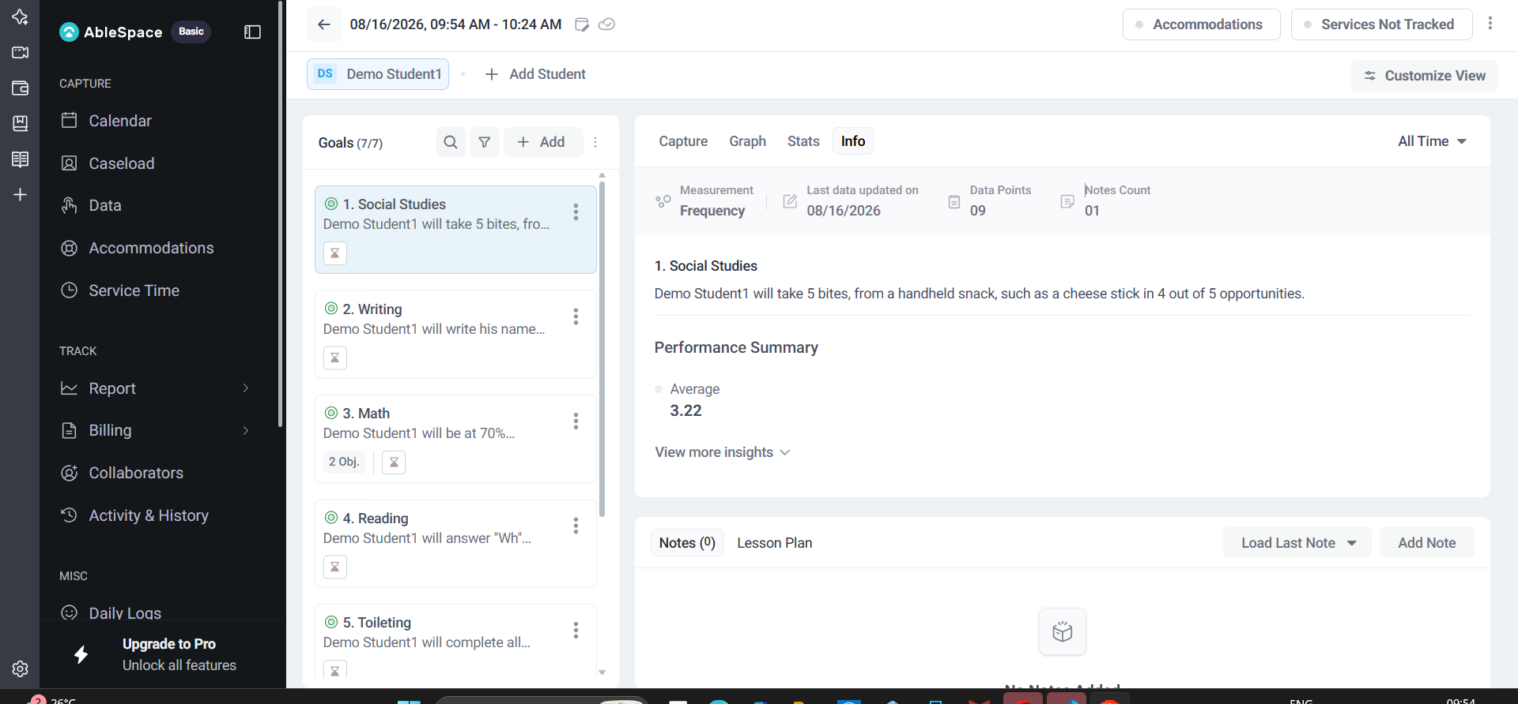
Info tab — Measurement type (Frequency), Data Points count, Notes Count, the full goal target sentence, and a smaller, unlocked “Average” figure (3.22).
Interesting inconsistency: Info's own “Performance Summary → Average” is visible for free, while Stats' “Performance Summary” block for the same goal is locked behind “Unlock with free trial” — two panels with the same name, different access rules, on the same goal, in the same trial account.

5. Notes and Lesson Plan
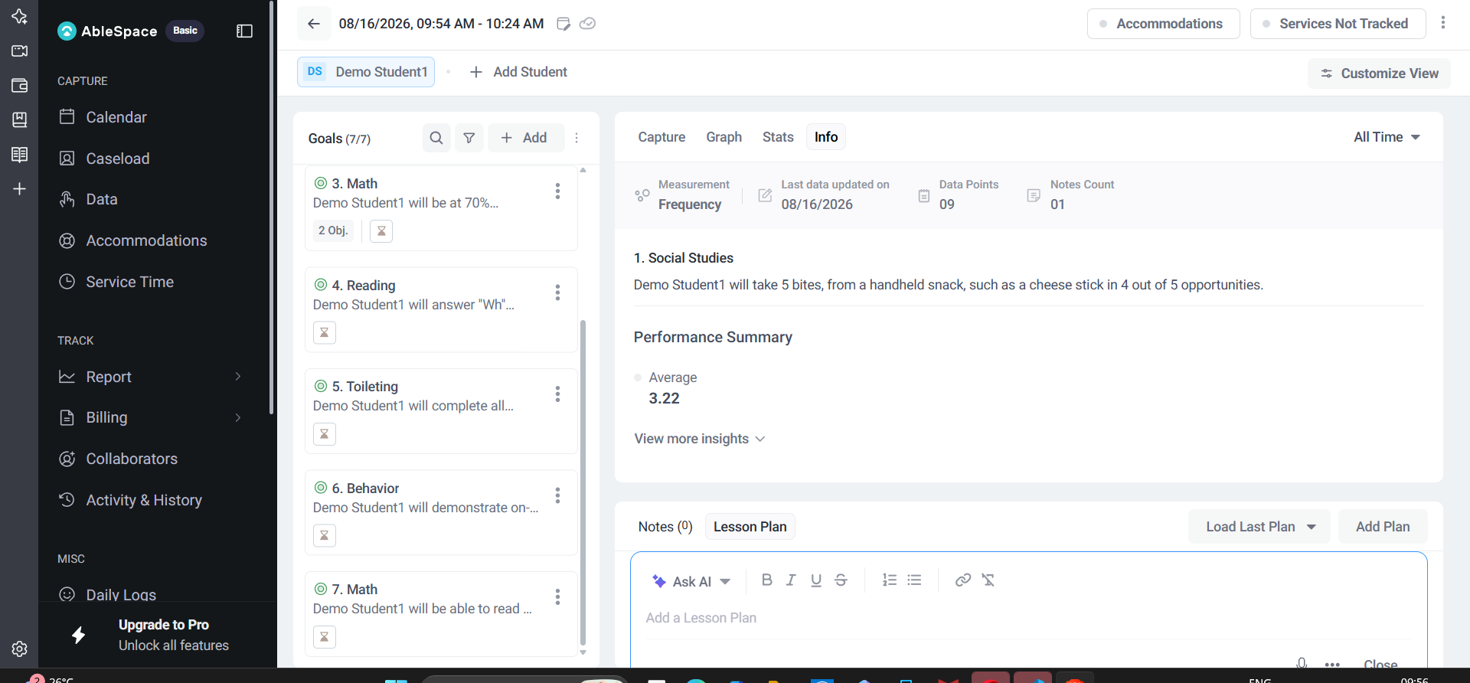
The Lesson Plan tab opens a full rich-text editor (Bold/Italic/Underline/Strikethrough, lists, link, and an “Ask AI” assist button) — richer than the plain Notes field next to it.

6. Board view — AbleSpace supports multiple data types, one per goal
“Customize View” switches the whole session between List, Board, and Group layouts, and can show/hide Instructions and Data Collection Buttons, with a “Set as Default View” option.
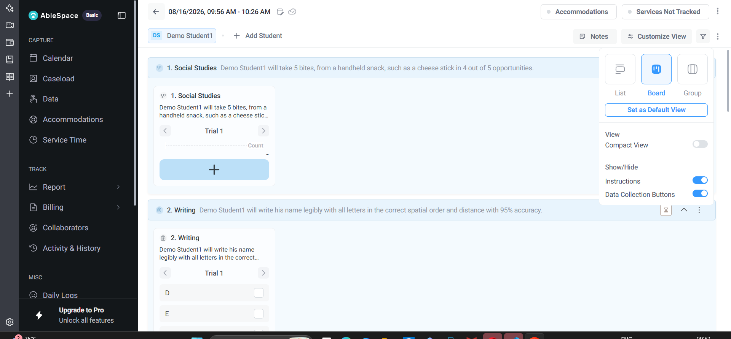
Board view: every goal is shown at once, each with a data-capture widget matched to its own measurement type.
Working through all 7 demo goals in Board view surfaced at least five distinct data-collection UI types, which matches AbleSpace's marketing claim of “10+ data types”:
- Social Studies — a simple tally/frequency counter (tap “+”, Undo available).
- Writing — a letter-by-letter checklist (D, E, M, O — checking off each correctly-written letter of the student's name).
- Math (goal 3, which has 2 Objectives) — splits into sub-cards 3.1 / 3.2, each with independent Prompted/Accuracy counters and a prompt-level dropdown (“P”).
- Reading — an accordion of sub-questions (Answer Who / Answer What / Answer When / Answer Where), each expandable separately.
- Toileting — a 4-point independence scale (Independent / 1–2 verbal or visual prompts / More than 2 verbal or visual prompts / More intrusive prompts).
- Behavior — a 6-point frequency scale (Not applicable / Never / Hardly ever / Sometimes / Often / Always).
- Math (goal 7, clock-reading) — back to a Prompted/Accuracy counter, shown as a running “0/0” ratio.
None of this variety is visible from the Goals list itself — every goal card looks identical (title + truncated sentence + one small icon) until you open it, so a clinician can't tell at a glance whether the next goal is a 2-second tap or a multi-part accordion.

7. Group view and multi-student sessions
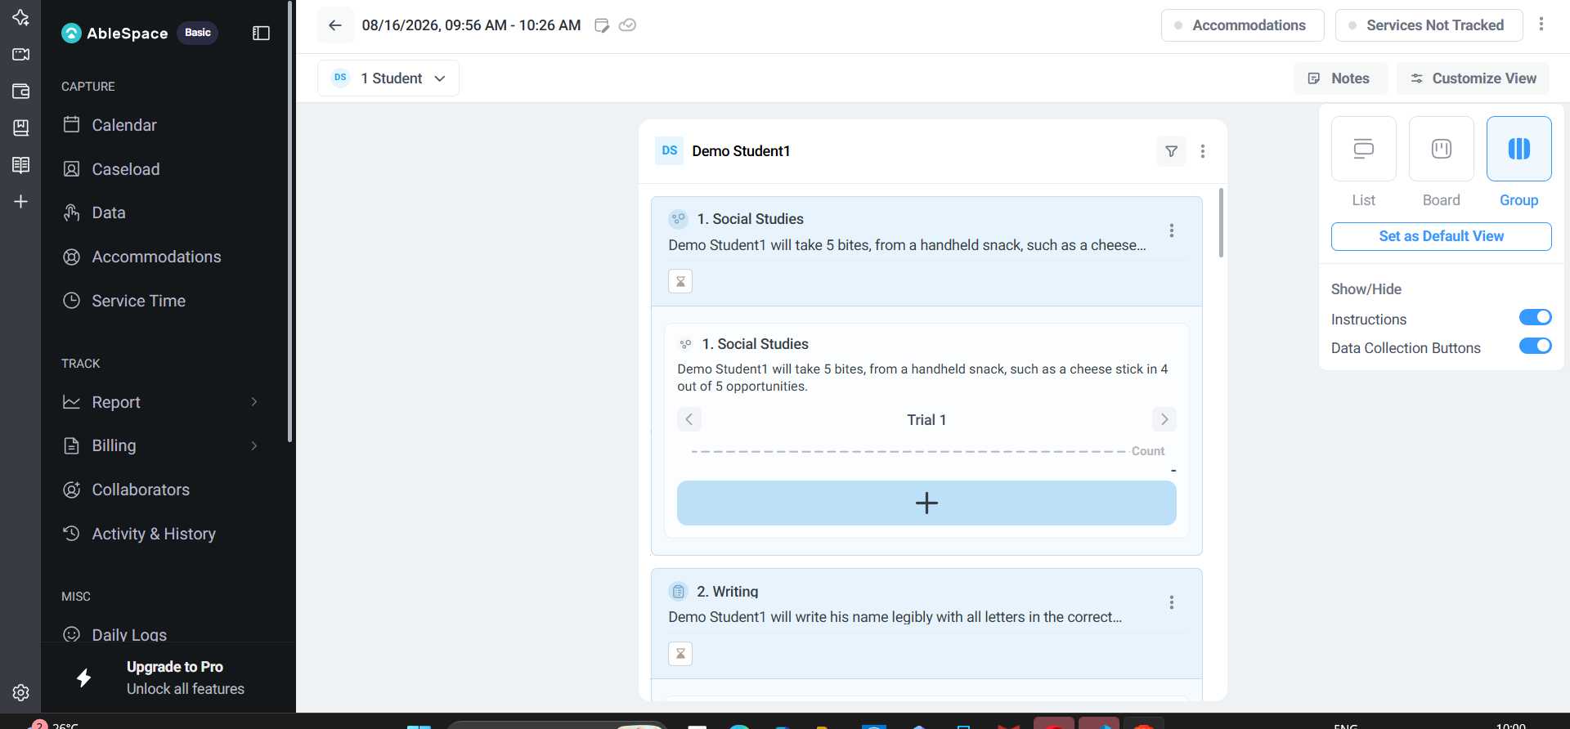
Group view — the same Board layout, now scoped under a “1 Student” selector, for running data collection across several students in one session.

8. Trial-level and Service-level management menus
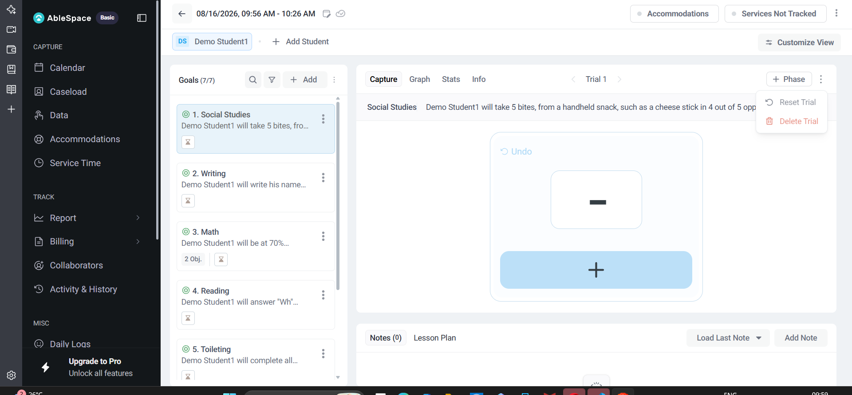
The “…” menu next to Trial navigation exposes “Reset Trial” and a destructive “Delete Trial” — with no confirmation step visible before the click.
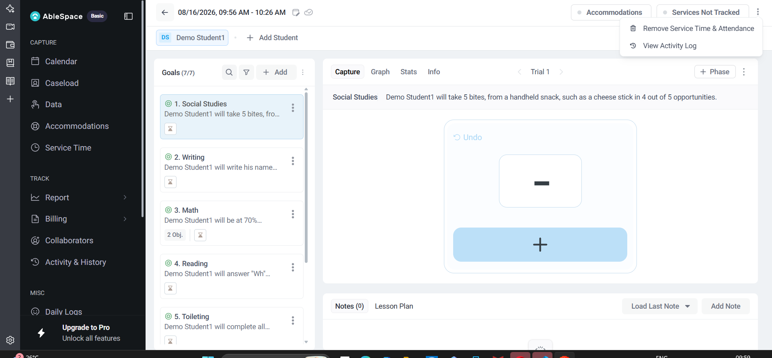
The “…” menu on the “Services Not Tracked” chip offers “Remove Service Time & Attendance” and “View Activity Log”.

9. Outside the session: the student's own profile page
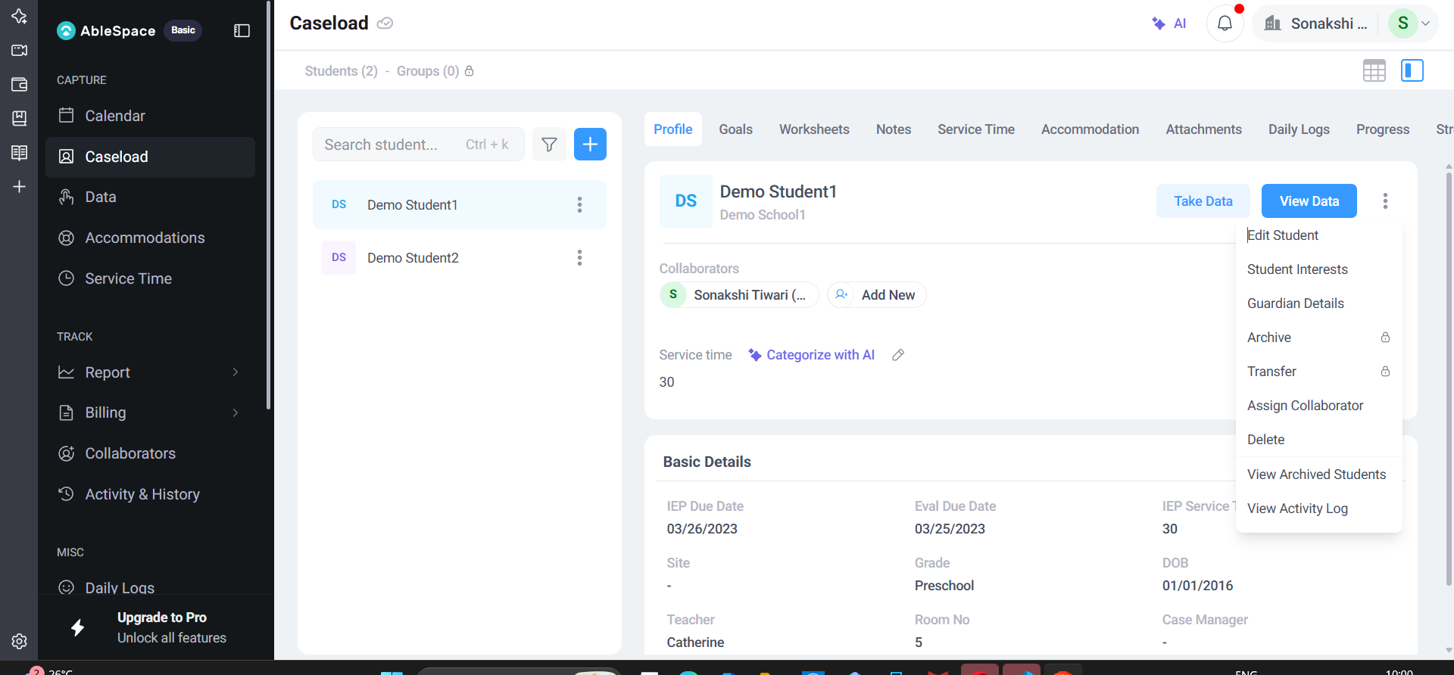
Clicking a student's name (rather than “Take Data”) opens a full profile: Profile / Goals / Worksheets / Notes / Service Time / Accommodation / Attachments / Daily Logs / Progress tabs, Basic Details (IEP & Eval due dates, Site, Grade, DOB, Teacher, Room, Case Manager), and both a “Take Data” and a separate “View Data” button.
The “…” menu here adds account-management actions: Edit Student, Student Interests, Guardian Details, Archive (locked, Pro), Transfer (locked, Pro), Assign Collaborator, Delete, View Archived Students, View Activity Log.

10. Caseload Filters
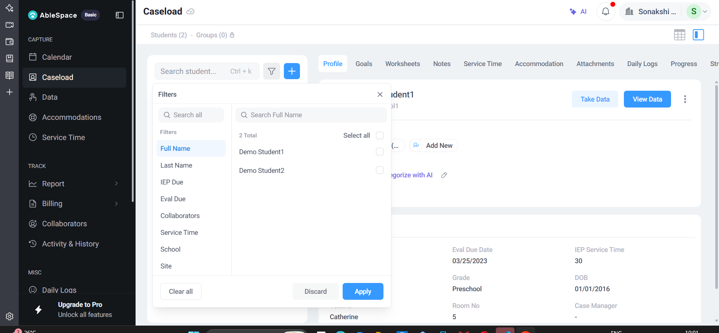
The Filters modal on Caseload — left column lists filterable fields (Full Name, Last Name, IEP Due, Eval Due, Collaborators, Service Time, School, Site); selecting “Full Name” shows a checklist of students to filter by name.

11. Workflow summary, in my own words
- From Caseload, click “Take Data” on a student — or click their name for the full profile first.
- AbleSpace opens a Session with a default 30-minute window and every active goal loaded into the Goals list.
- Pick a layout: List (one goal open at a time), Board (all goals, all capture widgets, at once), or Group (Board, scoped to multiple students).
- Log data using whichever widget matches that goal's measurement type — tally, checklist, accuracy/prompt level, multi-part accordion, or frequency scale — with Undo, Reset Trial, or Delete Trial available per trial.
- Independently, log Accommodations provided and Service Time/attendance from the top toolbar.
- Check progress without leaving the session via Graph (trend line), Stats (raw session table + paywalled summary), or Info (quick stats + the goal's full target sentence).
- Add session Notes or a richer, AI-assisted Lesson Plan before moving on.

12. UX / functionality observations & suggested improvements

12.1 Goal cards give no hint of data-entry effort before you open them
A one-tap tally goal and a 4-part Wh-question accordion look identical in the Goals list (title + truncated sentence + one small icon). A tiny badge indicating the data type (tally / checklist / scale / accuracy) would let a clinician gauge how long the next goal will take, which matters when juggling a caseload against the clock.

12.2 Two “Performance Summary” panels, two different access rules
Info tab shows an unlocked “Average” under a heading literally called “Performance Summary,” while the Stats tab's “Performance Summary” for the same goal is locked behind “Unlock with free trial.” Reusing the same label for a free metric and a paid one, on the same goal, is likely to make users think the paywall is a bug rather than a plan boundary.

12.3 Destructive Trial actions have no visible confirmation
“Delete Trial” sits one click away in a small dropdown, styled in red but with no “Are you sure?” step visible before the action fires — a mis-click during a live session with a student could silently lose that trial's data.

12.4 Take Data vs. View Data as separate buttons is easy to conflate
On the student profile page, “Take Data” and “View Data” sit side by side and look similar in weight (one is just a filled variant of the other). A clinician glancing quickly could open the read-only view when they meant to start a session, or vice versa.

12.5 Locked Pro features are shown but not explained inline
Archive, Transfer, and the Stats Performance Summary all show a small lock icon with no visible price, plan name, or “Upgrade” tooltip on hover — a user has to already know AbleSpace's pricing page to understand what unlocking involves.

12.6 Filters modal's left column reads like column visibility, but behaves like a per-field value filter
The left list (Full Name, Last Name, IEP Due, Eval Due, Collaborators, Service Time, School, Site) looks like a set of toggleable table columns at first glance, but clicking one instead opens a value-selection list on the right (e.g. picking specific student names under “Full Name”). Separating “which columns to show” from “filter caseload by this field's value” into two distinct, clearly-labelled controls would remove that ambiguity.

12.7 No visible session-end / completeness check
Nothing in the session view summarizes “x/7 goals captured, service time logged, notes added” before the clinician navigates away — everything auto-saves, but a first-time user has no way to confirm the session is actually complete.

13. Notes on scope
This walkthrough covered every tab and view mode I could reach on a fresh trial account with the two pre-seeded demo students. I did not test Reports, Billing, multi-student real Group sessions with more than one active student, or any Pro-tier feature that required payment to unlock.

