**Social Media App Documentation:**

**Project Overview:**

This social media app allows users to connect and interact in multiple ways. Users can chat with each other, share posts including images and videos, and create channels to build communities around shared interests. The app aims to provide a seamless and engaging user experience, fostering communication and collaboration among its users.

**Key Features:**

1. User Authentication:
2. Chat Functionality
3. Posting Content
4. Creating Channels
5. User Profiles
6. Mobile Responsiveness

**Technologies Used:**

Frontend:

1. React
2. MUI(Material-UI)

Backend

1. NodeJS

operations:

1. ExpressJS
2. Socket.io

Database

1. MongoDB

**PROGRESS REPORT:**

1: Dependencies Documentation:

The following is a brief description of the dependencies installed in the social media app:

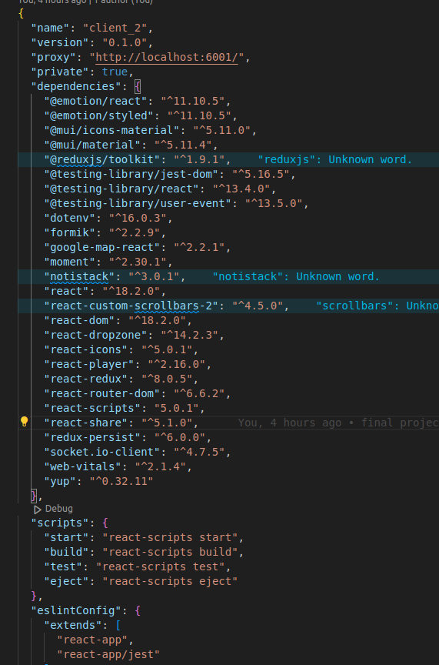

2: App.js file Documentation:

Overview:

The App.js file serves as the main entry point for the social media application. It initializes necessary configurations, sets up routing using react-router-dom, manages theme settings with Material-UI, and initializes socket connections for real-time communication.

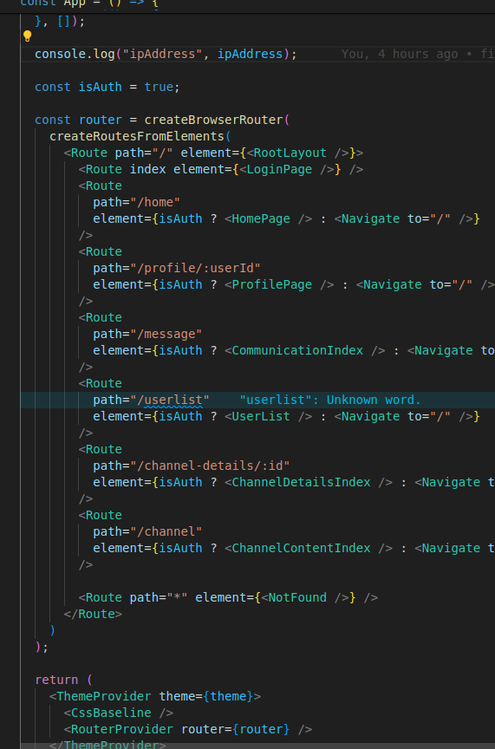

Explanation:

Socket Initialization: initializeSocket() initializes socket connections for real-time features.

Theme Management: Uses useSelector to fetch the current mode from Redux state and updates the theme accordingly.

IP Address Retrieval: Uses WebRTC (RTCPeerConnection) to fetch the user's IP address dynamically.

Routing: Defines routes using createBrowserRouter and createRoutesFromElements, protecting routes based on authentication status (isAuth).

ThemeProvider: Wraps the entire application in ThemeProvider to apply the Material-UI theme.

3: Login & Sign-up Page:

Overview:

The LoginPage component renders the login page interface of the social media application. It includes branding, a form for user credentials, and responsive design considerations using Material-UI components and hooks.

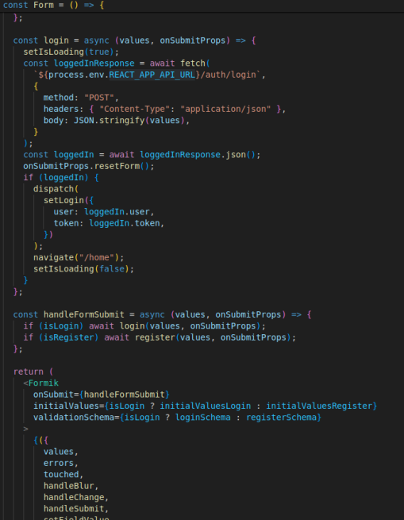

Form Component for login & register page:

Manages state variables (pageType, passwordShown, isLoading) using useState.

Retrieves theme (useTheme), dispatch function (useDispatch), navigation hook (useNavigate), and media query (useMediaQuery) for responsive design.

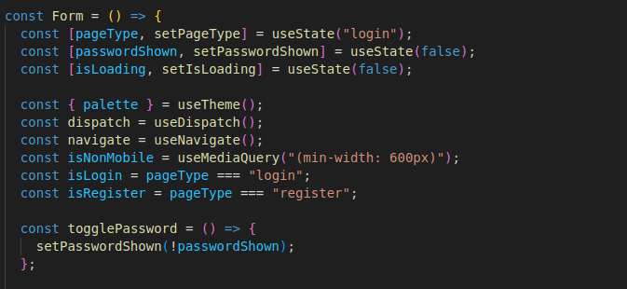

Form Submission Handlers

register(values, onSubmitProps): Handles registration form submission, uploads user data including profile picture to the server.

login(values, onSubmitProps): Handles login form submission, sends user credentials to authenticate and dispatches login action upon success.

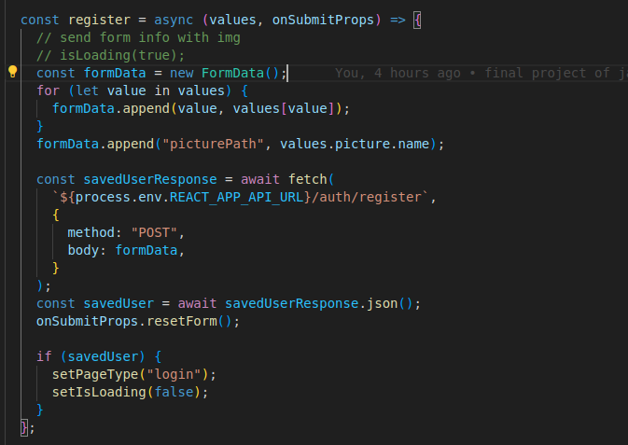

Screenshot of login page and resigster page:

A: Login Page:

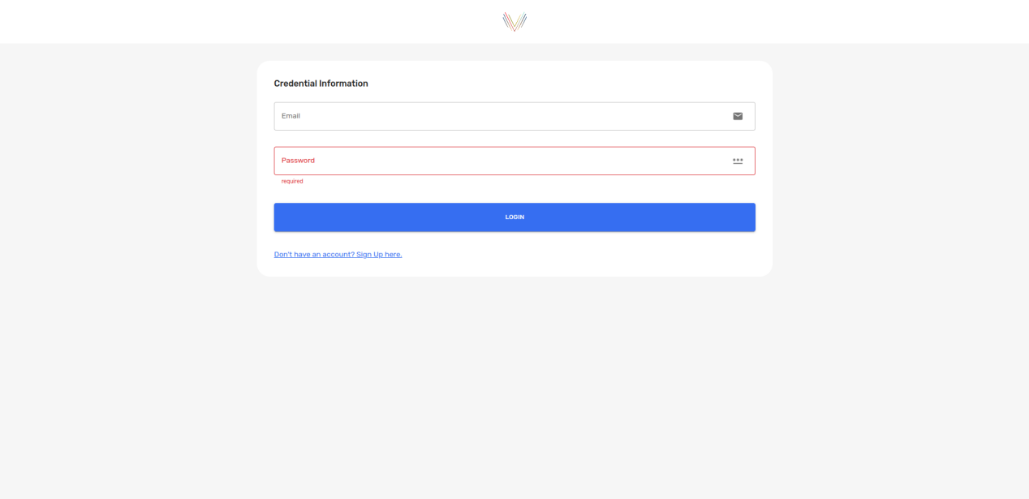

B: Register Page:

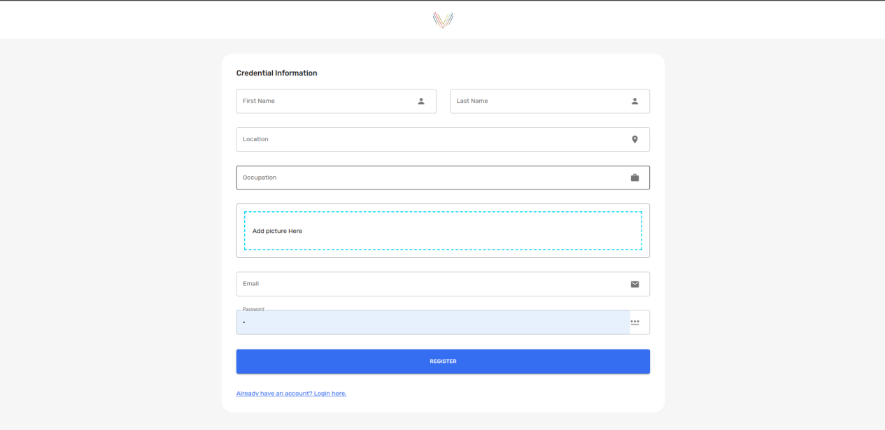

4: Home Page:

Introduction:

The HomePage component serves as the main landing page for logged-in users. It displays various widgets that provide a personalized experience based on the user's data.

Components and Layout:

Navbar:

Positioned at the top of the page.

Provides navigation options and access to user settings.

Main Content Layout:

Uses a responsive layout that adapts to different screen sizes. On non-mobile screens (min-width: 1000px), the content is displayed in a flex layout with three columns.

On smaller screens, the layout switches to a block format.

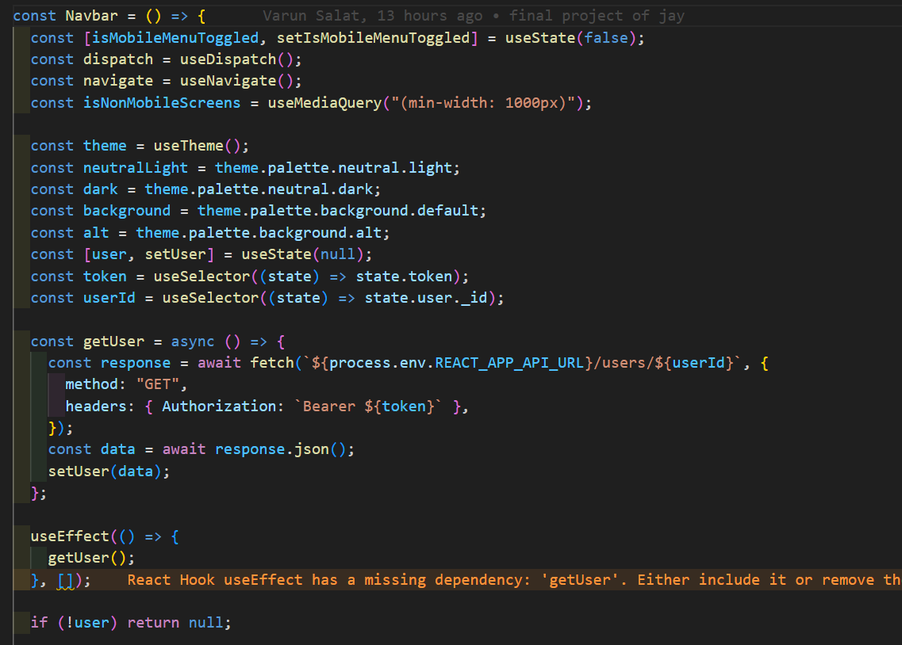

State Management:

Uses useSelector to retrieve user data (_id and picturePath) from the Redux store.

Maintains an internal state isRefresh using useState to trigger re-renders of the ChannelCardList component.

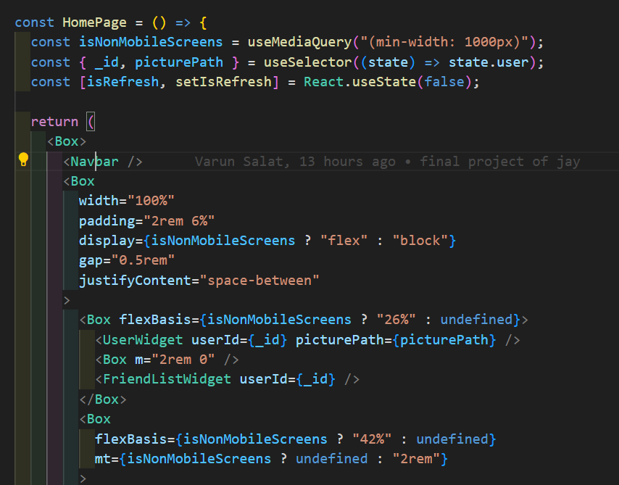

Responsive Design:

Adapts to screen sizes using the useMediaQuery hook from Material-UI.

Adjusts layout and component visibility based on screen width.

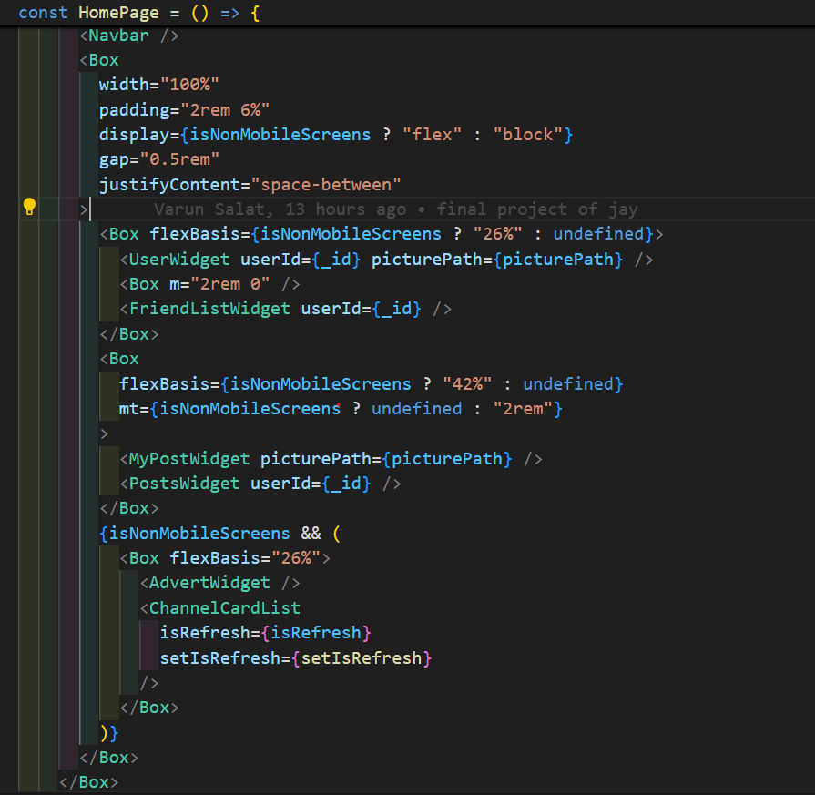

The HomePage component serves as the main interface for users after they log in. It integrates multiple widgets to provide a comprehensive user experience, including user details, posts, advertisements, and friend lists.

The layout adjusts dynamically based on screen size to ensure an optimal viewing experience on both mobile and non-mobile screens.

Desktop Design:

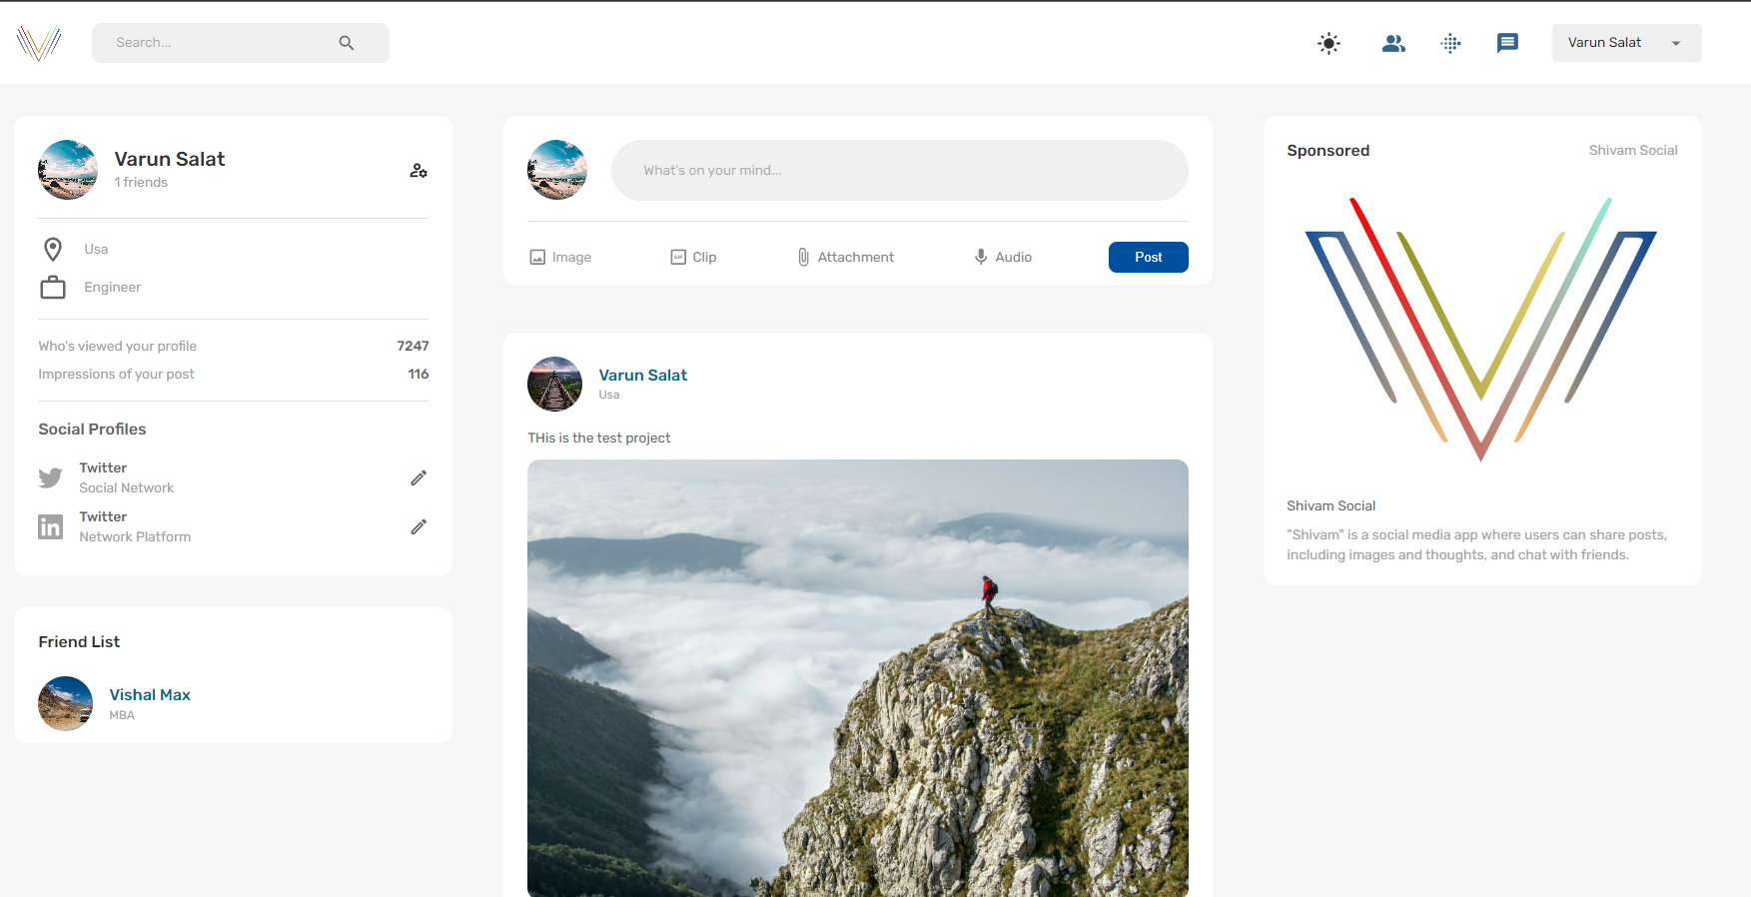

Desktop Design Comment Design:

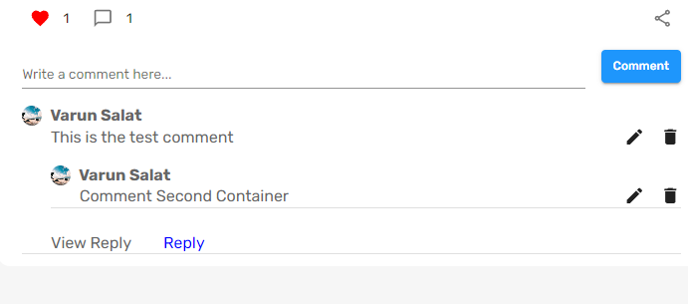

Mobile design Screenshot:

