`

Blockchain Assignment 2

Question 1

1. The creation time of the contract in UTC is Apr-21-2022 06:00:05 PM UTC

* The transaction hash is : **0x5c533e574a9ad13eefa418c020ac0fc61cfad9df5704b0348993cdec16a445e3**
* The transaction fee Is **0.00758367791496894 ETH**
* The function called is **update(bytes32 _oldRoot,bytes32 _newRoot,bytes _signature)**
* The sender is 0xfF3703E510f4Ff4D8686f2f33f722D5C565D18f7 and its an external owned account

Question 2:

**0x46EFc27a8C65D69053Db6eFb394bFdc5c93c73dE:**

1. The active period was from **May-10-2021 07:02:04 AM UTC - May-14-2021 01:50:15 AM UTC (4 days)**
2. The balance is **0** ETH and **0** USDT
3. There are **14** transactions in total (7 ETH and 7 USDT)
4. The Ether was transferred to this address: **0x639CA9717b227DBA9AF2b92035cC2298597bCe73**
5. There are **7** ERC-20 Token (USDT) transfers in this account
6. There is one token that is **USDT**
7. The highest amount (incoming) was 415,661.922359 USDT
8. Total amount of ETH sent is: **0.008205051402089904 ETH**
9. Only one method transfer(address _to, uint256 _value) is called in all the contract transactions
10. A screenshot of a computer

    AI-generated content may be incorrect.

If you see the transactions, you see that large amounts are received from multiple addresses and they are all sent to two address. This address is more like a middle man address and this seems like a money laundering process One more point to note is that all of it happens on the same day making it a big red flag. Hence this is **suspicious**.

**0xc07394ce7f0089f2f410306afd0d4c818ef379ba**

1. The active period is **Feb-08-2021 06:50:27 AM UTC - Jul-12-2021 08:04:51 AM UTC** (**155 days**)
2. The balance in the account is **0.155601699903764823 ETH, 0.03 USDT** and **0.84 USDC**
3. There are 235 transactions in total including all token transactions
4. In the most recent outgoing ETH transaction, 0.05 ETH was sent to 0x0a80DbFdE6C8e876848AaB066AD21ad1F3D28e20. This is the transaction with a finite amount of ETH going out. For the latest transaction in the list, there was 0 ETH sent to the USDT Stablecoin smart contract address
5. There are 168 USDT transactions and 7 USDC transactions and in total 175 contract transactions
6. There are two types of tokens, USDC and USDT
7. For tether, its 11,471,000 sent to 0xf9CA54dA82B683483957c463090CeF235076525d and for USDC 6,001,876 sent to 0xf9CA54dA82B683483957c463090CeF235076525d
8. The total amount of ether sent from this address is **0.07 ETH**
9. Methods: **USDC**: transfer(address to,uint256 value)

**USDT**: **transfer**(address _to, uint256 _value), **SendMultiSigToken**(address toAddress, uint256 value, address tokenContractAddress, uint256 expireTime, uint256 sequenceId, bytes signature)

1. A screenshot of a computer

   AI-generated content may be incorrect.

Similar to the previous question we can see large amount of crypto obtained from a few accounts and all sent to a single account starting with 0xf9CA54d. This seems like a middle man account and all of it happens in a single day making it suspicious. Apart from that huge amounts of USDT is obtained from a crypto exchange which is another suspicious activity as they could have converted large amounts of other currencies to USDT using the exchange

**0x8A18254839061123e168E3B6f765c4e34250f6be**

1. The active period for this address is from **Sep-08-2020 09:40:58 AM UTC to May-20-2022 08:30:55 AM UTC** (**618 days)**
2. **The balance is 0 ETH, 0 USDT (mentioned in etherscan)**
3. In the latest transaction 0.93332274 ETH was sent to 0x1eAb3B222A5B57474E0c237E7E1C4312C1066855
4. There are a total of 132 transactions associated with this address (mentioned in **etherscan**)
5. The number of token transfers transactions is 79 (mentioned in **etherscan**)
6. There is one token: USDT (mentioned in **etherscan**)
7. The highest value transferred is 3,000,000 USDT in 4 occasions
8. The total amount of ether sent is **1.32858724401 ETH**
9. The method used was USDT: transfer(address _to, uint256 _value).

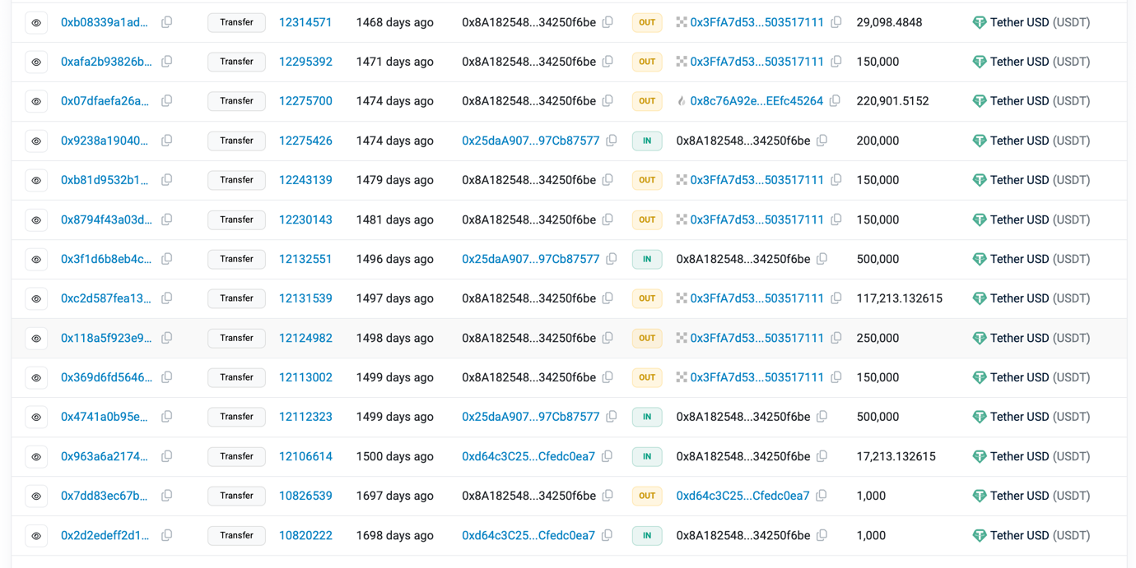

Here the suspicious activity is large amounts of USDT is obtained a few addresses and they are all sent to OKX exchange and probably could be exchanged for Fiat or other crypto. This seems like a potential money laundering problem. This is suspicious. Again all of this process happens multiple times and the transfer to the exchange is broken down into smaller amounts over multiple days

Question 3:

**0x0aC9acB7CFC9F19279034DbD96DB31f07045633F**

1. Total amount of USDT sent is 385.9k

The total balance for this address on the day the second outbound transaction happened is **309.259.248848** USDT

Money Flow Diagram

1. For all token transactions in this account, the contract that is used is 0xdAC17F958D2ee523a2206206994597C13D831ec7 which is the USDT Stablecoin contract
2. The creator of this contract is Bitfinex: Deployer 5 and the contract was created on (Nov-28-2017 12:41:21 AM UTC)

**0x815F335f976301f496167bfeF237f0622F92ac38:**

1. The total amount of USDT transferred out is 0 USDT
2. A screenshot of a computer

   AI-generated content may be incorrect. After the second USDT transfer in, the total balance of USDT was **367,550.90187**
3. The money flow diagram is

1. The contract addresses in all the contracts as follows:

USDC: 0xA0b86991c6218b36c1d19D4a2e9Eb0cE3606eB48

USDT: 0xdAC17F958D2ee523a2206206994597C13D831ec7

ERC-20 Owlswap: 0x4E0b2A80E158f8d28a2007866ab80B7f63bE6076

1. The details are as follows:

**USDT**

Creator: Bitfinex: Deployer 5

Date of Creation: Nov-28-2017 12:41:21 AM UTC

**USDC:**

Creator: Circle:Deployer

Date: Aug-03-2018 07:28:24 PM UTC

**Owlswap**:

Creator: 0x409cEaD0c1aD0aa6aa9c42650A5a00E9A3708A72

Date: Aug-28-2022 04:36:15 AM UTC

Question 4)

**TJmtrDdnVq2orCr1jjCzar72aQpetm4haw**

1. The active period is 2021-08-30 09:42:42 (UTC) to 2022-12-29 04:09:54 (UTC) (486 days)
2. The TRC20 balances are 0 USDT, 999,999.888 niuniu456.com tokens and 8.888888 OSE
3. There are total of 25 TRC20 token transfers
4. The fee for the latest USDT transfer is 6.153 TRX
5. The highest USDT transfer is 20,000 USDT which occurred 4 times
6. Total amount of USDT transferred to this address is 1180860.448
7. The Money flow diagram is :

**TJbsbT75JejMMy7v1GTTQMLEBgsvzrT3Ug**

1. The active period is from 2021-05-13 17:53:42 (UTC) – 2023-05-31 14:38:36 UTC (**747 days**)
2. The TRC20 balances are 10USDT, 13,219.004931 NFT, and 0 WRAP
3. There 8 TRC20 transfers relating to this address
4. The fee for the most recent USDT transaction is 27.2559 TRX
5. The highest USDT transaction value is 80.148514 USDT
6. A total of 90.148514 USDT was sent to this address
7. The money flow diagram:

