**Python Programming Lab**

**Name**: Deeraj R Ramchandani

**Class**: V BCA

**Roll Number**: 1541019

**Program 1**: Demonstrate the use of input and type conversion functions by accepting name (string), age(integer) and marks(float) from user and displaying the same.

Program

def input1():

name=input("\n Enter the name of the student: ")

age=int(input("\n Enter the age of the student: "))

marks=float(input("\n Enter the marks out of 300: "))

while(marks>300 or marks<0):

marks=float(input("\n Invalid. Please re-nter the marks out of 300: "))

print("\n Name: "+name+"\n Age: "+str(age)+"\n Marks(out of 300): "+str(marks))

a=1

while(a==1):

print("\n Menu\n ----\n\n 1. Input and display\n 2. Exit")

ch=int(input("\n Enter your choice: "))

if(ch==1):

input1()

elif(ch==2):

a=0

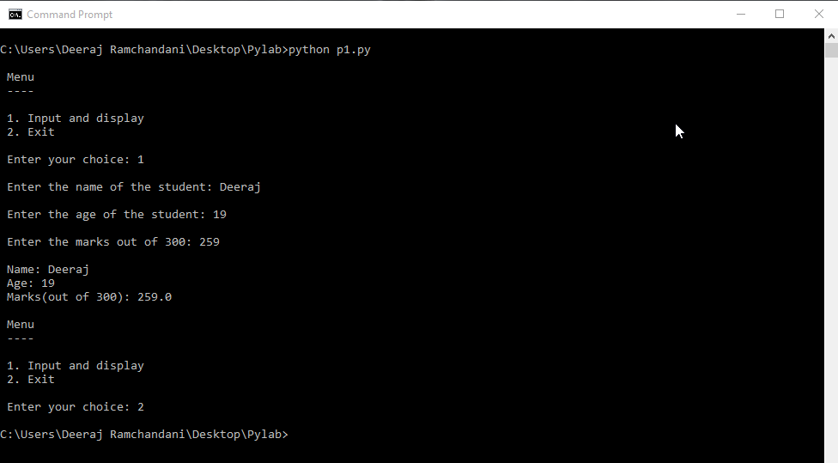Output

**Program 2:** Demonstrate the use of arithmetic operators (+, -, /, =, %) and conditional statement with a basic calculator program by reading the operands and operator from the user. Also check for divide by zero.

Program

def read_input():

x = int(input("\n Enter the value of x: "))

y = int(input("\n Enter the value of y: "))

main_program(x,y)

def main_program(x,y):

a = 1

while a == 1:

print("\n\n Menu\n ----\n\n (+) - Addition\n (-) - Subtraction\n (*) - Multiplication\n (/) - Division\n (%) - Remainder\n (!) - Exit")

ch = input("\n\n Enter your choice: ")

if ch == '+':

b = x+y

print("\n The result is: "+str(b))

elif ch == '-':

b = x-y

print("\n The result is: "+str(b))

elif ch == '*':

b = x*y

print("\n The result is: "+str(b))

elif ch == '/':

if y == 0:

print("\n Invalid divsion")

else:

b = x/y

print("\n The result is: "+str(b))

elif ch =='%':

if y == 0:

print("\n Invalid divsion")

else:

b = x%y

print("\n The result is: "+str(b))

elif ch == '!':

a = -1

else:

print("\n Invalid input")

print("\n End of program")

read_input()

Output

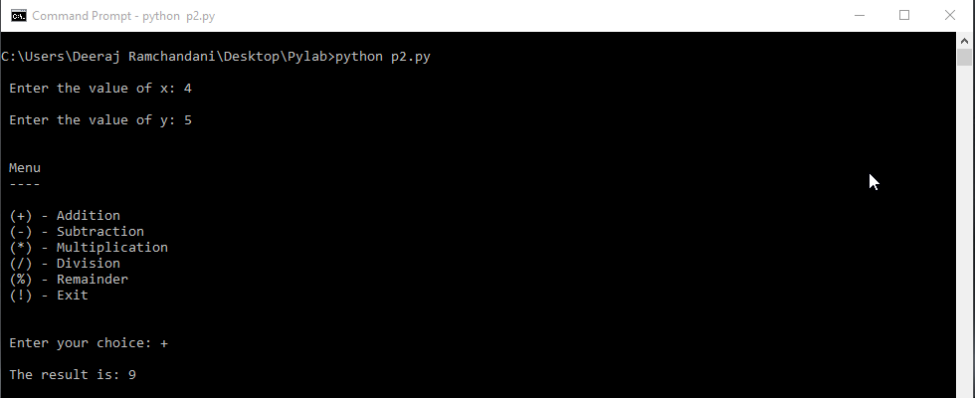

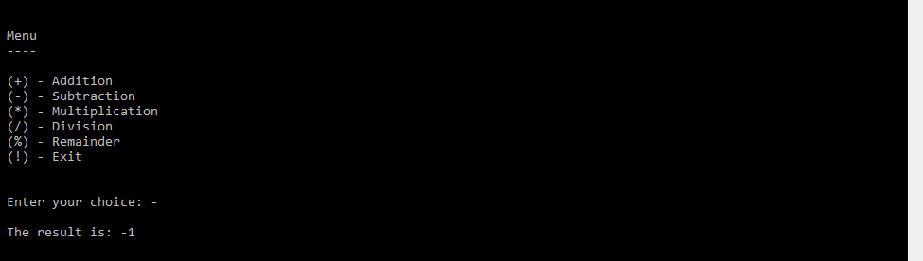

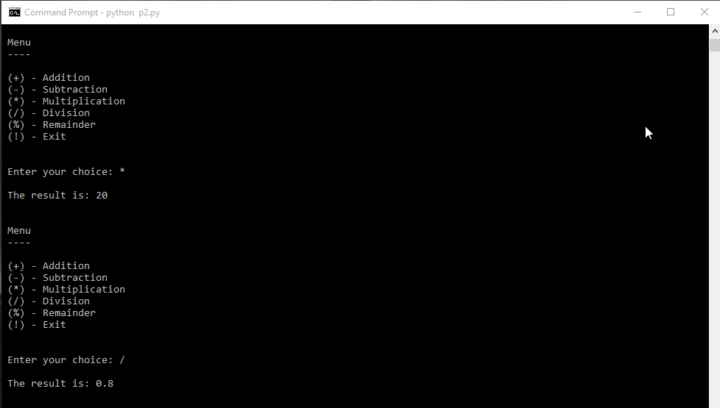

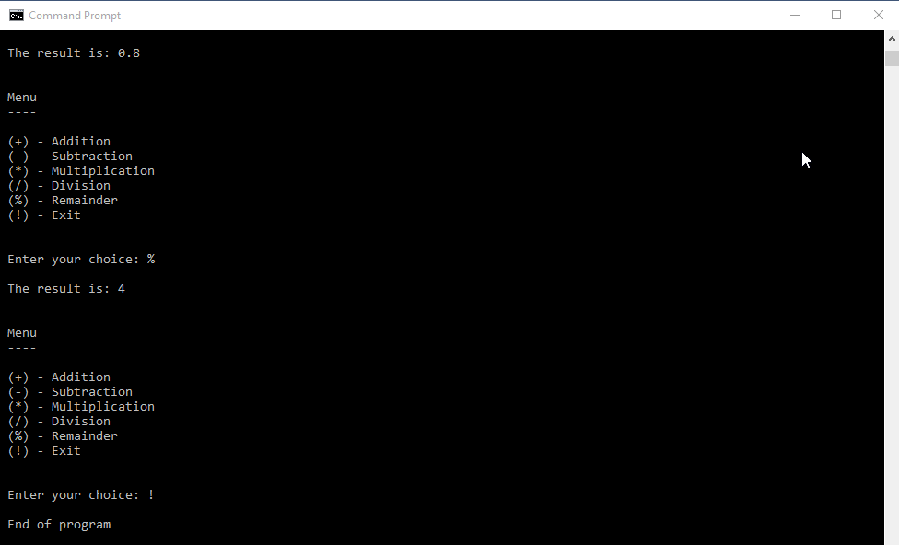

**Program 3**: Demonstrate the use of relational, logical and concatenation operators by accepting three integers from the user and displaying the smallest and greatest of the three.

Program

x = input("\n Enter the first number : ")

y = input("\n Enter the second number : ")

z = input("\n Enter the third number : ")

if(x>y and x>z):

l=x

if(y>z):

sl=y

else:

sl=z

elif(y>x and y>z):

l=y

if(x>z):

sl=x

else:

sl=z

elif(z>x and z>y):

l=z

if(y>x):

sl=y

else:

sl=x

print("\n "+str(l)+" is the largest")

print("\n "+str(sl)+" is the second largest")

Output

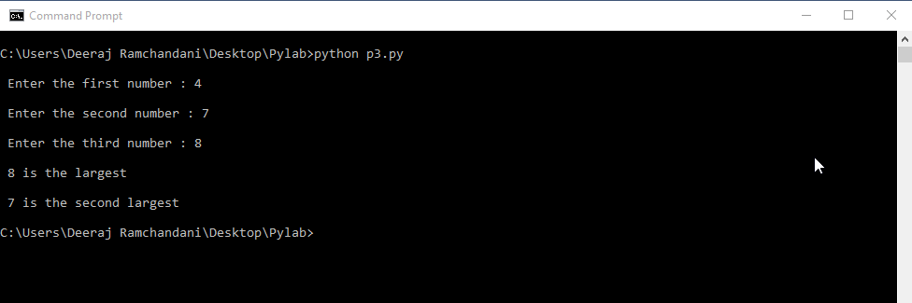

**Program 4:** Demonstrate the use of complex data types by performing complex number operations by reading the real and imaginary values from user.

Program

real=int(input("\n Enter the real part of the first complex number: "))

imag=int(input("\n Enter the imaginary part of the first complex number: "))

x=complex(real,imag)

real=int(input("\n Enter the real part of the first complex number: "))

imag=int(input("\n Enter the imaginary part of the first complex number: "))

y=complex(real,imag)

print("\n First complex number: "+str(x))

print("\n Second complex number: "+str(y))

a=1

while a==1:

print("\n MENU\n ----\n\n 1. Addition\n 2. Subtraction\n 3. Multiplication\n 4. Division\n 5. Exit\n")

ch=int(input("\n Enter your choice: "))

if(ch==1):

real=x.real+y.real

imag=x.imag+y.imag

z = complex(real,imag)

print("\n The sum is: "+str(z))

elif(ch==2):

real=x.real-y.real

imag=x.imag-y.imag

z = complex(real,imag)

print("\n The difference is: "+str(z))

elif(ch==3):

z= x*y

print("\n The product is: "+str(z))

elif(ch==4):

z=x/y

print("\n The quotient is: "+str(z))

elif(ch==5):

a=0

Output

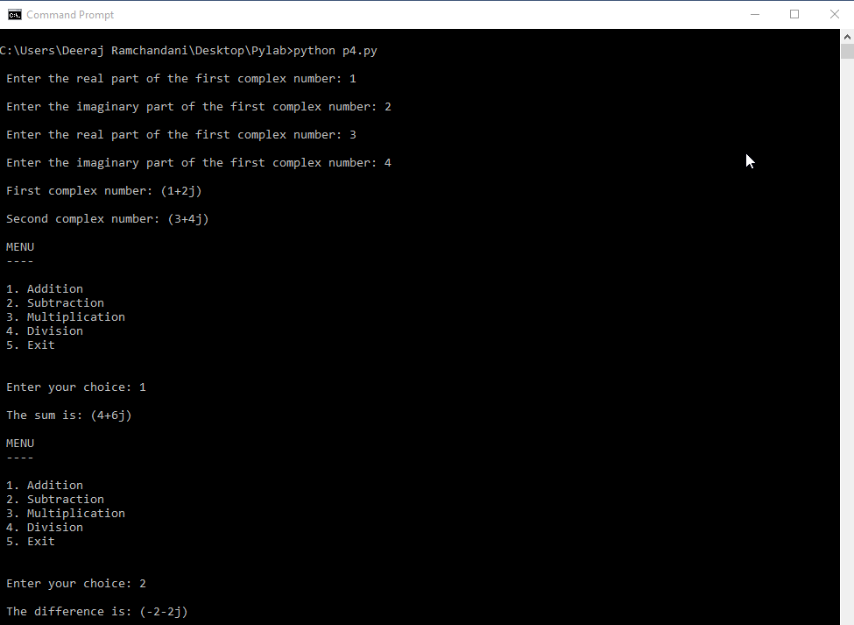

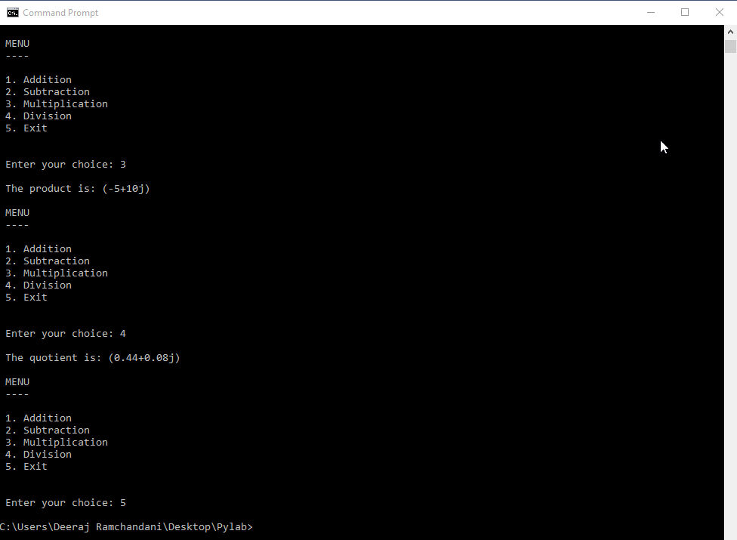

**Program 5:** Write a program that accepts a sentence, the start position and end position from the user and passes in to a function. The function should display the string from the start position to end position using (i) slice (:) operator and (ii) while loop on the string

Program

def display(s,start,end):

print("\n Displaying the sentence using slice(:) operator: "+s[start:end])

s1=""

while(start<end):

s1+=s[start]

start+=1

print("\n Displaying the sentence using while loop: "+s1)

s=input("\n Enter the sentence: ")

start=int(input("\n Enter the start value: "))

end=int(input("\n Enter the end value: "))

display(s,start,end)

Output

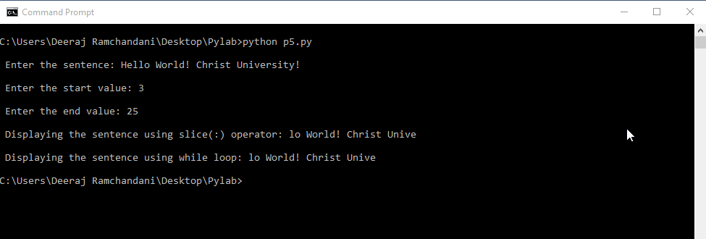

**Program 6:** Demonstrate the use of for loop by accepting a lower limit and upper limit from the user and displaying the prime numbers between the limits.

Program

lower=int(input("\n Enter the lower limit: "))

upper=int(input("\n Enter the upper limit: "))

while lower>=upper:

lower=int(input("\n Invalid. Re-nter the lower limit: "))

upper=int(input("\n Invalid. Re-enter the upper limit: "))

print("\n The prime numbers betweeen ",lower," and ",upper,"are : ")

for i in range(lower,upper+1):

flag=1

for j in range(2,int(i/2+1)):

if i==1:

flag=0

break

if i%j==0:

flag=0

break

if(flag==1):

print(" "+str(i))

Output

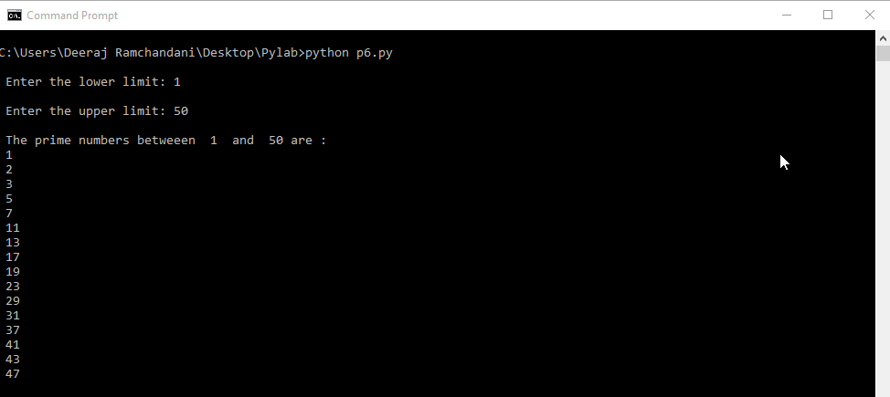

**Program 7:** Demonstrate the use of dictionary by declaring a dictionary called ‘rainbow’ and appending it with the seven colors of the rainbow by accepting the colors from the user. Read a number from the user and pass it to a function that display the corresponding color in the rainbow.

Program

rainbow={}

def display(ch):

print("\n The colour is: "+rainbow[ch])

i=1

while i<=7:

color = input("\n Enter the colour: ")

rainbow[i]=color

i+=1

ch=int(input("\n Enter the number of what colour you want to display: "))

display(ch)

Output

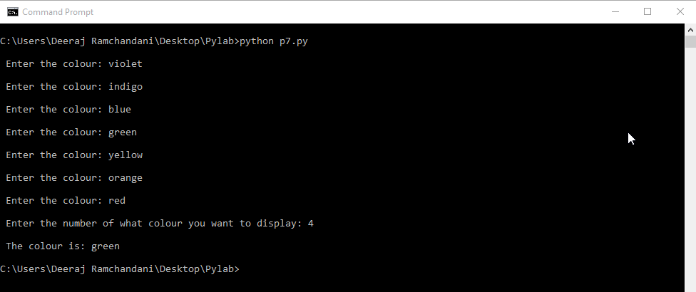

**Program 8:** Create a python module that contains the function definitions with two formal variables for addition, multiplication, subtraction and division (with divide by zero check). Demonstrate the use of the module by a python menu-driven calculator program that inputs values from the user.

Module

def addition(x,y):

return x+y

def subtraction(x,y):

return x-y

def multiplication(x,y):

return x*y

def division(x,y):

if y == 0:

return 0

else:

return x/y

Program

import maths

def read_input():

x = int(input("\n Enter the value of x: "))

y = int(input("\n Enter the value of y: "))

main_program(x,y)

def main_program(x,y):

a = 1

while a == 1:

print("\n\n Menu\n ----\n\n 1. Addition\n 2. Subtraction\n 3. Multiplication\n 4. Division\n 5. Change input\n 6. Exit")

ch = int(input("\n\n Enter your choice: "))

if ch == 1:

b = maths.addition(x,y)

print("\n The result is: "+str(b))

elif ch == 2:

b = maths.subtraction(x,y)

print("\n The result is: "+str(b))

elif ch == 3:

b = maths.multiplication(x,y)

print("\n The result is: "+str(b))

elif ch == 4:

b = maths.division(x,y)

if b == 0:

print("\n Invalid divsion")

else:

print("\n The result is: "+str(b))

elif ch == 5:

read_input()

elif ch == 6:

a = -1

else:

print("\n Invalid input")

print("\n End of program")

read_input()

Output

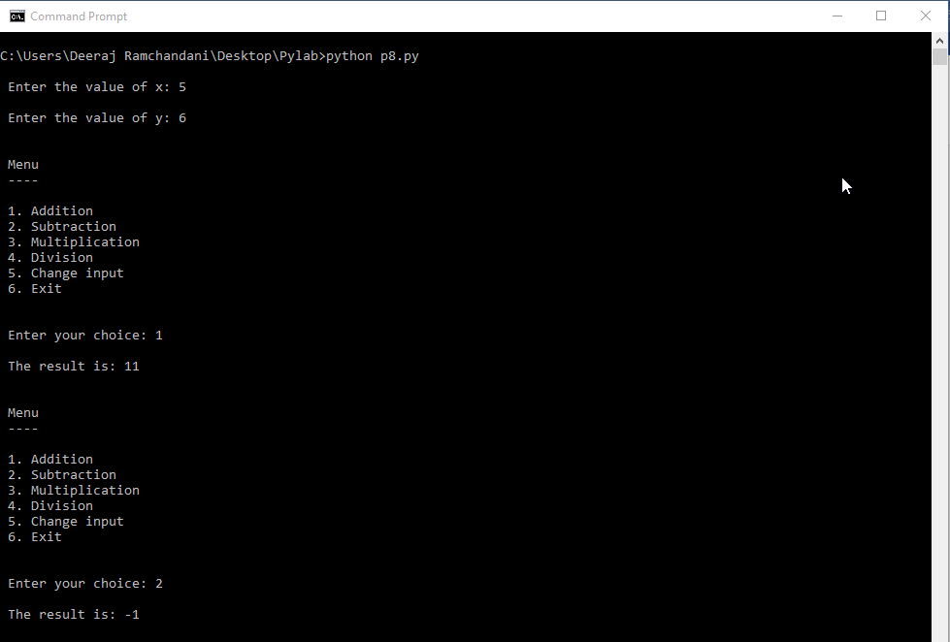

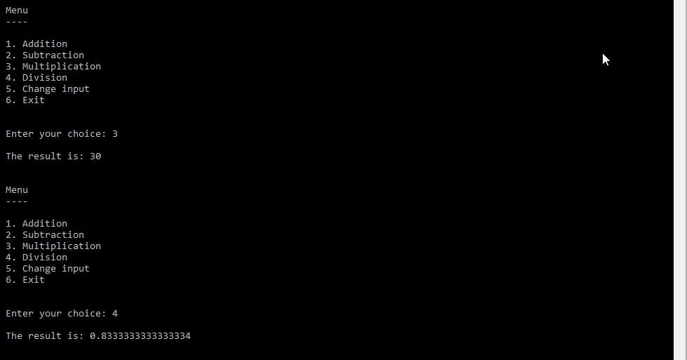

**Program 9:** Create a python package called ‘arithmetic’ that contains four modules for addition, multiplication, subtraction and division with each module having function definitions for 2, 3 and 4 formal variables respectively. Demonstrate the use of the package by a python program that passes user-input values to the corresponding functions in the package and displays the result.

Package name: ‘athematic’

Modules in package ‘arithmetic’

1. *addition.py*

def addition1(a,b):

return a+b

def addition2(a,b,c):

return a+b+c

def addition3(a,b,c,d):

return a+b+c+d

2. *subtraction.py*

def subtraction1(a,b):

return a-b

def subtraction2(a,b,c):

return a-b-c

def subtraction3(a,b,c,d):

return a-b-c-d

3. *multiplication.py*

def multiplication1(a,b):

return a*b

def multiplication2(a,b,c):

return a*b*c

def multiplication3(a,b,c,d):

return a*b*c*d

4. *division.py*

def division1(a,b):

return a/b

def division2(a,b,c):

return (a/b)/c

def division3(a,b,c,d):

return (((a/b)/c)/d)

Program

from arthematics.addition import *

from arthematics.subtraction import *

from arthematics.multiplication import *

from arthematics.division import *

def main_program():

a = 1

while a == 1:

no=int(input("\n Enter the number of inputs you want to give? (2,3,4): "))

if(no==2):

w = int(input("\n Enter the value of w: "))

x = int(input("\n Enter the value of x: "))

elif(no==3):

w = int(input("\n Enter the value of w: "))

x = int(input("\n Enter the value of x: "))

y = int(input("\n Enter the value of y: "))

elif(no==4):

w = int(input("\n Enter the value of w: "))

x = int(input("\n Enter the value of x: "))

y = int(input("\n Enter the value of y: "))

z = int(input("\n Enter the value of z: "))

else:

print("\n Invalid number. Please re-enter: ")

main_program()

print("\n\n Menu\n ----\n\n 1. Addition\n 2. Subtraction\n 3. Multiplication\n 4. Division\n 5. Exit")

ch = int(input("\n\n Enter your choice: "))

if ch == 1:

if no==2:

b = addition1(w,x)

elif no==3:

b = addition2(w,x,y)

elif no==4:

b = addition3(w,x,y,z)

print("\n The result is: "+str(b))

elif ch == 2:

if no==2:

b = subtraction1(w,x)

elif no==3:

b = subtraction2(w,x,y)

elif no==4:

b = subtraction3(w,x,y,z)

print("\n The result is: "+str(b))

elif ch == 3:

if no==2:

b = multiplication1(w,x)

elif no==3:

b = multiplication2(w,x,y)

elif no==4:

b = multiplication3(w,x,y,z)

print("\n The result is: "+str(b))

elif ch == 4:

if no==2:

if x==0:

print("\n Invalid division.")

else:

b = division1(w,x)

elif no==3:

if x==0 or y==0:

print("\n Invalid division.")

else:

b = division2(w,x,y)

elif no==4:

if x==0 or y==0 or z==0:

print("\n Invalid division.")

else:

b = division1(w,x,y,z)

elif ch == 5:

a = -1

else:

print("\n Invalid input")

print("\n End of program")

main_program()

Output

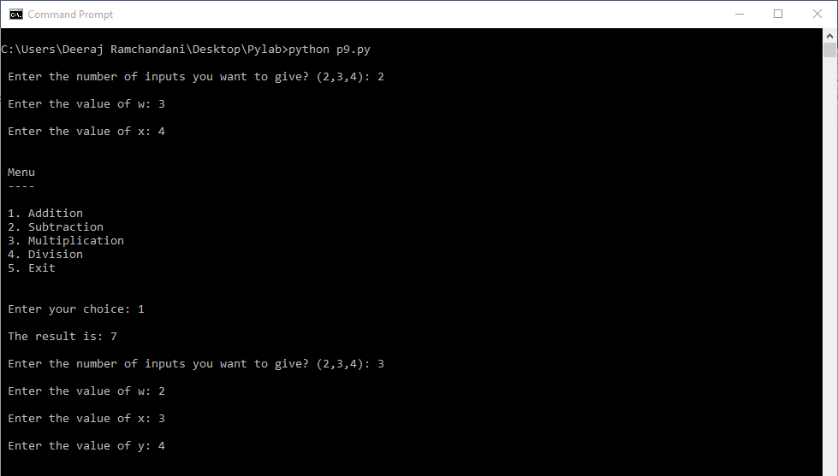

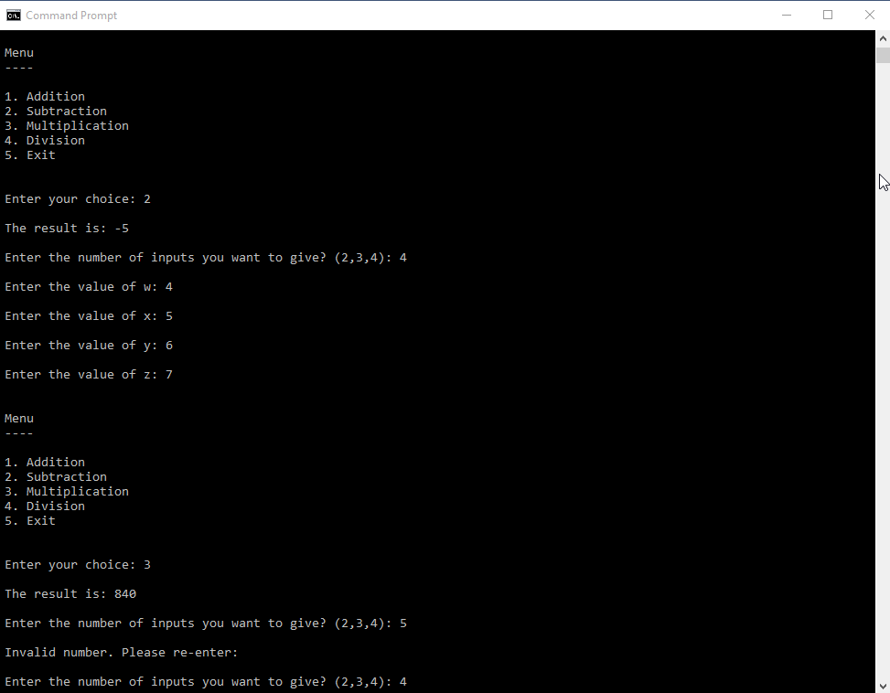

**Program 10:** Demonstrate the use of file-handling functions by creating three folders within a parent folder by accepting the names of the folders from the user. Create a file in the first folder with a user-input filename. Write a user input sentence into this file. Read a starting and ending position from the user and read the sub-string from the first file and write it into a new file in the second folder. Copy the contents of the second file into a new file in the third folder. Rename the file in the second folder as ‘second.txt’. Delete the file in the first folder.

Program

import os

pdir=input("\n Enter the name of the parent directory: ")

os.mkdir(pdir)

os.chdir(pdir)

s1=input("\n Enter the name of the first sub directory: ")

os.mkdir(s1)

s2=input("\n Enter the name of the second sub directory: ")

os.mkdir(s2)

s3=input("\n Enter the name of the third sub directory: ")

os.mkdir(s3)

os.chdir(s1)

print("\n Currently in folder "+s1)

name=input("\n Input the name of the first file: ")

f=open(name,"a+")

string=input("\n Enter the sentence to be written onto the file: ")

f.write(string)

start=int(input("\n Enter the starting position: "))

end=int(input("\n Enter the ending position: "))

f.seek(start)

s=""

while start<=end:

s+=f.read(1)

start+=1

print("\n The string to be copied to the second file in the second directory is: "+s)

f.close()

os.chdir("..")

os.chdir(s2)

print("\n Currently in folder "+s2)

name2="t2.txt"

f=open(name2,"a+")

f.write(s)

print("\n Copying to the second textfile is done")

f.seek(0)

print("\n Copying contents of "+name2+" to a new file in folder"+s3)

s=f.read()

f.close()

os.chdir("..")

os.chdir(s3)

print("\n Currently in folder "+s3)

f=open("t3.txt","a+")

f.write(s)

print("\n Copying to the third textfile is done")

f.close()

os.chdir("..")

os.chdir(s2)

print("\n Currently in folder "+s2)

name3="second.txt"

print("\n Changing file name from "+name2+" to "+name3+": ")

os.rename(name2,name3)

print("\n Renaming done.")

os.chdir("..")

os.chdir(s1)

print("\n Currently in folder "+s1)

print("\n Removing file "+name)

os.remove(name)

print("\n Program complete!")

Output

