Executive Summary — Advanced Signaling Techniques for Refrigeration Cases
Refrigeration cases in supermarkets and food retail environments are critical assets where temperature integrity directly impacts food safety, energy consumption, and maintenance cost. Traditional threshold-based alarm systems are inadequate: they generate frequent false positives, miss early signs of degradation, and lack the context to discriminate between localised faults and systemic rack issues. This paper develops a comprehensive framework for advanced signaling in refrigeration cases, combining model-based diagnostics, multi-sensor fusion, and cross-case correlation to create a predictive, evidence-driven maintenance architecture.

ARMAX Modelling, Sensor and Digital Signal Requirements

Autoregressive Moving Average model with exogenous inputs.
Breakdown:
- AR (Autoregressive): current output depends on past outputs.
- MA (Moving Average): includes past error terms to capture random noise.
- X (Exogenous inputs): incorporates external signals that influence the system (e.g., door openings, defrost, fans, lighting, ambient).
In refrigeration cases:
- Output variable = case temperature.
- AR terms = how yesterday’s temps influence today’s.
- MA terms = correction for random noise.
- X terms = inputs like defrost status, door openings, ambient conditions.

ARMAX Model Definition
ARMAX = AutoRegressive Moving Average with eXogenous inputs
General form:
$$T_{t}=c+\sum_{i=1}^{p}{ϕ_{i}}T_{t-i}+\sum_{j=1}^{q}{θ_{j}}ε_{t-j}+\sum_{k=1}^{m}{β_{k}}X_{k,t}+ε_{t}$$
Where:
- $T_{t}$ = case temperature at time t.
- $iT_{t-i}$ = autoregressive terms (thermal inertia).
- $jε_{t-j}$ = moving average terms (noise, control correction).
- $X_{k,t}$ = exogenous inputs (defrost, doors, ambient, fans, lighting, misting).
- $ε_{t}$ = random disturbance.
Residuals: ($r_{t}=T_{t}-ε_{t}$). These residuals drive drift, variance, recovery slope, and apex tests.

So ARMAX is used to build a predictive baseline of “what good looks like”, against which residuals (differences between predicted and actual) are calculated. Those residuals drive the drift, variance, recovery slope, and apex tests in your state ladders
For a dairy case the ARMAX baseline model can be written as Advanced Signalling Techniques …:
Tt=αTt−1+βDt+γOt+δAt+∑i=1pϕiTt−i+∑j=1qθjεt−j+εtT_t = T_{t-1} + D_t + O_t + A_t + _{i=1}^{p}_i T_{t-i} + _{j=1}^{q}_j _{t-j} + _tTt​=αTt−1​+βDt​+γOt​+δAt​+i=1∑p​ϕi​Tt−i​+j=1∑q​θj​εt−j​+εt​or
$$T_{t}=αT_{t-1}+βD_{t}+γO_{t}+δA_{t}+\sum_{i=1}^{p}{ϕ_{i}}T_{t-i}+\sum_{j=1}^{q}{θ_{j}}ε_{t-j}+ε_{t}$$
Where:
- $T_{t}$​ = case air temperature at time $t$.
- $αT_{t-1}$= autoregressive term (previous temperature).
- $D_{t}$​ = defrost input (binary/digital).
- $O_{t}​$= door opening indicator.
- $A_{t}​$= ambient/store temperature.
- $ϕ_{i}T_{t-i}$= higher-order autoregressive lags (p terms).
- $θ_{j}ε_{t-j}$= moving average component using past error terms (q terms).
- $ε_{t}$​ = random disturbance (white noise).
Interpretation:
- The AR part captures the natural thermal inertia of the case.
- The MA part captures short-term noise and controller fluctuations.
- The X part (exogenous inputs) explains disturbances from door openings, defrost, lighting, or ambient.
Residuals are computed as:
$$rt=Tt-T^t r_t=T_t -_t rt​=Tt​-T^t ​$$
or
$$r_{t}=T_{t}-T^{t}$$

and then tested for drift, variance, recovery slope, etc.

Category | Sensor / Digital Signal | Purpose in Model / Signals
Core Case Sensors | Case air temperature probes (multiple) | Residual drift, variance, probe divergence, warm-zone index, stratification
 | Product simulant probe | Compliance with food safety, reference vs control probe
 | Door switch (open/closed) | Door-spike overshoot, recovery slope, curtain lag detection
 | Defrost status (heater on/off, termination probe) | Defrost apex, defrost interval irregularity, recovery slope
 | Fan status (on/off or current) | Recovery slope, airflow verification, icing correlation
 | Lighting status (on/off, dimming) | Lighting bias, probe heating false signals
 | Misting valve/pump status (produce) | Mist correlation, recovery slope shifts
 | Night cover deployment (switch or inferred) | Night drift detection, recovery analysis
Rack / Systemic Sensors | Suction pressure ($P_{s}$) | Rack-level drift correlation, systemic fault detection
 | Discharge / head pressure ($P_{d}$) | Condenser faults, floating head tuning detection
 | Liquid line temperature | Subcooling calculation, receiver/liquid line restriction detection
 | Receiver level (if available) | Undercharge, liquid starvation analysis
 | Compressor staging (digital enables, VFD speed) | Staging fault patterns, capacity mapping
 | Condenser fan status (digital, speed) | Condenser performance, head pressure diagnostics
 | Hot-gas defrost valve status | Concurrency detection, systemic overshoot patterns
Environmental / Auxiliary | Ambient temperature near case | ARMAX exogenous input, drift attribution
 | Store HVAC supply air / diffuser status | Air curtain disruption, environmental drafts
 | Solar gain proxy (lux sensor or lighting schedules) | Produce/draft warming, solar-linked spikes

1. Case-Level Behavioral Envelopes and Modelling
Each case type (dairy, frozen, produce, meat, bakery, deli, hybrid, and specialist categories) is mapped to a What Good Looks Like (WGLL) envelope. ARMAX models with exogenous inputs (defrost events, door openings, ambient conditions, misting, lighting, and operating modes) generate dynamic baselines. Deviations from predicted behavior yield residuals that are assessed with drift, variance, autocorrelation, recovery slope, and defrost apex tests. Case-specific thresholds define escalation ladders from Clear → Warning → Major → Critical → Return-to-Clear, ensuring both sensitivity and resilience to noise.

2. Event Signaling and Evidence Trails
Seventeen core analytic signals (e.g., drift, recovery delay, curtain lag, warm-zone index, probe divergence) are mapped into technician-friendly events with clear definitions and first-line checks. An expanded dictionary of 40 events, including operational deviations, early warning patterns, and component interaction faults, provides a holistic coverage of case-level anomalies. Each event is formalised into a state machine with persistence and hysteresis rules, enabling reproducible escalation and controlled de-escalation.
When multiple signals align, they form evidence trails that increase diagnostic confidence. For example, drift + slow post-defrost recovery + large swings + coil icing together indicate refrigerant undercharge or fouling; curtain lag + uneven shelves + poor door recovery indicates airflow or fan failure. This pattern-based reasoning reduces false positives and directs technicians to likely root causes.

3. Systemic Correlation and Rack-Level Diagnostics
Local anomalies must be distinguished from systemic failures. By analysing correlations across multiple cases in the same suction group, it is possible to detect pack/rack-level faults. Formal statistical screens are introduced, including fraction of cases affected, cross-case synchrony, correlation with rack suction/discharge, subcooling, receiver level, and defrost concurrency. Ten systemic fault patterns are identified, including floating suction mis-tuning, receiver undercharge, condenser faults, staging failures, oil management trips, hot-gas defrost concurrency, suction/liquid-line filter restrictions, and rack sensor mapping errors.
Each systemic trail is defined with mathematical thresholds (e.g., synchrony ≥0.6, subcooling <3–5 K, ≥50% cases affected) to ensure reproducible detection. Technician checks are mapped to these signals, covering rack control policy, suction/receiver validation, condenser operation, compressor staging, oil management, and EMS change logs.

4. Implementation and Predictive Mapping
All detectors operate with persistence windows to avoid transient noise. Predictive mapping provides time-to-breach estimates: Warning (~3–7 days), Major (~1–3 days), Critical (<24h). Hysteresis ensures controlled return to Clear once baselines are restored. By quantifying drift slopes, recovery delays, and defrost apex trends, the system forecasts imminent safety or efficiency breaches, enabling planned interventions rather than emergency call-outs.

5. Conclusion
The integration of ARMAX modelling, structured state ladders, technician-ready event definitions, evidence trails, and systemic correlation yields a signaling framework that is precise, predictive, and transparent. It moves supermarket refrigeration from reactive fault response to proactive, evidence-driven asset management. By embedding escalation logic and cross-case correlation, the framework avoids false alarms, prioritises real risks, and provides actionable diagnostics that scale from individual cases to rack-level systemic issues. This approach enhances food safety assurance, reduces energy waste, and lowers maintenance costs while providing a rigorous, auditable methodology suitable for both research and field deployment.

1. Introduction
- Context: Supermarket refrigeration → safety, energy, cost.
- Problem: Threshold-based alarms insufficient.
- Solution: Model-based signaling using case-specific ARMAX, multi-sensor fusion, event-linked analytics.

2. Case Behavioural Envelopes
Define What Good Looks Like (WGLL) across case types with formulas.

Dairy (Scaffold)
- ARMAX: ($T_{t}=αT_{t-1}+βD_{t}+γO_{t}+δA_{t}+ARMA\left(p,q\right)+ε_{t}$ )
- Clear: ( $T_{t}$ ∈ [2,4] °C, ΔT = 3–6 °C ).
- Warning: ( |μ_r| > 1.5 °C/24h ).
- Major: ( |μ_r| > 2.0 °C/24h, recovery > 20 min ).
- Critical: Flatline, overshoot > 12 °C.
- Return to Clear: residual mean ≈ 0, recovery slope back within baseline ±10%.

Frozen
- ARMAX: $\left(T_{t}=αT_{t-1}+βD_{t}+γO_{t}+δA_{t}+κWZ_{t}+ARMA\left(p,q\right)+ε_{t}\right)$.
- Clear: ($T_{t}$ ≤ -18 °C, apex ≤ 0 °C ).
- Warning: Drift > 0.5 °C/12h.
- Major: Drift > 1 °C/12h, recovery > 30 min.
- Critical: ( max(T_{defrost}) > 0 °C ⇒ OS_{freeze}=1 ).
- Return to Clear: T ≤ -18 °C stable, overshoot eliminated.

Produce
- ARMAX:$\left(T_{t}=αT_{t-1}+βD_{t}+γO_{t}+δA_{t}+μ{\text{Mist}}_{t}+ARMA\left(p,q\right)+ε_{t}\right).$
- Clear: ( $T_{t}$ ∈ [1,4] °C, Δτ ≤ 30 min ).
- Warning: Drift > 1 °C/24h, shelf ΔT > 3 °C.
- Major: Recovery > 20 min, curtain-lag > 30 min.
- Critical: Apex > 8 °C (if electric defrost).
- Return to Clear: drift resolved, curtain lag baseline restored.

Meat
- ARMAX: $\left(T_{t}=αT_{t-1}+βD_{t}+γO_{t}+δA_{t}+ARMA\left(p,q\right)+ε_{t}\right).$
- Clear: ( $T_{t}$ ∈ [-2,2] °C ).
- Warning: Drift > 0.5 °C/24h.
- Major: Drift > 1 °C/24h, recovery > 20 min.
- Critical: Apex > 5 °C.
- Return to Clear: T stable near 0 °C, residual mean ~0.

Bakery
- ARMAX: $\left(T_{t}=αT_{t-1}+βD_{t}+γO_{t}+δA_{t}+κ{\text{Lighting}}_{t}+ARMA\left(p,q\right)+ε_{t}\right)$.
- Clear: ( $T_{t}$∈ [2,7] °C, apex ≤ 10 °C (cream ≤ 7 °C) ).
- Warning: Drift > 1.5 °C/24h.
- Major: Lighting-driven spikes misaligned with ${\text{Lighting}}_{t}$.
- Critical: Overshoot > 10 °C.
- Return to Clear: Spikes correlate with ${\text{Lighting}}_{t}$ apex ≤ spec.

Deli
- ARMAX: $\left(T_{t}=αT_{t-1}+βD_{t}+γO_{t}+δA_{t}+ARMA\left(p,q\right)+ε_{t}\right)$.
- Clear: ( $T_{t}$ ∈ [0,3] °C ).
- Warning: Drift > 0.5 °C/24h.
- Major: Drift > 1 °C/24h, recovery > 20 min.
- Critical: Apex > 5 °C.
- Return to Clear: drift within band, recovery restored.

Hybrid / Convertible
- Option A: Mode-aware ARMAX.
- Fridge Mode Clear: $T∈[2,4]°C,apex≤8°C$.
- Freezer Mode Clear: $T≤-18°C,apex≤0°C$.
- Warning: step offset $|κ|>0.5°C$.
- Major: cycle collapse after mode switch.
- Critical: mismatch defrost profile, continuous run > 60 min.
- Return to Clear: parameters switch coherently, setpoint holds.

Other Case Types
- Seafood: Clear if $T∈[-1,2]°C$, drift minimal. Critical if upward drift tied to ice depletion.
- Floral: Clear if $T∈[1,5]°C\backslash \&RH≥85\%$. Warning if RH < 80%. Critical if both $T$drift and RH drop persist.
- Beverage: Clear if $T∈[2,10]°C$. Warning if drift $>2°C\backslash /24h$. Major if persistent. Critical not safety but energy/quality.
- Grab-and-Go: Clear if $T∈[0,5]°C$. Warning if drift $>0.5°C\backslash /24h$. Major if $>1°C\backslash /24h$. Critical if recovery > 20 min.

3. Advanced Signaling Methodologies

Signal State Mapping
Each signal is tracked across four states with formulas for escalation and de-escalation.

Signal | Clear | Warning | Major | Critical | Back to Clear
Residual Drift (μᵣ) |  | $$\left(μ_{r}\right)$$ | ≤ θ_clear |  | $$\left(μ_{r}\right)$$
Variance $σ_{r}$ | $σ_{r}$≤ 2σ_baseline | 2–3σ_baseline | 3–4σ_baseline | >4σ_baseline | $σ_{r}$≤ 2σ_baseline
Defrost Apex ($T_$apex) | $T_$apex ≤ threshold | 80–90% of threshold | Exceedance ≤ 1 °C | Exceedance > 1 °C (any >0 °C in freezer) | Apex ≤ threshold
Recovery Slope $\left(β_{1}\right)$ | $\left(β_{1}\right)$ ≈ baseline | 10–20% slower | >20% slower | Flat/positive | $β_1$ within ±10% baseline
Curtain-Lag Drift (Δτ) |  | Δτ | ≤ 15 min | 15–30 min | 30–45 min
Warm-Zone Index (WZ) | WZ ≤ 2 | 2–3 | 3–4 | >4 sustained 2h | WZ ≤ 2
Flatline | Variance present | — | — | var(T,2h)<0.01 °C² & range<0.2 °C | Variance restored

4. Fault Typology & Early Warning Patterns
Mapped states by signal ensure unambiguous escalation. For each fault pattern (icing, leak, airflow, misconfig), the corresponding signal maps from Clear → Warning → Major → Critical and back.

5. Signaling Architecture
Real-time scoring loop applies state mapping per signal, escalates on persistence, and de-escalates once baseline is restored.

6. Predictive Mapping
TTB estimates are tied to escalation stages: - Warning: TTB 3–7 days. - Major: TTB 1–3 days. - Critical: TTB < 24h. - Back to Clear: drift slope ~0, apex within spec, recovery slope restored.

7. Implementation Considerations
All detectors use hysteresis: must persist ≥ 2 cycles to escalate, and ≥ 1 stable cycle to return Clear.

8. Conclusion
Each signal has a mapped pathway from Clear to Critical and back, reducing false positives and guiding safe de-escalation. Advanced signalling provides transparency, safety, and predictive accuracy.

9. Signal State Maps — Escalation, Hysteresis, and Return-to-Clear
State ladder per signal: Clear → Warning → Major → Critical → (de‑escalate) → Clear.

Conventions
- Residuals: $r_{t}=T_{t}-{\hat{T}}_{t}$.
- Rolling means: $μ_{r}\left(W\right)=\left(1/W\right)Σr_{t}$.
- Variance: $σ_{r}^{2}\left(W\right)=\left(1/W\right)Σ{\left(r_{t}-μ_{r}\right)}^{2}$.
- Hysteresis: de‑escalate only if metric < lower bound for M windows.

9.1 Residual Drift (baseline bias)
Formulas: - $μ_r=(1\backslash /W)Σr_t$ or $μ_{r}=\frac{1}{W}\sum_{ }^{ }{r_{t}}$(W=24h default).
- Clear: $\left|μ_{r}\right|≤θ_{\text{info}}$
- Warning: $\left|μ_{r}\right|>θ_{\text{warn for }}N\text{ windows}\}$.
- Major: $\left|μ_{r}\right|>θ_{\text{major for }}N\text{ windows}\}$.
- Critical: $(d\backslash /dt)|μ_r |$ > 0.2 °C/h ∨ safety margin breach.
- De‑escalation: Warning→Clear if |μ_r| < θ_warn_lo; Major→Warning if |μ_r| < θ_major_lo.

9.2 Post‑Event Recovery Time
Formulas:
- Recovery τ = end − event or $τ=t_{\text{end}}-t_{\text{event}}$
- Clear: τ ≤ τ_spec or $τ≤τ_{\text{spec}}$
- Warning: τ_spec < τ ≤ τ_spec+5 or $τ_{\text{spec}}<τ≤τ_{\text{spec}}+5$
- Major: τ_spec+5 < τ ≤ τ_spec+15 or $τ_{\text{spec}}+5<τ≤τ_{\text{spec}}+15$
- Critical: τ > τ_spec+15 or $τ>τ_{\text{spec}}+15$
- De‑escalation: step down when τ ≤ $t_$spec for M consecutive events.

9.3 Defrost Apex (overshoot)
Formulas:
- Apex = max($T$defrost_window).
- Clear: Apex ≤ L_case or $\text{Apex}≤L_{\text{case}}$.
- Warning: Z_apex = (Apex−μ_apex)/σ_apex > 2, Apex ≤ L_case or $Z_{\text{apex}}=\frac{\text{Apex}-μ_{\text{apex}}}{σ_{\text{apex}}}>2, \text{Apex}≤L_{\text{case}}e\}\}$
- Major: Apex ≥ L_case−1 for ≥2 cycles or $\text{Apex}≥L_{\text{case}}-1 \text{for }≥2 \text{cycles}\}$
- Critical: Apex > L_case or $\text{Apex}>L_{\text{case}}$
- De‑escalation: Apex < L_case−1 for 2 cycles or $\text{Apex}<L_{\text{case}}-1 \text{for 2 cycles}\}$.

9.4 Flatline (sensor/control stall)
Formulas: Var = var(T,2h).
- Range = $\max\left(T\right)-\min\left(T\right)$.
- Range = max(T)−min(T).
- Clear: Var ≥ 0.01 ∨ Range ≥ 0.2.
- Warning: Var approaching 0.01.
- Major: Var < 0.01 ∧ Range < 0.2 for 1 window.
- Critical: Same for ≥2 windows.
- De‑escalation: Var ≥ 0.02 and Range ≥ 0.4 for M windows.

9.5 Defrost Interval Irregularity
Formulas:
- $Δ_k=t_k-t_(k-1)$.
- $CVΔ=σ(Δ_k )\backslash /μ(Δ_k )$
- $KS-D=\sup_{x}\left|F_{\text{emp}}\left(x\right)-F_{\text{ref}}\left(x\right)\right|$
- Clear: CVΔ ≤ CV0+0.1, KS−D ≤ D0+0.05.
- Warning: CVΔ > CV0+0.2 ∨ KS−D > D0+0.1 once.
- Major: Same for ≥2 days.
- Critical: Collapse (Δ_k≈0) or runaway (Δ_k≫baseline).
- De‑escalation: CVΔ ≤ CV0+0.1, KS−D ≤ D0+0.05 for 2 days.

9.6 Curtain‑Lag Drift (open cases)
Formulas:
- $r_{A},T\left(τ\right)=Σ\left(A_{t}-μ_{A}\right)\left(T_{t+τ}-μ_{T}\right)/\left(σ_{A}σ_{T}\right)$.
- Δτ = τ̂_current−τ̂_baseline.
- Clear: |Δτ| ≤ 15.
- Warning: $15<|Δτ|≤30$.
- Major: $|Δτ|>30$.
- Critical: Major + SLA breach.
- De‑escalation: |Δτ| < 15 for M windows.

9.7 Warm‑Zone Index
Formulas:
- $-z_i=(T̄_i-T() ̄ )\backslash /σ.-WZ=max⁡(z_i )$. - G = $T_$ top− bottom.
- Clear: $WZ≤2,G≤tol$.
- Warning: WZ > 2 or G > tol 1h.
- Major: WZ > 2 2h.
- Critical: WZ > 2 + safety breach.
- De‑escalation: WZ ≤ 1.5 and G ≤ tol.

9.8 Variance/Instability
Formulas: - = σ_r(6h)/σ_base.
- Clear: σ_ratio ≤ 1.5.
- Warning: 1.5 < σ_ratio ≤ 2.0.
- Major: 2.0 < σ_ σ_ratio ratio ≤ 3.0.
- Critical: σ_ratio > 3.0.
- De‑escalation: σ_ratio < 2.0 → Major, <1.5 → Warning, sustained → Clear.

9.9 Residual Whiteness
Formulas: - Ljung–Box:$Q=N\left(N+2\right)\sum^{⍁}{r_{k}^{2}N-k}$ .
p = $1-F_{χ}^{2}\left(Q\right)$.
- Clear: p > 0.05.
- Warning: 0.02 < p ≤ 0.05.
- Major: p ≤ 0.02.
- Critical: Major + other anomalies.
- De‑escalation: p > 0.05.

9.10 Door‑Spike Overshoot
Formulas:
- Spike = $\max\left(T_{\text{event}}-T_{\text{baseline}}\right)$
- Clear: Spike ≤ 3 (5 freezer glass), recovery ≤ SLA.
- Warning: Recovery > SLA+5 once.
- Major: Spike > spec ∨ recovery > SLA+5 consistently.
- Critical: Repeated Major.
- De‑escalation: 2 compliant events.

9.11 Cycle Amplitude
Formulas: - Amp = $\max\left(T_{cycle}\right)-\min\left(T_{cycle}\right)$.
- Clear: Amp within ±20% baseline.
- Warning: Amp > baseline+3.
- Major: Amp > baseline+3 for 2 cycles.
- Critical: Amp collapse + flatline.
- De‑escalation: Amp back within ±20%.

9.12 Cycle Frequency
Formulas: - f = cycles/hour.
- Clear: f ≤ 6.
- Warning: f > 6 stable mean.
- Major: f > 6 + rising mean.
- Critical: f > 6 + thermal runaway.
- De‑escalation: f ≤ 6 for M hours.

9.13 Baseline Step
Formulas: - κ = mean_after−mean_before.
- Clear: |κ| < 0.5.
- Warning: 0.5 ≤ |κ| < 1.0.
- Major: |κ| ≥ 1.0.
- Critical: Major + control loss.
- De‑escalation: |κ| < 0.5.

9.14 Lighting Bias
Formulas: - Correlation = corr(T,Lighting$(t^)$).
- Clear: corr ≈ 0.
- Warning: corr > 0, spikes ≤ 2.
- Major: spikes > 2.
- Critical: Major + overcool.
- De‑escalation: corr ≈ 0 for M days.

9.15 Mist Correlation
Formulas: - Corr = corr(T,Mist$(_t^)$).
- Clear: corr present, ΔT ≤ 2.
- Warning: ΔT > 2.
- Major: coil wetting: cycle length ↑, recovery slope ↓.
- Critical: persistent icing.
- De‑escalation: no misaligned mist for M days.

9.16 Night Drift
Formulas: - ΔNight = mean_night − baseline.
- Clear: ΔNight ≤ 0.5.
- Warning: ΔNight > 1 once.
- Major: ΔNight > 1 on 2 nights.
- Critical: ΔNight > 1 + product risk.
- De‑escalation: ΔNight ≤ 0.5 for M nights.

9.17 Probe Divergence
Formulas: - ΔProbe = max(T_i)−min(T_i).
- Clear: ΔProbe ≤ tol.
- Warning: ΔProbe > tol 1h.
- Major: ΔProbe > tol 2h.
- Critical: ΔProbe > tol + safety breach.
- De‑escalation: ΔProbe ≤ tol for M hours.

10.A Step‑to‑Step Formulas (State Machine per Signal)
Notation: time index k over scoring windows. Indicator I[·] ∈ {0,1}. State S_k ∈ {0=Clear,1=Warning,2=Major,3=Critical}. Persistence N↑ for escalation, M↓ for de‑escalation. For each signal define metric m_k, thresholds, and counters. Generic transitions (applied after computing U_crit, U_maj, U_warn, D_maj, D_warn): 1) If U_crit(k)=1 → S_k=3. 2) Else if U_maj(k)=1 → S_k=max(S_{k−1},2). 3) Else if U_warn(k)=1 → S_k=max(S_{k−1},1). 4) Else if S_{k−1}=3 and D_maj(k)=1 → S_k=2. 5) Else if S_{k−1}=2 and D_warn(k)=1 → S_k=1. 6) Else if S_{k−1}=1 and D_clear(k)=1 → S_k=0. 7) Else S_k=S_{k−1}.
Counters (example for an “above‑threshold” escalation and “below‑threshold” de‑escalation): - c↑(k) = I[m_k > T↑] ? c↑(k−1)+1 : 0. U = I[c↑(k) ≥ N↑]. - c↓(k) = I[m_k < T↓] ? c↓(k−1)+1 : 0. D = I[c↓(k) ≥ M↓].
Below, per‑signal definitions of m_k, T↑, T↓, and U/D conditions.
OR:
- State at time window k: 0 = Clear, 1 = Warning, 2 = Major, 3 = Critical.
- Persistence:
  - N↑ = how long a problem must persist to escalate.
  - M↓ = how long healthy readings must persist to de-escalate.
- Counters (example for “above threshold” up and “below threshold” down):
  - c↑(k): number of consecutive windows with metric above the up-threshold. If c↑ ≥ N↑ → raise U (up trigger).
  - c↓(k): number of consecutive windows with metric below the down-threshold. If c↓ ≥ M↓ → raise D (down trigger).
- Priority of transitions (evaluate in this order each window):
  - If U_crit → state = Critical.
  - Else if U_maj → state = max(previous, Major).
  - Else if U_warn → state = max(previous, Warning).
  - Else if previous was Critical and D_maj → state = Major.
  - Else if previous was Major and D_warn → state = Warning.
  - Else if previous was Warning and D_clear → state = Clear.
  - Else keep the same state.
Notes: “windows” can be minutes/hours/days depending on the check. Thresholds (T↑, T↓) and case-type limits are configured per site/equipment.

10.1 Residual Drift
m_k = |mu_r| over window. T↑_warn=theta_warn, T↑_maj=theta_major. T↓_maj=theta_major_lo, T↓_warn=theta_warn_lo. U_crit = I[ safety_breach OR d|mu_r|/dt > 0.2 AND margin<2 ]. U_maj = I[ c↑_maj(k) ≥ N↑ ] with c↑_maj uses T↑_maj. U_warn = I[ c↑_warn(k) ≥ N↑ ] with c↑_warn uses T↑_warn. D_maj = I[ c↓_maj(k) ≥ M↓ ] with c↓_maj uses T↓_maj. D_warn = I[ c↓_warn(k) ≥ M↓ ] with c↓_warn uses T↓_warn. D_clear= D_warn.
- Metric: absolute residual mean |μ_r| over the window.
- Up triggers:
  - Critical: safety breach or d|μ_r|/dt > 0.2 while margin < 2.
  - Major: |μ_r| above major threshold for N↑ windows.
  - Warning: |μ_r| above warn threshold for N↑ windows.
- Down triggers
  - To Major/Warning: metric below corresponding down thresholds for M↓ windows.
  - Clear: same as Warning down.

10.2 Post-Event Recovery
— Post‑event recovery (9.2) m_k = tau (time‑to‑baseline) per event; aggregate with max over window. T↑_warn = tau_spec; T↑_maj = tau_spec+5; T↑_crit = tau_spec+15. U_crit = I[ tau > T↑_crit OR fans_not_restarted ]. U_maj = I[ tau > T↑_maj ] for ≥ N↑ events in window. U_warn = I[ tau_spec < tau ≤ T↑_maj ] for ≥ N↑ events. D_maj = I[ next M↓ events: tau ≤ tau_spec ]. D_warn = I[ next M↓ events: tau ≤ tau_spec ]. D_clear= D_warn.
- Metric: τ = time for temperature to return to baseline after an event; aggregate by max within the window.
- Up triggers:
  - Critical: τ > (spec + 15 min) or fans not restarted.
  - Major: τ > (spec + 5 min) for at least N↑ events in the window.
  - Warning: spec < τ ≤ (spec + 5 min) for at least N↑ events.
- Down triggers
  - To Major/Warning: next M↓ events each recover within spec (τ ≤ spec).
  - Clear: same as Warning down.

10.3 Defrost Apex
m_k = apex temperature during defrost. L = case limit. T↑_crit_case = {Freezer:0, Meat/Deli:5, Dairy:12, Produce(elec):8, Bakery:10} (°C). U_crit = I[ m_k > T↑_crit_case ]. U_maj = I[ c↑(k) ≥ N↑ ] with T↑ = L−1. U_warn = I[ Z_apex > +2 over ≥ N↑ cycles AND m_k ≤ L ]. D_maj = I[ two consecutive compliant defrosts: apex < L−1 ]. D_warn = I[ two consecutive compliant defrosts: apex ≤ L ]. D_clear= D_warn for M↓ cycles.
- Metric: peak (apex) temperature during defrost; compare to case-type limit L.
- Up triggers:
  - Critical: apex exceeds case critical temp (e.g., Freezer 0 °C; Meat/Deli 5 °C; Dairy 12 °C; Produce (elec) 8 °C; Bakery 10 °C).
  - Major: apex ≥ L − 1 °C for N↑ consecutive defrosts.
  - Warning: statistically high apex (Z_apex > +2) for N↑ cycles and apex ≤ L.
- Down triggers:
  - To Major: two consecutive compliant defrosts with apex < L − 1 °C.
  - To Warning/Clear: two consecutive compliant defrosts with apex ≤ L; keep for M↓ cycles to clear.

10.4 Flatline
m1_k = var(T,2h); m2_k = range(T,2h). U_crit = I[ m1_k<0.01 AND m2_k<0.2 for ≥2 windows OR probe/control corroboration ]. U_maj = I[ m1_k<0.01 AND m2_k<0.2 for 1 window ]. U_warn = I[ m1_k near floor OR m2_k near floor for 1 window ]. D_maj = I[ var ≥ 0.01 OR range ≥ 0.2 for M↓ windows ]. D_warn = I[ var,range above floors for additional M↓ windows ]. D_clear= D_warn.
- Metrics: var(T, 2h) and range(T, 2h) in a 2-hour window.
- Up triggers:
  - Critical: both variance < 0.01 and range < 0.2 °C for ≥2 windows or corroborated by probe/control.
  - Major: same condition but for 1 window.
  - Warning: either metric is very low (“near floor”) for 1 window.
- Down triggers:
  - To Major: variance ≥ 0.01 or range ≥ 0.2 °C for M↓ windows.
  - To Warning/Clear: metrics stay above floors for additional M↓ windows; Clear uses the Warning-down condition.

10.5 Defrost Interval Irregularity
m1_k = CV_delta; m2_k = KS_D. Baselines CV0,D0. U_crit = I[ schedule collapse/expansion pattern ]. U_maj = I[ (m1_k>CV0+0.2) OR (m2_k>D0+0.1) ] on ≥2 successive days. U_warn = same once. D_maj = I[ (m1_k≤CV0+0.1) AND (m2_k≤D0+0.05) ] for M↓ days. D_warn = same for M↓ days. D_clear= D_warn.
- Metrics:
  - CV_delta (coefficient of variation of defrost gaps), KS_D (distribution shift vs. baseline).
- Up triggers:
  - Critical: clear schedule collapse/expansion pattern.
  - Major: CV_delta > (CV0 + 0.2) or KS_D > (D0 + 0.1) on 2+ successive days.
  - Warning: same but seen once.
- Down triggers
  - To Major/Warning: CV_delta ≤ (CV0 + 0.1) and KS_D ≤ (D0 + 0.05) for M↓ days.
  - Clear: same as Warning down.

10.6 Curtain-Lag Drift
m_k = |Delta_tau|. T↑_warn=15, T↑_maj=30 (min). T↓_maj=15. U_crit = I[ m_k>T↑_maj AND repeated recovery SLA breaches ]. U_maj = I[ c↑_maj ≥ N↑ ]. U_warn = I[ 15<m_k≤30 for N↑ windows ]. D_maj = I[ m_k<15 for M↓ windows ]. D_warn = same. D_clear=D_warn.
- Metric: |Δτ| = extra pull-down time after night curtains open.
- Up triggers:
  - Critical: |Δτ| > 30 min and repeated recovery-SLA breaches.
  - Major: |Δτ| ≥ 30 min for N↑ windows.
  - Warning: 15 < |Δτ| ≤ 30 min for N↑ windows.
- Down triggers:
  - To Major/Warning/Clear: |Δτ| < 15 min for M↓ windows (same condition all the way down).

10.7 Warm-Zone Index
m1_k = WZ; m2_k = G (vertical gradient). T↑_warn: WZ>2 OR G>tol; T↑_maj: WZ>2 for ≥2h OR G>tol for ≥4h. U_crit = I[ Major AND food safety margin breached ]. U_maj = I[ T↑_maj condition ]. U_warn = I[ T↑_warn for ≥1h ]. D_maj = I[ WZ≤2 AND G≤tol for M↓h ]. D_warn = same. D_clear=D_warn.
- Metrics: WZ (warm-zone index), G (vertical temperature gradient).
- Up triggers
  - Critical: Major condition plus food-safety margin breach.
  - Major: WZ > 2 for ≥2 h or G > tol for ≥4 h.
  - Warning: WZ > 2 or G > tol for at least 1 h.
- Down triggers
  - To Major/Warning/Clear: WZ ≤ 2 and G ≤ tol for M↓ hours (same condition all the way down).

10.8 Variance/Instability
m_k = sigma_r(6h)/sigma_base. T↑_warn=1.5; T↑_maj=2.0; T↑_crit=3.0. U_crit = I[ m_k>3.0 OR (m_k>2.0 AND drift/overshoot also true) ]. U_maj = I[ m_k>2.0 for N↑ windows OR spectral_peak_shift ]. U_warn = I[ m_k>1.5 for N↑ windows ]. D_maj = I[ m_k<2.0 for M↓ windows ]. D_warn = I[ m_k<1.5 for M↓ windows ]. D_clear=D_warn.
- Metric: σ_r(6h) / σ_base (6-hour residual std vs. baseline).
- Up triggers:
  - Critical: metric > 3.0 or (> 2.0 and drift/overshoot also detected).
  - Major: metric > 2.0 for N↑ windows or spectral peak shift present.
  - Warning: metric > 1.5 for N↑ windows.
- Down triggers
  - To Major: metric < 2.0 for M↓ windows.
  - To Warning/Clear: metric < 1.5 for M↓ windows; Clear uses the Warning-down condition.

10.9 Residual Whiteness
m_k = p‑value. T↑_warn: 0.02<p≤0.05; T↑_maj: p≤0.02. U_crit = I[ p≤0.02 AND other instability detectors active ]. U_maj = I[ p≤0.02 for N↑ windows ]. U_warn = I[ 0.02<p≤0.05 for N↑ windows ]. D_maj = I[ p>0.05 for M↓ windows ]. D_warn = same. D_clear=D_warn.
- Metric: p-value from residual independence test.
- Up triggers:
  - Critical: p ≤ 0.02 and other instability detectors also active.
  - Major: p ≤ 0.02 for N↑ windows.
  - Warning: 0.02 < p ≤ 0.05 for N↑ windows.
- Down triggers:
  - To Major/Warning/Clear: p > 0.05 for M↓ windows (same condition all the way down).

10.10 Door-Spike Overshoot
m1_k = spike magnitude; m2_k = recovery time. Specs by case. U_crit = I[ repeated Major AND gasket_failure_evidence ]. U_maj = I[ m1_k>spec OR m2_k>spec+5 ] for N↑ events. U_warn = I[ m1_k≤spec AND 0<m2_k−spec≤5 ] for N↑ events. D_maj = I[ two compliant events ]. D_warn = same. D_clear=D_warn.
- Metrics: door-event spike size and recovery time; compare to case specs.
- Up triggers:
  - Critical: repeated Major events plus evidence of gasket failure.
  - Major: spike > spec or recovery time > (spec + 5 min) for N↑ events.
  - Warning: spike within spec and recovery time within 0–5 min over spec, for N↑ events.
- Down triggers:
  - To Major/Warning/Clear: two consecutive compliant door events (same condition all the way down).

10.11 Cycle Amplitude
m_k = pk‑pk vs baseline. T↑_warn: > base+3 °C (Dairy/Produce) or +7 °C (Frozen). T↑_maj: ≥2 cycles or <50% base. U_crit = I[ amplitude collapse AND flatline/ACF anomaly ]. U_maj = I[ T↑_maj ]. U_warn = I[ T↑_warn for N↑ cycles ]. D_maj = I[ within ±20% base for M↓ cycles ]. D_warn = same. D_clear=D_warn.
- Metric: peak-to-peak cycle amplitude vs. baseline.
- Up triggers:
  - Critical: amplitude collapses and flatline/ACF anomaly also present.
  - Major: ≥2 abnormal cycles or amplitude < 50% of baseline.
  - Warning: amplitude exceeds baseline by +3 °C (Dairy/Produce) or +7 °C (Frozen) for N↑ cycles.
- Down triggers:
  - To Major/Warning/Clear: amplitude within ±20% of baseline for M↓ cycles (same condition all the way down).

10.12 Cycle Frequency
m_k = cycles per hour. T↑_warn: >6 with mean stable. T↑_maj: >6 with mean rising. U_crit = I[ protection timers breached OR thermal runaway ]. U_maj = I[ >6 AND d(mean)>0 for N↑ windows ]. U_warn = I[ >6 AND d(mean)≈0 for N↑ windows ]. D_maj = I[ ≤6 for M↓ hours ]. D_warn = same. D_clear=D_warn.
- Metric: cycles per hour.
- Up triggers:
  - Critical: protection timers breached or clear thermal-runaway signature.
  - Major: > 6 cyc/h and the mean temperature is rising (d(mean) > 0) for N↑ windows.
  - Warning: > 6 cyc/h and mean is stable (d(mean) ≈ 0) for N↑ windows.
- Down triggers:
  - To Major/Warning/Clear: ≤ 6 cyc/h for M↓ hours (same condition all the way down).

10.13 Baseline Step/Config Change
m_k = |kappa| (step magnitude). T↑_warn: 0.5≤m_k<1.0; T↑_maj: m_k≥1.0. U_crit = I[ Major AND control loss indicators ]. U_maj = I[ m_k≥1.0 AND no documented change ]. U_warn = I[ 0.5≤m_k<1.0 ]. D_maj = I[ documented rollback OR |kappa|<1.0 for M↓ windows ]. D_warn = I[ |kappa|<0.5 for M↓ windows ]. D_clear=D_warn.
- Metric: |κ| = size of step change in baseline.
- Up triggers:
  - Critical: Major step plus control-loss indicators.
  - Major: |κ| ≥ 1.0 °C and no documented configuration change.
  - Warning: 0.5 °C ≤ |κ| < 1.0 °C.
- Down triggers:
  - To Major: documented rollback or |κ| < 1.0 °C for M↓ windows.
  - To Warning/Clear: |κ| < 0.5 °C for M↓ windows; Clear uses the Warning-down condition.

10.14 Lighting Bias
m_k = corr(Temperature, Lighting_t) and spike size. U_crit = I[ over‑cooling risk OR safety impact ]. U_maj = I[ corr>0 AND spikes>2 °C for N↑ days ]. U_warn = I[ corr>0 AND spikes≤2 °C ]. D_maj = I[ corr≈0 AND no spikes for M↓ days ]. D_warn = same. D_clear=D_warn.
- Metrics: correlation between temperature and lighting state, plus lighting-driven spike size.
- Up triggers:
  - Critical: over-cooling risk or direct safety impact.
  - Major: positive correlation and spikes > 2 °C for N↑ days.
  - Warning: positive correlation and spikes ≤ 2 °C.
- Down triggers:
  - To Major/Warning/Clear: near-zero correlation and no spikes for M↓ days (same condition all the way down).

10.15 Mist Correlation
m_k = alignment with Mist_t and secondary effects. U_crit = I[ icing risk signature present ]. U_maj = I[ coil‑wetting: cycle_length up AND recovery lag for N↑ windows ]. U_warn = I[ mis‑timed or >2 °C bumps ]. D_maj = I[ normal cycles AND aligned bumps for M↓ windows ]. D_warn = same. D_clear=D_warn.
- Metrics: alignment with misting schedule and secondary effects on cycling.
- Up triggers:
  - Critical: icing-risk signature detected.
  - Major: coil-wetting pattern (longer cycles + recovery lag) for N↑ windows.
  - Warning: mis-timed mists or bumps > 2 °C.
- Down triggers:
  - To Major/Warning/Clear: normal cycles and bumps aligned to misting for M↓ windows (same condition all the way down).

10.16 Night Drift
m_k = night mean − baseline. U_crit = I[ Major AND product risk ]. U_maj = I[ m_k>+1 °C on ≥2 nights OR morning pull‑down lag ]. U_warn = I[ m_k>+1 °C once ]. D_maj = I[ m_k≤+0.5 °C for M↓ nights AND covers used ]. D_warn = same. D_clear=D_warn.
- Metric: night-time mean minus baseline.
- Up triggers:
  - Critical: Major drift with product-risk indicators.
  - Major: increase > +1 °C on 2+ nights or morning pull-down lag.
  - Warning: increase > +1 °C on 1 night.
- Down triggers:
  - To Major/Warning/Clear: ≤ +0.5 °C for M↓ nights and night covers in use (same condition all the way down).

10.17 Probe Divergence
m_k = max cross‑probe ΔT. U_crit = I[ severe airflow block OR sensor failure corroborated ]. U_maj = I[ m_k > tol for ≥2 h or repeats daily ]. U_warn = I[ m_k > tol for ≥1 h ]. D_maj = I[ m_k ≤ tol for M↓ hours ]. D_warn = same. D_clear=D_warn.
- Metric: maximum temperature difference across probes (max ΔT).
- Up triggers:
  - Critical: severe airflow block or sensor failure corroborated.
  - Major: ΔT > tol for ≥ 2 h or repeats daily.
  - Warning: ΔT > tol for **≥ 1 h`.
- Down triggers:
  - To Major/Warning/Clear: ΔT ≤ tol for M↓ hours (same condition all the way down).

Technician Event State Maps — Escalation, Hysteresis, and Return-to-Clear
This document lists all 40 refrigeration case events surfaced in the Complete Case Profile. Each event is mapped into a state ladder: Clear → Warning → Major → Critical → Return-to-Clear and is also summarised in a technician-ready table. An Evidence Trail Matrix is included to show how correlated events build confidence toward root causes.

Technician Event Dictionary Table
Event Name | What It Means | Likely Causes | First Check
Product Temperature Rising Out of Range | Case product temps exceed food safety spec | Refrigerant leak, dirty coil, incorrect setpoint | Verify setpoint, inspect coil, leak check
Case Slow to Cool After Door or Defrost | Slow recovery after disturbance | Weak fans, blocked airflow, bad gaskets | Confirm fans running, inspect airflow, check seals
Defrost Temperature Too High | Defrost apex above limit | Heater overrun, termination probe fault | Measure heater amps, check probe placement
Temperature Sensor Not Responding | Probe flatline or stuck | Probe failure, iced probe, controller lock | Cross-check with IR thermometer, inspect cabling
Defrosts Occurring at Wrong Times | Defrost intervals irregular | Termination probe fault, wrong schedule | Check defrost schedule, verify probe
Air Curtain Not Holding Temperature | Warm air infiltration in open case | HVAC drafts, weak curtain fans | Run smoke test, verify fans and diffusers
Uneven Temperatures Across Shelves | Shelf-to-shelf imbalance | Blocked vents, signage, overstocking | Clear vents, check baffles
Case Cycling Temperature Too Widely | Large temperature swings | TXV hunting, airflow restriction | Inspect TXV, check airflow
Controller Not Holding Steady Temperature | Control loop instability | PID mis-tune, firmware bug | Review firmware/config, verify PID
Case Does Not Recover After Door Opening | Recovery too slow after door use | Worn gaskets, poor closers, weak fans | Inspect door seals and closers
Large Temperature Swings in Case | Amplitude of cycles too large | Airflow restriction, defrost misalign | Inspect airflow, confirm defrost timing
Compressor or Fans Starting and Stopping Too Often | Short cycling | Tight control differential, TXV hunting | Check controller parameters, TXV tuning
Case Setpoint Changed Without Record | Baseline shifted unexpectedly | Manual override, global push | Compare logs with policy, rollback if needed
Temperature Probe Heated by Lights | False warm readings from lights | Probe too close to lamps | Shade or relocate probe
Produce Case Spikes During Misting | Spikes linked to mist events | Mist schedule misaligned, drainage issue | Verify mist timing, inspect drains
Night Cover Not Used or Damaged | Night temperatures too high | Covers not deployed or torn | Verify cover use and sealing
Temperature Probes Disagree | Probes give inconsistent readings | Airflow blockage, misplacement | Clear airflow, reseat probes
Case Slow to Cool After Defrost | Extended recovery after defrost | Coil icing, fan delay | Inspect coil, confirm fans restart
Random Temperature Spikes in Case | Non-cyclic spikes | Door misuse, warm stocking | Correlate spikes with logs
Case Holding Above or Below Target Temperature | Mean offset vs target | Setpoint override, probe drift | Compare controller vs product probe
Top and Bottom Shelves at Wrong Temperatures | Stratification/inversion | Fan reversal, duct blockage | Verify fan orientation, inspect ducts
Case Slow to Cool After Doors Open | Slow pull-down after access | Air curtain disruption, weak fans | Inspect curtain, test fan CFM
Warm Stock Loaded Into Case | Slow recovery after stocking | Stock not pre-chilled | Check stock temp, review SOP
Bakery Case Heated by Nearby Oven | Spikes during oven cycles | Radiant/convective load | Confirm placement, add shielding
Service Doors Left Open Too Long | Temperature spikes during service | Doors propped open, gasket leak | Inspect doors, train staff
Defrost Temperatures Creeping Higher Each Cycle | Apex trending up | Termination drift, heater run-on | Inspect termination probe
Temperature Cycles Getting Flatter | Loss of swing | Control stall, probe drift | Inspect controller and probes
Temperature Cycles Becoming Unstable | Cycle frequency increases | PID instability, TXV hunting | Check PID, TXV
Frozen Case Temperatures Approaching Thaw Point | Near –12 °C or above | Door ajar, rack suction fault | Check door switch, suction stability
One Shelf Consistently Warmer Than Others | Persistent warm zone | Blocked diffuser, signage | Clear air paths, reposition probes
Night Temperatures Rising Above Normal | Higher night baseline | Covers missing, HVAC setback | Confirm cover use, review HVAC
Second Spike Appears After Defrost Ends | Secondary peaks | Fan delay, early door opening | Confirm fan timing, check SOP
Produce Case Warms During Sun or Entrance Drafts | Heat bursts linked to sun/entrance | Solar gain, entrance drafts | Inspect shading, layout
Meat/Deli Case Bottom Shelf Warmer Than Top | Gravity coil inversion | Baffle misplacement, airflow issue | Balance baffles, inspect airflow
Fans Weak or Iced → Coil Icing Worsens | Fan weakness promotes icing | Fan fault, iced coil | Check coil, measure CFM
Defrost Heater Runs Too Long or Too Short | Heater not stopping correctly | Termination mis-set, heater failure | Check termination, heater amps
Door Switch Not Detected by Controller | Door not logged | Switch wiring fault | Test switch input, verify wiring
Probe Heated by Lights Gives False Reading | Lighting biases probe | Probe placement | Relocate/shade probe
HVAC Draft Breaking Air Curtain | Draft collapse | HVAC diffuser misaligned | Smoke test, adjust diffuser
Signage or Stock Blocking Airflow | Warm zones from airflow block | Overstocking, signage | Remove signage, repack

State Ladders (Clear → Warning → Major → Critical → Return)
Event | Clear | Warning | Major | Critical | Return
1) Product Temperature Rising Out of Range | Within spec | >1.5 °C/24h (dairy), >1.0 °C/24h (meat/produce) | >2.0 °C/24h | Freezer > –15 °C or meat/deli > +3 °C | 2 compliant windows
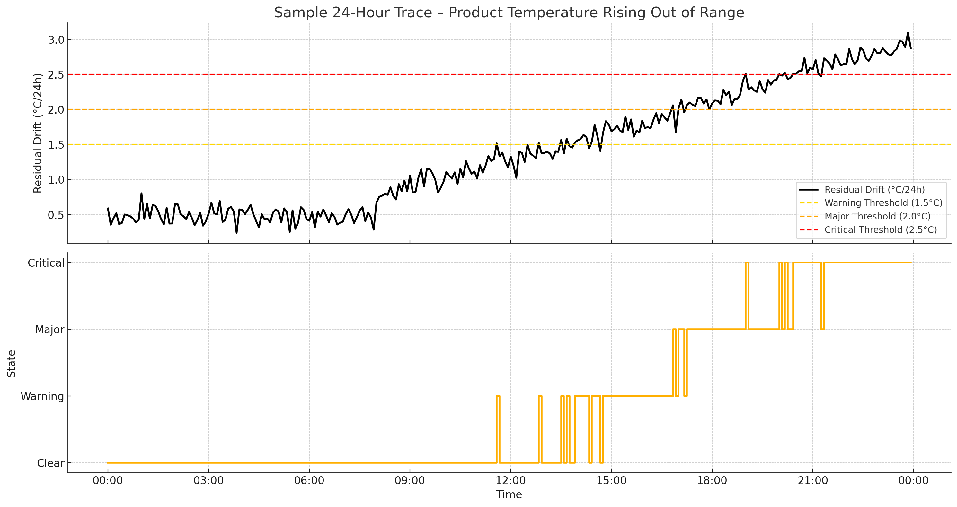
2) Case Slow to Cool After Door or Defrost | ≤ spec (10/20 dairy, 15/30 frozen) | Spec +5 min | Spec +15 min | Fans fail or no recovery | 2 compliant events
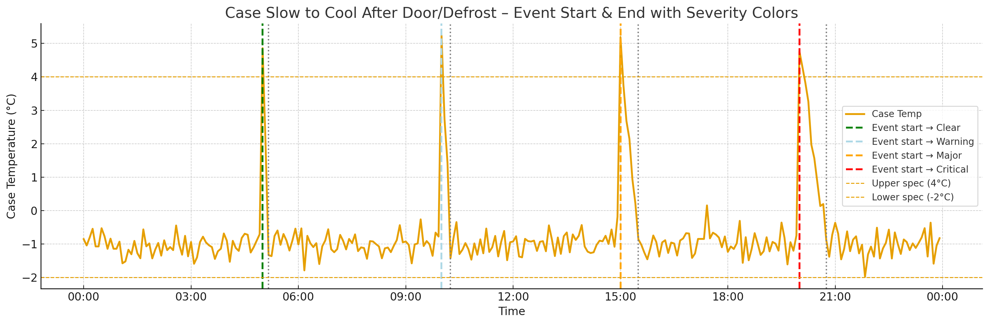
3) Defrost Temperature Too High | Apex ≤ limit | Rising apex trend | Apex within 1 °C of limit | Apex > limit (0 °C frozen, 5 °C meat/deli, 8 °C produce, 10 °C bakery, 12 °C dairy) | 2 compliant defrosts
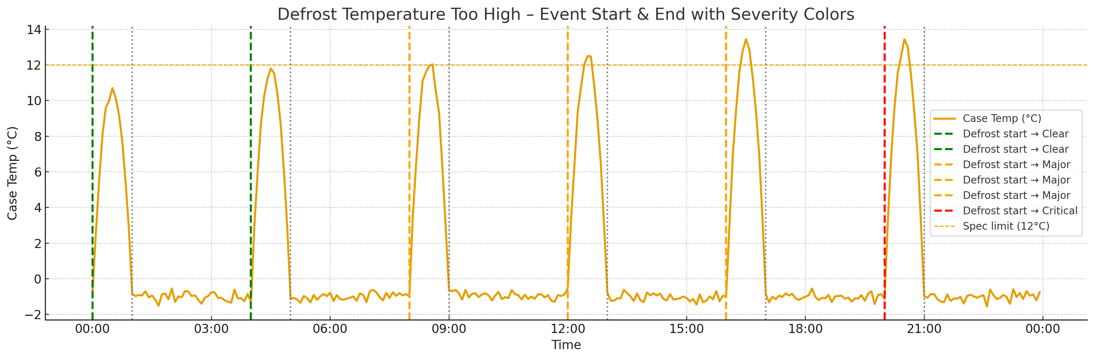
4) Temperature Sensor Not Responding | Variance >0.01 °C² | Trending toward flatline | Flatline 1 window | Flatline ≥2 windows | Variance restored for 2 windows
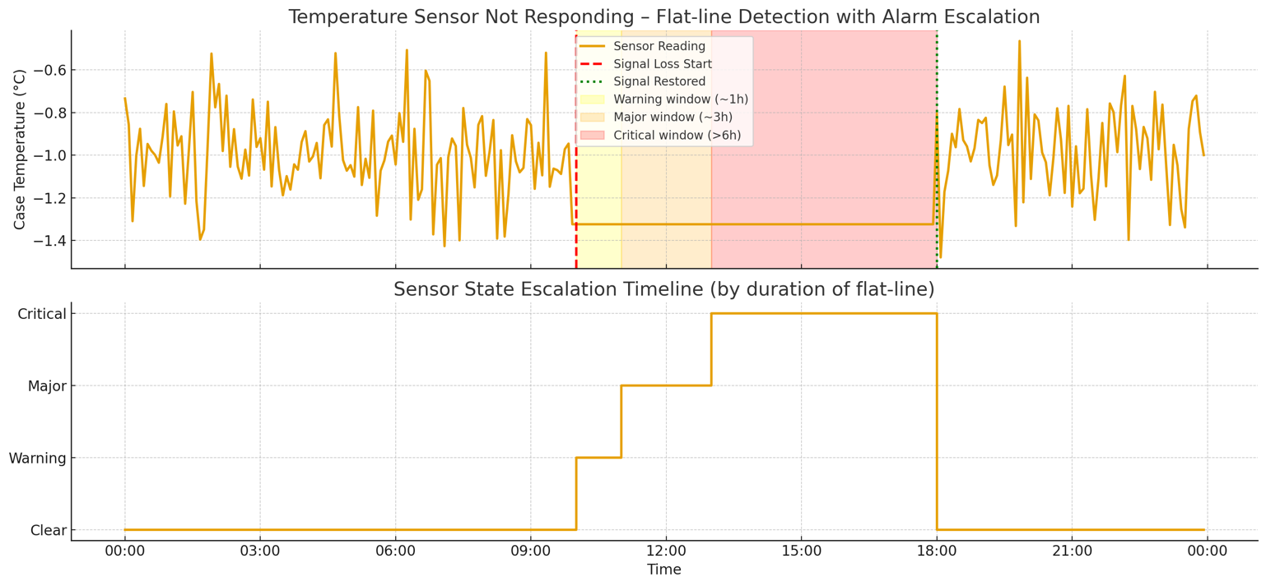
5) Defrosts Occurring at Wrong Times | CV, KS-D within baseline | CV>0.2 once | CV>0.2 two days | Defrost collapse/over-run | 2 stable days
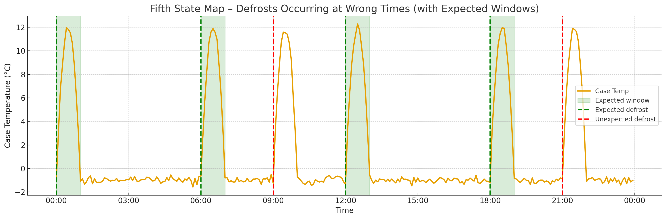
6) Air Curtain Not Holding Temperature | ≤15 min | 15–30 min | >30 min | + Recovery SLA breach | Δτ ≤15 min
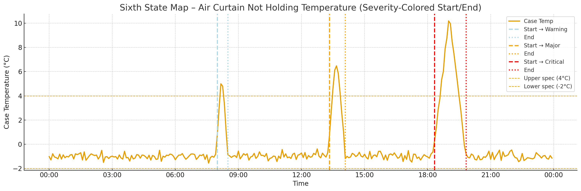
7) Uneven Temperatures Across Shelves | WZ≤2, ΔT within tolerance | ΔT > tolerance once | ΔT > tolerance for ≥2h | Product safety at risk (meat/deli) | ΔT back within tolerance
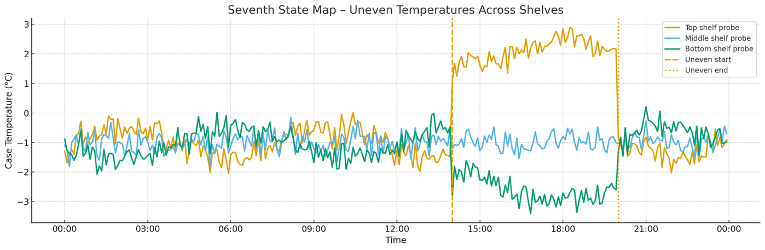
8) Case Cycling Temperature Too Widely | ≤1.5× baseline | >1.5 | >2.0 | >3.0 | Back <1.5
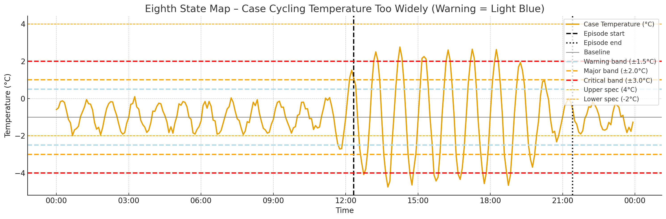

9) Controller Not Holding Steady Temperature | p>0.05 | 0.02<p≤0.05 | p≤0.02 | Persistent + other faults | p>0.05
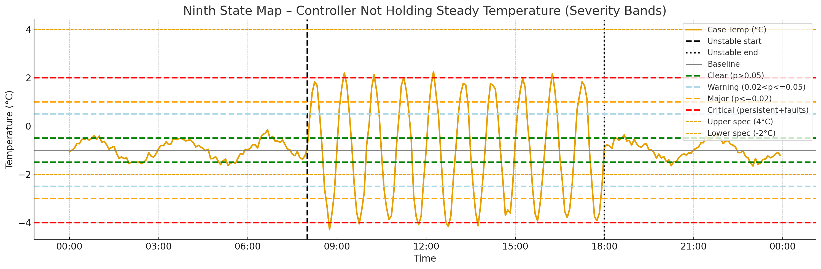
10) Case Does Not Recover After Door Opening | Spike ≤3 °C (≤5 frozen glass) | Recovery slow by ≤5 min | Recovery slow >5 min | Repeated major + gasket leak | 2 compliant door events
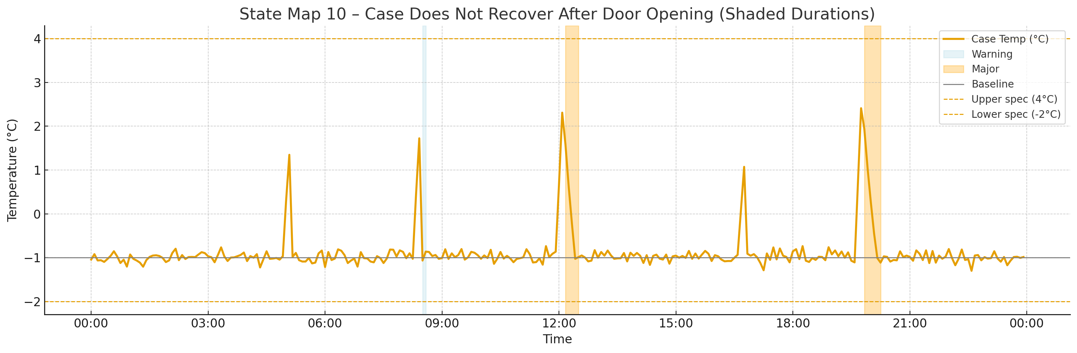
11) Large Temperature Swings in Case | ±20% baseline | >+3 °C (Dairy/Produce) or +7 °C (Frozen) | > spec ≥2 cycles | Amplitude collapse + flatline | Within ±20% baseline
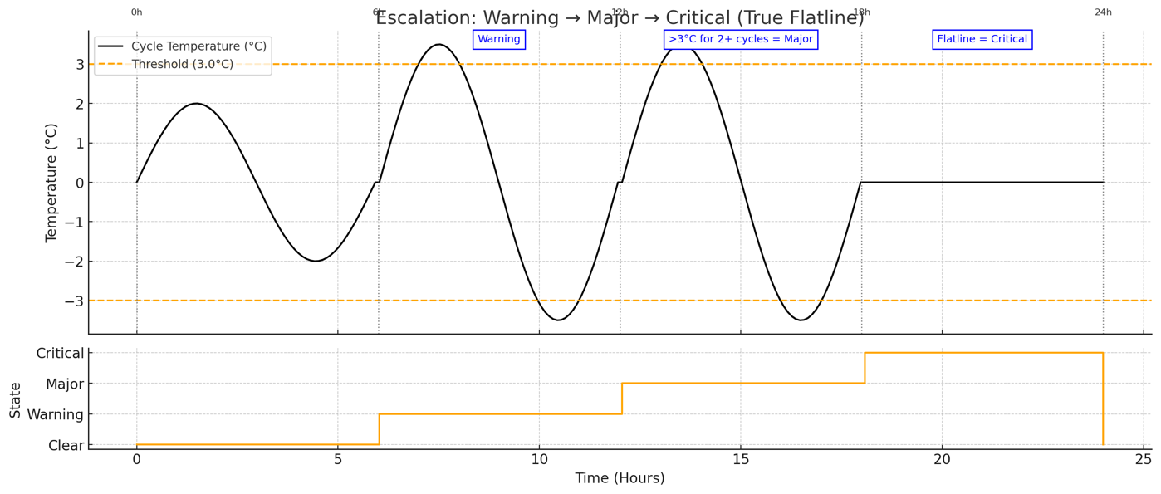
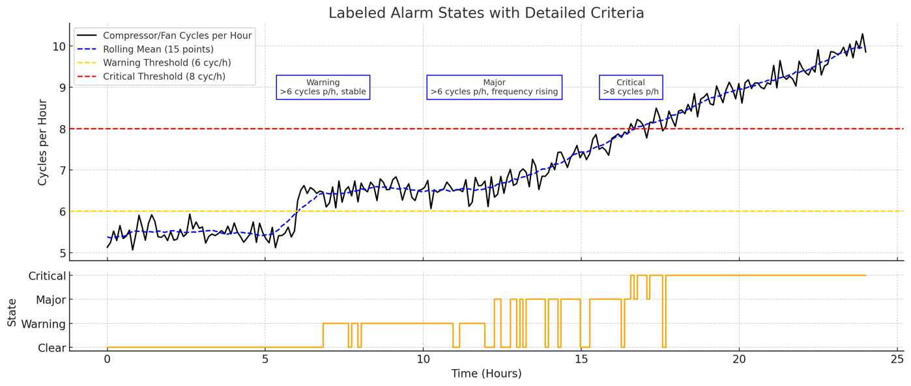  12) Compressor or Fans Starting and Stopping Too Often | ≤6 cycles/h | >6 stable mean | >6 + rising mean | Short cycling with trip | ≤6 for 2h
13) Case Setpoint Changed Without Record |  | κ | <0.5 °C | 0.5–1.0 °C | ≥1 °C undocumented
14) Temperature Probe Heated by Lights | No correlation | ≤2 °C spikes | >2 °C spikes | Major + product freezing | No correlated spikes
15) Produce Case Spikes During Misting | ≤2 °C aligned bumps | >2 °C mis-timed bumps | Cycle length increase | Icing + recovery failure | Normal mist alignment
16) Night Cover Not Used or Damaged | Stable | +1 °C once | +1 °C ≥2 nights | Major + food risk | Covers fixed, ≤0.5 °C drift
17) Temperature Probes Disagree | ≤ tolerance (3 °C dairy, 2 °C meat/deli) | > tolerance ≥1h | > tolerance ≥2h | Probe failure or block | ΔT ≤ tolerance
18) Case Slow to Cool After Defrost | ≤ spec | Recovery 5 min over spec | Recovery 15 min over spec | Recovery not achieved or coil iced | 2 compliant defrosts
19) Random Temperature Spikes in Case | None | Isolated spike ≤2 °C | Repeated spikes 2–4 °C | >5 °C or linked to safety risk | No spikes for 24h
20) Case Holding Above or Below Target Temperature | ±0.5 °C | ±1.0 °C | ±2.0 °C | Product temps unsafe | Mean restored within ±0.5 °C
21) Top and Bottom Shelves at Wrong Temperatures | Within tolerance (3 °C dairy, 2 °C meat/deli) | Exceed tolerance once | Exceed tolerance >2h | Inversion causing unsafe temps | Restored balance
22) Case Slow to Cool After Doors Open | ≤ spec | Spec+5 min | Spec+15 min | >20 min or persistent | 2 compliant recoveries
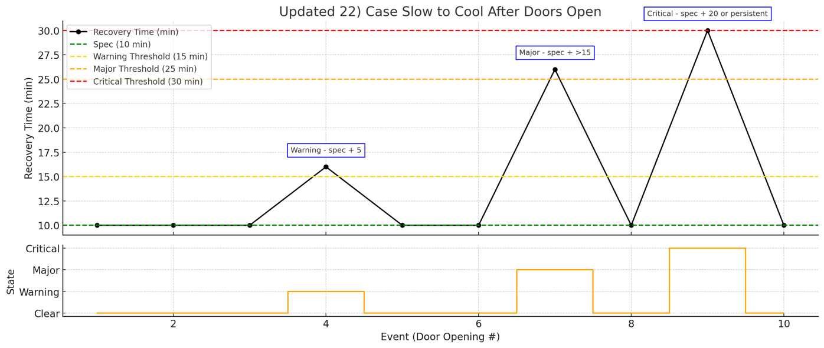
23) Warm Stock Loaded Into Case | Normal slope | Slope degradation once | Slope degradation ≥2 loads | Persistent warm loads, no cooling | Compliant loads
24) Bakery Case Heated by Nearby Oven | None | ≤2 °C spikes | >2 °C repeated | >5 °C sustained | 2 oven cycles no spikes
25) Service Doors Left Open Too Long | Spike ≤3 °C, recovery ≤10 min | Recovery +5 min | Recovery +15 min | Unsafe temps, repeated | 2 compliant door cycles
26) Defrost Temperatures Creeping Higher Each Cycle | Stable apex | +2 Z-score | Within 1 °C of limit | Overshoot | 2 stable defrosts
27) Temperature Cycles Getting Flatter | Within baseline | <75% baseline | <50% baseline | Flatline | Restored amplitude
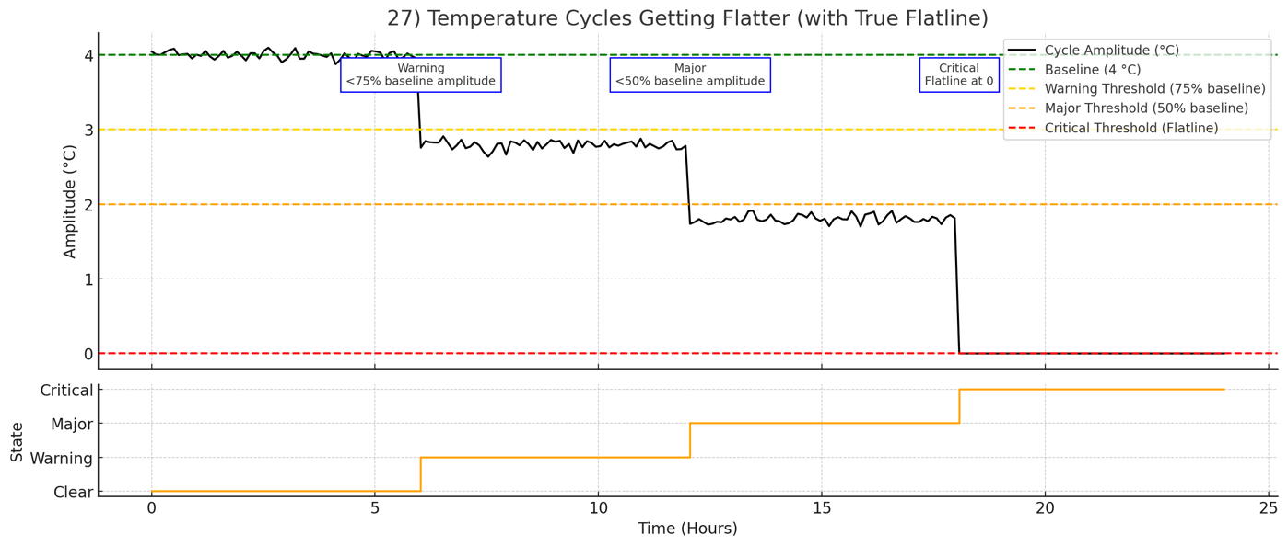
28) Temperature Cycles Becoming Unstable | Baseline frequency | +25% cycles | +50% cycles | Runaway cycling | Baseline cycles
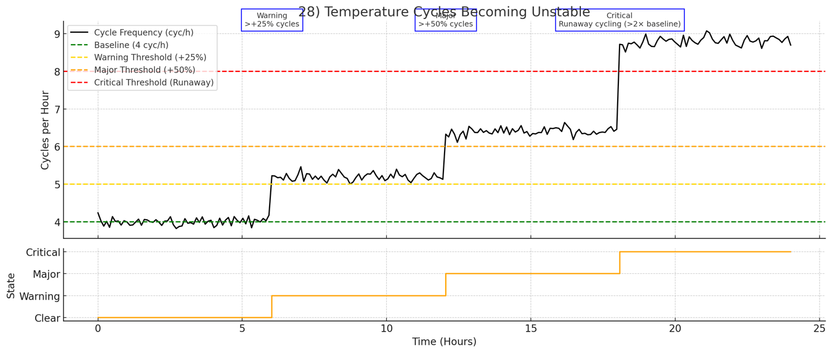
29) Frozen Case Temperatures Approaching Thaw Point | ≤ –18 °C | > –15 °C | > –12 °C | 0 °C | ≤ –18 °C
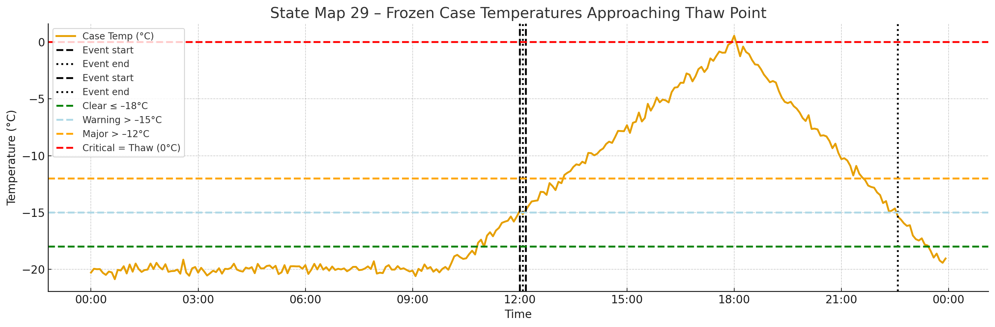
30) One Shelf Consistently Warmer Than Others | Within ±2 °C | +3 °C one shelf | +5 °C sustained | Food risk | Shelf balance
31) Night Temperatures Rising Above Normal | Stable | +1 °C | +2 °C | Unsafe temps | Normal night mean
32) Second Spike Appears After Defrost Ends | None | +2 °C | >3 °C sustained | Repeated + unsafe | 2 cycles without spike
33) Produce Case Warms During Sun or Entrance Drafts | None | ≤2 °C | 2–5 °C | >5 °C | 24h without spikes
34) Meat/Deli Case Bottom Shelf Warmer Than Top | ≤2 °C | Inversion once | Inversion sustained | Unsafe temps | Balance restored
35) Fans Weak or Iced → Coil Icing Worsens | Normal slope | Slope degraded once | Degraded ≥2 cycles | Recovery fails | 2 compliant cycles
36) Defrost Heater Runs Too Long or Too Short | Within spec | Slight deviation | Repeat deviation | Overshoot/ice persists | 2 compliant defrosts
37) Door Switch Not Detected by Controller | Door events logged | Missing log once | Repeated missing logs | Chronic + safety risk | All doors logged
38) Probe Heated by Lights Gives False Reading | None | ≤2 °C | >2 °C | Product freezing | No light-linked spikes
39) HVAC Draft Breaking Air Curtain | Stable curtain | Δτ >15 min | Δτ >30 min | Infiltration + unsafe | Δτ ≤15 min
40) Signage or Stock Blocking Airflow | Balanced | Imbalance once | Imbalance sustained | Unsafe warm zone | Balance restored

Evidence Trail Matrix

Refrigerant / Coil Issues
- Trail: Product Temperature Rising Out of Range + Case Slow to Cool After Defrost + Large Temperature Swings + Fans Weak or Iced → Coil Icing.
- Root Cause: Refrigerant leak or fouled coil.
- Checks: Leak test, coil inspection, TXV function.

Airflow / Fan Problems
- Trail: Case Slow to Cool After Door or Defrost + Uneven Temperatures Across Shelves + Case Does Not Recover After Door Opening + Top/Bottom Shelves Wrong.
- Root Cause: Fan weakness, blockage, orientation fault.
- Checks: Fan CFM, return air paths, ducting.

Defrost / Termination Sensor Faults
- Trail: Defrost Temperature Too High + Defrosts at Wrong Times + Creeping Apex Higher Each Cycle.
- Root Cause: Termination probe drift/misplacement.
- Checks: Probe location, termination logic, heater run time.

Door / Gasket / Switch Faults
- Trail: Random Spikes + Case Door Recovery Failures + Service Doors Left Open + Door Switch Not Detected.
- Root Cause: Gasket leak, poor closers, switch wiring fault.
- Checks: Gaskets, closers, continuity of switch input.

Environmental / HVAC Influences
- Trail: Air Curtain Not Holding + Produce Case Draft Spikes + Night Temps Rising.
- Root Cause: HVAC diffuser mis-aimed, ambient drafts, missing night covers.
- Checks: Smoke test, diffuser alignment, night cover SOP.

Probe Placement / Bias
- Trail: Probe Heated by Lights + False Reading from Lights + Temperature Probes Disagree.
- Root Cause: Poor probe placement, weighting error in control logic.
- Checks: Probe shading, relocation, calibration.

Stocking / Operations Errors
- Trail: Warm Stock Loaded + Case Slow After Doors Open + Random Spikes.
- Root Cause: Stocking warm product, restocking during defrost, poor SOP.
- Checks: Verify stock temp, enforce SOP.

Gravity Coil / Deli Specific
- Trail: Uneven Temperatures + Meat/Deli Bottom Shelf Warmer Than Top.
- Root Cause: Gravity coil imbalance, baffle misplacement.
- Checks: Baffle balance, coil airflow checks.

Component Interaction Failures
- Trail: Fan Weakness + Coil Icing → Recovery Failures.
- Trail: Defrost Heater + Termination Sensor Mis-Sync → Overshoot.
- Trail: Door Switch Not Detected + Random Spikes → I/O mapping fault.
- Trail: Lighting + Probe Bias → False alarms.
- Trail: HVAC Draft + Curtain Collapse → Produce warming.
- Trail: Signage or Stock Blocking Return → Local hot zones.
- Checks: Component-by-component tests depending on interaction.

Usage: A single event = symptom. Two correlated events = pattern. Three or more = evidence trail → strong confidence in root cause. This structure reduces false positives and directs technicians to the correct component or practice to check first.

Multi‑Case Correlation Patterns → Pack/Rack Issues (Unified Reference)

Scope
Cross‑case patterns that indicate rack/pack faults rather than local case issues. Includes plain‑English signals, rack telemetry links, math tests, default screens, and technician checks.

Notation
- Circuit cases: 𝒞 = {1..N}.
- Case temp (setpoint‑normalized): x_i(t).
- Windowed residual mean: μ_{r,i}(W).
- Affected flag: a_i = 1{μ_{r,i} > θ}.
- Affected fraction: f = (1/N)∑ a_i.
- Synchrony: S_x = (2/[N(N−1)])∑_{i<j} ρ(x_i, x_j).
- Avg case signal: x_avg = (1/N)∑ x_i.
- Rack suction P_s(t), discharge P_d(t), subcooling SC(t), receiver level L_rec(t).
- Compressor stages u(t), condenser fans v(t).
- Cross‑corr ρ_{x_avg,·}(τ).
- Step detector CUSUM Step(·) → κ.
- Freezer defrost concurrency: D_conc(t) = ∑ 1{defrost_i(t)=1} (i in freezer set).

Rack Fault Patterns

1) Floating Suction / Low Suction Capacity
- Signals: Multiple cases drift warm together, slow recovery after defrost/door events, larger temp swings.
- Rack link: suction setpoint/capacity change; compressors unavailable.
- Math tests: f ≥ f, S_x ≥ S, max_τ ρ_{x_avg,P_s}(τ) ≥ ρ*, κ_{P_s} ≠ 0.
- Checks: suction setpoint, staging/VFD, transducer.

2) Receiver Undercharge / Liquid Starvation
- Signals: Warm drift, unstable superheat, wide‑open EEVs, slow post‑defrost pull‑down.
- Rack link: low receiver level, low subcooling.
- Math tests: f ≥ f, u_EEV ≥ u, SC ≤ SC, L_rec ≤ L.
- Checks: receiver level, subcooling, LL sight glass, filter ΔP.

3) Head Pressure / Condenser Fault
- Signals: Store‑wide warming in hot hours, better at night, freezer apex trending up.
- Rack link: high/erratic discharge; failed or disabled condenser fans.
- Math tests: Δ_day/night > Δ, max_τ ρ_{x_avg,P_d}(τ) ≥ ρ.
- Checks: condenser fans, coil condition, HP targets.

4) Floating Head Mis‑Tune (Too Low)
- Signals: Widespread slow pull‑down, EEV hunting, noisy superheat.
- Rack link: head target too low → poor subcooling.
- Math tests: SC ≤ SC, ΔP_d ≥ Δ, σ(u_EEV) ≥ σ, S_x ≥ S.
- Checks: raise head setpoint, reassess stability.

5) Rack Control Schedule / Policy Push
- Signals: Case mean temps step up/down together, alarms surge or vanish.
- Rack link: EMS/rack setpoint or schedule change.
- Math tests: Coherency C ≥ C*, κ_{P_s} ≠ 0.
- Checks: EMS logs, config changes.

6) Compressor Availability / Staging Fault
- Signals: Periodic store‑wide temp waves, cases warm in sync when a stage drops.
- Rack link: missing stage, trip, staging error.
- Math tests: ρ(x_avg,h(u)) ≥ ρ, γ²(f_x,f_u) ≥ γ.
- Checks: compressor enables, safeties, capacity trace.

7) Oil Management Impact (Compressor Trips)
- Signals: Short synchronized warm bumps, fast recovery, no local case fault.
- Rack link: oil differential alarms, compressor trips.
- Math tests: Event enrichment: P(bump|trip) − P(bump) ≥ ε*, p<0.01.
- Checks: oil separator, return lines, alarm logs.

8) Hot‑Gas Defrost Interaction
- Signals: Many freezers overshoot together, long pull‑downs store‑wide.
- Rack link: hot‑gas header pressure, too many concurrent defrosts.
- Math tests: D_conc ≥ D, ρ_{x_avg,D_conc} ≥ ρ, mean apex > limit−1 °C.
- Checks: stagger defrosts, header pressure.

9) Suction / Liquid‑Line Filter Restriction (Upstream)
- Signals: Broad drift, distant cases worst.
- Rack link: high ΔP across suction or liquid‑line filter.
- Math tests: slope(μ_{r,i} vs d_i) ≥ β_d, ΔP ≥ ΔP.
- Checks: replace/clean filters, verify ΔP.

10) Rack PT Sensor / Mapping Error
- Signals: All cases drift but local mechanics normal; rack PT step.
- Rack link: suction PT error or mapping issue.
- Math tests: J = |P_s − P_s,ref| ≥ J, κ_{P_s} ≠ 0, C ≥ C.
- Checks: validate transducer vs gauge; remap/replace sensor.

Default Screens
- Affected fraction f* = 0.5–0.7
- Synchrony S* = 0.5–0.7
- Correlation ρ* = 0.5–0.7
- Coherency C* = 0.6–0.8
- Spectral coherence γ* = 0.6–0.8
- Subcooling SC* = 3–5 K
- Defrost concurrency D* = 3–5 simultaneous freezers
- Step κ* = 0.5–1.0 °C
- Event enrichment ε* = 0.1–0.2
- Filter ΔP thresholds: per rack spec

Glossary of Math Terms
- x_i(t): Setpoint‑normalized temperature for case i.
- μ_{r,i}(W): Rolling mean residual for case i over window W.
- a_i: Binary flag =1 if μ_{r,i} > threshold.
- f: Affected fraction across cases.
- S_x: Synchrony index (avg pairwise correlation).
- ρ(x,y): Pearson correlation coefficient.
- x_avg: Mean case temperature across all cases.
- P_s, P_d: Rack suction and discharge pressures.
- SC: Subcooling = T_sat(P_d) − T_LL.
- L_rec: Receiver liquid level.
- u(t): Compressor staging vector.
- v(t): Condenser fan status vector.
- ρ_{x_avg,·}(τ): Cross‑correlation of x_avg with rack variable at lag τ.
- κ: Step change detected (CUSUM or regression).
- D_conc(t): Concurrent freezers in defrost.
- u_EEV: Average EEV opening.
- σ(u_EEV): Std dev of EEV openings (hunting measure).
- Δ_day/night: Day–night temp contrast.
- γ²(f): Spectral coherence between case temps and rack signal.
- $β_d$: Regression slope of residual vs hydraulic distance.
- J: Implausibility index = |measured suction PT − reference gauge|.
- Step(x): Step detection in series x.
- p<0.01: Statistical significance threshold.

