INTRODUCTION

This assignment uses data from the given data of companies that are registered in the Leh and Ladakh region.

It has the following columns:

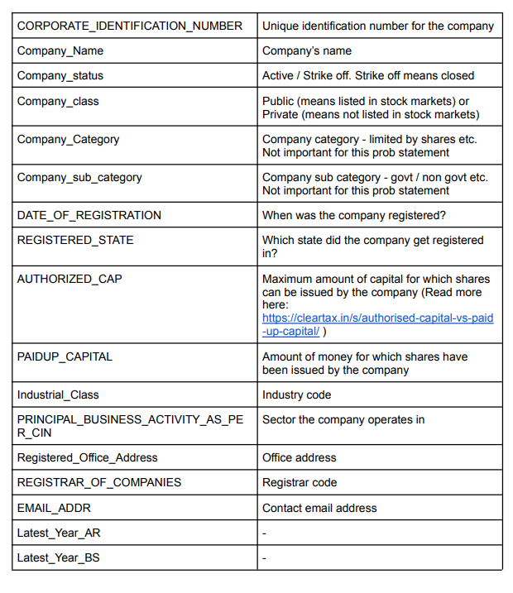

* Dataset : data.xlsx
* Interpreter/Environment : python 3
* Library used : pandas,matplotlib,numpy

**Loading the data**

* loading the dataset into python using pandas library

import pandas as pd

data='data.xlsx'

d=pd.read_excel(data)

* Data consist of 63 rows and 17 columns
* Each row contains the information about individual company

**Making Plots**

Our overall goal here is simply to examine how the region of Leh & Ladakh is ouccupied by various companies. To achieve this goal we use various criteria to examine the data.

* **Company Status**

Company status is classified into two classes “Active” and “Strike off”

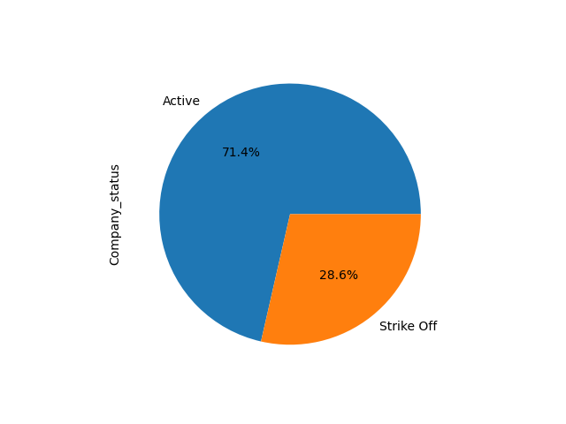

This pie chart shows that out of all companies 71.4% are in active state and 28.6% are in strike off state.

* **Registration Year**

Registration year is classifies the data on the basis of the registration year of the company

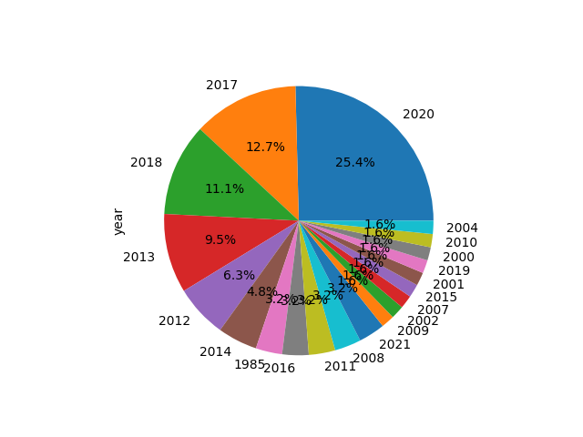

This plot shows the number of companies registered in the following year

Example , 25.4% of the companies are registered in the year 2020.

* **Company Sector**

The company sector gives the information about the sector in which the company is working.

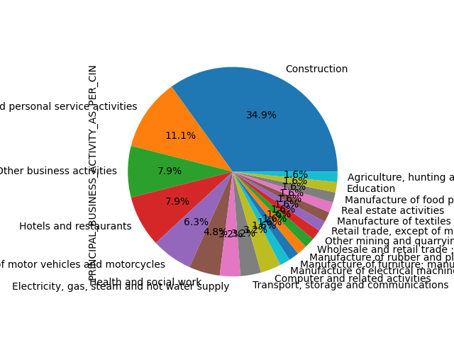

From the above plot we get information about the sector of the companies . out of all companies 34.9% are working in construction sector , 7.9% in hotel and restaurants ,and further more details we get from this plot.

* **Company Class**

Class of companies consist of 3 types

1. Private
2. Public
3. Private(one person company)

The 87.3% of companies are private ,4.8% are public and 7.9% are also private but these companies are one person company

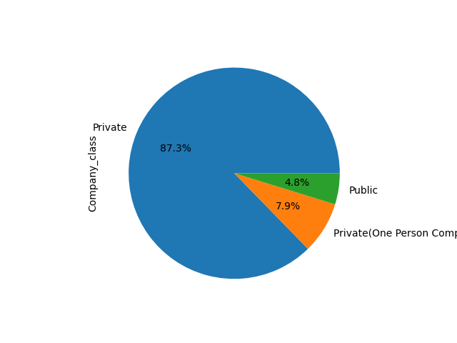

Similarly various information is gathered from various plots for the analysis of data set.

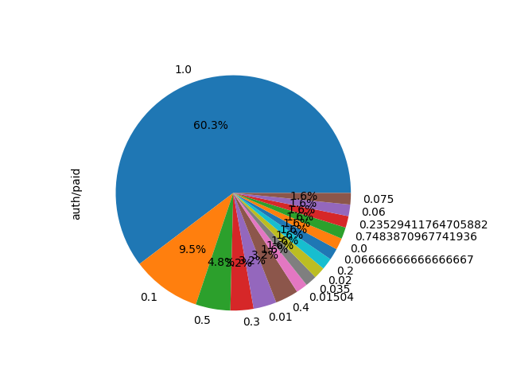

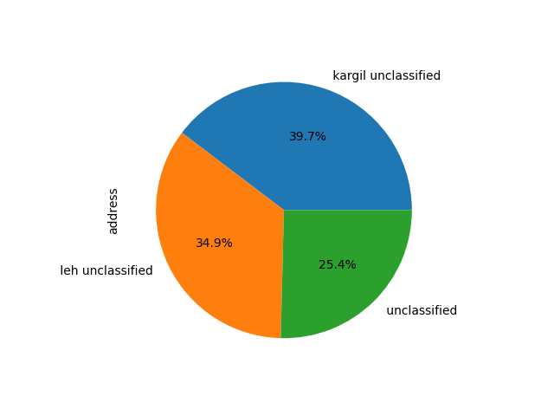

**Conclusion**

From the ananlysis of given dataset the following conclusion are acquired:

* GRNACO INDUSTRIES AND CONSTRUCTIONSLIMITED company has the highest Authorised capital (50000000) in the activestatus.
* SABOO RESORTS PRIVATE LIMITED company has the highest Paidup capital ( 11600000) in the active status.
* On the basis of paidup/authorised capital classification

Paidup/auth_capital No. Of companies

1.000000 38

0.100000 6

0.500000 3

0.300000 2

0.010000 2

0.400000 2

0.015040 1

0.035000 1

0.020000 1

0.200000 1

0.066667 1

0.000000 1

0.748387 1

0.235294 1

0.060000 1

0.075000 1

* On the basis of Registration year classification

Registration year No. Of companies

2020 16

2017 8

2018 7

2013 6

2012 4

2014 3

1985 2

2016 2

2011 2

2008 2

2021 2

2009 1

2002 1

2007 1

2015 1

2001 1

2019 1

2000 1

2010 1

2004 1

* On the basis of sector classification

Sector No. Of companies

Construction 22

Other community, social and personal service activities 7

Other business activities 5

Hotels and restaurants 5

Other 24

Where other includes

1. Electricity, gas, steam and hot water supply
2. Transport, storage and communications
3. Computer and related activities
4. Manufacture of electrical machinery and apparatus n.e.c.
5. Manufacture of furniture; manufacturing n.e.c.
6. Manufacture of rubber and plastics products
7. Wholesale and retail trade ; repair of motor vehicles, motorcycles and personal and household goods
8. Other mining and quarrying
9. Retail trade, except of motor vehicles and motorcycles; repair of personal and household goods
10. Manufacture of textiles
11. Real estate activities
12. Manufacture of food products and beverages
13. Education
14. Agriculture, hunting and related service activities

* On the basis of Company class classification

Class No. Of companies

Private 55

Private(One Person Company) 5

Public 3

* On the basis of Company status classification

Status No. Of companies

Active 45

Strike Off 18

* On the basis of Region classification

Region No. Of companies

kargil unclassified 25

leh unclassified 22

unclassified 16