A
Course End Project Report on

“ELECTRICITY GENERATION BY ENERGY SOURCE ANALYSIS ”
For the Course of

EXPLORATORY DATA ANALYSIS AND VISUALIZATION(22ADC31N)
in

B.E, III-SEM, INFORMATION TECHNOLOGY

Submitted by

BASUDE VARUN (160125737072)

Under the guidance of Course Faculty:

Dr Geedikanti Srikanth, Assistant Professor, Dept of IT.



DEPARTMENT OF INFORMATION TECHNOLOGY

CHAITANYA BHARATHI INSTITUTE OF TECHNOLOGY(A)
(Affiliated to Osmania University; Accredited by NBA,NAAC A++,ISO)
Kokapet(V),Gandipet(M),Hyderabad, Telangana, India -500075 website: www.cbit.ac.in

Date : 3-11-2025

CHAITANYA BHARATHI INSTITUTE OF TECHNOLOGY(A)
(Affiliated to Osmania University; Accredited by NBA,NAAC A++,ISO) DEPARTMENT OF INFORMATION TECHNOLOGY A.Y: 2025-26

Course End Project Marks AWARD SHEET

B.E, IT, III-SEM (IT-2) EDAV:22ADC31N MAXIMUM MARKS:10

Q.No | 1 | 2 | 3 | 4 | 5 | Total
CO# | 1 | 2 | 3 | 4 | 5 | -
BL# | 3 | 3 | 4 | 4 | 5 | -
Marks Allocated | 2 | 2 | 2 | 2 | 2 | 10
Marks Awarded

Faculty Signature



CERTIFICATE

This is to certify that the course-end project report entitled “Exploratory Data Analysis and Electricity generation by Energy Sourse Analysis” is a bonafide record of the work carried out by Basude Varun(Roll.No.160125737072), in partial fulfilment of the requirements of the course Exploratory Data Analysis and Visualization (22ADC31N) of the programme B.E(IT), III-SEM, during the academic year 2026–2027.

The project was carried out under my guidance and supervision. To the best of my knowledge, the work reported here is original and has not been submitted to any other institution or university for the award of any degree, diploma or certificate.

Place: Hyderabad
Date: / /

Course Faculty

(Asst.Prof. Geedikanti Srikanth )

DECLARATION
I / We hereby declare that the project report entitled “Exploratory Data Analysis and Electricity Generation by Energy Source Analysis” submitted to Dept of IT, CBIT is a record of original work done by me under the guidance of Dr Geedikanti Srikanth, Assistant Professor, IT, CBIT.
The data used was taken from the dataset supplied for the course; all external sources, tools and libraries have been acknowledged in the References. This work has not been submitted, in part or in full, for any other course, degree or diploma.

Place: Hyderabad

Date:

Signature of the Student
[Basude Varun Roll No.072]

ACKNOWLEDGEMENT

I express my sincere gratitude to my project guide and course faculty, Asst Prof Geedikanti Srikanth, Dept. of IT, CBIT, for valuable guidance, encouragement and constructive feedback throughout this project.
I thank the Head of the Department, the faculty members and the management of Chaitanya Bharathi Institute of Technology (CBIT) for providing the facilities and the learning environment that made this work possible.
I am also grateful to the open-source community behind Python, pandas, Matplotlib, Seaborn, Folium, Plotly and scikit-learn, and to the publishers of the youth hostel dataset, without which this analysis would not have been possible. Finally, I thank my family and friends for their constant support.

B Varun , 160125737072

Abstract
Electricity is made from many different sources, and the mix decides how much carbon comes with each unit of power. This project studies a global yearly electricity dataset (104,241 rows, 224 countries and regions, 1985 to 2025) to see how much electricity the world generates, which sources supply it, and whether it is getting cleaner. The work was done in Python with pandas, NumPy, Matplotlib and Seaborn, following the order of cleaning, analysis, visualization and conclusion.
Missing values were filled first: shares and intensity were recalculated, capacity was estimated where generation existed, and gaps in text columns were labelled. Summary rows such as Total generation were removed to avoid double counting. World generation grew from 15,325 TWh in 2000 to 31,071 TWh in 2024, an increase of about 103 per cent. The fossil share peaked at about 68.4 per cent in 2007 and fell to 57.7 per cent in 2025, while solar and wind grew from 0.2 to 17.3 per cent. Carbon intensity fell from 528 to 460 gCO2e per kWh. China, the United States and India are the largest generators, and India still gets about 75 per cent of its electricity from coal.
Keywords: electricity generation; energy sources; exploratory data analysis; carbon intensity; renewables; Python.

Contents
Evaluation Sheet and Certificate ii
Acknowledgement and Declaration iv,v
Abstract vi
1. Introduction 8
2. Requirements Analysis and Technology Stack 10
3. Project Data Diagram 11
4. Data Collection and Description 13
5. Data Cleaning and Preparation 15
6. Exploratory Data Analysis 18
7. Data Visualization 21
8. Methodology and Question-wise Implementation 24
9. Results and Discussion 34
10. Conclusion and Recommendations 36
11. References 37
12. Appendices 38

1. Introduction

1.1 Background and context
Electricity runs homes, factories, hospitals, railways and the internet. Almost every country needs more of it each year as populations grow and economies develop. But electricity is not made in one way. Coal, gas and oil plants burn fuel and release carbon dioxide. Hydro, wind and solar plants release very little. Nuclear plants release almost no carbon while running, though they come with their own costs and debates.
Because of this, the source mix matters as much as the total amount. Two countries can generate the same number of units and still have very different effects on the climate, depending on what they burn. Planners, researchers and energy companies need reliable data to see where electricity comes from and how that is changing over time.

1.2 About the problem
The dataset used here records electricity generation for more than two hundred countries and regions. It has one row for every combination of area, year and source, and it gives the amount generated, the share of the total, the installed capacity and the emissions. The data is detailed, but it is not ready to use. It has many empty cells, it mixes real sources with summary rows, and its totals can be counted twice if it is handled carelessly. Before any conclusion can be trusted, the data has to be inspected, cleaned and checked.

1.3 Objectives
1. Inspect the dataset and document its quality problems, such as missing values and summary rows.
2. Fill the missing values with clear rules (fillna and recalculation) before doing any calculation.
3. Measure how total world generation has changed between 2000 and 2025.
4. Compare the share of each energy source across years and across regions.
5. Find which countries generate the most electricity and how different their source mixes are.
6. Track the carbon intensity of electricity over time.
7. Present the main findings with a small number of clear charts.

1.4 Questions answered through EDA
The project answers five questions. Each one has a course outcome and a Bloom level, written as [CO#, BL#].
Table 1.1 Project questions with course outcomes and Bloom levels
Q | Question | Method | [CO#, BL#]
Q1 | What are the average, minimum and maximum yearly generation of each source in the world? | NumPy array statistics | [CO1, BL3]
Q2 | How did the source mix, the fossil share and the regions change over time? | Pandas groupby and pivot tables | [CO2, BL4]
Q3 | How should the missing values be handled so that the data is ready for analysis? | fillna, recalculation, estimation | [CO3, BL3]
Q4 | How do continents and countries differ in total generation and fossil share? | groupby with agg, describe, cut | [CO4, BL4]
Q5 | How can the findings be shown clearly in charts? | Line, bar and heatmap plots | [CO5, BL5]

1.5 Importance and relevance
Electricity generation is one of the biggest sources of carbon emissions in the world, so the way electricity is produced is central to any plan for cutting emissions. A simple, careful look at the numbers answers practical questions. Is the world using more electricity? Is the new demand being met by clean sources? Which parts of the world still depend on coal? The answers help to see how far the energy transition has really gone and where it is slow.

1.6 Units used in this report
Electricity is measured in terawatt-hours (TWh). One TWh is one billion kilowatt-hours. Capacity is measured in gigawatts (GW), emissions in million tonnes of carbon dioxide equivalent (MtCO2e), and carbon intensity in grams of carbon dioxide equivalent per kilowatt-hour (gCO2e/kWh).

1.7 How this report is organised
Chapter 2 lists the requirements and tools. Chapter 3 shows the flow of the project in a diagram. Chapter 4 describes the data. Chapter 5 explains the cleaning. Chapters 6 and 7 present the exploratory analysis and the charts. Chapter 8 gives the code and output for each question. Chapters 9 and 10 discuss the results and give conclusions and recommendations. The references and appendices come at the end.

2. Requirements Analysis and Technology Stack

2.1 What the project needs to do
• Read a CSV file of about 16 MB with more than 100,000 rows.
• Find and fill missing values, and keep a record of what was filled.
• Group and summarise the data by year, region, continent, country and source.
• Produce a few clear charts with titles, labelled axes and units.
• Run from top to bottom in one notebook and give the same results each time.

2.2 Software requirements
Table 2.1 Software and libraries used
Software | Use in this project
Python 3 | Programming language for all the code
Jupyter Notebook | Runs the code in cells and keeps the explanations next to the results
pandas | Loading the CSV, filling missing values, groupby, pivot tables
NumPy | Array statistics (mean, min, max, std, argmax, diff) and conditional calculations
Matplotlib | Line, bar and stacked bar charts
Seaborn | Chart styling and the heatmap
Microsoft Word | Writing and formatting this report

2.3 Hardware requirements
The dataset is small by modern standards, so any ordinary laptop with 4 GB of memory or more can run the notebook. No GPU and no internet connection are needed once the libraries are installed.

2.4 Installing the libraries
If a library is missing, it can be installed from the command line or from a notebook cell:
pip install numpy pandas matplotlib seaborn

2.5 Why these tools were chosen
pandas and NumPy are the standard tools for table and array work in Python, and the course is built around them. Jupyter lets me mix code, results and notes, so a reader can follow every step. Matplotlib and Seaborn are enough for the few charts needed here. I did not use interactive dashboards or maps, because the questions can be answered with simple static charts, and keeping the tool list short makes the work easier to repeat.

2.6 Reproducibility
All the code is in one notebook. The raw file is loaded once and never edited, and every change is made to a copy. Running the notebook from the first cell to the last gives the same tables and charts that appear in this report.

Project Data Diagram

The diagram below shows how the data moves through the project, from the raw CSV file to the findings. The coloured groups match the four phases that the instructions ask for: preparation, cleaning, analysis and presentation.

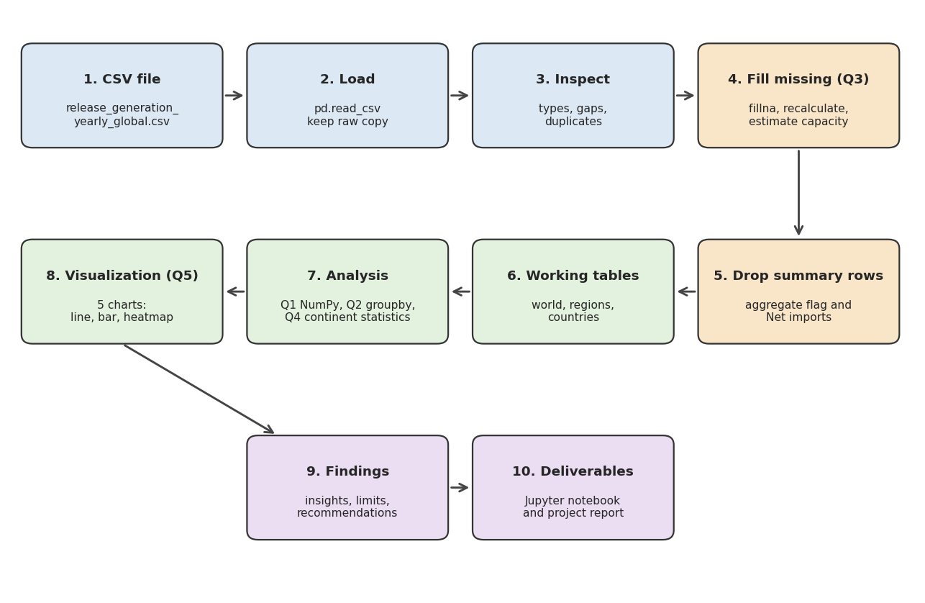

Fig. 3.1 Data flow of the electricity generation project

3.1 What happens at each stage
Table 3.1 Stages of the project
Stage | Input | Action | Output
1-2 Load | CSV file | Read with pd.read_csv, keep a raw copy | DataFrame with 104,241 rows
3 Inspect | DataFrame | Check types, gaps, duplicates | Missing-value table
4 Fill (Q3) | DataFrame | fillna, recalculate shares and intensity, estimate capacity | No gaps in data columns
5 Remove | Filled data | Drop summary rows and Net imports | 54,541 source rows
6 Tables | Source rows | Split into world, regions, countries | Three working tables
7 Analysis | Working tables | NumPy and groupby calculations (Q1, Q2, Q4) | Summary tables
8 Visualize | Summary tables | Draw line, bar and heatmap charts (Q5) | Five charts
9-10 Report | Tables and charts | Interpret and write up | Notebook and report

3.2 Why the order matters
The most important rule in the diagram is that missing values are filled before any calculation, and summary rows are removed before any total is made. If these two steps are done in the wrong order, the sums, shares and averages in later steps will be wrong without any error message to warn about it.

4. Data Collection and Description

4.1 Source of the data
The data comes from the CSV file release_generation_yearly_global.csv, supplied for the course. The file does not state who published it. Some of its column names (for example "Ember region") suggest that it is a release of Ember's global electricity data, but this should be confirmed with the course faculty or the original website before it is cited. The place for the final citation is kept in the References chapter.

4.2 Size and structure
The file has 104,241 rows and 24 columns and uses about 16 MB on disk. One row describes one area in one year for one electricity source. There are 224 areas: 209 countries or economies (97,975 rows) and 15 regions such as Asia, the EU and the World (6,266 rows). The country rows run from 1985 to 2025. The World and the other region rows start in 2000, so all world and regional results in this report use 2000 to 2025.

4.3 Data dictionary
Table 4.1 Data dictionary
Column | Type | Meaning
Area | Text | Country, economy or region name
ISO 3 code | Text | Three-letter country code (empty for regions)
Year | Integer | Calendar year
Area type | Text | Country or economy, or Region
Electricity source | Text | Coal, Gas, Solar, Wind and so on, plus summary rows
Is aggregated source | Boolean | True when the row is a total or a group of other rows
Generation (TWh) | Number | Electricity generated
Generation YoY change (TWh) | Number | Change from the previous year, in TWh
Generation YoY change (%) | Number | Change from the previous year, in per cent
Share of generation (%) | Number | Part of the area's total generation
Share of generation YoY change (% points) | Number | Change in that share from the previous year
Capacity (GW) | Number | Installed capacity
Emissions (MtCO2e) | Number | Emissions in million tonnes of CO2 equivalent
Emissions YoY change (MtCO2e) | Number | Change in emissions from the previous year
Emissions YoY change (%) | Number | Change in emissions in per cent
Share of emissions (%) | Number | Part of the area's total emissions
Emissions intensity (gCO2e/kWh) | Number | Emissions per unit of electricity
Continent | Text | Continent of the country (empty for regions)
Ember region | Text | Regional grouping used by the publisher (empty for regions)
EU member, OECD member, G20 member, G7 member, ASEAN member | Boolean | Five yes/no columns for group membership

4.4 Real sources and summary rows
The Electricity source column has 17 different values. Only nine of them are real ways of making electricity. The rest are summary rows that add up other rows, and one row (Net imports) is not generation at all.
Table 4.2 Kinds of rows in the Electricity source column
Kind of row | Values | Used for totals?
Real generation sources (9) | Coal, Gas, Other fossil, Nuclear, Hydro, Bioenergy, Other renewables, Wind, Solar | Yes
Summary rows (7) | Total generation, Demand, Fossil, Clean, Renewables, Wind and solar, Hydro bioenergy and other renewables | No, they would double count
Not generation (1) | Net imports | No

4.5 Libraries, modules and functions used
Table 4.3 Main functions used
Function | Syntax | Use in this project
pd.read_csv | pd.read_csv('file.csv') | Loads the dataset into a DataFrame
isna().sum() | df.isna().sum() | Counts missing values in each column
fillna | df['col'].fillna(value) | Replaces missing values
np.where | np.where(cond, a, b) | Chooses a value row by row (for example to avoid dividing by zero)
groupby | df.groupby('col')['x'].sum() | Splits into groups and adds up each group
agg | groupby(..).agg(n=('x','count')) | Several summary numbers at once
pivot_table | df.pivot_table(index, columns, values) | Reshapes long data into a table of years by sources
to_numpy | df.to_numpy() | Turns a table into a NumPy array
np.mean, np.min, np.max, np.std | np.mean(arr, axis=0) | Statistics down each column of an array
np.argmax | np.argmax(arr, axis=0) | Finds the position of the largest value (peak year)
np.diff | np.diff(total) | Year-to-year changes
pd.cut | pd.cut(x, bins, labels) | Puts numbers into bands such as 0-25 %
describe | series.describe() | Count, mean, quartiles, minimum and maximum
plt.subplots, ax.plot, ax.barh | fig, ax = plt.subplots() | Draws the line and bar charts
sns.heatmap | sns.heatmap(table, annot=True) | Draws the region by source heatmap

4.6 Things to know about the data
• The data describes what was generated, not why. It has no information on prices, policy or weather.
• Emissions for solar, wind, hydro and nuclear are small but not zero, which suggests that the file includes life-cycle emissions.
• Regions overlap. Asia and ASEAN, or the EU and Europe, contain some of the same countries, so regional rows should never be added together.
• The newest year (2025) is the most likely to be revised by the publisher.

5. Data Cleaning and Preparation
Real data is rarely clean, so I checked and fixed it before doing any analysis. This chapter explains what I found, what I decided, and why. The code for each step is shown in Chapter 8 under Q3.

5.1 What the inspection showed
There are no duplicate rows, and no negative generation values. But 13 of the 24 columns have missing cells. Table 5.1 lists them.
Table 5.1 Missing values before cleaning
Column | Missing cells | Percent of rows
Emissions YoY change (%) | 48,746 | 46.8
Emissions intensity (gCO2e/kWh) | 40,583 | 38.9
Generation YoY change (%) | 37,028 | 35.5
Capacity (GW) | 28,355 | 27.2
Emissions YoY change (MtCO2e) | 9,826 | 9.4
Share of emissions (%) | 6,337 | 6.1
Emissions (MtCO2e) | 6,305 | 6.0
Continent | 6,266 | 6.0
ISO 3 code | 6,266 | 6.0
Ember region | 6,266 | 6.0
Share of generation YoY change (% points) | 3,779 | 3.6
Generation YoY change (TWh) | 3,745 | 3.6
Share of generation (%) | 34 | 0.0

The gaps have different causes, so one rule for all of them would be wrong. For example, the percentage-change columns are empty when the previous value was zero, because a percentage change from zero cannot be calculated. The ISO code, continent and region are empty because region rows do not belong to a country. Emissions are empty only on the Demand rows.

5.2 Rules used to fill the missing values
Table 5.2 Rules for handling missing values
Column | Cause of the gap | How it was filled
ISO 3 code, Continent, Ember region | Region rows have no country | Label: Region or Not applicable
Emissions (MtCO2e) | Only the Demand rows | 0, because demand is not a producing source
Share of generation, Share of emissions | A few rows | Recalculated from the area total of the same year
Capacity (GW) | No plant, or capacity not reported | 0 if generation is 0, otherwise estimated from the capacity factor
YoY change in TWh, MtCO2e, % points | First year of a series | Recalculated with diff(), the first year set to 0
YoY change in per cent | Previous value was 0 | 0 (a percentage is undefined)
Emissions intensity | Not given for many rows | Emissions divided by generation times 1000

5.3 The capacity decision
Capacity needed the most thought. Using zero for every empty cell would have been easy but wrong. Among the real sources there were 11,974 rows with no capacity. In 7,223 of them the generation is also zero, so zero capacity is correct. In the other 4,751 rows there was generation but no capacity, mostly in the early years. A plant that produces electricity must have capacity, so a zero there would be false.
For those rows I estimated the capacity from the capacity factor. The capacity factor is the actual generation divided by what a plant would produce if it ran at full power all year. I took the median capacity factor of each source from the rows where both numbers exist, and then divided the generation by it.
Table 5.3 Median capacity factor used for the estimate
Source | Typical capacity factor
Bioenergy | 0.50
Coal | 0.56
Gas | 0.42
Hydro | 0.39
Nuclear | 0.81
Other fossil | 0.35
Other renewables | 0.69
Solar | 0.13
Wind | 0.24

The values look sensible. Nuclear plants run for most of the year, coal and gas plants run for about half of it or less, and solar is lowest because the sun is available only part of the day. This estimate affects only the capacity column, and none of the results in this report depends on capacity.

5.4 Keeping a record of the filled cells
For every column that had gaps I added a True/False column ending in "(was missing)". This means that any filled value can be told apart from an original one later. After the filling, the data columns had no missing values left.
Table 5.4 Number of cells filled in each column
Column | Cells filled
Emissions YoY change (%) | 48,746
Emissions intensity (gCO2e/kWh) | 40,583
Generation YoY change (%) | 37,028
Capacity (GW) | 28,355
Emissions YoY change (MtCO2e) | 9,826
Share of emissions (%) | 6,337
Emissions (MtCO2e) | 6,305
Continent | 6,266
ISO 3 code | 6,266
Ember region | 6,266
Share of generation YoY change (% points) | 3,779
Generation YoY change (TWh) | 3,745
Share of generation (%) | 34

5.5 Removing summary rows
After filling, I removed the summary rows and Net imports, which left the nine real sources: 54,541 rows out of 104,241. I checked the result in a simple way. For the world in 2024 the nine sources add up to 31,070.7 TWh, and the reported Total generation is 31,070.7 TWh. The two match, so nothing was lost or counted twice.

5.6 Outliers and unusual values
Generation cannot be negative, and there are no negative values. Large values do exist. Among the 193 countries that generated electricity in 2024, 32 fall above the usual statistical limit for outliers (more than 1.5 times the interquartile range above the third quartile). These include the biggest economies such as China, the United States and India. They are real, not errors, and they are the countries that matter most for the world total, so I kept them. The median country generated only 14.8 TWh while the average was 160.4 TWh, which shows how strongly a few large countries pull the average up.

5.7 Transformations
• The long table was reshaped into a years-by-sources table with pivot_table, so that NumPy could work on it.
• Sources were grouped into fossil (coal, gas, other fossil) and low-carbon (the other six).
• Shares, growth rates and carbon intensity were calculated as ratios.
• No normalisation or scaling was needed, because the analysis uses shares and totals and not a prediction model.

5.8 Tools used
All cleaning used pandas (isna, fillna, groupby, diff, map, loc) together with NumPy (where, to_numpy). The raw data was never changed, and the cleaned copy is the only table used from this point on.

6. Exploratory Data Analysis

6.1 World generation
World electricity generation was 15,325 TWh in 2000. It reached 21,327 TWh in 2010, 26,803 TWh in 2020 and 31,071 TWh in 2024. In 2025 it was 31,923 TWh. Between 2000 and 2024 this is growth of about 103 per cent. The average yearly growth is about 3 per cent. Growth was fastest in 2010 (6.6 per cent, a rebound after the 2009 dip) and generation fell in only two years, 2009 (-0.8 per cent) and 2020 (-0.4 per cent). The data does not give the reasons for these two dips.
Table 6.1 World generation in selected years
Year | Total (TWh) | Fossil (TWh) | Low-carbon (TWh) | Fossil share (%) | Solar+Wind (%)
2000 | 15,325 | 9,917 | 5,408 | 64.7 | 0.2
2005 | 18,184 | 12,166 | 6,018 | 66.9 | 0.6
2010 | 21,327 | 14,399 | 6,928 | 67.5 | 1.8
2015 | 24,063 | 16,011 | 8,053 | 66.5 | 4.5
2020 | 26,803 | 16,697 | 10,106 | 62.3 | 9.1
2024 | 31,071 | 18,442 | 12,629 | 59.4 | 15.0
2025 | 31,923 | 18,416 | 13,507 | 57.7 | 17.3

6.2 Statistics of each source
Table 6.2 Yearly world generation of each source, 2000-2025 (TWh)
Source | Mean | Min | Max | Peak year | Last / first
Coal | 8,707 | 5,841 | 10,652 | 2024 | 1.8x
Gas | 5,053 | 2,747 | 6,920 | 2025 | 2.5x
Hydro | 3,598 | 2,567 | 4,463 | 2024 | 1.7x
Nuclear | 2,647 | 2,432 | 2,805 | 2025 | 1.1x
Other fossil | 1,089 | 793 | 1,329 | 2000 | 0.7x
Wind | 867 | 31 | 2,705 | 2025 | 86.8x
Solar | 491 | 1 | 2,807 | 2025 | 2593.9x
Bioenergy | 394 | 155 | 652 | 2025 | 4.1x
Other renewables | 67 | 44 | 91 | 2025 | 2.1x

Coal and gas have the highest averages. Coal also has the highest single-year output, 10,652 TWh in 2024. Wind and solar start from almost nothing, so they show the biggest growth: wind produced 87 times more in 2025 than in 2000 and solar about 2,594 times more. In 2025 solar (2,807 TWh) just passed nuclear (2,805 TWh), and solar and wind together (5,512 TWh) produced more than hydro (4,446 TWh). Nuclear output stayed almost flat (1.1x) and other fossil fuels fell (0.7x).

6.3 The source mix
Table 6.3 Share of world generation by source (%)
Source | 2000 | 2010 | 2020 | 2025
Coal | 38.1 | 39.9 | 35.5 | 33.2
Gas | 17.9 | 22.6 | 23.9 | 21.7
Other fossil | 8.7 | 5.0 | 3.0 | 2.8
Nuclear | 16.6 | 12.8 | 9.9 | 8.8
Hydro | 17.2 | 16.1 | 16.2 | 13.9
Bioenergy | 1.0 | 1.5 | 2.1 | 2.0
Other renewables | 0.3 | 0.3 | 0.3 | 0.3
Wind | 0.2 | 1.6 | 5.9 | 8.5
Solar | 0.0 | 0.2 | 3.2 | 8.8

Coal is the largest single source in all four years, though its share fell from 38.1 per cent in 2000 to 33.2 per cent in 2025. Gas rose from 17.9 to 22.6 per cent by 2010 and has stayed around a fifth to a quarter since. The nuclear share fell from 16.6 to 8.8 per cent. This is not because nuclear output fell; it stayed about the same, while total generation doubled. The same is true of hydro, whose output rose but whose share fell from 17.2 to 13.9 per cent.

6.4 Fossil share
The fossil share rose from 64.7 per cent in 2000 to a peak of 68.4 per cent in 2007. It stayed close to that level until about 2013 and has fallen every year since 2013, except for a small rise in 2021, to 57.7 per cent in 2025. Fossil generation itself fell slightly in 2025, by about 26 TWh, as it had in 2009, 2015, 2019 and 2020. In 2025 total generation still grew by about 2.7 per cent, so all of that growth came from low-carbon sources.

6.5 Differences between countries
In 2024, 193 countries generated electricity. Their fossil share has a very wide spread. The mean is 57.2 per cent and the median is 64.2 per cent, and the values run from 0 to 100 per cent. Table 6.4 groups the countries into bands.
Table 6.4 Countries by fossil share of generation, 2024
Fossil share band | Number of countries
0-25 % | 46
25-50 % | 31
50-75 % | 38
75-90 % | 36
90-100 % | 42

The two ends are the largest groups: 46 countries get less than a quarter of their electricity from fossil fuels and 42 get more than 90 per cent. Very few countries are in the middle, so the world average of about 59 per cent describes almost no actual country.

6.6 Relationships between variables
I checked two relationships across the 193 countries. First, size and fossil share: the correlation between the logarithm of total generation and the fossil share is -0.17, which is a weak negative relationship. Bigger generators do not have a clearly higher or lower fossil share. Second, solar and wind share against fossil share: the correlation is -0.29, a weak negative relationship. Countries with more solar and wind tend to have a lower fossil share, but the link is not strong, because many countries with a low fossil share rely on hydro or nuclear instead. Correlation shows that two things move together; it does not show that one causes the other.

6.7 What the exploratory analysis tells us
• World generation roughly doubled in 25 years and fell in only two of them.
• Coal is still the biggest source, but the fossil share has been falling since about 2013.
• Solar and wind are now a large part of the mix, while nuclear and hydro have lost share because they did not grow with demand.
• The world average hides very different countries; a typical country is either mostly fossil or mostly clean.
• A few very large generators decide the world totals.

7. Data Visualization
I kept the number of charts small, with one chart for each main question. Every chart has a title, labelled axes and units. This chapter shows the five charts and explains how to read each one. The code for the charts is in Chapter 8 under Q5.

7.1 Growth of world generation
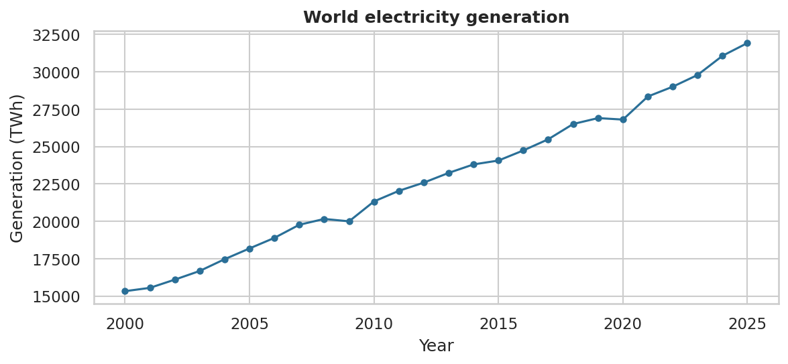
Fig. 7.1 World electricity generation, 2000-2025 (TWh)
The line rises almost every year, from 15,325 TWh to 31,923 TWh. The only visible dips are 2009 and 2020, and both are small. This shows that demand for electricity has grown steadily.

7.2 How the source mix changed
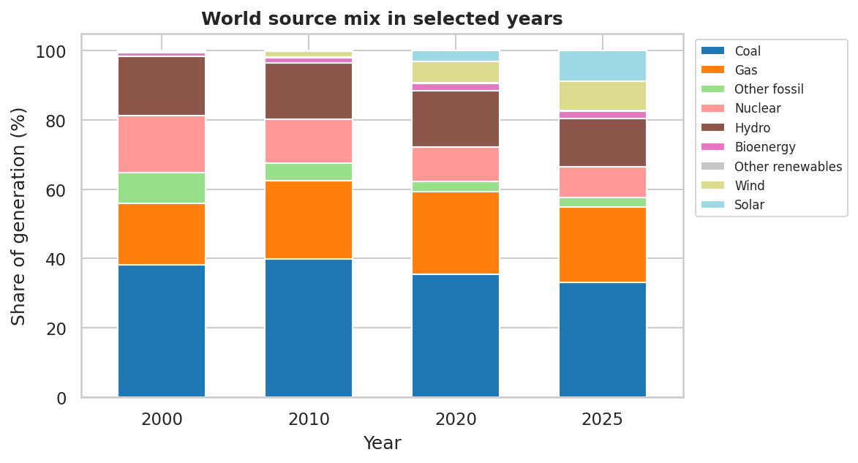
Fig. 7.2 World source mix in 2000, 2010, 2020 and 2025 (% of generation)
Each bar adds up to 100 per cent. The blue coal segment shrinks only slowly, while the solar and wind segments at the top grow from almost nothing to a large slice. The brown hydro and pink nuclear segments get thinner, not because they produce less but because the whole bar represents a much bigger total.

7.3 The largest generators
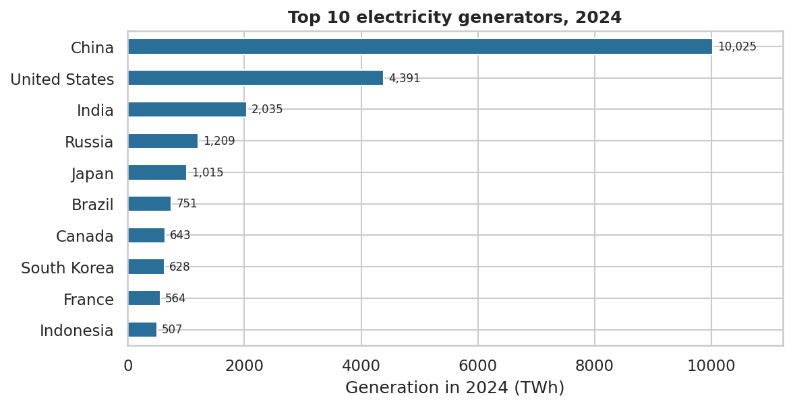
Fig. 7.3 Top 10 electricity generators in 2024 (TWh)
China generated 10,025 TWh, about 32 per cent of the world total and more than twice the United States. The top three (China, the United States and India) together produce about 53 per cent of the world total.

7.4 Regions compared
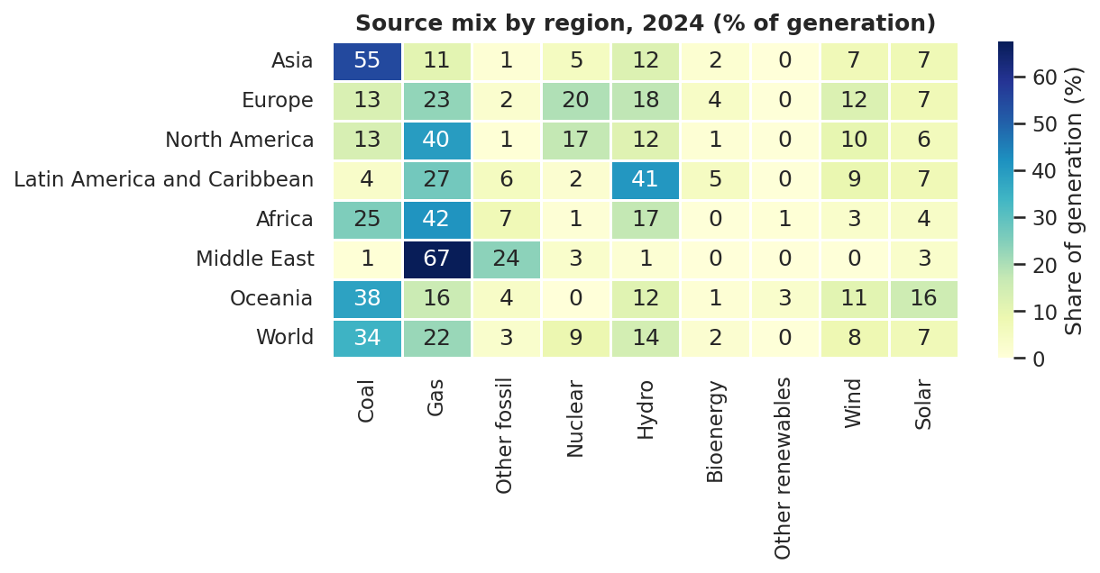
Fig. 7.4 Source mix by region in 2024 (% of generation)
The heatmap shows that each region has a different main source. Asia depends on coal (55 per cent), the Middle East on gas (67 per cent) and Latin America on hydro (41 per cent). Europe has a fairly balanced mix, with gas, nuclear, hydro and wind all between 12 and 23 per cent. Darker cells mean a bigger share.

7.5 Carbon intensity
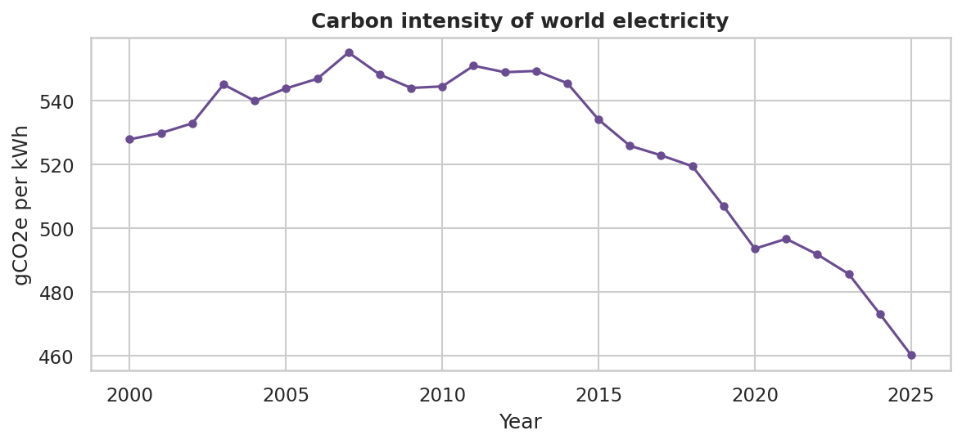
Fig. 7.5 Carbon intensity of world electricity (gCO2e per kWh)
Carbon intensity was 528 gCO2e/kWh in 2000. It rose to 555 around 2007, when the fossil share was at its highest, and has fallen since, reaching 460 in 2025. The fall has been slow, because coal and gas still produce most of the electricity.

7.6 Why only five charts
Many more charts are possible, for example a chart for every country or a map. I chose not to draw them because they would repeat the same message. The tables in Chapter 6 give the detailed numbers, and the five charts show the main patterns.

8. Methodology and Question-wise Implementation

8.1 Techniques and software
The analysis was done in a Jupyter notebook with pandas for tables, NumPy for array statistics, and Matplotlib and Seaborn for charts. Each question below follows the format asked for in the instructions: a concept note, the code, the output and a short insight. Because the other questions need clean data, Q3 (missing values) is done first. The code and outputs shown here are the real ones from the notebook.

Setup and loading
Code:
import numpy as np
import pandas as pd
import matplotlib.pyplot as plt
import seaborn as sns
sns.set_theme(style='whitegrid')
plt.rcParams['figure.dpi'] = 110
pd.set_option('display.width', 100)
pd.set_option('display.max_columns', 30)

Code:
raw = pd.read_csv('release_generation_yearly_global.csv')
df = raw.copy()
print('Rows and columns :', df.shape)
print('Years covered :', df['Year'].min(), 'to', df['Year'].max())
print('Areas :', df['Area'].nunique())
print('Area types :', df['Area type'].value_counts().to_dict())
print('Sources in file :', df['Electricity source'].nunique())

Output:
Rows and columns : (104241, 24)
Years covered : 1985 to 2025
Areas : 224
Area types : {'Country or economy': 97975, 'Region': 6266}
Sources in file : 17

Inspection
Code:
print(df.dtypes.value_counts().to_string())
print()
print('Duplicate rows:', df.duplicated().sum())
print()
missing = df.isna().sum()
missing = missing[missing > 0].sort_values(ascending=False).to_frame('missing')
missing['percent'] = (missing['missing'] / len(df) * 100).round(1)
print(missing)

Output:
float64 11
str 6
bool 6
int64 1
Duplicate rows: 0
missing percent
Emissions YoY change (%) 48746 46.8
Emissions intensity (gCO2e/kWh) 40583 38.9
Generation YoY change (%) 37028 35.5
Capacity (GW) 28355 27.2
Emissions YoY change (MtCO2e) 9826 9.4
Share of emissions (%) 6337 6.1
Emissions (MtCO2e) 6305 6.0
Continent 6266 6.0
ISO 3 code 6266 6.0
Ember region 6266 6.0
Share of generation YoY change (% points) 3779 3.6
Generation YoY change (TWh) 3745 3.6
Share of generation (%) 34 0.0

Code:
# The file has a flag that marks summary rows (totals and groups of other rows)
flag_view = df.groupby('Is aggregated source')['Electricity source'].unique()
for flag, names in flag_view.items():
print('Is aggregated source =', flag)
print(' ', ', '.join(names))

Output:
Is aggregated source = False
Solar, Wind, Hydro, Bioenergy, Other renewables, Nuclear, Coal, Gas, Other fossil, Net imports
Is aggregated source = True
Wind and solar, Hydro, bioenergy and other renewables, Renewables, Clean, Fossil, Total generation, Demand

8.2 Q3: Handling missing values [CO3, BL3]
Concept. Missing values break averages, totals and shares, so they are handled before any other question. The rules are in Table 5.2: text gaps get a label, shares and intensity are recalculated, capacity is zero where there is no generation and estimated where there is, and the year-on-year columns are rebuilt with diff(). A flag column keeps track of every filled cell.
Code:
# Step 1: remember which cells were missing
gap_cols = [c for c in df.columns if df[c].isna().any()]
for c in gap_cols:
df[c + ' (was missing)'] = df[c].isna()
print('Columns that had gaps:', len(gap_cols))
# Step 2: text columns
df['ISO 3 code'] = df['ISO 3 code'].fillna('Region')
df['Continent'] = df['Continent'].fillna('Not applicable')
df['Ember region'] = df['Ember region'].fillna('Not applicable')
# Step 3: emissions - only the Demand rows are empty
df['Emissions (MtCO2e)'] = df['Emissions (MtCO2e)'].fillna(0)
# Step 4: shares - recalculate from the 'Total generation' row of the same area and year
tot = df[df['Electricity source'] == 'Total generation'].set_index(['Area', 'Year'])
key = pd.MultiIndex.from_arrays([df['Area'], df['Year']])
tot_gen = tot['Generation (TWh)'].reindex(key).to_numpy()
tot_em = tot['Emissions (MtCO2e)'].reindex(key).to_numpy()
share_gen = np.where(tot_gen > 0, df['Generation (TWh)'] / tot_gen * 100, 0)
share_em = np.where(tot_em > 0, df['Emissions (MtCO2e)'] / tot_em * 100, 0)
df['Share of generation (%)'] = df['Share of generation (%)'].fillna(pd.Series(share_gen, index=df.index))
df['Share of emissions (%)'] = df['Share of emissions (%)'].fillna(pd.Series(share_em, index=df.index))
print('Share columns still missing:', df[['Share of generation (%)', 'Share of emissions (%)']].isna().sum().sum())

Output:
Columns that had gaps: 13
Share columns still missing: 0

Code:
# Step 5: capacity
real = df[(~df['Is aggregated source']) & (df['Electricity source'] != 'Net imports')]
ok = real[(real['Capacity (GW)'] > 0) & (real['Generation (TWh)'] > 0)]
# capacity factor = actual generation / (capacity x hours in a year)
cf = (ok['Generation (TWh)'] * 1000 / (ok['Capacity (GW)'] * 8760)).groupby(ok['Electricity source']).median().clip(upper=1)
print('Typical capacity factor by source:')
print(cf.round(2).to_string())
is_real = ~(df['Is aggregated source'] | (df['Electricity source'] == 'Net imports'))
need = df['Capacity (GW)'].isna() & is_real # real sources with no capacity value
print()
print('Real-source rows with missing capacity :', need.sum())
print(' of which generation is 0 (no plant) :', (need & (df['Generation (TWh)'] == 0)).sum())
print(' of which there is generation :', (need & (df['Generation (TWh)'] > 0)).sum())
estimate = df['Generation (TWh)'] * 1000 / (8760 * df['Electricity source'].map(cf))
df.loc[need & (df['Generation (TWh)'] > 0), 'Capacity (GW)'] = estimate
df['Capacity (GW)'] = df['Capacity (GW)'].fillna(0) # no generation -> no capacity; summary rows -> 0

Output:
Typical capacity factor by source:
Electricity source
Bioenergy 0.50
Coal 0.56
Gas 0.42
Hydro 0.39
Nuclear 0.81
Other fossil 0.35
Other renewables 0.69
Solar 0.13
Wind 0.24
Real-source rows with missing capacity : 11974
of which generation is 0 (no plant) : 7223
of which there is generation : 4751

Code:
# Step 6: YoY columns and emissions intensity
df = df.sort_values(['Area', 'Electricity source', 'Year']).reset_index(drop=True)
grp = df.groupby(['Area', 'Electricity source'])
df['Generation YoY change (TWh)'] = df['Generation YoY change (TWh)'].fillna(grp['Generation (TWh)'].diff())
df['Emissions YoY change (MtCO2e)'] = df['Emissions YoY change (MtCO2e)'].fillna(grp['Emissions (MtCO2e)'].diff())
pp = 'Share of generation YoY change (% points)'
df[pp] = df[pp].fillna(grp['Share of generation (%)'].diff())
intensity_calc = np.where(df['Generation (TWh)'] > 0, df['Emissions (MtCO2e)'] / df['Generation (TWh)'] * 1000, 0)
df['Emissions intensity (gCO2e/kWh)'] = df['Emissions intensity (gCO2e/kWh)'].fillna(pd.Series(intensity_calc, index=df.index))
# Step 7: whatever is still empty (first year of a series, undefined % changes) becomes 0
num_cols = df.select_dtypes('number').columns
df[num_cols] = df[num_cols].fillna(0)

Code:
# Check: no missing values should remain in the data columns
flag_cols = [c for c in df.columns if c.endswith('(was missing)')]
data_cols = [c for c in df.columns if c not in flag_cols]
print('Missing values left in data columns:', int(df[data_cols].isna().sum().sum()))
print()
print('How many cells were filled in each column:')
filled = df[flag_cols].sum().sort_values(ascending=False)
filled.index = [c.replace(' (was missing)', '') for c in filled.index]
print(filled.to_string())

Output:
Missing values left in data columns: 0
How many cells were filled in each column:
Emissions YoY change (%) 48746
Emissions intensity (gCO2e/kWh) 40583
Generation YoY change (%) 37028
Capacity (GW) 28355
Emissions YoY change (MtCO2e) 9826
Share of emissions (%) 6337
Emissions (MtCO2e) 6305
Continent 6266
ISO 3 code 6266
Ember region 6266
Share of generation YoY change (% points) 3779
Generation YoY change (TWh) 3745
Share of generation (%) 34

Insight. Every data column is complete, and each filled cell can be traced through its flag column. The main judgement was capacity: zero where a source produces nothing, and an estimate from the typical capacity factor where it produces electricity but the capacity was not reported.

Separating real sources
Code:
not_a_source = df['Is aggregated source'] | (df['Electricity source'] == 'Net imports')
sources = df[~not_a_source].copy()
countries = sources[sources['Area type'] == 'Country or economy']
regions = sources[sources['Area type'] == 'Region']
world = sources[sources['Area'] == 'World']
FOSSIL = ['Coal', 'Gas', 'Other fossil']
print('Rows kept :', len(sources), 'of', len(df))
print('Real sources :', sorted(sources['Electricity source'].unique()))
print('Countries / economies :', countries['Area'].nunique())
print('Regions :', regions['Area'].nunique())
print('World rows :', len(world), '| years', world['Year'].min(), 'to', world['Year'].max())
# Consistency check: do the nine sources add up to the reported world total?
check_year = 2024
reported = df[(df['Area'] == 'World') & (df['Year'] == check_year) & (df['Electricity source'] == 'Total generation')]['Generation (TWh)'].iloc[0]
summed = world[world['Year'] == check_year]['Generation (TWh)'].sum()
print(f'World {check_year}: sum of sources = {summed:,.1f} TWh | reported total = {reported:,.1f} TWh')

Output:
Rows kept : 54541 of 104241
Real sources : ['Bioenergy', 'Coal', 'Gas', 'Hydro', 'Nuclear', 'Other fossil', 'Other renewables', 'Solar', 'Wind']
Countries / economies : 209
Regions : 15
World rows : 234 | years 2000 to 2025
World 2024: sum of sources = 31,070.7 TWh | reported total = 31,070.7 TWh

8.3 Q1: NumPy statistics [CO1, BL3]
Concept. The world's yearly generation of each source is placed in a NumPy array with one row per year and one column per source. Functions such as np.mean and np.max with axis=0 then work down each column, giving a statistic for every source in one step. np.argmax gives the position of the peak, which is turned into a year. np.diff gives the year-to-year changes of the total.
Code:
gen = world.pivot_table(index='Year', columns='Electricity source', values='Generation (TWh)', aggfunc='sum').sort_index()
years = gen.index.to_numpy()
arr = gen.to_numpy() # shape: (number of years, number of sources)
print('Array shape (years x sources):', arr.shape)
stats = pd.DataFrame({
'mean': np.mean(arr, axis=0),
'min': np.min(arr, axis=0),
'max': np.max(arr, axis=0),
'std': np.std(arr, axis=0),
'peak_year': years[np.argmax(arr, axis=0)],
'first': arr[0],
'last': arr[-1],
}, index=gen.columns)
stats['change_x'] = (stats['last'] / stats['first']).round(1)
print()
print(stats.round(1).sort_values('mean', ascending=False).to_string())

Output:
Array shape (years x sources): (26, 9)
mean min max std peak_year first last change_x
Electricity source
Coal 8706.6 5841.1 10652.4 1499.4 2024 5841.1 10606.8 1.8
Gas 5053.1 2747.1 6920.5 1320.4 2025 2747.1 6920.5 2.5
Hydro 3598.2 2566.6 4462.9 643.8 2024 2632.6 4446.2 1.7
Nuclear 2647.2 2431.9 2805.0 98.0 2025 2540.5 2805.0 1.1
Other fossil 1089.4 793.4 1329.1 163.1 2000 1329.1 889.0 0.7
Wind 866.7 31.2 2705.1 834.1 2025 31.2 2705.1 86.8
Solar 490.8 1.1 2806.6 732.5 2025 1.1 2806.6 2593.9
Bioenergy 393.9 154.6 652.4 166.7 2025 159.0 652.4 4.1
Other renewables 66.7 43.6 91.5 16.2 2025 43.6 91.5 2.1

Code:
# Total generation and its yearly growth, again with NumPy
total = arr.sum(axis=1)
growth = np.diff(total) / total[:-1] * 100 # % change from one year to the next
n_years = years[-1] - years[0]
cagr = ((total[-1] / total[0]) ** (1 / n_years) - 1) * 100
print(f'Total generation {years[0]}: {total[0]:,.0f} TWh')
print(f'Total generation {years[-1]}: {total[-1]:,.0f} TWh')
print(f'Average yearly growth : {growth.mean():.2f} %')
print(f'Compound annual growth rate : {cagr:.2f} %')
print(f'Fastest year : {years[1:][np.argmax(growth)]} ({growth.max():.1f} %)')
print(f'Slowest year : {years[1:][np.argmin(growth)]} ({growth.min():.1f} %)')
print('Years with a fall in generation:', years[1:][growth < 0].tolist())

Output:
Total generation 2000: 15,325 TWh
Total generation 2025: 31,923 TWh
Average yearly growth : 2.99 %
Compound annual growth rate : 2.98 %
Fastest year : 2010 (6.6 %)
Slowest year : 2009 (-0.8 %)
Years with a fall in generation: [2009, 2020]

Insight. Coal and gas have the highest averages, and coal also has the highest peak. Solar and wind have the smallest averages but the biggest growth from the first to the last year. Total generation grew in every year except 2009 and 2020. The average growth is about 3 per cent a year, so generation roughly doubled in 25 years.

8.4 Q2: Pandas groupby analysis [CO2, BL4]
Concept. groupby splits the table into groups (a year, a region), calculates a number for each group and joins the results. It is used here to split generation into fossil and low-carbon by year, to calculate the share of every source, and to compare regions in 2000 and 2024.
Code:
# Fossil vs low-carbon generation in the world, by year
w = world.assign(group=np.where(world['Electricity source'].isin(FOSSIL), 'Fossil', 'Low-carbon'))
by_group = w.groupby(['Year', 'group'])['Generation (TWh)'].sum().unstack()
by_group['Fossil share (%)'] = by_group['Fossil'] / by_group[['Fossil', 'Low-carbon']].sum(axis=1) * 100
sw = world[world['Electricity source'].isin(['Solar', 'Wind'])].groupby('Year')['Generation (TWh)'].sum()
by_group['Solar+Wind share (%)'] = sw / by_group[['Fossil', 'Low-carbon']].sum(axis=1) * 100
print(by_group.loc[[2000, 2005, 2010, 2015, 2020, 2024, 2025]].round(1).to_string())

Output:
group Fossil Low-carbon Fossil share (%) Solar+Wind share (%)
Year
2000 9917.3 5408.0 64.7 0.2
2005 12165.8 6017.8 66.9 0.6
2010 14399.0 6928.2 67.5 1.8
2015 16010.5 8052.9 66.5 4.5
2020 16697.4 10105.7 62.3 9.1
2024 18442.0 12628.7 59.4 15.0
2025 18416.3 13506.9 57.7 17.3

Code:
# Share of every source in selected years
snap = [2000, 2010, 2020, 2025]
mix = world[world['Year'].isin(snap)].pivot_table(index='Electricity source', columns='Year', values='Generation (TWh)', aggfunc='sum')
mix_share = (mix / mix.sum() * 100).round(1)
order = ['Coal', 'Gas', 'Other fossil', 'Nuclear', 'Hydro', 'Bioenergy', 'Other renewables', 'Wind', 'Solar']
mix_share = mix_share.loc[order]
print(mix_share.to_string())

Output:
Year 2000 2010 2020 2025
Electricity source
Coal 38.1 39.9 35.5 33.2
Gas 17.9 22.6 23.9 21.7
Other fossil 8.7 5.0 3.0 2.8
Nuclear 16.6 12.8 9.9 8.8
Hydro 17.2 16.1 16.2 13.9
Bioenergy 1.0 1.5 2.1 2.0
Other renewables 0.3 0.3 0.3 0.3
Wind 0.2 1.6 5.9 8.5
Solar 0.0 0.2 3.2 8.8

Code:
# Regions: growth from 2000 to 2024 and fossil share in 2024
r = regions[regions['Year'].isin([2000, 2024])]
reg_total = r.groupby(['Area', 'Year'])['Generation (TWh)'].sum().unstack()
reg_total['Growth (%)'] = (reg_total[2024] / reg_total[2000] - 1) * 100
r24 = regions[regions['Year'] == 2024]
fossil_24 = r24[r24['Electricity source'].isin(FOSSIL)].groupby('Area')['Generation (TWh)'].sum()
reg_total['Fossil share 2024 (%)'] = fossil_24 / reg_total[2024] * 100
reg_total = reg_total.rename(columns={2000: 'TWh 2000', 2024: 'TWh 2024'})
print(reg_total.sort_values('TWh 2024', ascending=False).round(0).astype({'Growth (%)': int}).to_string())

Output:
Year TWh 2000 TWh 2024 Growth (%) Fossil share 2024 (%)
Area
World 15325.0 31071.0 103 59.0
G20 13077.0 26133.0 100 58.0
Asia 4246.0 16208.0 282 66.0
OECD 9620.0 11199.0 16 48.0
G7 7254.0 7657.0 6 50.0
Europe 4478.0 5093.0 14 39.0
North America 4406.0 5034.0 14 54.0
EU 2622.0 2772.0 6 29.0
MENA 625.0 2009.0 222 91.0
Latin America and Caribbean 1008.0 1871.0 86 36.0
Middle East 483.0 1560.0 223 92.0
ASEAN 425.0 1526.0 259 75.0
Africa 441.0 965.0 119 74.0
AU 439.0 962.0 119 74.0
Oceania 263.0 340.0 29 58.0

Insight. The fossil share rose to 68.4 per cent in 2007 and has fallen to 57.7 per cent in 2025, while solar and wind grew from 0.2 to 17.3 per cent. Growth is very uneven between regions. Asia grew by about 282 per cent and produced about 76 per cent of all the extra electricity, while the EU and the G7 grew by only about 6 per cent. Some regions overlap, so their rows must not be added together.

8.5 Q4: Descriptive statistics by continent and country [CO4, BL4]
Concept. A table with one row per country is built for 2024, with the generation of each source. It is then grouped by continent, and for each group the number of countries, the total, the mean and median generation, and the fossil share are calculated. The same table is used to describe how the fossil share is spread, to list the biggest generators, and to compare the carbon intensity of the sources.
Code:
c24 = countries[countries['Year'] == 2024]
by_country = c24.pivot_table(index=['Area', 'Continent'], columns='Electricity source', values='Generation (TWh)', aggfunc='sum').fillna(0)
by_country['total'] = by_country.sum(axis=1)
by_country = by_country[by_country['total'] > 0].reset_index()
by_country['fossil_share'] = by_country[FOSSIL].sum(axis=1) / by_country['total'] * 100
by_country['solar_wind_share'] = by_country[['Solar', 'Wind']].sum(axis=1) / by_country['total'] * 100
print('Countries with generation in 2024:', len(by_country))
cont = by_country.groupby('Continent').agg(
countries=('Area', 'count'),
total_TWh=('total', 'sum'),
mean_TWh=('total', 'mean'),
median_TWh=('total', 'median'),
avg_fossil=('fossil_share', 'mean'))
cont['wtd_fossil'] = by_country.groupby('Continent')[FOSSIL].sum().sum(axis=1) / cont['total_TWh'] * 100
print()
print(cont.sort_values('total_TWh', ascending=False).round(1).to_string())

Output:
Countries with generation in 2024: 193
countries total_TWh mean_TWh median_TWh avg_fossil wtd_fossil
Continent
Asia 49 18108.8 369.6 49.1 68.5 68.3
North America 27 5571.0 206.3 4.5 67.8 55.5
Europe 40 4649.4 116.2 38.1 35.8 37.6
South America 13 1328.0 102.2 42.4 39.1 20.9
Africa 50 961.4 19.2 3.4 59.1 74.3
Oceania 14 340.2 24.3 0.4 68.1 58.1

Code:
# How are fossil shares spread across countries?
print(by_country['fossil_share'].describe().round(1).to_string())
bands = pd.cut(by_country['fossil_share'], bins=[-0.1, 25, 50, 75, 90, 100.1],
labels=['0-25 %', '25-50 %', '50-75 %', '75-90 %', '90-100 %'])
print()
print('Number of countries by fossil share band:')
print(bands.value_counts().sort_index().to_string())

Output:
count 193.0
mean 57.2
std 33.2
min 0.0
25% 26.5
50% 64.2
75% 86.7
max 100.0
Number of countries by fossil share band:
fossil_share
0-25 % 46
25-50 % 31
50-75 % 38
75-90 % 36
90-100 % 42

Code:
# The ten biggest generators of 2024
top10 = by_country.sort_values('total', ascending=False).head(10).set_index('Area')
top10 = top10[['Continent', 'total', 'fossil_share', 'solar_wind_share']].round(1)
top10.columns = ['Continent', 'Total TWh', 'Fossil %', 'Solar+Wind %']
print(top10.to_string())

Output:
Continent Total TWh Fossil % Solar+Wind %
Area
China Asia 10025.0 62.3 18.3
United States North America 4391.0 58.1 17.2
India Asia 2035.2 77.6 11.0
Russia Europe 1209.3 64.1 0.6
Japan Asia 1015.0 68.9 10.6
Brazil South America 751.3 9.9 23.7
Canada North America 642.6 22.6 8.7
South Korea Asia 627.8 59.5 6.6
France Europe 564.5 5.1 12.9
Indonesia Asia 507.3 85.2 0.4

Code:
# Carbon intensity by source (world, 2024) and India's mix
w24 = world[world['Year'] == 2024].set_index('Electricity source')
ci = w24[['Generation (TWh)', 'Emissions (MtCO2e)', 'Emissions intensity (gCO2e/kWh)']].round(0).sort_values('Emissions intensity (gCO2e/kWh)', ascending=False)
ci.columns = ['TWh', 'MtCO2e', 'gCO2e/kWh']
print(ci.to_string())
india = countries[(countries['Area'] == 'India') & (countries['Year'] == 2024)].set_index('Electricity source')['Generation (TWh)']
print()
print(f"India 2024 total: {india.sum():,.0f} TWh")
print((india / india.sum() * 100).round(1).sort_values(ascending=False).to_string())

Output:
TWh MtCO2e gCO2e/kWh
Electricity source
Coal 10652.0 9631.0 904.0
Other fossil 896.0 591.0 660.0
Gas 6893.0 4081.0 592.0
Bioenergy 635.0 138.0 218.0
Solar 2161.0 103.0 48.0
Other renewables 88.0 3.0 38.0
Hydro 4463.0 106.0 24.0
Wind 2506.0 29.0 12.0
Nuclear 2775.0 15.0 5.0
India 2024 total: 2,035 TWh
Electricity source
Coal 74.6
Hydro 7.7
Solar 7.0
Wind 4.0
Gas 2.8
Nuclear 2.7
Bioenergy 1.1
Other fossil 0.2

Insight. Asia generates about 18,109 of the 31,071 TWh produced in 2024. The fossil share varies widely between countries: 46 countries get less than a quarter of their electricity from fossil fuels and 42 get more than 90 per cent. Among the ten largest generators, France (5 per cent) and Brazil (10 per cent) are very clean, while Indonesia (85 per cent) and India (78 per cent) are very fossil-heavy. Coal has the highest carbon intensity, about 904 gCO2e/kWh, roughly 1.5 times that of gas.

8.6 Q5: Visualization [CO5, BL5]
Concept. Charts make the tables easier to read. A line chart shows a trend, a stacked bar chart shows how a total is divided, a horizontal bar chart ranks countries, and a heatmap shows a table of shares as colours. The output of each cell is the chart shown in Chapter 7 (Fig. 7.1 to Fig. 7.5).
Code:
fig, ax = plt.subplots(figsize=(8, 3.8))
ax.plot(gen.index, total, marker='o', ms=4, color='#2a6f97')
ax.set_xlabel('Year'); ax.set_ylabel('Generation (TWh)')
ax.set_title('World electricity generation', fontweight='bold')
plt.tight_layout(); plt.show()

Output: Fig. 7.1
Code:
share_all = world[world['Year'].isin(snap)].pivot_table(index='Year', columns='Electricity source', values='Generation (TWh)', aggfunc='sum')
share_all = share_all[order].div(share_all.sum(axis=1), axis=0) * 100
fig, ax = plt.subplots(figsize=(8, 4.4))
share_all.plot(kind='bar', stacked=True, ax=ax, colormap='tab20', width=0.6)
ax.set_xlabel('Year'); ax.set_ylabel('Share of generation (%)')
ax.set_title('World source mix in selected years', fontweight='bold')
ax.legend(bbox_to_anchor=(1.01, 1), loc='upper left', fontsize=8)
plt.xticks(rotation=0); plt.tight_layout(); plt.show()

Output: Fig. 7.2
Code:
fig, ax = plt.subplots(figsize=(8, 4.2))
top10['Total TWh'].sort_values().plot(kind='barh', ax=ax, color='#2a6f97')
for i, v in enumerate(top10['Total TWh'].sort_values()):
ax.text(v + 80, i, f'{v:,.0f}', va='center', fontsize=8)
ax.set_xlabel('Generation in 2024 (TWh)'); ax.set_ylabel('')
ax.set_title('Top 10 electricity generators, 2024', fontweight='bold')
ax.set_xlim(0, top10['Total TWh'].max() * 1.12)
plt.tight_layout(); plt.show()

Output: Fig. 7.3
Code:
geo = ['Asia', 'Europe', 'North America', 'Latin America and Caribbean', 'Africa', 'Middle East', 'Oceania', 'World']
h = regions[(regions['Year'] == 2024) & (regions['Area'].isin(geo))].pivot_table(index='Area', columns='Electricity source', values='Generation (TWh)', aggfunc='sum')
h = (h[order].div(h[order].sum(axis=1), axis=0) * 100).loc[geo]
fig, ax = plt.subplots(figsize=(8.5, 4.4))
sns.heatmap(h, annot=True, fmt='.0f', cmap='YlGnBu', linewidths=.5, cbar_kws={'label': 'Share of generation (%)'}, ax=ax)
ax.set_title('Source mix by region, 2024 (% of generation)', fontweight='bold')
ax.set_xlabel(''); ax.set_ylabel('')
plt.tight_layout(); plt.show()

Output: Fig. 7.4
Code:
ci_year = world.groupby('Year').agg(em=('Emissions (MtCO2e)', 'sum'), g=('Generation (TWh)', 'sum'))
ci_year['intensity'] = ci_year['em'] / ci_year['g'] * 1000
fig, ax = plt.subplots(figsize=(8, 3.8))
ax.plot(ci_year.index, ci_year['intensity'], marker='o', ms=4, color='#6a4c93')
ax.set_xlabel('Year'); ax.set_ylabel('gCO2e per kWh')
ax.set_title('Carbon intensity of world electricity', fontweight='bold')
plt.tight_layout(); plt.show()
print(ci_year['intensity'].loc[[2000, 2005, 2010, 2015, 2020, 2024, 2025]].round(0).to_string())

Output: Fig. 7.5
Output:
Year
2000 528.0
2005 544.0
2010 544.0
2015 534.0
2020 494.0
2024 473.0
2025 460.0

Insight. The charts support the tables: steady growth, a slow shift in the mix, a few very large generators, very different regional mixes, and a carbon intensity that is falling slowly.

9. Results and Discussion

9.1 Key insights
1. World electricity generation grew from 15,325 TWh in 2000 to 31,071 TWh in 2024, about 103 per cent more.
2. Coal is still the largest single source, at 33.2 per cent of generation in 2025, but its share fell from 38.1 per cent in 2000.
3. The fossil share peaked at 68.4 per cent in 2007 and fell to 57.7 per cent in 2025.
4. Solar and wind grew from 0.2 to 17.3 per cent of world generation. In 2025 solar passed nuclear and solar plus wind passed hydro.
5. Carbon intensity fell from 528 to 460 gCO2e per kWh, a fall of about 13 per cent.
6. Asia produced about 76 per cent of the world's extra electricity between 2000 and 2024.
7. China, the United States and India together generate about 53 per cent of the world's electricity.
8. Countries are either mostly fossil or mostly clean; few are in the middle.

9.2 How the results answer the project questions
Table 9.1 Answers to the project questions
Q | Answer from the analysis
Q1 | Coal and gas have the highest average yearly output. Solar and wind grew the most, wind 87 times and solar about 2,594 times between 2000 and 2025.
Q2 | The fossil share peaked in 2007 and has fallen since. Asia and other fast-growing regions drove growth, while the EU and G7 grew very little.
Q3 | All data columns were filled with documented rules, and no gaps remain. Capacity needed an estimate, and summary rows had to be removed to avoid double counting.
Q4 | Asia is the largest generating continent. Fossil share varies from 0 to 100 per cent across countries. Coal is the most carbon-intensive source.
Q5 | Five charts show growth, the changing mix, the largest generators, regional differences and carbon intensity.

9.3 Regional discussion
Growth has come mainly from Asia, which grew by about 282 per cent from 4,246 TWh to 16,208 TWh. The Middle East and ASEAN also more than tripled their output. In the EU, Europe, North America and the G7, generation grew by only 6 to 14 per cent. In these older systems the story is the change in the mix, not the growth. The fossil share in 2024 was about 92 per cent in the Middle East, 75 per cent in ASEAN, 66 per cent in Asia, but only about 29 per cent in the EU. This means that the regions that are growing fastest are also those that still depend most on fossil fuels. Since these regions dominate the world total, the world fossil share falls only slowly.

9.4 India as a case
India generated about 2,035 TWh in 2024, the third highest in the world. Coal supplied 74.6 per cent of it. The rest came from hydro (7.7 per cent), solar (7.0 per cent), wind (4.0 per cent), gas (2.8 per cent), nuclear (2.7 per cent) and bioenergy (1.1 per cent). India's fossil share is about 78 per cent, compared with 59 per cent for the world in 2024. Its solar and wind share is 11 per cent, compared with 15 per cent for the world. India is therefore a large system that still depends on coal, but where solar and wind already make up a meaningful part.
Table 9.2 India electricity source mix, 2024
Source | Share of India's generation, 2024 (%)
Coal | 74.6
Hydro | 7.7
Solar | 7.0
Wind | 4.0
Gas | 2.8
Nuclear | 2.7
Bioenergy | 1.1
Other fossil | 0.2

9.5 Limitations and possible bias
• Estimated capacity. About 4,751 capacity values for real sources are estimates based on typical capacity factors. They do not affect generation, share or emissions results.
• Newest year. The data for 2025 is the most recent and may be revised, so country comparisons use 2024.
• Averages hide differences. Continent and world averages combine very different countries.
• Overlapping regions. Regions such as Asia, ASEAN and the G20 contain the same countries and cannot be added together.
• Emission values for clean sources. Solar, wind, hydro and nuclear have small non-zero emissions, probably life-cycle amounts, so their intensity values are low but not zero.
• No causes. The data shows what changed but not why. Policy, prices, weather and economic growth are not in the file.
• Size bias. Large countries dominate the totals, and the file has no population data, so no per-person comparison is made.

10. Conclusion and Recommendations

10.1 Summary of main findings
Electricity generation has grown strongly since 2000, by about 103 per cent to 2024, and most of the extra electricity was produced in Asia. Fossil fuels still make most of the world's electricity, but their share peaked in 2007 and has fallen to 57.7 per cent. Solar and wind went from almost nothing to 17.3 per cent, and in 2025 low-carbon sources supplied all of the growth in demand. Carbon intensity has fallen from 528 to 460 gCO2e per kWh, but the fall is slow. Countries differ greatly, and total size does not show how clean a system is.

10.2 Recommendations
These recommendations are based on the patterns in the data. They are suggestions for further thought, not forecasts.
1. Focus on the fast-growing, fossil-heavy regions. Asia, the Middle East and ASEAN account for most of the new demand, so cleaner supply there has the largest effect on the world total.
2. Report the source mix together with total output. Two countries with the same output can have very different fossil shares, so total generation alone is a poor measure of progress.
3. Track the share of low-carbon sources and also the absolute fossil generation. The fossil share can fall while fossil generation still grows, as happened for most years in this period.
4. Keep the data complete. Capacity values were missing for thousands of rows that had generation, so publishers should record capacity for every source and year.
5. For large coal-based systems such as India, track both coal use and the speed of solar and wind growth, because the two together decide the carbon intensity.

10.3 Future work
• Add population data to compare generation per person.
• Draw a map of the source mix by country to show regional patterns.
• Use a forecasting model to estimate when solar and wind might pass coal if current trends continue.
• Add electricity demand and price data to study why some countries change faster than others.
• Repeat the analysis when the next release of the dataset is published.

11. References

11.1 Libraries and literature
1. McKinney, W. (2010). Data structures for statistical computing in Python. Proceedings of the 9th Python in Science Conference, 56-61. https://pandas.pydata.org
2. Harris, C. R. et al. (2020). Array programming with NumPy. Nature, 585, 357-362. https://numpy.org
3. Hunter, J. D. (2007). Matplotlib: A 2D graphics environment. Computing in Science and Engineering, 9(3), 90-95. https://matplotlib.org
4. Waskom, M. L. (2021). seaborn: statistical data visualization. Journal of Open Source Software, 6(60), 3021. https://seaborn.pydata.org
5. Kluyver, T. et al. (2016). Jupyter Notebooks: a publishing format for reproducible computational workflows. Positioning and Power in Academic Publishing, 87-90. https://jupyter.org

11.2 Data source
Dataset: release_generation_yearly_global.csv, supplied for the course. Original publisher and access date: [to be added by the student; the file itself does not state its source].

11.3 Links
Report Google link: _https://drive.google.com/drive/u/0/folders/18Woh1ZJ6wCplzsklpbfUmnGTnaUuMrE_
GitHub project repository: https://github.com/varunbasude16/EDAV-Course-End-project
Dataset link : https://ember-energy.org/data/

12. Appendices

Appendix A: Notebook structure
The notebook electricity_generation_analysis.ipynb has these parts, in order: (1) setup and loading, (2) inspection, (3) Q3 missing values, (4) separating real sources, (5) Q1 NumPy statistics, (6) Q2 groupby analysis, (7) Q4 descriptive statistics, (8) Q5 visualization and (9) conclusion. Place the CSV file in the same folder as the notebook and use Kernel, Restart and Run All to reproduce every number and chart in this report.

Appendix B: World generation by year
Table 12.1 World generation, fossil share and carbon intensity by year
Year | Total (TWh) | Fossil (TWh) | Low-carbon (TWh) | Fossil (%) | Solar+Wind (%) | gCO2e/kWh
2000 | 15,325 | 9,917 | 5,408 | 64.7 | 0.2 | 528
2001 | 15,548 | 10,129 | 5,418 | 65.2 | 0.3 | 530
2002 | 16,098 | 10,561 | 5,537 | 65.6 | 0.3 | 533
2003 | 16,676 | 11,167 | 5,510 | 67.0 | 0.4 | 545
2004 | 17,464 | 11,604 | 5,860 | 66.4 | 0.5 | 540
2005 | 18,184 | 12,166 | 6,018 | 66.9 | 0.6 | 544
2006 | 18,890 | 12,685 | 6,205 | 67.2 | 0.7 | 547
2007 | 19,767 | 13,511 | 6,256 | 68.4 | 0.9 | 555
2008 | 20,157 | 13,652 | 6,505 | 67.7 | 1.2 | 548
2009 | 19,998 | 13,449 | 6,549 | 67.3 | 1.5 | 544
2010 | 21,327 | 14,399 | 6,928 | 67.5 | 1.8 | 544
2011 | 22,037 | 15,021 | 7,016 | 68.2 | 2.3 | 551
2012 | 22,585 | 15,421 | 7,163 | 68.3 | 2.8 | 549
2013 | 23,236 | 15,754 | 7,482 | 67.8 | 3.3 | 549
2014 | 23,804 | 16,017 | 7,787 | 67.3 | 3.8 | 545
2015 | 24,063 | 16,011 | 8,053 | 66.5 | 4.5 | 534
2016 | 24,739 | 16,298 | 8,441 | 65.9 | 5.2 | 526
2017 | 25,486 | 16,667 | 8,819 | 65.4 | 6.2 | 523
2018 | 26,507 | 17,213 | 9,295 | 64.9 | 7.0 | 519
2019 | 26,902 | 17,162 | 9,741 | 63.8 | 7.9 | 507
2020 | 26,803 | 16,697 | 10,106 | 62.3 | 9.1 | 494
2021 | 28,346 | 17,683 | 10,663 | 62.4 | 10.3 | 497
2022 | 29,002 | 17,889 | 11,113 | 61.7 | 11.9 | 492
2023 | 29,789 | 18,147 | 11,642 | 60.9 | 13.4 | 486
2024 | 31,071 | 18,442 | 12,629 | 59.4 | 15.0 | 473
2025 | 31,923 | 18,416 | 13,507 | 57.7 | 17.3 | 460

Appendix C: Top 20 generators in 2024
Table 12.2 The 20 largest electricity generators, 2024
Rank | Country | Continent | TWh | Fossil (%) | Solar+Wind (%)
1 | China | Asia | 10,025 | 62.3 | 18.3
2 | United States | North America | 4,391 | 58.1 | 17.2
3 | India | Asia | 2,035 | 77.6 | 11.0
4 | Russia | Europe | 1,209 | 64.1 | 0.6
5 | Japan | Asia | 1,015 | 68.9 | 10.6
6 | Brazil | South America | 751 | 9.9 | 23.7
7 | Canada | North America | 643 | 22.6 | 8.7
8 | South Korea | Asia | 628 | 59.5 | 6.6
9 | France | Europe | 564 | 5.1 | 12.9
10 | Indonesia | Asia | 507 | 85.2 | 0.4
11 | Germany | Europe | 492 | 41.7 | 43.0
12 | Saudi Arabia | Asia | 458 | 97.6 | 2.4
13 | Iran | Asia | 396 | 92.9 | 0.5
14 | Mexico | North America | 388 | 77.1 | 12.0
15 | Türkiye | Asia | 341 | 54.4 | 18.2
16 | Viet Nam | Asia | 311 | 56.4 | 14.7
17 | Taiwan (China) | Asia | 289 | 84.7 | 8.9
18 | United Kingdom | Europe | 284 | 35.0 | 34.6
19 | Australia | Oceania | 284 | 64.2 | 29.8
20 | Spain | Europe | 281 | 23.3 | 42.9

Appendix D: Regions in 2000 and 2024
Table 12.3 Generation by region (regions overlap and must not be added)
Region | TWh 2000 | TWh 2024 | Growth (%) | Fossil 2024 (%)
World | 15,325 | 31,071 | 103 | 59
G20 | 13,077 | 26,133 | 100 | 58
Asia | 4,246 | 16,208 | 282 | 66
OECD | 9,620 | 11,199 | 16 | 48
G7 | 7,254 | 7,657 | 6 | 50
Europe | 4,478 | 5,093 | 14 | 39
North America | 4,406 | 5,034 | 14 | 54
EU | 2,622 | 2,772 | 6 | 29
MENA | 625 | 2,009 | 222 | 91
Latin America and Caribbean | 1,008 | 1,871 | 86 | 36
Middle East | 483 | 1,560 | 223 | 92
ASEAN | 425 | 1,526 | 259 | 75
Africa | 441 | 965 | 119 | 74
AU | 439 | 962 | 119 | 74
Oceania | 263 | 340 | 29 | 58

Appendix E: Glossary
Table 12.4 Glossary
Term | Plain meaning
TWh | Terawatt-hour, a unit of electrical energy (one billion kWh)
Generation | Electricity produced in a year
Share | Part of the total that comes from one source, in per cent
Capacity | The most power a plant can produce at one time, in GW
Capacity factor | Actual generation divided by the maximum possible in a year
Fossil fuels | Coal, gas and oil, which release carbon when burned
Low-carbon | Nuclear, hydro, wind, solar, bioenergy and other renewables
Carbon intensity | Carbon released per unit of electricity, in gCO2e/kWh
Aggregate row | A row that adds up other rows, such as Fossil or Total generation
Imputation | Filling a missing value with a calculated or estimated one
YoY | Year on year, the change from the previous year

