**Program52.c – Dry Run Diagram**

Layout1

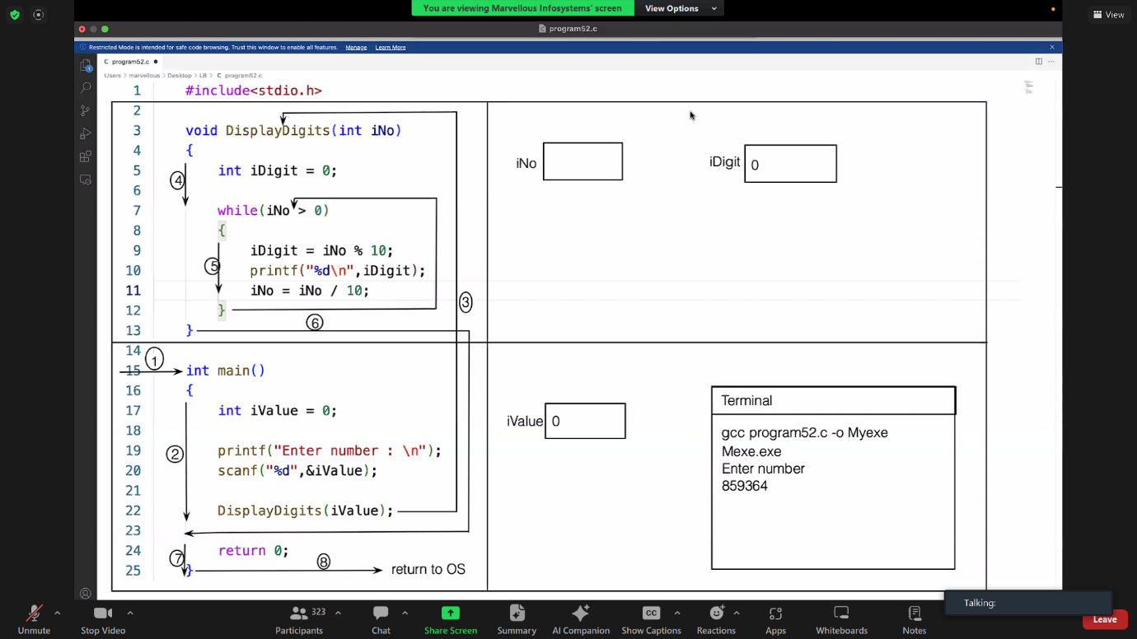

Layout2 – Dry Run Complete

