

#### Full Stack Web Development Mini Project

On

#### Online Portal for Course Registration

#### TYBTECH-CSF PANEL-B SEM-5

Submitted by

**PA-46 Varun Behere (1032221987)**

**PA-48 Aniket Mogal (1032222060)**

Under the guidance of

#### Mr. Sagar Apune

School of Computer Engineering and Technology MIT World Peace University, Kothrud,

Pune 411 038, Maharashtra - India



**SCHOOL OF COMPUTER ENGINEERING AND TECHNOLOGY**

**C E R T I F I C A T E**

This is to certify that

**PA-46 Varun Behere (1032221987)**

**PA-48 Aniket Mogal (1032222060)**

of TY-BTech. (Computer Engineering and Technology – Cybersecurity and Forensics) have completed their Mini Project report on **Online Portal for Course Registration** and have submitted this End term partial report towards fulﬁllment of the requirement for the Degree-Bachelor of Computer Science & Engineering (BTech CSE CSF) for the academic year 2023-2024.

**Dr. Sagar Apune**

Mini Project Guide

School of CET-MIT WPU, Pune

**INDEX**

1. Introduction
2. Problem Statement
3. Objectives
4. Methodology
5. Technology Stacks
6. Work Flow Diagram
7. Architecture Overflow
8. Data Collection
9. Feature Selection
10. User Interface
11. Challenges and Solutions
12. Future Enhancements
13. Conclusion
14. References

# Introduction

The "Online Portal for Course Registration" project addresses the critical need for modernizing the traditional course registration procedures prevalent in educational institutions. The conventional manual registration processes often lead to administrative bottlenecks, data inaccuracies, and a lack of real-time accessibility for students. This comprehensive online portal seeks to revolutionize the course registration experience by providing a robust, user-friendly platform that caters to the needs of both students and administrators.

# Problem Statement

In the current educational landscape, the manual course registration process proves cumbersome and outdated. Students face challenges in obtaining up-to-date information on course availability, and administrators grapple with the tedious management of paper-based registration forms. The need for a digital solution becomes apparent to streamline the process, minimize errors, and enhance overall efficiency.

# Objectives

* **Streamline Process:** Simplify the course registration process for both students and administrators.
* **User-Friendly Interface:** Design an intuitive and user-friendly interface to enhance user experience.
* **Error Reduction:** Improve data accuracy and reduce errors associated with manual registration.
* **Real-Time Accessibility:** Ensure real-time access to course availability and registration status.

# Methodology

The development of the "Online Portal for Course Registration" follows the well-structured and sequential Waterfall Model, providing a systematic and linear approach to software development. In this method, each phase of the project is completed before moving on to the next, allowing for a thorough understanding of requirements and meticulous planning at every stage.

1. **Requirements Gathering:**

The project initiation phase involved an in-depth exploration of requirements through comprehensive interviews and workshops with stakeholders, including students, administrators, and other end-users. This phase aimed to establish a clear and detailed understanding of the functionalities, features, and user expectations for the course registration portal.

2. **System Design:**

Following the requirements gathering phase, the system design phase focused on creating a detailed blueprint for the entire online portal. This involved designing the user interface, defining the database structure, and planning the overall system architecture. The objective was to create a solid foundation that aligns with the project's goals and user needs.

3. **Implementation (Coding):**

With the design specifications in place, the development team initiated the implementation phase, focusing on coding the various components of the online portal using PHP. This phase involved translating the design documents into functional code, adhering to coding standards, and ensuring the seamless integration of different modules within the system.

4. **Testing:**

Once the implementation phase concluded, the testing phase commenced. Rigorous testing, including unit testing and system testing, was performed to ensure the functionality, reliability, and security of the developed features. Test cases were executed systematically to identify and address any discrepancies or issues within the system.

5. **Deployment:**

Upon successful completion of testing, the project transitioned to the deployment phase. The online portal was deployed on a web server, making it accessible for user interactions. This involved configuring the server environment, securing the application, and ensuring compatibility with various browsers and devices.

6. **Maintenance and Support:**

The Waterfall Model includes a maintenance and support phase where the development team monitors and addresses post-deployment issues. Any necessary updates or enhancements are systematically implemented to improve the system's performance and address any unforeseen challenges that may arise in the live environment.

1. **Technological Stack**

The technology stacks encompass cutting-edge tools and frameworks to deliver a robust solution:

* **Frontend:** HTML5, CSS3, JavaScript, Bootstrap for a responsive and visually appealing user interface.
* **Backend:** PHP for server-side scripting, ensuring dynamic and interactive functionalities.
* **Database:** MySQL for efficient storage and retrieval of user and course-related data.
* **Version Control:** Git for effective collaboration and version management

1. **Work Flow Diagram**

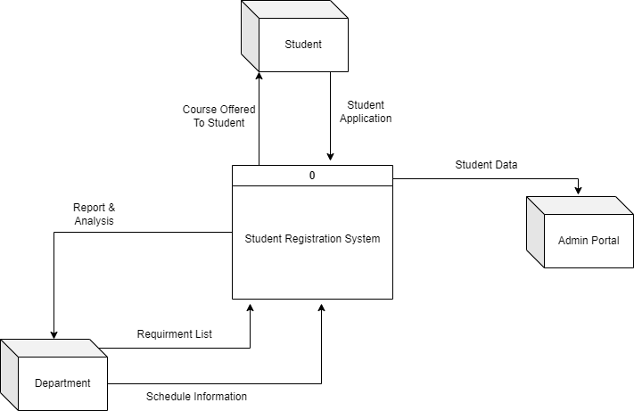

1. **Architecture Diagram**

The system architecture adopts a three-tier structure, ensuring a clear separation of concerns:

* **Presentation Layer:** HTML, CSS, JavaScript for an engaging and responsive user interface.
* **Business Logic Layer:** PHP to handle the processing and logic behind user actions.
* **Data Layer:** MySQL Database for efficient and secure data storage.

# Data Collection

# Data isbeing collected in the database ’onlinecourse’.

# Database onlinecourse has 10 tables as shown in the figure below:

# 

1. **Feature Selection**

**Features for Students:**

1. **Enroll for Course:**
   * Browse and select courses with detailed information.
   * Confirm and submit course selections securely.
2. **Enroll History:**
   * View comprehensive history of enrolled courses.
   * Track academic progress and plan future courses.
3. **My Profile:**
   * View and edit personal information.
   * Ensure up-to-date and accurate profiles.
4. **Change Password:**
   * Securely update login credentials.
   * Requires authentication for security.
5. **Logout:**
   * Securely log out of accounts.
   * Reauthentication for secured areas after logout.

**Features for Admin:**

1. **Session:**
   * Manage academic sessions for accurate course tracking.
2. **Semester:**
   * Add, edit, or remove academic semesters.
3. **Department:**
   * Manage academic departments within the institution.
4. **Course:**
   * Add, modify, or remove courses with details.
5. **Registration:**
   * Monitor and manage the course registration process.
6. **Manage Students:**
   * View and manage student information.
7. **Enroll History:**
   * View comprehensive history of course enrollments.
8. **Student Logs:**
   * Record and review logs of student activities.
9. **News:**
   * Post and manage important news or announcements.
10. **Logout:**
    * Securely log out of admin accounts.
11. **User Interface**

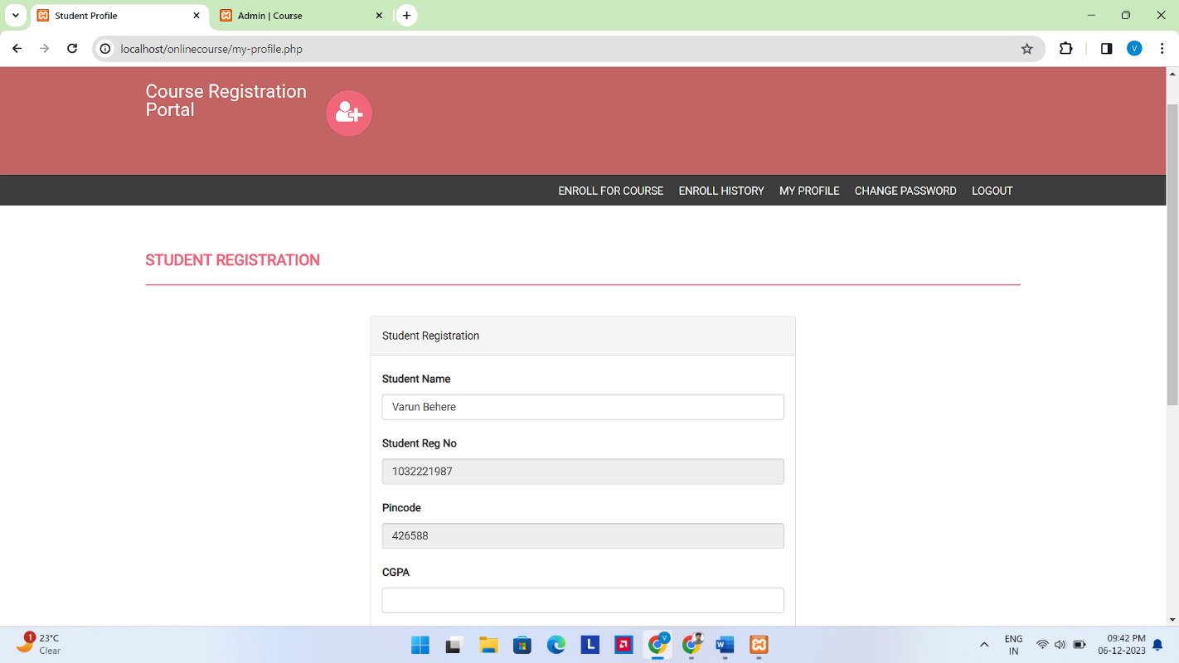

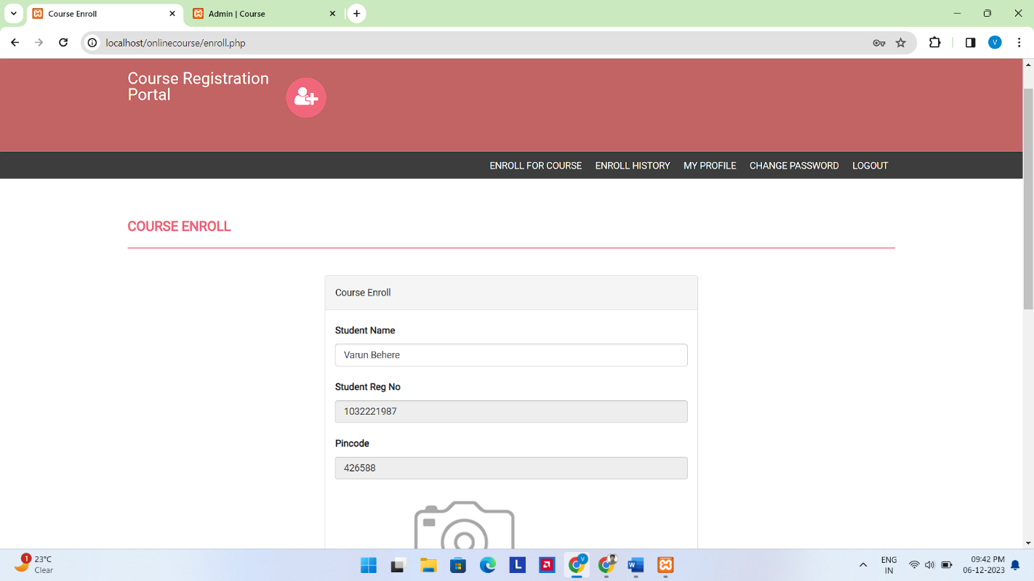

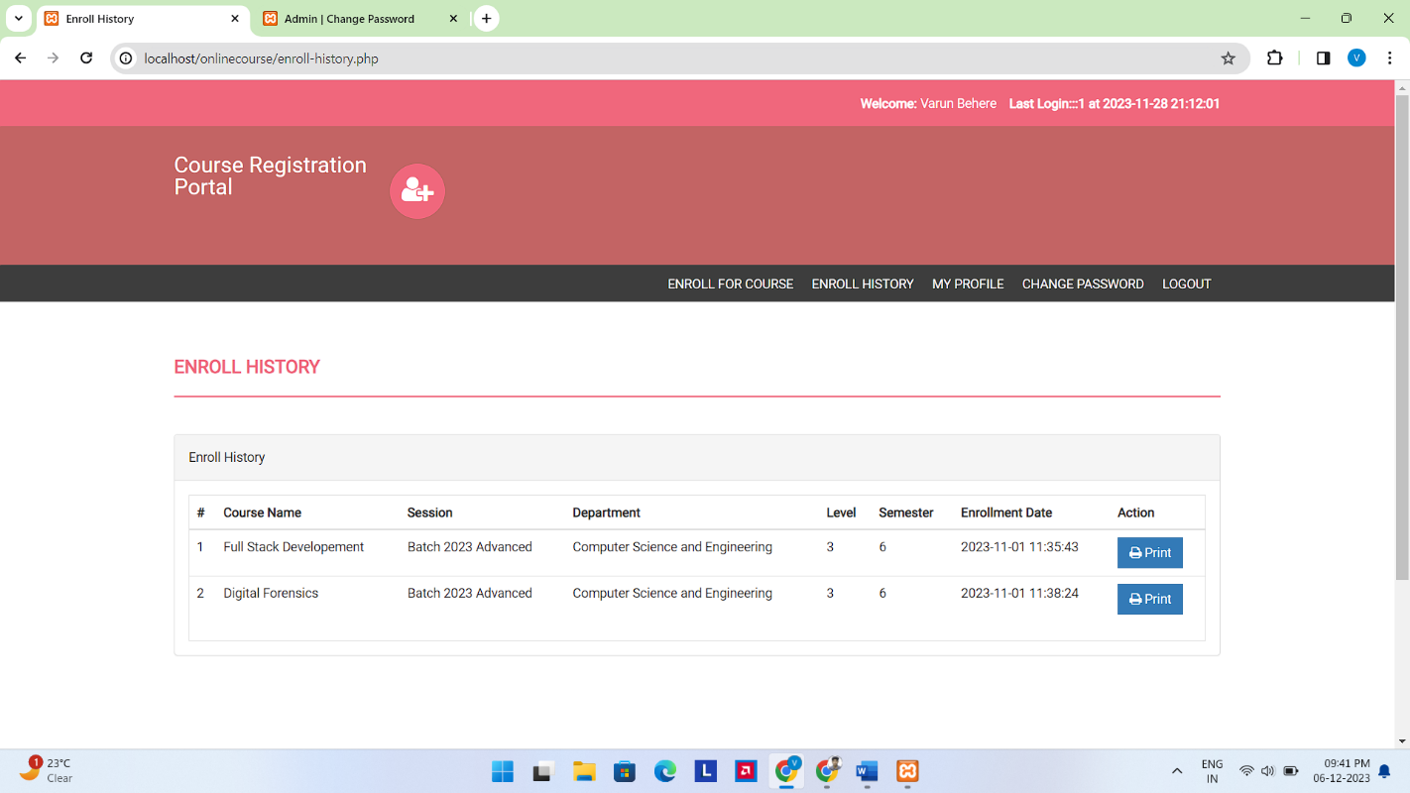

**For Admin**

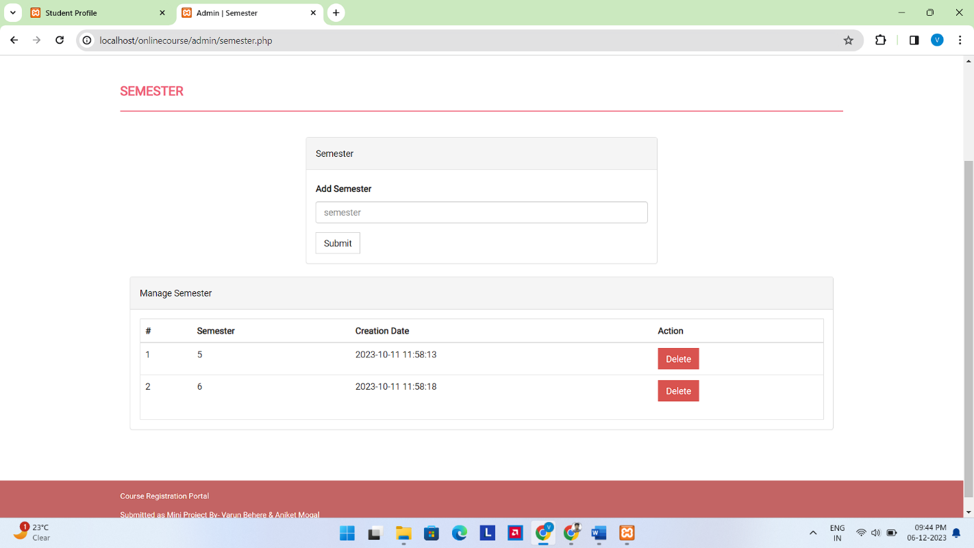

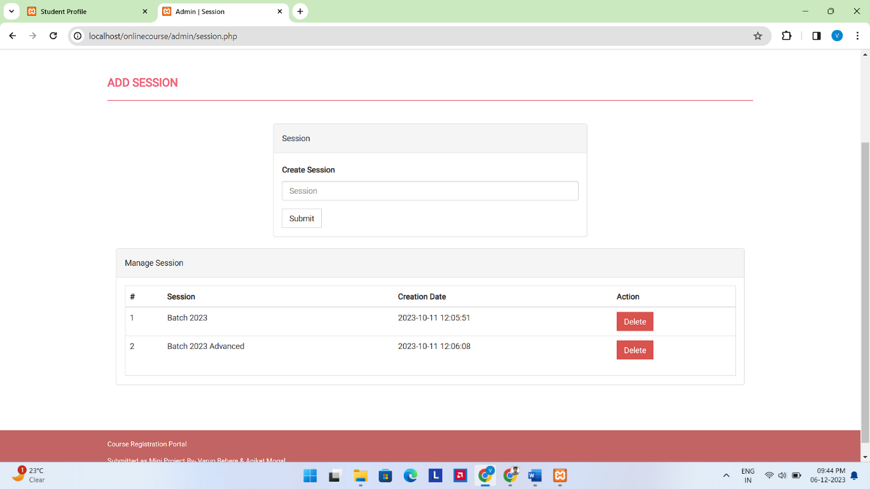

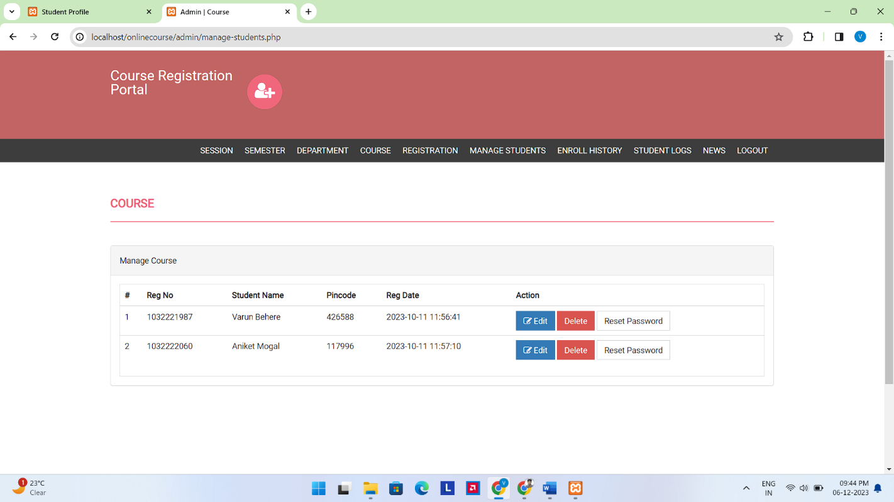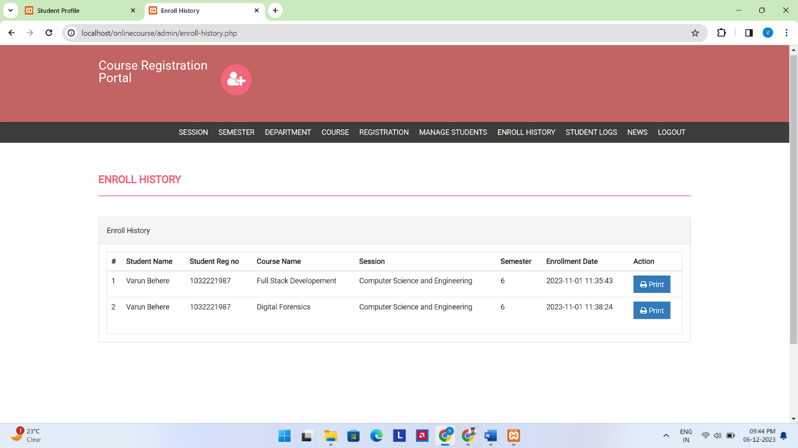

1. **Challenges & Solutions**
2. **Concurrency Issues:**
   * *Challenge:* Managing simultaneous access to the system during peak registration periods, which may lead to data inconsistencies or conflicts.
   * *Solution:* Implement locking mechanisms to control access to critical sections of the system and employ transaction management to ensure data consistency.
3. **Data Validation and Sanitization:**
   * *Challenge:* Ensuring that user inputs are properly validated and sanitized to prevent security vulnerabilities, such as SQL injection or cross-site scripting (XSS).
   * *Solution:* Enforce server-side validation, use parameterized queries, and implement input sanitization functions. Regularly update security practices to mitigate emerging threats.
4. **User Session Management:**
   * *Challenge:* Managing user sessions securely to prevent unauthorized access and session hijacking.
   * *Solution:* Use secure session management techniques, implement session timeout mechanisms, and store sensitive session data securely. Consider implementing multi-factor authentication for added security.
5. **Error Handling and Logging:**
   * *Challenge:* Developing a robust error-handling mechanism and logging system to facilitate debugging and system monitoring.
   * *Solution:* Implement detailed error messages for developers during development and generic error messages for users. Set up a centralized logging system to track and analyze system errors in production.
6. **Future Enhancements**
7. **Deployment to a Web Server:**
   * *Current State:* Hosted on localhost.
   * *Future Improvement:* Deploy the application to a web server with a domain name for public access. This could involve using a hosting service or setting up a dedicated server.
8. **Domain Name and SSL Certificate:**
   * *Current State:* Accessed via IP address or localhost.
   * *Future Improvement:* Obtain a domain name for the online portal, and implement SSL to ensure secure data transmission. This enhances trust and security for users.
9. **Scalability Planning:**
   * *Current State:* Local environment.
   * *Future Improvement:* Consider architectural improvements to ensure scalability. This might involve optimizing database queries, implementing caching mechanisms, or exploring cloud-based solutions for scalability.
10. **User Authentication Enhancements:**
    * *Current State:* Basic user authentication.
    * *Future Improvement:* Implement additional security measures such as multi-factor authentication (MFA) to enhance user account security.
11. **Mobile Responsiveness:**
    * *Current State:* Designed primarily for desktop.
    * *Future Improvement:* Ensure the online portal is fully responsive to different screen sizes, providing an optimal user experience on mobile devices and tablets.
12. **Notification System:**
    * *Current State:* Limited communication.
    * *Future Improvement:* Implement a notification system to alert users about important updates, registration deadlines, and any changes related to courses or the portal.
13. **Automated Backup and Recovery:**
    * *Current State:* Limited backup procedures.
    * *Future Improvement:* Implement automated backup procedures to prevent data loss and ensure a quick recovery in case of system failures.
14. **Integration with Learning Management Systems (LMS):**
    * *Current State:* Standalone system.
    * *Future Improvement:* Explore integration with existing Learning Management Systems to synchronize course information, grades, and other relevant data.

**Conclusion**

In conclusion, our journey in developing a Stocks Recommender and Predictor web application has been both enlightening and challenging. As we reflect on the project's evolution, achievements, and areas for improvement, several key takeaways emerge.

### **1. Achievements and Insights:**

* The successful implementation of a machine learning model capable of providing real-time stock recommendations and predictions based on technical indicators.
* Valuable insights gained from the analysis of individual stock performances, model interpretability, and alignment with real-world market trends.

### **2. User-Centric Design:**

* The development of a user interface that prioritizes user experience, accessibility, and clear presentation of stock recommendations.
* Responsive design and customization options contribute to a user-friendly and adaptable platform.

### **3. Challenges Overcome:**

* Solutions devised to address challenges related to data quality, model generalization, ethical considerations, user interface adaptability, and real-time data updates.

### **4. Ethical Considerations:**

* A commitment to ethical and responsible model usage, ensuring that recommendations are presented transparently and in a manner that fosters user trust.

### **5. Future Paths and Opportunities:**

* Identification of potential future enhancements, including advanced machine learning models, integration with external financial platforms, and continuous user engagement through feedback loops.

### **6. Acknowledgment of Limitations:**

* Recognition of limitations, such as data quality constraints and the inherent complexity of financial markets, highlighting the importance of cautious interpretation of model predictions.

### **7. User Engagement and Education:**

* Emphasis on continuous user engagement and education, fostering a community where users can actively contribute feedback and insights for the improvement of the application.

### **8. Continuous Iteration and Improvement:**

* The acknowledgment that the journey does not end here. Continuous iteration, refinement, and adaptation to emerging technologies and user needs will be integral to the sustained success of the project.

### **9. Appreciation:**

* Our sincere appreciation extends to the users who have engaged with the application, provided valuable feedback, and contributed to the ongoing improvement of the platform.
  + 1. **References**