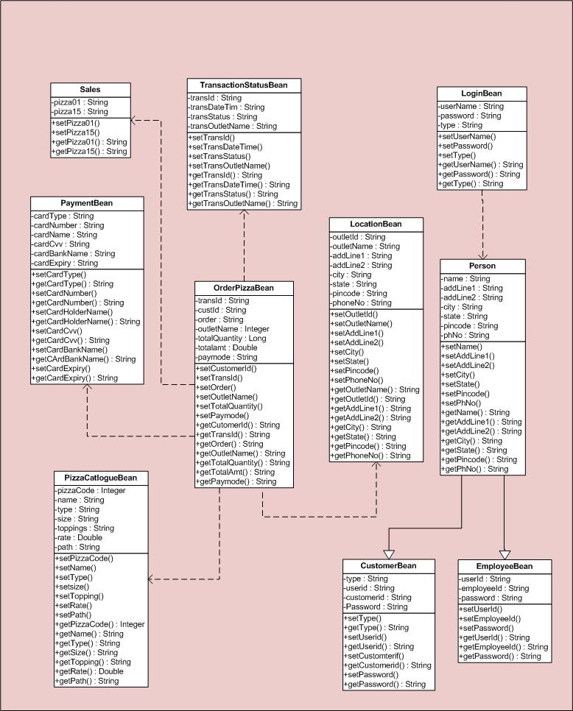

BEAN LAYER CLASS DIAGRAM

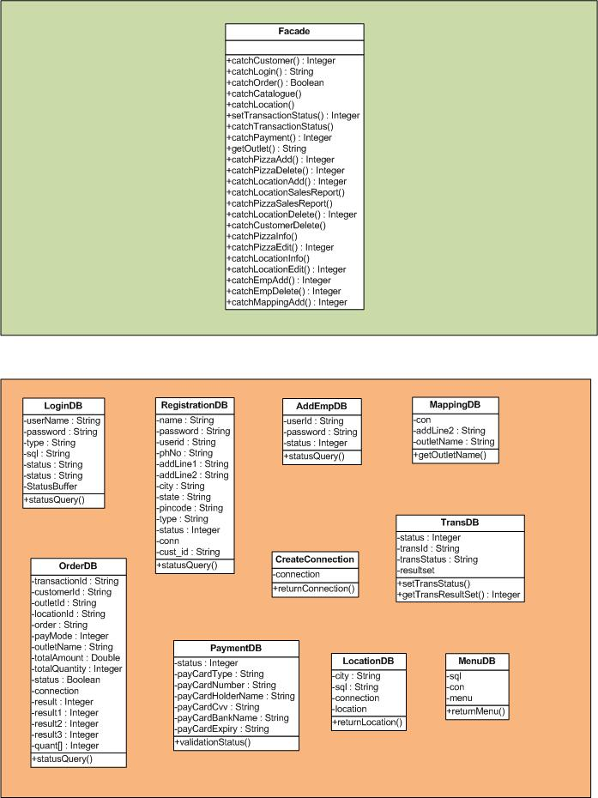

FAÇADE DB LAYER CLASS DIAGRAM

