MULTIPLEXER
Team-1

High Level Design for
Online Pizza Ordering System
Version No 1.0
1st Feb 2010

Submitted By:
Rahul Jain-2815
Amit Saxena-2818
Praveen Kumar K-2820
Lakhaa J-2832

Collabera Solutions Pvt. Ltd
No.31, Grape Garden, 17th H Main,
Koramangala 6,
Bangalore 560 095
Karnataka
INDIA

Table of Contents
1 System Overview 3
1.1 Purpose 3
1.2 Scope 3
1.3 System Overview 3
1.3.1 User Services 3
1.3.2 Business Services 3
1.3.3 Data Services 3
1.4 Document Organization 4
2. Design Considerations 5
2.1 Assumptions and Dependencies 5
2.2 Goals and Guidelines 5
3 Design Strategies 6
4 Module Level Design 7
5 MODULE LEVEL DIAGRAM: 9
6 ER Diagram 10
7 UML USE CASE DIAGRAM 11

System Overview

Purpose
This Document consists of High-level design of a web-based application named as Online Pizza Ordering System. It allows pizzas to be ordered online from the different outlets at 5 major cities Bangalore, Mumbai, Delhi, Chennai and Kolkata.

Scope
There are three types of users who will use this portal to order pizza

First time user who is by default a guest user.

Individual users who are registered.

Corporate users (Companies like Collabera, TCS, Wipro etc).

System Overview
This system gives information about the localities of the pizza outlet, types of pizzas they are serving.

User Services
- All type of user can browse through the website and see the details like menu, locations, feedback, contact us etc.
- To place an order a user must register him self as a regular user or a corporate user after that he can choose from many available Veg and Non Veg Pizzas with different size and toppings.
- For the payment he can go for cash/credit card/debit card option
- He can also edit some of his information, which he submitted at the time of registration.
- A user can modify his order any times before finalizing the order. Once final order is committed he cannot make any changes.

Business Services
This system also enforces some business rules such as
- A user can order any combination of pizza from any outlets near to his locality, if he wants to select some other outlet then no guarantee of in time delivery as well as he has to pay some extra charge.
- Individual user gets a discount of 10% if he has ordered pizza for more than 3 times but each order must be greater than 250 Rs and aggregate must be greater than 750 Rs.
- Corporate user has to order more than 50 pizzas and he will get 20 % discount on the total bill amount.
- The payment can be made through cash/credit card/debit card, but cash payment is assumed as cash on delivery where 2% more has to be paid on the bill amount as Service Charge.

Data Services
The system will generate certain reports based on the following details
- Highest pizza type sold
- Least pizza type sold
- Outlet making the highest sale of pizza
- Outlet making the least sale of pizza
- Customer wise sales report
- Locality wise sales report

1.4 Document Organization
In the next sections of document we will discuss about the assumptions, dependencies, constraints and goals of design under the section Design and Consideration after that document will contain Design strategies followed by Module level design of the system in which we will discuss all the modules and their functionalities. In the last we will describe all our HLD with the help of diagrams

2. Design Considerations

2.1 Assumptions and Dependencies
The assumptions or dependencies regarding the software and its use are:
- Only lightweight technologies such as HTML, CSS, JavaScript and JSP will be used.
- XP, Vista, Windows 7 will be able to support this portal.
- We are assuming that user is having some basic knowledge of computer and Internet
- Later we can generate its Flash design, which will be more interactive.

2.2 Goals and Guidelines
Design goal is to create a lightweight user-friendly application which takes minimum time to load and can serve May threads at a time. It should be easy to modify and faster in generating reports should be secure and robust.

Design Strategies
We are using only open source technologies for developing this system, which will, makes the design lightweight and easy to modify
- HTML, CSS, JAVASCRIPT, JSP and SQL will be used for developing the system
- Pre developed JAVA libraries and functions will be used.
- Unit test cases for each modules as well as Integration test cases will be developed to find the bugs and error in the system design
- We will use multithreading for proper synchronization.
- JDBC-ODBC will be used for connection set and communication

Module Level Design
The various modules included in this system are
1. Admin Module
2. Login Module
3. Registration/Edit profile module
4. Order Processing Module
5. Payment Module
6. Menu Details
7. Outlet Module
8. Static Website pages

- Admin Modules:
This module allows Administrator to interact with the System. It gives certain functionality to the Admin. such as
1. Edit the database tables
2. Add/Delete any particular item offered by an outlet
3. Generate business reports
4. Change the portal functionality
5. Manage the website

- Login Module:
It provides functionality to login in the system as registered or corporate customer, outlet manager, and admin manager. It directs the user to its respective module according to the privileges for example Admin manager will be directed to Admin module.

- Registration/Edit profile Module:
This module makes provision for entering user information in the system database. Its measure functionalities are:
1. It allows the guest user to register him on the system and become registered user so that he can place the order through the system.
2. It gives the functionality to already registered user to edit some of the information of on its profile such as address, phone number etc.
3. This generates a customer ID on every new registration, which is used internally in the system.

- Order Processing Module:
This module is available for registered user so that they can place their order, It is connected with payment module, outlet module etc. Its measure functionalities are:
1. Allows user to place their order.
2. Provide them an option to pay through cash/credit/debit card
3. After validate the payment it generate order for nearest outlet to deliver the order
4. Maintain the status of the order.
5. Provide the functionality to select pizza from available and also allows user to select the outlet from which they want delivery.
6. Provides the discount if applicable and generate the bill.

- Payment Module:
It is basically dummy module acting like a payment gateway of bank. Its functionalities are:
1. Validate the user information if he wants to pay through credit/debit card.
2. Contact to order processing module and tell the status of the payment.

- Menu details module:
It makes the provision for displaying the various Pizza items the outlets are offering. Its functionalities are:
1. Generate the pages contain all the information of menu offered.
2. Display all the offers/discount available.

- Outlet Module:
This module deals with the provision of order information to the concerned outlet. It gets information about the order from the order-processing module. Its functionalities are:
1. Taking care of status of delivery and update the transaction status.
2. Maintain all the information of all the order done or in process.
3. Get orders from the order-processing module

- Static web pages Module
It consists of static information of the web application such as locations, menu, contact us, feedback etc.
Its functionalities are:
1. It allows the browsing of read only pages of website
2. Admin can edit and maintenance of these pages.

Other than this whole system is in constant communication with the database, which comprises of various tables that holds the System information.

MODULE LEVEL DIAGRAM:
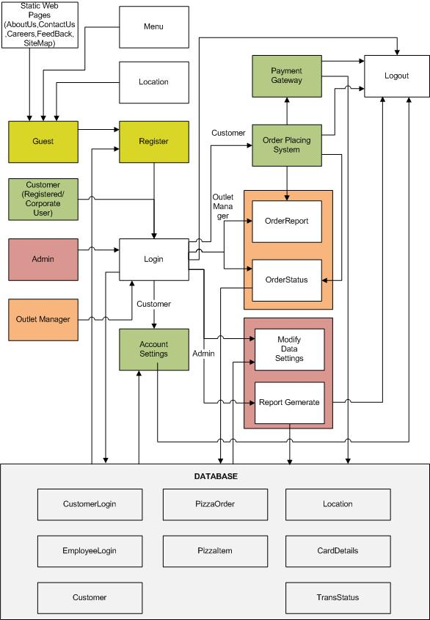

ER Diagram
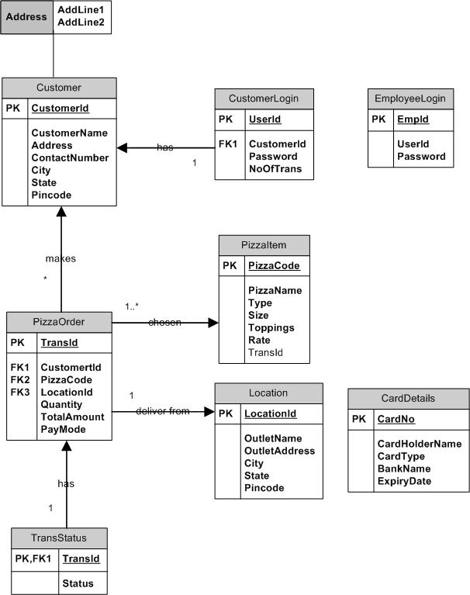

UML USE CASE DIAGRAM
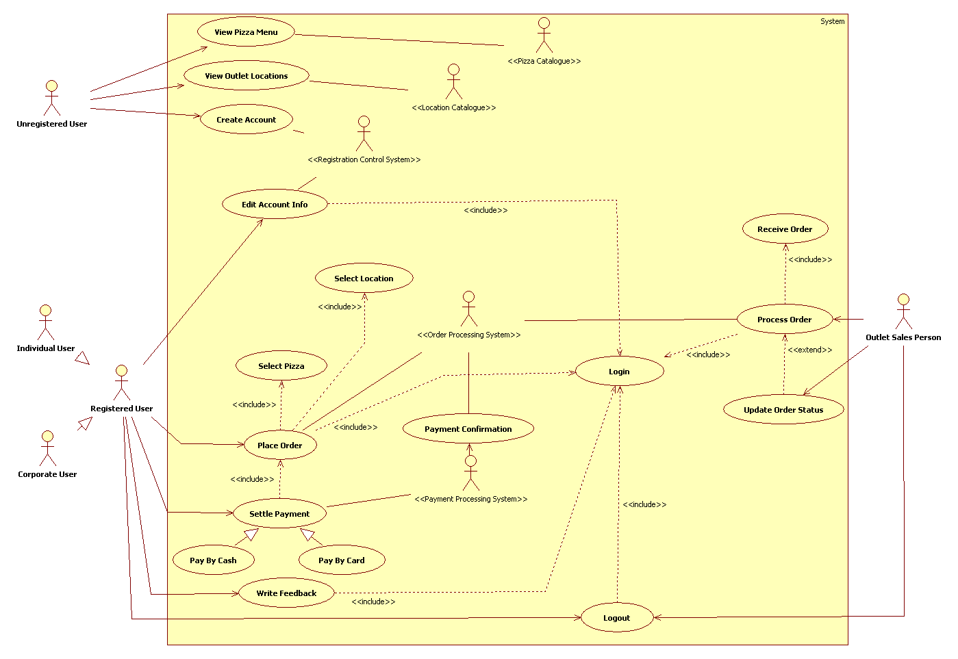
Diagram 1

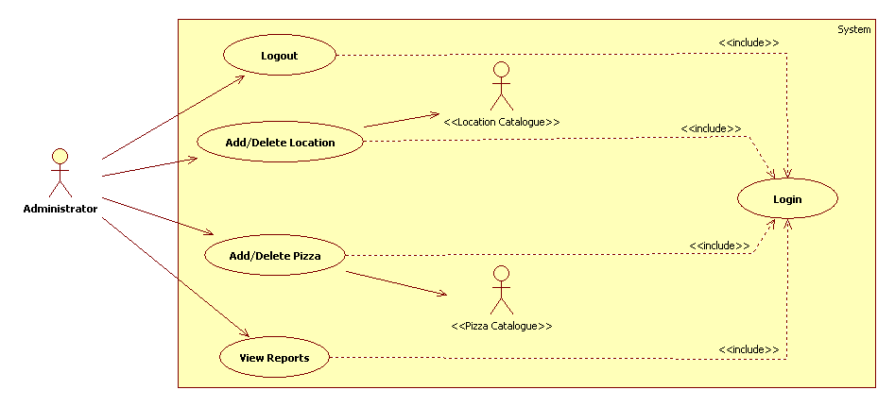

Diagram 2

Software Used:
ER Diagram, Module Level Diagram: Microsoft Visio
UML Use Case Diagram: Star UML
Assumption:
In ER diagram we have used statements instead of diamond box to show the relationships, as Visio is not supporting that features.

