Modules & Functionalities

TEAM 1

By:
Amit Saxena
Lakhaa J
Praveen K
Rahul Jain

List of Modules
- Registration Module (Done by Praveen)
- Login Module (Done by Praveen)
- Location Module/Mapping Module (Done by Praveen+Rahul)
- Menu Module (Done by Rahul)
- Order Module (Done by Rahul)
- Payment Module (Done by Lakhaa)
- Admin Module (Done by Amit)
- Outlet Manager Module (Done by Lakhaa)
- Static Pages (Done by Rahul+Praveen)

1. Registration Module:

- Allows guest user to register with the website and order
- Registration modes:
  - Individual
  - Corporate
- Individual module data flow as shown in the diagram

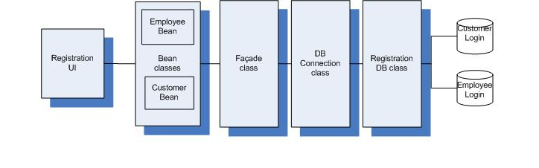

2. Login Module:

- Registered users shall use this module to login and order
- Login modes as individual and corporate with respect to Registration
- Admin (and Outlet Manager (login id & password generated by admin) shall use this module to login and process request
- No of Transactions maintained as the user logins
- Session management implemented

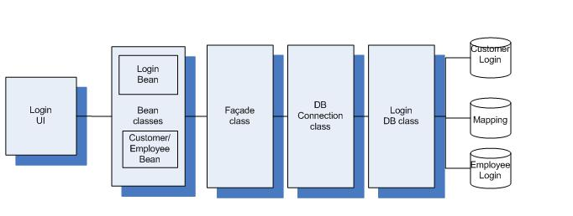

3. Location Module:

- Lists all the store location available dynamically from the DB
- Automatic mapping for delivery address based on user’s registration address

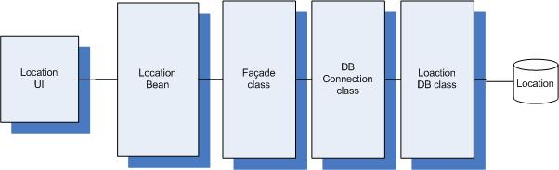

4. Menu Module:

- Lists all the pizza’s available in the store dynamically from the DB
- Price, Topping and Size details
- Guest user perspective

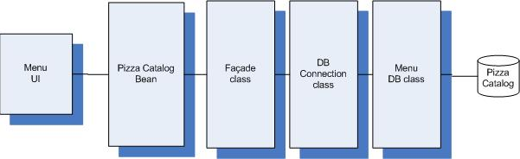

5. Order Module:

- Registered users can place order using this module
- Pizza details listed dynamically from the DB
- User can modify order at any time before payment for that session
- All Business consideration below as per requirements implemented
  - Corporate users can order above 50
  - Discount 20% for corporate users
  - If number of transactions for individual users is more than 3 than 10%
  - If pay mode is by cash than 2% extra pay
- Payment by cash and card
- Assigned outlet address information provided to the user according to the mapping done between outlet addresses customer delivery address according to the address line2 provided by customer during registration.

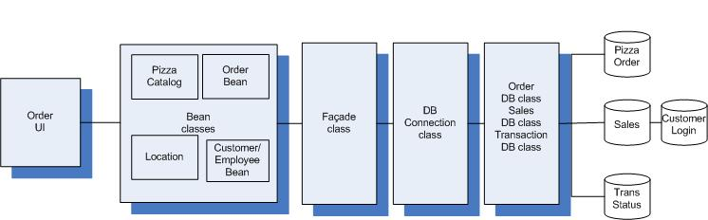

6. Payment Module:

- Payment mode by credit card implemented
- User’s card details are taken as input and validated

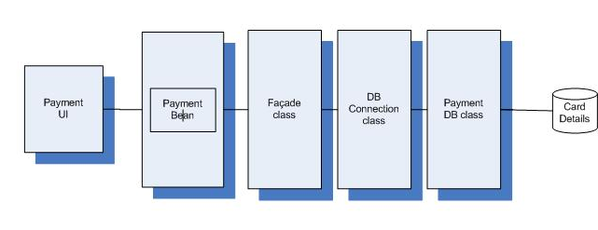
7.Admin Module:

- GUI for the database
- Admin functionalities as below implemented
- Add, Edit or Delete Pizza
- Add, Edit or Delete Location
- Add or Delete Employee login
- Deletion of Customer
- Six Report generation as per requirements
- All modifications done by Admin module on DB is reflected in all other modules

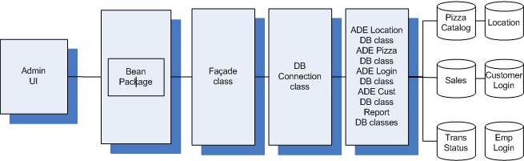

7. Outlet Manager Module:

- Store delivery functionality implemented
- Selection of city and outlets made dynamically generated from the DB
- Transaction details for the particular outlet store is fetched from the database
- Outlet Manager can view individual transaction reports
- Outlet Manager can edit the status of the transaction as Pending/Delivered/Canceled

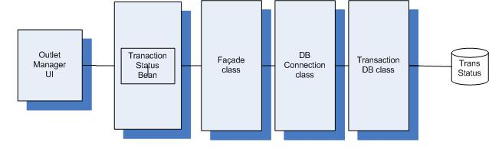

USP’s

- Full website is dynamic except some static pages. That means if the Admin adds some information in the database the Order Processing module, Location module, Menu module will be able to use that regularly updated info for use by the end user.
- Created Outlet Manager as a complete module.
- Admin can generate various sales reports & edit complete database. It’s like we have created a complete GUI for the database.
- Menu, Order, Location, Outlet Manager are in complete sync with Admin module. The structure in these modules automatically changes if a data is altered in DB by Admin.
- Created a Mapping table for implementing the logic of automatic allotment of nearest outlet to the user.
- Created a Status table for maintaining the status of the delivery of pizza like Pending, Cancelled, Delivered.
- Instead of using simple button structures we have used a spin menu for navigation.
- In Order and Menu user can see large images of pizza on click which contains the details of corresponding pizza.
- Data Integrity: 3-Tier validation is done; Client side, Server side and Database (Check and Unique Constraints) side. Anyhow wrong data can’t be send to the database.

