NAME : VARUN CHOUDHARY
ROLL NO. : 2620030156

ATM TRANSACTION SIMULATOR

1. Project Abstract
The ATM Transaction Simulator is a Java-based console application designed to demonstrate the basic operations performed through an Automated Teller Machine. The project provides a simple and interactive environment where a user can authenticate using a PIN and perform common banking operations such as checking balance, depositing money and withdrawing money .
The application applies important Java programming concepts including primitive data types, variables, operators , conditional statements, switch-case, loops, Scanner-based input. The project helps demonstrate how these concepts can be combined to solve a practical problem using structured programming.

2. Project Objectives
- To simulate basic ATM operations using Java.
- To implement PIN-based user authentication.
- To perform balance inquiry, deposit and withdrawal .
- To apply operators, conditional statements and loops in one practical application.
- To improve understanding of problem-solving and menu-driven Java programs.

3. Advantages
- Simple and user-friendly: The menu-driven interface makes the application easy to operate.
- Secure authentication: A PIN verification step is included before accessing banking operations.
- Realistic simulation: The project represents common ATM activities in a simplified form.
- Concept integration: Multiple Java programming concepts are demonstrated in one project.
- Validation: Conditions can prevent invalid operations such as withdrawing more money than the available balance.
- Easy to extend: Additional banking features can be added without changing the basic structure.

4. Implementation Details

à Programming Language and Tools
Programming Language: Java
Input Method: Scanner class
Main Class: ATMTRANSACTIONSIMULATOR

à Java Concepts Used
Java Concept | Application in the Project
Data types and variables | Store PIN, account details, balances, transaction amounts, and menu choices.
Operators | Arithmetic, relational, logical, assignment, and unary operators are used in calculations and validation.
if-else | Validate PINs, balances, amounts, and transaction conditions.
switch-case | Handle the user's selected ATM menu option.
Loops | while/do-while loops control authentication and repeated menu operations; for loops display transaction records.
Scanner | Accept account numbers, PINs, amounts, and menu choices from the user.

à Main Modules
- Authentication Module – accepts and validates the user's PIN.
- Balance Inquiry Module – displays the current account balance.
- Deposit Module – adds a valid deposit amount to the account balance.
- Withdrawal Module – checks available balance and deducts a valid withdrawal amount.
- Menu Module – repeatedly displays available operations until the user chooses Exit.
.

5. Output Screenshots
Screenshot 1 – Deposit Money
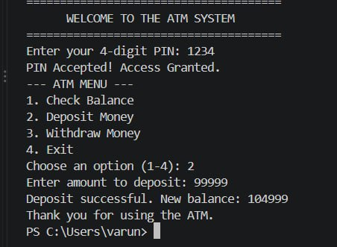
Screenshot 2 – Withdrawal Money
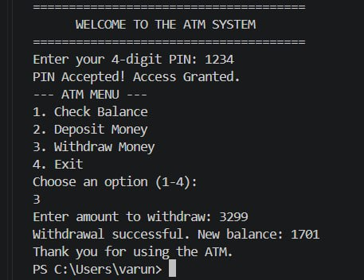
Screenshot 3 – Exit from ATM
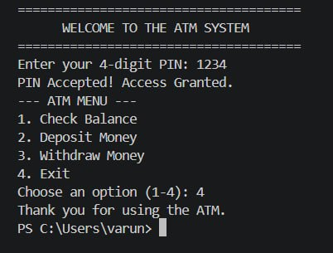
Screenshot 4 – PIN Validation and Balance Inquiry
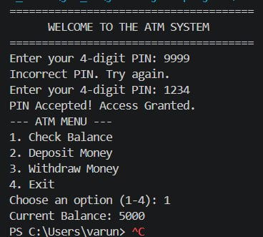
These screenshots demonstrate successful PIN authentication, balance inquiry, deposit, withdrawal, invalid-PIN handling, and exiting the ATM.

6. Conclusion
The ATM Transaction Simulator successfully demonstrates how Java programming concepts can be applied to a practical banking scenario. The project implements PIN authentication, balance inquiry, deposit, withdrawal features through a menu-driven interface. It makes effective use of operators, data types, methods, conditional statements, loops, Scanner input, and one-dimensional and two-dimensional arrays. Overall, the project provides a clear understanding of program structure, decision making, repetition, data storage, and modular programming in Java.

7. Future Work
- Add support for multiple customers and multiple bank accounts.
- Store customer and transaction data permanently using files or a database.
- Add date and time to every transaction.
- Provide a more detailed mini statement with transaction type and amount.
- Add fund-transfer support between different customer accounts.
- Implement stronger authentication and account-locking rules.
- Develop a graphical user interface (GUI) for a more realistic ATM experience.
- Add features such as PIN change, account creation, balance alerts, and receipt generation.

