**Hands on Day -6**

**INTCDE21ID008**

**C N S Varun**

**916214**

1. **Create a Razor view to list a few Organizations at Hyderabad and highlight the one that has recently build its largest offshore office at India.**

**HomeController.cs**

using Microsoft.AspNetCore.Mvc;

using Microsoft.Extensions.Logging;

using SecondH.Models;

using System;

using System.Collections.Generic;

using System.Diagnostics;

using System.Linq;

using System.Threading.Tasks;

namespace OrganizationsAtHyderabad.Controllers

{

public class HomeController : Controller

{

private readonly ILogger<HomeController> _logger;

public HomeController(ILogger<HomeController> logger)

{

_logger = logger;

}

public IActionResult Index()

{

return View();

}

public IActionResult Privacy()

{

return View();

}

public IActionResult ViewSam()

{

List<string> organizationList = new List<string>

{

"Microsoft www.microsoft.com","CTS www.cognizant.com", "Google", "Amazon","TCS"

};

return View(organizationList);

}

[ResponseCache(Duration = 0, Location = ResponseCacheLocation.None, NoStore = true)]

public IActionResult Error()

{

return View(new ErrorViewModel { RequestId = Activity.Current?.Id ?? HttpContext.TraceIdentifier });

}

}

}

**Layout.cshtml**

<!DOCTYPE html>

<html lang="en">

<head>

<meta charset="utf-8" />

<meta name="viewport" content="width=device-width, initial-scale=1.0" />

<title>@ViewData["Title"] - OrganizationsAtHyderabad</title>

<link rel="stylesheet" href="~/lib/bootstrap/dist/css/bootstrap.min.css" />

<link rel="stylesheet" href="~/css/site.css" />

</head>

<body>

<header>

<nav class="navbar navbar-expand-sm navbar-toggleable-sm navbar-light bg-white border-bottom box-shadow mb-3">

<div class="container">

<a class="navbar-brand" **asp-area**="" **asp-controller**="Home" **asp-action**="Index">OrganizationsAtHyderabad</a>

<button class="navbar-toggler" type="button" data-toggle="collapse" data-target=".navbar-collapse" aria-controls="navbarSupportedContent"

aria-expanded="false" aria-label="Toggle navigation">

<span class="navbar-toggler-icon"></span>

</button>

<div class="navbar-collapse collapse d-sm-inline-flex flex-sm-row-reverse">

<ul class="navbar-nav flex-grow-1">

<li class="nav-item">

<a class="nav-link text-dark" **asp-area**="" **asp-controller**="Home" **asp-action**="Index">Home</a>

</li>

<li class="nav-item">

<a class="nav-link text-dark" **asp-area**="" **asp-controller**="Home" **asp-action**="Privacy">Privacy</a>

</li>

<li class="nav-item">

<a class="nav-link text-dark" **asp-area**="" **asp-controller**="Home" **asp-action**="ViewSam">ITOrganizations</a>

</li>

</ul>

</div>

</div>

</nav>

</header>

<div class="container">

<main role="main" class="pb-3">

@RenderBody()

</main>

</div>

<footer class="border-top footer text-muted">

<div class="container">

&copy; 2021 - OrganizationsAtHyderabad - <a **asp-area**="" **asp-controller**="Home" **asp-action**="Privacy">Privacy</a>

</div>

</footer>

<script src="~/lib/jquery/dist/jquery.min.js"></script>

<script src="~/lib/bootstrap/dist/js/bootstrap.bundle.min.js"></script>

<script **src**="~/js/site.js" **asp-append-version**="true"></script>

@RenderSection("Scripts", required: false)

</body>

</html>

**ViewSam.cshtml**

@*

For more information on enabling MVC for empty projects, visit https://go.microsoft.com/fwlink/?LinkID=397860

*@

@{

}

@model List<string>

@foreach (var organization in Model)

{

<div>

@if (organization.Equals("Amazon"))

{

<span><b>@Html.DisplayFor(o => organization)</b></span>

}

else

{

<span>@Html.DisplayFor(o => organization)</span>

}

</div>

}

**OuTPUT**

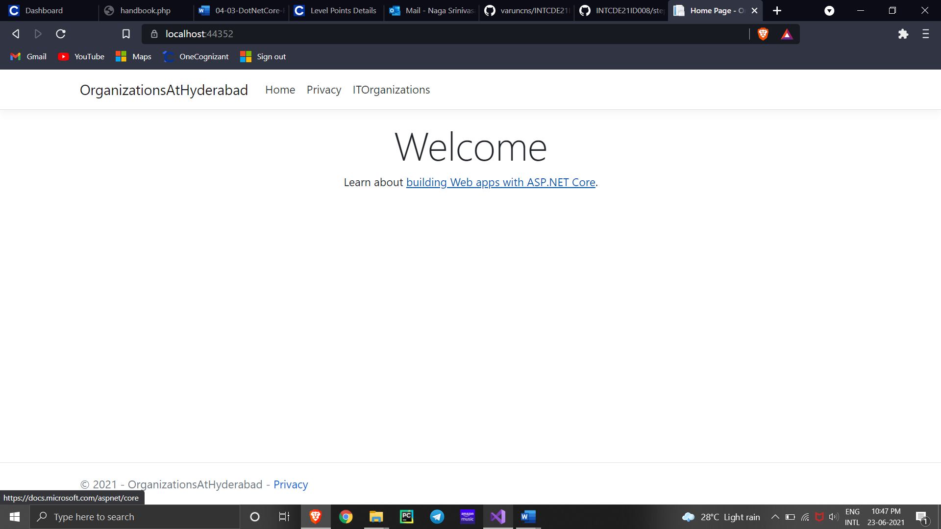

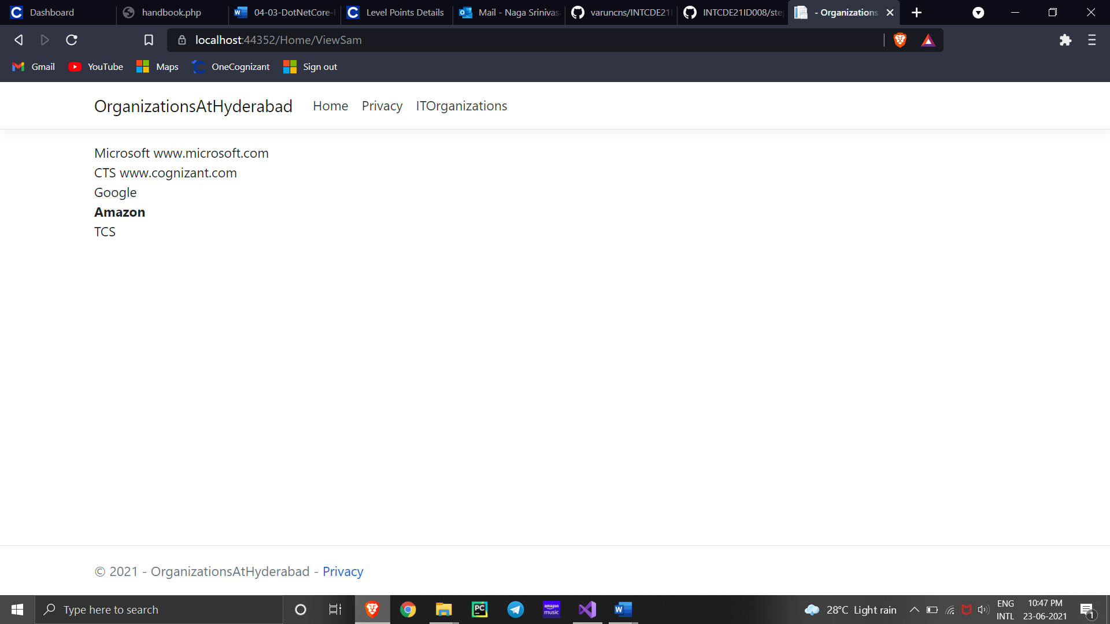

1. **Create a Razor view to list few employee details using Model data binding.**

**Employee.cs**

using System;

using System.Collections.Generic;

using System.Linq;

using System.Threading.Tasks;

namespace SecondH.Models

{

public class Employee

{

public int Id { get; set; }

public string Name { get; set; }

public decimal Salary { get; set; }

public bool IsPermanent { get; set; }

}

}

**ViewStart.cshtml**

@*

For more information on enabling MVC for empty projects, visit https://go.microsoft.com/fwlink/?LinkID=397860

*@

@model List<SecondH.Models.Employee>

@{

ViewData["Title"] = "GetEmployeeList";

<div class="row">

<span class="col-md-4">Name</span>

<span class="col-md-4">Salary</span>

<span class="col-md-4">IsPermanent</span>

</div>

}

@foreach (var employee in Model)

{

<div class="row">

@if (employee.IsPermanent.Equals(true))

{

<span class="col-md-4"><b>@employee.Name</b></span>

<span class="col-md-4"><b>@employee.Salary</b></span>

<span class="col-md-4"><b>@employee.IsPermanent</b></span>

}

else

{

<span class="col-md-4">@employee.Name</span>

<span class="col-md-4">@employee.Salary</span>

<span class="col-md-4">@employee.IsPermanent</span>

}

</div>

}

**HomeCOntroller.cs**

using Microsoft.AspNetCore.Mvc;

using Microsoft.Extensions.Logging;

using SecondH.Models;

using System;

using System.Collections.Generic;

using System.Diagnostics;

using System.Linq;

using System.Threading.Tasks;

namespace OrganizationsAtHyderabad.Controllers

{

public class HomeController : Controller

{

private readonly ILogger<HomeController> _logger;

public HomeController(ILogger<HomeController> logger)

{

_logger = logger;

}

public IActionResult Index()

{

return View();

}

public IActionResult Privacy()

{

return View();

}

public IActionResult ViewSam()

{

List<Employee> employeeList = new List<Employee>();

employeeList.Add(new Employee()

{

Id = 1,

Name = "John",

Salary = 10000,

IsPermanent = true

});

employeeList.Add(new Employee()

{

Id = 2,

Name = "Smith",

Salary = 5000,

IsPermanent = false

});

employeeList.Add(new Employee()

{

Id = 3,

Name = "Mark",

Salary = 5000,

IsPermanent = false

});

employeeList.Add(new Employee()

{

Id = 4,

Name = "Mary",

Salary = 5000,

IsPermanent = false

});

return View(employeeList);

}

[ResponseCache(Duration = 0, Location = ResponseCacheLocation.None, NoStore = true)]

public IActionResult Error()

{

return View(new ErrorViewModel { RequestId = Activity.Current?.Id ?? HttpContext.TraceIdentifier });

}

}

}

**PartialViewSam.cshtml**

@*

For more information on enabling MVC for empty projects, visit https://go.microsoft.com/fwlink/?LinkID=397860

*@

@model List<SecondH.Models.Employee>

@{

ViewData["Title"] = "GetEmployeeList";

<div class="row">

<span class="col-md-4">Name</span>

<span class="col-md-4">Salary</span>

<span class="col-md-4">IsPermanent</span>

</div>

}

@foreach (var employee in Model)

{

<div class="row">

@if (employee.IsPermanent.Equals(true))

{

<span class="col-md-4"><b>@employee.Name</b></span>

<span class="col-md-4"><b>@employee.Salary</b></span>

<span class="col-md-4"><b>@employee.IsPermanent</b></span>

}

else

{

<span class="col-md-4">@employee.Name</span>

<span class="col-md-4">@employee.Salary</span>

<span class="col-md-4">@employee.IsPermanent</span>

}

</div>

}

**ViewSam.cshtml**

@*

For more information on enabling MVC for empty projects, visit https://go.microsoft.com/fwlink/?LinkID=397860

*@

@{

}

<**partial** **name**="partialViewSam" />

**Layout.html**

<!DOCTYPE html>

<html lang="en">

<head>

<meta charset="utf-8" />

<meta name="viewport" content="width=device-width, initial-scale=1.0" />

<title>@ViewData["Title"] - Employee</title>

<link rel="stylesheet" href="~/lib/bootstrap/dist/css/bootstrap.min.css" />

<link rel="stylesheet" href="~/css/site.css" />

</head>

<body>

<header>

<nav class="navbar navbar-expand-sm navbar-toggleable-sm navbar-light bg-white border-bottom box-shadow mb-3">

<div class="container">

<a class="navbar-brand" **asp-area**="" **asp-controller**="Home" **asp-action**="Index">EmployeeDetails</a>

<button class="navbar-toggler" type="button" data-toggle="collapse" data-target=".navbar-collapse" aria-controls="navbarSupportedContent"

aria-expanded="false" aria-label="Toggle navigation">

<span class="navbar-toggler-icon"></span>

</button>

<div class="navbar-collapse collapse d-sm-inline-flex flex-sm-row-reverse">

<ul class="navbar-nav flex-grow-1">

<li class="nav-item">

<a class="nav-link text-dark" **asp-area**="" **asp-controller**="Home" **asp-action**="Index">Home</a>

</li>

<li class="nav-item">

<a class="nav-link text-dark" **asp-area**="" **asp-controller**="Home" **asp-action**="Privacy">Privacy</a>

</li>

<li class="nav-item">

<a class="nav-link text-dark" **asp-area**="" **asp-controller**="Home" **asp-action**="ViewSam">GetEmployeeList </a>

</li>

</ul>

</div>

</div>

</nav>

</header>

<div class="container">

<main role="main" class="pb-3">

@RenderBody()

</main>

</div>

<footer class="border-top footer text-muted">

<div class="container">

&copy; 2021 - OrganizationsAtHyderabad - <a **asp-area**="" **asp-controller**="Home" **asp-action**="Privacy">Privacy</a>

</div>

</footer>

<script src="~/lib/jquery/dist/jquery.min.js"></script>

<script src="~/lib/bootstrap/dist/js/bootstrap.bundle.min.js"></script>

<script **src**="~/js/site.js" **asp-append-version**="true"></script>

@RenderSection("Scripts", required: false)

</body>

</html>

**OUTPUT**

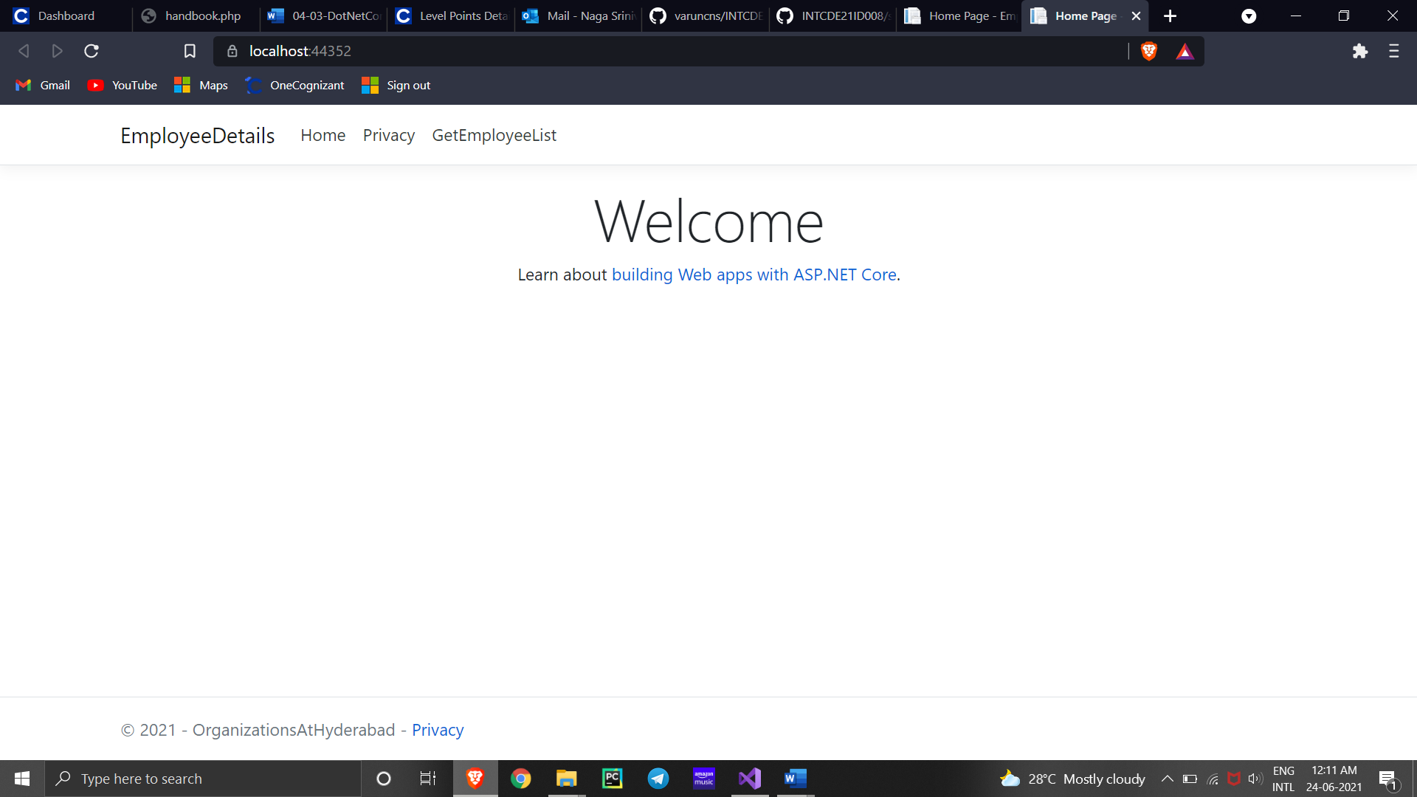

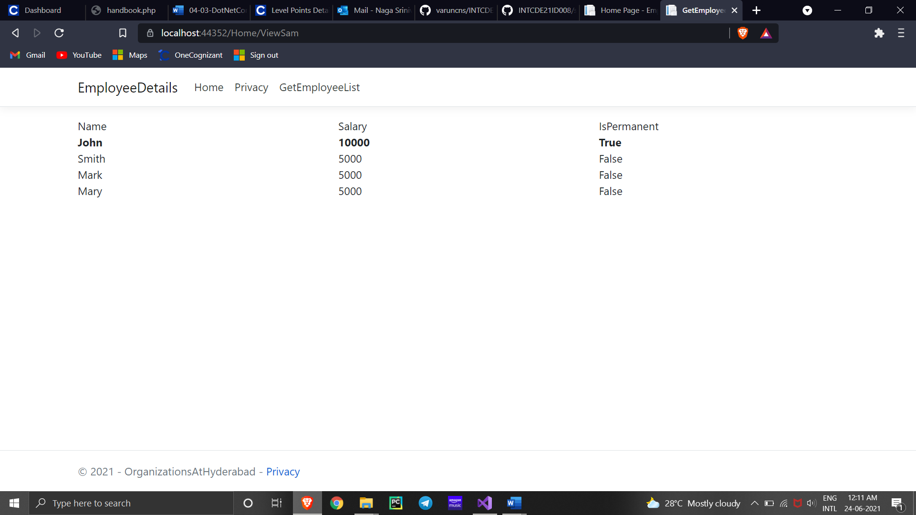

Demonstrate partial view usage

**Employee.cs**

using System;

using System.Collections.Generic;

using System.Linq;

using System.Threading.Tasks;

namespace SecondH.Models

{

public class Employee

{

public int Id { get; set; }

public string Name { get; set; }

public decimal Salary { get; set; }

public bool IsPermanent { get; set; }

}

}

**Layout.html**

<!DOCTYPE html>

<html lang="en">

<head>

<meta charset="utf-8" />

<meta name="viewport" content="width=device-width, initial-scale=1.0" />

<title>@ViewData["Title"] - Employee</title>

<link rel="stylesheet" href="~/lib/bootstrap/dist/css/bootstrap.min.css" />

<link rel="stylesheet" href="~/css/site.css" />

</head>

<body>

<header>

<nav class="navbar navbar-expand-sm navbar-toggleable-sm navbar-light bg-white border-bottom box-shadow mb-3">

<div class="container">

<a class="navbar-brand" **asp-area**="" **asp-controller**="Home" **asp-action**="Index">EmployeeDetails</a>

<button class="navbar-toggler" type="button" data-toggle="collapse" data-target=".navbar-collapse" aria-controls="navbarSupportedContent"

aria-expanded="false" aria-label="Toggle navigation">

<span class="navbar-toggler-icon"></span>

</button>

<div class="navbar-collapse collapse d-sm-inline-flex flex-sm-row-reverse">

<ul class="navbar-nav flex-grow-1">

<li class="nav-item">

<a class="nav-link text-dark" **asp-area**="" **asp-controller**="Home" **asp-action**="Index">Home</a>

</li>

<li class="nav-item">

<a class="nav-link text-dark" **asp-area**="" **asp-controller**="Home" **asp-action**="Privacy">Privacy</a>

</li>

<li class="nav-item">

<a class="nav-link text-dark" **asp-area**="" **asp-controller**="Home" **asp-action**="ViewSam">GetEmployeeList </a>

</li>

</ul>

</div>

</div>

</nav>

</header>

<div class="container">

<main role="main" class="pb-3">

@RenderBody()

</main>

</div>

<footer class="border-top footer text-muted">

<div class="container">

&copy; 2021 - OrganizationsAtHyderabad - <a **asp-area**="" **asp-controller**="Home" **asp-action**="Privacy">Privacy</a>

</div>

</footer>

<script src="~/lib/jquery/dist/jquery.min.js"></script>

<script src="~/lib/bootstrap/dist/js/bootstrap.bundle.min.js"></script>

<script **src**="~/js/site.js" **asp-append-version**="true"></script>

@RenderSection("Scripts", required: false)

</body>

</html>

