Angular Hands On Day 1

INTCDE21ID008

C N S Varun

916214

Session-1

1. Demonstrate usage of JavaScript Object Notation (JSON)

JavaScript for ff

<script>

  var ff = {firstName:"John",lastName:"Stoke", salary:5000, permanentStaff:false};

  console.log(ff);

</script>

OUTPUT

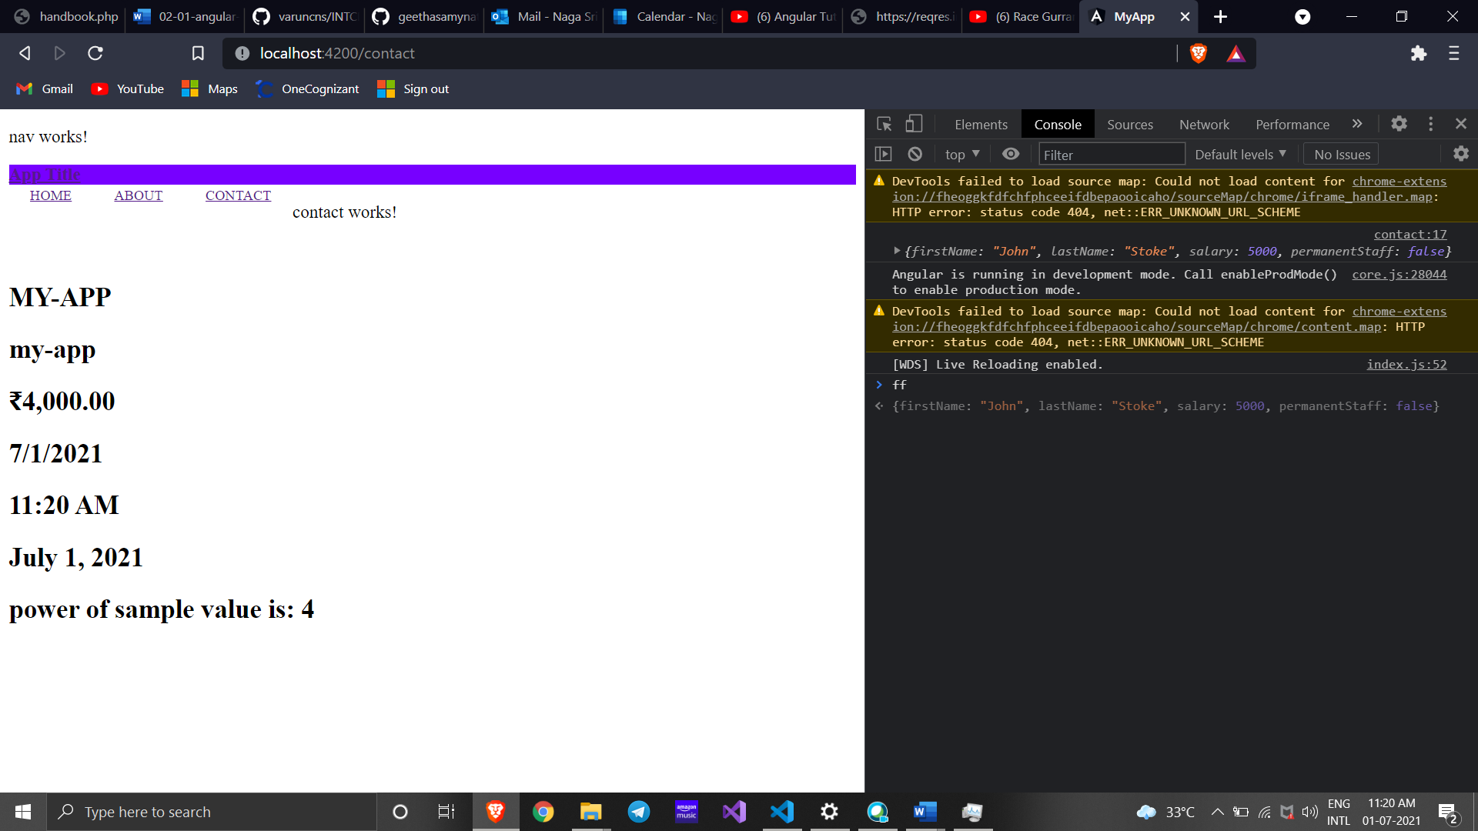

JSON for ff1

<script>

  var ff1 = JSON.parse('{"firstName":"John", "lastName":"Stoke", "salary":"5000","permanentStaff":"false"}');

  console.log("firstName : "+ff1.firstName);

  console.log("lastName : "+ff1.lastName);

  console.log("salary : "+ff1.salary);

  console.log("permanentStaff : "+ff1.permanentStaff);

  </script>

OUTPUT

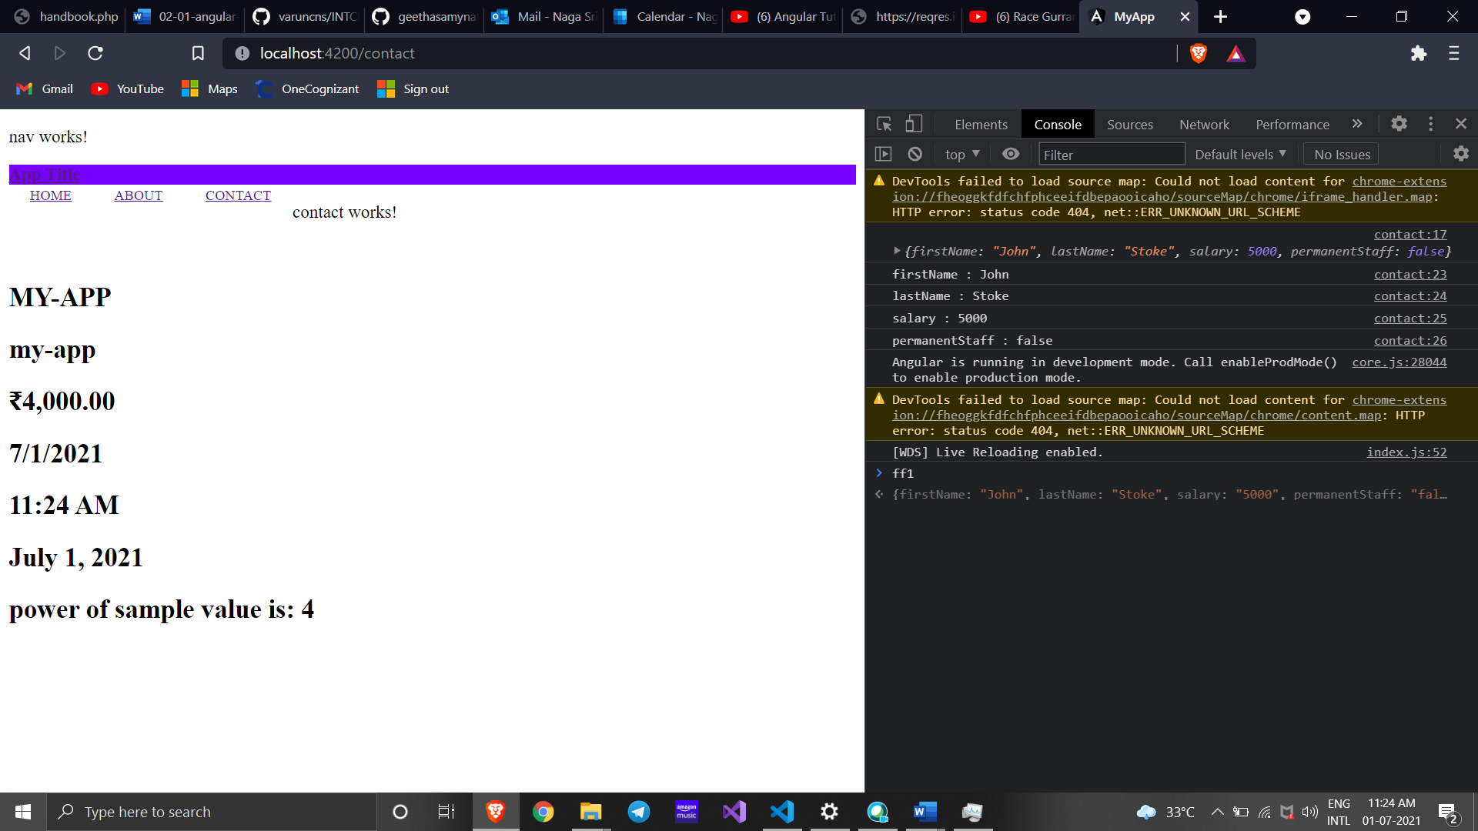

Adding Department to json

<script>

  const data = '{"firstName":"John", "lastName":"Stoke", "salary":"5000", "permanentStaff":"false", "Department":[{"id":"3","name":"payroll"}]}';

  var ff1 = JSON.parse(data);

  console.log("firstName : "+ff1.firstName);

  console.log("lastName : "+ff1.lastName);

  console.log("salary : "+ff1.salary);

  console.log("permanentStaff : "+ff1.permanentStaff);

  console.log("Department id : "+ff1.Department[0].id);

  console.log("Department name : "+ff1.Department[0].name);

  </script>

OUTPUT

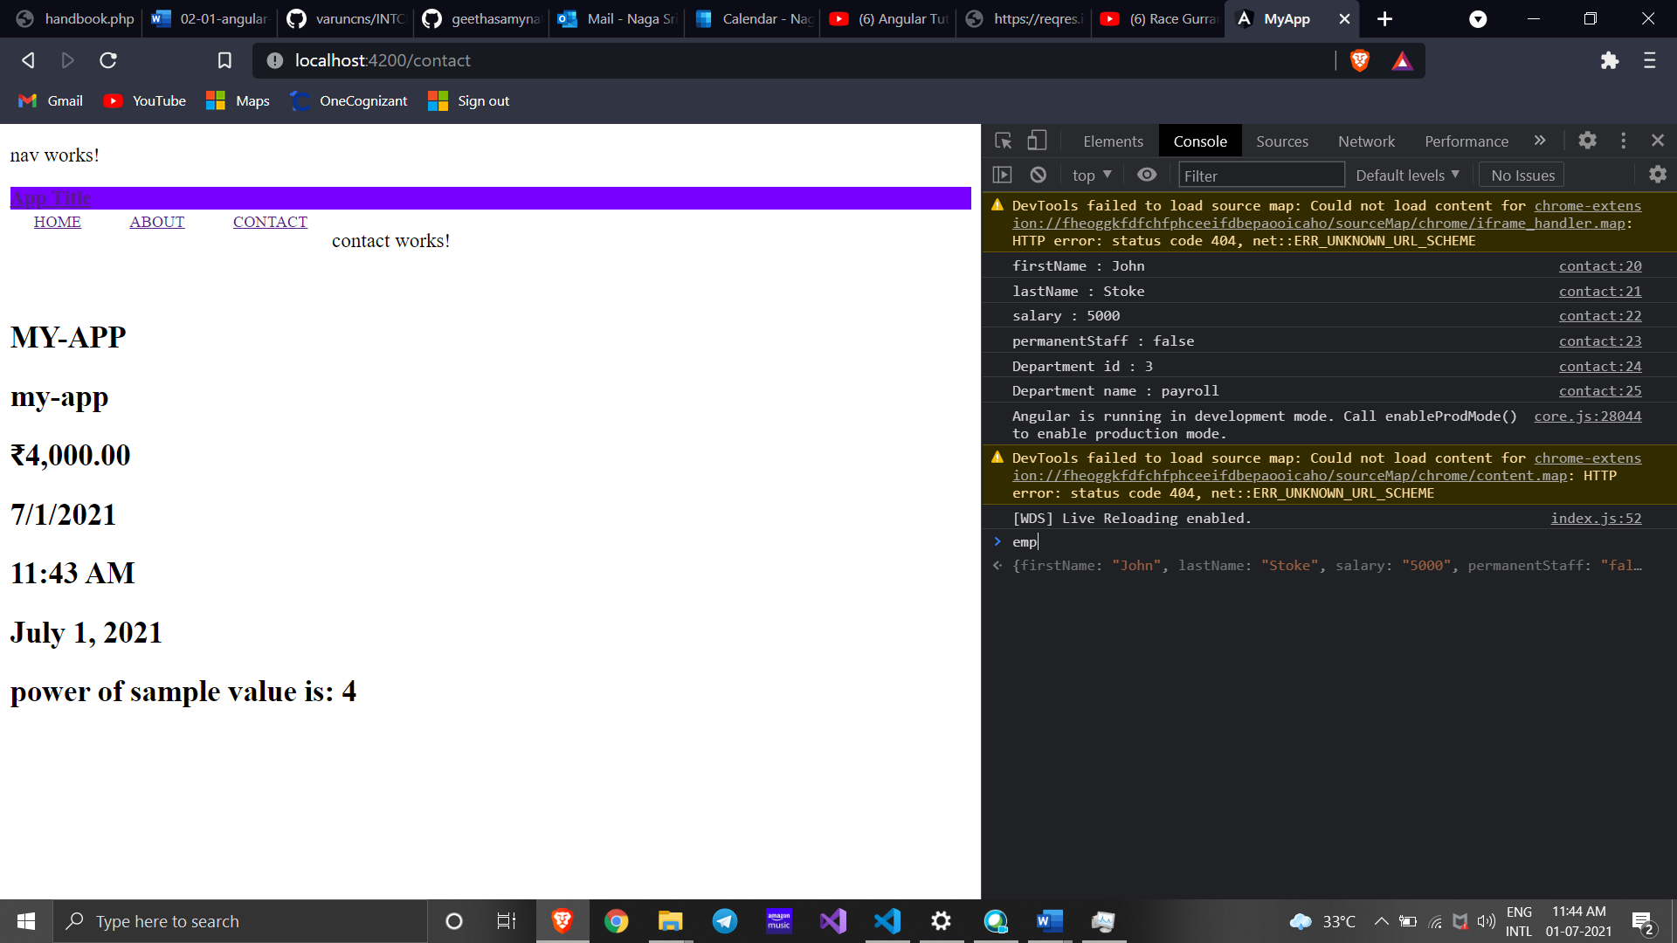

Adding Skills to json

<script>

  const data = '{"firstName":"John", "lastName":"Stoke", "salary":"5000", "permanentStaff":"false", "Department":[{"id":"3","name":"payroll"}], "skill":[{"id":"1", "value":"HTML"},{"id":"2", "value":"CSS"},{"id":"2", "value":"Javascript"}]}';

  var ff1 = JSON.parse(data);

  console.log("firstName : "+ff1.firstName);

  console.log("lastName : "+ff1.lastName);

  console.log("salary : "+ff1.salary);

  console.log("permanentStaff : "+ff1.permanentStaff)

  console.log("Department id : "+ff1.Department[0].id);

  console.log("Department name : "+ff1.Department[0].name);

  for(var i=0; i<ff1.skill.length; i++)

  {

  console.log("Skill "+(i+1)+" : "+ff1.skill[i].id+", "+ff1.skill[i].value);

  }

  </script>

OUTPUT

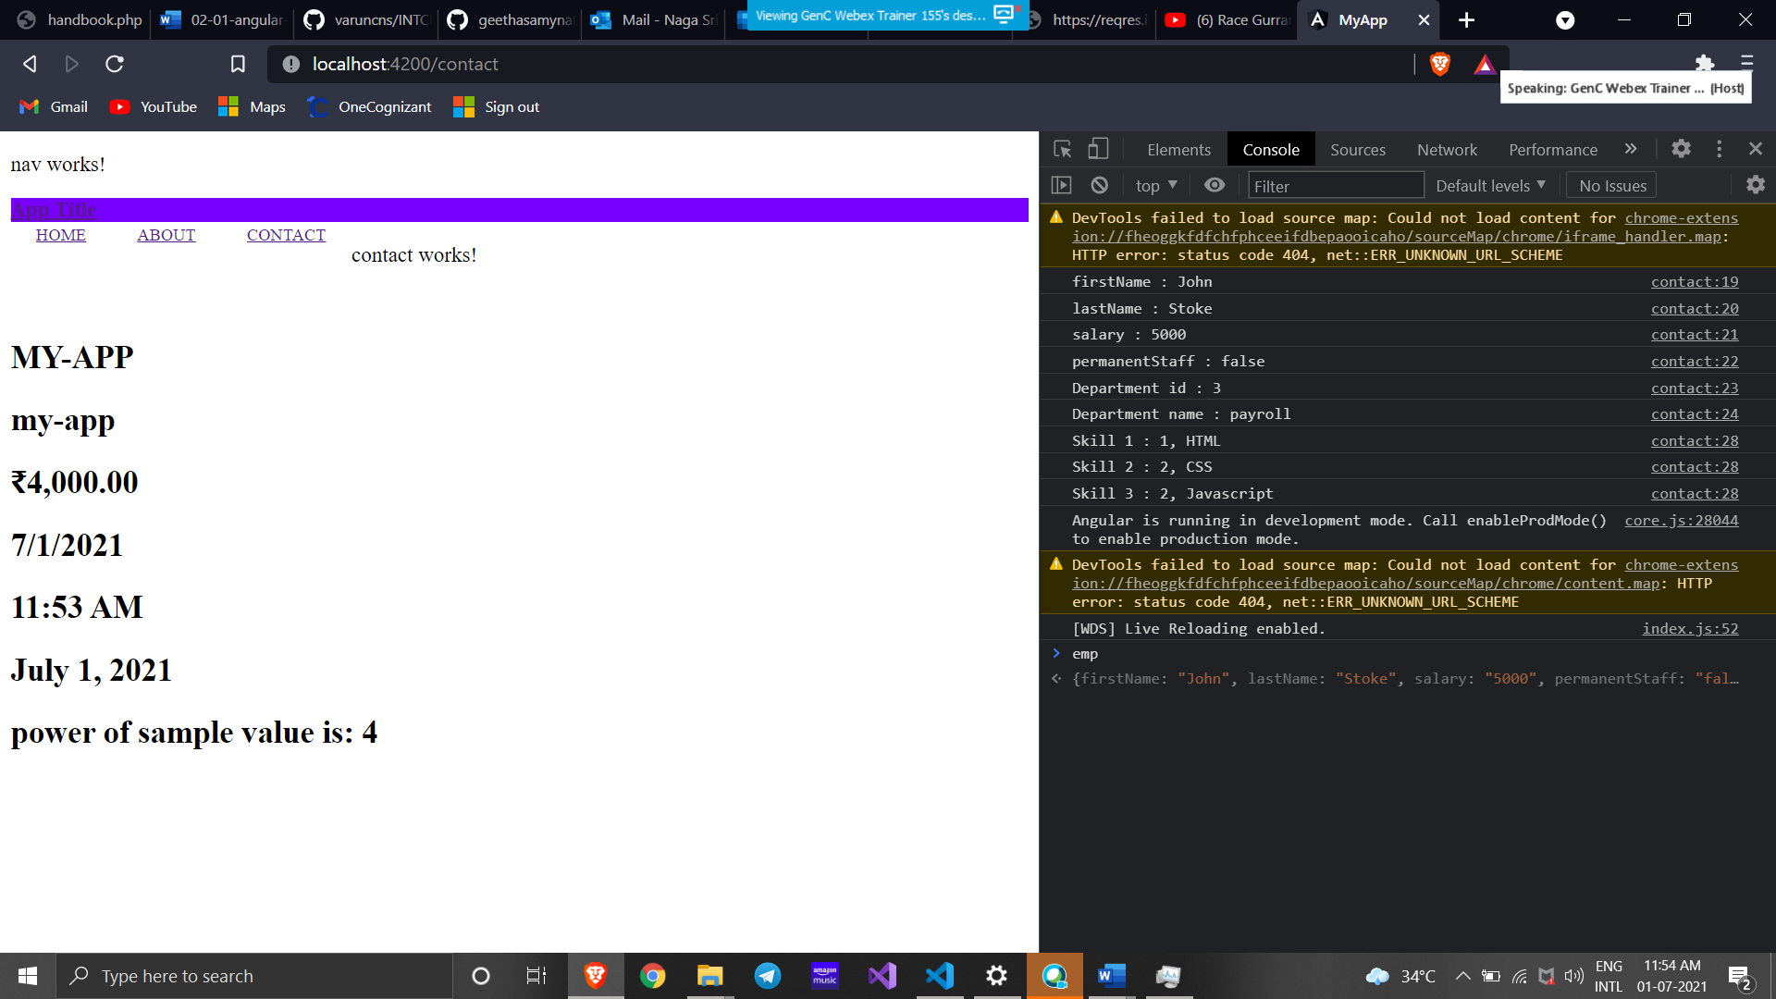

Session-2

1.

Employee.ts

export interface Employee {

    id:number;

    name:string;

    salary:number;

    permanent:boolean;

    }

Employee-test.js after converting

var emp = {

    id: 3,

    name: "John",

    salary: 5000,

    permanent: true,

};

console.log("id : " + emp.id);

console.log("name : " + emp.name);

console.log("salary : " + emp.salary);

console.log("permanent : " + emp.permanent);

export {};

OUTPUT

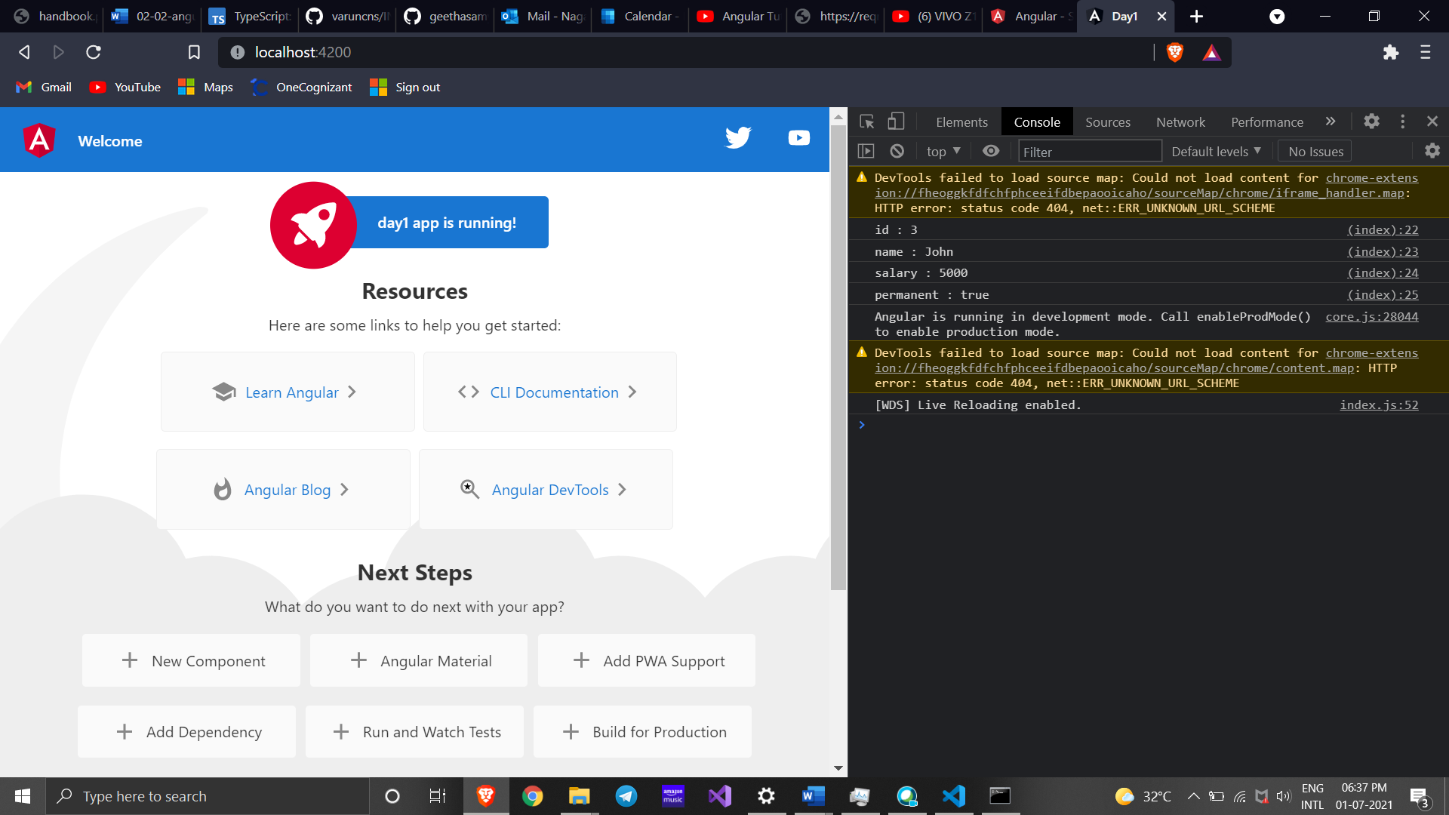

2.

Department.ts

export interface Department{

    id:number;

    name:string;

    }

Employee.ts

import { Department } from './Department';

export class Employee implements Department{

id:number;

name:string;

salary:number;

permanent:boolean;

constructor(id:number, name:string, salary:number, permanent:boolean){

this.id = id;

this.name = name;

this.salary = salary;

this.permanent = permanent;

}

}

Employee-test.ts

import { Department } from './Department';

import { Employee } from './Employee';

var emp1 = new Employee(123, "John", 5000, true);

console.log("id: "+emp1.id);

console.log("name: "+emp1.name);

console.log("salary: "+emp1.salary);

console.log("permanent: "+emp1.permanent);

var dept:Department = {

id:1,

name:"Payroll",

}

console.log("Department id : "+dept.id);

console.log("Department name : "+dept.name);

OUTPUT

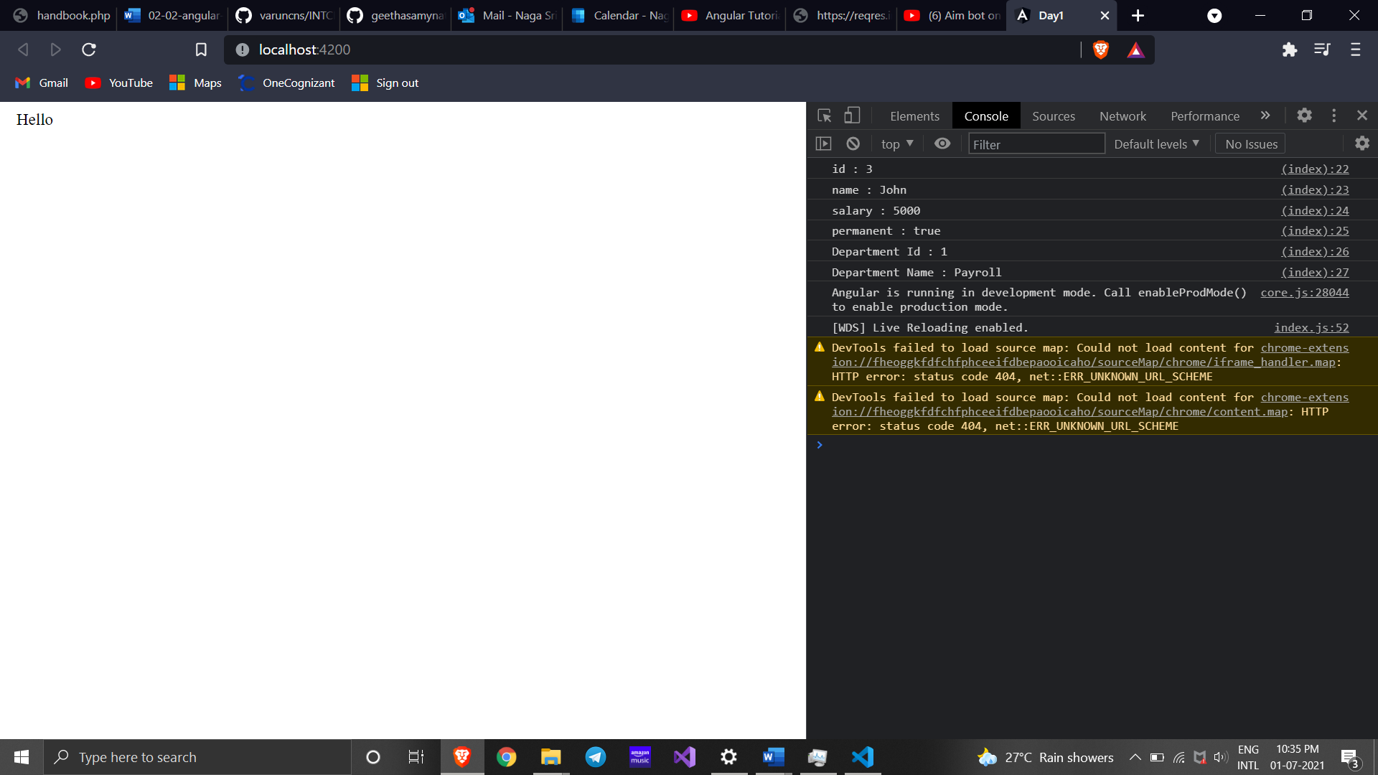

3.

Department.ts

export interface Department{

    id:number;

    name:string;

    }

Skill.ts

export interface Skill{

    id:number;

    name:string;

    }

Employee.ts

import { Employee } from './Employee';

import { Skill } from './Skill';

import { Department } from './Department';

var emp1 = new Employee(123, "John", 10000, true);

console.log("id: "+emp1.id);

console.log("name: "+emp1.name);

console.log("salary: "+emp1.salary);

console.log("permanent: "+emp1.permanent);

var dept:Department = {

    id:1,

    name:"Payroll",

    }

console.log("Department id : "+dept.id);

console.log("Department name : "+dept.name);

var skill1:Skill = {

    id:1,

    name:"HTML",

    }

var skill2:Skill = {

    id:2,

    name:"CSS",

    }

var skill3:Skill = {

    id:3,

    name:"JavaScript",

    }

console.log("Skill[0]:"+skill1.id+", "+skill1.name);

console.log("Skill[1]:"+skill2.id+", "+skill2.name);

console.log("Skill[2]:"+skill3.id+", "+skill3.name);

Employee-test.ts

import { Employee } from './Employee';

var emp1 = new Employee(1, "HTML");

var emp2 = new Employee(2, "CSS");

var emp3 = new Employee(3, "Javascript");

console.log("Skill 1: "+emp1.id+", "+emp1.name);

console.log("Skill 2: "+emp2.id+", "+emp2.name);

console.log("Skill 3: "+emp3.id+", "+emp3.name);

OUTPUT

