**Hands on Day -4**

**INTCDE21ID008**

**C N S Varun**

**916214**

**HANDSON-1**

**Form.cs**

using System;

using System.Text.RegularExpressions;

using System.Windows.Forms;

namespace WindowsFormsApplication1

{

public partial class Form1 : Form

{

public Form1()

{

InitializeComponent();

}

private void Form1_Load(object sender, EventArgs e)

{

}

private void button1_Click(object sender, EventArgs e)

{

string input1 = textBox1.Text;

string input2 = textBox2.Text;

if (!Regex.IsMatch(input1, @"\d+$") || !Regex.IsMatch(input2, @"\d+$"))

{

MessageBox.Show(" Please enter valid input for the operands");

}

if (radioButton1.Checked)

{

MessageBox.Show((int.Parse(input1) + int.Parse(input2)).ToString());

}

else if (radioButton2.Checked)

{

MessageBox.Show((int.Parse(input1) - int.Parse(input2)).ToString());

}

else if (radioButton3.Checked)

{

MessageBox.Show((int.Parse(input1) * int.Parse(input2)).ToString());

}

else if (radioButton4.Checked)

{

MessageBox.Show((int.Parse(input1) / int.Parse(input2)).ToString());

}

else

{

MessageBox.Show("Please Select a valid Option");

}

}

}

}

**Form1.Designer.cs**

namespace WindowsFormsApplication1

{

partial class Form1

{

/// <summary>

/// Required designer variable.

/// </summary>

private System.ComponentModel.IContainer components = null;

/// <summary>

/// Clean up any resources being used.

/// </summary>

/// <param name="disposing">true if managed resources should be disposed; otherwise, false.</param>

protected override void Dispose(bool disposing)

{

if (disposing && (components != null))

{

components.Dispose();

}

base.Dispose(disposing);

}

#region Windows Form Designer generated code

/// <summary>

/// Required method for Designer support - do not modify

/// the contents of this method with the code editor.

/// </summary>

private void InitializeComponent()

{

this.textBox1 = new System.Windows.Forms.TextBox();

this.textBox2 = new System.Windows.Forms.TextBox();

this.button1 = new System.Windows.Forms.Button();

this.radioButton1 = new System.Windows.Forms.RadioButton();

this.radioButton2 = new System.Windows.Forms.RadioButton();

this.radioButton3 = new System.Windows.Forms.RadioButton();

this.radioButton4 = new System.Windows.Forms.RadioButton();

this.SuspendLayout();

//

// textBox1

//

this.textBox1.Location = new System.Drawing.Point(146, 62);

this.textBox1.Name = "textBox1";

this.textBox1.Size = new System.Drawing.Size(125, 27);

this.textBox1.TabIndex = 0;

//

// textBox2

//

this.textBox2.Location = new System.Drawing.Point(367, 62);

this.textBox2.Name = "textBox2";

this.textBox2.Size = new System.Drawing.Size(125, 27);

this.textBox2.TabIndex = 1;

//

// button1

//

this.button1.Location = new System.Drawing.Point(270, 206);

this.button1.Name = "button1";

this.button1.Size = new System.Drawing.Size(94, 29);

this.button1.TabIndex = 6;

this.button1.Text = "Calculate";

this.button1.UseVisualStyleBackColor = true;

this.button1.Click += new System.EventHandler(this.button1_Click);

//

// radioButton1

//

this.radioButton1.AutoSize = true;

this.radioButton1.Location = new System.Drawing.Point(72, 133);

this.radioButton1.Name = "Addition";

this.radioButton1.Size = new System.Drawing.Size(117, 24);

this.radioButton1.TabIndex = 7;

this.radioButton1.TabStop = true;

this.radioButton1.Text = "Addition";

this.radioButton1.UseVisualStyleBackColor = true;

//

// radioButton2

//

this.radioButton2.AutoSize = true;

this.radioButton2.Location = new System.Drawing.Point(238, 133);

this.radioButton2.Name = "Subtraction";

this.radioButton2.Size = new System.Drawing.Size(117, 24);

this.radioButton2.TabIndex = 8;

this.radioButton2.TabStop = true;

this.radioButton2.Text = "Subtraction";

this.radioButton2.UseVisualStyleBackColor = true;

//

// radioButton3

//

this.radioButton3.AutoSize = true;

this.radioButton3.Location = new System.Drawing.Point(406, 133);

this.radioButton3.Name = "Multiplication";

this.radioButton3.Size = new System.Drawing.Size(117, 24);

this.radioButton3.TabIndex = 9;

this.radioButton3.TabStop = true;

this.radioButton3.Text = "Multiplication";

this.radioButton3.UseVisualStyleBackColor = true;

//

// radioButton4

//

this.radioButton4.AutoSize = true;

this.radioButton4.Location = new System.Drawing.Point(560, 133);

this.radioButton4.Name = "Division";

this.radioButton4.Size = new System.Drawing.Size(117, 24);

this.radioButton4.TabIndex = 10;

this.radioButton4.TabStop = true;

this.radioButton4.Text = "Division";

this.radioButton4.UseVisualStyleBackColor = true;

//

// Form1

//

this.AutoScaleDimensions = new System.Drawing.SizeF(8F, 20F);

this.AutoScaleMode = System.Windows.Forms.AutoScaleMode.Font;

this.ClientSize = new System.Drawing.Size(800, 450);

this.Controls.Add(this.radioButton4);

this.Controls.Add(this.radioButton3);

this.Controls.Add(this.radioButton2);

this.Controls.Add(this.radioButton1);

this.Controls.Add(this.button1);

this.Controls.Add(this.textBox2);

this.Controls.Add(this.textBox1);

this.Name = "Form1";

this.Text = "Form1";

this.Load += new System.EventHandler(this.Form1_Load);

this.ResumeLayout(false);

this.PerformLayout();

}

#endregion

private System.Windows.Forms.TextBox textBox1;

private System.Windows.Forms.TextBox textBox2;

private System.Windows.Forms.Button button1;

private System.Windows.Forms.RadioButton radioButton1;

private System.Windows.Forms.RadioButton radioButton2;

private System.Windows.Forms.RadioButton radioButton3;

private System.Windows.Forms.RadioButton radioButton4;

}

}

**Program**

using System;

using System.Collections.Generic;

using System.Linq;

using System.Threading.Tasks;

using System.Windows.Forms;

using WindowsFormsApplication1;

namespace D4Handson

{

static class Program

{

/// <summary>

/// The main entry point for the application.

/// </summary>

[STAThread]

static void Main()

{

Application.SetHighDpiMode(HighDpiMode.SystemAware);

Application.EnableVisualStyles();

Application.SetCompatibleTextRenderingDefault(false);

Application.Run(new Form1());

}

}

}

**OUTPUT**

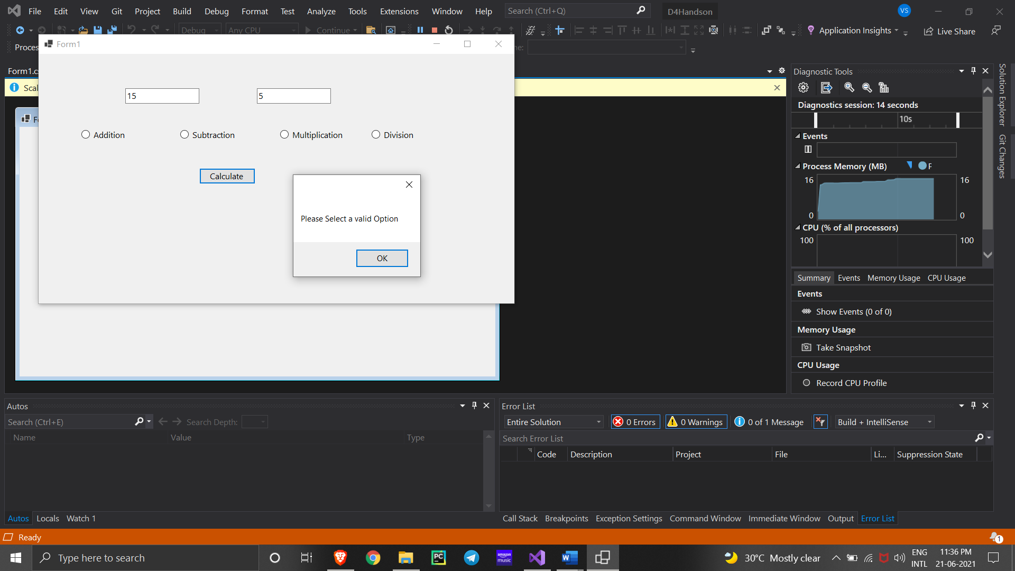

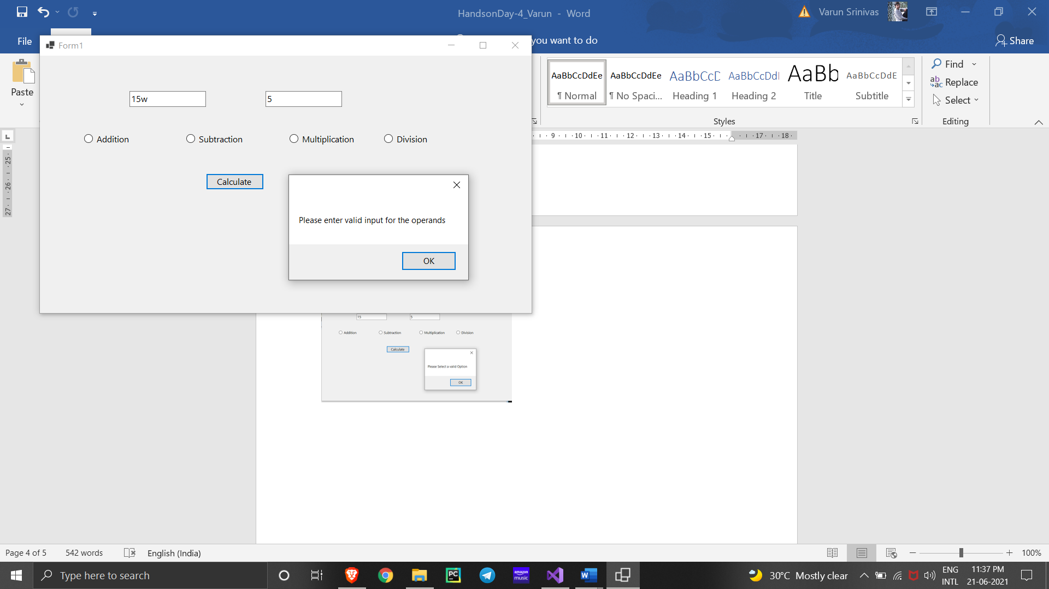

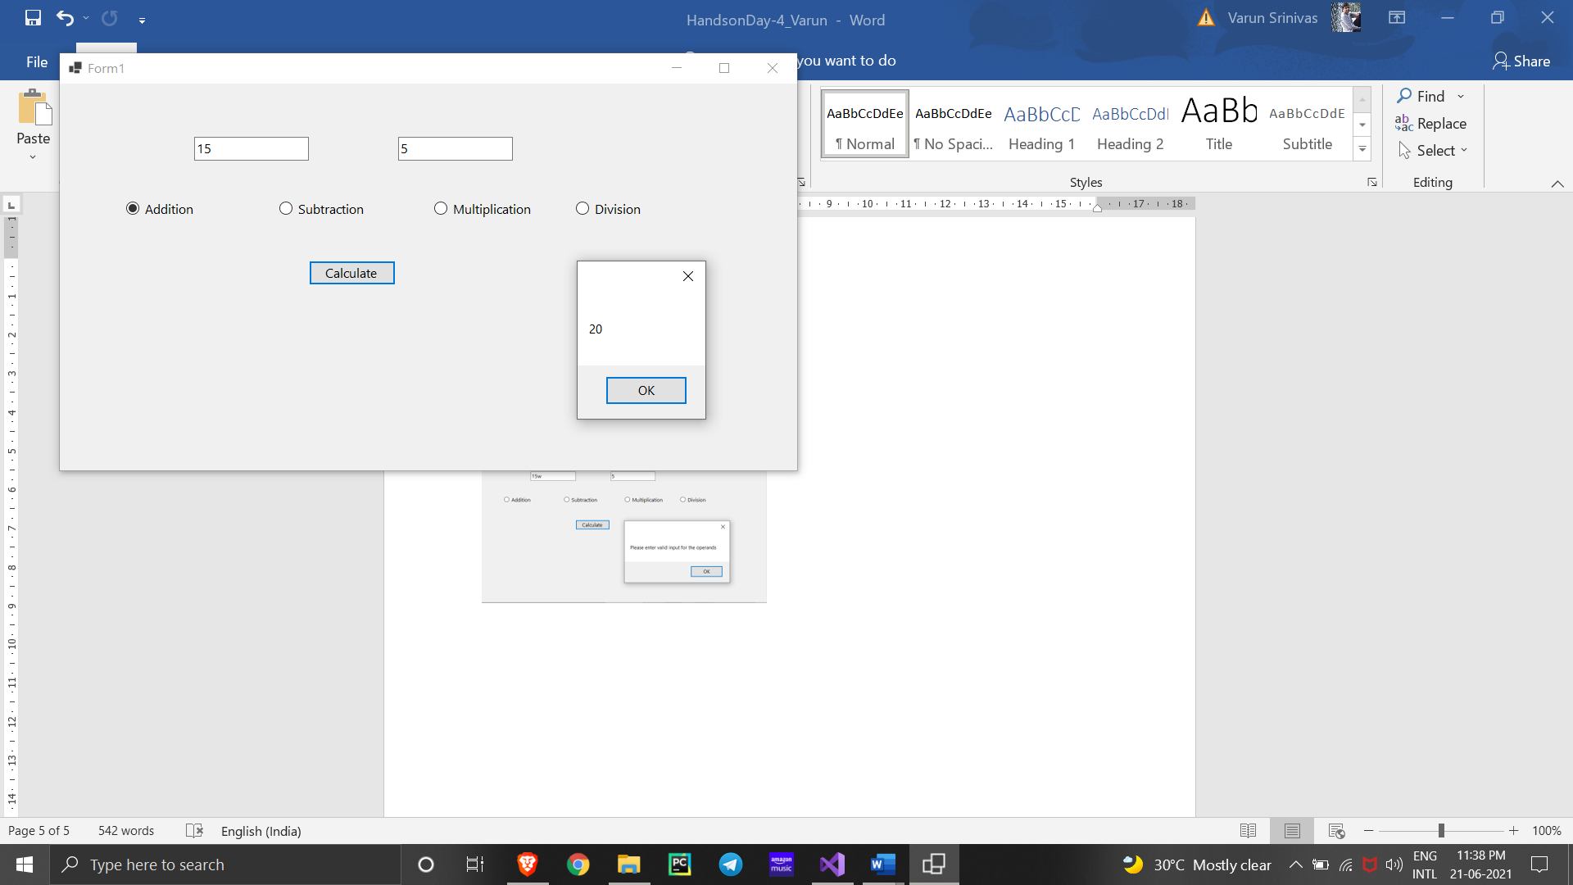

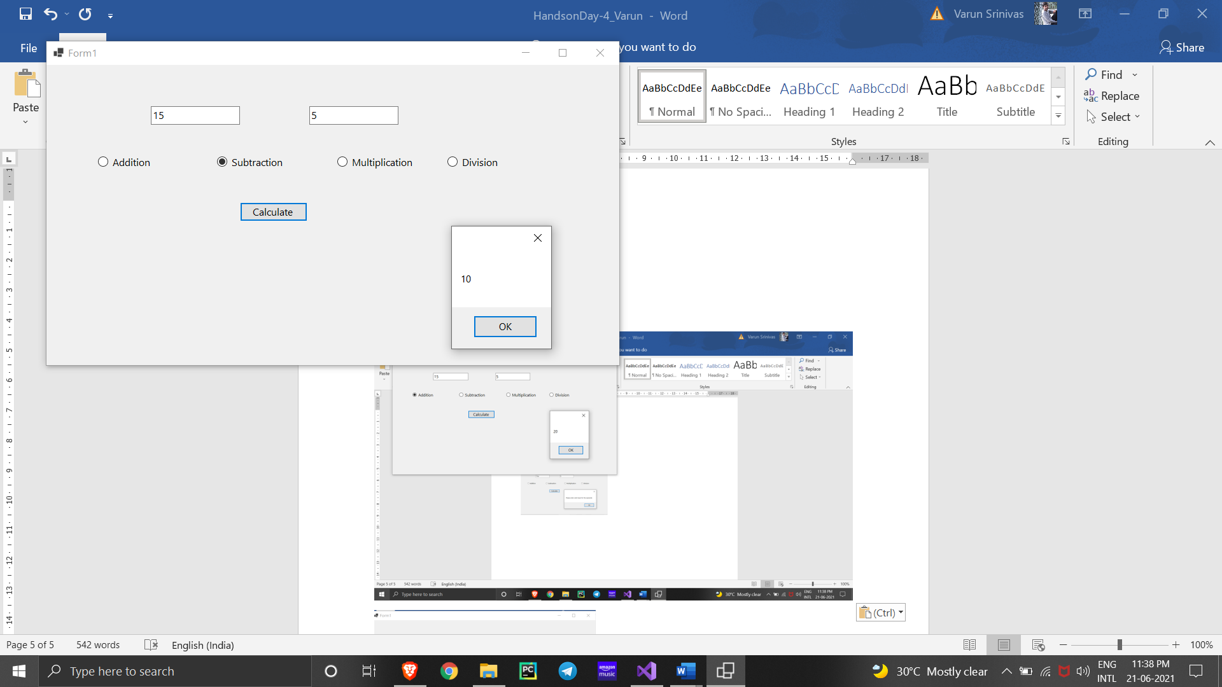

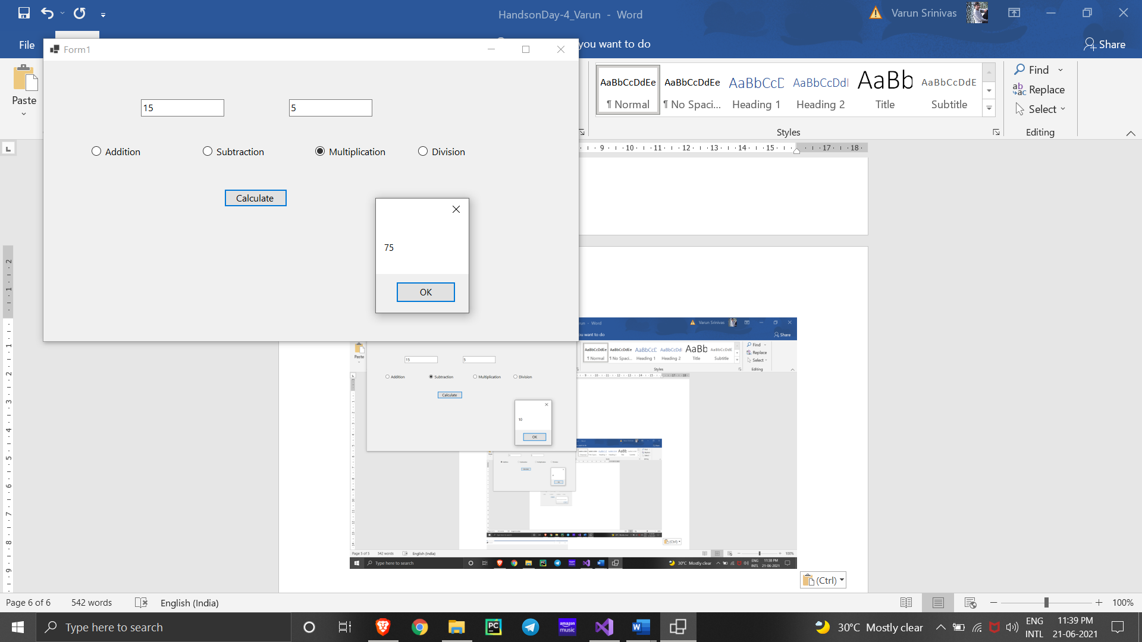

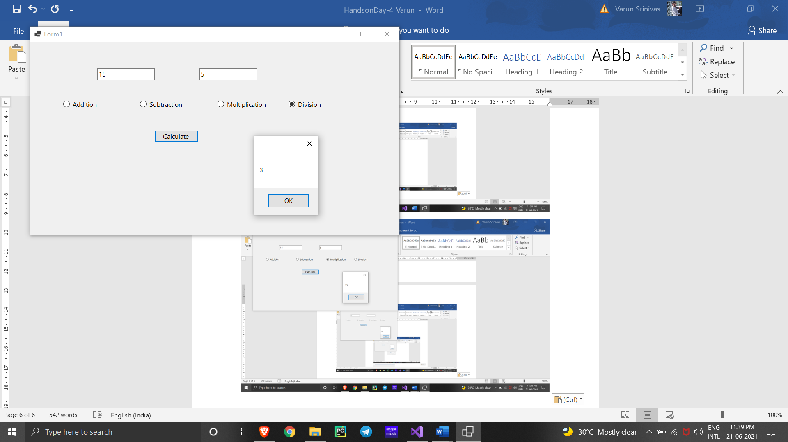

**HANDSON-2**

**Form.cs**

using System;

using System.Collections.Generic;

using System.ComponentModel;

using System.Data;

using System.Drawing;

using System.Linq;

using System.Text;

using System.Threading.Tasks;

using System.Windows.Forms;

namespace WindowsFormsApplication2

{

public partial class Form1 : Form

{

public Form1()

{

InitializeComponent();

}

private void pictureBox1_Click(object sender, EventArgs e)

{

}

private void button1_Click(object sender, EventArgs e)

{

OpenFileDialog openFileDialog1 = new OpenFileDialog

{

InitialDirectory = @"D:\",

Filter = "image(*.jpg) | *.jpg"

};

if (openFileDialog1.ShowDialog() == DialogResult.OK)

{

pictureBox1.SizeMode = PictureBoxSizeMode.StretchImage;

pictureBox1.Image = new Bitmap(openFileDialog1.FileName);

}

}

}

}

**Form1.Designer.cs**

namespace WindowsFormsApplication2

{

partial class Form1

{

/// <summary>

/// Required designer variable.

/// </summary>

private System.ComponentModel.IContainer components = null;

/// <summary>

/// Clean up any resources being used.

/// </summary>

/// <param name="disposing">true if managed resources should be disposed; otherwise, false.</param>

protected override void Dispose(bool disposing)

{

if (disposing && (components != null))

{

components.Dispose();

}

base.Dispose(disposing);

}

#region Windows Form Designer generated code

/// <summary>

/// Required method for Designer support - do not modify

/// the contents of this method with the code editor.

/// </summary>

private void InitializeComponent()

{

this.openFileDialog1 = new System.Windows.Forms.OpenFileDialog();

this.pictureBox1 = new System.Windows.Forms.PictureBox();

this.button1 = new System.Windows.Forms.Button();

((System.ComponentModel.ISupportInitialize)(this.pictureBox1)).BeginInit();

this.SuspendLayout();

//

// openFileDialog1

//

this.openFileDialog1.FileName = "openFileDialog1";

//

// pictureBox1

//

this.pictureBox1.Location = new System.Drawing.Point(59, 48);

this.pictureBox1.Name = "pictureBox1";

this.pictureBox1.Size = new System.Drawing.Size(700, 343);

this.pictureBox1.TabIndex = 0;

this.pictureBox1.TabStop = false;

this.pictureBox1.Click += new System.EventHandler(this.pictureBox1_Click);

//

// button1

//

this.button1.Location = new System.Drawing.Point(320, 409);

this.button1.Name = "button1";

this.button1.Size = new System.Drawing.Size(94, 29);

this.button1.TabIndex = 1;

this.button1.Text = "button1";

this.button1.UseVisualStyleBackColor = true;

this.button1.Click += new System.EventHandler(this.button1_Click);

//

// Form1

//

this.AutoScaleDimensions = new System.Drawing.SizeF(8F, 20F);

this.AutoScaleMode = System.Windows.Forms.AutoScaleMode.Font;

this.ClientSize = new System.Drawing.Size(800, 450);

this.Controls.Add(this.button1);

this.Controls.Add(this.pictureBox1);

this.Name = "Form1";

this.Text = "Form1";

((System.ComponentModel.ISupportInitialize)(this.pictureBox1)).EndInit();

this.ResumeLayout(false);

}

#endregion

private System.Windows.Forms.OpenFileDialog openFileDialog1;

private System.Windows.Forms.PictureBox pictureBox1;

private System.Windows.Forms.Button button1;

}

}

**Program.cs**

using System;

using System.Collections.Generic;

using System.Linq;

using System.Threading.Tasks;

using System.Windows.Forms;

using WindowsFormsApplication2;

namespace D4Handson2

{

static class Program

{

/// <summary>

/// The main entry point for the application.

/// </summary>

[STAThread]

static void Main()

{

Application.SetHighDpiMode(HighDpiMode.SystemAware);

Application.EnableVisualStyles();

Application.SetCompatibleTextRenderingDefault(false);

Application.Run(new Form1());

}

}

}

**OUTPUT**

